Supplementary data for
Identification of Monocytes Associated with Severe COVID-19 in the PBMCs of Severely Infected patients Through Single-Cell Transcriptome Sequencing
Yan Zhang ^{a,#}, Shuting Wang ^{a,#}, He Xia ^{a,#}, Jing Guo ª, Kangxin He ª, Chenjie Huang ª, Rui Luo ª, Yanfei Chen ª, Kaijin Xu ª, Hainv Gao ^{b}, Jifang Sheng ª, Lanjuan Li ^{a,}*
ª State Key Laboratory for Diagnosis and Treatment of Infectious Disease, National Clinical Research Center for Infectious Diseases, Collaborative Innovation Center for Diagnosis and Treatment of Infectious Diseases, Department of Infectious Disease, The First Affiliated Hospital, College of Medicine, Zhejiang University, Hangzhou 310003, China
^{b} Shulan (Hangzhou) Hospital Affiliated to Zhejiang Shuren University Shulan International Medical College, Hangzhou 310022, China

Table S1
The guidelines for the diagnosis and management of COVID-19 (6th edition, Chinese).
Type | Criteria
Mild |  | Light clinical symptoms, and no sign of pneumonia on imaging
Moderate |  | With manifestation of fever, respiratory tract and other symptoms, and pneumonia in imaging
Severe |  | With any of the following: ① dyspnea, respiration rate (RR) ≥ 30 times per minute; ② the oxygen saturation ≤ 93% in the resting state; ③ PaO2/FiO2 ≤ 300 mmHg (1 mmHg = 0.133 kPa); ④ rate of lung infiltration > 50% within 24–48 h in imaging
Critically ill |  | Coincide with any of the following: ① respiratory failure occurs and mechanical ventilation is required; ② shock; ③ the patient develops other organ failure and needs ICU monitoring and treatment

Table S2
The data characteristics of scRNA-seq of the 20 samples in the study
Sample No. | Reads kept percent | Cell number | Mapping rate | Total reads | Mapped reads | Total reads per cell | Mapped reads per cell
R2 | 0.570125 | 4407 | 90.09% | 1.83 × 10⁸ | 1.65 × 10⁸ | 41613 | 37490
S3 | 0.460408 | 3443 | 89.63% | 1.78 × 10⁸ | 1.60 × 10⁸ | 51797 | 46424
R3 | 0.548164 | 3963 | 90.68% | 1.70 × 10⁸ | 1.55 × 10⁸ | 43001 | 38992
R4 | 0.490646 | 3491 | 89.92% | 1.69 × 10⁸ | 1.52 × 10⁸ | 48445 | 43563
N1 | 0.745752 | 5869 | 89.12% | 1.89 × 10⁸ | 1.68 × 10⁸ | 32160 | 28661
R5 | 0.830155 | 6083 | 89.66% | 1.75 × 10⁸ | 1.57 × 10⁸ | 28717 | 25747
M1 | 0.617407 | 4695 | 89.47% | 1.82 × 10⁸ | 1.63 × 10⁸ | 38694 | 34619
N2 | 0.533044 | 4325 | 89.48% | 1.94 × 10⁸ | 1.73 × 10⁸ | 44810 | 40098
R6 | 0.752208 | 5703 | 89.66% | 1.81 × 10⁸ | 1.62 × 10⁸ | 31691 | 28415
N3 | 0.497278 | 4103 | 89.05% | 1.98 × 10⁸ | 1.76 × 10⁸ | 48269 | 42982
R7 | 0.624460 | 4017 | 90.18% | 1.52 × 10⁸ | 1.37 × 10⁸ | 37953 | 34228
M2 | 0.433330 | 3845 | 90.98% | 2.08 × 10⁸ | 1.90 × 10⁸ | 54216 | 49325
N4 | 1.000000 | 5401 | 88.32% | 1.31 × 10⁸ | 1.15 × 10⁸ | 24199 | 21374
M3 | 0.597807 | 4509 | 90.56% | 1.78 × 10⁸ | 1.61 × 10⁸ | 39479 | 35754
N5 | 0.669423 | 5306 | 87.40% | 1.94 × 10⁸ | 1.69 × 10⁸ | 36530 | 31929
M4 | 0.709864 | 5067 | 90.99% | 1.68 × 10⁸ | 1.53 × 10⁸ | 33091 | 30110
N6 | 0.949829 | 5427 | 88.64% | 1.38 × 10⁸ | 1.22 × 10⁸ | 25386 | 22503
S1 | 0.586376 | 4228 | 89.65% | 1.72 × 10⁸ | 1.54 × 10⁸ | 40662 | 36451
R1 | 0.405987 | 2861 | 90.19% | 1.67 × 10⁸ | 1.51 × 10⁸ | 58371 | 52647
S2 | 0.62673 | 3853 | 89.07% | 1.48 × 10⁸ | 1.31 × 10⁸ | 38290 | 34104

Fig. S1. Differential gene expression in distinct clusters of monocytes. (a) Differential gene expression in distinct clusters of mononuclear cells. (b) Differential gene expression heat maps in distinct clusters of mononuclear cells. (c) Upstream transcription factors of differential genes expressed in Mono 0 and Mono 5.

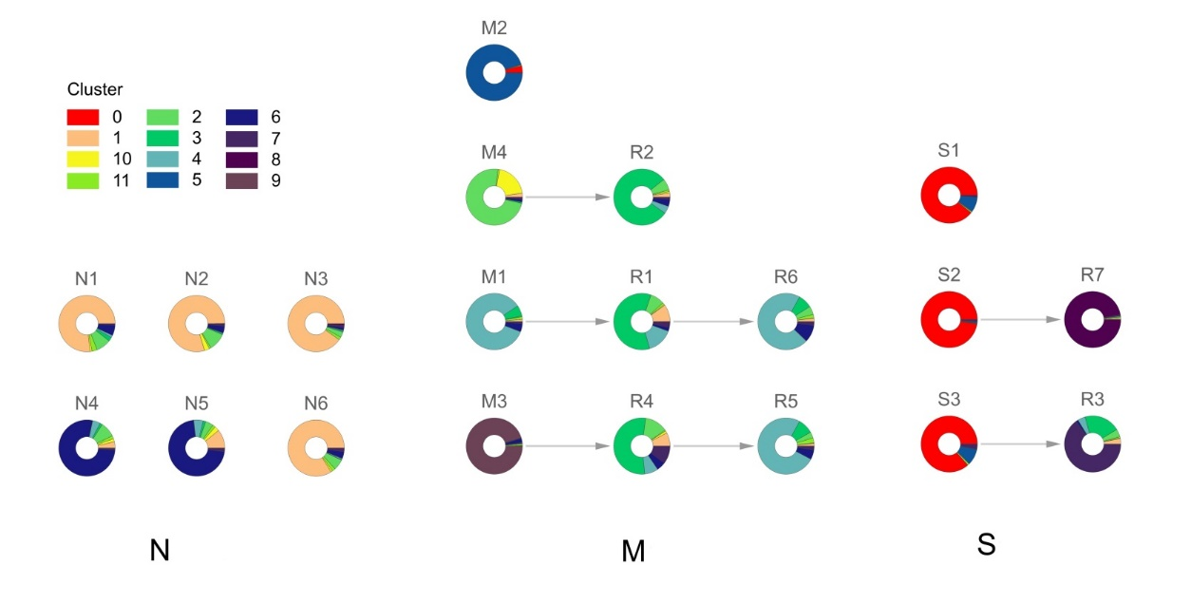
Fig. S2. The dynamic changes of monocytes composition in different groups. The dynamic changes of monocytes composition in different groups, including S group, M group, R group, and N group. Clusters 0–11 represent the monocytes clusters. Severe-disease specific clusters Mono 0 dominated in the samples S1 and S3 from severely cases and sample S2 from the critically ill case, whereas Mono 5 dominated in the sample M2 from the pre-severe case. The ratio of Mono 0/ Mono 5 in S1, S2, and S3 were inversed relatively to M2, and highest in S2.
Fig. S3. Different features of monocyte clusters in different patients. UMAP of monocytes from patients who finally develop severe or critical disease. (a) The UMAP of samples M1, M3, and M4; (b) the UMAP of samples M2; (c) the UMAP of samples S1, S2, and S3.

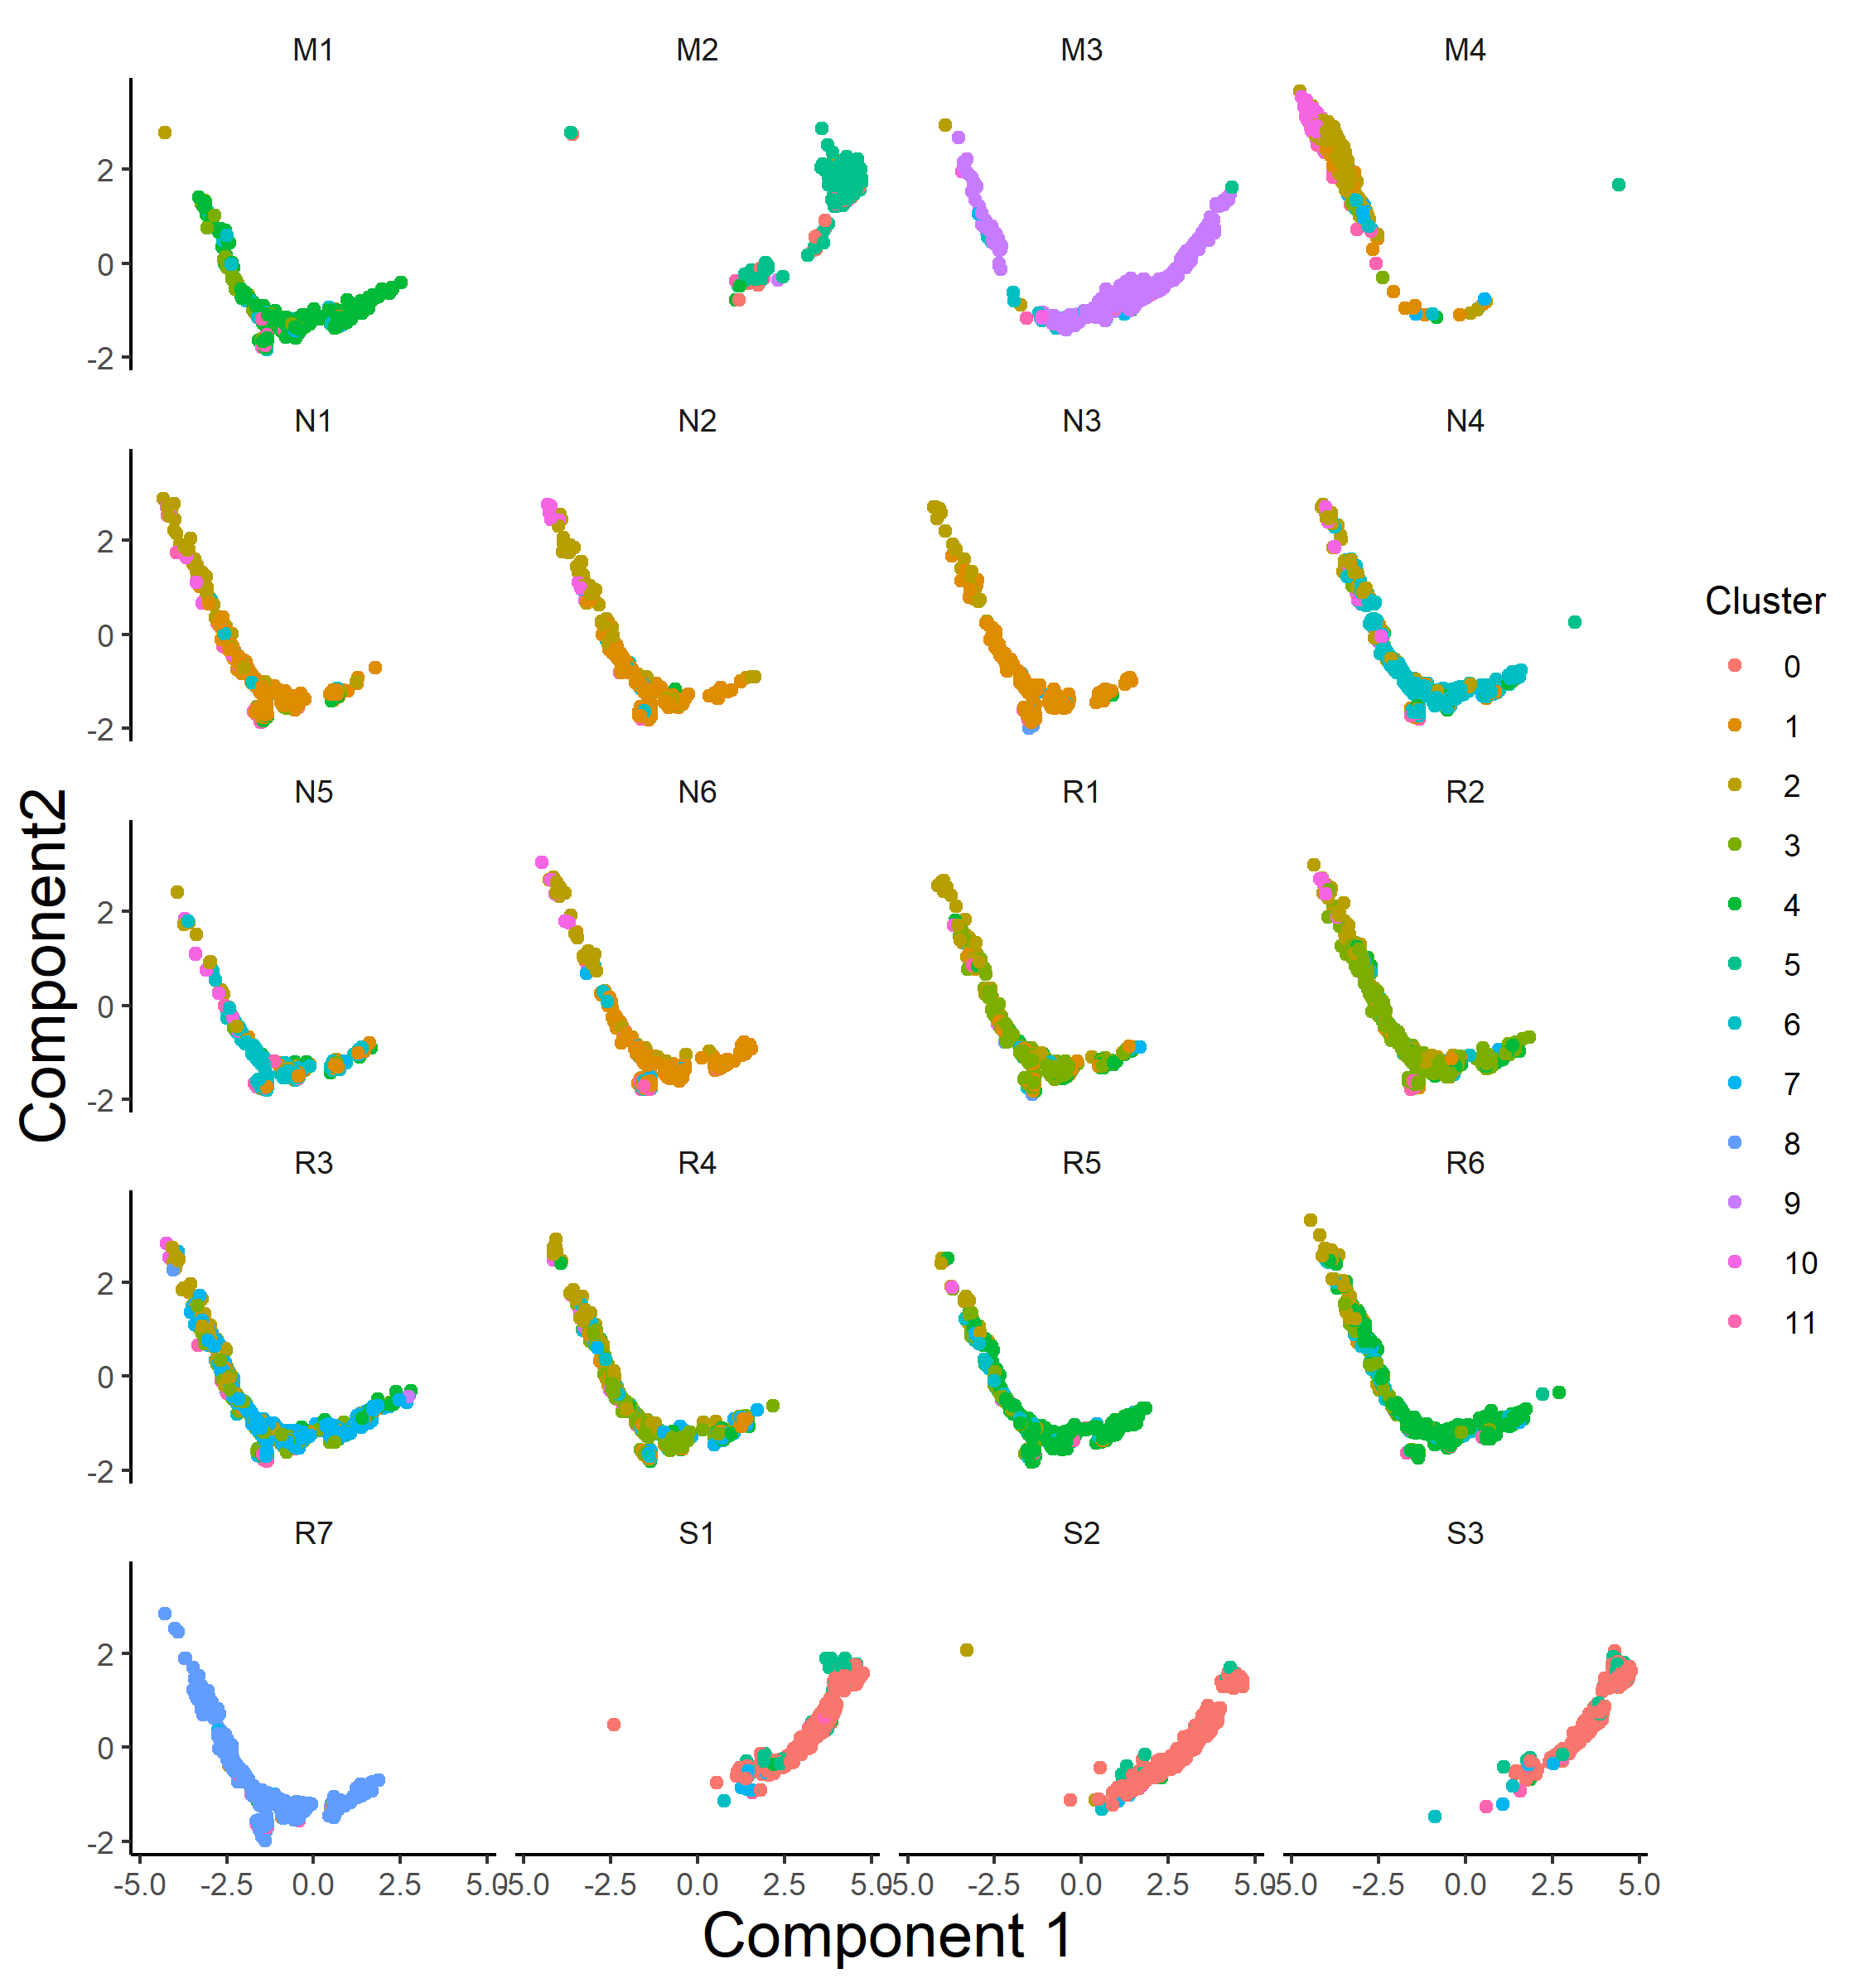
Fig. S4. Pseudo-time analysis of monocyte sub-clusters in different samples. Clusters 0–11 represent the monocytes clusters.

