Supplementary Data for

Ca-Alginate-Based Janus Capsules with a Pumping Effect for Intestinal-Targeted Controlled Release
Shuang Wen ª, Xiao-Jie Ju ^{a,b,}*, Wen-Ying Liu ª, Yu-Qiong Liu ª, Xing-Qun Pu ª, Zhuang Liu ^{a,b}, Wei Wang ^{a,b}, Rui Xie ^{a,b}, Yousef Faraj ª, Liang-Yin Chu ^{a,b}
ª School of Chemical Engineering, Sichuan University, Chengdu 610065, China
^{b} State Key Laboratory of Polymer Materials Engineering, Sichuan University, Chengdu 610065, China

* Corresponding author.
E-mail address: juxiaojie@scu.edu.cn (X.J. Ju).

Fig. S1. Schematic illustration of microfluidic preparation for HPMCP microspheres. (a) Preparation of emulsion templates by a microfluidic device. (b) HPMCP microspheres prepared by solvent diffusion.

Fig. S2. Digital photographs and diameter changes of θ-ACPSi capsules in different pH solutions. The scale bar is 5 mm.

Fig. S3. Mechanical properties of θ-AC and θ-ACPSi capsules. (a, b) Digital photographs of (a) deformation and (b) final rupture of θ-ACPSi capsule under extrusion, and the scale bar is 1 cm. (c) The stress–strain curves of extruded θ-AC and θ-ACPSi capsules. (d, e) The stress and strain values of extruded θ-AC and θ-ACPSi capsules.

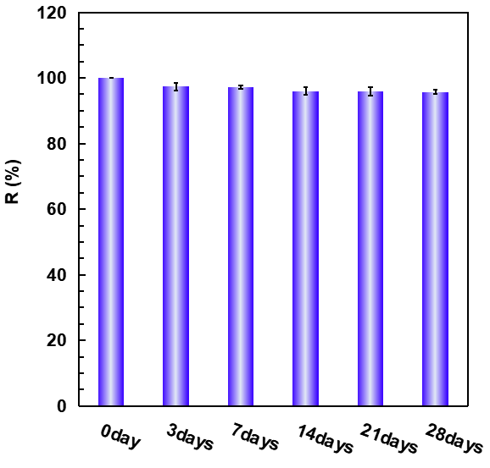
Fig. S4. The change in drug loading contents of θ-ACPSi capsules stored in 0.2 mol·L⁻¹ acetic acid solution.

