Supplementary data for

Bifunctional Asymmetric Fabric with Tailored Thermal Conduction and Radiation for Personal Cooling and Warming
Yucan Peng¹, Hiang Kwee Lee¹, David S. Wu¹, Yi Cui^{1,2}*
¹Department of Materials Science and Engineering, Stanford University, Stanford, CA 94305, USA.
²Stanford Institute for Materials and Energy Sciences, SLAC National Accelerator Laboratory, 2575 Sand Hill Road, Menlo Park, CA 94025, USA.
*Corresponding author:
Yi Cui (yicui@stanford.edu)

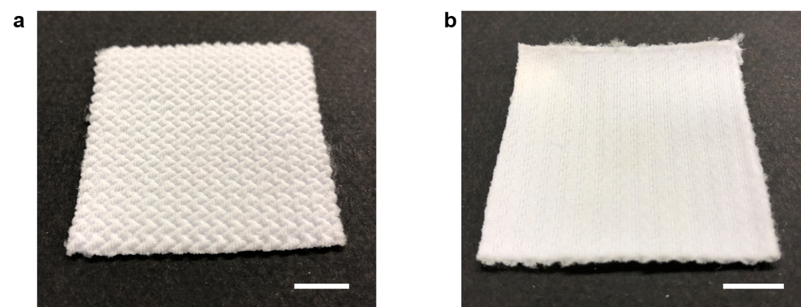
Fig. S1. Photographs of blank asymmetric fabric with laminated structure. (a) Rough side; (b) smooth side. The roughness contrast due to the structure asymmetry can be clearly observed. Scale bars, 1 cm.

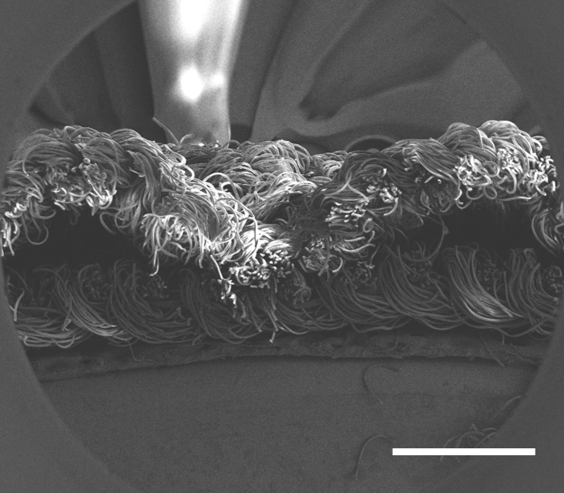
Fig. S2. Cross-section SEM image of the blank asymmetric fabric. The top surface shows apparent larger roughness. Scale bar, 1 mm.

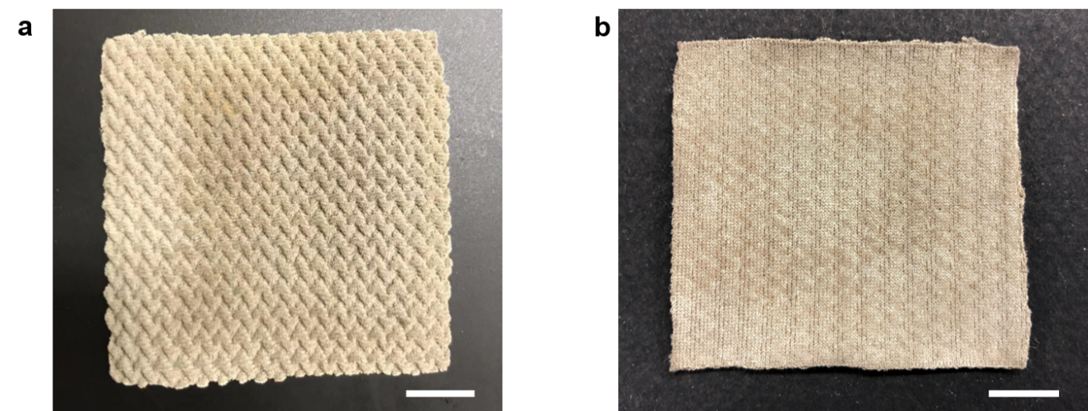
Fig. S3. Photographs of Ag fabric fabricated by Ag electroless plating. (a) Rough side; (b) smooth side. After Ag electroless plating, the whole fabric became silver color and the asymmetric surface roughness was retained. Scale bars, 1 cm.

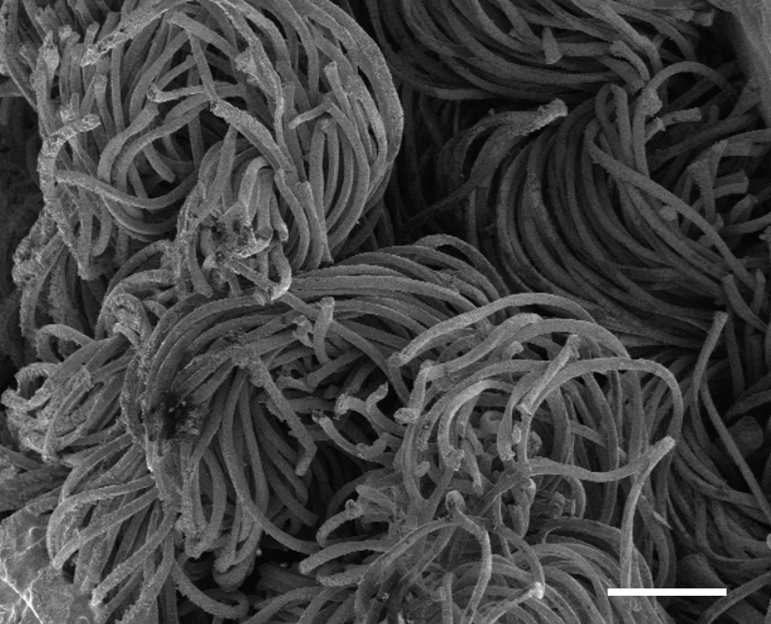
Fig. S4. SEM image showing the cross section of Ag fabric. Ag coating covers every fiber inside the fabric. Scale bar, 200 µm.

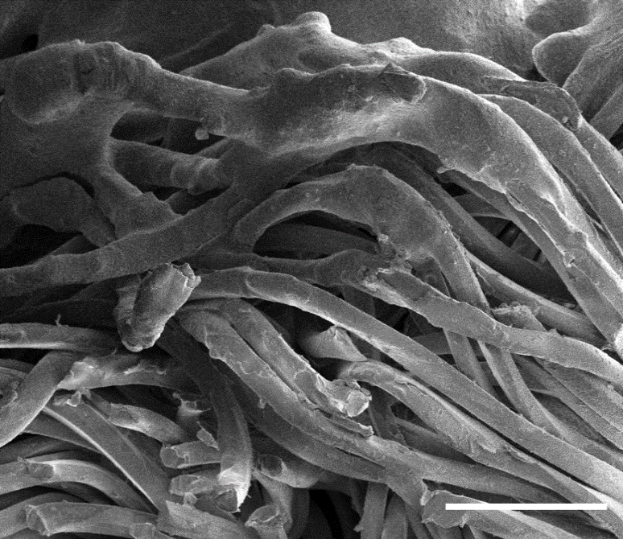
Fig. S5. SEM image of BAF cross section near the rough side. It is clearly to see the paint coating on the surface part and underneath Ag coated fibers. Scale bar, 100 µm.
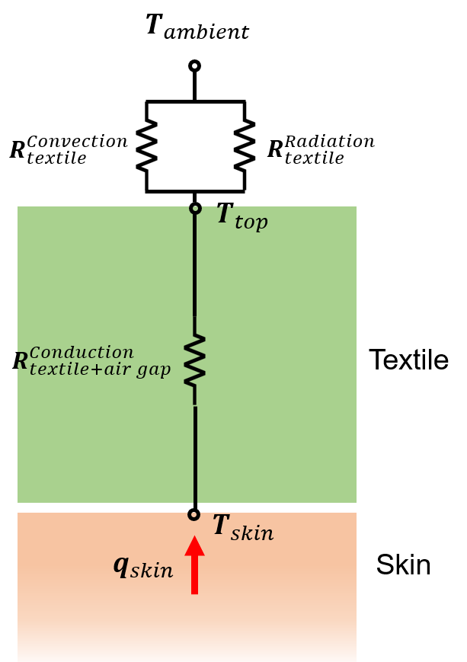
Fig. S6. Thermal circuit diagram of the thermal measurement with simulated skin.

