Tailoring Resorption Rates and Osteogenic Response in Xeno-Hybrid Bone Grafts: The Effect of Added Gelatins
Hao Zhu ^{a,b}, Håvard Jostein Haugen ^{b,}*, Giuseppe Perale ^{c,d,e}, Janne Elin Reseland ^{b}, Liebert Parreiras Nogueira ^{b}, Antonio Gonzalez Cantalapiedra ^{f}, Fernando Maria Guzon Muñoz ^{f}, Maria Permuy Mendaña ^{f}, Felice Betge ^{c}, Ståle Petter Lyngstadaas ^{b}, Jun Xiao ^{a,}*
ª Department of Orthopedic Surgery, Tongji Hospital, Tongji Medical College, Huazhong University of Science and Technology, Wuhan 430030, China
^{b} Department of Biomaterials, Institute of Clinical Dentistry, University of Oslo, Oslo 0317, Norway
^{c} Industrie Biomediche Insubri SA, Mezzovico-Vira 6805, Switzerland
^{d} Ludwig Boltzmann Institute for Experimental and Clinical Traumatology, Donaueschingenstrasse 13, 1200 Vienna, Austria
^{e} Faculty of Biomedical Sciences, University of Southern Switzerland, Lugano 6900, Switzerland
^{f} Faculty of Veterinary, University of Santiago de Compostela, Lugo 27002, Spain

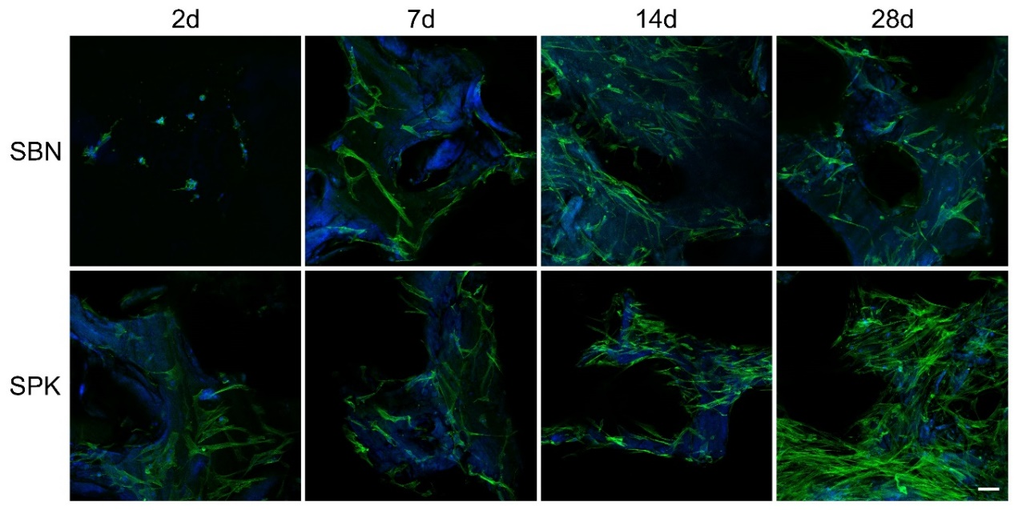
Fig. S1. Representative images of osteoblast cell behavior from Donor 2 taken by laser scanning confocal microscopy on Day 2, 7, 14 and 28.
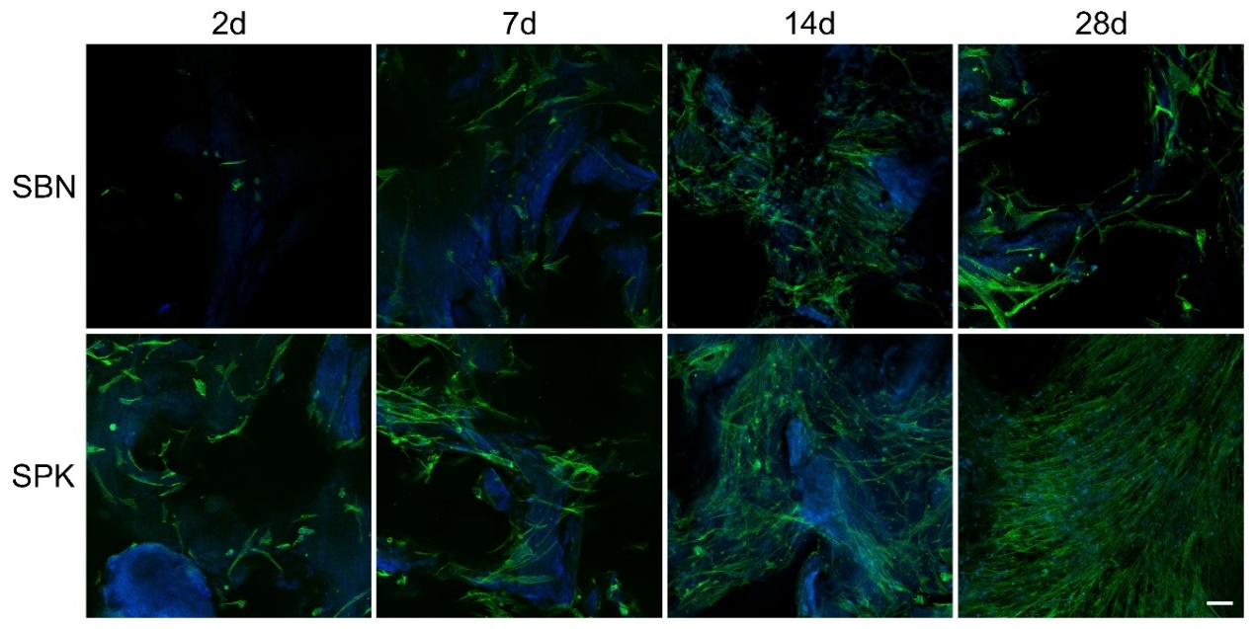
Fig. S2. Representative images of osteoblast cell behavior from Donor 3 taken by laser scanning confocal microscopy on Day 2, 7, 14 and 28.

