Supplementary file for

Xuanfei Baidu Formula Ameliorates Influenza A Virus-induced Lung Inflammation by Repressing the NLRP3 Inflammasome in Macrophages
Tao Liu^{a,d,g,#}, Yueyuan Xu^{b,e,#}, Ziwei Yan^{c,#}, Lin Ma^{a,d}, Hongda Sheng^{c}, Mingyu Ding^{b,e}, Jiabao Wang^{a,d}, Qingdi Fang^{b,e}, Qianru Zhao^{a,d}, Yu Tang^{c}, Tianyuan Zhang^{a,d}, Lu Chen^{a,d}, Rui Shao^{a,d}, Bin Qu^{f}, Jing Qian^{c}, Yi Wang^{c}, Junhua Zhang^{a,d}, Xiaohuan Guo^{b,e,}*, Yu Wang^{d,}*, Han Zhang^{a,d,}*

ª Institute of Traditional Chinese Medicine, Tianjin University of Traditional Chinese Medicine, Tianjin 301617, China

^{b} Institute for Immunology, School of Basic Medical Sciences, Tsinghua Medicine, Tsinghua University, Beijing 100084, China

^{c} Pharmaceutical Informatics Institute, College of Pharmaceutical Sciences, Zhejiang University, Hangzhou 310058, China

^{d} State Key Laboratory of Component-Based Chinese Medicine, Tianjin University of Traditional Chinese Medicine, Tianjin 301617, China

^{e} Beijing Key Laboratory of Immunological Research of Allergy (LIRA), Tsinghua University, Beijing 100084, China

^{f} Department of Biophysics, Center for Integrative Physiology and Molecular Medicine (CIPMM), School of Medicine, Saarland University, Homburg 66421, Germany

^{g} Haihe Laboratory of Modern Chinese Medicine, Tianjin 301617, China

# These authors contributed equally to this work.
*Corresponding authors.
E-mail addresses: zhanghan0023@126.com (H. Zhang), wangyu@tjutcm.edu.cn (Y. Wang), guoxiaohuan@tsinghua.edu.cn (X. Guo)

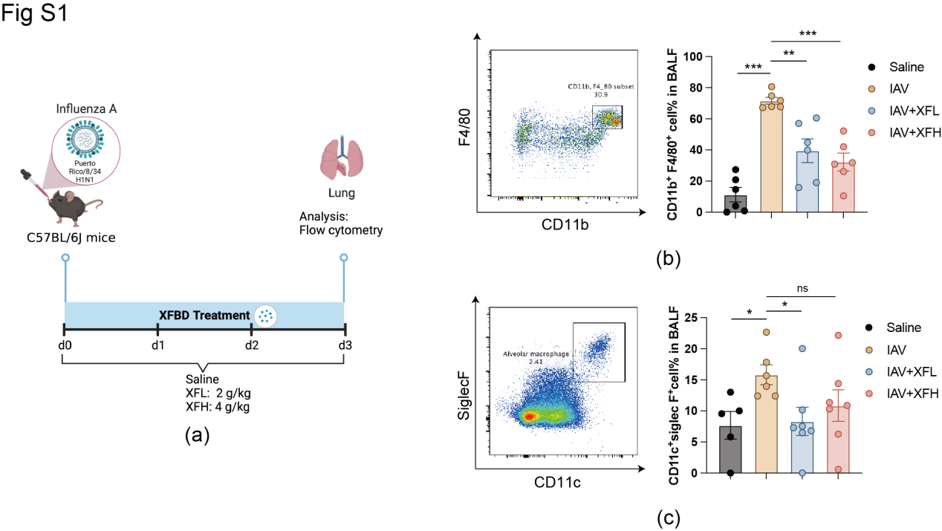
Fig. S1. XFBD reduces the number of macrophages in BALF of IAV infected mice. (a) Experimental design: C57BL/6J mice were inoculated with the influenza virus A/PR8/34 (H1N1) (100 PFU), followed by XFBD (low dose: 2 g∙kg^{–1}; high dose: 4 g∙kg^{–1}) therapy. (b, c) Macrophage and alveolar macrophage phenotype in the BALF at 3 dpi was determined using flow cytometry (n = 6). Data were expressed as mean ± SD and alalyzed by unpaired students’ t test. #,*p < 0.05, ##,**p < 0.01, ###,***p < 0.001 vs saline and IAV groups, respectively; ns, no significance.

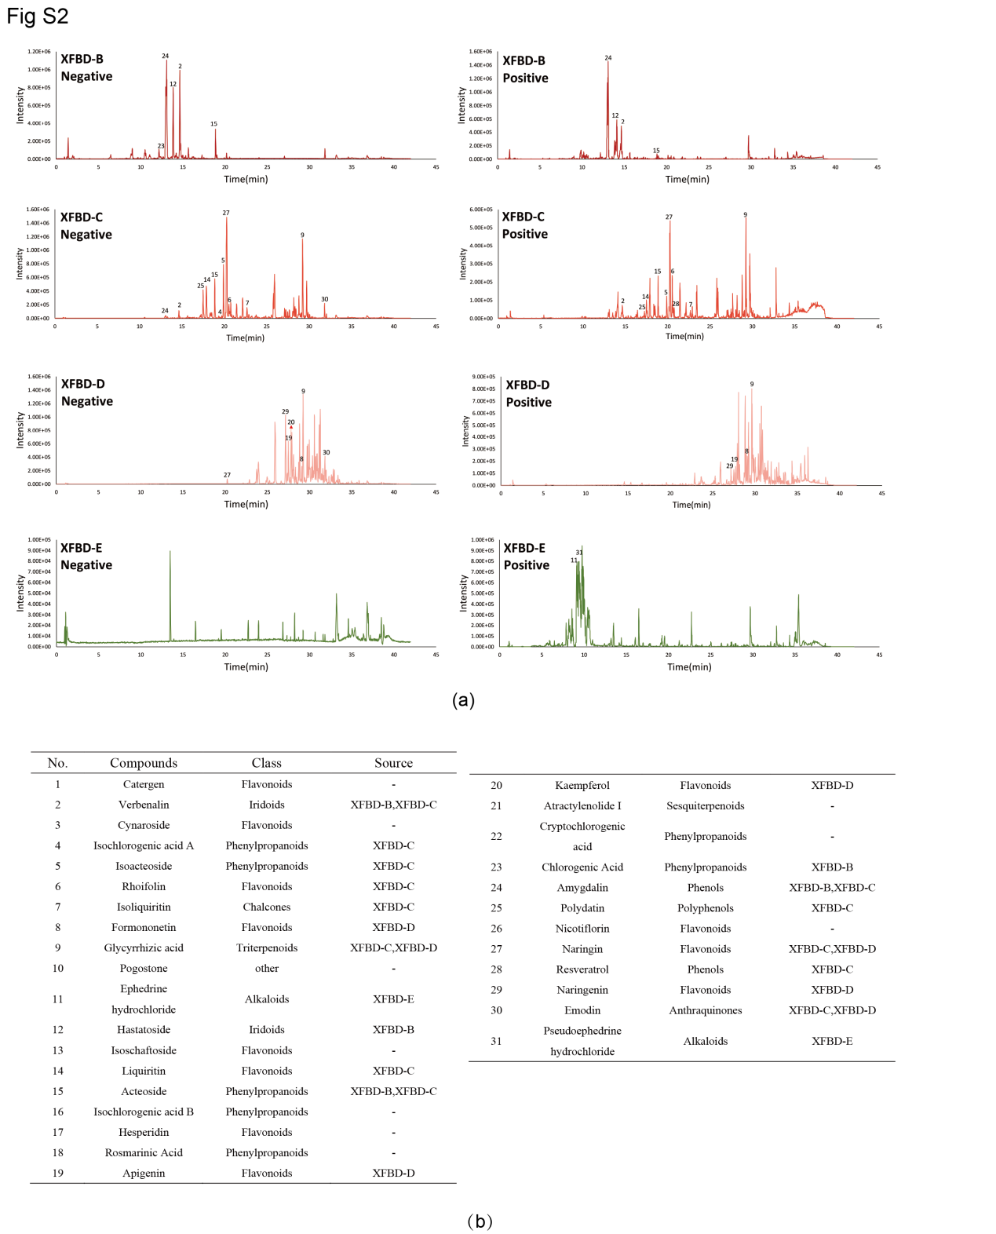
Fig. S2. Identification of XFBD’ five fractions by UPLC-QTOF-MS analysis. (a) Base peak chromatogram of the XFBD’ five fractions (XFBD-B/C/D/E) in negative ion mode. (b) Compounds identified by UPLC-QTOF-MS in the negative ion mode.

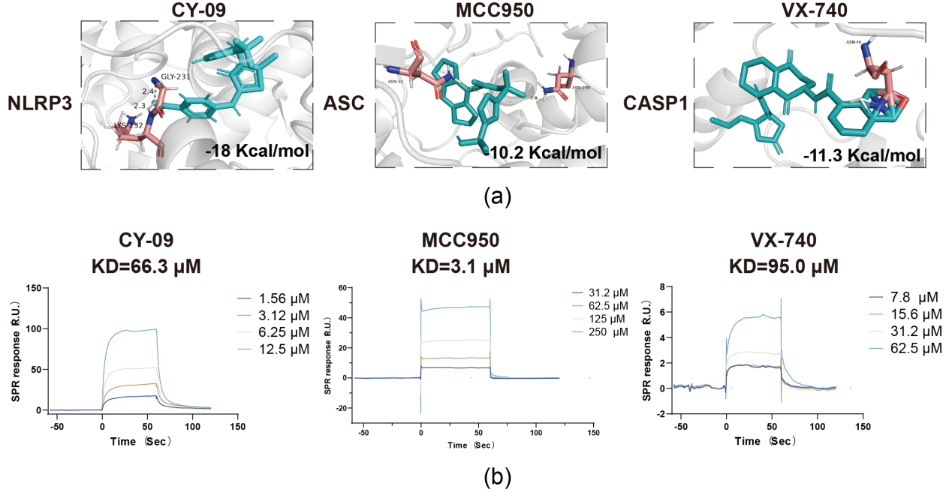
Fig. S3. CY09, MCC950, and VX-740 directly interact with NLRP3 inflammasome components. (a) CY-09, MCC950, or VX-740 with NLRP3, ASC, and CASP1 was determined using molecular docking. (b) The interaction between CY-09, MCC950, VX-740, and NLRP3, ASC, CASP1 were determined using SPR assay.
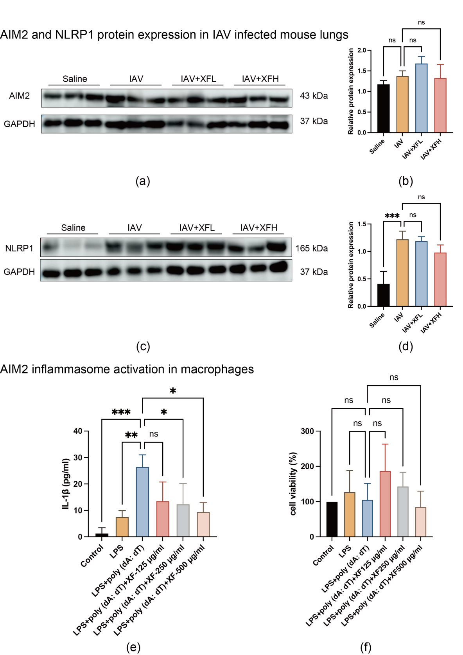
Fig. S4. The effect of XFBD on AIM2 inflammasome. (a, b) AIM2 protein expression levels at 3 dpi in lungs of IAV infected mice was determined using WB (n = 3). (c, d) AIM2 protein expression levels at 3 dpi in lungs of IAV infected mice was determined using WB (n = 3). (e) IL-1β expression in cell culture supernatant was determined using ELISA (n = 3). (f) Cell viability was determined using MTT (n = 3). #,*p < 0.05, ##,**p < 0.01, ###,***p < 0.001 vs control and LPS + ATP groups, respectively; ns, no significance vs LPS + ATP group.

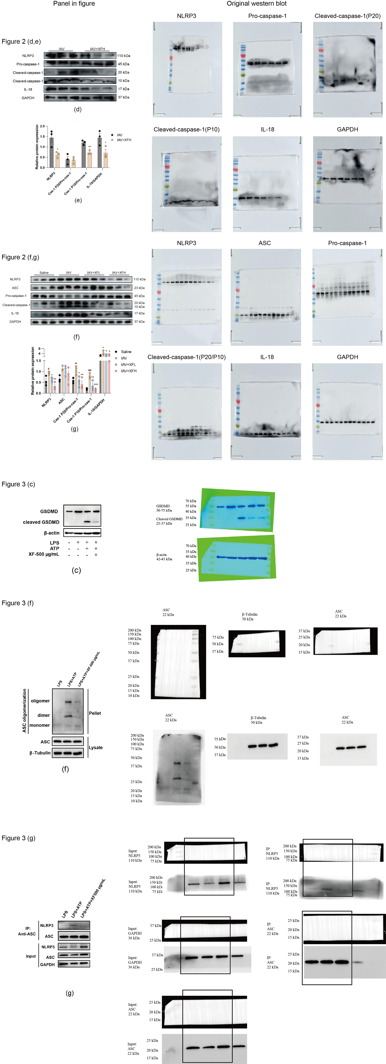
Fig. S5. Full, uncropped western blots.
Table S1
Docking results score between XFBD-Comb1 and NLRP3, ASC, or Caspase-1.
XFBD-Comb1 | NLRP3 (-kJ/Mol) |  | ASC (-kJ/Mol) |  | Caspse-1 (-kJ/Mol)
XFBD-Comb1 | PYD | NACHT | PYD | CARD | CARD | Caspse
Emodin | 26.78 | 34.31 | 35.98 | 38.49 | 35.15 | 35.56
Naringin | 26.78 | 39.74 | 40.17 | - | 42.68 | 32.64
Liquiritin | 33.47 | 39.33 | 38.49 | - | 38.07 | 33.05
Polydatin | 26.78 | 39.75 | 35.98 | - | 36.82 | 32.22
Glycyrrhizic acid | 31.80 | 38.07 | 36.82 | - | 35.36 | 32.22

Table S2
Amino acid residues between XFBD-Comb1 and NLRP3, ASC, or Caspase-1.
XFBD-Comb1 | NLRP3
XFBD-Comb1 | PYD | NACHT
XFBD-Comb1 | PYD | FISNA | NBD | HD1 | WHD | HD2
Emodin | ASP19, LYS26, GLU47, ALA49 | - | ALA228 | TYR381 | - | ARG578
Naringin | LYS23,  GLN45,  GLU47  LYS48,  ASP50 | - | ALA227,  ALA228,  GLY229,  HIS260,  GLU306 | - | THR439,  GLN509,  ILE521 | ARG578
Liquiritin | ASP31,  ARG43,  GLY44 | THR169 | ALA227,  ALA228,  HIS260 | - | THR439,  HIS522 | -
Polydatin | LYS26,  GLU47,  LYS48 | ASN155,  ARG167,  THR169 | - | - | GLN509,  PHE520,  ILE521 | -
Glycyrrhizic acid | LYS23,  GLU30,  CYS38  ARG43,  GLY44,  GLU47 | ILE151 | HIS260,  ARG262,  GLU306,  WAL353 | - | ILE521,  MET523 | ARG578,  GLU629
 | ASC
 | PYD | CARD | - | - | - | -
Emodin | THR19,  ARG41,  GLY77,  LEU78 | - | - | - | - | -
Naringin | ASN12,  GLU13,  ASP14,  LYS22,  GLU44,  ASP65,  ARG66 | GLU153 | - | - | - | -
Liquiritin | LEU12,  ASP14,  THR16,  ALA49,  TRP62,  ASP65,  ARG66,  GLN79 | GLU153 | - | - | - | -
Polydatin | LEU15,  ASP48,  ALA49,  TRP62,  ARG66 | - | - | - | - | -
Glycyrrhizic acid | LYS15,  THR16,  GLU44,  LYS55,  ASP75 | - | - | - | - | -
 | Caspase-1
 | CARD | Caspase domain | - | - | - | -
Emodin | GLU18,  ARG44 | ARG352,  PHE377 | - | - | - | -
Naringin | GLU38,  VAL42,  ARG44,  ASP58 | ARG383 | - | - | - | -
Liquiritin | ALA55 | VAL184,  ARG341,  SER347 | - | - | - | -
Polydatin | VAL42,  ARG44 | ARG352,  SER376,  GLN385 | - | - | - | -
Glycyrrhizic acid | GLU18,  GLU38,  LYS43,  ARG44 | ARG341 | - | - | - | -

