Supplementary Data for

Ultrahigh Pressure Generation at High Temperatures in a Walker-Type Large-Volume Press and Multiple Applications
Xuyuan Hou, Yuchen Shang, Luyao Chen, Bingtao Feng, Yuanlong Zhao, Xinyu Zhao, Kuo Hu *, Qiang Tao, Pinwen Zhu, Zhihui Li, Ran Liu, Zhaodong Liu *, Mingguang Yao, Bingbing Liu *
State Key Laboratory of Superhard Materials, Synergetic Extreme Condition User Facility, Jilin University, Changchun 130012, China

* Corresponding authors.
E-mails addresses: hukuo@jlu.edu.cn (K. Hu); Liu_zhaodong@jlu.edu.cn (Z. Liu); liubb@jlu.edu.cn (B. Liu).

Table S1
Summarized calibration results of ultrahigh pressure generation.
Anvil type | Hardness (HRA) | Assembly | LVP type | Load (MN)ª | Pressure (GPa) | Temperature (K) | Reference
TF05 | 95.1 | 6.8/1.5 | Osugi-type | 3.5 | 36 | 2000 | [19]
 |  | 6.8/1.5 | Osugi-type | 8.7 | 44 | 2000 | [19]
 |  | 5.7/1.5 | Osugi-type | 8.7 | 43 | 300 | [19]
TJS01 | 97.8 | 5.7/1.5 | Osugi-type | 8.7 | 52.4(9)^{b} | 2000 | [20]
 |  | 5.7/1.5 | Osugi-type | 8.7 | 64 | 300 | [21]
ZK01F | 93.5 | 6/1.5 | Walker-type | 7.4 | 36 | 1700 | [25]
New-ZK01F | 93.5 | 6/1.5 | Walker-type | 6.7 | 37.3(9) | 2100 | This work
 |  | 6/1.5 | Walker-type | 9.0 | 40.4(4) | 1950 | This work
ª Calculated by force analysis on stationary mechanisms, the required hydraulic ram load (oil pressure) applied on the first-stage anvils to obtain the same load on inner anvils is $\sqrt{3}$ times higher for a Walker-type than an Osugi-type (DIA) guide-block system. All of the applied load data from Osugi-type LVPs are therefore divided by $\sqrt{3}$ for comparison. However, owing to the substantially different geometry of the two LVP types, other factors (e.g., actual friction between moving parts, oil pressure measurement errors) also affect the applied load on the inner anvils. An accurate comparison of the load in different LVPs remains an open question.
^{b} Numbers in brackets represent the pressure uncertainties of the last digit.

Table S2
Parameters of the pyrophyllite gaskets.
Cell assembly | Thickness (mm) | Width (mm) | L_{is} (mm)ª | L_{il} (mm)^{b} | References
14/8 | 2.83 | 4.50 | 10.00 | 14.00 | [30]
10/5 | 2.36 | 4.50 | 6.67 | 10.00 | [30]
10/4 | 2.84 | 5.06 | 6.00 | 10.00 | [25,30]
New 10/4 | 2.36 | 4.50 | 6.67 | 10.00 | —
8/3 | 2.36 | 3.36 | 4.67 | 8.00 | [30]
7/3 | 2.00 | 3.00 | 4.33 | 7.00 | —
6/1.5^{c} | 1.00 | 3.00 | 2.90 |  | —
ª Gaskets are generally designed as trapezoidal plates. L_{is} represents the inner edge length of shorter gaskets.
^{b} Inner edge length of longer gaskets.
^{c} The gaskets designed for 6/1.5 assemblies are sloped at the top to eliminate any vacant space between the anvils and octahedron (Fig. 2(b)). Twenty-four identical gaskets are used for one experiment. The other assemblies use six long gaskets and six short gaskets.

Table S3
Compositions of bridgmanite recovered various pressure and temperature.
Assembly | Applied load (MN) | MgO (wt%) | Al₂O₃ (wt%) | SiO₂ (wt%) | Tot (wt%) | Mg | Al | Si | O
6/1.5 | 6.7 | 26.38(45) | 22.64(54) | 50.85(96) | 99.88(85) | 2.61(4) | 1.77(4) | 3.37(6) | 12
6/1.5 | 9.0 | 32.45(53) | 20.95(21) | 47.79(47) | 101.20(99) | 3.21(5) | 1.64(2) | 3.17(3) | 12
8/3 | 9.7 | 36.91(61) | 8.67(8) | 54.60(74) | 100.30(115) | 3.68(6) | 0.68(1) | 3.65(5) | 12
8/3* | 9.7 | 38.01(50) | 9.19(82) | 52.50(61) | 99.71(27) | 3.82(5) | 0.73(6) | 3.54(4) | 12
7/3* | 9.7 | 35.92(41) | 14.09(121) | 49.94 (83) | 99.95 (7) | 3.60(4) | 1.12(10) | 3.36(6) | 12
Numbers marked in parentheses correspond to the standard deviation for last digit(s). Each EPMA result shows the averaged data of four tests. The * represents the result from EDS after the reduction of minor Pt₂O₅ component in bridgmanite.
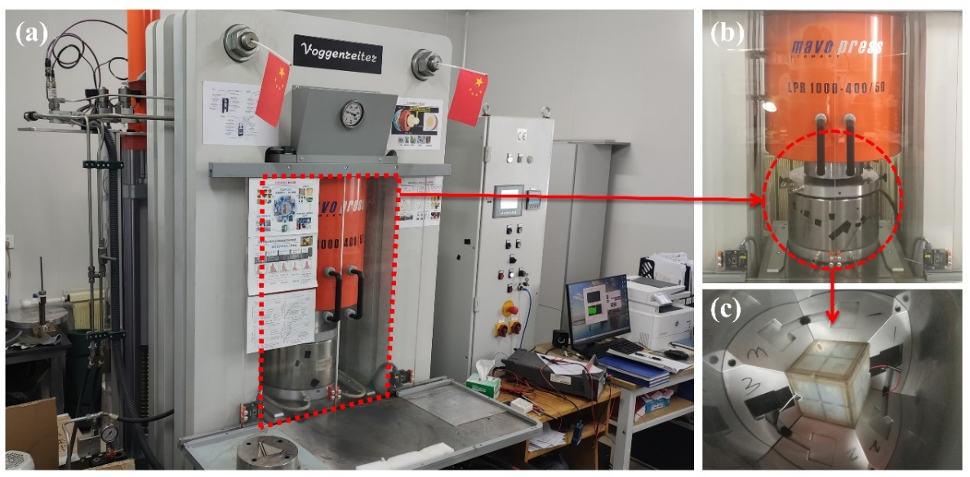
Fig. S1. (a) Photograph of the JLUHC Walker-type LVP with a maximum hydraulic ram load of ~10 MN. (b) Front view of the confinement ring in the work position under the uniaxial vertical pressing hydraulic ram. (c) Downward view looking inside the confinement ring with the assembled lower three split-cylinder first-stage anvils. A cubic Kawai-cell with connected thermocouples is positioned in the middle.

Fig. S2. Three-dimensional cross sections of the assemblies designed by COMPRES: (a) 14/8 assembly; (b) 10/5 and 10/4 assemblies use the same cell design, but are compressed by anvils with different truncation sizes; (c) and 8/3 assembly. The octahedron size is noted in red.

Fig. S3. Axial cross-section views of the high-pressure assemblies in 3D. The 2D version is presented in Fig. 3. (a) Improved 6/1.5 assembly. (b) Redesigned 7/3 assembly.

Fig. S4. Conceptual diagram of the four-wire method assembly for measuring the Zr ω-β phase transition.
Fig. S5. (a) Comparison of the new 10/4 assembly with thinner gaskets and 10/5 assembly. The pressure efficiency is notably improved. The GaP semiconductor-metal transition at 23 GPa is detected in the new 10/4, but not in the 10/5 assemblies. (b) Comparison of five different assembly designs. The highest pressure limit generally increases with decreasing octahedron size and increasing OEL/TEL.

Fig. S6. Comparison of different heater materials in the same 10/5 assembly design. Both materials can stably generate temperatures higher than 2500 K. The blue and red dotted lines represent the linear and polynomial fittings to the power-temperature curves, respectively.

