Supplementary file for

Low and Decreasing Cholesterol Levels and Risk of All-Cause and Cause-Specific Mortality: A Prospective and Longitudinal Cohort Study

Qin Jiang ª, Jiachen Wu ^{b}, Yu Yuan ª, Xingjie Hao ^{c}, Pinpin Long ª, Kang Liu ^{a,d}, Shihe Liu ^{e}, Rong Peng ª, Kuai Yu ª, Rui Zeng ª, Shuohua Chen ^{f}, Handong Yang ^{g}, Xiulou Li ^{g}, Xiaomin Zhang ª, Meian He ª, Lin Wang ^{h}, Xiang Cheng ^{i}, An Pan ^{c}, Shouling Wu ^{j,}*, Chaolong Wang ^{c,}*, Tangchun Wu ^{a,}*

ª Department of Occupational and Environmental Health, Key Laboratory of Environment and Health, Ministry of Education and State Key Laboratory of Environmental Health (Incubating), School of Public Health, Tongji Medical College, Huazhong University of Science and Technology, Wuhan 430030, China

^{b} Department of Scientific Research, Tongji Hospital, Tongji Medical College, Huazhong University of Science and Technology, Wuhan 430030, China

^{c} Department of Epidemiology and Biostatistics, Key Laboratory of Environment and Health, Ministry of Education, School of Public Health, Tongji Medical College, Huazhong University of Science and Technology, Wuhan 430030, China

^{d} School of Public Health, Guangzhou Medical University, Guangzhou 511495, China

^{e} Graduate School, North China University of Science and Technology, Tangshan 063210, China

^{f} Kailuan General Hospital, Tangshan 063001, China

^{g} Department of Cardiovascular Diseases, Sinopharm Dongfeng General Hospital, Hubei University of Medicine, Shiyan 442008, China

^{h} Department of Clinical Laboratory, Union Hospital, Tongji Medical College, Huazhong University of Science and Technology, Wuhan 430022, China

^{i} Department of Cardiology, Union Hospital, Tongji Medical College, Huazhong University of Science and Technology, Wuhan 430022, China

^{j} Department of Cardiology, Kailuan General Hospital, Tangshan 063001, China

*Corresponding authors.

E-mail addresses: wut@mails.tjmu.edu.cn (T. Wu), chaolong@hust.edu.cn (C. Wang), drwusl@163.com (S. Wu)

S1. Supplementary methods

S1.1. Study population and design
Uniform exclusion criteria were applied across all three cohorts to improve comparability.

S1.2. Dongfeng–Tongji cohort
The Dongfeng–Tongji cohort is an ongoing population-based cohort composed of retired employees from the Dongfeng Motor Corporation in Shiyan, Hubei, China [1]. In brief, the cohort enrolled study participants (n = 27 009) from September 2008 to June 2010 at baseline survey, and conducted follow-up visits in 2013 and 2018, with additional participants (n = 14 120) enrolled during 2013. In the baseline analysis, we included all the 41,129 participants as baseline population. After excluding individuals with lipid-lowering treatment, preexisting CHD, stroke, cancer, clinically diagnosed COPD, BMI < 18.5 kg∙m–² at baseline, or deaths within the first two years of follow-up, and those with missing or extreme lipid values (TC, HDL-C, LDL-C, or non-HDL-C values < 0.1th or > 99.9th percentile) to obtain an apparently healthy population. A total of 25 523 participants remained for analysis. Flowchart for the study participant selection was visualized in Fig. S1. The number of the study population in each cholesterol–mortality analysis differed slightly.
In the longitudinal change analysis, we included 24 175 participants who attended both the baseline survey during 2008–2010 (baseline) and the first follow-up visit in 2013 (resurvey) in the Dongfeng–Tongji cohort, with an interval of 4.6 years. The interval was consistent with guideline recommendations for lipid screening [2,3]. The exposure variable was cholesterol changes between baseline and resurvey, and the outcome follow-up started after resurvey. Therefore, we excluded individuals with lipid-lowering treatment, preexisting CHD, stroke, cancer, clinically diagnosed COPD, BMI < 18.5 kg∙m–² at or before resurvey, deaths within 2 years of follow-up after resurvey, and those with missing or extreme lipid values measured at both baseline and resurvey. Finally, 12 947 participants were included in the longitudinal change analysis (Fig. S2).

S1.3. Kailuan study
The Kailuan study was launched in 2006 and included employees and retirees from the coal mining company of Kailuan company in Tangshan, Hebei, China [4]. The subsequent surveys were conducted every two years to update medical and lifestyle information, which also enrolled new participants. In the baseline analysis, we included 159 017 individuals who provided their first information during 2006–2013 as the baseline study population. Similarly, to minimize reverse causality and confounding from pharmacological factors, we excluded those with the aforementioned conditions and missing or extreme lipid values as in the Dongfeng-Tongji cohort, resulting in 317 305 participants included in the final analysis (Fig. S1). In the longitudinal change analysis, we included 68 746 participants who were investigated both in the first survey during 2006–2007 (baseline) and the resurvey during 2010–2011 (resurvey) with a 4-year interval. A consistent interval was maintained to assess longitudinal changes in cholesterol levels across the cohorts. Accordingly, we excluded those with the aforementioned diseases at or before resurvey, the first two years of deaths occurred after resurvey, and missing or extreme lipid values measured at the two time points, 59 043 participants were included in the final analysis (Fig. S2).

S1.4. UK Biobank
The UK Biobank recruited over 500 000 participants aged 37 to 73 years during 2006–2010. This large prospective study is available for open access with data from questionnaires, physical measures, sample assays, accelerometry, and longitudinal follow-up for multiple health-related outcomes [5]. In the baseline analysis, we included all of the 502 401 participants initially enrolled during 2006–2010 as baseline population. Similarly as in the Dongfeng-Tongji cohort and Kailuan study, we excluded aforementioned diseases and extreme or missing lipids values, remaining 317 305 participants in the final analysis (Fig. S1). In the longitudinal change analysis, the UK Biobank invited 20 343 (4%) participants who lived near the assessment center to attend the resurvey during 2012–2013 (interval of 4.3 years). Therefore, we included these participants with repeated cholesterol measurements. Similarly before analysis, we excluded aforementioned conditions and missing or extreme lipid values, a total of 11,738 participants were included in the final analysis (Fig. S2).

S1.5. Measurement of blood lipids
Blood lipid profiles were measured according to the manufacturer’s protocols using ARCHITECT Ci8200 automatic analyzer in the Dongfeng-Tongji cohort (ABBOTT Laboratories, Abbott Park, Illinois, USA) [6] and AU5800 analytical platform in the UK Biobank (Beckman Coulter) [7], and were measured enzymatically in the Kailuan Study (Mind Bioengineering Co. Ltd, Shanghai, China) [8]. Measurements were followed the same protocols at both baseline and resurvey.
S2. Supplementary figures and tables
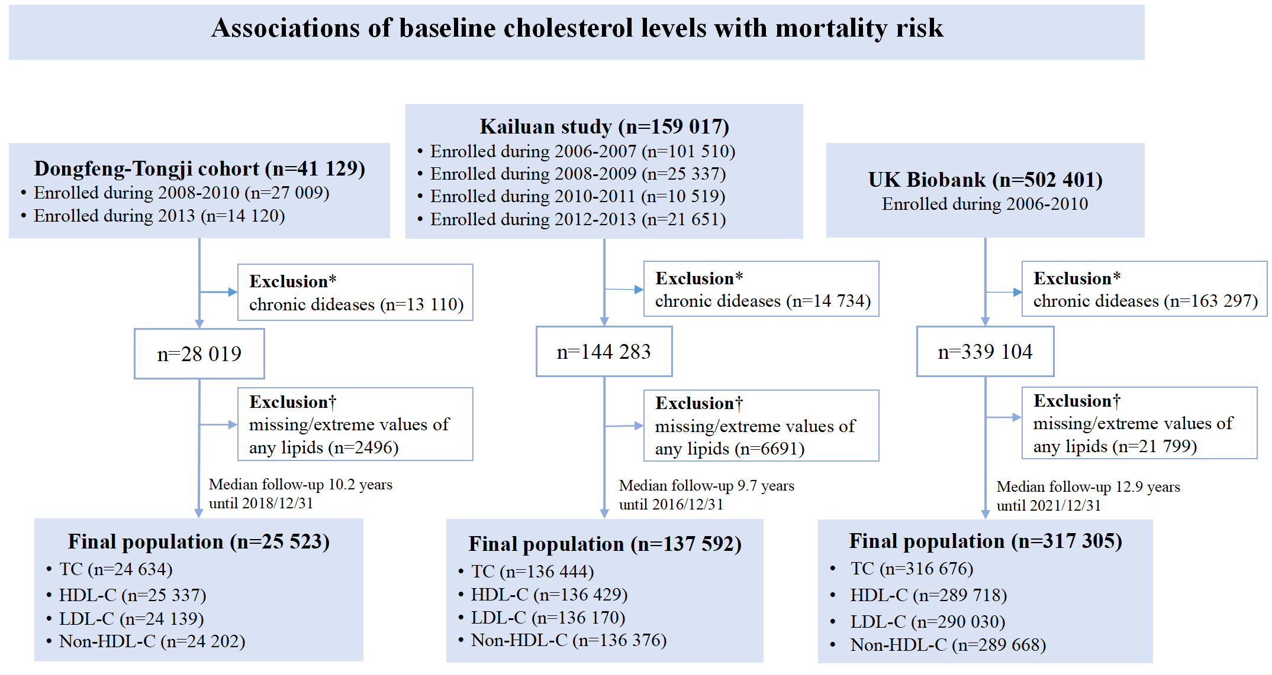
Fig. S1. Flowchart of population inclusion criteria in the baseline analysis. *Exclusion of participants with lipid-lowering medication, coronary heart disease, stroke, cancer, clinically diagnosed chronic obstructive pulmonary disease, or low body mass index (< 18.5 kg∙m^{–2}) at baseline, or deaths within the first two years of follow-up in each cohort. †Exclusion of participants without measurement of any fraction of lipids (TC, HDL-C, LDL-C, or non-HDL-C) and their extreme values (< 0.1th or > 99.9th).
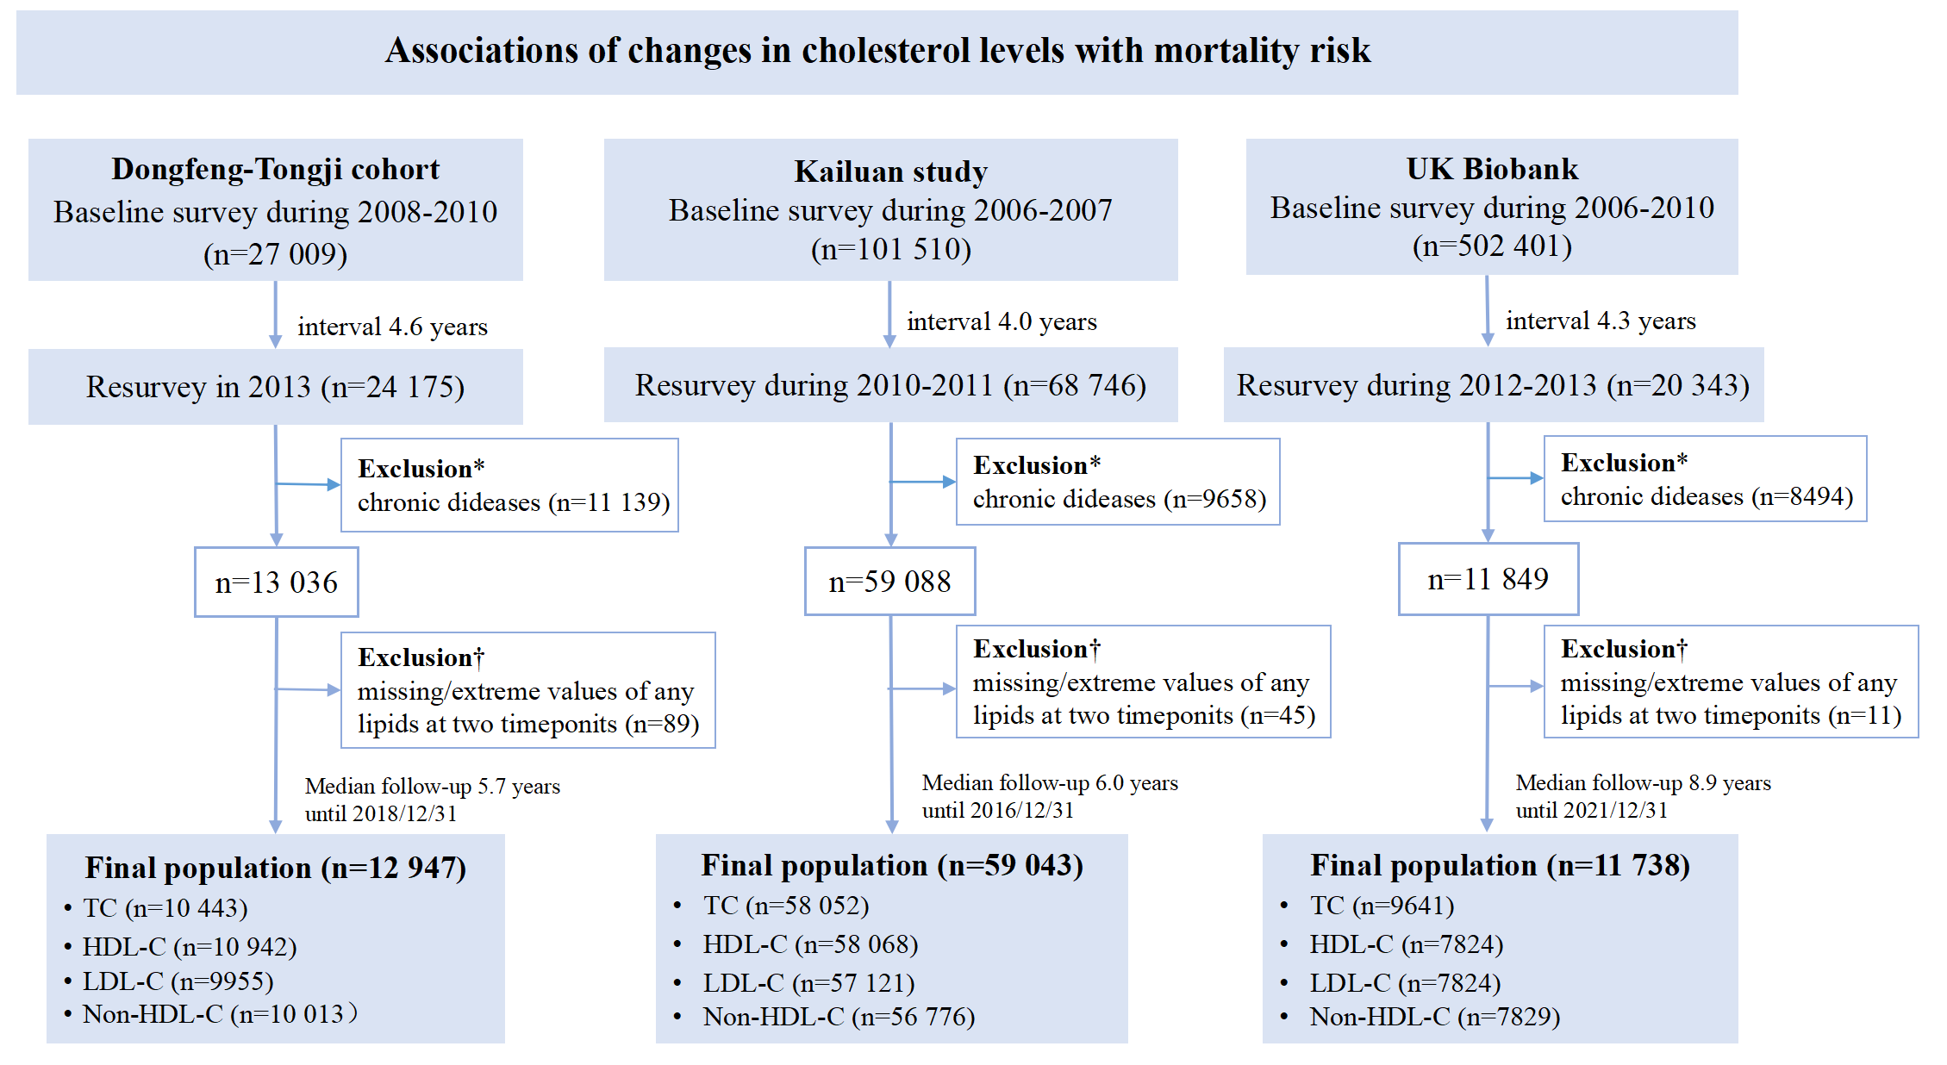
Fig. S2. Flowchart of population inclusion criteria in the longitudinal change analysis. *Exclusion of participants with lipid-lowering medication, coronary heart disease, stroke, cancer, clinically diagnosed chronic obstructive pulmonary disease, or low body mass index (< 18.5 kg∙m–²) at or before resurvey, or deaths within the first two years of follow-up in each cohort. †Exclusion of participants without measurement of lipids (TC, HDL-C, LDL-C, or non-HDL-C) and their extreme values (< 0.1th or > 99.9th) at both baseline and resurvey.
Fig. S3. Adjusted hazard ratios of CVD, cancer, and other mortality at different baseline cholesterol levels. The forest plots represent CVD, cancer, and other mortality respectively in (A) the Dongfeng–Tongji and Kailuan studies and (B) the UK Biobank. Models were stratified by the 5-year interval of baseline age and gender, and adjusted for body mass index, education level, smoking status, drinking status, physical activity, and history of hypertension and diabetes at baseline.
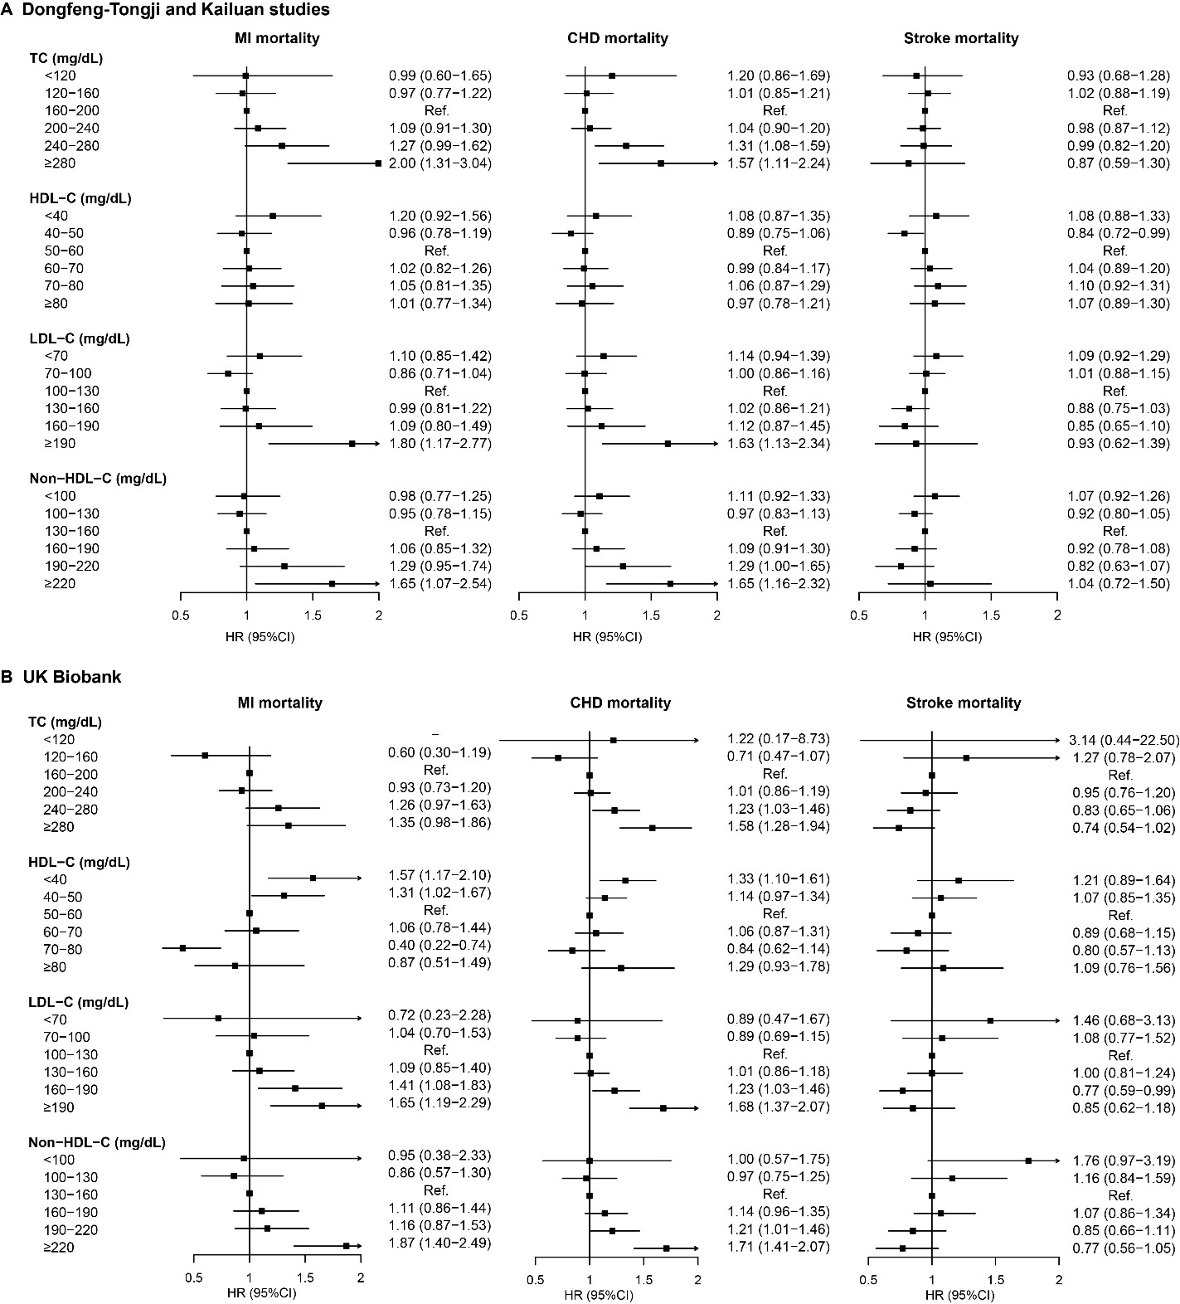
Fig. S4. Adjusted hazard ratios of mortality from CVD subtypes at different baseline cholesterol levels. The forest plots represent MI, CHD, and stroke mortality respectively in (A) the Dongfeng–Tongji and Kailuan studies and (B) the UK Biobank. Models were stratified by the 5-year interval of baseline age and gender, and adjusted for body mass index, education level, smoking status, drinking status, physical activity, and history of hypertension and diabetes at baseline.

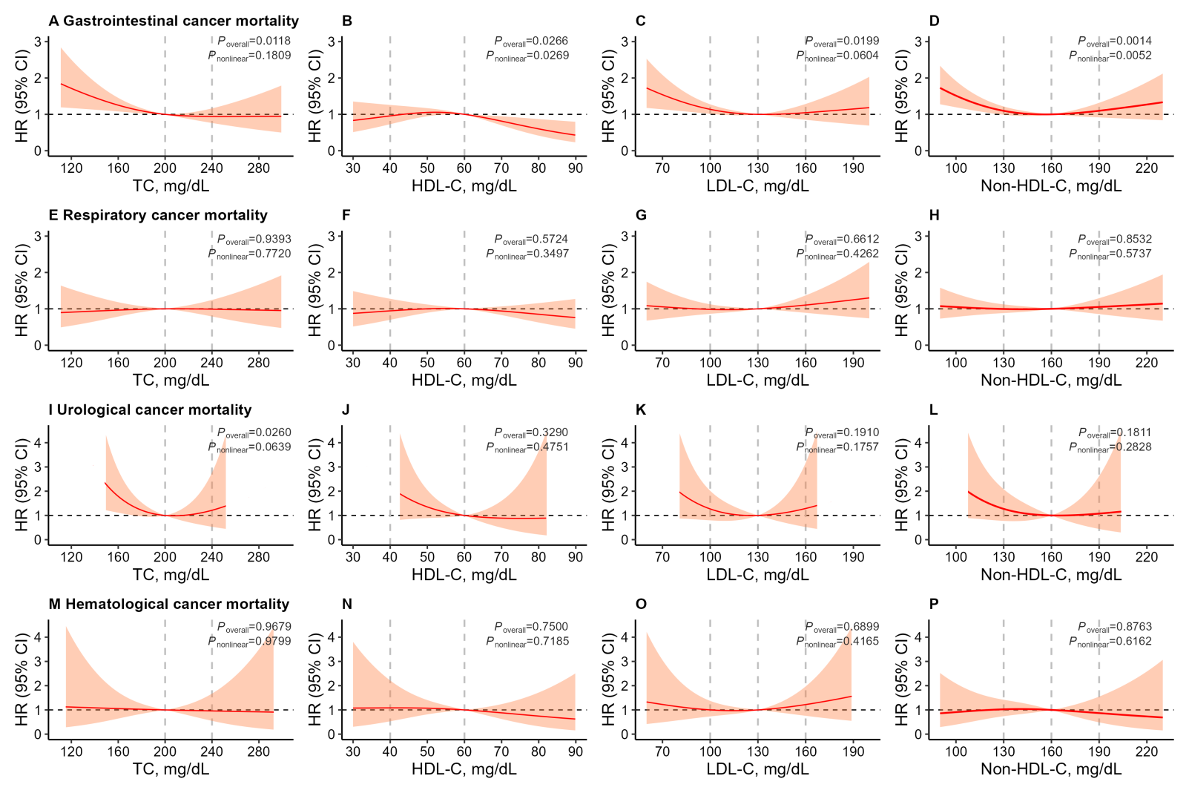
Fig. S5. Dose–response associations of baseline cholesterol levels with mortality from cancer subtypes in the Dongfeng–Tongji cohort. The colored curves and areas represent point estimates and 95% CIs of the HRs of (A–D) gastrointestinal cancer, (E–H) respiratory cancer, (I–L) urological cancer, and (M–P) hematological cancer estimated by restricted cubic splines. The vertical dotted grey lines showed the cut-offs of blood cholesterol levels according to the guidelines. Models were adjusted for age, gender, body mass index, education, drinking, smoking, physical activity, and history of hypertension and diabetes at baseline. Knots were set at the 5th, 50th, and 95th percentiles of cholesterol levels, with reference at 200, 60, 130, and 160 mg∙dL^{–1} for TC, HDL-C, LDL-C, and non-HDL-C, respectively.
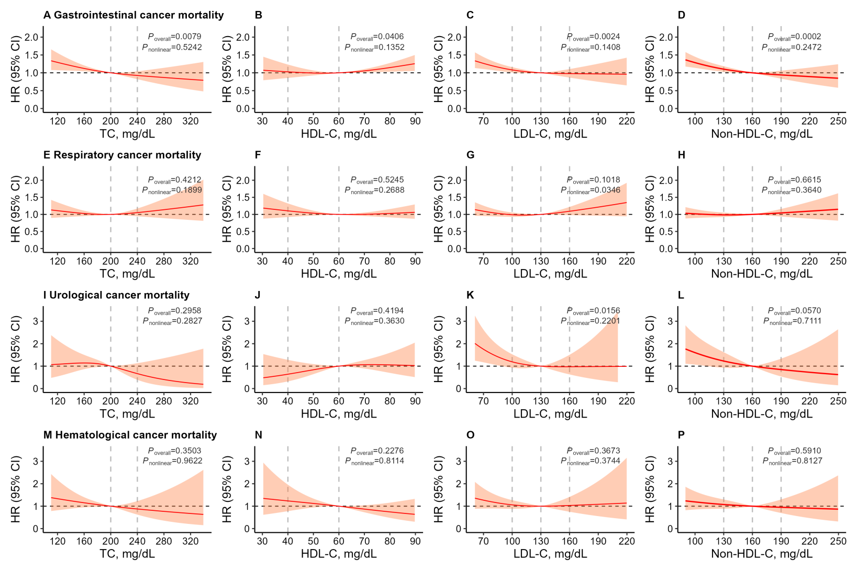
Fig. S6. Dose–response associations of baseline cholesterol levels with mortality from cancer subtypes in the Kailuan study. The curves and areas represent point estimates and 95% CIs of the HRs of (A–D) gastrointestinal cancer, (E–H) respiratory cancer, (I–L) urological cancer, and (M–P) hematological cancer estimated by restricted cubic splines. The vertical dotted grey lines showed the cut-offs of blood cholesterol levels according to the guidelines. Models were adjusted for age, gender, body mass index, education, drinking, smoking, physical activity, and history of hypertension and diabetes at baseline. Knots were set at the 5th, 50th, and 95th percentiles of cholesterol levels, with reference at 200, 60, 130, and 160 mg∙dL^{–1} for TC, HDL-C, LDL-C, and non-HDL-C, respectively.

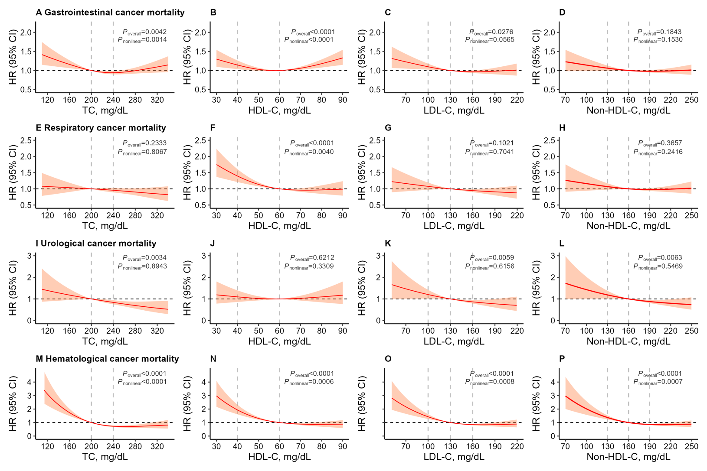
Fig. S7. Dose–response associations of baseline cholesterol levels with mortality from cancer subtypes in the UK Biobank. The curves and areas represent point estimates and 95% CIs of the HRs of (A–D) gastrointestinal cancer, (E–H) respiratory cancer, (I–L) urological cancer, and (M–P) hematological cancer estimated by restricted cubic splines. The vertical dotted grey lines showed the cut-offs of blood cholesterol levels according to the guidelines. Models were adjusted for age, gender, body mass index, education, drinking, smoking, physical activity, and history of hypertension and diabetes at baseline. Knots were set at the 5th, 50th, and 95th percentiles of cholesterol levels, with reference at 200, 60, 130, and 160 mg∙dL^{–1} for TC, HDL-C, LDL-C, and non-HDL-C, respectively.

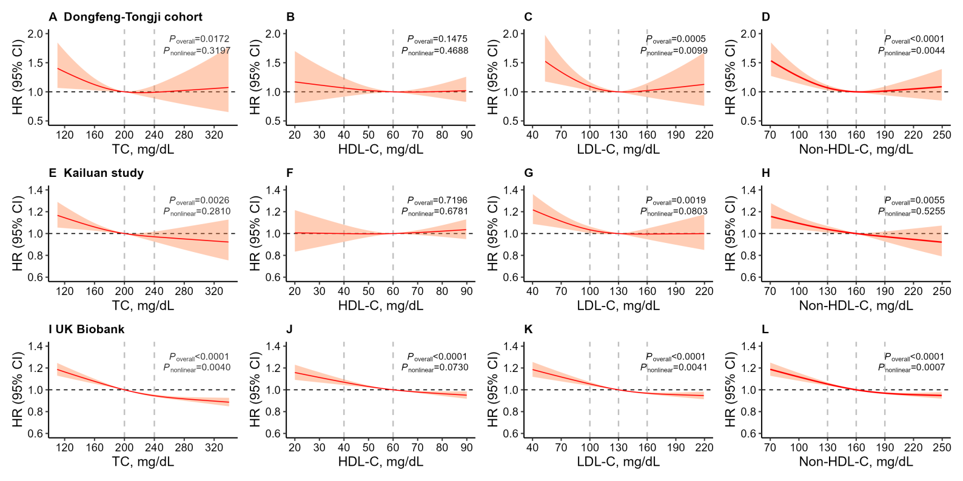

Fig. S8. Dose–response associations of baseline cholesterol levels with incident cancer. The curves and the areas represent point estimates and 95% CIs of the HRs of incident cancer in the (A–D) Dongfeng–Tongji cohort, (E–H) Kailuan study, and (I–L) UK Biobank estimated by restricted cubic splines. The vertical dotted grey lines showed the cut-offs of blood cholesterol levels according to the guidelines. The models were adjusted for age, gender, body mass index, education, drinking, smoking, physical activity, and history of hypertension and diabetes at baseline. Knots were set at the 5th, 50th, and 95th percentiles of cholesterol levels, with reference set at 200, 60, 130, and 160 mg∙dL^{–1} for TC, HDL-C, LDL-C, and non-HDL-C, respectively.

Fig. S9. Dose–response associations of cholesterol changes with all-cause, CHD, and cancer mortality in the Dongfeng–Tongji and Kailuan studies. The curves and areas represented HRs and 95% CIs of mortality from (A–D) all causes, (E–H) CVD, and (I–L) cancer, estimated by restricted cubic splines from nonlinear dose–response meta results of Dongfeng–Tongji and Kailuan studies. Models were stratified by 5-year intervals of baseline age and gender, and adjusted for corresponding baseline lipid levels, body mass index, smoking, drinking, and physical activity, changes in body mass index, smoking, drinking, and physical activity from baseline to resurvey, education, and hypertension and diabetes history before resurvey. Knots were set at the 5th, 50th, and 95th percentiles of lipid change levels, with reference set at 0.

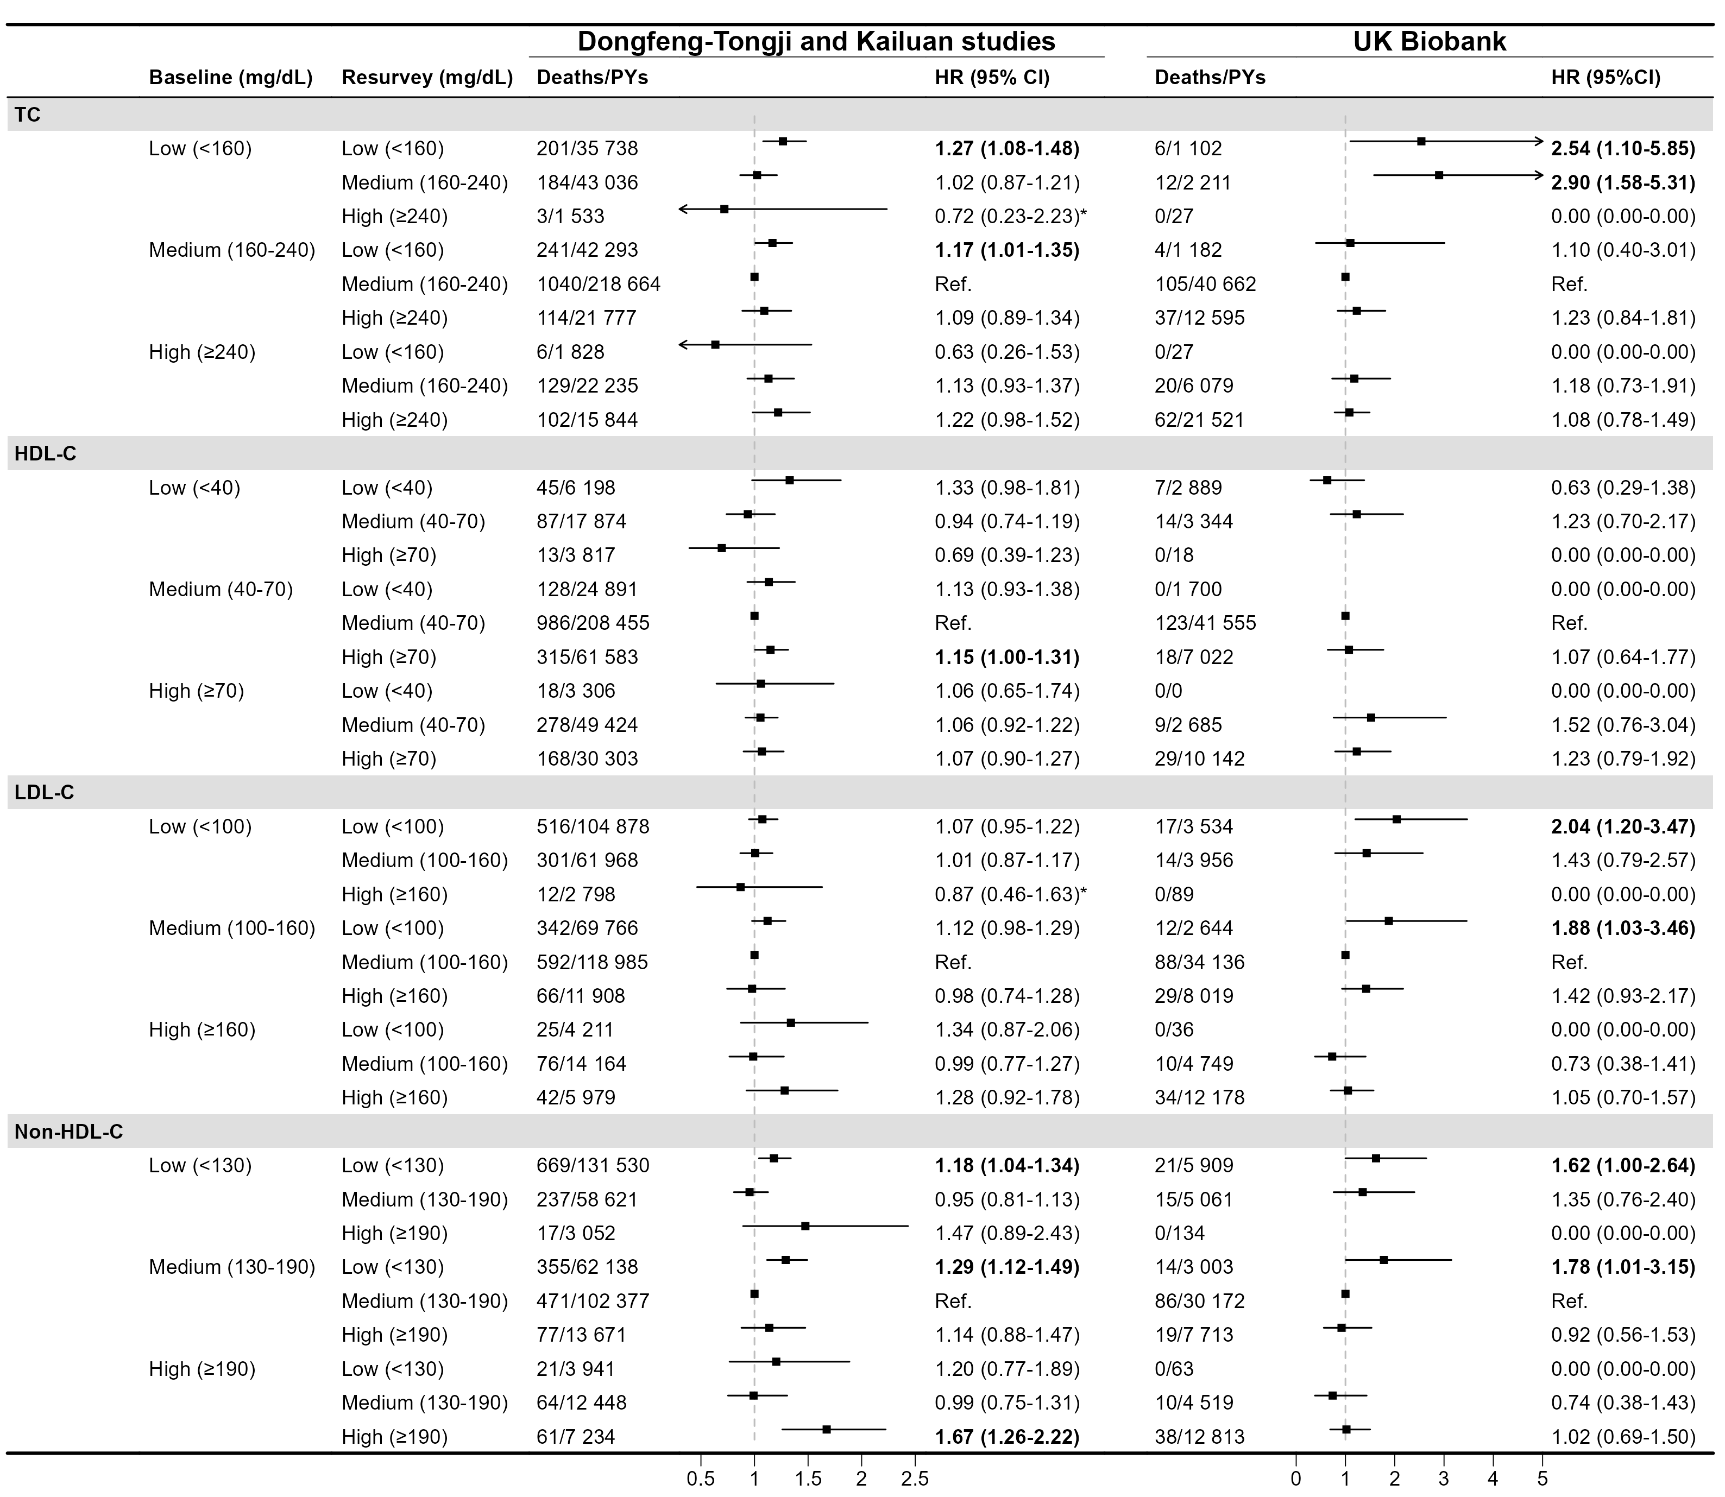Fig. S10. Adjusted hazard ratios of all-cause mortality by joint patterns of cholesterol levels at baseline and resurvey over four years. Models were stratified by the 5-year intervals of baseline age and gender, and adjusted for body mass index, smoking status, drinking status, and physical activity at baseline, and changes in body mass index, smoking status, drinking status, and physical activity from baseline to resurvey, education level, and history of hypertension and diabetes before resurvey (change in physical activity was not adjusted in the UK Biobank due to unavailable data). Bold values indicate HRs (95% CIs) all ≥ 1.00. *The HRs from the Dongfeng–Tongji cohort were not included due to no death.

Table S1

Number of deaths from CVD and cancer subtypes.
Death causes | ICD-10 code | Number of cases
Death causes | ICD-10 code | Dongfeng–Tongji cohort | Kailuan study | UK Biobank
CVD | I00-99 | 669 | 2623 | 2549
MI | I21-22 | 278 | 503 | 514
CHD | I20-25 | 333 | 890 | 1196
Stroke | I60-69 | 260 | 1207 | 604
Cancer | C00-99 | 635 | 1849 | 7614
Gastrointestinal cancer | C15-26 | 272 | 702 | 2609
Respiratory cancer | C30-39 | 224 | 666 | 1223
Urological cancer | C64-68 | 15 | 63 | 420
Hematological cancer | C81-96 | 37 | 95 | 674
MI: myocardial infarction.

Table S2

Definitions of covariates in each cohort.
Covariates/definition | Dongfeng–Tongji cohort | Kailuan study | UK Biobank
Education level:  - below high school;  - high school;  - above high school | Self-reported | Self-reported | Mapped from “O/GCSEs/CSEs”, “A/AS/NVQ/HND/HNC”, and “College/University”, respectively, and an additional “other qualifications” group
Smoking status:  - never;  - former;  - current | “never” indicated never smoke or < 1 cigarette/day; “former” indicated quit smoking; “current” indicated ≥ 1 cigarette /day for ≥ 6 months | “never” indicated never smoke or < 1 cigarette/day; “former” indicated quit smoking; “current” indicated ≥ 1 cigarette/day | Same as Kailuan study
Drinking status:  - never;  - former;  - current | “never” indicated never drink or less than once/week; “former” indicated quit drinking; “current” indicated at least once/week for ≥ 6 months | “never” indicated never drink or 1–3 times/month; “former” indicated quit drinking; “current” indicated every day | “never” indicated never drink or less than once/week; “former” indicated quit drinking; “current” indicated at least once/week
Physical activity:  - inactive;  - less inactive;  - active | Equally divided the weekly duration of physical exercise into three groups | Mapped from “never,” “occasional,” and “frequent”, respectively.  (active indicated exercising > 4 times/week and ≥ 20 min per time in the first two surveys, while exercising > 3 times and ≥ 30 min in the third and fourth surveys) | Same as Dongfeng-Tongji cohort
Dietary habit (non-consistent) | Daily fruits and vegetables and meat 1–6 days/week as healthy diet; otherwise unhealthy | Diet was unavailable.  Salt preference (as proxy) of “light/normal” as healthy diet and “salty” as unhealthy | Same as Dongfeng-Tongji cohort
Socioeconomic status (non-consistent) | Data unavailable | Income level | Townsend deprivation index
CRP, ApoA1, ApoB (non-consistent) | Data unavailable | Data unavailable | Measured CRP, ApoA1, ApoB levels in blood
Hypertension | SBP ≥ 140 mmHg; DBP ≥ 90 mmHg; antihypertensive usage; or self-reported physician diagnosis
Diabetes: | Fasting glucose ≥ 7.0 mmol∙L^{–1}; medication usage; or self-reported physician diagnosis |  | Additionally included HbA1c ≥ 6.5% or random glucose ≥ 11.1 mmol∙L^{–1}
BMI change | Difference in BMI levels between baseline and resurvey
Smoking status change | Participants were initially categorized at both baseline and resurvey as “never smoker”, “ever smoker”, and “current smoker”. Transitions between these categories were then grouped into:  1. “remained non-smoker”;  2. “change from former/current to former smoker”;  3.“change from never/former/current to current smoker”
Drinking status change | Participants were initially categorized at both baseline and resurvey as “never drinker”, “ever drinker”, and “current drinker”. Transitions between these categories were then grouped into:  1.“remained non-drinker”;  2.“change from former/current to former drinker”;  3.“change from never/former/current to current drinker”.
Physical activity change | Participants were initially categorized at both baseline and resurvey as “inactive”, “less active”, and “active”. Transitions between these categories were then grouped into:  1.“remained inactive/less active”;  2.“change from active to inactive/less active”;  3.“change from inactive/less active to active”

Table S3

Adjusted hazard ratios of all-cause mortality at different baseline cholesterol levels in each of the three cohorts.
Cholesterol | Dongfeng–Tongji cohort |  |  | Kailuan study |  |  | UK Biobank
Cholesterol | n | HR (95% CI) |  | n | HR (95% CI) |  | n | HR (95% CI)
TC (mg∙dL^{–1})
Low (< 120) | 526 | 1.42 (0.99-2.06) |  | 3 662 | 1.20 (1.06-1.35) |  | 188 | 1.66 (0.98-2.80)
Slightly low (120-160) | 3 498 | 1.26 (1.09-1.45) |  | 25 829 | 1.11 (1.04-1.19) |  | 10 948 | 1.28 (1.17-1.41)
Medium (160-200) | 10 036 | Ref. |  | 57 087 | Ref. |  | 69 913 | Ref.
Slightly high (200-240) | 7 853 | 0.94 (0.84-1.06) |  | 37 223 | 1.03 (0.97-1.08) |  | 122 880 | 0.90 (0.86-0.94)
High (240-280) | 2 268 | 0.99 (0.83-1.18) |  | 10 824 | 1.07 (0.98-1.16) |  | 80 850 | 0.87 (0.82-0.91)
Very high (≥ 280) | 453 | 1.34 (0.96-1.85) |  | 2644 | 1.26 (1.09-1.46) |  | 31 897 | 0.89 (0.84-0.95)
HDL-C (mg∙dL^{–1})
Low (< 40) | 2 800 | 1.12 (0.97-1.31) |  | 11 825 | 1.03 (0.93-1.13) |  | 29 755 | 1.17 (1.10-1.24)
Slightly low (40-50) | 6 326 | 0.95 (0.84-1.09) |  | 30 638 | 0.97 (0.91-1.04) |  | 73 406 | 1.03 (0.99-1.09)
Medium (50-60) | 7 381 | Ref. |  | 41 820 | Ref. |  | 79 853 | Ref.
Slightly high (60-70) | 4 657 | 0.95 (0.82-1.10) |  | 28 055 | 1.00 (0.93-1.06) |  | 56 350 | 1.00 (0.95-1.06)
High (70-80) | 2 243 | 0.91 (0.75-1.12) |  | 14 683 | 1.03 (0.95-1.11) |  | 30 341 | 1.02 (0.95-1.10)
Very high (≥ 80) | 1 930 | 0.95 (0.76-1.18) |  | 10 242 | 1.05 (0.97-1.14) |  | 20 013 | 1.15 (1.07-1.25)
LDL-C (mg∙dL^{–1})
Low (< 70) | 1 561 | 1.24 (1.00-1.53) |  | 18 228 | 1.18 (1.10-1.26) |  | 2 878 | 1.26 (1.08-1.49)
Slightly low (70-100) | 6 320 | 1.06 (0.93-1.20) |  | 41 746 | 1.05 (0.99-1.11) |  | 26 593 | 1.18 (1.11-1.26)
Medium (100-130) | 9 092 | Ref. |  | 45 265 | Ref. |  | 83 144 | Ref.
Slightly high (130-160) | 5 232 | 0.95 (0.84-1.09) |  | 22 063 | 1.02 (0.95-1.09) |  | 97 763 | 0.93 (0.89-0.97)
High (160-190) | 1 576 | 1.05 (0.86-1.27) |  | 6 452 | 1.03 (0.92-1.15) |  | 55 644 | 0.87 (0.83-0.92)
Very high (≥ 190) | 358 | 1.40 (1.01-1.93) |  | 2 085 | 1.20 (1.02-1.42) |  | 24 008 | 0.93 (0.87-0.99)
Non-HDL-C (mg∙dL^{–1})
Low (< 100) | 2 634 | 1.44 (1.22-1.70) |  | 23 713 | 1.16 (1.08-1.24) |  | 6 327 | 1.47 (1.30-1.67)
Slightly low (100-130) | 7 326 | 1.06 (0.93-1.20) |  | 43 095 | 1.02 (0.96-1.09) |  | 36 048 | 1.14 (1.07-1.22)
Medium (130-160) | 8 025 | Ref. |  | 40 319 | Ref. |  | 77 913 | Ref.
Slightly high (160-190) | 4 340 | 0.89 (0.77-1.03) |  | 19 902 | 1.01 (0.94-1.09) |  | 84 633 | 0.94 (0.90-0.99)
High (190-220) | 1 418 | 1.02 (0.83-1.25) |  | 6 325 | 1.12 (1.01-1.25) |  | 53 596 | 0.90 (0.85-0.95)
Very high (≥ 220) | 459 | 1.36 (1.01-1.84) |  | 2 555 | 1.27 (1.09-1.48) |  | 31 151 | 0.93 (0.88-0.99)

Models were stratified by the 5-year intervals of baseline age and gender, and adjusted for body mass index, education level, smoking status, drinking status, physical activity, and history of hypertension and diabetes at baseline. Bold values indicate HRs (95% CIs) all ≥ 1.00.

Table S4

Adjusted hazard ratios of all-cause mortality at different baseline cholesterol levels based on percentiles.
Cholesterol | Dongfeng–Tongji cohort |  |  | Kailuan Study |  |  |  | UK Biobank
Cholesterol | Concentration | HR (95% CI) |  | Concentration |  | HR (95% CI) |  | Concentration | HR (95% CI)
TC (mg∙dL^{–1})
< 5th | <137 | 1.75 (1.39-2.21) |  | <131 | 1.16 (1.04-1.29) |  |  | <165 | 1.41 (1.30-1.53)
5th-20th | 137-164 | 1.34 (1.13-1.58) |  | 131-158 | 1.14 (1.05-1.23) |  |  | 165-193 | 1.07 (1.01-1.13)
20th-40th | 164-184 | 1.18 (1.00-1.38) |  | 158-178 | 1.00 (0.93-1.08) |  |  | 193-215 | 1.04 (0.99-1.09)
40th-60th | 184-202 | Ref. |  | 178-197 | Ref. |  |  | 215-235 | Ref.
60th-80th | 202-224 | 1.11 (0.95-1.30) |  | 197-220 | 1.05 (0.98-1.13) |  |  | 235-260 | 0.95 (0.90-1.00)
80th-95th | 224-258 | 1.08 (0.91-1.28) |  | 220-256 | 1.01 (0.93-1.09) |  |  | 260-298 | 0.96 (0.91-1.01)
≥ 95th | ≥258 | 1.25 (0.98-1.58) |  | ≥256 | 1.17 (1.06-1.30) |  |  | ≥298 | 1.01 (0.93-1.09)
HDL-C (mg∙dL^{–1})
< 5th | <36 | 1.16 (0.94-1.43) |  | <37 | 1.04 (0.92-1.18) |  |  | <36 | 1.22 (1.12-1.31)
5th-20th | 36-44 | 1.02 (0.87-1.19) |  | 37-46 | 0.96 (0.89-1.05) |  |  | 36-44 | 1.09 (1.03-1.16)
20th-40th | 44-51 | 0.92 (0.79-1.06) |  | 46-53 | 1.00 (0.93-1.08) |  |  | 44-52 | 1.01 (0.95-1.06)
40th-60th | 51-58 | Ref. |  | 53-60 | Ref. |  |  | 52-59 | Ref.
60th-80th | 58-68 | 0.99 (0.85-1.15) |  | 60-69 | 0.99 (0.92-1.06) |  |  | 59-68 | 1.00 (0.94-1.06)
80th-95th | 68-86 | 0.91 (0.76-1.08) |  | 69-85 | 1.02 (0.95-1.10) |  |  | 68-83 | 1.02 (0.96-1.09)
≥ 95th | ≥86 | 0.99 (0.76-1.30) |  | ≥85 | 1.10 (1.00-1.21) |  |  | ≥83 | 1.21 (1.10-1.32)
LDL-C (mg∙dL^{–1})
< 5th | <66 | 1.20 (0.93-1.54) |  | <53 | 1.15 (1.03-1.28) |  |  | <89 | 1.33 (1.22-1.44)
5th-20th | 66-89 | 1.16 (0.98-1.37) |  | 53-78 | 1.15 (1.07-1.25) |  |  | 89-112 | 1.16 (1.09-1.23)
20th-40th | 89-106 | 1.03 (0.88-1.20) |  | 78-97 | 1.02 (0.95-1.10) |  |  | 112-131 | 1.07 (1.01-1.13)
40th-60th | 106-121 | Ref. |  | 97-113 | Ref. |  |  | 131-148 | Ref.
60th-80th | 121-140 | 0.95 (0.81-1.11) |  | 113-133 | 1.01 (0.94-1.09) |  |  | 148-169 | 0.98 (0.93-1.04)
80th-95th | 140-169 | 0.96 (0.81-1.13) |  | 133-165 | 1.00 (0.92-1.08) |  |  | 169-201 | 0.94 (0.89-1.00)
≥ 95th | ≥169 | 1.18 (0.95-1.47) |  | ≥165 | 1.12 (1.01-1.25) |  |  | ≥201 | 1.02 (0.94-1.11)
Non-HDL-C (mg∙dL^{–1})
< 5th | <87 | 1.43 (1.13-1.82) |  | <78 | 1.11 (1.00-1.23) |  |  | <111 | 1.44 (1.32-1.58)
5th-20th | 87-111 | 1.18 (1.00-1.40) |  | 78-103 | 1.13 (1.05-1.23) |  |  | 111-137 | 1.14 (1.07-1.22)
20th-40th | 111-129 | 1.10 (0.94-1.29) |  | 103-122 | 0.99 (0.92-1.07) |  |  | 137-158 | 1.05 (1.00-1.11)
40th-60th | 129-146 | Ref. |  | 122-139 | Ref. |  |  | 158-178 | Ref.
60th-80th | 146-167 | 0.98 (0.83-1.14) |  | 139-161 | 0.97 (0.90-1.05) |  |  | 178-203 | 0.99 (0.94-1.04)
80th-95th | 167-199 | 0.98 (0.83-1.16) |  | 161-196 | 1.02 (0.94-1.10) |  |  | 203-239 | 0.95 (0.90-1.01)
≥ 95th | ≥199 | 1.15 (0.92-1.44) |  | ≥196 | 1.12 (1.01-1.26) |  |  | ≥239 | 0.99 (0.92-1.08)

Models were stratified by the 5-year intervals of baseline age and gender, and adjusted for body mass index, education level, smoking status, drinking status, physical activity, and history of hypertension and diabetes at baseline. Bold values indicate HRs (95% CIs) all ≥1.00.

Table S5

Adjusted hazard ratios of all-cause, CHD, and cancer mortality at different baseline cholesterol levels with adjustment for continuous covariates.
Cholesterol | Dongfeng–Tongji and Kailuan studies |  |  |  | UK Biobank
Cholesterol | All-cause mortality | CHD mortality | Cancer mortality |  | All-cause mortality | CHD mortality | Cancer mortality
TC (mg∙dL^{–1})
< 120 | 1.22 (1.08-1.36) | 1.17 (0.84-1.64) | 1.37 (1.10-1.72) |  | 2.00 (1.42-2.82) | 1.66 (0.53-5.20) | 1.31 (0.54-3.16)
120-160 | 1.15 (1.08-1.22) | 1.01 (0.85-1.21) | 1.16 (1.03-1.30) |  | 1.30 (1.19-1.42) | 0.83 (0.58-1.20) | 1.28 (1.12-1.47)
160-200 | Ref. | Ref. | Ref. |  | Ref. | Ref. | Ref.
200-240 | 1.00 (0.95-1.05) | 1.01 (0.87-1.16) | 0.96 (0.87-1.06) |  | 0.86 (0.82-0.90) | 0.97 (0.82-1.14) | 0.91 (0.86-0.98)
240-280 | 1.02 (0.95-1.10) | 1.25 (1.03-1.52) | 0.94 (0.80-1.09) |  | 0.82 (0.78-0.86) | 1.10 (0.93-1.31) | 0.88 (0.82-0.94)
≥ 280 | 1.22 (1.06-1.39) | 1.50 (1.07-2.10) | 1.18 (0.90-1.55) |  | 0.86 (0.80-0.91) | 1.50 (1.21-1.85) | 0.90 (0.82-0.99)
HDL-C (mg∙dL^{–1})
< 40 | 1.06 (0.98-1.15) | 1.07 (0.86-1.34) | 1.10 (0.94-1.28) |  | 1.26 (1.19-1.34) | 1.44 (1.20-1.73) | 1.31 (1.20-1.43)
40-50 | 0.97 (0.92-1.03) | 0.90 (0.76-1.07) | 1.07 (0.96-1.21) |  | 1.08 (1.03-1.13) | 1.20 (1.03-1.41) | 1.09 (1.02-1.16)
50-60 | Ref. | Ref. | Ref. |  | Ref. | Ref. | Ref.
60-70 | 0.98 (0.93-1.04) | 0.97 (0.82-1.14) | 1.05 (0.94-1.19) |  | 0.99 (0.94-1.04) | 1.00 (0.81-1.22) | 0.99 (0.92-1.06)
70-80 | 1.00 (0.93-1.07) | 0.99 (0.81-1.20) | 1.06 (0.92-1.22) |  | 0.98 (0.92-1.05) | 0.81 (0.60-1.09) | 1.00 (0.91-1.10)
≥ 80 | 1.02 (0.95-1.10) | 0.92 (0.74-1.15) | 1.10 (0.94-1.29) |  | 1.08 (1.00-1.16) | 1.14 (0.82-1.56) | 0.99 (0.89-1.10)
LDL-C (mg∙dL^{–1})
< 70 | 1.18 (1.10-1.27) | 1.14 (0.94-1.38) | 1.26 (1.10-1.44) |  | 1.31 (1.15-1.51) | 1.18 (0.74-1.88) | 1.14 (0.90-1.45)
70-100 | 1.06 (1.00-1.12) | 1.00 (0.86-1.16) | 1.09 (0.99-1.21) |  | 1.21 (1.14-1.29) | 0.93 (0.73-1.18) | 1.15 (1.05-1.26)
100-130 | Ref. | Ref. | Ref. |  | Ref. | Ref. | Ref.
130-160 | 1.00 (0.94-1.06) | 1.01 (0.85-1.19) | 1.00 (0.89-1.13) |  | 0.92 (0.89-0.96) | 1.00 (0.85-1.16) | 0.94 (0.88-1.00)
160-190 | 1.01 (0.92-1.11) | 1.02 (0.79-1.31) | 0.96 (0.79-1.16) |  | 0.87 (0.83-0.91) | 1.16 (0.98-1.38) | 0.89 (0.83-0.96)
≥ 190 | 1.22 (1.06-1.42) | 1.59 (1.12-2.26) | 1.35 (1.02-1.79) |  | 0.93 (0.87-0.99) | 1.66 (1.36-2.04) | 0.95 (0.87-1.04)
Non-HDL-C (mg∙dL^{–1})
< 100 | 1.21 (1.14-1.29) | 1.13 (0.94-1.35) | 1.29 (1.14-1.46) |  | 1.53 (1.37-1.71) | 0.98 (0.61-1.59) | 1.43 (1.21-1.70)
100-130 | 1.03 (0.98-1.09) | 0.97 (0.84-1.13) | 1.07 (0.96-1.18) |  | 1.17 (1.10-1.24) | 1.04 (0.82-1.32) | 1.08 (0.99-1.18)
130-160 | Ref. | Ref. | Ref. |  | Ref. | Ref. | Ref.
160-190 | 0.99 (0.95-1.04) | 1.08 (0.91-1.29) | 0.92 (0.81-1.05) |  | 0.94 (0.90-0.98) | 1.11 (0.94-1.31) | 0.95 (0.89-1.02)
190-220 | 1.07 (0.97-1.18) | 1.20 (0.94-1.53) | 0.97 (0.80-1.19) |  | 0.90 (0.85-0.95) | 1.13 (0.95-1.35) | 0.94 (0.88-1.01)
≥ 220 | 1.24 (1.08-1.42) | 1.63 (1.17-2.27) | 1.16 (0.87-1.55) |  | 0.95 (0.89-1.00) | 1.70 (1.41-2.05) | 0.97 (0.89-1.06)
All models were stratified by the 5-year intervals of baseline age and gender, and adjusted for education level, smoking status, alcohol intake (g/day) (only in Dongfeng–Tongji and UK Biobank cohorts, since the alcohol intake variable in the Kailuan study was missing 41%), physical activity, body mass index, systolic blood pressure, blood glucose levels, as well as antihypertensive and antidiabetic medications. Bold values indicate HRs (95% CIs) all ≥1.00.

Table S6

Adjusted hazard ratios of all-cause, CHD, and cancer mortality at different baseline cholesterol levels with additional adjustment for income and dietary factors.
Cholesterol | Dongfeng–Tongji and Kailuan studies |  |  |  | UK Biobank
Cholesterol | All-cause mortality | CHD mortality | Cancer mortality |  | All-cause mortality | CHD mortality | Cancer mortality
TC (mg∙dL^{–1})
< 120 | 1.22 (1.09-1.37) | 1.15 (0.82-1.61) | 1.39 (1.11-1.74) |  | 1.65 (0.98-2.79) | 1.21 (0.17-8.65) | 1.53 (0.69-3.41)
120-160 | 1.13 (1.07-1.20) | 0.99 (0.83-1.18) | 1.15 (1.03-1.29) |  | 1.27 (1.16-1.39) | 0.70 (0.46-1.06) | 1.27 (1.11-1.45)
160-200 | Ref. | Ref. | Ref. |  | Ref. | Ref. | Ref.
200-240 | 1.01 (0.96-1.06) | 1.04 (0.90-1.19) | 0.95 (0.86-1.05) |  | 0.90 (0.86-0.95) | 1.02 (0.86-1.20) | 0.93 (0.87-0.99)
240-280 | 1.05 (0.98-1.14) | 1.32 (1.09-1.60) | 0.95 (0.81-1.10) |  | 0.87 (0.83-0.92) | 1.24 (1.04-1.47) | 0.89 (0.83-0.95)
≥ 280 | 1.28 (1.12-1.47) | 1.64 (1.17-2.31) | 1.19 (0.91-1.57) |  | 0.89 (0.84-0.95) | 1.59 (1.29-1.95) | 0.92 (0.84-0.99)
HDL-C (mg∙dL^{–1})
< 40 | 1.05 (0.97-1.14) | 1.07 (0.86-1.33) | 1.10 (0.94-1.29) |  | 1.17 (1.10-1.24) | 1.33 (1.10-1.61) | 1.25 (1.15-1.36)
40-50 | 0.97 (0.91-1.02) | 0.89 (0.75-1.05) | 1.08 (0.96-1.21) |  | 1.03 (0.99-1.09) | 1.14 (0.97-1.34) | 1.07 (1.00-1.14)
50-60 | Ref. | Ref. | Ref. |  | Ref. | Ref. | Ref.
60-70 | 0.99 (0.93-1.05) | 0.98 (0.84-1.16) | 1.06 (0.94-1.19) |  | 1.00 (0.95-1.06) | 1.06 (0.86-1.30) | 1.00 (0.93-1.08)
70-80 | 1.01 (0.94-1.09) | 1.02 (0.84-1.24) | 1.06 (0.92-1.22) |  | 1.02 (0.95-1.09) | 0.83 (0.62-1.13) | 1.03 (0.94-1.13)
≥ 80 | 1.04 (0.97-1.13) | 0.96 (0.77-1.19) | 1.11 (0.95-1.30) |  | 1.14 (1.05-1.24) | 1.26 (0.91-1.74) | 1.03 (0.93-1.15)
LDL-C (mg∙dL^{–1})
< 70 | 1.19 (1.11-1.27) | 1.14 (0.94-1.38) | 1.27 (1.11-1.45) |  | 1.26 (1.07-1.48) | 0.89 (0.47-1.68) | 1.14 (0.89-1.44)
70-100 | 1.05 (1.00-1.11) | 0.99 (0.85-1.14) | 1.09 (0.98-1.21) |  | 1.18 (1.11-1.26) | 0.89 (0.69-1.15) | 1.15 (1.05-1.26)
100-130 | Ref. | Ref. | Ref. |  | Ref. | Ref. | Ref.
130-160 | 1.00 (0.94-1.07) | 1.02 (0.86-1.20) | 1.00 (0.89-1.13) |  | 0.93 (0.89-0.97) | 1.02 (0.86-1.19) | 0.94 (0.88-0.99)
160-190 | 1.03 (0.93-1.13) | 1.08 (0.84-1.40) | 0.97 (0.80-1.17) |  | 0.88 (0.83-0.93) | 1.24 (1.04-1.47) | 0.89 (0.83-0.96)
≥ 190 | 1.25 (1.08-1.45) | 1.66 (1.16-2.36) | 1.36 (1.03-1.80) |  | 0.93 (0.87-0.99) | 1.70 (1.38-2.09) | 0.95 (0.87-1.04)
Non-HDL-C (mg∙dL^{–1})
< 100 | 1.20 (1.12-1.27) | 1.09 (0.91-1.30) | 1.29 (1.14-1.45) |  | 1.45 (1.28-1.64) | 0.98 (0.56-1.71) | 1.43 (1.21-1.70)
100-130 | 1.03 (0.97-1.09) | 0.97 (0.83-1.12) | 1.06 (0.96-1.18) |  | 1.13 (1.06-1.21) | 0.96 (0.74-1.24) | 1.07 (0.98-1.17)
130-160 | Ref. | Ref. | Ref. |  | Ref. | Ref. | Ref.
160-190 | 0.99 (0.92-1.05) | 1.10 (0.93-1.31) | 0.92 (0.80-1.04) |  | 0.94 (0.90-0.99) | 1.14 (0.96-1.35) | 0.95 (0.89-1.02)
190-220 | 1.10 (1.00-1.21) | 1.27 (0.99-1.62) | 0.98 (0.81-1.20) |  | 0.91 (0.86-0.95) | 1.22 (1.02-1.47) | 0.94 (0.87-1.01)
≥ 220 | 1.30 (1.13-1.49) | 1.77 (1.28-2.46) | 1.19 (0.89-1.58) |  | 0.94 (0.88-0.99) | 1.72 (1.42-2.09) | 0.96 (0.89-1.05)

All models were stratified by the 5-year intervals of baseline age and gender, and adjusted for body mass index, education level, smoking status, drinking status, physical activity, and history of hypertension and diabetes at baseline, as well as income and dietary factors available in each cohort (namely, additional adjustments of dietary habit [intake of vegetables and fruits every day and red meat 1 to 6 days a week, or not] in the Dongfeng–Tongji cohort; income level and habit of salt intake which was used to indicate dietary habit in the Kailuan study; Townsend deprivation index and dietary habit [intake of vegetables and fruits every day and red meat 1 to 6 days a week, or not] in the UK Biobank). Bold values indicate HRs (95% CIs) all ≥1.00.

Table S7

Adjusted hazard ratios of all-cause, CHD, and cancer mortality at different baseline cholesterol levels with additional adjustment for other lipid levels.
Cholesterol | Dongfeng–Tongji and Kailuan studies |  |  |  | UK Biobank
Cholesterol | All-cause mortality | CHD mortality | Cancer mortality |  | All-cause mortality | CHD mortality | Cancer mortality
TC (mg∙dL^{–1})
< 120 | 1.21 (1.08-1.37) | 1.03 (0.73-1.45) | 1.44 (1.15-1.81) |  | 1.66 (0.98-2.81) | 1.24 (0.17-8.88) | 1.66 (0.98-2.81)
120-160 | 1.13 (1.07-1.20) | 1.01 (0.85-1.20) | 1.14 (1.02-1.28) |  | 1.29 (1.18-1.41) | 0.71 (0.47-1.08) | 1.29 (1.18-1.41)
160-200 | Ref. | Ref. | Ref. |  | Ref. | Ref. | Ref.
200-240 | 1.01 (0.96-1.06) | 1.03 (0.90-1.19) | 0.96 (0.87-1.06) |  | 0.90 (0.86-0.94) | 1.01 (0.86-1.19) | 0.90 (0.86-0.94)
240-280 | 1.06 (0.98-1.14) | 1.29 (1.06-1.56) | 0.96 (0.83-1.13) |  | 0.86 (0.82-0.91) | 1.21 (1.02-1.45) | 0.86 (0.82-0.91)
≥ 280 | 1.28 (1.12-1.47) | 1.49 (1.05-2.11) | 1.22 (0.93-1.62) |  | 0.88 (0.83-0.94) | 1.54 (1.24-1.91) | 0.88 (0.83-0.94)
HDL-C (mg∙dL^{–1})
< 40 | 1.06 (0.98-1.15) | 1.06 (0.85-1.33) | 1.14 (0.97-1.33) |  | 1.14 (1.07-1.21) | 1.44 (1.18-1.77) | 1.22 (1.12-1.34)
40-50 | 0.97 (0.91-1.03) | 0.89 (0.75-1.05) | 1.09 (0.97-1.23) |  | 1.03 (0.98-1.08) | 1.15 (0.98-1.36) | 1.06 (0.99-1.13)
50-60 | Ref. | Ref. | Ref. |  | Ref. | Ref. | Ref.
60-70 | 0.99 (0.93-1.05) | 0.99 (0.84-1.16) | 1.05 (0.93-1.18) |  | 1.00 (0.95-1.05) | 1.08 (0.87-1.32) | 1.00 (0.93-1.08)
70-80 | 1.01 (0.94-1.08) | 1.01 (0.83-1.23) | 1.06 (0.92-1.23) |  | 1.02 (0.95-1.09) | 0.86 (0.64-1.18) | 1.03 (0.94-1.13)
≥ 80 | 1.04 (0.96-1.12) | 0.95 (0.76-1.19) | 1.12 (0.96-1.32) |  | 1.13 (1.05-1.23) | 1.30 (0.93-1.81) | 1.03 (0.92-1.14)
LDL-C (mg∙dL^{–1})
< 70 | 1.19 (1.11-1.27) | 1.07 (0.88-1.30) | 1.31 (1.14-1.50) |  | 1.26 (1.07-1.48) | 0.89 (0.47-1.67) | 1.17 (0.92-1.49)
70-100 | 1.05 (1.00-1.11) | 0.98 (0.85-1.14) | 1.10 (0.99-1.21) |  | 1.18 (1.10-1.26) | 0.88 (0.68-1.14) | 1.14 (1.04-1.25)
100-130 | Ref. | Ref. | Ref. |  | Ref. | Ref. | Ref.
130-160 | 1.01 (0.95-1.07) | 1.02 (0.87-1.21) | 1.00 (0.89-1.13) |  | 0.93 (0.88-0.97) | 1.01 (0.86-1.18) | 0.93 (0.88-0.99)
160-190 | 1.04 (0.95-1.15) | 1.10 (0.85-1.42) | 0.99 (0.81-1.20) |  | 0.87 (0.83-0.92) | 1.21 (1.02-1.45) | 0.89 (0.83-0.95)
≥ 190 | 1.25 (1.08-1.44) | 1.65 (1.16-2.35) | 1.37 (1.03-1.81) |  | 0.92 (0.86-0.98) | 1.67 (1.35-2.06) | 0.94 (0.86-1.03)
Non-HDL-C (mg∙dL^{–1})
< 100 | 1.19 (1.12-1.27) | 1.09 (0.91-1.31) | 1.28 (1.13-1.45) |  | 1.47 (1.30-1.67) | 1.02 (0.58-1.79) | 1.44 (1.21-1.71)
100-130 | 1.03 (0.97-1.09) | 0.98 (0.84-1.14) | 1.06 (0.96-1.18) |  | 1.14 (1.07-1.21) | 0.95 (0.73-1.23) | 1.09 (0.99-1.19)
130-160 | Ref. | Ref. | Ref. |  | Ref. | Ref. | Ref.
160-190 | 0.99 (0.92-1.05) | 1.09 (0.91-1.29) | 0.92 (0.81-1.05) |  | 0.94 (0.89-0.98) | 1.13 (0.95-1.34) | 0.94 (0.88-1.01)
190-220 | 1.10 (1.00-1.21) | 1.23 (0.96-1.58) | 1.00 (0.82-1.22) |  | 0.89 (0.84-0.94) | 1.20 (1.00-1.45) | 0.92 (0.85-0.99)
≥ 220 | 1.31 (1.14-1.51) | 1.65 (1.18-2.32) | 1.20 (0.89-1.61) |  | 0.91 (0.85-0.97) | 1.69 (1.37-2.08) | 0.93 (0.85-1.02)
Models were stratified by the 5-year intervals of baseline age and gender, and adjusted for body mass index, education level, smoking status, drinking status, physical activity, and history of hypertension and diabetes at baseline, as well as other lipid levels (namely, triglyceride levels in TC model, triglyceride and LDL-C levels in HDL-C model, and triglyceride and HDL-C levels in LDL-C and non-HDL-C models). Bold values indicate HRs (95% CIs) all ≥ 1.00.

Table S8

Adjusted hazard ratios of all-cause, CHD, and cancer mortality at different baseline cholesterol levels with additional adjustment for other lipids, apolipoproteins, and CRP levels.
Cholesterol | UK Biobank
Cholesterol | All-cause mortality | CHD mortality | Cancer mortality
TC (mg∙dL^{–1})
< 120 | 1.86 (1.07-3.23) | 2.15 (0.30-15.63) | 1.59 (0.65-3.84)
120-160 | 1.27 (1.15-1.41) | 0.79 (0.49-1.27) | 1.26 (1.09-1.47)
160-200 | Ref | Ref. | Ref.
200-240 | 0.87 (0.82-0.92) | 0.79 (0.64-0.98) | 0.90 (0.83-0.98)
240-280 | 0.82 (0.75-0.90) | 0.74 (0.54-1.01) | 0.86 (0.76-0.97)
≥ 280 | 0.81 (0.71-0.93) | 0.69 (0.43-1.10) | 0.86 (0.71-1.04)
HDL-C (mg∙dL^{–1})
< 40 | 1.11 (1.02-1.21) | 1.34 (1.00-1.80) | 1.27 (1.13-1.43)
40-50 | 1.02 (0.96-1.07) | 1.11 (0.92-1.35) | 1.08 (1.00-1.16)
50-60 | Ref. | Ref. | Ref.
60-70 | 1.00 (0.94-1.07) | 1.11 (0.88-1.40) | 0.98 (0.90-1.06)
70-80 | 1.03 (0.94-1.12) | 0.92 (0.64-1.33) | 0.99 (0.88-1.11)
≥ 80 | 1.15 (1.02-1.30) | 1.36 (0.85-2.19) | 0.96 (0.81-1.14)
LDL-C (mg∙dL^{–1})
< 70 | 1.33 (1.11-1.60) | 1.55 (0.79-3.02) | 1.17 (0.89-1.52)
70-100 | 1.21 (1.13-1.30) | 1.11 (0.84-1.47) | 1.15 (1.04-1.27)
100-130 | Ref. | Ref. | Ref.
130-160 | 0.90 (0.85-0.95) | 0.80 (0.66-0.97) | 0.93 (0.86-0.99)
160-190 | 0.82 (0.76-0.89) | 0.75 (0.57-0.99) | 0.87 (0.78-0.98)
≥ 190 | 0.83 (0.73-0.94) | 0.72 (0.47-1.10) | 0.91 (0.76-1.08)
Non-HDL-C (mg∙dL^{–1})
< 100 | 1.54 (1.33-1.78) | 1.81 (0.99-3.32) | 1.41 (1.16-1.72)
100-130 | 1.16 (1.08-1.25) | 1.21 (0.91-1.60) | 1.08 (0.98-1.19)
130-160 | Ref. | Ref. | Ref.
160-190 | 0.91 (0.86-0.96) | 0.86 (0.70-1.05) | 0.95 (0.87-1.02)
190-220 | 0.84 (0.77-0.91) | 0.70 (0.53-0.94) | 0.92 (0.82-1.03)
≥ 220 | 0.82 (0.72-0.93) | 0.66 (0.43-1.01) | 0.93 (0.78-1.11)
Models were stratified by the 5-year intervals of baseline age and gender, and adjusted for body mass index, education level, smoking status, drinking status, physical activity, and history of hypertension and diabetes at baseline, as well as other lipid levels (namely, triglyceride, apoB, apoA1, and CRP levels in TC model, triglyceride, LDL-C, apoA1, and CRP levels in HDL-C model, and triglyceride, HDL-C, apoB, and CRP levels in LDL-C and non-HDL-C models). Bold value indicates HR (95% CI) all ≥ 1.00.

Table S9

Adjusted hazard ratios of all-cause, CHD, and cancer mortality at different baseline cholesterol levels with additional stringent exclusion of potentially ill individuals.
Cholesterol | Dongfeng–Tongji and Kailuan studies |  |  |  | UK Biobank
Cholesterol | All-cause mortality | CHD mortality | Cancer mortality |  | All-cause mortality | CHD mortality | Cancer mortality
TC (mg∙dL^{–1})
< 120 | 1.20 (1.04-1.39) | 0.96 (0.62-1.49) | 1.50 (1.11-2.04) |  | 0.74 (0.28-1.98) | 1.68 (0.23-12.01) | 0.92 (0.23-3.68)
120-160 | 1.09 (1.01-1.18) | 0.96 (0.77-1.19) | 1.05 (0.89-1.25) |  | 1.26 (1.12-1.41) | 0.75 (0.47-1.19) | 1.37 (1.16-1.62)
160-200 | Ref. | Ref. | Ref. |  | Ref. | Ref. | Ref.
200-240 | 1.00 (0.93-1.06) | 0.98 (0.83-1.17) | 0.92 (0.80-1.06) |  | 0.94 (0.89-0.99) | 1.00 (0.83-1.21) | 1.00 (0.92-1.08)
240-280 | 1.06 (0.97-1.17) | 1.24 (0.98-1.57) | 0.89 (0.71-1.11) |  | 0.91 (0.86-0.97) | 1.18 (0.97-1.43) | 0.96 (0.88-1.05)
≥ 280 | 1.25 (1.06-1.49) | 1.47 (0.96-2.26) | 1.19 (0.81-1.75) |  | 0.92 (0.85-0.99) | 1.57 (1.24-1.98) | 0.96 (0.86-1.07)
HDL-C (mg∙dL^{–1})
< 40 | 1.04 (0.93-1.15) | 1.13 (0.86-1.49) | 1.14 (0.91-1.42) |  | 1.10 (1.02-1.18) | 1.22 (0.98-1.51) | 1.20 (1.08-1.33)
40-50 | 0.93 (0.86-1.01) | 0.88 (0.71-1.08) | 1.05 (0.89-1.23) |  | 1.02 (0.97-1.08) | 1.10 (0.91-1.32) | 1.06 (0.98-1.15)
50-60 | Ref. | Ref. | Ref. |  | Ref. | Ref. | Ref.
60-70 | 0.99 (0.92-1.07) | 1.12 (0.92-1.36) | 1.08 (0.91-1.27) |  | 1.01 (0.94-1.07) | 1.02 (0.80-1.28) | 1.03 (0.94-1.13)
70-80 | 1.01 (0.92-1.10) | 1.12 (0.88-1.41) | 1.04 (0.85-1.28) |  | 1.02 (0.94-1.11) | 0.94 (0.67-1.30) | 1.03 (0.92-1.16)
≥ 80 | 1.00 (0.91-1.11) | 0.96 (0.74-1.25) | 1.04 (0.83-1.30) |  | 1.16 (1.05-1.27) | 1.20 (0.83-1.75) | 1.01 (0.88-1.16)
LDL-C (mg∙dL^{–1})
< 70 | 1.18 (1.08-1.28) | 1.05 (0.83-1.33) | 1.22 (1.01-1.47) |  | 1.23 (1.01-1.50) | 0.80 (0.38-1.70) | 1.23 (0.91-1.66)
70-100 | 1.07 (1.00-1.14) | 1.05 (0.88-1.25) | 1.09 (0.94-1.26) |  | 1.15 (1.06-1.25) | 0.92 (0.69-1.22) | 1.13 (1.01-1.28)
100-130 | Ref. | Ref. | Ref. |  | Ref. | Ref. | Ref.
130-160 | 1.00 (0.92-1.08) | 0.96 (0.78-1.18) | 0.94 (0.79-1.12) |  | 0.93 (0.88-0.98) | 0.96 (0.80-1.15) | 0.96 (0.89-1.03)
160-190 | 1.04 (0.92-1.18) | 0.95 (0.68-1.33) | 0.84 (0.63-1.11) |  | 0.91 (0.85-0.96) | 1.14 (0.93-1.39) | 0.94 (0.86-1.03)
≥ 190 | 1.19 (0.99-1.43) | 1.43 (0.88-2.32) | 1.23 (0.82-1.85) |  | 0.95 (0.87-1.02) | 1.72 (1.36-2.16) | 0.94 (0.84-1.05)
Non-HDL-C (mg∙dL^{–1})
< 100 | 1.18 (1.09-1.28) | 1.02 (0.82-1.28) | 1.27 (1.07-1.51) |  | 1.42 (1.22-1.66) | 1.24 (0.69-2.22) | 1.49 (1.19-1.85)
100-130 | 1.03 (0.96-1.10) | 0.94 (0.78-1.13) | 1.03 (0.88-1.19) |  | 1.12 (1.04-1.21) | 0.98 (0.73-1.30) | 1.02 (0.91-1.15)
130-160 | Ref. | Ref. | Ref. |  | Ref. | Ref. | Ref.
160-190 | 1.01 (0.93-1.10) | 1.03 (0.83-1.28) | 0.87 (0.72-1.05) |  | 0.97 (0.91-1.02) | 1.10 (0.91-1.34) | 0.98 (0.91-1.06)
190-220 | 1.09 (0.97-1.24) | 1.19 (0.88-1.61) | 0.81 (0.60-1.09) |  | 0.94 (0.88-0.99) | 1.16 (0.94-1.43) | 0.98 (0.89-1.07)
≥ 220 | 1.23 (1.03-1.47) | 1.57 (1.02-2.41) | 1.08 (0.72-1.64) |  | 0.97 (0.90-1.04) | 1.69 (1.36-2.11) | 0.97 (0.88-1.08)
After additionally excluded individuals who had self-reported chronic hepatitis/liver cirrhosis, gastric ulcer/intestinal ulcer, chronic nephritis/nephrotic syndrome/renal failure/renal dialysis, pulmonary tuberculosis, hyperthyreosis, and anemia, as well as who developed cancer or died or experienced a weight loss exceeding 5% (participants with resurvey data) within the first four years of follow-up. Consequently, 6,474, 17,127, and 32,567 individuals were additionally excluded from the Dongfeng–Tongji cohort, Kailuan study, and UK Biobank, respectively. All models were stratified by the 5-year intervals of baseline age and gender, and adjusted for body mass index, education level, smoking status, drinking status, physical activity, and history of hypertension and diabetes at baseline. Bold values indicate HRs (95% CIs) all ≥ 1.00.

Table S10

Basic characteristics of the study population in the longitudinal change analysis.
Characteristic | Dongfeng–Tongji cohort | Kailuan study | UK Biobank
Characteristic | (n = 12 947) | (n = 59 043) | (n = 11 738)
Male, n (%) | 5 382 (41.6) | 45 418 (76.9) | 5 301 (45.2)
Age at baseline (years) | 61.6±7.4 | 48.7±11.7 | 55.3±7.5
BMI at baseline (kg∙m^{–2})ª | 24.3±3.1 | 24.9±3.4 | 26.3±4.2
BMI change (kg∙m^{–2})ª | −0.1±1.7 | 0.3±2.2 | 0.1±1.7
Education level, n (%)
Below high school | 8 473 (65.5) | 42,984 (72.8) | 2 657 (22.7)
High school | 3 271 (25.3) | 8 984 (15.2) | 4 831 (18.5)
Beyond high school | 1 196 (9.2) | 7 058 (12.0) | 5 553 (47.4)
Other qualifications or none of the above | - | - | 1 344 (11.5)
Smoking status at baseline, n (%)
Never | 9 528 (73.7) | 37 336 (64.9) | 7 620 (64.9)
Former | 1 167 (9.0) | 2 790 (4.9) | 3 669 (31.3)
Current | 2 240 (17.3) | 17 391 (30.2) | 445 (3.8)
Drinking status at baseline, n (%)
Never | 9 522 (73.6) | 45 815 (79.6) | 2 621 (22.3)
Former | 506 (3.9) | 1 610 (2.8) | 281 (2.4)
Current | 2 915 (22.5) | 10 115 (17.6) | 8 832 (75.3)
Physical activity at baseline, n (%)^{b}
Inactive | 4 466 (34.5) | 4 894 (8.6) | 3 921 (33.4)
Less active | 4 205 (32.5) | 44 672 (78.3) | 3 749 (31.9)
Active | 4 276 (33.0) | 7 460 (13.1) | 4 068 (34.7)
Smoking status change, n (%)
Remained never | 8 829 (69.8) | 29 262 (51.1) | 7 326 (62.5)
Change from former/current to former | 1 890 (15.0) | 8 524 (14.9) | 4 063 (34.6)
Change from never/former/current to current | 1 921 (15.2) | 19 473 (34.0) | 337 (2.9)
Drinking status change, n (%)
Remained never | 8 031 (63.5) | 32 770 (57.2) | 2 098 (17.9)
Change from former/current to former | 1 466 (11.6) | 4 303 (7.5) | 1 164 (9.9)
Change from never/former/current to current | 3 150 (24.9) | 20 199 (35.3) | 8 466 (72.2)
Physical activity change, n (%)
Remained inactive/less active | 5 978 (46.2) | 43 610 (76.8) | 6 039 (51.4)
Change from active to inactive/less active | 4 560 (35.2) | 8 017 (14.1) | 1 828 (15.6)
Change from inactive/less active to active | 2 409 (18.6) | 5 148 (9.1) | 3 871 (33.0)
History of hypertension, n (%)^{c} | 8 213 (63.4) | 36 255 (61.4) | 7 283 (62.0)
History of diabetes, n (%)^{d} | 2 432 (18.8) | 7 944 (13.5) | 205 (1.7)
TC at baseline (mg∙dL^{–2}) | 199.1±34.3 | 189.3±41.9 | 224.3±38.7
HDL-C at baseline (mg∙dL^{–2}) | 56.3±14.7 | 59.9±14.8 | 57.8±14.3
LDL-C at baseline (mg∙dL^{–2}) | 119.0±30.2 | 105.0±34.8 | 139.0±32.5
Non-HDL-C at baseline (mg∙dL^{–2}) | 142.8±32.8 | 131.5±37.1 | 166.6±36.9
TC at resurvey (mg∙dL^{–2}) | 187.0±41.4 | 191.8±37.2 | 231.8±40.2
HDL-C at resurvey (mg∙dL^{–2}) | 59.0±17.2 | 59.8±16.9 | 60.3±14.9
LDL-C at resurvey (mg∙dL^{–2}) | 107.4±30.6 | 104.6±32.9 | 143.0±33.6
Non-HDL-C at resurvey (mg∙dL^{–2}) | 132.6±34.4 | 132.1±36.4 | 171.5±37.7
TC change, (%) | −4.5 (−13.7, 5.3) | 0.0 (−10.3, 12.8) | 3.4 (−4.1, 11.5)
HDL-C change, (%) | 2.5 (−12.0, 25.2) | −1.5 (−19.9, 22.0) | 4.8 (−3.8, 14.2)
LDL-C change, (%) | −9.6 (−23.3, 6.4) | −1.0 (−21.2, 23.5) | 2.9 (−7.5, 14.3)
Non-HDL-C change, (%) | −6.5 (−19.0, 7.0) | −0.4 (−16.5, 18.2) | 2.9 (−6.1, 13.2)
Values were presented as mean ± SD or median (interquartile range) for continuous variables-and numbers (percentage) for categorical variables (data on change in physical activity in the UK Biobank was unavailable).
ªBody mass index was calculated as weight in kilograms divided by height in meters square.
^{b}Physical activity was defined based on the tertiles of exercise time per week in the Dongfeng-Tongji cohort. According to the questionnaire in the Kailuan Study, active physical activity was defined as exercising > 4 times per week and ≥ 20 min per time in the baseline survey, while exercising >3 times and ≥ 30 min in the resurvey, inactive was defined as no physical activity, and others as less active.
^{c}Hypertension was defined if systolic blood pressure ≥ 140 mmHg, or diastolic blood pressure ≥ 90 mmHg, taking anti-hypertensive medication, or self-reported physician diagnosis prior to resurvey.
^{d}Diabetes was defined if fasting glucose ≥ 7.0 mmol∙L^{–1}, taking anti-diabetic agents, or self-reported physician diagnosis of diabetes, as well as HbA1c ≥ 6.5% or non-fasting glucose ≥ 11.1 mmol∙L^{–1} in the UK Biobank prior to resurvey.

Table S11

The reproducibility of blood cholesterols between baseline and resurvey.
Cholesterol | Dongfeng–Tongji cohort | Kailuan study | UK Biobank
TC | 0.46 | 0.48 | 0.75
HDL-C | 0.32 | 0.22 | 0.82
LDL-C | 0.52 | 0.39 | 0.74
Non-HDL-C | 0.56 | 0.46 | 0.78

Values are presented as intraclass correlation coefficients.

Table S12

Adjusted hazard ratios of all-cause mortality by longitudinal changes in cholesterol levels in each of the three cohorts.
Cholesterol | Dongfeng–Tongji cohort |  |  | Kailuan study |  |  | UK Biobank
Cholesterol | n | HR (95% CI) |  | n | HR (95% CI) |  | n | HR (95% CI)
TC
< –20% | 1 419 | 1.63 (1.26-2.10) |  | 5 345 | 1.11 (0.93-1.33) |  | 190 | 1.40 (0.65-3.03)
–20% to –10% | 2 137 | 0.85 (0.66-1.10) |  | 9 480 | 1.18 (1.03-1.36) |  | 897 | 1.17 (0.76-1.81)
±10% | 5 156 | Ref. |  | 26 227 | Ref. |  | 5 753 | Ref
10% to20% | 1 041 | 0.74 (0.50-1.09) |  | 7 571 | 0.89 (0.75-1.05) |  | 1 867 | 1.20 (0.86-1.68)
> 20% | 690 | 0.87 (0.55-1.38) |  | 9 425 | 1.00 (0.86-1.18) |  | 934 | 1.40 (0.91-2.18)
HDL-C
< –20% | 1 596 | 1.07 (0.79-1.46) |  | 14 450 | 1.09 (0.94-1.26) |  | 187 | 0.92 (0.34-2.53)
–20% to –10% | 1 490 | 1.09 (0.81-1.47) |  | 7 752 | 1.03 (0.87-1.21) |  | 740 | 1.10 (0.68-1.78)
±10% | 3 529 | Ref. |  | 14 968 | Ref. |  | 4 113 | Ref
10% to 20% | 1 138 | 0.94 (0.67-1.31) |  | 5 590 | 0.94 (0.78-1.14) |  | 1 609 | - 0.74-1.55)
> 20% | 3 189 | 1.01 (0.79-1.29) |  | 15 301 | 0.97 (0.84-1.12) |  | 1 175 | 1.23 (0.81-1.86)
LDL-C
< –20% | 2 766 | 1.37 (1.06-1.77) |  | 14 296 | 1.08 (0.94-1.25) |  | 503 | 0.99 (0.54-1.81)
–20% to –10% | 1 957 | 1.27 (0.96-1.68) |  | 6 985 | 0.97 (0.81-1.16) |  | 1 040 | 1.22 (0.81-1.85)
±10% | 3 071 | Ref. |  | 14 266 | Ref. |  | 3 669 | Ref
10% to 20% | 884 | 1.06 (0.72-1.57) |  | 5 468 | 0.81 (0.67-0.99) |  | 1 266 | 0.78 (0.49-1.24)
> 20% | 1 277 | 0.90 (0.61-1.32) |  | 16 104 | 0.93 (0.80-1.07) |  | 1 346 | 1.46 (1.01-2.12)
Non-HDL-C
< –20% | 2 060 | 1.44 (1.11-1.87) |  | 10 877 | 1.19 (1.03-1.38) |  | 325 | 1.25 (0.65-2.42)
–20% to –10% | 2 040 | 1.24 (0.94-1.62) |  | 8 017 | 1.08 (0.92-1.27) |  | 934 | 1.17 (0.76-1.80)
±10% | 3 728 | Ref. |  | 18 094 | Ref. |  | 4 094 | Ref
10% to 20% | 979 | 1.33 (0.94-1.88) |  | 6 621 | 1.00 (0.84-1.19) |  | 1 396 | 0.97 (0.65-1.45)
> 20% | 1 206 | 0.87 (0.59-1.29) |  | 13 524 | 1.04 (0.90-1.21) |  | 1 080 | 1.03 (0.66-1.61)
Models were stratified by the 5-year intervals of baseline age and gender, and adjusted for body mass index, education level, smoking status, drinking status, physical activity at baseline, and changes in body mass index, smoking status, drinking status, and physical activity from baseline to resurvey, education level, and history of hypertension and diabetes before resurvey. Bold values indicate HRs (95% CIs) all ≥ 1.00.

Table S13

Adjusted hazard ratios of all-cause, CHD, and cancer mortality by changes in cholesterol levels in the Dongfeng–Tongji and Kailuan studies in the sensitivity analysis.
Cholesterol | Model 1: Additionally adjusting for other lipid fractions |  |  |  | Model 2: Additionally adjusting for income and dietary factors
Cholesterol | All-cause mortality | CHD mortality | Cancer mortality |  | All-cause mortality | CHD mortality | Cancer mortality
TC
< –20% | 1.26 (1.09-1.46) | 1.38 (0.92, 2.06) | 1.45 (1.11-1.89) |  | 1.27 (1.10-1.47) | 1.39 (0.93, 2.08) | 1.42 (1.08-1.86)
–20% to –10% | 1.10 (0.97-1.25) | 1.06 (0.74, 1.51) | 1.09 (0.86-1.38) |  | 1.10 (0.97-1.25) | 1.05 (0.74, 1.50) | 1.09 (0.86-1.38)
±10% | Ref. | Ref. | Ref. |  | Ref. | Ref. | Ref.
10% to20% | 0.86 (0.73-1.01) | 0.65 (0.38, 1.11) | 0.77 (0.56-1.06) |  | 0.86 (0.73-1.01) | 0.68 (0.40, 1.16) | 0.78 (0.57-1.08)
> 20% | 0.96 (0.82-1.13) | 1.28 (0.82, 1.99) | 0.93 (0.68-1.27) |  | 0.97 (0.83-1.14) | 1.30 (0.83, 2.03) | 0.94 (0.69-1.28)
HDL-C
< –20% | 1.02 (0.88-1.17) | 0.94 (0.63, 1.41) | 0.86 (0.66-1.12) |  | 1.02 (0.89-1.17) | 0.95 (0.64, 1.40) | 0.86 (0.66-1.11)
–20% to –10% | 1.01 (0.87-1.18) | 1.01 (0.66, 1.55) | 0.84 (0.63-1.12) |  | 1.00 (0.86-1.16) | 0.95 (0.62, 1.46) | 0.82 (0.62-1.09)
±10% | Ref. | Ref. | Ref. |  | Ref. | Ref. | Ref.
10% to 20% | 0.97 (0.82-1.16) | 1.09 (0.69, 1.74) | 0.82 (0.59-1.14) |  | 0.98 (0.82-1.16) | 1.05 (0.65, 1.68) | 0.84 (0.61-1.17)
> 20% | 1.02 (0.89-1.16) | 1.02 (0.71, 1.48) | 0.96 (0.76-1.22) |  | 1.03 (0.90-1.17) | 1.05 (0.73, 1.50) | 0.99 (0.79-1.25)
LDL-C
< –20% | 1.15 (1.01-1.31) | 1.08 (0.77, 1.53) | 1.23 (0.97-1.56) |  | 1.16 (1.02-1.32) | 1.11 (0.79, 1.57) | 1.23 (0.97-1.56)
–20% to –10% | 1.07 (0.92-1.25) | 0.91 (0.60, 1.39) | 1.11 (0.83-1.47) |  | 1.06 (0.91-1.24) | 0.93 (0.61, 1.42) | 1.11 (0.83-1.47)
±10% | Ref. | Ref. | Ref. |  | Ref. | Ref. | Ref.
10% to 20% | 0.86 (0.71-1.03) | 0.61 (0.35, 1.08) | 0.83 (0.59-1.18) |  | 0.83 (0.69-1.00) | 0.61 (0.34, 1.06) | 0.84 (0.59-1.18)
> 20% | 0.89 (0.77-1.02) | 0.69 (0.45, 1.05) | 0.78 (0.59-1.03) |  | 0.89 (0.78-1.03) | 0.71 (0.47, 1.09) | 0.80 (0.60-1.05)
Non-HDL-C
< –20% | 1.28 (1.12-1.45) | 1.50 (1.09, 2.06) | 1.34 (1.05-1.71) |  | 1.28 (1.12-1.46) | 1.31 (0.91, 1.89) | 1.35 (1.06-1.72)
–20% to –10% | 1.12 (0.97-1.29) | 1.37 (0.98, 1.92) | 1.11 (0.85-1.45) |  | 1.13 (0.98-1.30) | 1.17 (0.79, 1.73) | 1.10 (0.85-1.44)
±10% | Ref. | Ref. | Ref. |  | Ref. | Ref. | Ref.
10% to 20% | 1.05 (0.89-1.24) | 1.09 (0.71, 1.67) | 1.08 (0.80-1.46) |  | 1.05 (0.89-1.24) | 0.85 (0.49, 1.45) | 1.10 (0.81-1.48)
> 20% | 0.97 (0.84-1.12) | 1.19 (0.82, 1.73) | 0.83 (0.62-1.11) |  | 1.00 (0.86-1.15) | 1.16 (0.77, 1.75) | 0.85 (0.64-1.14)
All models models were stratified by the 5-year intervals of baseline age and gender, and adjusted for the corresponding lipid levels, body mass index, smoking status, drinking status, and physical activity at baseline, and changes in body mass index, smoking status, drinking status, and physical activity from baseline to resurvey, education level, and history of hypertension and diabetes before resurvey. In addition, model 1 adjusted for other lipid levels at baseline (namely, triglyceride levels in TC model, triglyceride and LDL-C levels in HDL-C model, and triglyceride and HDL-C levels in LDL-C and non-HDL-C models); model 2 adjusted for available income and dietary factors in each cohort (namely, dietary habit [intake of vegetables and fruits every day and red meat 1 to 6 days a week, or not] in the Dongfeng–Tongji cohort, and income level and habit of salt intake which was used to indicate dietary habit in the Kailuan study). Bold values indicate HRs (95% CIs) all ≥ 1.00.

Table S14

Adjusted hazard ratios of all-cause, CHD, and cancer mortality by mean cholesterol levels of baseline and resurvey.
Cholesterol | Dongfeng–Tongji and Kailuan studies |  |  |  |  | UK Biobank
Cholesterol | Total deaths/  PYs | All-cause mortality | CHD  mortality | Cancer  mortality |  | Total deaths/  PYs | All-cause  mortality | CHD  mortality | Cancer  mortality
TC (mg∙dL^{–1})
< 120 | 40/6 552 | 1.16 (0.84-1.61) | 1.59 (0.64-3.96)* | 1.38 (0.77-2.46) |  | 0/0 | 0.00 (0.00-0.00)* | 0.00 (0.00-0.00)* | 0.00 (0.00-0.00)*
120-160 | 328/60 607 | 1.12 (0.98-1.28) | 1.05 (0.72-1.53) | 1.18 (0.92-1.51) |  | 13/1 932 | 2.67 (1.44-4.96) | 0.00 (0.00-0.00)* | 4.50 (2.04-9.92)
160-200 | 896/188 204 | Ref. | Ref. | Ref. |  | 50/17 823 | Ref | Ref. | Ref
200-240 | 444/97 346 | 0.99 (0.87-1.12) | 0.94 (0.68-1.28) | 1.06 (0.82-1.35)* |  | 98/35 504 | 0.91 (0.65-1.29) | 4.06 (0.48-34.14) | 1.13 (0.68-1.90)
240-280 | 281/46 244 | 0.97 (0.83-1.12) | 1.22 (0.76-1.95) | 0.85 (0.65-1.11) |  | 63/22 745 | 0.93 (0.63-1.36) | 5.15 (0.59-44.69) | 1.22 (0.70-2.13)
≥ 280 | 31/3 994 | 1.60 (1.09-2.33) | 1.71 (0.87-3.34)* | 1.69 (0.83-3.44) |  | 22/7 402 | 0.94 (0.56-1.58) | 6.79 (0.66-70.01) | 1.46 (0.72-2.94)
HDL-C (mg∙dL^{–1})
< 40 | 102/15 143 | 1.20 (0.96-1.50) | 1.56 (0.90-2.71) | 1.07 (0.70-1.63) |  | 13/4 524 | 1.06 (0.56-2.01) | 1.11 (0.10-12.07) | 1.20 (0.50-2.85)
40-50 | 355/73 095 | 0.96 (0.84-1.10) | 0.87 (0.58-1.31) | 0.86 (0.66-1.12) |  | 55/15 180 | 1.40 (0.94-2.11) | 2.58 (0.63-10.47) | 1.53 (0.88-2.65)
50-60 | 648/138 355 | Ref. | Ref. | Ref. |  | 45/20 020 | Ref | Ref. | Ref
60-70 | 528/104 652 | 1.05 (0.93-1.18) | 1.03 (0.73-1.44) | 1.12 (0.90-1.41) |  | 48/15 188 | 1.57 (1.03-2.38) | 1.09 (0.17-7.03) | 1.79 (1.03-3.11)
70-80 | 255/47 708 | 1.07 (0.92-1.24) | 1.01 (0.70-1.47) | 1.26 (0.96-1.66) |  | 25/9 061 | 1.52 (0.91-2.54) | 0.00 (0.00-0.00)* | 0.99 (0.45-2.20)
≥ 80 | 150/26 899 | 1.03 (0.85-1.24) | 0.96 (0.69-1.34) | 1.21 (0.86-1.69) |  | 14/5 384 | 1.43 (0.76-2.69) | 0.00 (0.00-0.00)* | 1.84 (0.84-4.04)
LDL-C (mg∙dL^{–1})
< 70 | 75/13 701 | 1.31 (1.11-1.53) | 1.24 (0.78-1.97) | 1.51 (1.12-2.03) |  | 3/337 | 3.54 (1.08-11.59) | 0.00 (0.00-0.00)* | 6.48 (1.48-28.27)
70-100 | 307/47 195 | 1.04 (0.94-1.17) | 0.94 (0.69-1.29) | 1.04 (0.84-1.28) |  | 28/5 367 | 2.26 (1.42-3.60) | 0.00 (0.00-0.00)* | 2.96 (1.55-5.64)
100-130 | 706/146 039 | Ref. | Ref. | Ref. |  | 54/20 597 | Ref | Ref. | Ref
130-160 | 629/137 833 | 0.89 (0.77-1.03) | 1.06 (0.73-1.53) | 0.88 (0.67-1.15) |  | 67/25 168 | 1.01 (0.70-1.46) | 5.97 (0.69-51.73) | 1.37 (0.82-2.30)
160-190 | 71/11 870 | 1.07 (0.83-1.38) | 0.44 (0.16-1.20) | 1.00 (0.61-1.65) |  | 38/13 201 | 1.08 (0.71-1.65) | 6.78 (0.72-63.73) | 1.39 (0.76-2.52)
≥ 190 | 16/2 125 | 1.51 (0.90-2.52) | 0.00 (0.00-0.00)* | 2.47 (1.15-5.29) |  | 14/4 671 | 1.08 (0.59-1.96) | 7.62 (0.65-88.72) | 1.53 (0.70-3.34)
Non-HDL-C (mg∙dL^{–1})
< 100 | 297/53 362 | 1.20 (1.03-1.39) | 1.13 (0.73-1.74) | 1.35 (1.03-1.78) |  | 6/1 046 | 2.84 (1.20-6.71) | 0.00 (0.00-0.00)* | 4.42 (1.50-13.00)
100-130 | 694/143 764 | 1.07 (0.96-1.21) | 1.02 (0.74-1.40) | 1.13 (0.91-1.40) |  | 31/8 024 | 1.64 (1.04-2.59) | 0.00 (0.00-0.00)* | 2.21 (1.19-4.13)
130-160 | 596/127 004 | Ref. | Ref. | Ref. |  | 53/19 952 | Ref | Ref. | Ref
160-190 | 286/54 518 | 1.03 (0.89-1.19) | 1.11 (0.74-1.66) | 0.90 (0.64-1.26) |  | 63/22 106 | 0.96 (0.66-1.39) | 3.95 (0.42-37.06) | 1.23 (0.72-2.08)
190-220 | 74/13 316 | 0.98 (0.75-1.27) | 0.80 (0.38-1.67) | 0.95 (0.57-1.60) |  | 30/12 602 | 0.83 (0.53-1.31) | 7.13 (0.79-64.50) | 1.16 (0.62-2.15)
≥ 220 | 25/3 270 | 1.71 (1.13-2.58) | 2.61 (1.33-5.16)* | 1.85 (0.90-3.77) |  | 20/5 657 | 1.17 (0.69-1.98) | 7.77 (0.77-78.45) | 1.64 (0.80-3.33)
Models were stratified by the 5-year intervals of baseline age and gender, and adjusted for body mass index, smoking status, drinking status, and physical activity at baseline, and changes in body mass index, smoking status, drinking status, and physical activity from baseline to resurvey, education level, and history of hypertension and diabetes before resurvey. Bold values indicate HRs (95% CIs) all ≥ 1.00.
There were no deaths in the Dongfeng–Tongji cohort or UK Biobank.

Table S15

Basic characteristics of the study population across baseline LDL-C groups in the Dongfeng–Tongji cohort
Characteristic | Concentration of LDL-C (mg∙dL^{–1})
Characteristic | ＜70 | 70-100 | 100-130 | 130-160 | 160-190 | ≥ 190
n (%) | 1 561 (6.5) | 6 320 (26.2) | 9 092 (37.7) | 5 232 (21.7) | 1 576 (6.5) | 358 (1.5)
Male, n (%) | 785 (50.3) | 2 980 (47.2) | 3 943 (43.4) | 2 046 (39.1) | 517 (32.8) | 97 (27.1)
Age (years) | 60.2±8.2 | 60.7±8.2 | 61.1±7.9 | 61.9±7.7 | 62.1±7.8 | 62.2±8.5
BMI (kg∙m^{–2}) | 24.1±3.1 | 24.2±3.1 | 24.3±3.1 | 24.5±3.0 | 24.5±3.0 | 24.9±3.1
Education level, n (%)
Below high school | 881 (56.4) | 3 639 (57.6) | 5 317 (58.5) | 3 101 (59.3) | 929 (58.9) | 237 (66.2)
High school | 505 (32.4) | 1 949 (30.8) | 2 763 (30.4) | 1 521 (29.1) | 464 (29.4) | 87 (24.3)
Beyond high school | 168 (10.8) | 711 (11.3) | 992 (10.9) | 599 (11.4) | 180 (11.4) | 34 (9.5)
Smoking status, n (%)
Never | 1 065 (68.2) | 4 371 (69.2) | 6 599 (72.6) | 3 884 (74.2) | 1216 (77.2) | 292 (81.6)
Former | 179 (11.5) | 611 (9.7) | 828 (9.1) | 474 (9.1) | 128 (8.1) | 23 (6.4)
Current | 313 (20.1) | 1 324 (20.9) | 1 657 (18.2) | 871 (16.6) | 230 (14.6) | 42 (11.7)
Drinking status, n (%)
Never | 1 024 (65.6) | 4 344 (68.7) | 6 493 (71.4) | 3 813 (72.9) | 1213 (77.0) | 280 (78.2)
Former | 72 (4.6) | 297 (4.7) | 381 (4.2) | 202 (3.9) | 52 (3.3) | 8 (2.2)
Current | 463 (29.7) | 1 671 (26.4) | 2 205 (24.3) | 1 213 (23.2) | 311 (19.7) | 68 (19.0)
Physical activity, n (%)
Inactive | 560 (35.9) | 2 143 (33.9) | 2 942 (32.4) | 1 759 (33.6) | 553 (35.1) | 124 (34.6)
Less active | 495 (31.7) | 2 163 (34.2) | 3 268 (35.9) | 1 953 (37.3) | 578 (36.7) | 122 (34.1)
Active | 506 (32.4) | 2 014 (31.9) | 2 882 (31.7) | 1 520 (29.1) | 445 (28.2) | 112 (31.3)
Hypertension, n (%) | 763 (48.9) | 2 926 (46.3) | 4 339 (47.7) | 2 640 (50.5) | 773 (49.0) | 195 (54.5)
Diabetes, n (%) | 263 (16.8) | 899 (14.2) | 1 307 (14.4) | 806 (15.4) | 279 (17.7) | 96 (26.8)

Table S16

Basic characteristics of the study population across baseline LDL-C groups in the Kailuan Study.
Characteristic | Concentration of LDL-C (mg∙dL^{–1})
Characteristic | ＜70 | 70-100 | 100-130 | 130-160 | 160-190 | ≥ 190
n (%) | 18 228 (13.4) | 41 746 (30.7) | 45 265 (33.3) | 22 063 (16.2) | 6 452 (4.8) | 2 085 (1.5)
Male, n (%) | 14 952 (82.0) | 33 286 (79.7) | 36 436 (80.5) | 17 683 (80.1) | 5 166 (80.1) | 1 672 (80.2)
Age (years) | 47.9±14.4 | 47.8±14.2 | 49.5±13.3 | 51.1±12.4 | 52.2±11.8 | 53.1±11.9
BMI (kg∙m^{–2}) | 25.0±3.5 | 24.9±3.4 | 25.0±3.3 | 25.3±3.3 | 25.4±3.2 | 25.4±3.3
Education level, n (%)
Below high school | 13 042 (74.3) | 29 521 (73.7) | 32 912 (75.8) | 16 129 (76.7) | 4 742 (78.0) | 1 613 (82. 1)
High school | 2 635 (15.0) | 6 115 (15.3) | 6 405 (14.8) | 3 125 (14.9) | 905 (14.9) | 261 (13.3)
Beyond high school | 1 874 (10.7) | 4 410 (11.0) | 4 074 (9.4) | 1 777 (8.4) | 429 (7.1) | 91 (4.6)
Smoking status, n (%)
Never | 11 485 (65.2) | 26 356 (65.5) | 27 265 (62.5) | 12 526 (59.1) | 3 587 (58.7) | 1 181 (59.8)
Former | 776 (4.4) | 1 808 (4.5) | 2 040 (4.7) | 1 117 (5.3) | 338 (5.5) | 107 (5.4)
Current | 5 364 (30.4) | 12 045 (30.0) | 14 324 (32.8) | 7 546 (35.6) | 2 190 (35.8) | 688 (34.8)
Drinking status, n (%)
Never | 13 511 (76.8) | 31 253 (77.9) | 33 084 (76.0) | 15 398 (72.9) | 4 349 (71.4) | 1 404 (71.3)
Former | 441 (2.5) | 1 033 (2.6) | 1 283 (2.9) | 693 (3.3) | 192 (3.2) | 68 (3.5)
Current | 3 641 (20.7) | 7 849 (19.6) | 9 149 (21.0) | 5 018 (23.8) | 1 548 (25.4) | 497 (25.2)
Physical activity, n (%)
Inactive | 3 093 (17.0) | 7 028 (16.8) | 8 224 (18.2) | 4 225 (19.1) | 1 874 (21. 3) | 437 (21.0)
Less active | 12 966 (71.1) | 29 414 (70.5) | 30 729 (67.9) | 14 230 (64.5) | 3 954 (61. 3) | 1 262 (60.5)
Active | 2 169 (11.9) | 5 304 (12.7) | 6 312 (13.9) | 3 608 (16.4) | 1 124 (17.4) | 386 (18.5)
Hypertension, n (%) | 7 433 (40.8) | 15 802 (37.9) | 18 132 (40.1) | 9 506 (43.1) | 3 027 (46. 9) | 1 141 (54.7)
Diabetes, n (%) | 1 658 (9.1) | 2 967 (7.1) | 3 540 (7.8) | 2 151 (9.7) | 748 (11.6) | 304 (14.6)

Table S17

Basic characteristics of the study population across baseline LDL-C groups in the UK Biobank.
Characteristic | Concentration of LDL-C (mg∙dL^{–1})
Characteristic | ＜70 | 70-100 | 100-130 | 130-160 | 160-190 | ≥ 190
n (%) | 2 878 (1.0) | 26 593 (9.2) | 83 144 (28.7) | 97 763 (33.7) | 55 644 (19.2) | 24 008 (8.3)
Male, n (%) | 1 445 (50.2) | 12 137 (45.6) | 38 132 (45.9) | 44 788 (45.8) | 24 163 (43.4) | 9 004 (37.5)
Age (years) | 51.7±8.5 | 51.8±8.2 | 53.6±8.2 | 55.4±7.9 | 56.5±7.6 | 57.4±7.3
BMI (kg∙m^{–2}) | 26.8±5.2 | 26.4±4.8 | 26.8±4.7 | 27.2±4.5 | 27.5±4.3 | 27.5±4.1
Education level, n (%)
Below high school | 804 (27.9) | 7 232 (27.2) | 22 772 (27.4) | 26 878 (27.5) | 15 323 (27.5) | 6 495 (27.1)
High school | 526 (18.3) | 4 844 (18.2) | 15 174 (18.3) | 17 669 (18.1) | 9 856 (17.7) | 4 126 (17.2)
Beyond high school | 1 050 (36.5) | 10 275 (38.6) | 30 446 (36.6) | 33 852 (34.6) | 18 256 (32.8) | 7 495 (31.2)
Other qualifications or none of the above | 464 (16.1) | 3 932 (14.8) | 13 814 (16.6) | 18 343 (18.8) | 11 621 (20.9) | 5 649 (23.5)
Smoking status, n (%)
Never | 1 699 (59.2) | 16 394 (61.8) | 51 470 (62.0) | 59 661 (61.1) | 33 322 (60.0) | 14 144 (58.9)
Former | 926 (32.2) | 7 996 (30.2) | 25 738 (31.0) | 31 093 (31.9) | 18 013 (32.4) | 7 834 (32.6)
Current | 247 (8.6) | 2 119 (8.0) | 5 770 (7.0) | 6 849 (7.0) | 4 239 (7.6) | 2 001 (8.3)
Drinking status, n (%)
Never | 812 (28.3) | 7 185 (27.1) | 21 668 (26.1) | 25 419 (26.1) | 14 440 (26.0) | 6 536 (27.2)
Former | 121 (4.2) | 935 (3.5) | 2 482 (3.0) | 2 913 (3.0) | 1 652 (3.0) | 769 (3.2)
Current | 1 935 (67.5) | 18 388 (69.4) | 58 790 (70.9) | 69 236 (71.0) | 39 446 (71.0) | 16 664 (69.4)
Physical activity, n (%)
Inactive | 929 (32.3) | 8 334 (31.3) | 26 384 (31.7) | 32 096 (32.8) | 18 887 (33.9) | 8 481 (35.3)
Less active | 1 018 (35.4) | 9 773 (36.8) | 29 769 (35.8) | 34 364 (35.2) | 19 188 (34.5) | 8 112 (33.8)
Active | 931 (32.3) | 8 486 (31.9) | 26 991 (32.5) | 31 303 (32.0) | 17 569 (31.6) | 931 (32.3)
Hypertension, n (%) | 1 351 (46.9) | 11 556 (43.5) | 40 568 (48.8) | 53 418 (54.6) | 32 675 (58.7) | 14 862 (61.9)
Diabetes, n (%) | 218 (7.6) | 1 064 (4.0) | 1 975 (2.4) | 1 686 (1.7) | 887 (1.6) | 372 (1.5)

References

[1] Wang F, Zhu J, Yao P, Li X, He M, Liu Y, et al. Cohort profile: the Dongfeng–Tongji cohort study of retired workers. Int J Epidemiol 2013;42:731–40.
[2] Expert Panel on Detection, Evaluation, and Treatment of High Blood Cholesterol in Adults. Executive summary of the Third Report of the National Cholesterol Education Program (NCEP) Expert Panel on Detection, Evaluation, and Treatment of High Blood Cholesterol in Adults (Adult Treatment Panel III). JAMA 2001;285(19):2486–97.
[3] Stone NJ, Robinson JG, Lichtenstein AH, Bairey Merz CN, Blum CB, Eckel RH, et al. 2013 ACC/AHA guideline on the treatment of blood cholesterol to reduce atherosclerotic cardiovascular risk in adults: a report of the American College of Cardiology/American Heart Association Task Force on Practice Guidelines. Circulation 2014;129(25 Suppl 2):S1–S45.
[4] Yuan Y, Liu K, Zheng MY, Chen S, Wang H, Jiang Q, et al. Analysis of changes in weight, waist circumference, or both, and all-cause mortality in Chinese adults. JAMA Netw Open 2022;5(8):e2225876.
[5] Sudlow C, Gallacher J, Allen N, Beral V, Burton P, Danesh J, et al. UK Biobank: an open access resource for identifying the causes of a wide range of complex diseases of middle and old age. PLoS Med 2015;12(3):e1001779.
[6] Jiang Q, Xiao Y, Long P, Li W, Yu Y, Liu Y, et al. Associations of plasma metal concentrations with incident dyslipidemia: prospective findings from Dongfeng–Tongji cohort. Chemosphere 2021;285:131497.
[7] Liu C, Dhindsa D, Almuwaqqat Z, Ko Y, Mehta A, Alkhoder A, et al. Association between high-density lipoprotein cholesterol levels and adverse cardiovascular outcomes in high-risk populations. JAMA Cardiol 2022;7:672–80.
[8] Guan XM, Wu SL, Yang XL, Han X, Yang YH, Li XT, et al. Association of total cholesterol, low-density lipoprotein cholesterol, and non-high-density lipoprotein cholesterol with atherosclerotic cardiovascular disease and cancer in a Chinese male population. Int J Cancer 2018;142:1209–17.

