Supplementary data for

Multifunctional, Wearable, and Wireless Sensing System via Thermoelectric Fabrics
Xinyang He ª, Jiaxin Cai ª, Mingyuan Liu ª, Xuepeng Ni ^{b}, Wendi Liu ª, Hanyu Guo ª, Jianyong Yu ^{c}, Liming Wang ^{a,}*, Xiaohong Qin ^{a,}*
ª Key Laboratory of Textile Science & Technology, Ministry of Education, College of Textiles, Donghua University, Shanghai 201620, China
^{b} State Key Laboratory for Modification of Chemical Fibers and Polymer Materials, College of Materials Science and Engineering, Donghua University, Shanghai 201620, China
^{c} Innovation Center for Textile Science and Technology, Donghua University, Shanghai 201620, China

* Corresponding authors.
E-mail addresses: wangliming@dhu.edu.cn (L. Wang), xhqin@dhu.edu.cn (X. Qin).
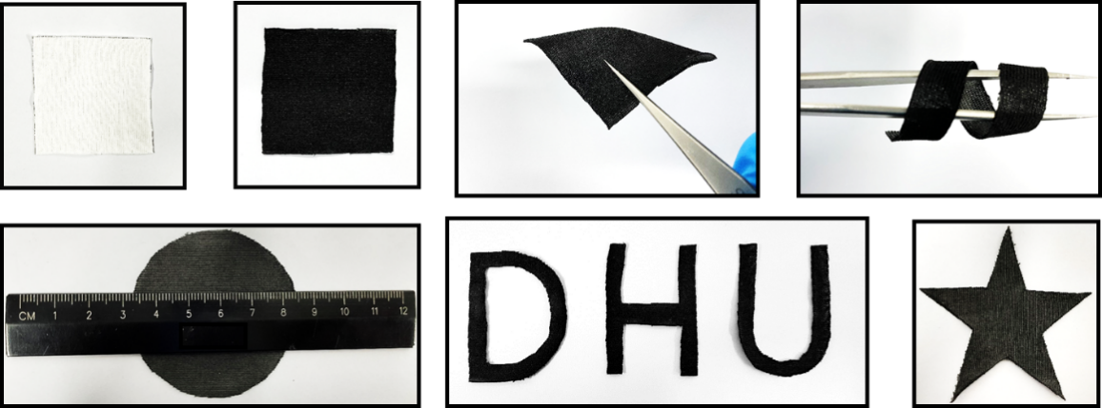
Figure S1. Physical diagrams of cotton fabrics and thermoelectric fabrics. Thermoelectric fabrics can undergo various physical deformations and shear into any shape.

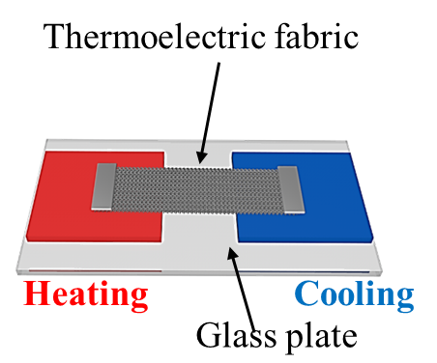
Figure S2. Schematic diagram of the thermoelectric testing of thermoelectric fabrics.

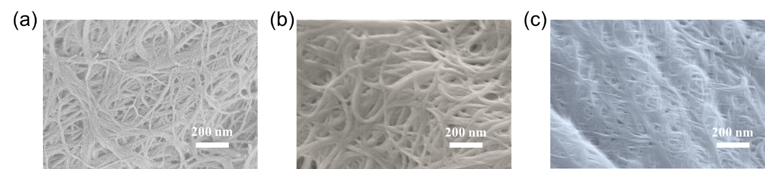
Figure S3. (a) SEM of the distribution of CNTs on the original thermoelectric fabrics. (b) SEM of the distribution of CNTs on the n-type thermoelectric fabrics. (c) SEM of the distribution of CNTs on the p-type thermoelectric fabrics.

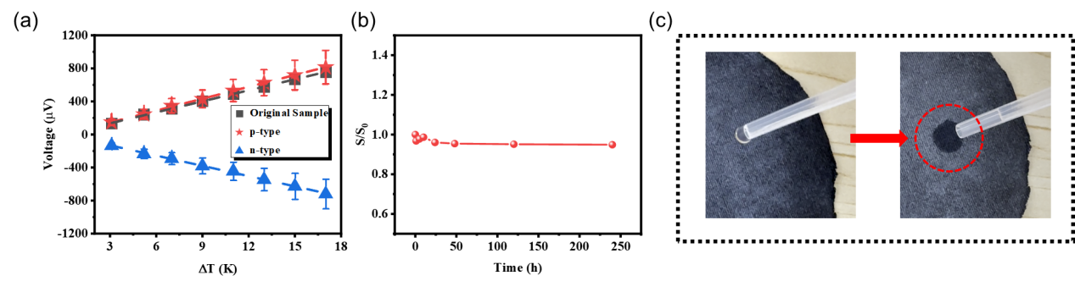
0.9 s
Figure S4. (a) Temperature difference (ΔT) across the original, p-type and n-type thermoelectric fabrics shower a good linear relationship with the output thermal voltage. (b) Stability of thermoelectric properties of n-type thermoelectric fabrics. (c) Demonstration of hygroscopic properties of thermoelectric fabrics.

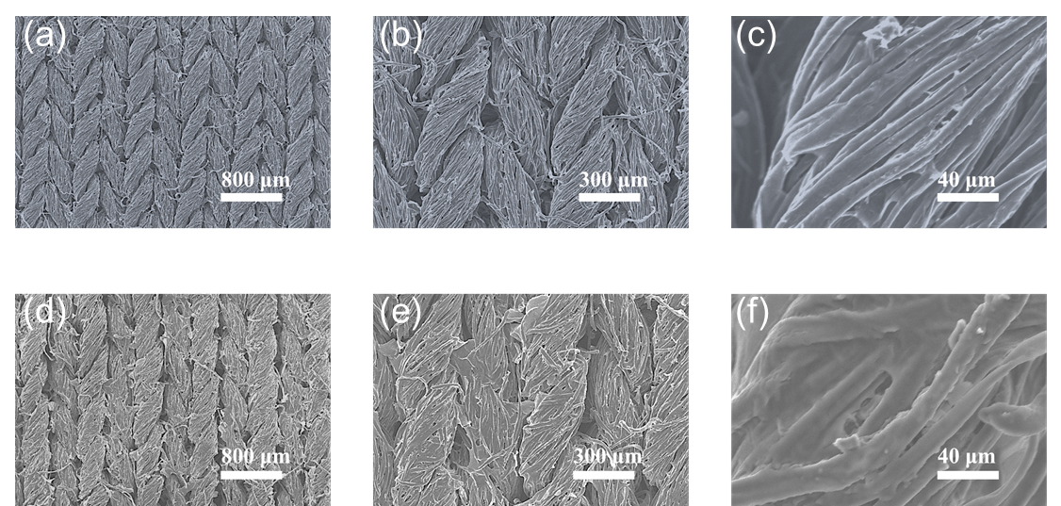
Figure S5. (a-c) Surface SEM images of p-type thermoelectric fabrics under different magnifications. (e-f) Surface SEM images of n-type thermoelectric fabrics under different magnifications.

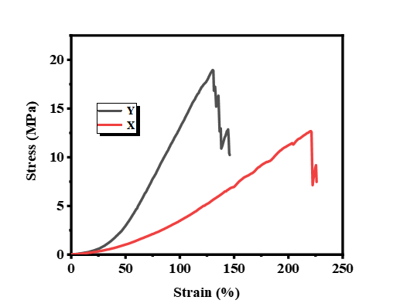
Figure S6. Stress-strain curves of cotton fabrics in different directions.

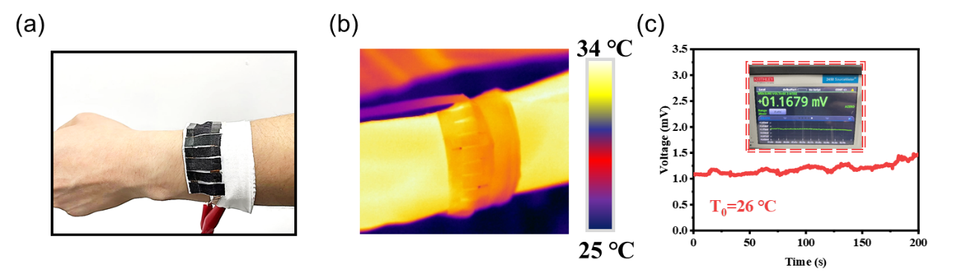
Figure S7. (a) Physical diagram of the device fixed on the wrist. (b) Infrared image of the device fixed on the wrist. (c) Device can collect about 1.16 mV stably when fixed on the wrist under room temperature.

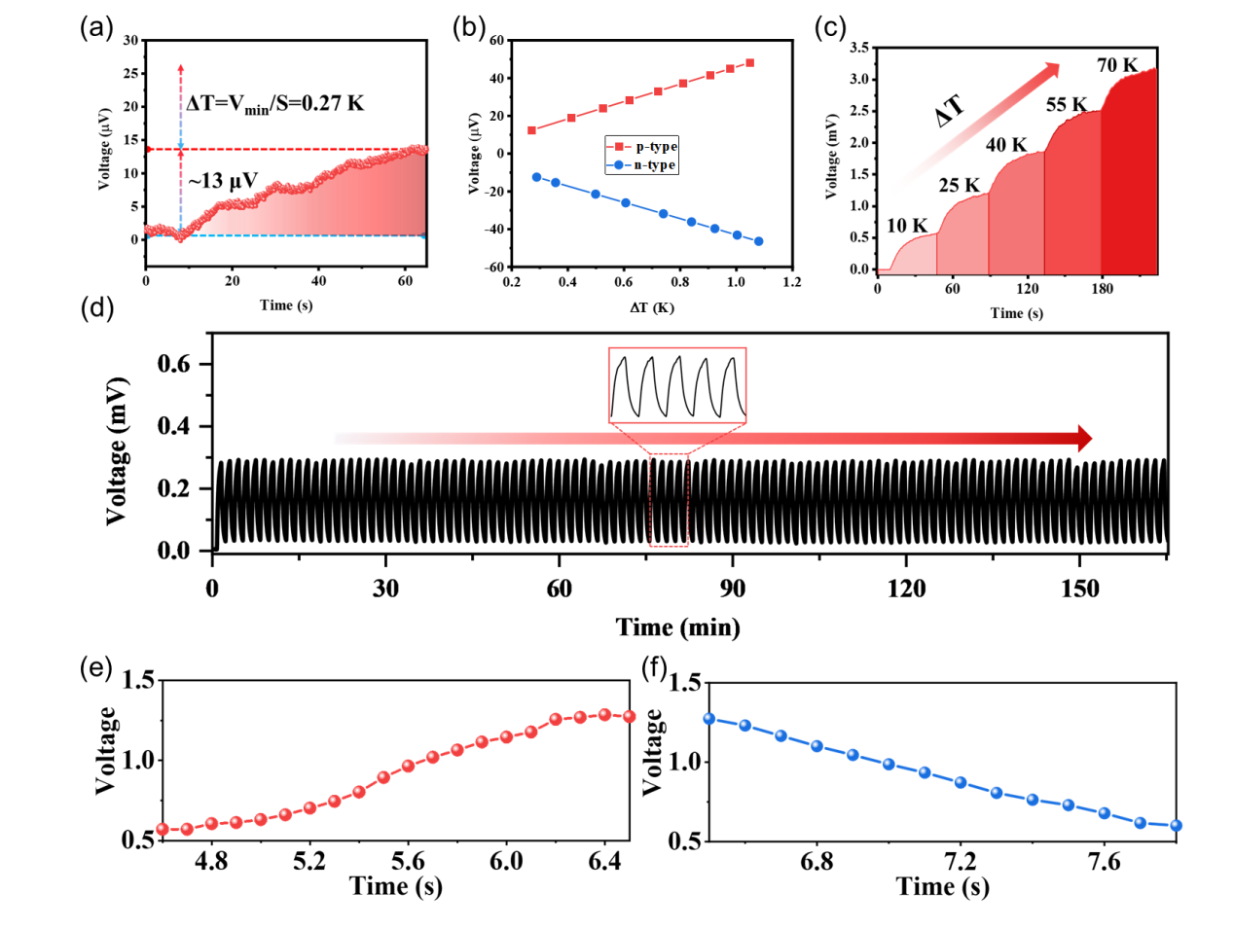
Figure S8. (a) The output voltage signal of the fabric has a minimum discernible temperature difference of 0.27 K. (b) The output thermal voltage corresponding to the temperature difference from 0 to 1 K of n-type fabric and p-type fabric. (c) The output thermal voltage response of the fabric under different ΔT. (d) Self-powered temperature sensing performance of the fabric remains stable and accurate after 100 cycles (e) Thermal voltage generated by the device during exhalation. (f) Thermal voltage generated by the device during inhalation.
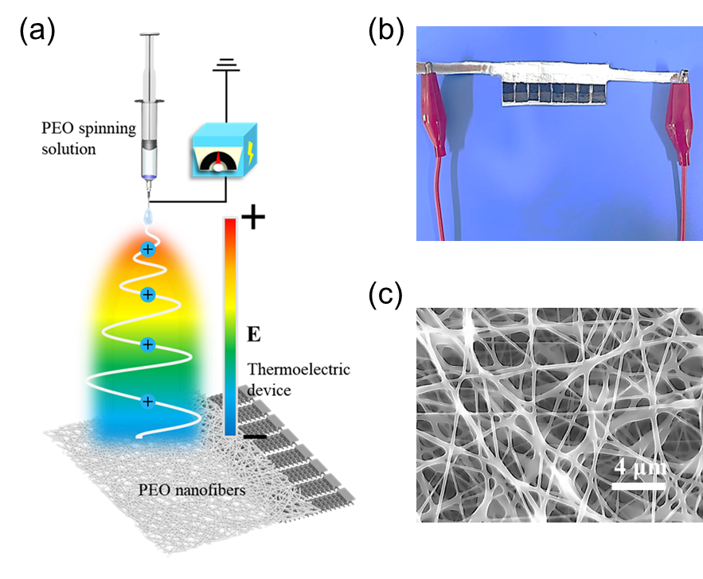
Figure S9. (a) Direct electrospinning of PEO nanofiber membrane at one end of the device to prepare self-powered solar flux monitoring system. (b) Physical diagram of self-powered solar flux monitoring system. (c) SEM of PEO nanofiber film.

Figure S10. Surface temperature of PEO nanofiber film and thermoelectric fabric under 1-sun irradiation.

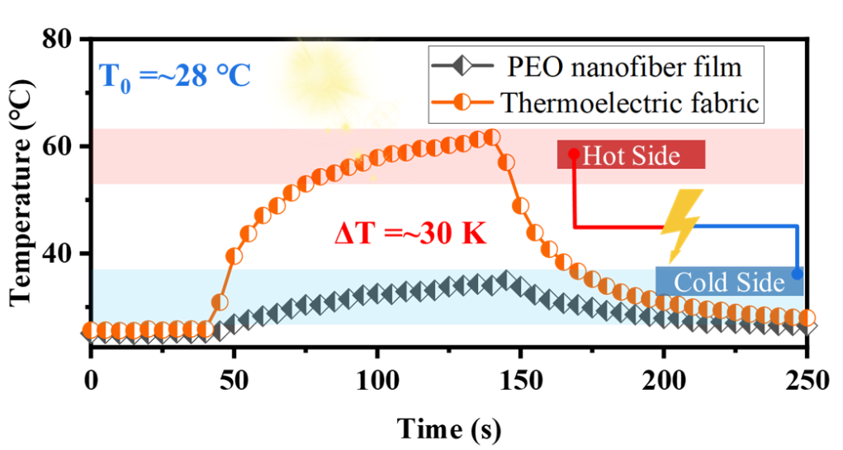
Figure S11. The temperature difference generated between the two ends of the device under 1-sun irradiation.

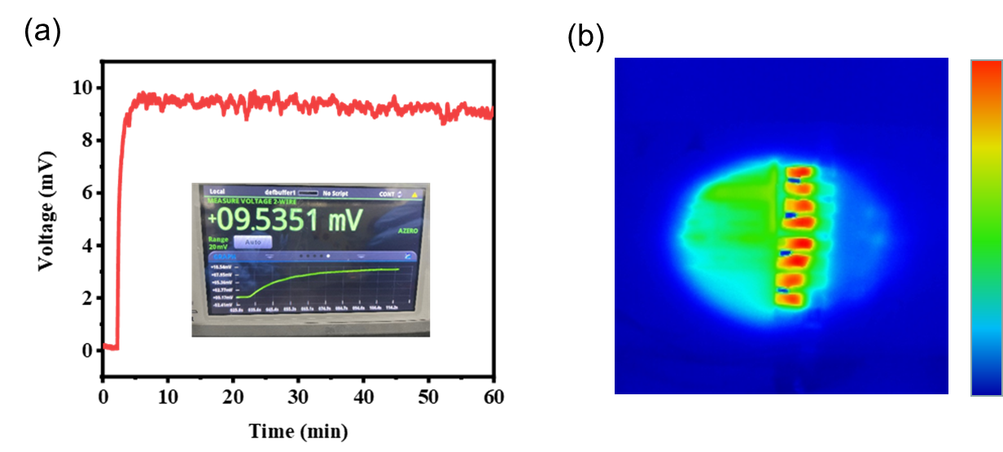
Figure S12. (a) Infrared image of the device under 1-sun irradiation. (b) The thermal voltage generated by the device under 1-sun irradiation.
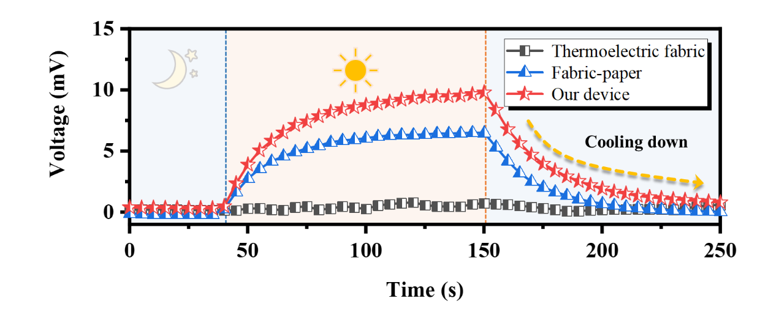
Figure S13. Compare the thermal voltage generated by the device without PEO nanofiber film, a thermoelectric fabric with paper and our device under 1-sun irradiation.

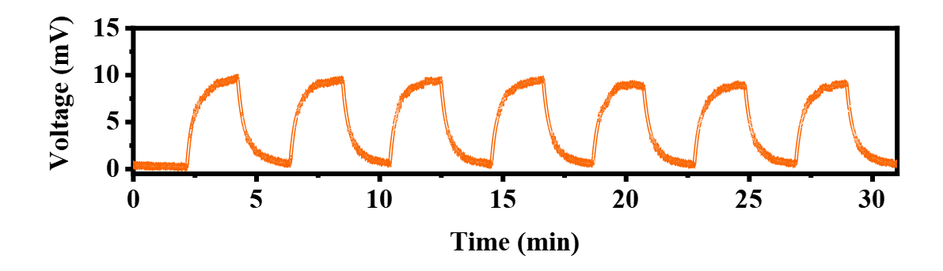
Figure S14. Repeated response of the device to light under 1-sun irradiation was displayed on a mobile phone APP.

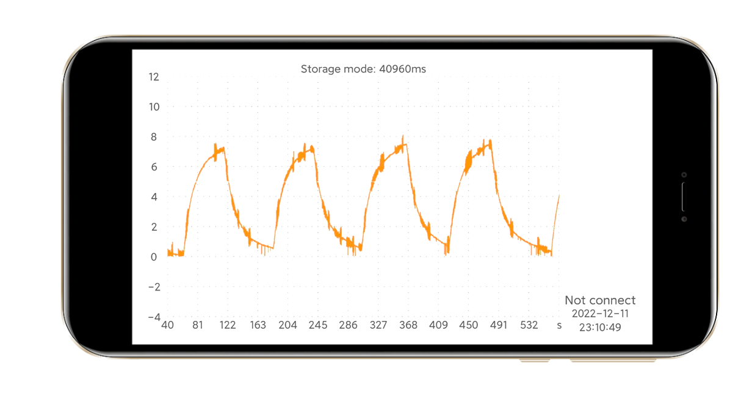
Figure S15. Repeated response of the device to light under 1-sun irradiation.

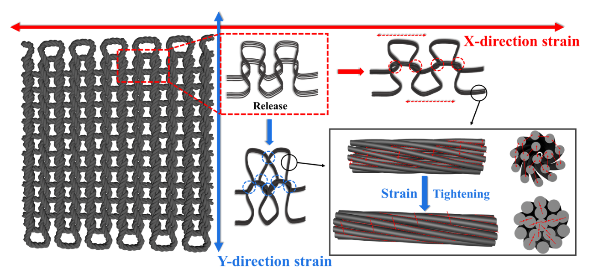
Figure S16. Schematic diagram of the fabric stretched in different directions, including the tightening between fibers and contact between loops.

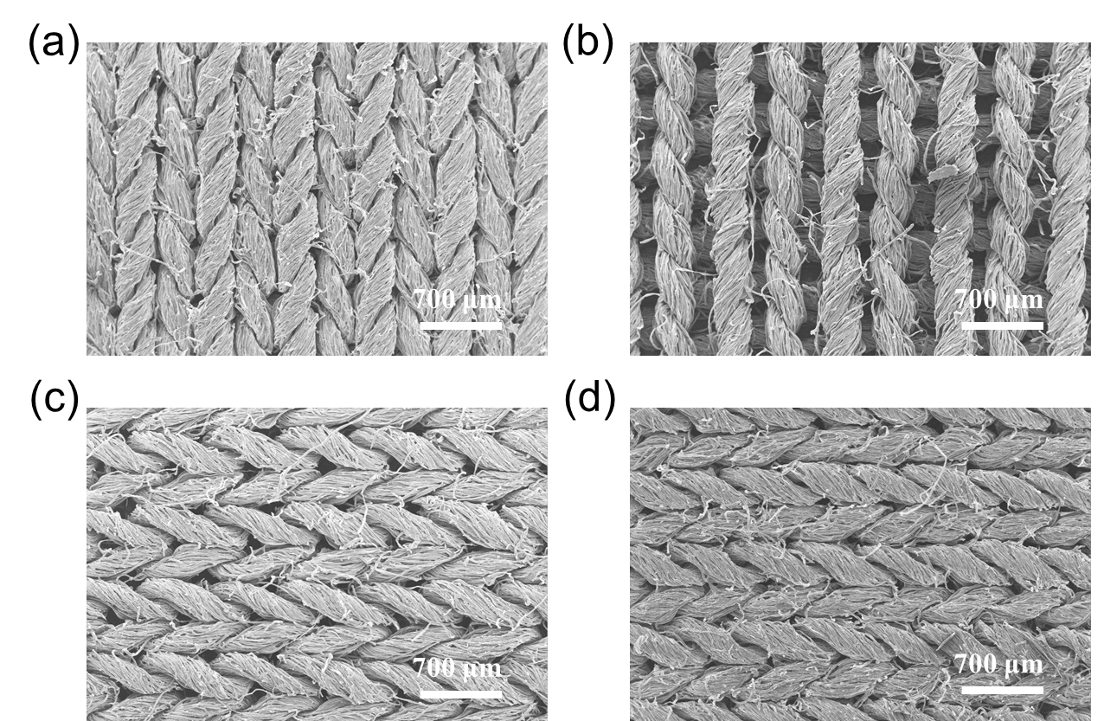
Figure S17. SEM of the thermoelectric fabric (a) before and (b) after stretching along the X-direction. SEM of the thermoelectric fabric (a) before and (b) after stretching along the Y-direction.

Figure S18. Stability of resistance change of fabric stretched along the X direction under 100 cycles.

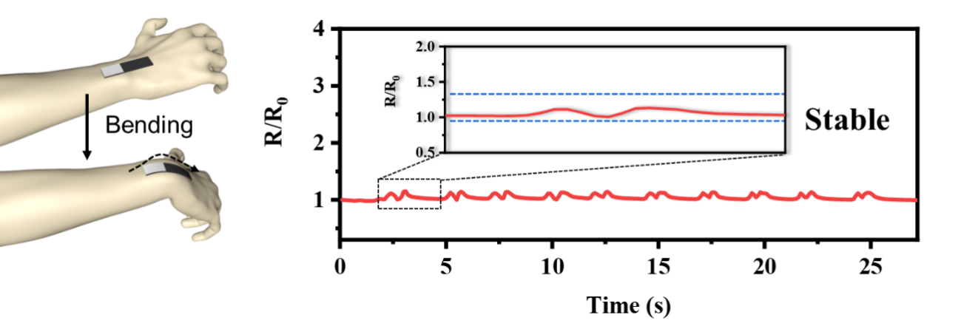
Figure S19. The change of resistance of the sensor in the state of repeatedly bending the wrist, the resistance exhibits relative stability.

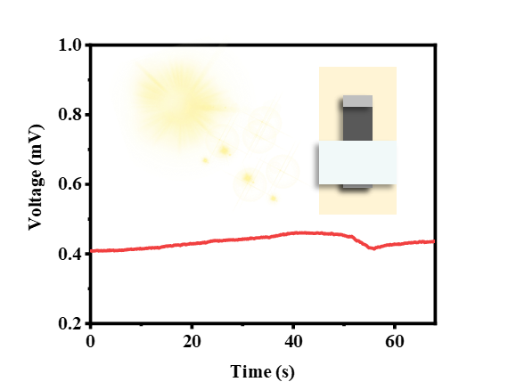
Figure S20. Schematic diagram of the device attached to the skin and its corresponding output voltage.

Figure S21. Real-time monitoring data of wrist bending was monitored by self-powered wireless sensing systems.

