Supplementary file for

Macrophage-secreted U2AF1 Orchestrates Coronary Artery Angiogenesis to Facilitate Myocardial Infarction Repair through the Regulation of Yap1 Variable Splicing
Manyu Gong ^{a,b,c,#}, Haodong Li ^{a,b,#}, Lei Jiao ^{a,b,#}, Tong Liu ^{a,b,#}, Yanwei Zhang ^{a,b}, Jie Liu ^{a,b}, Siyu Wang ^{a,b}, Hao Wang ^{a,b}, Dongping Liu ^{a,b}, Zhaoyue Li ^{e,f}, Zhiyuan Du ^{a,b}, Lihua Sun ^{a,b}, Lina Xuan ^{a,b}, Shihua Lv ^{d}, Xuewen Yang ^{a,b}, Yanying Wang ^{a,b}, Yingfeng Tu ^{e}, Mengmeng Li ^{l}, Haodi Wu ^{g}, Xin Li ^{h}, Xue Feng ^{b,i,j}, Juan Xu ^{c}, Wenzhi Li ^{d,}*, Yong Zhang ^{a,b,}*, Ying Zhang ^{a,b,k,}*, Baofeng Yang ^{a,b,}*
ª Department of Pharmacology & Key Laboratory of Cardiovascular Medicine Research, Ministry of Education of the People’s Republic of China, College of Pharmacy, Harbin Medical University, Harbin 150081, China
^{b} State Key Laboratory of Frigid Zone Cardiovascular Diseases (SKLFZCD), Harbin Medical University, Harbin 150081, China
^{c} College of Bioinformatics Science and Technology, Harbin Medical University, Harbin 150081, China
^{d} The Heilongjiang Key Laboratory of Anesthesia and Intensive Care Research, Harbin Medical University, Harbin 150081, China
^{e} Department of Cardiology, The First Affiliated Hospital of Harbin Medical University, Harbin 150000, China
^{f} Department of Cardiology, Affiliated Hospital of Yangzhou University, Yangzhou University, Yangzhou 225001, China
^{g} Heart, Lung, and Blood Vascular Medicine Institute, Division of Cardiology, Department of Medicine, School of Medicine, University of Pittsburgh, Pittsburgh, PA 15261, USA
^{h} Department of Cardiovascular Sciences, School of Engineering, University of Leicester, Leicester, LE1 7RH, UK
^{i} Department of Cardiology, The 2nd Affiliated Hospital of Harbin Medical University, Harbin 150081, China
^{j} The Key Laboratory of Myocardial Ischemia, Ministry of Education of the People’s Republic of China, Harbin Medical University, Harbin 150081, China
^{k} Ultrasound Imaging Department, The 2nd Affiliated Hospital of Harbin Medical University & State-Province Key Laboratories of Biomedicine-Pharmaceutics, College of Pharmacy, Harbin Medical University, Harbin 150081, China
^{l} Key Laboratory of Basic and Application Research of Beiyao, Ministry of Education of the People’s Republic of China, Heilongjiang University of Chinese Medicine, Harbin 150040, China

# These authors contributed equally to this work.
*Corresponding authors.
E-mail addresses: liwenzhi@hrbmu.edu.cn (W. Li), hmuzhangyong@hotmail.com (Y. Zhang), jennying223@126.com (Y. Zhang), yangbf@ems.hrbmu.edu.cn (B. Yang)

S1. Materials and methods

S1.1. Measurement of NAD⁺ levels in macrophages
The NAD⁺ content in macrophages was assayed using a microplate reader following the protocol provided with the NAD⁺/NADH detection kit (WST-8 method; Cat# S0175; Beyotime, China). Briefly, RAW264.7 cells were seeded into six-well plates. Once the cell confluency reached 70%–80%, NMN (Cat# HY-F0004; MedChemExpress, USA) was added at concentrations of 0.25, 0.5, 1, and 2 mmol∙L^{–1} and incubated for 24 h. The cells were lysed in pre-cooled extraction buffer and then centrifuged at 12 000g for 5 min at 4°C. The supernatant was collected for subsequent analyses. Alcohol dehydrogenase was added to the macrophage extract, and the mixture was incubated at 37 °C in the dark for 10 min. A chromogenic reagent was then added, mixed well, and incubated at 37 °C in the dark for 30 min. Absorbance was measured at 450 nm. Standard curves were generated, and the NAD⁺/NADH ratio was calculated based on these curves. The NAD⁺ concentration was determined as [NAD⁺] = [NAD_{total}] – [NADH], and the [NAD⁺]/[NADH] ratio as ([NAD_{total}] – [NADH])/[NADH].

S1.2. Adeno-associated virus serotype 9 (AAV9)-based endotheliotropic-specific overexpression of U2af1
To generate mice with endothelial-specific overexpression of U2af1, recombinant AAV-Vec vectors (Hanbio, Inc., China) bearing the mouse U2af1 gene driven by the Tie promoter (U2af1-v) were employed. Briefly, C57BL/6 mice received an intravenous injection of a mixture consisting of 100 μL of the U2af1-v virus suspension (virus titer: 1 × 10¹³ GC∙mL^{–1}) and 100 μL of normal saline. Control mice were injected with an equal volume of AAV9-control suspension. In addition, to verify the specific infection efficiency of recombinant AAV-Vec vectors with a Tie promoter on the cardiac vascular endothelium, the Tie promoter was conjugated with green fluorescence (AAV9-Tie-zsgreen). Infection efficiency was examined under a confocal microscope after AAV9-Tie-zsgreen four weeks in mice in the tail vein.

S1.3. Transmission electron microscopy
Initially, 10 μL of macrophage-derived exosome suspension was pipetted onto a copper mesh grid and allowed to adsorb at room temperature for 10 min. Excess liquid was removed using filter paper. A drop of 2% phosphotungstic acid solution (pH = 6.5) was added to the grid, followed by removal of excess stain with filter paper. After air drying, the exosomes were visualized using transmission electron microscopy.

S1.4. Real time fluorescence qRT-PCR
Total RNA was extracted from tissues using Trizol reagent (Cat# 15596026; Invitrogen, USA) as previously described. The RNA was reverse-transcribed into cDNA using the TOYOBO reverse transcription kit (Cat# FSQ-201; Whatman, UK) following the manufacturer’s protocol. Subsequently, qRT-PCR was carried out with SYBR green (Cat# 04913914001; Roche, Switzerland). Then detect the expression of Nos2, Tnf, Il1b, Il6, C-C motif chemokine ligand 3 (Ccl3), Il10, Vegf, and Yes1 associated transcriptional regulator (YAP1) using the following primers (5'-3'): Nos2 (forward primer, CTGCAGCACTTGGATCAGGAACCTG; reverse primer, GGGAGTAGCCTGTGTGCACCTGGAA), Tnf (forward primer, CAGGCGGTGCCTATGTCTC; reverse primer, CGATCACCCCGAAGTTCAGTAG) , Il1b (forward primer, AATCTATACCTGTCCTGTGTAATGAAAGAC; reverse primer, TGGGTATTGCTTGGGATCCA), Il6 (forward primer, CCTCTGGTCTTCTGGAGTACC; reverse primer, GGAGAGCATTGGAAATTGGGG), Ccl3 (forward primer, CAAGCAGCAGCGAGTACCAGTC; reverse primer, CAGGCATTCAGTTCCAGGTCAGTG), Il10 (forward primer, GCTCTTACTGACTGGCATGAG; reverse primer, CGCAGCTCTAGGAGCATGTG), Vegf (forward primer, ACCCACGACAGAAGGAGAGCAG; reverse primer, CACAGGACGGCTTGAAGATGTACTC), U2af1 (forward primer, TGACAACCTGGGAGACCACCTG; reverse primer, CAATCACAGCCTTTTCCGCATCTTC), Yap1, design primers for the exon 4 skipping event of Yap1 (forward primer, GCTGTCCCAGATGAACGTCA; reverse primer, TGGAGCACTCTGACTGATTCTCT), Yap1, design primers for the splicing variants of Yap1 (forward primer, CAGTCCACCAGTGCAGCAGAATA; reverse primer, TGCTCCAGTGTTGGTAACTGGCTA). Calculate gene expression levels.

S1.5. Western blotting
Total protein was extracted from heart tissue at 0, 7, 14, and 28 days post MI using radioimmunoprecipitation assay (RIPA) lysis buffer (Cat# P0013B; Beyotime) supplemented with phenylmethylsulfonyl fluoride (PMSF; Cat# ST2573-5g; Beyotime). Protein concentration was quantified using a BCA kit (Beyotime, China). Proteins were separated by sodium dodecyl-sulfate polyacrylamide gel electrophoresis (SDS-PAGE) based on molecular weight and transferred to nitrocellulose membranes via wet transfer. Membranes were incubated with primary antibodies overnight at 4 °C and with appropriate secondary antibodies (Sigma-Aldrich) for 50 min at room temperature in the dark. Primary antibodies included: anti-U2AF1 (1:1000; Cat# ab172614; Abcam), anti-SEC22 homolog B, vesicle trafficking protein (SEC22B) (1:1000; Cat# ab181076; Abcam), anti-solute carrier family 7 member 5 (SLC7A5) (1:500; Cat# A2833; ABclonal, China), anti-β-actin (1:1000; Cat# AC026; ABclonal), anti-CD63 (1:1000; Cat# ab315108; Abcam), and anti-CD81 (1:1000; Cat# ab109201; Abcam). Protein bands were scanned using an Odyssey infrared imaging system (LI-COR, USA), and quantification was performed using its software.

S1.6. Tandem mass tag marker quantitative proteomics
RAW264.7 macrophages were cultured to 70%–80% confluence and divided into control and NMN (0.5 mmol∙L^{–1}) treatment groups, with three independent replicates per group. After 48 h, culture media were collected and exosomes were isolated. Protein concentrations were determined using a BCA assay. TMT-labeled peptides were separated via reverse-phase high-performance liquid chromatography (HPLC) and analyzed using NanoLC-tandem mass spectrometry (MS/MS). Data were processed with the MASCOT engine (version 2.6; Matrix Science, UK). A reverse database search with a 1% false discovery rate was used for peptide/protein identification. Proteins with a fold change (FC) >1.2 and P < 0.05 (independent t-test) were considered differentially expressed.

S2. Data availability
Serum RNA-seq data produced and used in this study were deposited on Gene Expression Omnibus (GEO) database under accession number GSE208194.Except for the above,all sequencing datasets used in this study were self tested by the authors and can be obtained from the corresponding authors.

Fig. S1. Effect of NMN on macrophage polarization. (A) Detection of the NAD⁺/NADH ratio via the WST-8 method. n = 3. One-way ANOVA with Tukey’s test. (B) Schematic representation of the Luminex liquid-phase suspension chip technology. (C, D) Relative concentrations of CXCL1, IL1B, TNF, IL6, VEGF, IL10, CXCL12, and FGF in cell culture medium. n = 4–8. Two-way ANOVA with Tukey’s test. (E–I) The mRNA levels of Nos2 (n = 6), Tnf (n = 5), Ccl3 (n = 4), Il10 (n = 4), and Vegf (n = 5) in macrophages. Student’s t-test. (J–N) The mRNA expression level of Il1b (n = 3), Il-6 (n = 3), Ccl3(n = 4), Tnf (n = 4), and Il-10 (n = 4) in macrophages. One-way ANOVA with Tukey’s test.
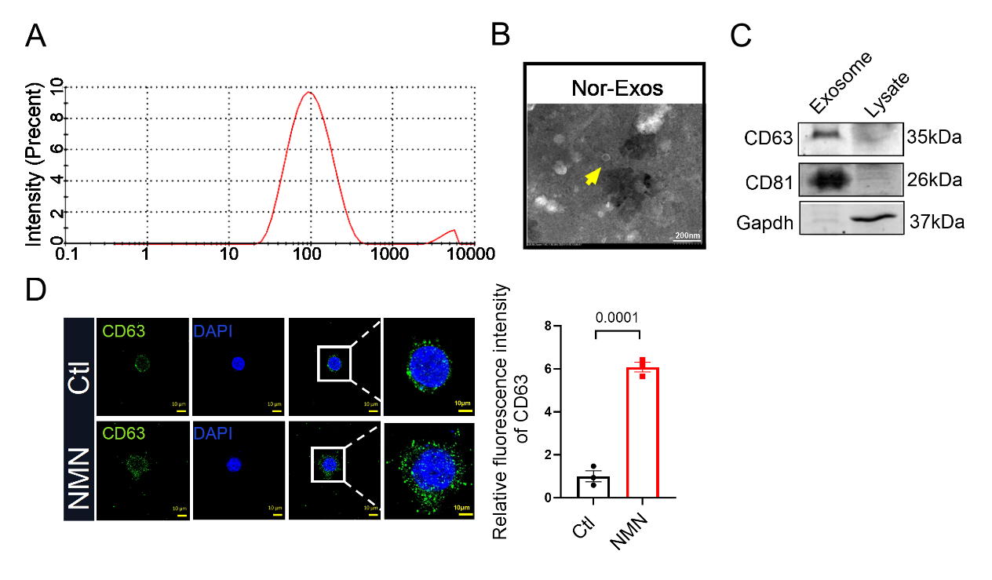

Fig. S2. Macrophage exosome extraction and characterization. (A) Nanoparticle analysis of exosome particle size. (B) Exosome examination under transmission electron microscopy. Scale bar, 200 nm. (C) The expression levels of exosome marker proteins CD63 and CD81 as determined by Western blotting. n = 3. (D) Detection of CD63-labeled exosomes by immunofluorescence. Scale bars, 10 μm, 10 μm (second magnification). n = 3. Student’s t-test.

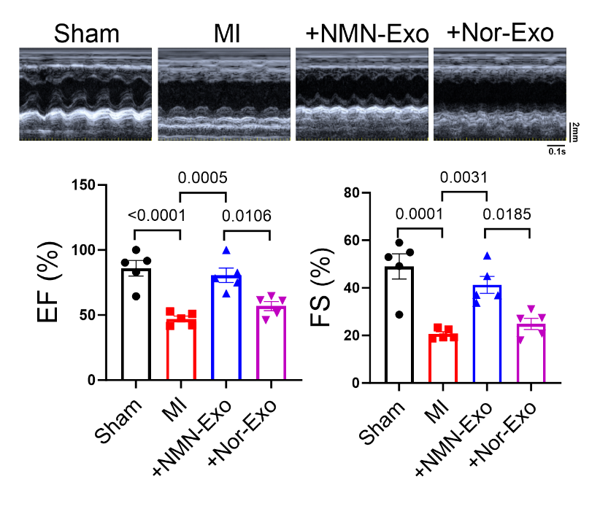
Fig. S3. Echocardiographic detection of changes in cardiac function on day 28 after myocardial infarction. n = 5. Scale bars, 2 mm (right row), 0.1 s (bottom row). One-way ANOVA with Tukey’s test.
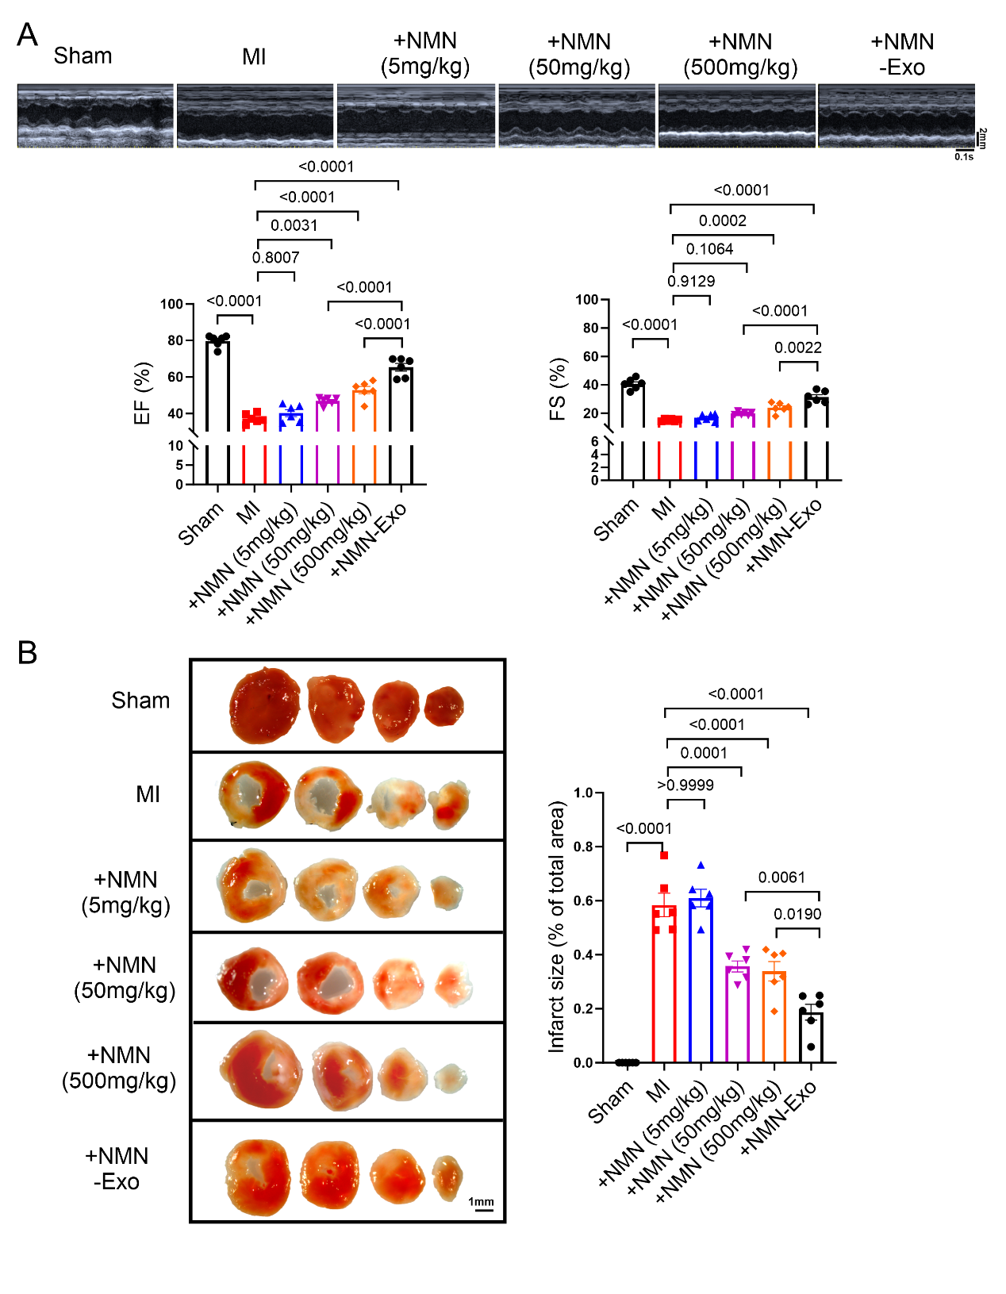
Fig. S4. Cardiac effects of NMN dosing and NMN-Exo treatment in MI model mice. (A) Echocardiographic detection of changes in cardiac function on day 7 after MI. n = 6. Scale bars, 2 mm (right row), 0.1 s (bottom row). One-way ANOVA with Tukey’s test. (B) Representative images of four cardiac slices from the Sham group, MI group, and mice treated with NMN or NMN-Exo after MI, followed by TTC staining. Scale bar, 1 mm. n = 6. One-way ANOVA with Tukey’s test.
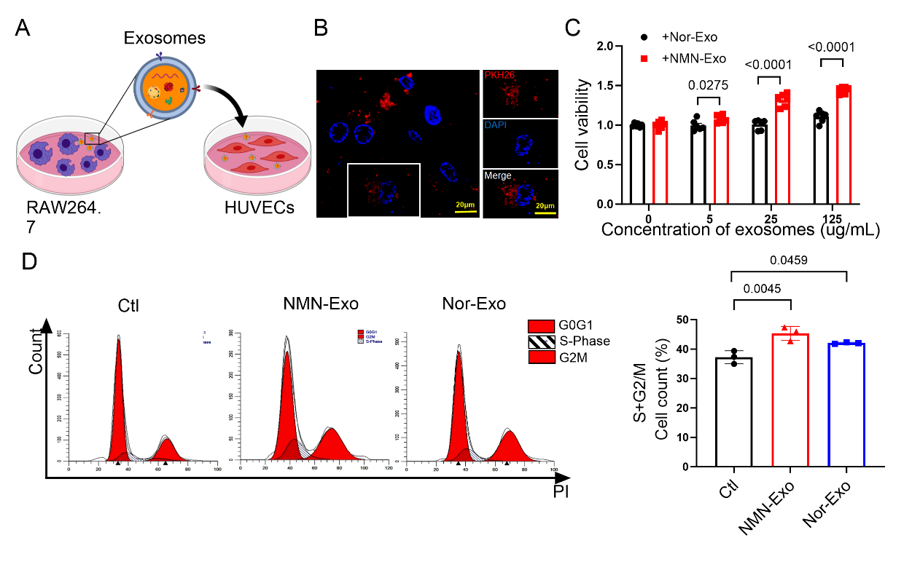

Fig. S5. NMN-Exo treatment promotes HUVEC proliferation, migration, and tube formation. (A) Pattern diagram of HUVECs treated with macrophage exosomes. (B) Immunofluorescence detection of NMN-Exo internalized by HUVECs. Blue, DAPI staining of the nuclei; green, red, PKH26 staining for NMN-Exo. Scale bar, 20 μm. n = 4. (C) CCK-8 assay-based detection of HUVEC viability. n = 6. Two-way ANOVA with Tukey’s test. (D) Flow cytometry-based detection of the cell cycle in HUVECs. n = 3. One-way ANOVA with Tukey’s test.
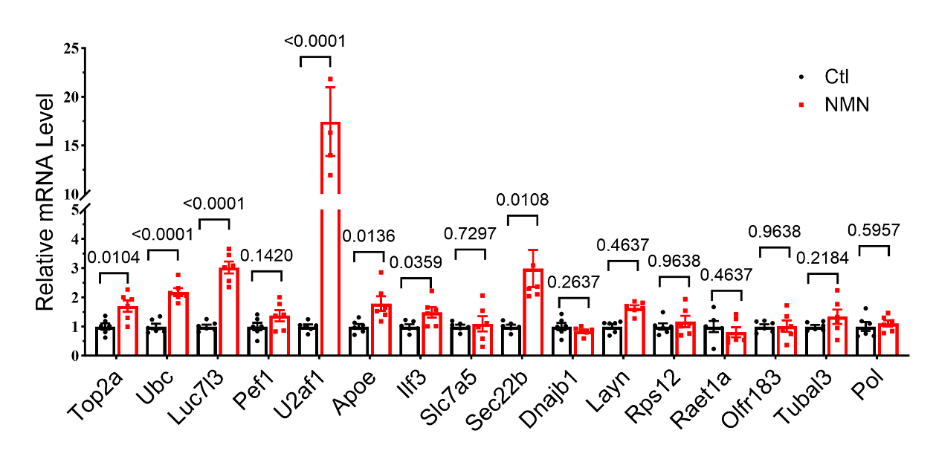

Fig. S6. qRT-PCR validation of genes upregulated in NMN-treated macrophages. The mRNA expression levels of Top2a, Ubc, Luc7l3, Pef1, U2af1, Apoe, Ilf3, Slc7a5, Sec22b, Dnajb1, Layn, Rps12, Rate1a, Olfr183, Tubal3, and Pol in macrophages. n = 6. Student’s t-test.
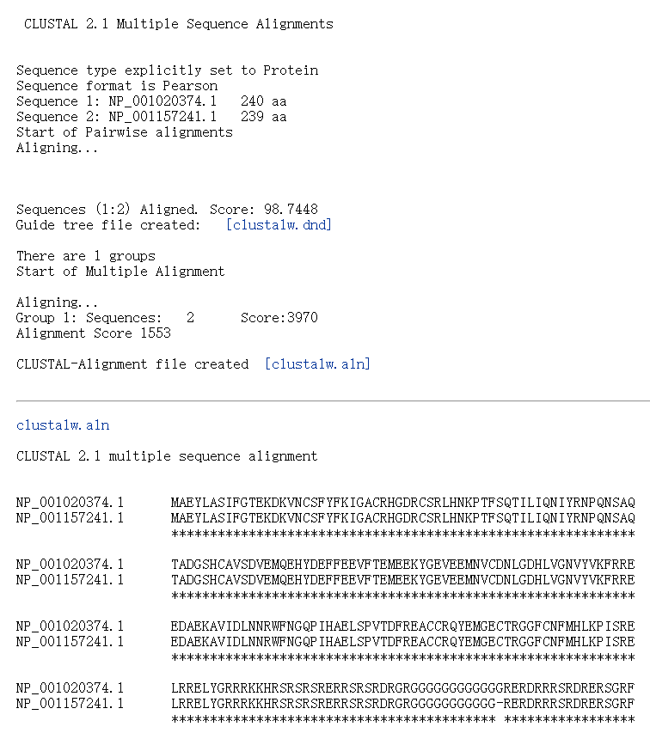
Fig. S7. ClustalW homology alignment of human and mouse U2AF1 sequences. The protein sequence accession number for human U2AF1 is NP_001020374.1, while that for murine U2AF1 is NP_001157241.1.
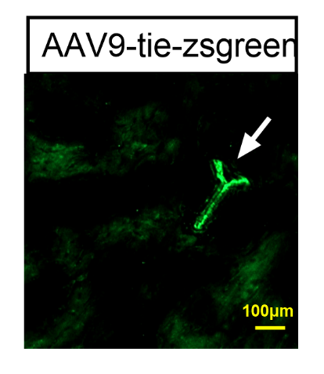
Fig. S8. Validation of endothelial-specific infection efficiency of AAV-based endothelial-specific overexpression of U2AF1 in the murine heart. Scale bar, 100 μm.
Fig. S9. Role of U2AF1 in hypoxia-induced myocardial cell injury. (A) The protein level expression of U2AF1 in cardiomyocytes. n = 3. One-way ANOVA with Tukey’s test. (B) The protein level expression of U2AF1 in cardiomyocytes. n = 4. One-way ANOVA with Tukey’s test. (C, D) Flow cytometry examination of U2AF1-associated inhibition of hypoxia-induced myocardial cell apoptosis. n = 4. One-way ANOVA with Tukey’s test.
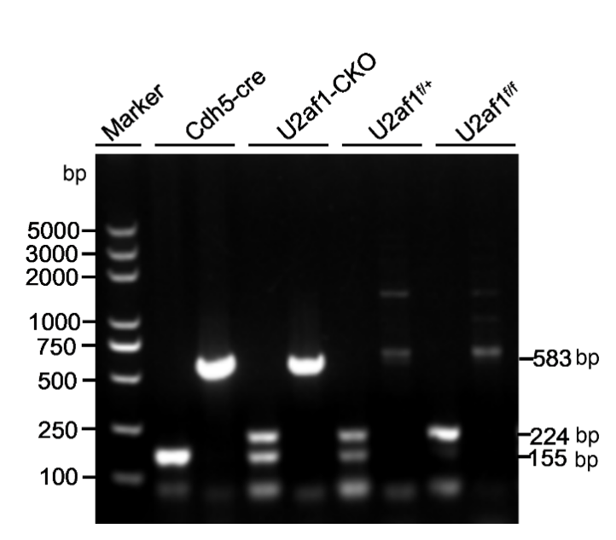
Fig. S10. Agarose gel-based identification of vascular endothelium-specific U2af1 transgenic mice.

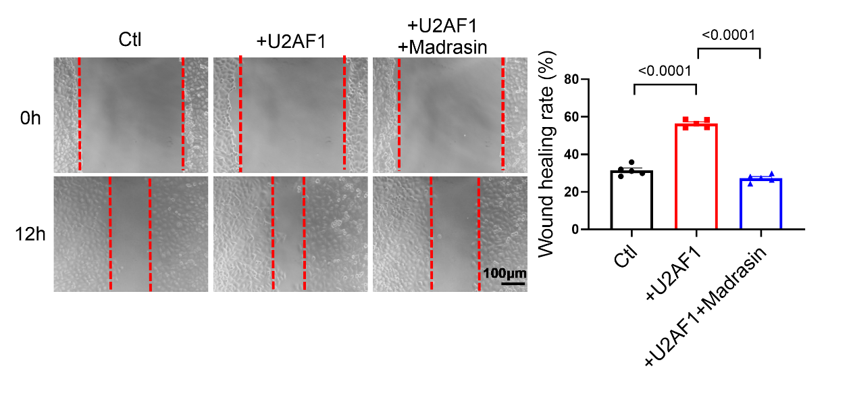

Fig. S11. U2AF1 regulates vascular endothelial cell migration via Yap1 splicing. Scale bar, 100 μm. n = 5. One-way ANOVA with Tukey’s test.

