Supplementary data for

Electron Transfer Pathways and Vanadium Isotope Fractionation During Microbially Mediated Vanadate Reduction
Wenyue Yanª, Baogang Zhang^{a,}*, Yi’na Liª, Jianping Luª, Yangmei Feiª, Shungui Zhou^{b}, Hailiang Dong^{c}, Fang Huang^{d,}*
ª School of Water Resources and Environment, Minisitry of Education (MOE) Key Laboratory of Groundwater Circulation and Environmental Evolution, China University of Geosciences Beijing, Beijing 100083, China
^{b} Fujian Provincial Key Laboratory of Soil Environmental Health and Regulation, College of Resources and Environment, Fujian Agriculture and Forestry University, Fuzhou 350002, China
^{c} Center for Geomicrobiology and Biogeochemistry Research, State Key Laboratory of Biogeology and Environmental Geology, School of Earth Sciences and Resources, China University of Geosciences Beijing, Beijing 100083, China
^{d} Chinese Academy of Sciences (CAS) Key Laboratory of Crust-Mantle Materials and Environments, School of Earth and Space Sciences, University of Science and Technology of China, Hefei 230026, China
* Corresponding authors
E-mail addresses: baogangzhang@cugb.edu.cn (B. Zhang); fhuang@ustc.edu.cn (F. Huang).

This supporting information contains:
number of pages: 7
number of tables: 1
number of figures: 3

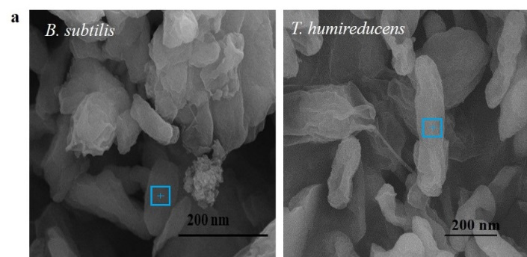
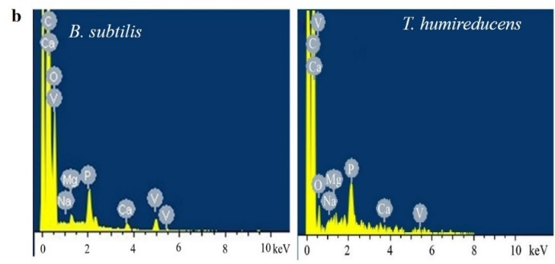
Fig. S1. Morphology and composition of the produced precipitates during V(V) bio-reduction by B. subtilis and T. humireducens. (a) SEM images; (b) EDS spectra. The bacterium is in short rod shape with smooth surface, while the irregular and rough materials are the produced precipitates. Blue hollow square indicates the area of EDS analysis.

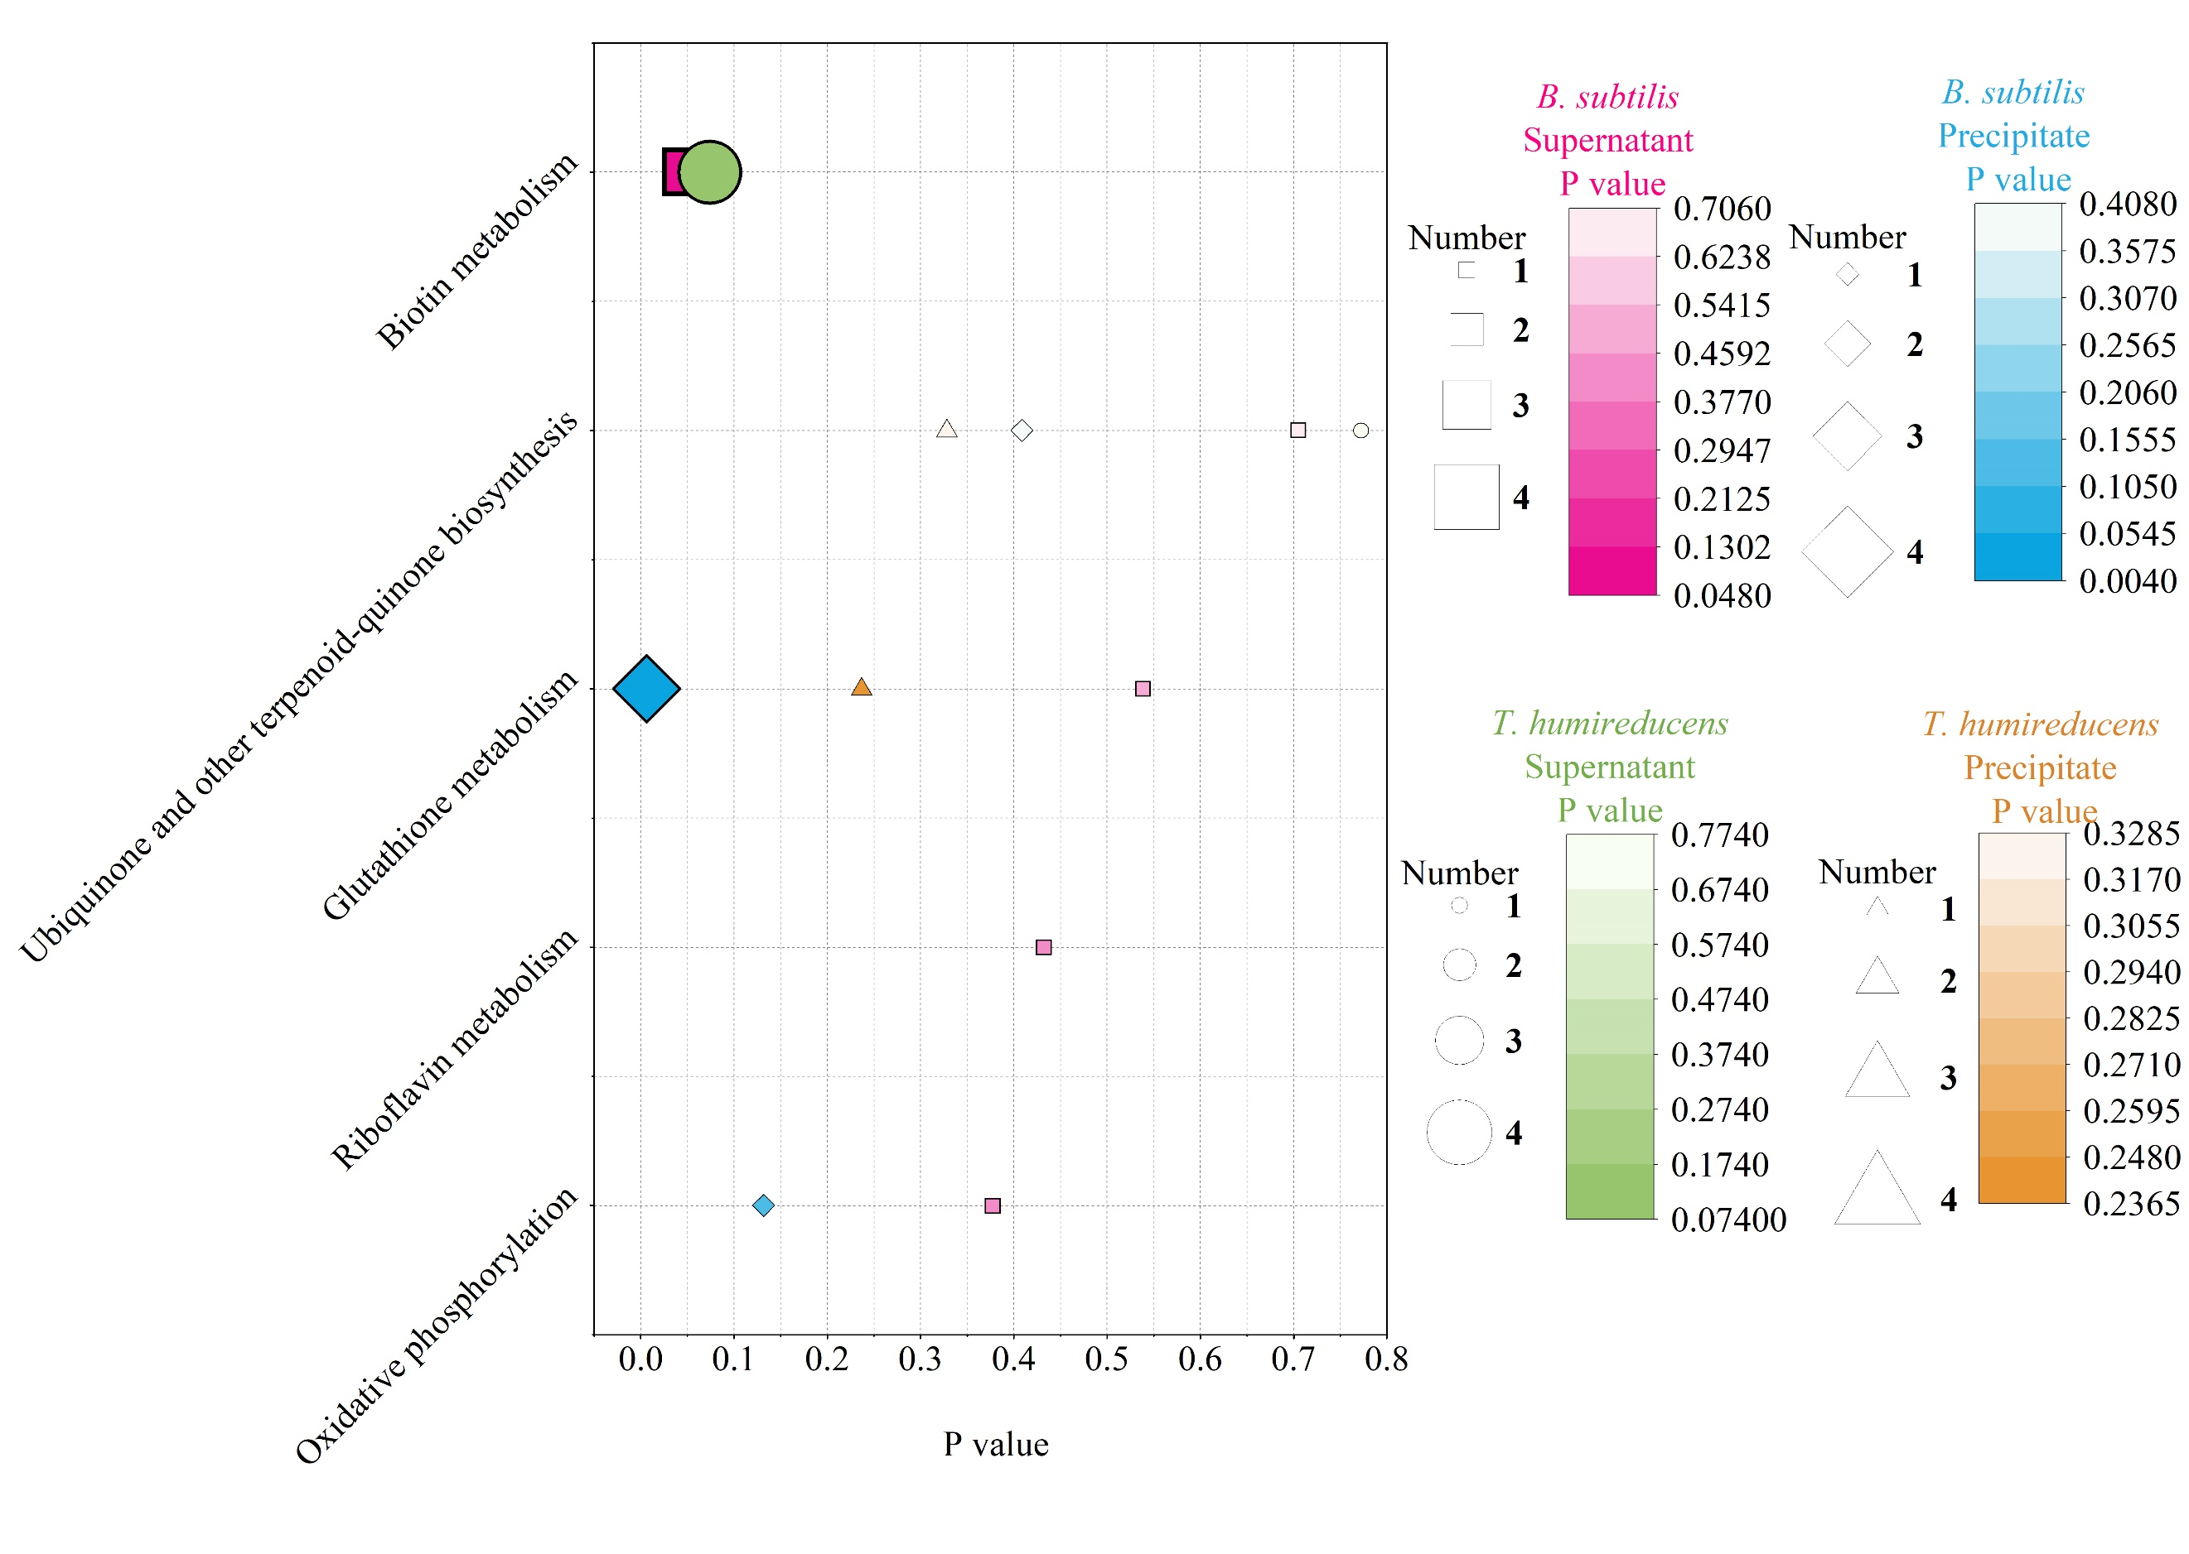
Fig. S2. Differentially expressed pathways in the supernatant and precipitate of the two strains for V(V) reduction compared to those in V(V)-free solution.
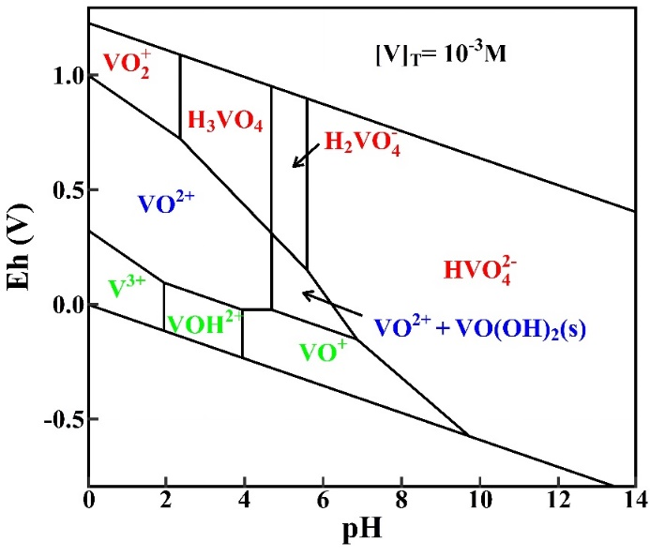
Fig. S3. Eh-pH diagram of vanadium species in aqueous solution obtained by using HSC Chemistry (Version 6.0).

Table S1. Data source for vanadium isotope composition of environmental samples exhibited in Fig. 7b.
Number | Reference
(1) | Chételat, J.; Nielsen, S. G.; Auro, M.; Carpenter, D.; Mundy, L.; Thomas, P. J.. Vanadium stable isotopes in biota of terrestrial and aquatic food chains. Environ. Sci. Technol. 2021, 55, 4813-4821.
(2) | Qi, Y.-H.; Gong, Y.-Z.; Wu, F.; Lu, Y.; Cheng, W.; Huang, F.; Yu, H.-M. Coupled variations in V-Fe abundances and isotope compositions in latosols: Implications for V mobilization during chemical weathering. Geochim. Cosmochim. Acta 2022, 320, 26-40.
(3) | Huang, Y.; Long, Z.; Zhou, D.; Wang, L.; He, P.; Zhang, G.; Hughes, S. S.; Yu, H.; Huang, F. Fingerprinting vanadium in soils based on speciation characteristics and isotope compositions. Sci. Total Environ. 2021, 791, 148240.
(4) | Schuth, S.; Brüske, A.; Hohl, S. V.; Jiang, S.-Y.; Meinhardt, A.-K.; Gregory, D. D.; Viehmann, S.; Weyer, S. Vanadium and its isotope composition of river water and seawater: Analytical improvement and implications for vanadium isotope fractionation. Chem. Geol. 2019, 528, 119261.
(5) | Wu, F.; Owens, J. D.; Huang, T.; Sarafian, A.; Huang, K.-F.; Sen, I.S.; Horner, T.J.; Blusztajn, J.; Morton, P.; Nielsen, S. G. Vanadium isotope composition of seawater. Geochim. Cosmochim. Acta 2019a, 244, 403-415.
(6) | Ventura, G.T.; Gall, L.; Siebert, C.; Prytulak, J.; Szatmari, P.’ Hürlimann, M.; Halliday, A.N. The stable isotope composition of vanadium, nickel, and molybdenum in crude oils. Appl. Geochem. 2015, 59, 104-117.
(7) | Gao, Y.; Casey, J. F.; Bernardo, L. M.; Yang, W.; Bissada, K. K(Adry). Vanadium isotope composition of crude oil: effects of source, maturation and biodegradation. Geol. Soc. Lond. Spec. Publ. 2018, 468, 83-103.
(8) | Wu, F.; Owens, J. D.; Scholz, F.; Huang, L.; Li, S.; Riedinger, N.; Peterson, L. C.; German, C. R.; Nielsen, S. G. Sedimentary vanadium isotope signatures in low oxygen marine conditions. Geochim. Cosmochim. Acta 2020, 284, 134-155.
(9) | Chen, X.; Li, S.; Newby, S. M.; Lyons, T. W.; Wu, F.; Owens, J. D. Iron and manganese shuttle has no effect on sedimentary thallium and vanadium isotope signatures in Black Sea sediments. Geochim. Cosmochim. Acta 2022, 317, 218-233.
(10) | Malinovsky, D.; Kashulin, N. A. Vanadium isotope ratio measurements in fruit-bodies of Amanita muscaria. Anal. Methods 2016, 8, 5921-5929.
(11) | Wu, F.; Owens, J. D.; Tang, L.; Dong, Y.; Huang, F. Vanadium isotopic fractionation during the formation of marine ferromanganese crusts and nodules. Geochim. Cosmochim. Acta 2019b, 265, 371-385.
(12) | Wu, F.; Owens, J. D.; German, C. R., Mills, R. A.; Nielsen, S.G. Vanadium isotope fractionation during hydrothermal sedimentation: Implications for the vanadium cycle in the oceans. Geochim. Cosmochim. Acta 2022, 328, 168-184.
(13) | Li, S. Q.; Friedrich, O.; Nielsen, S. G.; Wu, F.; Owens, J. D. Reconciling biogeochemical redox proxies: Tracking variable bottom water oxygenation during OAE-2 using vanadium isotopes. Earth Planet. Sci. Lett. 2023, 617, 118237.

