Supplementary Information for

The Nanoscale Density Gradient as a Structural Stabilizer for Glass Formation
Shaoxiong Zhou ^{a,b,}*, Bangshao Dong ^{b,c}, Yanguo Wang ^{d}, Jingyu Qin ^{e}, Weihua Wang ^{d,}*
ª China Iron and Steel Research Institute Group, Beijing 100081, China
^{b} Institute of Advanced Materials, North China Electric Power University, Beijing 102206, China
^{c} Jiangsu JITRI Advanced Energy and Materials Research Institute, Changzhou 213032, China
^{d} Beijing National Laboratory of Condensed Matter Physics, Institute of Physics, Chinese Academy of Sciences, Beijing 100190, China
^{e} Key Laboratory for Liquid-Solid Structural Evolution and Processing of Materials (Ministry of Education), Shandong University, Jinan 250061, China

* Corresponding authors.
E-mail addresses: sxzhou@atmcn.com (S. Zhou), whw@iphy.ac.cn (W. Wang).

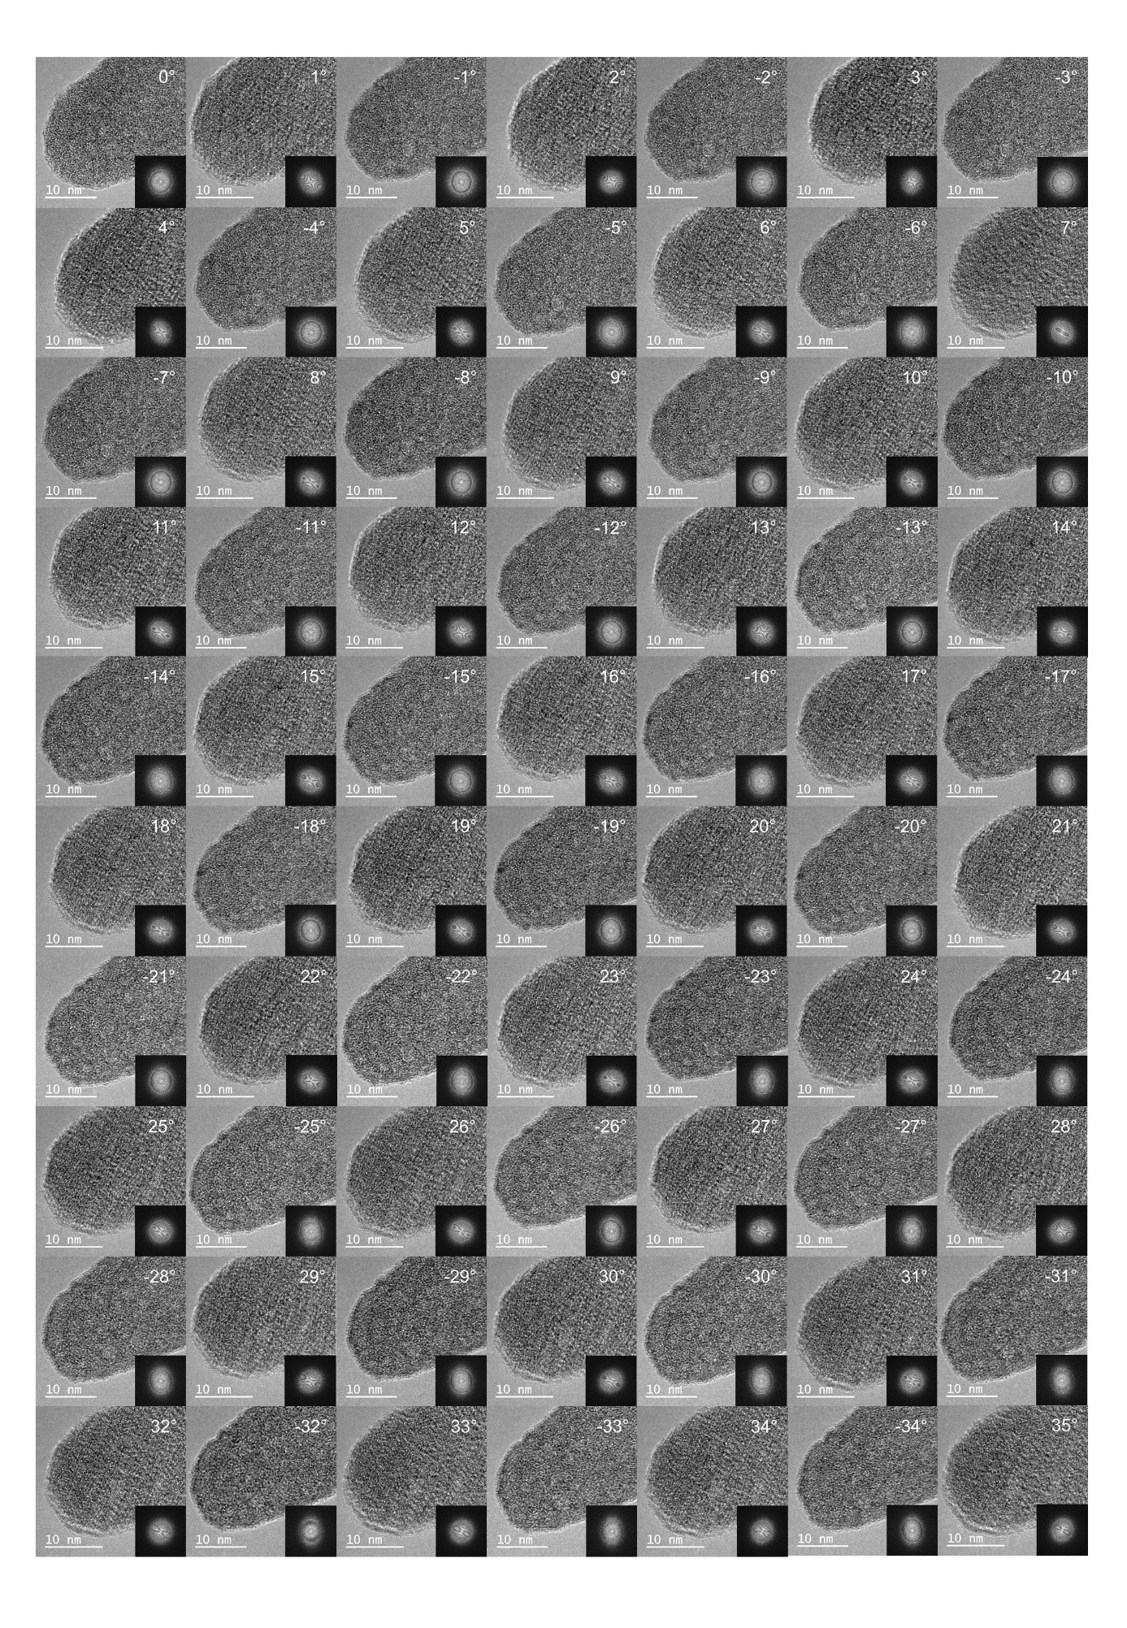
Fig. S1. 128 raw HRTEM images of the Zr₆₀Cu₃₀Al₁₀ amorphous alloy with a tilt range from −71° to 66° and the 2D power spectra of the images are shown in the insets.

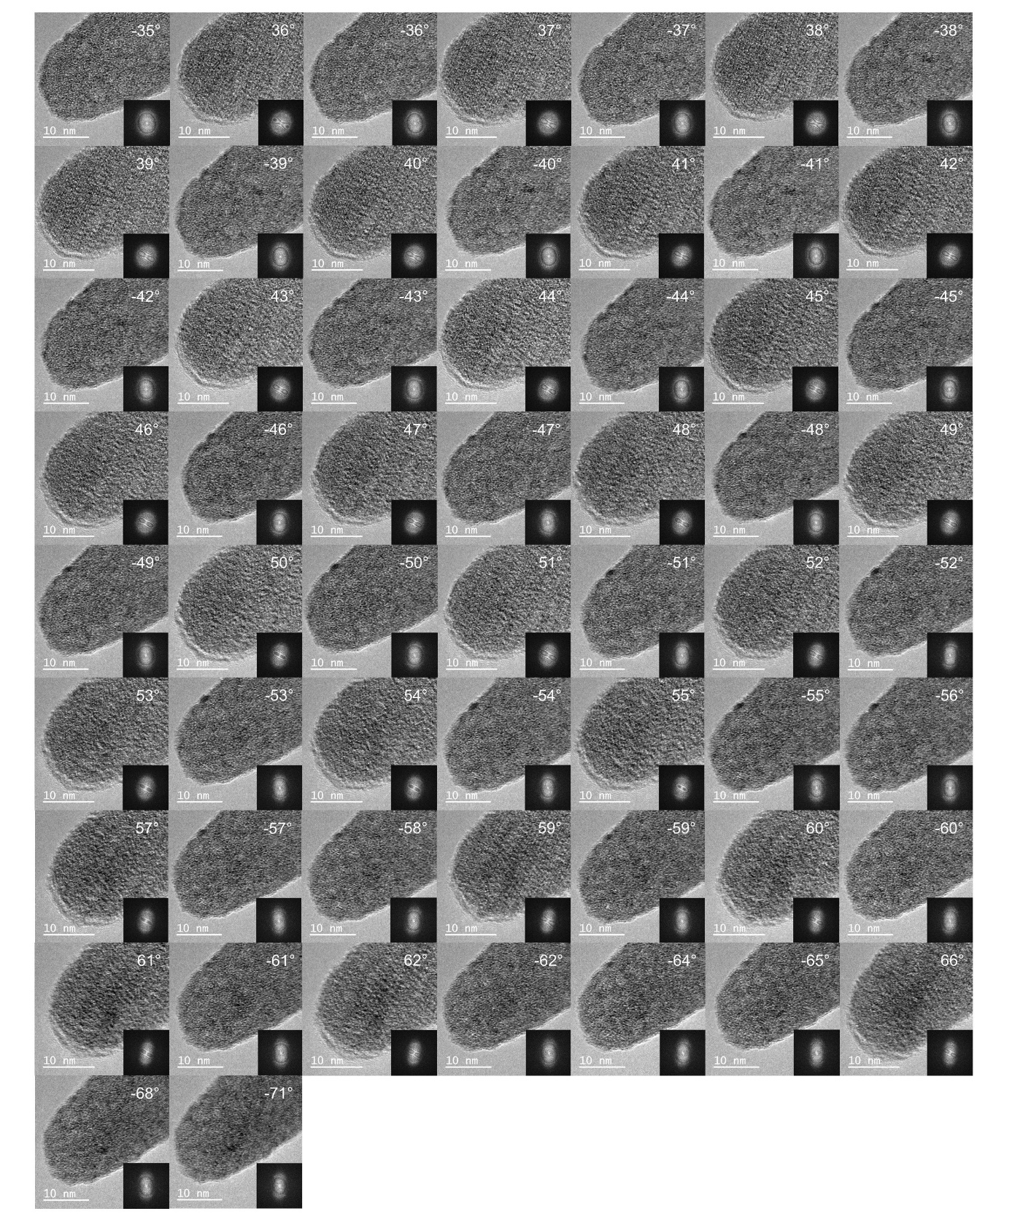
Fig. S1 (continued)

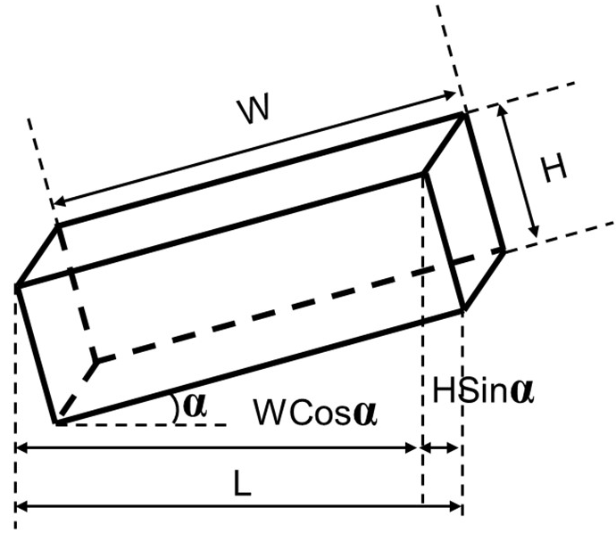
Fig. S2. A schematic diagram shows the correlation between the projected size L, the thickness H and tilt angle α, the equation relating these three parameters can be deduced as L(α) = W·cos α + H·sin α.

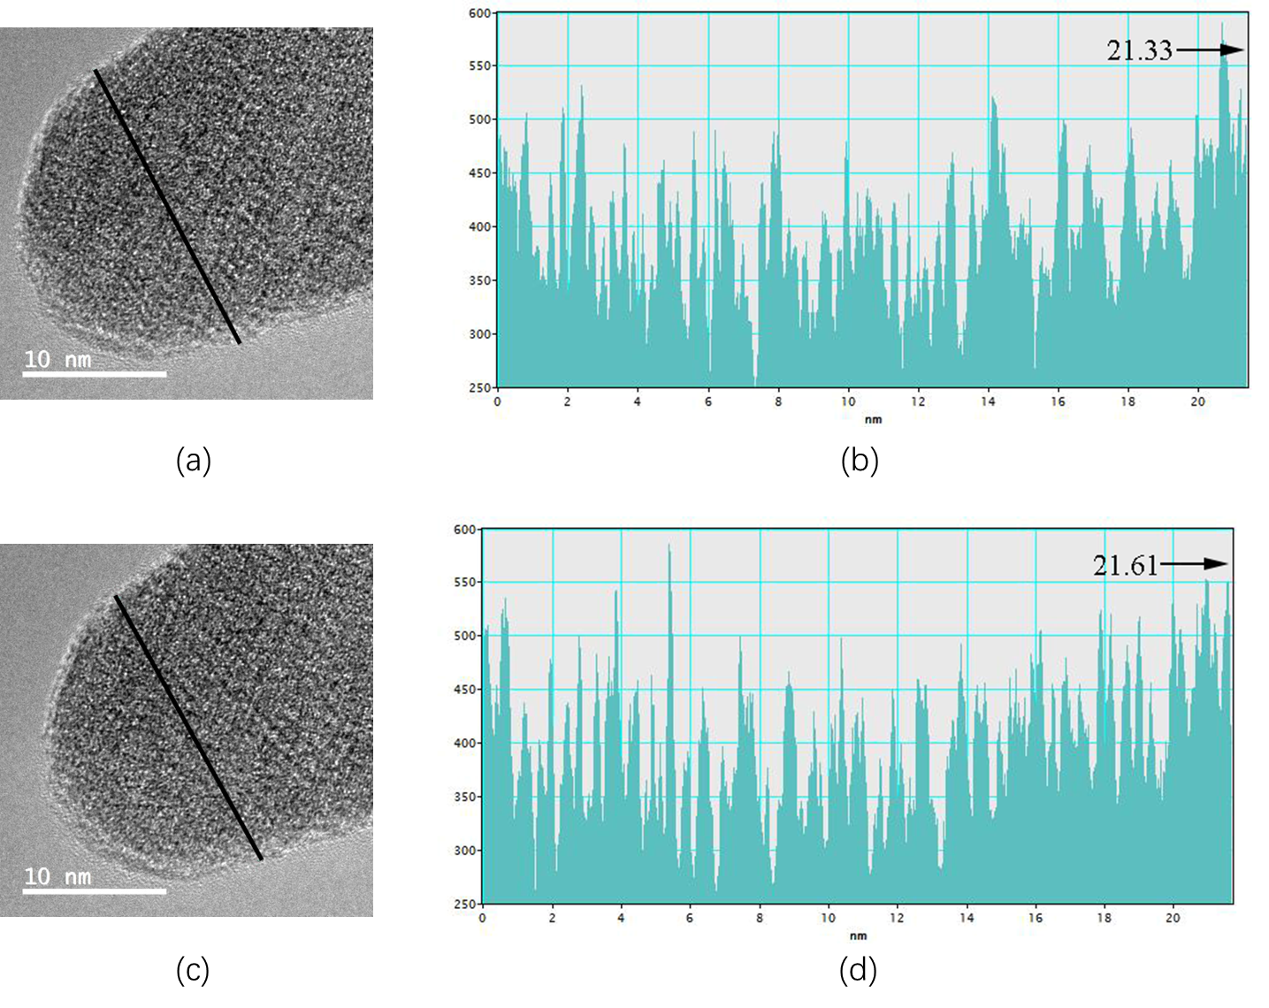
Fig. S3. (a) The HRTEM photos of the Zr₆₀Cu₃₀Al₁₀ amorphous alloy at respective tilt angles of (a) 5° and (c) 10°, the projected sizes respectively measured along the lines marked in (a) and (c) are (b) 21.33 nm and (d) 21.61 nm. Using these measured projected widths, two equations 21.33 = W‧cos 5° + H‧sin 5° and 21.61 = W‧cos 10° + H‧sin 10° are obtained. By solving the two combined equations, the real thickness of H has been determined to be about 6 nm.

