Supplementary data for

An AuNPs/Mesoporous NiO/Nickel Foam Nanocomposite as a Miniaturized Electrode for Heavy Metal Detection in Groundwater
Boyuan Xue^{a§}, Qian Yang^{a§}, Kaidong Xia^{a,b§}, Zhihong Li^{b}, George Y. Chen^{c}, Dayi Zhang^{d*}, Xiaohong Zhou^{a,e*}
ª State Key Joint Laboratory of ESPC, School of Environment, Tsinghua University, Beijing 100084, China
^{b} National Key Laboratory of Science and Technology on Micro/Nano Fabrication, Institute of Microelectronics, Peking University, Beijing 100871, China
^{c} Shenzhen Key Laboratory of Photonic Devices and Sensing Systems for Internet of Things, Guangdong and Hong Kong Joint Research Centre for Optical Fiber Sensors, Shenzhen University, Shenzhen 518060, China
^{d} College of New Energy and Environment, Jilin University, Changchun 130021, China
^{e} The Research Institute of Environmental Innovation (Suzhou), Tsinghua University, Suzhou 215000, China
* Corresponding author:
Dayi Zhang; Email: zhangdayi@tsinghua.org.cn; Xiaohong Zhou; Email: xhzhou@mail.tsinghua.edu.cn
§ These authors contributed equally to this work.
Fig. S1. Photo of AuNPs/Mesoporous NiO/Nickel Foam electrode.
Fig. S2. SEM images of the β-Ni(OH)₂ nanosheet/nickel foam electrode under different hydrothermal times.
Fig. S3. Cyclic voltammograms and their corresponding plots of the redox peak current vs. the square root of the scan rate of the electrode at the different fabrication steps.
Fig. S4. Real effective surface areas (RESAs) of the electrode at the different fabrication steps.
Fig. S5. Pore size distributions of (a) AuNPs/mesoporous NiO/nickel foam and (b) AuNPs/mesoporous NiO/nickel foam electrodes.
Table S1. Comparison of the detection performance of different novel electrodes for Pb²⁺ and Cu²⁺.
Table S2. List of the work function of Au, and the band gap and electron affinity of metal hydroxides/oxides.
Note S1. Calculation of the real effective surface area of the electrode.

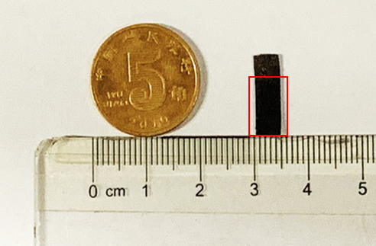
Fig. S1. Photo of AuNPs/mesoporous NiO/nickel foam electrode. The miniaturized size was 15×5 mm² in area and 1 mm in height. The sensing area is indicated by the red square (10×5 mm²).
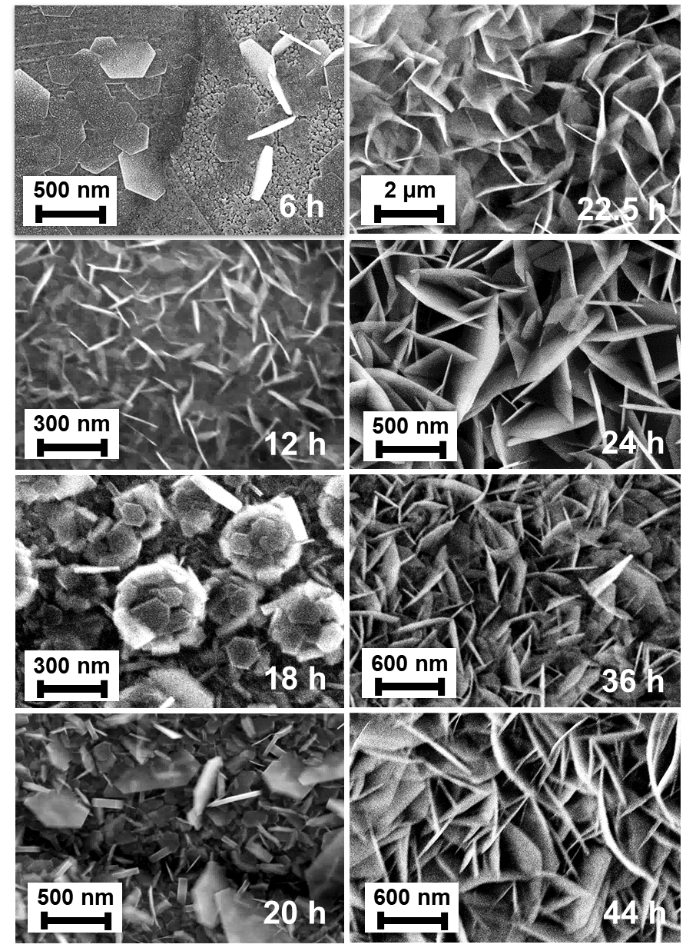
Fig. S2. SEM images of the β-Ni(OH)₂ nanosheet/nickel foam electrode under different hydrothermal times. The 3D porous Ni foam was fully covered with nanoscale disordered Ni(OH)₂ flakes after 24 h of hydrothermal treatment at 110 ℃.
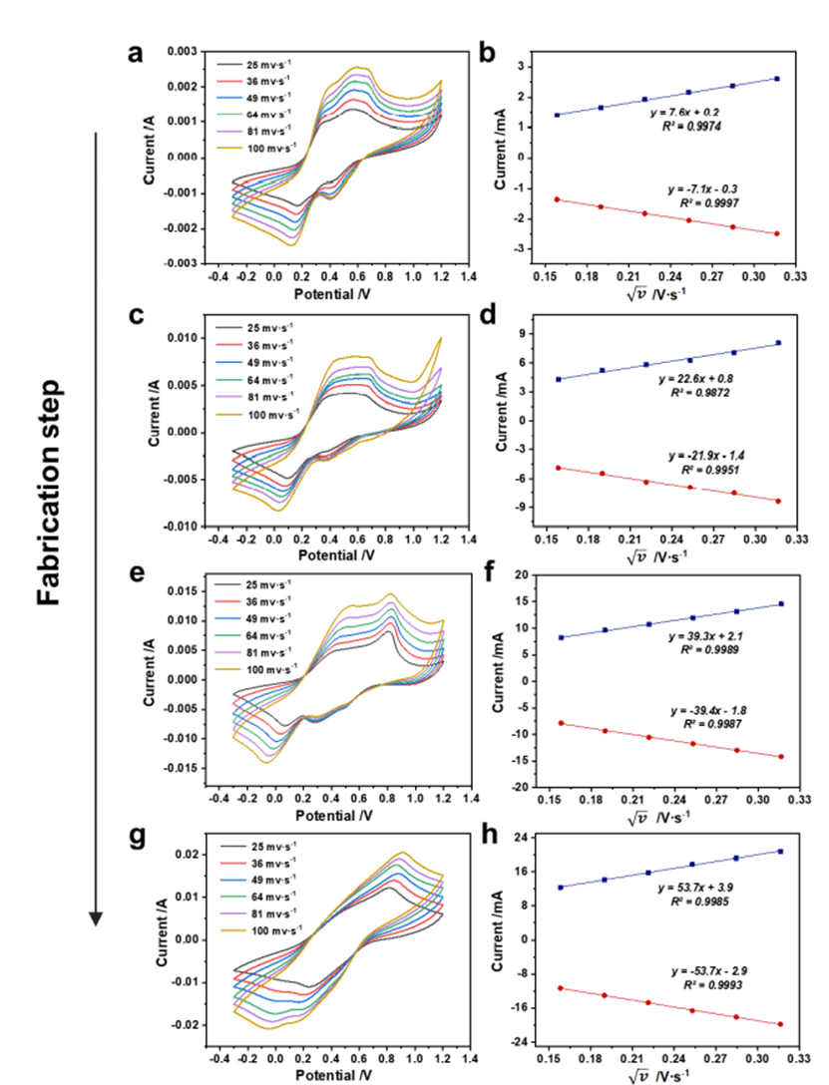
Fig. S3. Cyclic voltammograms and their corresponding plots of the redox peak current vs. the square root of the scan rate of the electrode at the different fabrication steps. (a) and (b) nickel foam, (c) and (d) β-Ni(OH)₂ nanosheets/nickel foam, (e) and (f) mesoporous NiO/nickel foam, and (g) and (h) AuNPs/mesoporous NiO/nickel foam. The cyclic voltammetry (CV) tests were conducted in PBS (0.1 M, pH=7) with 5 mM Fe[(CN)₆]^{3-/4-} at different scan rates from 25 to 100 mV/s. In any case, the good linear relationship between the redox peak current and square root of the scan rate demonstrated a typical diffusion-controlled electrochemical process.
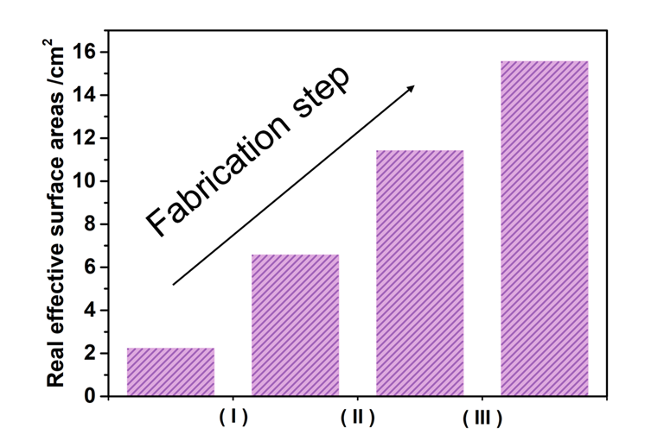
Fig. S4. Real effective surface areas (RESAs) of the electrode at the different fabrication steps. The RESAs significantly increased as the electrode fabrication steps advanced.
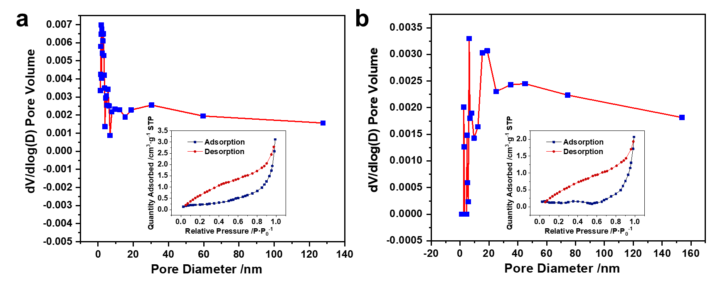
Fig. S5. Pore size distributions of (a) the AuNPs/mesoporous NiO/nickel foam and (b) AuNPs/mesoporous NiO/nickel foam electrodes. The materials were analyzed using the Barrett–Joyner–Halenda method with the inset of nitrogen adsorption-desorption isotherms.

Table S1
Comparison of the detection performance of different novel electrodes for Pb²⁺ and Cu²⁺.
Electrode | Analyte | LOD | Detection range | Ref.
MnFe₂O₄/GO/GCE | Pb²⁺ | 88.3 nM | 200-1100 nM | [1]
AgNPs/rGO/GCE | Pb²⁺ | 287 nM | 287-2000 nM | [2]
Mn₇O₁₃·5H₂O/α-MnO₂ | Cu²⁺ | 2.06 μM | 30 μM-2.83 mM | [3]
EDTA/PANI/SWCNTs/SS | Cu²⁺ | 80 nM | 1.2 μM-2 mM | [4]
CaO-Al₂O₃-SiO₂/GCE | Pb²⁺ | 840 nM | 500 nM-80 μM | [5]
CaO-Al₂O₃-SiO₂/GCE | Cu²⁺ | 440 nM | 500 nM-80 μM | [5]
AuNPs/Mesoporous NiO/Nickel Foam | Pb²⁺ | 96.5 nM | 9.7-77.2 μM | This work
AuNPs/Mesoporous NiO/Nickel Foam | Cu²⁺ | 81.4 nM | 2.5-80.2 μM | This work

Table S2
List of the work function of Au and the band gap and electron affinity of metal hydroxides/oxides.
Type | Materials | Band gap | Electron affinity | Work function of Au
P-type | NiO | 3.52 eV | 1.4 eV | 5.1 eV
P-type | RuO₂ | 2.2 eV | 4.87 eV | 5.1 eV
P-type | Co(OH)₂ | 2.7 eV | ~2 eV | 5.1 eV
P-type | PANI | 2.7 eV | 4.4 eV | 5.1 eV
N-type | SnO₂ | 2.7 eV | 4.32 eV | 5.1 eV
N-type | MnO₂ | 2.5 eV | 2.9 eV | 5.1 eV
N-type | ZnO | 3.37 eV | 4.3 eV | 5.1 eV
N-type | TiO₂ | 3.65 eV | 4.8 eV | 5.1 eV

Note S1. Calculation of the real effective surface area of the electrode.
The real effective surface area (RESA) of the electrode at the different fabrication steps in the plot of Fig. S4 was calculated as follows. The plots in Fig. S3 clearly demonstrate a typical diffusion-controlled electrochemical process. In the case of semi-infinite diffusion, as described above, the peak current I_{p} would be expressed by the classical Randles-Sevick equation as follows:
(s1)
After transformation:
(s2)
Thus:
(s3)
where
I_{p} is the peak current, A;
n is the number of electrons transferred (the redox indicator is K₃[Fe(CN)₆]/K₄[Fe(CN)₆]);
A is the apparent surface area of the electrode, cm²;
D₀ is the diffusion coefficient of the rate limiting species, cm²/s;
V is the scan rate, V/s;
C₀ is the proton concentration, mol/mL.
The tendency of the calculated RESAs at the different fabrication steps is presented in Fig. S4.

References
[1] Zhou S, Han X, Fan H, Huang J, Liu Y. Enhanced electrochemical performance for sensing Pb(II) based on graphene oxide incorporated mesoporous MnFe2O4 nanocomposites. J Alloys Compd 2018;747:447-54.
[2] Sang S, Li D, Zhang H, Sun Y, Jian A, Zhang Q, Zhang W. Facile synthesis of AgNPs on reduced graphene oxide for highly sensitive simultaneous detection of heavy metal ions. RSC Adv 2017;7(35):21618-24.
[3] Wu J, Zhou T, Wang Q, Umar A. Morphology and chemical composition dependent synthesis and electrochemical properties of MnO2-based nanostructures for efficient hydrazine detection. Sensor Actuat B-Chem 2016;224:878-84.
[4] Deshmukh MA, Celiesiute R, Ramanaviciene A, Shirsat MD, Ramanavicius A. EDTA_PANI/SWCNTs nanocomposite modified electrode for electrochemical determination of copper (II), lead (II) and mercury (II) ions. Electrochim Acta 2018;259:930-8.
[5] Mourya A, Sinha SK, Mazumdar B. Glassy carbon electrode modified with blast furnace slag for electrochemical investigation of Cu2+ and Pb2+ metal ions. Microchem J 2019;147:707-16.

