Supplementary Information for

Sodium Nitrate Passivation as a Novel Insulation Technology for Soft Magnetic Composites
Mi Yan ^{a,}*, Qiming Chen ª, Dong Liu ^{a,b}, Chen Wu ^{a,}*, Jian Wang ^{c}
ª State Key Laboratory of Silicon Materials, School of Materials Science and Engineering, Zhejiang University, Hangzhou 310027, China
^{b} School of Chemical Engineering, Shandong University of Technology, Zibo 255049, China
^{c} National Institute for Materials Science, Tsukuba 305-0047, Japan

* Corresponding authors.
E-mail addresses: mse_yanmi@zju.edu.cn (M. Yan), chen_wu@zju.edu.cn (C. Wu)

Samples for transmission electron microscopy (TEM) investigation have been prepared by depositing a Pt protecting layer on the powder surface indicated by the rectangle in Fig. S1(a) prior to trench milling along the sides of the Pt deposited region (Fig. S1(b)). The cross-sectional sample of the powder could then be removed and attached to a TEM grid (Fig. S1(c)), followed by focused ion beam (FIB) milling to a thickness of about 50 nm (Fig. S1(d)).

Fig. S1. Schematic procedures to prepare the cross-sectional TEM sample of the FeSiAl powder including (a) Pt deposition on the powder surface, (b) trench-milling on each side of the Pt deposition region, (c) separation of the cross-sectional sample from the FeSiAl powder, and (d) FIB milling of the cross-sectional area under bright field TEM imaging.

The density ρ and the open porosity q of the soft magnetic composites (SMCs) was measured by the principle of Archimedes using the following equation:
where m₁ is the mass of dry sample, m₂ is the mass of water-saturated sample in the air, and m₃ is the suspended mass of water-saturated sample in water.
Fig. S2 shows changes in the total core loss P_{cv} and effective permeability μ_{e} with the frequency for the samples passivated with NaNO₃ solution with varied concentrations. Increased core loss can be observed for all the samples with raised frequency from 25 to 175 kHz. The P_{cv} decreases gradually with the increase of concentration of NaNO₃ solutions and then has no significant changes after increasing the concentration to 20 wt%. It means the FeSiAl powders and NaNO₃ solution react completely when the concentration is above 20 wt%. Fig. 1(b) shows changes in the effective permeability μ_{e} as a function of frequency for the samples with different passivation concentrations. The μ_{e} exhibits satisfactory frequency stability between 25 and 175 kHz. The samples oxidized with low concentrations (< 20 wt%) of NaNO₃ solution exhibit large μ_{e} due to incomplete reactions between the base metal and the NaNO₃ solution, while higher NaNO₃ concentrations give rise to reduced μ_{e} due to the formation of complete and thicker insulation coatings.

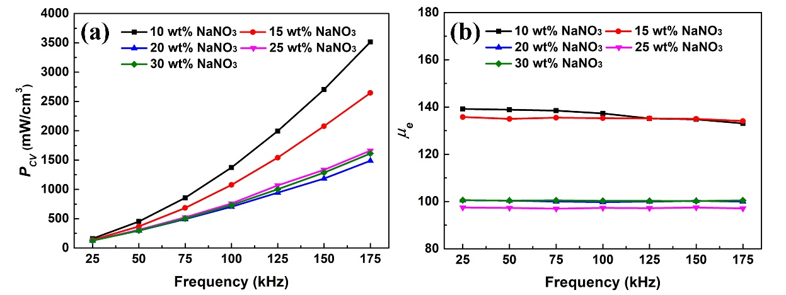
Fig. S2. (a) Core loss and (b) effective permeability as a function of frequency for the samples oxidized by different concentrations of NaNO₃ solution.

Table S1 compares the permeability (μ_{e}) and core loss (P_{cv}) with those of previously reported FeSiAl SMCs via various coating techniques. It should be noted that the testing conditions for these studies may be different. Since the μ_{e} changes with the applied magnetic fields, it cannot be compared directly. Whereas the P_{cv} can be roughly compared by converting the values under the same conditions (50 kHz, 100 mT) based on[1]:
P_{cv} = P_{h} + P_{e} = K_{h}B^{1.6}ƒ + K_{e}B²D²ƒ²/ρ
where P_{h} and P_{e} are the hysteresis loss and the eddy current loss, respectively; K_{h} and K_{e} are the hysteresis and eddy current loss coefficients, respectively; B is the applied magnetic induction; D is the thickness of the sample; and ƒ and ρ are frequency and electrical resistivity, respectively. Taking comprehensive consideration of both P_{cv} and μ_{e}, the performance obtained here are advantageous compared to those from the literatures.

Table S1 Summary of magnetic performances of FeSiAl SMCs prepared via various insulation methods
Samples | µ_{e} | P_{cv} | Test Conditions | Ref.
FeSiAl@MnZn ferrites | 72 | 1100 mW∙cm⁻³ | 25 kHz, 10 mT | [2]
FeSiAl@NiZn ferrites | 76 | 58 mW∙cm⁻³ | 25 kHz, 10 mT | [3]
FeSiAl@MnO/Al₂O₃ | 45 | 6.71 W∙kg⁻¹ | 50kHz, 20 mT | [4]
FeSiAl@Al₂O₃ | 116.3 | 331.2 mW∙cm⁻³ | 50 kHz, 100 mT | [5]
FeSiAl@Al₂O₃ | 57.98 | 25.67 mW∙cm⁻³ | 100 kHz, 20 mT | [6]
FeSiAl@phosphate | 33.02 | 614.1 mW∙cm⁻³ | 200 kHz, 30 mT | [7]
Sodium nitrate passivation | 97.2 | 296.4 mW∙cm⁻³ | 50 kHz, 100mT | This work

Fig. S3 shows the survey X-ray photoelectron spectroscopy (XPS) spectra for FeSiAl powders passivated by NaNO₃ with varied pH after annealing at 700 ºC. The relative intensity of the Fe 2p peak decreases with raised pH, indicating weakened participation of the Fe in the oxidation. Considerable intensity of the Al 2p peak is observed which enhances with the pH value since the Al is highly reactive even under alkaline conditions.

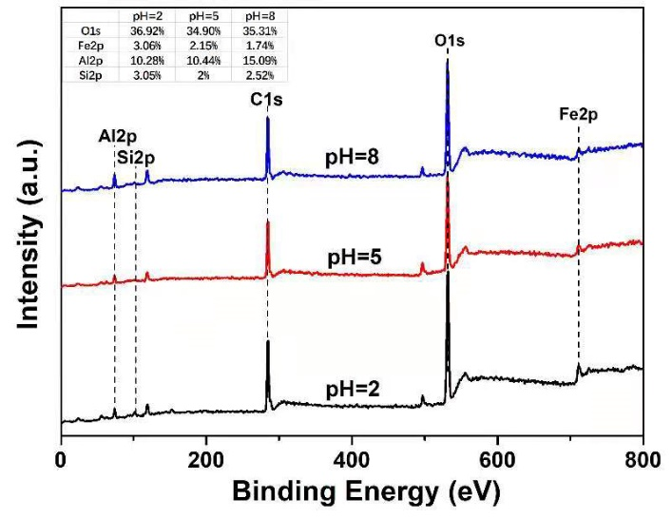
Fig. S3. XPS full scan spectra for FeSiAl powders passivated by NaNO₃ with pH values varied at 2, 5 and 8 after annealing

References
[1] Meng B, Yang B, Zhang X, Zhou B, Li X, Yu R. Combinatorial surface coating and greatly-improved soft magnetic performance of Fe/Fe₃O₄/resin composites. Mater Chem Phys 2020;242:122478.
[2] Li J, Peng X, Yang Y, Ge H. Preparation and characterization of MnZn/FeSiAl soft magnetic composites. J Magn Magn Mater 2017;426:132–6.
[3] Li J, Peng X, Yang Y, Ge H, Wang D, Du Y. FeSiAl soft magnetic composites with NiZn ferrite coating produced via solvothermal method. AIP Adv 2017;7:056109.
[4] Luo F, Fan X, Luo Z, Hu W, Wang J, Wu Z, et al. Preparation and magnetic properties of FeSiAl-based soft magnetic composites with MnO/Al₂O₃ insulation layer. J Magn Magn Mater 2020;498:166084.
[5] Liu D, Wu C, Yan M. Investigation on sol–gel Al₂O₃ and hybrid phosphate-alumina insulation coatings for FeSiAl soft magnetic composites. J Mater Sci 2015;50: 6559–66.
[6] Yi X, Peng Y, Yao Z, Xia C, Zhu S. Microstructure and magnetic properties of FeSiAl soft magnetic composites prepared by chemical in-situ coprecipitation with NaOH. Mater Chem Phys 2021;267:124626.
[7] Chen Z, Liu X, Kan X, Wang Z, Zhu R, Yang W, et al. Phosphate coatings evolution study and effects of ultrasonic on soft magnetic properties of FeSiAl by aqueous phosphoric acid solution passivation. J Alloys Compd 2019;783:434–40.

