Supplementary data for

Highly Selective Removal of Perchlorate from Water: Roles of Unconventional Hydrogen Bond and Hydrophobic Cavity
Jian Ao ª, Lingjun Bu ^{a,}*, Yangtao Wu ª, Jinming Luo ^{b}, Shiqing Zhou ^{a,}*
ª Hunan Engineering Research Center of Water Security Technology and Application, College of Civil Engineering, Hunan University, Changsha 410082, China
^{b} School of Environmental Science and Engineering, Shanghai Jiao Tong University, Shanghai 200240, China
* Corresponding authors
E-mail addresses: lingjunbu@hnu.edu.cn (L. Bu), shiqingzhouwater@163.com (S. Zhou)

Total pages: 32, including cover page
Number of tables: 7 (Tables S1-S7)
Number of figures: 17 (Figures S1-S17)

Text S1. Adsorption modeling and thermodynamic calculations
The adsorption capacity (q_{e}), the removal efficiency (%), and the distribution coefficient (K_{d}) were calculated using the following equations
$$q_{e}=\frac{\left(C_{0}-C_{e}\right)V}{m} (1)$$

$$removal effciency=\frac{\left(C_{0}-C_{e}\right)}{C_{0}}×100\% (2)$$

$$K_{d}=\frac{\left(C_{0}-C_{e}\right)}{C_{e}}×\frac{V}{m} (3)$$

$$β_{t}=\frac{K_{d,t}}{K_{d,c}} (4)$$

Where V is the volume of the ClO₄⁻ solution (mL), m is the mass of the adsorbent (g), and C₀ and C_{e} are the initial and equilibrium solution concentrations of ClO₄⁻ (mg L^{–1}), respectively. β_{t} is the selectivity coefficient for the target anion, K_{d,t} is the distribution coefficient for the target ion with a competitor present, and K_{d,c} is the distribution coefficient for the competitor with the target ion present.

The equilibrium adsorption isotherms are fitted by Langmuir and Freundlich models, respectively, using nonlinear equations
$$q_{e}=\frac{q_{m}k_{L}C_{e}}{1+k_{L}C_{e}} (5)$$
where q_{m} (mg g^{–1}) is the theoretical maximum adsorption capacity and k_{L} (L mg^{–1}) are the corresponding adsorption equilibrium constants, and n is the adsorption intensity.

Text S2. Rapid Small Scale Column Tests (RSSCTs).
Rapid Small-Scale Column Tests (RSSCT) were conducted to investigate the practical significance of modified bentonite for ClO₄⁻ removal. For the RSSCT with modified bentonite, the experimental setup involved injecting the modified bentonite sample (40 g) into a glass column (110 mL) with a diameter of 2 centimeters, which was one hundred times larger than the diameter of the modified bentonite to avoid channeling effects. The effective bed volume (BV) was 100 cubic centimeters, and the upflow velocity used in the RSSCT resulted in an empty bed contact time (EBCT) of 1 min.
The influent concentration of ClO₄⁻ in the solution was controlled at 500 μg L⁻¹, which exceeded the typical concentrations found in water contaminated with ClO₄⁻. Effluent samples were collected using timed collectors and analyzed for ClO₄⁻ concentration. Once the ClO₄⁻ concentration in the effluent reached complete saturation in the RSSCT column, regeneration was performed by adjusting the solution's pH and employing 0.1 M NaOH as the regenerant, passing it through the glass column in the opposite direction of the breakthrough experiments. The breakthrough experiments were then conducted by adjusting the solution's pH and using 0.1 M NaOH as the regenerant, passing it through the glass column in the opposite direction.

Text S3. RSSCT Related Calculations
The ClO₄⁻ adsorption capacity (mg g⁻¹) of the fixed-bed column was calculated as follows
$$q_{f}=\frac{\left(\left(C_{f} BV_{max}\right)-A\right)V}{m {10}^{6}} (6)$$
where C_{f} is the feed ClO₄⁻ concentration in the feedstock stream (μg L⁻¹), BV_{max} is the maximum bed volume treated by the adsorption column, V is the volume of the fixed-bed column (mL), m is the mass of the adsorbent packed in the bed column (g), and A is the area under the breakthrough curve (mg L⁻¹), and was calculated by the equation.
$$A=\int_{0}^{BV_{max}}{C}dBV (7)$$
where C is the effluent ClO₄⁻ concentration (μg L⁻¹). To precisely determine the value of parameter A, we employed a nonlinear curve-fitting approach using the Boltzmann model to fit the breakthrough curve.
$$C=A2+\left(A1-A2\right)\frac{1}{1+e^{(BV-X0)/dBV}} (8)$$

Where A1, A2, x0 and dBV are constants.

Text S4. Characterization and analysis methods
The morphologies and elemental distributions of the samples were obtained using scanning electron microscope (SEM, MIRA3 TESCAN) equipped with energy-dispersive spectroscopy (EDS). Transmission electron microscope (TEM, Hitachi JEM-3010) was used to obtain TEM images at an accelerating voltage of up to 200 kV. Crystallographic information was collected using an X-ray diffractometer with Cu-Kɑ radiation source (XRD, Smartlab). ¹H nuclear magnetic resonance (¹H NMR) spectra were recorded from an INOVA 400NB NMR (400 MHz, D₂O) (Zr-MSA was digested by NaOH solution for ¹H NMR measurement (m_{Zr-MSA}: m_{NaOH} = 1:1)). The Fourier transform infrared (FT-IR) spectrum of Zr-MSA was recorded from KBr pellets, while that of PVDF@MS and TLMSM were recorded in ATR mode (Thermo Scientific Nicolet iS5, Thermo Fisher Scientific). The chemical composition of the samples before and after ClO₄⁻ adsorption was analyzed through X-ray photoelectron spectrometer (XPS, EscaLab Xi+, Thermo Fisher Scientific) with an Al-Kɑ X-ray source. The concentration of ClO₄⁻ and other anions in the filtration solutions were determined using ion chromatography (IC) system (ICS1500, Dionex).

Text S5. DFT Calculations
The structures of cationic surfactants and their interactions with ClO₄⁻ were computed using Density Functional Theory (DFT) methods. The B3LYP method with the 6-311+g(d,p) basis set was employed to optimize the geometries of CTAB and CPC, followed by the generation of their electrostatic potential maps [1,2]. For the unconventional hydrogen bonding energy calculations, all single-point energies were computed at the B2PLYP-D3(BJ)/def2-TZVP level of theory, accounting for basis set superposition errors (BSSE). Solvent effects of water were considered in all optimization, frequency, and single-point calculations. The Hirshfeld atomic charges and Fukui indices (f, f⁺, f⁰) were calculated and analyzed using the Multiwfn software [3]. The minima and maxima of the molecular electrostatic potential (ESP) surfaces, represented by blue and yellow dots respectively, were derived based on the optimized structures. An independent gradient model (IGM) analysis of the complex structures was conducted with Multiwfn software to gain deeper insights into the nature of intermolecular interactions governed by weak forces. The colored isosurface maps resulting from the IGM analysis were visualized using the Visual Molecular Dynamics (VMD) program.

Table S1. Fitting of rate constants (K) and coefficients of determination (R²) for the adsorption of ClO₄⁻ by five materials using pseudo-second-order and pseudo-first-order models.
pseudo-second-order model | CTAB-MMT | CPC-MMT | PAC | Kaolin | MMT
K (min⁻¹) | 0.0306 | 0.0153 | 0.0030 | 0.0112 | --
R² | 0.99 | 0.98 | 0.97 | 0.99 | --
pseudo-first-order model | CTAB-MMT | CPC-MMT | PAC | Kaolin | MMT
K (min⁻¹) | 0.669 | 0.398 | 0.229 | 0.081 | --
R² | 0.99 | 0.98 | 0.98 | 0.97 | --

Table S2. Applying the Langmuir and Freundlich models to determine the saturated adsorption capacity (q_{m}) and fitting coefficient (R²) for ClO₄⁻ adsorption on four materials.
Langmuir | CTAB-MMT | CPC-MMT | PAC | Kaolin
q_{m} (mg g⁻¹) | 48.32 | 39.54 | 23.25 | 37.41
R² | 0.99 | 0.99 | 0.99 | 0.99
Freundich | CTAB-MMT | CPC-MMT | PAC | Kaolin
R² | 0.91 | 0.91 | 0.89 | 0.91

Table S3. Comparison of adsorption capacity and rate of materials.
Absorbent | CSB  [4] | CTAB-MMT | CLC  [5] | CPC-MMT | Fe-CC [6] | F400  [7] | GFH  [8] | Nuchar SN  [7] | SR-7  [9] | Fe-GAC  [10] | SAI-800-60C  [11]
Adsorption capacity  (mg g⁻¹) | 79.81 | 48.32 | 45.45 | 39.54 | 26.53 | 24.00 | 20.0 | 14.25 | 12.60 | 11.51 | 8.96
Adsorption saturation time  (h) | 12 | 0.18 | 0.09 | 0.19 | 0.02 | -- | 1 | -- | 0.21 | 0.1 | 4

Table S4. Concentrations of typical anions and DOC in the real water samples (mg L⁻¹).
Compositions | SO₄²⁻ | Cl⁻ | NO₃⁻ | PO₄³⁻ | HCO₃⁻ | F⁻ | Br⁻ | DOC
Xiangjiang river | 58.32 | 32.12 | 3.52 | 0.15 | 132.52 | 0.03 | 0.01 | 13.5
Tap water | 56.59 | 30.54 | 3.12 | 0.02 | 50.22 | 0.01 | 0.00 | 8.6

Table S5 Parameters of the designed fixed-bed column
Parameter | Column
Mass of the adsorbent (g) | 40
Column diameter (mm) | 20
Red depth (mm) | 275
Flow rate (mL min⁻¹) | 25
Hydraulic loading rate (mm min⁻¹) | 68.75
Red volume (BV) (mL) | 100
Empty bed contact time (EBCT) (min) | 4

Table S6 Fitting parameters of breakthrough curves from fixed-bed chromatography experiments using the Boltzmann model (CTAB-MMT).
Model | Parameter | Value
Boltzmann | A1 | -7.62
Boltzmann | A2 | 512.72
Boltzmann | X0 | 4095.59
Boltzmann | dBV | 607.65
Boltzmann | R² | 99.7%

Table S7 Fitting parameters of breakthrough curves from fixed-bed chromatography experiments using the Boltzmann model (CPC-MMT).
Model | Parameter | Value
Boltzmann | A1 | -8.43
Boltzmann | A2 | 572.92
Boltzmann | X0 | 4267.89
Boltzmann | dBV | 825.30
Boltzmann | R² | 99.7%

Figure S1. Adsorption kinetics of ClO₄⁻ onto CTAB-MMT, CPC-MMT, MMT, PAC, and kaolin (ClO₄⁻ concentration = 100 mg L⁻¹, adsorbent dosage = 0.4 g L⁻¹).

Figure S2. Isotherms of ClO₄⁻ adsorption onto CTAB-MMT, CPC-MMT, MMT and PAC (ClO₄⁻ concentration = 100 mg L⁻¹, adsorbent dosage = 0.4 g L⁻¹).

Figure S3. Removal of various oxygenated anions by CPC-MMT from individual and mixed solutions. Experimental condition: anion concentration = 10 mg L⁻¹, adsorbent dosage = 0.4 g L⁻¹.

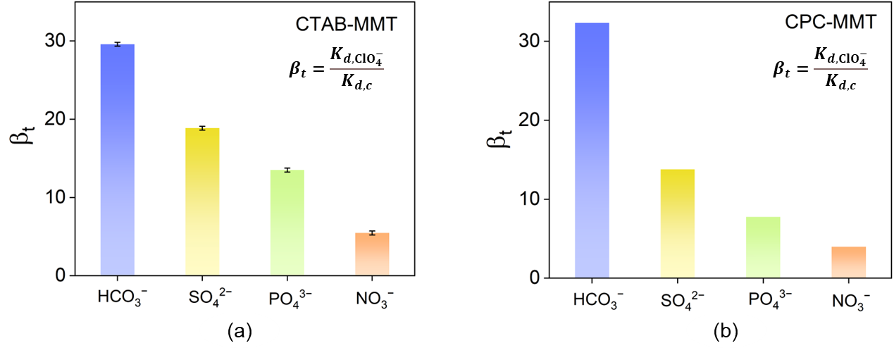
Figure S4. Selectivity coefficients of ClO₄⁻ for various oxygenated anions. Experimental condition: anion concentration = 10 mg L⁻¹, adsorbent dosage = 0.4 g L⁻¹.

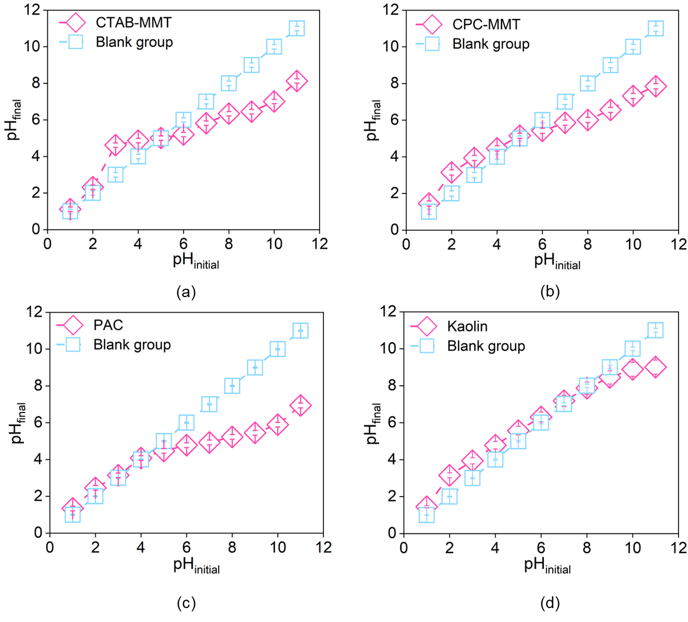

Figure S5. Measurement of (a) CTAB-MMT, (b) CPC-MMT, (c) PAC and (d) kaolin isoelectric points.

Figure S6. Examination of the isoelectric points of (a) CTAB-MMT, (b) CPC-MMT, (c) PAC, and (d) kaolin.

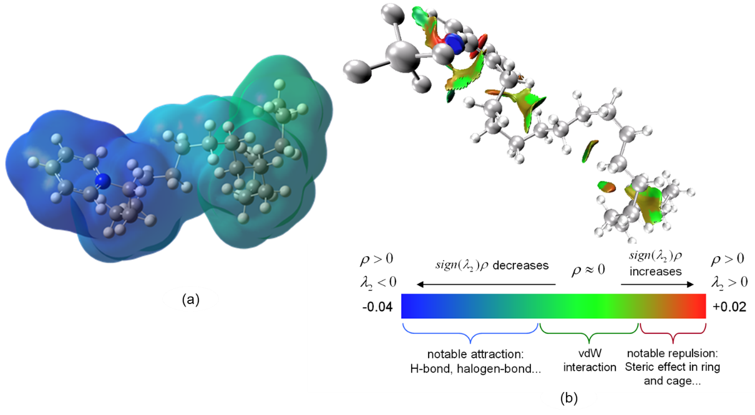

Figure S7. (a) Molecular electrostatic potential map of CPC calculated at the B3LYP-D3/6-31G(d,p) level of theory. (b) Visual representation of weak interactions between CPC and ClO₄⁻.

Figure S8. Removal efficiency of ClO₄⁻ by CTAB and CPC. Experimental condition: ClO₄⁻ concentration = 10 mg L⁻¹, adsorbent dosage = 0.4 g L⁻¹.

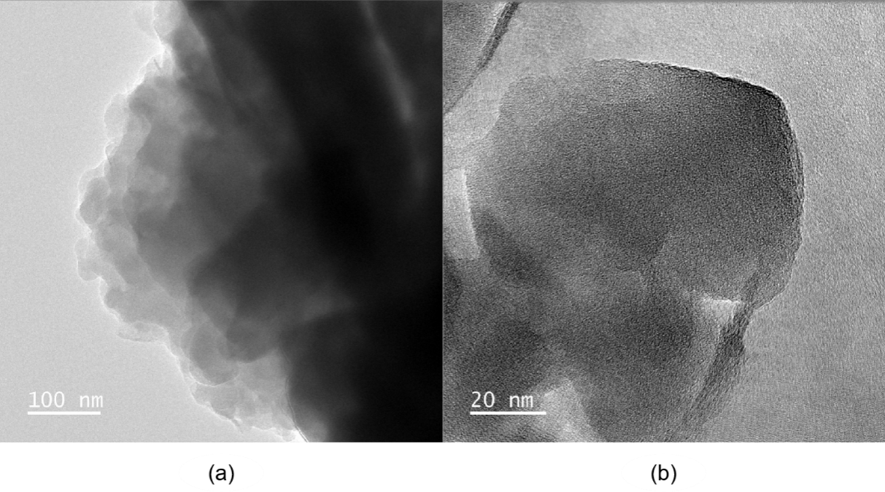
Figure S9. TEM image of (a) MMT and (b) modified MMT.

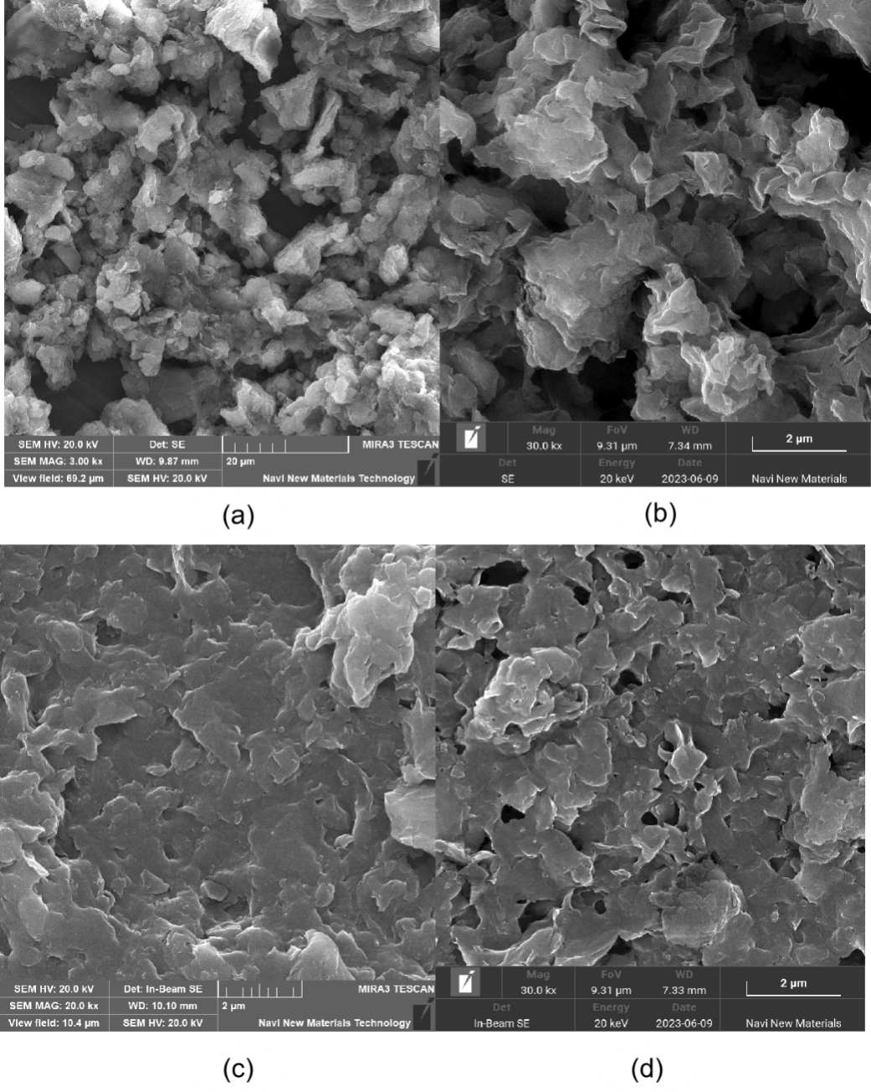
Figure S10. SEM images of (a) (b) MMT, (c) CTAB-MMT and (d) CPC-MMT.

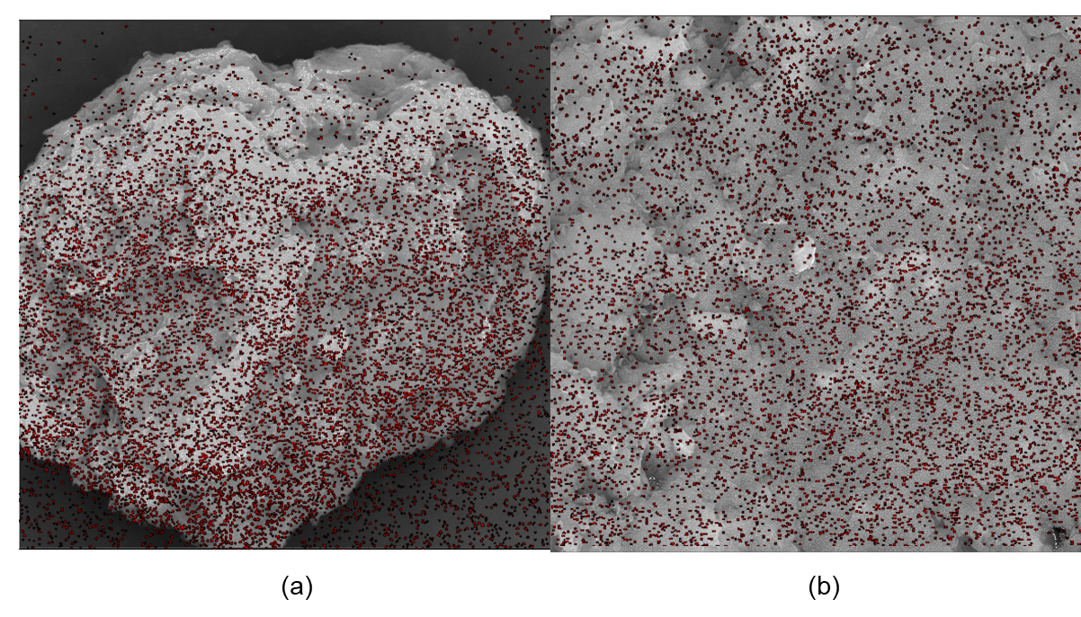
Figure S11. N-element EDS plots of (a) CTAB-MMT and (b) CPC-MMT.

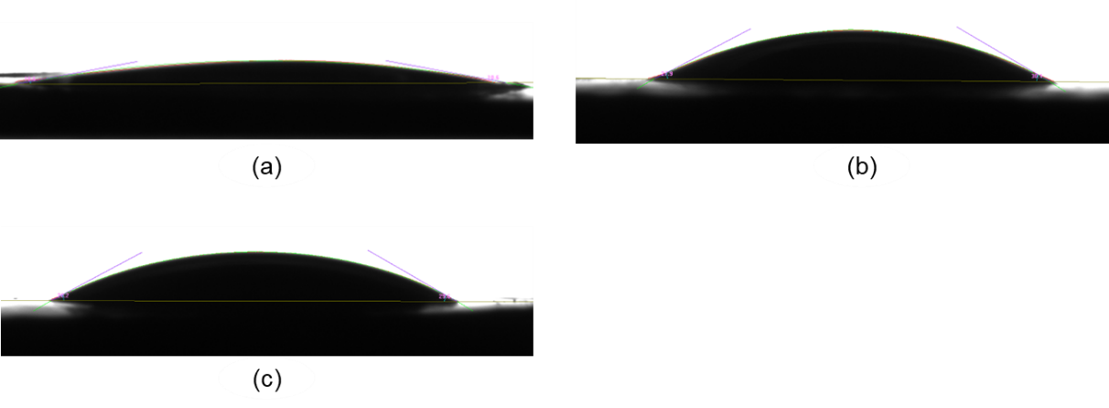
Figure S12. Contact angle tests of samples (a) MMT, (b) CTAB-MMT and (c) CPC-MMT.

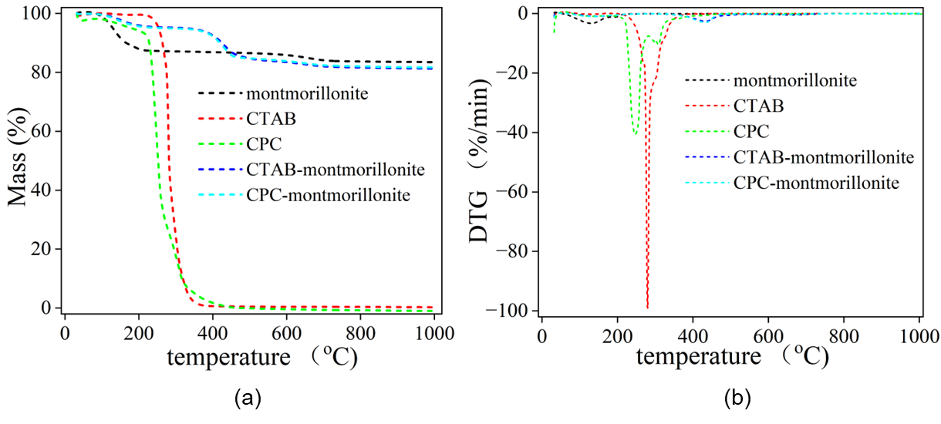
Figure S13. (a) Mass change and (b) derivative thermogravimetric (DTG) curves of the material.

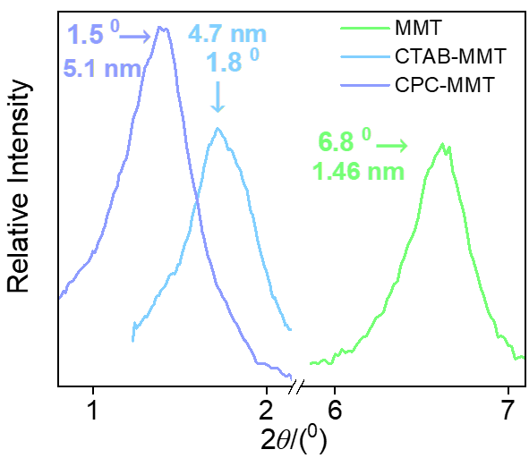
Figure S14. XRD analysis of MMT, CTAB-MMT and CPC-MMT. Experimental condition: Range = 0-90 º, Rate = 5 º min⁻¹.

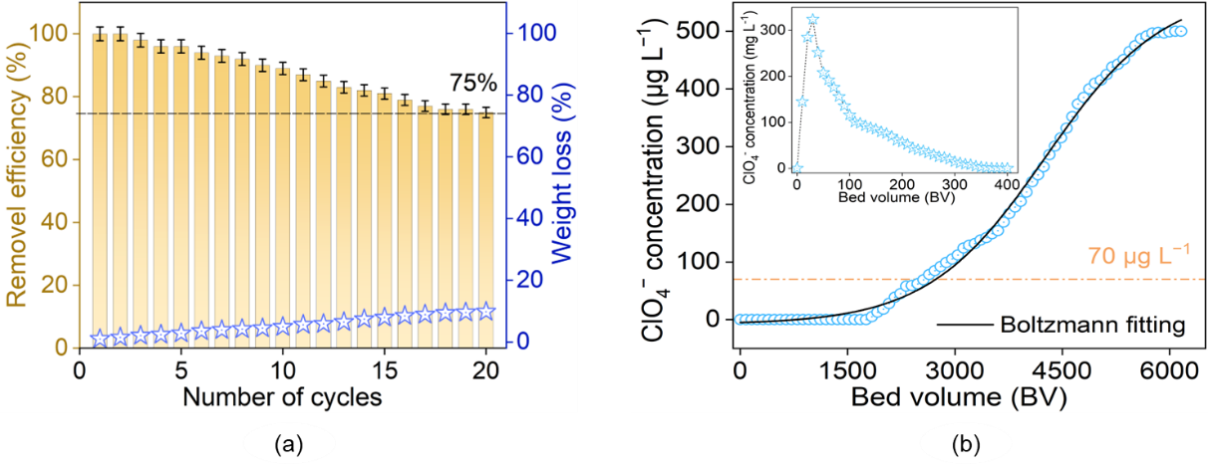
Figure S15. (a) Regeneration adsorption of ClO₄⁻ with CPC-MMT over 20 cycles, including the concurrent mass loss of CPC-MMT (ClO₄⁻ concentration = 500 μg L⁻¹, adsorbent dosage = 0.1 g L⁻¹). (b) Breakthrough curve for ClO₄⁻ adsorption on a CPC-MMT packed column (ClO₄⁻ concentration = 500 μg L⁻¹), with a subgraph illustrating ClO₄⁻ desorption using 0.1 M NaOH thiourea eluent in saturated CPC-MMT.

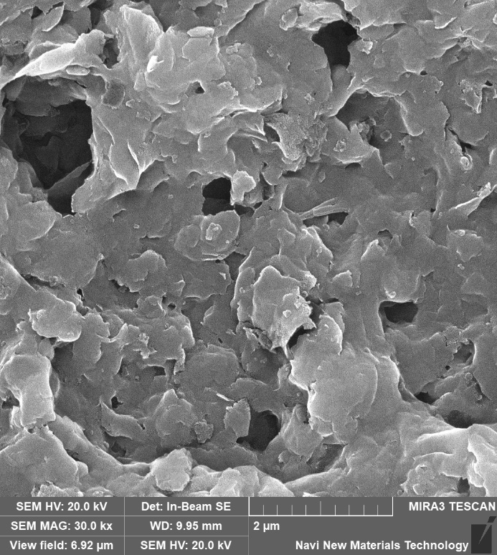

Figure S16. SEM images of CTAB-MMT after 20 adsorption-desorption cycles.

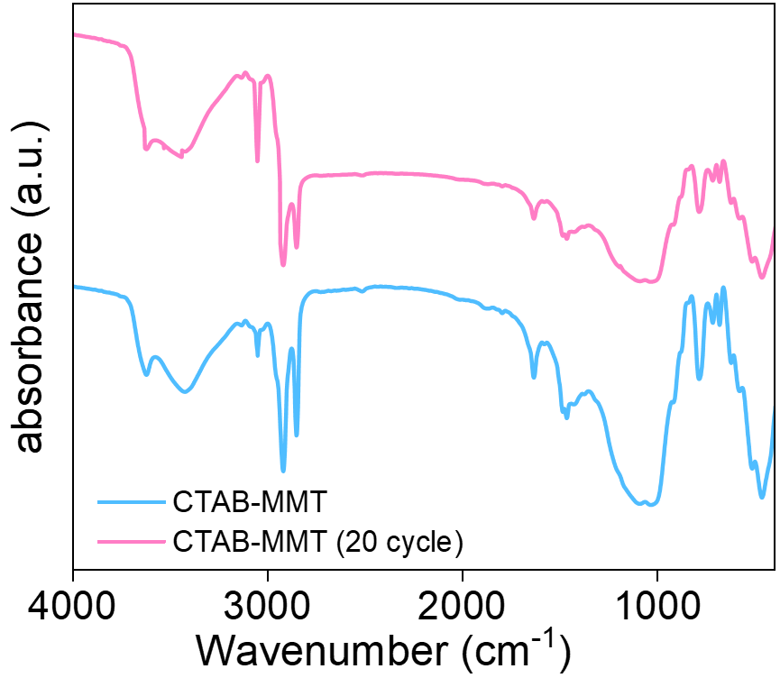
Figure S17. FTIR analysis of CTAB-MMT before and after 20 adsorption-desorption cycles.

References
[1] Fang Q, Chen B, Zhuang S. Triplex blue-shifting hydrogen bonds of ClO4–··· H–C in the nanointerlayer of montmorillonite complexed with cetyltrimethylammonium cation from hydrophilic to hydrophobic properties. Environmental science & technology. 2013, 47: 11013-22.
[2] Wang Y, Xiao Y, Wang Y, Lin Q, Zhu Y, Ni Z et al. Electroreductive Defluorination of Unsaturated PFAS by a Quaternary Ammonium Surfactant-Modified Cathode via Direct Cathodic Reduction. Environmental science & technology. 2023, 57: 7578-89.
[3] Lu T, Chen F. Multiwfn: A multifunctional wavefunction analyzer. Journal of computational chemistry. 2012, 33: 580-92.
[4] Yu X, Zhang J, Zheng Y. Perchlorate adsorption onto epichlorohydrin crosslinked chitosan hydrogel beads. Science of the Total Environment. 2021, 761: 143236.
[5] Xie Y, Li S, Wang F, Liu G. Removal of perchlorate from aqueous solution using protonated cross-linked chitosan. Chemical Engineering Journal. 2010, 156: 56-63.
[6] Lv L, Xie Y, Liu G, Liu G, Yu J. Removal of perchlorate from aqueous solution by cross-linked Fe (III)-chitosan complex. Journal of Environmental Sciences. 2014, 26: 792-800.
[7] Mahmudov R, Huang CP. Perchlorate removal by activated carbon adsorption. Separation and Purification Technology. 2010, 70: 329-37.
[8] Kumar E, Bhatnagar A, Choi J-A, Kumar U, Min B, Kim Y et al. Perchlorate removal from aqueous solutions by granular ferric hydroxide (GFH). Chemical Engineering Journal. 2010, 159: 84-90.
[9] Yoon I-H, Meng X, Wang C, Kim K-W, Bang S, Choe E et al. Perchlorate adsorption and desorption on activated carbon and anion exchange resin. Journal of hazardous materials. 2009, 164: 87-94.
[10] Xu J, Gao N, Zhao D, An N, Li L, Xiao J. Bromate reduction and reaction-enhanced perchlorate adsorption by FeCl3-impregnated granular activated carbon. Water research. 2019, 149: 149-58.
[11] Chen W, Cannon FS, Rangel-Mendez JR. Ammonia-tailoring of GAC to enhance perchlorate removal. II: Perchlorate adsorption. Carbon. 2005, 43: 581-90.

