Supplementary Information for

A GIS Open-Data Co-Simulation Platform for Photovoltaic Integration in Residential Urban Areas

Marco Massano ^{a,}*, Enrico Macii ª, Andrea Lanzini ^{b}, Edoardo Patti ^{c}, Lorenzo Bottaccioli ^{a,}*
ª Interuniversity Department of Regional and Urban Studies and Planning, Politecnico di Torino, Torino 10129, Italy
^{b} Department of Energy “Galileo Ferraris,” Politecnico di Torino, Torino 10129, Italy
^{c} Department of Control and Computer Engineering, Politecnico di Torino, Torino 10129, Italy

* Corresponding authors.
E-mail addresses: marco.massano@polito.it (M. Massano), lorenzo.bottaccioli@polito.it (L. Bottaccioli).

Section S1. Energy indicators
The self-consumption ratio (SCR) represents the self-consumed energy, aggregated over the selected simulation time, from time-step ($t=1$) to the last time-step ($t_{end}$). It consists of the share of PV power production that is directly consumed by the buildings (i.e., $P_{self}$), compared with the total PV power production (i.e., $P_{prod}$):
$SCR=\frac{\sum_{t=1}^{t_{end}}{‍}P_{self,t}⋅△t}{\sum_{t=1}^{t_{end}}{‍}P_{prod,t}⋅△t}$ (1)
The self-sufficiency ratio (SSR) consists of the share of electricity demand that is fulfilled by the directly self-consumed PV power. It is calculated as the share of PV power production that is directly consumed by the buildings ($P_{self}$), compared with the total electricity consumption in the building ($P_{load}$):
$SSR=\frac{\sum_{t=1}^{t_{end}}{‍}P_{self,t}⋅△t}{\sum_{t=1}^{t_{end}}{‍}P_{load,t}⋅△t}$ (2)

For each of the selected areas, we also consider$CO_{2}$ emissions. Following the European guidelines [1], a national emission factor (EF) is generally used to calculate the amount of $CO_{2}$ emissions; this is related to the national energy mix used for electricity production. The first indicator represents the amount of $CO_{2}$ produced in the actual situation (${CO}_{2}^{actual}$) (Eq. (3)), which corresponds to the amount of $CO_{2}$ gas emitted to produce the real energy loads of the area.
${CO}_{2}^{actual}=EF⋅E_{load}$ (3)
The second indicator represents the quantity of $CO_{2}$ that can be avoided if the electricity production were to switch to PV generation (${CO}_{2}^{avoid}$) (Eq. (4)); that is, it represents the quantity of $CO_{2}$ emissions that could be avoided if all the energy produced by the PV systems were to be used within the UES. This amount is proportional to $E_{prod}$ and does not account for whether the produced energy is self-consumed, injected into the distribution grid, or dissipated. The simplification assumed with this hypothesis is that all the energy produced by PV systems avoids being produced by traditional pollutant fossil-fuel systems. This assumption is true unless the energy produced is totally consumed, used instantaneously, or used after building up in storage systems. The dimensioning of energy storage systems goes beyond the purpose of this work, but this indicator well describes what can be obtained with an efficient design of the UES.
${CO}_{2}^{avoid}=EF⋅E_{prod}$ (4)

Section S2. Case study
Turin is a city located in Piedmont, in Northwest Italy. It covers an area of about 130 $km^{2}$ and has a population of over 875 000 inhabitants [2]. Fig. S1 represents the geographical division of the municipality: 25 urban districts (defined by colors and names in Fig. S1) and 3775 census tracts (defined by light grey lines in Fig. S1).
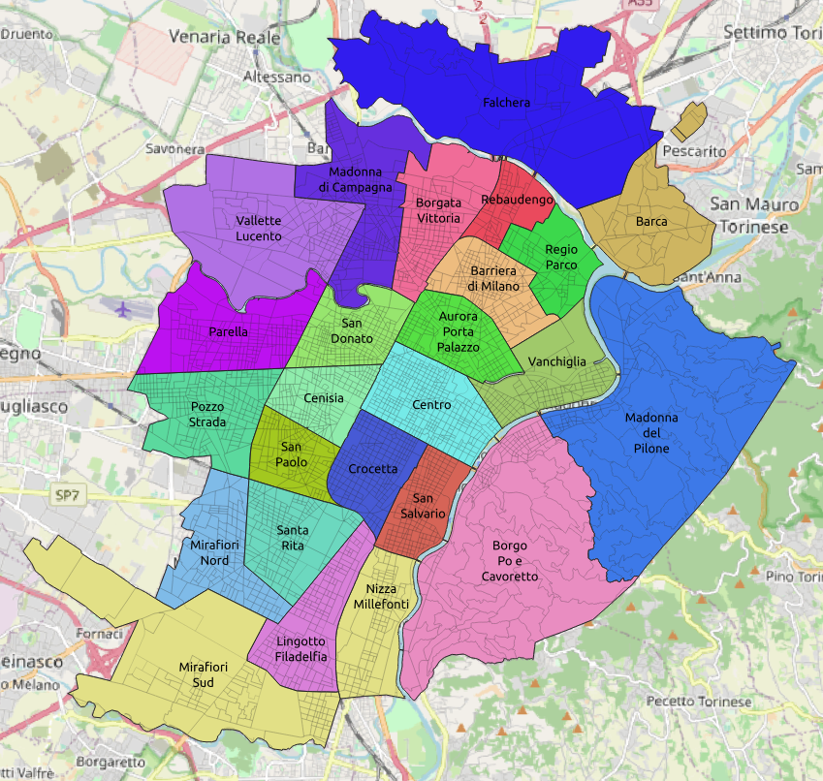
Fig. S1. Distribution of districts (colored shapes) and census tracts (grey lines) for the municipality of Turin.
According to the 15th Census survey [2], the total number of buildings in Turin is 58 515: 45 681 are residential, and 12 834 have other final uses (e.g., industrial, commercial, or schools). The cadastral map for this area was retrieved from the Geoportale del Piemonte [3], an open geospatial consortium web portal, and the current version update is 2011. The DSM was provided by the city council; it has a resolution of 25 cm, which reports rooftop shapes with high accuracy, highlighting encumbrances such as chimneys and dormers.
Through third-party web services [4], meteorological data (i.e., solar radiation and air temperature) were retrieved by the weather station in our university campus. The weather station collects global horizontal radiation by means of a first-class pyranometer with a granularity of 10 min. Data from an average mono-crystalline silicon cell PV-module were employed to compute the PV production with the following parameters: ① module power: 283 Wpeak (Wp); ② module efficiency: $20.2\%$; and ③ module temperature coefficient: 0.38%·℃⁻¹.
Both the TUS and Use of Energy surveys were retrieved from the Italian National Institute of Statistics (ISTAT). In this work, we used the latest results for TUS (2018–2019) [5] and Use of Energy (2017) [6].
To generate the synthetic population, we used disaggregated information from the 15th Italian Census, performed by ISTAT in 2011 [2]. The survey mainly provides ① the distribution of the population in Italy, giving information on the composition, age, gender, and profession of each household member; and ② the population composition in many sub-geographies (e.g., region, district, census tract), providing for each of them detailed information about the number of families and their composition.
The load profiles used in this work were collected in our previous work [7]. The dataset covers all the appliances reported in the National Survey on Use of Energy [8], and the resolution is 1 Hz. The input dataset can be easily replaced with other load profiles of appliances, or even with different sampling periods.
To calculate the quantity of $CO_{2}$ emissions according to European guidelines [1], we used a commonly used national standard emission factor of $EF=0.483 t_{{CO}_{2}}$·$($MW·h)⁻¹. This number reflects the average $CO_{2}$ emissions of the Italian energy mix used for electricity production.

Section S3. SCRs and SSRs
The spatial dependency of the SCR and SSR for each district is visualized using a color-coded geo-referenced map in Figs. S2 and S3 (for Scenario RES) and in Figs. S4 and S5 (for Scenario TOT). The results are shown for 25 districts, separated in the figure by black borders.
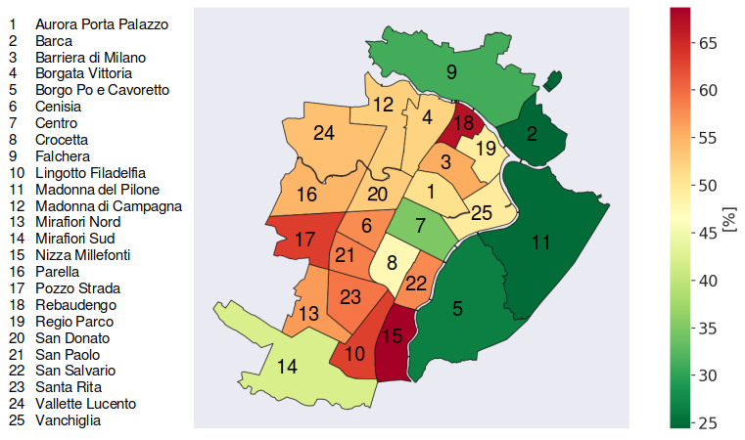
Fig. S2. Scenario RES: Self-consumption ratio (%).
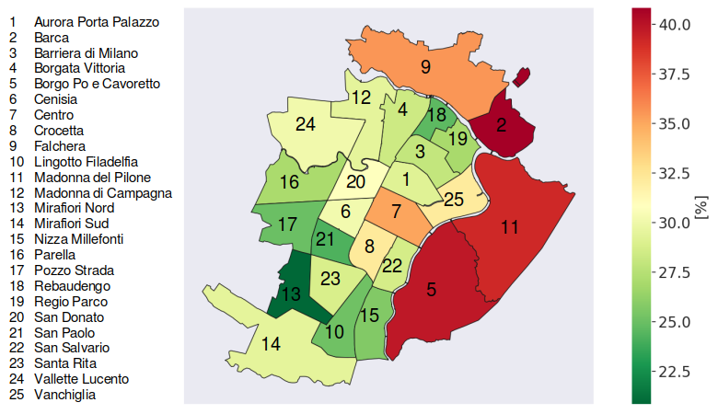
Fig. S3. Scenario RES: Self-sufficiency ratio (%).
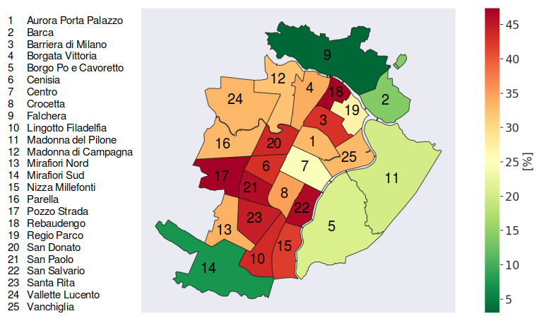
Fig. S4. Scenario TOT: Self-consumption ratio (%).
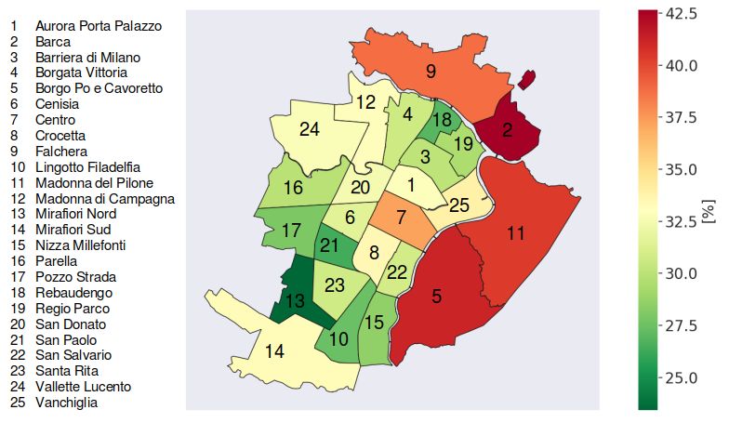
Fig. S5. Scenario TOT: Self-sufficiency ratio (%).
The average value of the SCR for Scenario RES is $50\%$ (see Fig. S2). The lowest values are obtained in Barca and Madonna del Pilone (around $24\%$), while the highest values are obtained in Nizza Millefonti and Rebaudengo (around $68\%$). The SCR is the ratio between $E_{self}$ and $E_{prod}$ (see Eq. (1)). Considering the same PV power production, a low SCR indicates low self-consumption (bad usage of energy) and a large surplus of PV energy production (i.e., high roof space available for PV systems). For example, this situation occurs in districts with low population and large houses, like the hilly districts of Madonna del Pilone and Borgo Po e Cavoretto. In contrast, high SCRs indicate high self-consumption of produced energy. This could indicate an excellent use of energy or a low PV production. In our case, energy storage systems and mitigation systems for the share of energy produced are not established. For that reason, a low SCR indicates limited PV potential and can be caused by a high concentration of historical buildings with relatively small roof areas and a wide variation in roof shape and height (e.g., San Paolo and Rebaudengo). These roofs induce shading effects, reducing the plane-of-array irradiance and thus the PV production. High SCRs can also be caused by high population density, resulting in a relatively high electricity consumption per unit area.
The average value of SSR for Scenario RES is $30\%$ (see Fig. S3). The lowest values are obtained in Mirafiori Nord and Rebaudengo (around $22\%$), while the highest values are obtained in Barca, Madonna del Pilone, and Borgo Po e Cavoretto (around $40\%$). The SSR is the ratio between $E_{self}$ and $E_{load}$ (see Eq. (2)). A low SSR indicates that the PV potential is not sufficient to fulfil the electricity demand (low self-consumption), and electricity import is a requirement. A high SSR indicates areas where the difference between energy consumed and the energy self-consumed is narrow, and there is a desirable use of energy produced by PV systems.
The average value of the SCR for Scenario TOT is $33\%$ (see Fig. S4), which is relatively lower compared with those obtained for Scenario RES. The lowest SCRs are achieved in Falchera and Mirafiori Sud (below $10\%$), while the highest SCRs are obtained in Pozzo Strada and Rebaudengo (around $47\%$). The SCR is the ratio between $E_{self}$ and $E_{prod}$ (see Eq. (1)). The lower ratio for Scenario TOT is due to the larger amounts of energy that can be produced by including non-residential rooftops. $E_{load}$ remains unchanged, but $E_{prod}$ strongly increases, especially for districts such as Falchera and Mirafiori Sud, which contain two large factories.
The average value of the SSR for Scenario TOT is $32\%$ (see Fig. S5). The lowest values are obtained in Mirafiori Nord and Rebaudengo (around $25\%$), while the highest values are obtained in Barca, Madonna del Pilone, and Borgo Po e Cavoretto (around $42\%$). The SSR is the ratio between $E_{self}$ and $E_{load}$ (see Eq. (2)), and it is not directly affected by energy production. For this reason, the values are not too far from those for the Scenario RES, being just a bit higher.
As a general comment, it is possible to assert that districts with a high SCR and low SSR have a limited area to install PV systems and will therefore have a limited PV yield. Districts with a relatively lower SCR and higher SSR have more time periods during the day when a surplus of PV energy production occurs. In the present work, the economic implications of PV installation are not considered; neither are possible policies to better manage and, eventually, sell the produced energy. The main purpose of this research is to maximize PV penetration. Scenario TOT considers the amount of electricity that can be produced by exploiting the entire and real suitable rooftop surface (while neglecting historical buildings and areas where deployable PV systems are smaller than $1 kWp$). As a consequence, the SSR is maximized because, under the same electricity consumption, the more energy is produced (and therefore the more energy is self-consumed), the more the SSR increases (see Eq. (2)). These detailed analyses on the SCR and SSR are possible because of the high spatiotemporal granularity of our results (i.e., 25 cm and 10 min); they provide a basis for further considerations in designing and developing novel control strategies, such as demand-side management and demand response, which could include storage systems, for example. Such results are needed in order to plan possible interventions in the distribution network to make it ready for massive installations of RES.
References
[1] Pasargad Energy Control Company. Technical annex to the SEAP template instructions document: the emission factors. Tehran: Covenant of Mayors SEAP; 2019. Persian.
[2] Istituto Nazionale di Statistica (ISTAT). Italian general censuses of population and housing. Rome: ISTAT; 2011.
[3] Regione Piemonte. Geoportale del Piemonte [Internet]. Piemonte: Geoportale Piemonte; c2021 [cited 2021 Mar 15]. Available from: http://www.geoportale.piemonte.it/.
[4] wunderground.com [Internet]. Atlanta: The Weather Company; c2014 [cited 2022 Jan 12]. Available from: https://www.wunderground.com/.
[5] Istituto Nazionale di Statistica (ISTAT). Multipurpose survey on households-time use: public use micro.stat files. Rome: ISTAT; 2018.
[6] Istituto Nazionale di Statistica (ISTAT). Household energy consumption: public use micro.stat files. Rome: ISTAT; 2017.
[7] Bottaccioli L, Di Cataldo S, Acquaviva A, Patti E. Realistic multi-scale modeling of household electricity behaviors. IEEE Access 2019;7:2467–89.
[8] Istituto Nazionale di Statistica (ISTAT). Household energy consumption: public use micro.stat files. Rome: ISTAT; 2017.

