Supplementary for

Dynamic Modeling Framework of Sediment Trapped by Check-Dam Networks: A Case Study of A Typical Watershed on the Chinese Loess Plateau
Pengcheng Sun^{1, 2} and Yiping Wu^{1,*}
¹ Department of Earth and Environmental Science, Xi’an Jiaotong University, Xi’an 710049, China
² Key Laboratory of Soil and Water Loss Process and Control on the Loess Plateau of Ministry of Water Resources, Yellow River Institute of Hydraulic Research, Zhengzhou 450003, China

Corresponding author:
E-mail address: yipingwu@xjtu.edu.cn (Y. Wu)

1. Software availability and operating procedures.
Name of software: SWAT-DCDam
Description: This software can be used to simulate sediment trapped by check dams dynamically at the watershed scale by integrating the widely-used SWAT model and a newly developed module, DCDam (Dynamic check dams).
Inputs:
- Datasets for constructing the SWAT project include the topographic data, land use data, weather data, crop management data, etc.
- Check dam dataset includes the position, construction year, controlling area, and the designed storage.
Steps for using the software:
- Assigning check dams into clusters based on subbasins defined by the SWAT project.
- Identification of check dams and preparing the check dam file.
- Set the input path for the check dam file and SWAT files for the DCDam module.
- Model execution.

Developers: Pengcheng Sun and Yiping Wu.
Availability: Free to the public (contact the developers).

2. Statistical indexes for model evaluation.
Three widely-used indexes, the Nash-Sutcliffe Efficiency (NSE), the coefficient of determination (R²), and the percentage bias (Pbias) were used in this study for evaluating the model performance. The NSE describes the explained variance for the observed values over time that is accounted for by the model, which ranges from -∞ to 1. The R², ranging from 0 to 1, is used to assess how accuracy the model tracks the changes of the observation. The Pbias measures the average difference between observation and simulation. The closer NSE and R² are to 1, and Pbias to 0, the better the model performs. These statistical terms were calculated as follows:
$$NSE=1-\frac{\sum_{i=1}^{n}{{(X_{o,i}-X_{s,i})}^{2}}}{\sum_{i=1}^{n}{{(X_{o,i}-X_{o,avg})}^{2}}}$$ | (1)
$$R^{2}=\frac{{[\sum_{i=1}^{n}{(X_{o,i}-X_{o,avg})(X_{s.i}-X_{s,avg})]}}^{2}}{\sum_{i=1}^{n}{{(X_{o,i}-X_{o,avg})}^{2}}\sum_{i=1}^{n}{{(X_{s.i}-X_{s,avg})}^{2}}}$$ | (2)
$$Pbias=\frac{\sum_{i=1}^{n}{(X_{s.i}-X_{o,i})}}{\sum_{i=1}^{n}{X_{o.i}}}×100\%$$ | (3)
where $X_{m.i}$ and $X_{s,i}$are observed and simulated streamflow/sediment load at each time step $i$; $X_{o,avg}$ and $X_{s,avg}$ are the mean value of the observed and simulated streamflow/sediment load; and $n$ is the number of time steps.

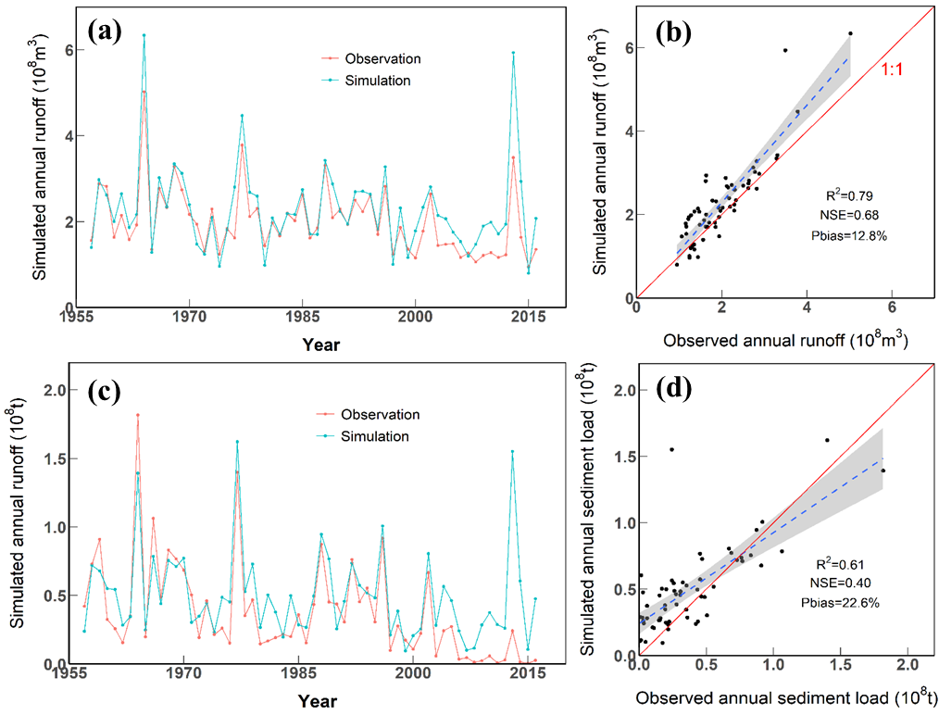
Fig. S1. Annually comparison of SWAT-simulated versus observed streamflow (a and b) and sediment (c and d) during the whole simulation period (1957-2016).
Fig. S2. The trend of sediment load at the Ganguyi station during the past 60 years (1957-2016).
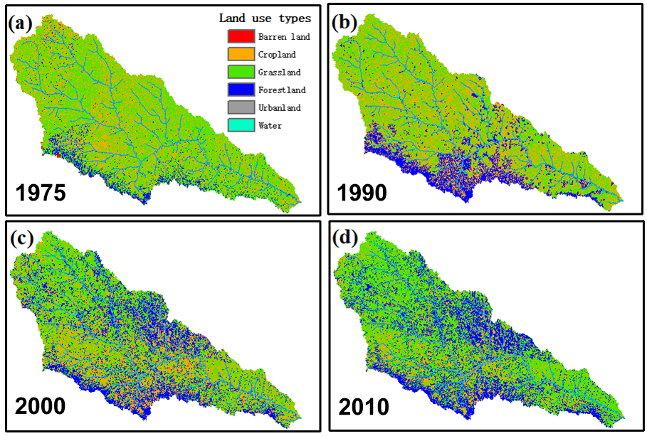

Fig. S3. Land use patterns during the past 40 years in the YanRB.
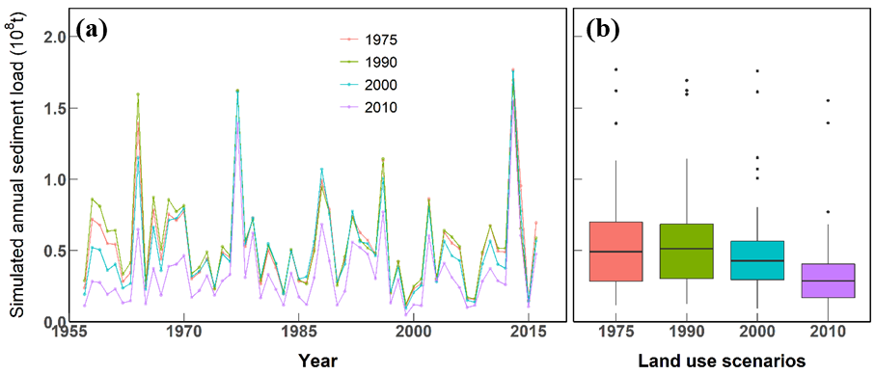
Fig. S4. Comparison of sediment load at the Ganguyi station under four land use scenarios.

Fig. S5. Comparison of the sediment trapping efficiency calculation methods from Brune’s and the current study.

