Supplementary data for

ARGs-OAP v3.0: Antibiotic-Resistance Gene Database Curation and Analysis Pipeline Optimization
Xiaole Yin, Xiawan Zheng, Liguan Li, An-Ni Zhang, Xiao-Tao Jiang, Tong Zhang *
Environmental Microbiome Engineering and Biotechnology Laboratory, Center for Environmental Engineering Research, Department of Civil Engineering, the University of Hong Kong, Hong Kong, China

* Corresponding author.
E-mail: zhangt@hku.hk (T. Zhang)

Assessing the performance of ARGs-OAP v3.0
To assess the identification performance of ARGs-OAP 3.0 with simulated metagenomic datasets, the evaluation parameters MCC, sensitivity, and precision were calculated following the equations shown below:
$$MCC=\frac{TP*TN-FP*FN}{\sqrt{\left(TP+FP\right)*\left(TP+FN\right)*\left(TN+FP\right)*TN+FN)}}$$
$$Sensitivity=\frac{TP}{TP+FN}$$
$$Precision=\frac{TP}{TP+FP}$$
where TP stands for true positives, TN stands for true negatives, FP stands for false positives and FN stands for false negatives.

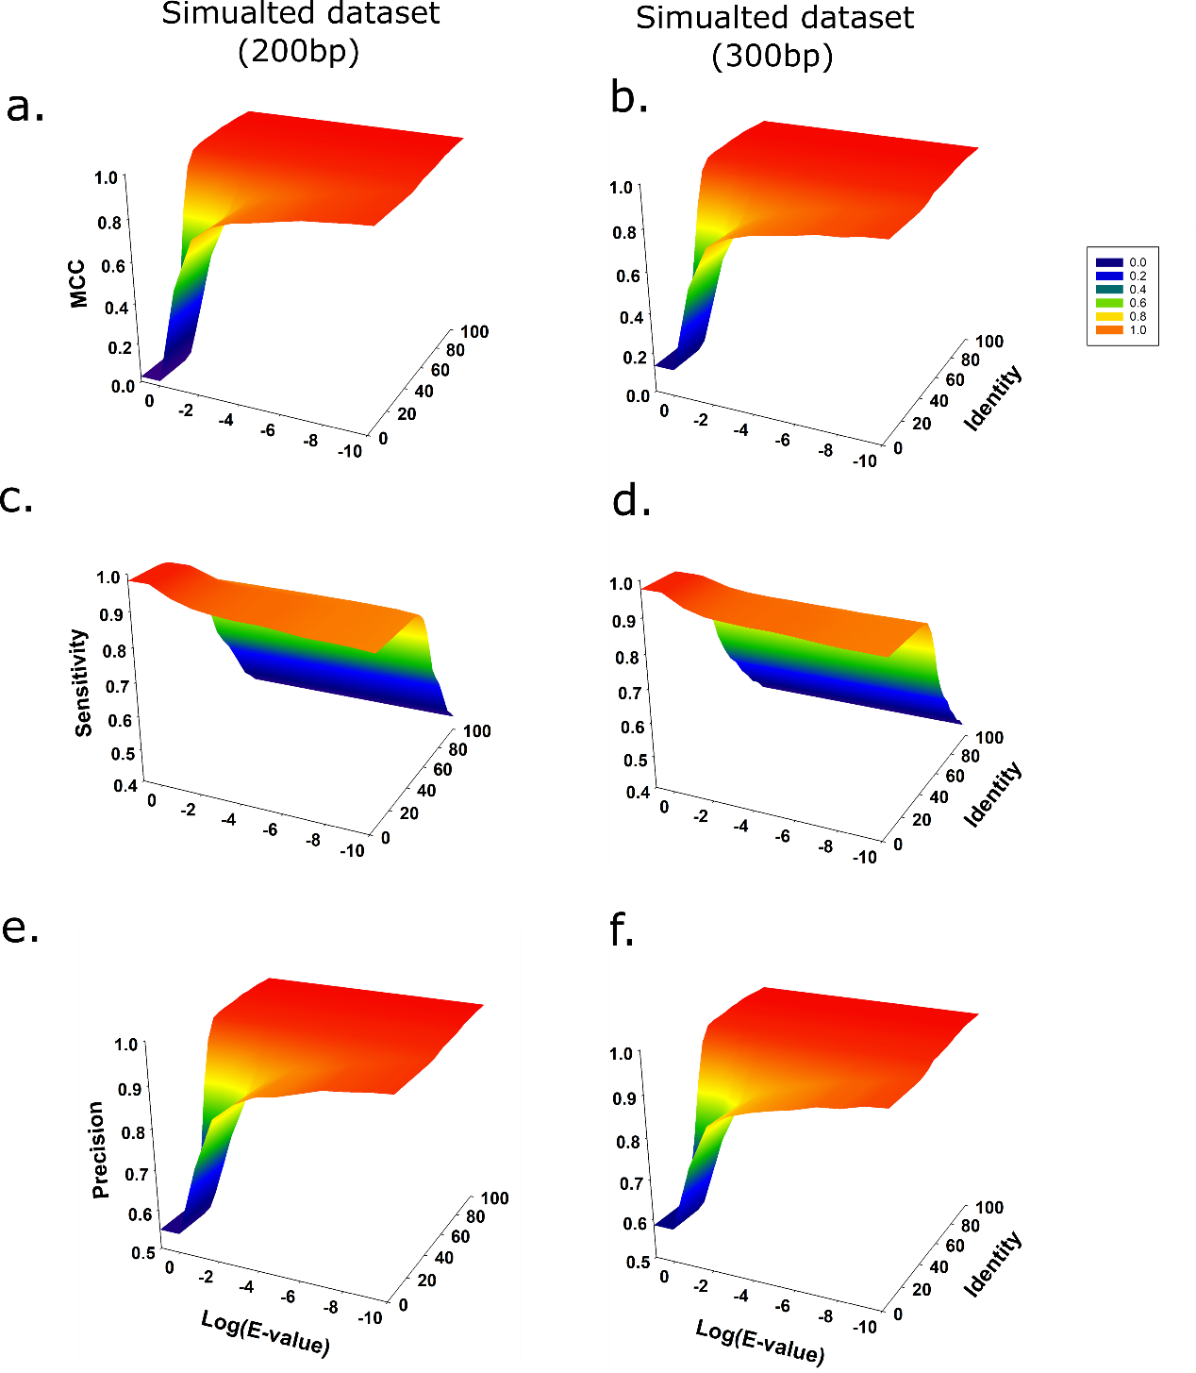
Fig. 1. Evaluation of the updated database and pipeline by using simulated metagenomic datasets with the read lengths of 201 bp (a, c, e) and 300 bp (b, d, f). The evaluation parameters include MCC (a, b), sensitivity (c, d) and precision (e, f). With recommended cut-off (E-value: 1e-7, identity: 80%, and hit length ratio: 75%) when applying ARGs-OAP v3.0, excellent performance was observed for annotating ARGs in metagenomes.

