Supplementary data for

Developing a Predictive Platform for Salmonella Antimicrobial Resistance Based on a Large Language Model and Quantum Computing
Yujie You ª, Kan Tan ª, Zekun Jiang ^{a,b}, Le Zhang ^{a,b,}*
ª College of Computer Science, Sichuan University, Chengdu 610065, China
^{b} West China Biomedical Big Data Center, West China Hospital, Sichuan University, Chengdu 610065, China
* Corresponding author.
E-mail address: zhangle06@scu.edu.cn (L. Zhang).

S1. The Salmonella resistance data acquisition
The Salmonella resistance data samples were obtained from the NARMS Now website provided by the Centers for Disease Control and Prevention in the United States [1]. All samples were Salmonella typhimurium isolated from patients in the United States. The Salmonella samples with the AST and WGS results were both qualified were selected with a total of 1167 cases. Based on the AST results, 1167 samples form the resistance matrix that indicate the sample is resistant or not. The sample size of antimicrobial and AST results are list in Tab. S1. Accroding to the sample numbers of 1167 Salmonella samples with drug resistance, this study obtained the WGS of Salmonella samples from the National Center for Biotechnology Information (NCBI) database in the United States [2]. The 1167 Salmonella gene annotation data was generated from raw WGS data through a hierarchical genome assembly process [3] and NCBI prokaryotic genome annotation pipeline [4]. Tab. S2 provides an example of antimicrobial resistance data for Salmonella samples.
The Salmonella resistance data can be access at:
https://github.com/347251369/Antimicrobial-resistance-prediction-in-Salmonella/blob/main/data/data%20acquisition/Salmonella_resistance_data_samples.csv

Table S1

The sample size of 5 Salmonella antimicrobials and AST results
Antimicrobial | Sensitivity(S) | Neutralit (I) | Resistance(R)
Amoxicillin-clavulanic acid(AUG) | 1028 | 68 | 71
Ceftriaxone(AXO) | 1096 | 0 | 71
Chloramphenicol(CHL) | 1041 | 11 | 115
Ampicillin(AMP) | 968 | 0 | 199
Cefoxitin(FOX) | 1096 | 8 | 63

Table S2

An example of antimicrobial resistance data for Salmonella samples
NCBI Accession Number | Data Year | AMP Concl | AUG Concl
SAMN07268531 | 2015 | S | S
SAMN07281088 | 2015 | R | R
SAMN07498742 | 2015 | R | S
The WGS data of Salmonella samples used in this study were obtained from the National Center for Biotechnology Information (NCBI) database in the United States [2]. Based on the Salmonella resistance data, using the Batch Entrez tool of NCBI to batch retrieve the NCBI Access Numbers of samples, we obtain the assembled WGS and annotation file in a .gbff file, hereinafter referred to as the gbff file. The GBFF file is generated from the original file of WGS through a hierarchical genome assembly process [3] and an NCBI prokaryotic genome annotation pipeline [4].
For the convenience of subsequent research, the Perl script bp_genbank2gff3.pl [5] was used to convert the GBFF file in Genbank annotation format to the generic annotation format .gff3, hereinafter referred to as the gff file. The structure of the gff file consists of two parts: the first part is gene annotation information, and the second part is the whole genome assembly sequence in FASTA format.

S2. The Conditional Information Maximization algorithm
Here, we provide the pseudo-code of conditional mutual information algorithm in our work.
Algorithm Conditional Information Maximization algorithm
Input: Feature set $X$ with feature$x_{i}$; Target feature$Y$；Selected number of feature$n$
Output: Conditional gene set $Z$
1: Initial a empty set $Z$
2: Calculate the conditional information of each feature $x_{i}$ in $X$ with target feature$Y$
$$t_{i}= I\left(x_{i};Y\right)$$
3: Select the feature$x_{k}$ with the largest value $t_{k}$ and add it to conditional gene set$Z$, then remove $x_{k}$ from $X$
4: Calculate the minimum value of conditional mutual information between each feature $x_{i}$ in the feature set $X$ with target feature $Y$ under the condition of each $s_{i}$ in $S$
$$t_{i}= \min_{s_{j }∈ S}{I\left(x_{i};Y|z_{j}\right)}$$
5: Add the feature $x_{k}$ with the largest value $t_{k}$ to conditional gene set $Z$
6: If the size of $Z$ is smaller than $n$, proceed to step 4, otherwise output $Z$

S3. The proof for calculating the similarity and Hamming distance
In the SWAP-Test circuit, the quantum state $\left|Ψ\right\rangle$changes of the entire system are as follows:
$$\left|Ψ_{0}\right\rangle =\left|0\right\rangle \left|ψ\right\rangle \left|ϕ\right\rangle$$ | (S1)
$$\left|Ψ_{1}\right\rangle =\frac{1}{\sqrt{2}}（\left|0\right\rangle +\left|1\right\rangle ）\left|ψ\right\rangle \left|ϕ\right\rangle$$ | (S2)
$$\left|Ψ_{2}\right\rangle =\frac{1}{\sqrt{2}}\left(\left|0\right\rangle \left|ψ\right\rangle \left|ϕ\right\rangle +\left|1\right\rangle \left|ϕ\right\rangle \left|ψ\right\rangle \right)$$ | (S3)
$$\left|Ψ_{3}\right\rangle =\frac{1}{2}\left|0\right\rangle \left(\left|ψ\right\rangle \left|ϕ\right\rangle +\left|ϕ\right\rangle \left|ψ\right\rangle \right)+\frac{1}{2}\left|1\right\rangle \left(\left|ψ\right\rangle \left|ϕ\right\rangle −\left|ϕ\right\rangle \left|ψ\right\rangle \right)$$ | (S4)
The probability of measuring the auxiliary qubit as $\left|1\right\rangle$ is:
$$P\left(1\right)=⟨Ψ_{3}|\left(\left|1\right\rangle ⟨1|⊗I⊗I\right)\left|Ψ_{3}\right\rangle =\left[\frac{1}{2}⟨0|\left(⟨ψ|⟨ϕ|+⟨ϕ|⟨ψ|\right)+\frac{1}{2}⟨0|\left(⟨ψ|⟨ϕ|−⟨ϕ|⟨ψ|\right)\right]\left(\left|1\right\rangle ⟨1|⊗I⊗I\right)\left[\frac{1}{2}\left|0\right\rangle \left(\left|ψ\right\rangle \left|ϕ\right\rangle +\left|ϕ\right\rangle \left|ψ\right\rangle \right)+\frac{1}{2}\left|1\right\rangle \left(\left|ψ\right\rangle \left|ϕ\right\rangle −\left|ϕ\right\rangle \left|ψ\right\rangle \right)\right]$$$$=\frac{1}{2}−\frac{1}{2}{\left|⟨ψ\left|ϕ\right\rangle \right|}^{2}$$ | (S5)
The formula for calculating the inner product of quantum states can be obtained from Eq. S5:
$$\left|⟨ψ\left|ϕ\right\rangle \right|=\sqrt{1−2P\left(1\right) }$$ | (S6)
The inner product of quantum states for any two samples ${ \left|ϕ_{A}\right\rangle }_{i}$ and ${ \left|ϕ_{A}\right\rangle }_{j}$ is:
$$\left|{\left\langle ϕ_{A}\right|}_{i}{\left|ϕ_{A}\right\rangle }_{j}\right|=\frac{1}{a}\sum_{p=0}^{a−1}{\left(x_{ip}⊙x_{jp}\right)}=\frac{1}{a}\left(\sum_{p=0}^{F−1}{\left(x_{ip}⊙x_{jp}\right)}+a−F\right)$$ | (S7)
From Eq. S6 and Eq. S7, we can get Eq. S8 and Eq. S9:
$$\sqrt{1−2P\left(1\right) }=\frac{1}{a}\left(\sum_{p=0}^{F−1}{\left(x_{ip}⊙x_{jp}\right)}+a−F\right)=\frac{1}{a}(Sim\left(X_{i},X_{j}\right)+a−F)$$ | (S8)
$$Sim\left(X_{i},X_{j}\right)=F−a(1−\sqrt{1−2P\left(1\right) })$$ | (S9)

S4. Supplementary results

S4.1 The pan-genomics analysis results of Roary
1167 general annotation data were analyzed by Roary to get $20515(gene)×1167(sample)$gene existence matrix. The gene existence matrix, which can be access at:
https://github.com/347251369/Antimicrobial-resistance-prediction-in-Salmonella/blob/main/results/Roary/gene_presence_absence.rar
After removing the core genes shared by all genomes in the gene existence matrix, the $18125(gene)×1167(sample)$ accessory gene existence matrix was obtained. The accessory gene existence matrix can be access at:
https://github.com/347251369/Antimicrobial-resistance-prediction-in-Salmonella/blob/main/results/Roary/accessory%20gene%20existence%20matrix.rar

S4.2 The pan-genomics analysis results of MAFFT
1167 general annotation data were analyzed by MAFFT for multiple sequence alignment of the entire genome to output the core gene alignment data. Taking the core gene alignment data as input, single nucleotide polymorphism (SNP) detection is performed by SNP-sites to output the $126087×1167(sample)$ core SNP matrix, which can be access at:
https://github.com/347251369/Antimicrobial-resistance-prediction-in-Salmonella/blob/main/results/MAFFT/coreSNP.rar

S4.3 The results of chi-square test
Taking the core SNP matrix and the subsidiary gene existence matrix as inputs, we used chi-square test to screen the antimicrobial resistance genes of Salmonella for 5 antimicrobials: AMP, AUG, AXO, CHL, and FOX respectively. The results can be access at:
https://github.com/347251369/Antimicrobial-resistance-prediction-in-Salmonella/tree/main/results/chi-square%20test

S4.4 The results of the conditional mutual information maximization algorithm
Using the characteristics of Salmonella resistance genes corresponding to each antimicrobial as inputs, the strongly correlated features of Salmonella resistance genes were screened by the conditional mutual information maximization algorithm. The results can be access at:
https://github.com/347251369/Antimicrobial-resistance-prediction-in-Salmonella/tree/main/results/cmim
Here, we list the top 5 gene features selected after two-step feature-selection on the complete dataset in Tab. S3.

Table S3
Top 5 features most correlated with resistance to each antimicrobial
Antimicrobial | Gene feature | Functional annotation information
AMP | GXG79_15935 | Bacteriophage tail tape measure protein
AMP | GXH02_05140 | Bacteriophage tail protein
AMP | FKE51_24750 | C-class β- lactamase CMY-2
AMP | CKP39_24515 | A-class broad-spectrum β - lactamase TEM-1
AMP | GRX98_004990 | Recombinase family proteins
AUG | GXG79_15935 | Bacteriophage tail tape measure protein
AUG | GXH02_05140 | Bacteriophage tail protein
AUG | FKE51_24750 | C-class β- lactamase CMY-2
AUG | EEK86_04735 | IS1380 like element ISEc9 family transposase
AUG | snp581705 | —
AXO | FKE51_24750 | C-class β - lactamase CMY-2
AXO | sugE | Anti quaternary ammonium compound protein SugE
AXO | merT | Mercury transporter MerT
AXO | merA | Mercury (II) Reductase
AXO | HF382_003898 | Endonuclease
CHL | GXH02_05140 | Bacteriophage tail protein
CHL | HF382_002470 | Assuming protein
CHL | HF382_003966 | LysR family transcriptional regulators
CHL | floR | Chloramphenicol/Flufenicol efflux MFS transporter FloR
CHL | GP118_004663 | DUF1367 Family Proteins
FOX | FKE51_24750 | C-class β - lactamase CMY-2
FOX | sugE | Anti quaternary ammonium compound protein SugE
FOX | FER41_22475 | Transcriptional regulator
FOX | CYN48_22375 | Hypothetical protein
FOX | GY345_004353 | Adenosine phosphate reductase family proteins

S5. Salmonella antimicrobial resistance prediction neural network model
We propose an Salmonella antimicrobial resistance prediction neural network (RPNN) model, which uses the Salmonella accessory genes feature and SNP feature obtained from two-step feature-selection process as inputs and learns the potential antimicrobial resistance relationships to predict the antimicrobial resistance of Salmonella samples. As shown in Fig. S1, the RPNN model consists of four modules: antimicrobial resistance embedding layer, resistance feature encoder layer, conditional mutual information aggregation layer, and antimicrobial resistance confidence layer. The functions and composition of each module are described as follows:
Fig. S1. The architecture of Salmonella antimicrobial resistance prediction neural network (RPNN) model. The RPNN model consists of four modules: antimicrobial resistance embedding layer, resistance feature encoder layer, conditional mutual information aggregation layer, and antimicrobial resistance confidence layer.
S5.1. Antimicrobial resistance embedding layer
The antimicrobial resistance embedding layer maps the discrete SNP features, accessory gene features and gene name attributes into low dimensional continuous vector representation (Eq. S10) by three sub-layers: SNPEmb, GeneEmb, and AttrEmb.
In SNPEmb, the input $X_{SNP}^{1}$ represents the nucleotide base types of SNP locus. The SNPEmb mine the similarity between different SNP locus to capture the potential combinations and interactions relationship of SNP locus, thereby improving the accuracy of antimicrobial resistance prediction.
In GeneEmb, the input $X_{ACC}^{1}$ represents the existence of accessory genes. Since resistance genes in the accessory genome play a central role in Salmonella antimicrobial resistance, the diversity and complexity of the resistance genes may lead to different Salmonella strains carrying different resistance genes. To comprehensively consider these factors, GeneEmb maps the accessory genome features to the same vector space to capture the relationship between genes and resistance.
In AttrEmb, the input $X_{att}^{1}$ represents the name attributes of SNP features and accessory genome features. Due to the significant impact of the position of genes or SNP locus on antimicrobial resistance, AttrEmb assigns identification information (position information) to gene and SNP features by introducing feature names, ensuring the completeness of biological significance of input data. The AttrEmb connects SNPEmb and GeneEmb by Eq. S11, and output a set of continuous feature matrices $X^{2}$.

$$Emb\left(X\right)=XW$$ | (S10)
$$X^{2}=(SNPEmb(X_{SNP}^{1}),GeneEmb(X_{acc}^{1}))+AttributeEmb\left(X_{att}^{1}\right)$$ | (S11)

S5.2. Resistance feature encoder layer
The resistance feature encoder layer is stacked by several Transformer encoders [6]. Since SNP can directly affect the antimicrobial resistance and the accessory genomes covers comprehensive antimicrobial resistance mechanisms, the resistance feature encoder layer takes feature matrices $X^{2}$ as input and outputs the feature representations ${ X}^{3}$ containing comprehensive resistance information by mine the potential antimicrobial resistance feature from directly single gene variations and entire genetic system variations; Each encoder contains self-attention mechanism, multi-head attention mechanism, feedforward neural network, and residual connection.
The multi-head attention mechanism is composed of multiple self-attention heads. Each self-attention head independently adopts self-attention mechanism, which consists of three trainable parameter matrices $W_{q}$, $W_{k}$ and ${ W}_{v}$ to perform linear transformations on input continuous feature vectors $X_{i}^{2}=\left(x_{i1}^{2},x_{i2}^{2},…,x_{in}^{2}\right)$ separately (Eq. S12) and outputs the resistance matrix ${head}_{i}$ that focuses on the interaction between pairwise gene features. Then, the multi-head attention generates a comprehensive outputs of antimicrobial resistance information by concatenating multiple heads and multiplying these concatenated heads by the trainable parameters ${ W}_{h}$ (Eq. S13):
$$\left\{\begin{aligned}Q_{i}=X_{i}^{2}W_{q} \\ K_{i}=X_{i}^{2}W_{k} \\ V_{i}=X_{i}^{2}W_{v} \\ X_{{head}_{i}}^{2}=softmax\left(\frac{Q_{i}K_{i}^{T}}{\sqrt{d}}\right)V_{i}\end{aligned}\right.$$ | (S12)
$$X_{head}^{2}=concat\left(X_{{head}_{1}}^{2},X_{{head}_{2}}^{2},…,X_{{head}_{h}}^{2}\right){ W}_{h}$$ | (S13)
Here, $Q_{i}$, $K_{i}$ and $V_{i}$ are referred to as query vector, key vector, and value vector respectively. $d$ is the dimensions of query vectors or key vectors. ${ W}_{h}$ can control the dimension of the output vector.
The resistance feature encoder layer adopts a feedforward neural network, which consists of two fully connected layers, to perform nonlinear transformation on the hidden vectors output by multi-head attention (Eq. S14). Then, residual connections are used to solve the gradient vanishing and exploding problems. Finally, several encoders are stacked to output the resistance information that focuses on multiple resistance features (Eq. S15).
$$X_{FFN}^{2}=ReLU\left(X_{head}^{2}W_{1}+b_{1}\right){ W}_{2}+b_{2}$$ | (S14)
$$X^{3}={Encoder}^{(k)}(X^{2})$$ | (S15)
$W_{1},W_{2},b_{1}$ and $b_{2}$ are trainable parameters and $ReLU$ is activation functions.
S5.3. Conditional mutual information aggregation layer
Considering the varying importance of different antimicrobial resistance feature in prediction, to integrate the multiple resistance information output by resistance feature encoder layer, we designed a conditional mutual information aggregation layer with fixed parameter based on the importance of resistance features. The conditional mutual information aggregation layer fixes the weight parameters with the conditional mutual information values $T={(t}_{1},t_{2},…,t_{n})$. Then, minimum-maximum normalization (Eq. S16) was performed to scale the weight values into $\left[u,1\right]$.
The conditional mutual information aggregation layer aggregates feature vectors sets output by encoder layer and output the the antimicrobial resistance feature aggregation vector by Eq. S17.
$$t_{i}^{'}=u+\left(1−u\right)\frac{t_{i}−min\left(T\right)}{max\left(T\right)−min\left(T\right)}$$ | (S16)
$$x_{i}^{4}=\frac{t_{i}^{'}}{\sum_{j=1}^{n}{t_{j}^{'}}}x_{i}^{3}$$ | (S17)
Here, $min\left(T\right)$ and $max\left(T\right)$ represent the minimum and maximum conditional mutual information in the conditional mutual information sets $T$ respectively. $u$ is hyperparameters with a value range of (0,1]. If $u$ is set to 1, the weights of all features are equal.
S5.4. Antimicrobial resistance confidence layer
We have designed a antimicrobial resistance confidence layer to provide the confidence for the antimicrobial resistance prediction, which adopts a single-layer linear fully connected network and uses the Sigmoid function as activation function to convert the antimicrobial resistance feature aggregation vector into probability values between 0 and 1 (Eq. S18). The higher probability value indicates the Salmonella sample is more likely antimicrobial resistant.
$${\hat{y}}_{i}=sigmoid\left(WX^{4}+b\right)$$ | (S18)

S5.5. Loss function
The RPNN model adopts Binary Cross Entropy Loss as loss function for the the prediction training (Eq. S19).
$$BinaryCrossEntropy\left(y_{i},{\hat{y}}_{i}\right)=−\left(y_{i}\log_{2}{{\hat{y}}_{i}}+\left(1−y_{i}\right)\log_{2}{{\hat{y}}_{i}}\right)$$ | (S19)
Where $y_{i}$ is the true antimicrobial resistance label, and ${ \hat{y}}_{i}$ is the predicted antimicrobial resistance label estimated by RPNN.

S6. The architecture parameters of machine learning model
S6.1 The architecture parameters of RPNN model
For RPNN model, the antimicrobial resistance embedding layer encodes the core SNP features, accessory gene features, and feature attributes respectively. The embedding vectors generated by the layer are all 16 dimensions;
The resistance feature encoder layer adopts two Transformer encoder modules and the multi-head attention section of each module contains four attention heads.
The number of neurons in the first layer of FFN is 32.
The minimum and maximum normalization parameter $u$ for conditional mutual information in the aggregation layer is 0.1.
The RPNN is trained in small batches with a batch size 32 and training epochs 30. The AdamW optimizer is used with default parameters with the default initial learning rate 0.001 and the default weight decay rate ${4×10}^{−3}$. In addition, dropout technology is used to randomly discard some neurons to prevent overfitting in the multi-head attention and FFN of the Transformer encoder. The probability being discarded is 0.1.

S6.2 The architecture parameters of traditional machine learning models
For traditional machine learning models, the support vector machine (SVM), logistic regression (LR), and random forest (RF) are implemented by the scikit-learn library in Python. In addition, the eXtreme gradient boosting (XGBoost) is implemented by the XGBoost library.
The LR is used with default parameters with the number of iterations is set to 10000, the default penalty term is set to L2, the solver is set to L-BFGS and the remaining parameters are set as default value.
The RF is implemented by the RandomForestClassifier function. To prevent excessive tree depth, we set max_depth equals the log2 of feature numbers, random_state equals repetitions of experiments counted from 0 and all other parameters are default.
The SVM use poly function with the parameter Probability set to True and the remaining parameters are set as default value.
The XGboost use binary:logitraw of objective parameter to do the binary classification task and output the category of classification. The min_child_weigh is set to 2 to avoid the model learning local special samples in the unbalanced sample.
The MLP use one hidden layer with 'tanh' activation. The initial learning rate is set to 1e-2 and and all other parameters are default.

S6.3 The architecture parameters of SARPLLM model
The Lora configuration is list as follows: the task_type of Lora is CAUSAL_LM, the target modules that added lora is "q", "k","v","o","gate","up" and "down", the low dimension is 32 and the alpha is 80.
The training configuration is list as follows: the training batch size is 4, the gradient accumulation steps is 2, the number of training epochs is 4, the learning rate is 1e-5 and the learning scheduler type is polynomial.

S7. The results of antimicrobial resistance prediction
This section presents the antimicrobial resistance prediction results for 5 antimicrobials, including AMP, AUG, AXO, CHL and FOX, from SARPLLM model, logistic regression (LR), random forest (RF) [7], eXtreme gradient boosting (XGBoost) [8], support vector machine (SVM) [9], multilayer perceptron (MLP) and RPNN model.
The records of the predicted results of the 5 antimicrobials can be access at:
https://github.com/347251369/Antimicrobial-resistance-prediction-in-Salmonella/blob/main/results/prediction_results.xlsx
The T-test of AMP and FOX antimicrobials are presented in Table S4.
Table S4
The T-test results of AMP and FOX antimicrobials on prediction models with 50 features
Models | AMP |  |  | FOX
Models | Mean | Variance | P value | Mean | Var | P value
LR | 0.915 | 0.005 | $$3.7×{10}^{−1}$$ | 0.923 | 0.008 | $$3.0×{10}^{−3}$$
RF | 0.894 | 0.009 | $$2.4×{10}^{−2}$$ | 0.943 | 0.016 | $$4.0×{10}^{−1}$$
SVM | 0.912 | 0.004 | $$8.6×{10}^{−1}$$ | 0.920 | 0.013 | $$1.4×{10}^{−2}$$
XGB | 0.894 | 0.010 | $$3.7×{10}^{−2}$$ | 0.952 | 0.001 | $$6.8×{10}^{−1}$$
MLP | 0.926 | 0.013 | $$9.8×{10}^{−2}$$ | 0.930 | 0.014 | $$5.2×{10}^{−2}$$
RPNN | 0.919 | 0.005 | $$9.1×{10}^{−2}$$ | 0.931 | 0.028 | $$2.4×{10}^{−1}$$
SARPLLM | 0.911 | 0.005 | — | 0.951 | 0.003 | —

S8. The results of of QSMOTEN on quantum virtual machine
Assuming there are four samples $X_{i}$($i∈[0−3]$), each sample has four features, and the value of each feature is $'A'$, $'T'$, $'G'$ or $'C'$. This experiment takes $ϕ_{0}='ATCG'$，$ϕ_{1}='ATGC'$，$ϕ_{2}='AAGT'$ and $ϕ_{3}='TATA'$ as examples to test the effectiveness of the quantum circuits of QSMOTEN. Based on the above assumptions, we provide the following quantum circuit Fig. S2-S7 for calculating the similarity between the above pairwise samples.
Fig. S2. The quantum circuit of the QSMOTEN algorithm for calculating the similarity between $ϕ_{0}='ATCG'$ and $ϕ_{1}='ATGC'$.
Fig. S3. The quantum circuit of the QSMOTEN algorithm for calculating the similarity between $ϕ_{0}='ATCG'$ and $ϕ_{2}='AAGT'$.
Fig. S4. The quantum circuit of the QSMOTEN algorithm for calculating the similarity between $ϕ_{0}='ATCG'$ and $ϕ_{3}='TATA'$.

Fig. S5. The quantum circuit of the QSMOTEN algorithm for calculating the similarity between $ϕ_{1}='ATGC'$ and $ϕ_{2}='AAGT'$.

Fig. S6. The quantum circuit of the QSMOTEN algorithm for calculating the similarity between $ϕ_{1}='ATGC'$ and $ϕ_{3}='TATA'$.

Fig. S7. The quantum circuit of the QSMOTEN algorithm for calculating the similarity between $ϕ_{2}='AAGT'$ and $ϕ_{3}='TATA'$.

S9. The quantum processor parameters of "Xiaohong" quantum computer
We demonstrate the "Xiaohong" quantum computer (https://quantumctek-cloud.com/) in Fig. S8(a) and the physical hardware structure of "Xiaohong" quantum computer in Fig. S8(b). The single-qubit gate error rates for each qubit on "Xiaohong" quantum computer are shown in Fig. S3, and the two-qubit CZ gate error rates are shown in Fig. S4 Fig. S5 shows the readout error for each qubit on "Xiaohong" quantum computer. The error rate is given in percentage (%).
Fig. S8. (a) The "Xiaohong" quantum computer supported by QuantumCTek. (b) The physical hardware structure of "Xiaohong" quantum computer.
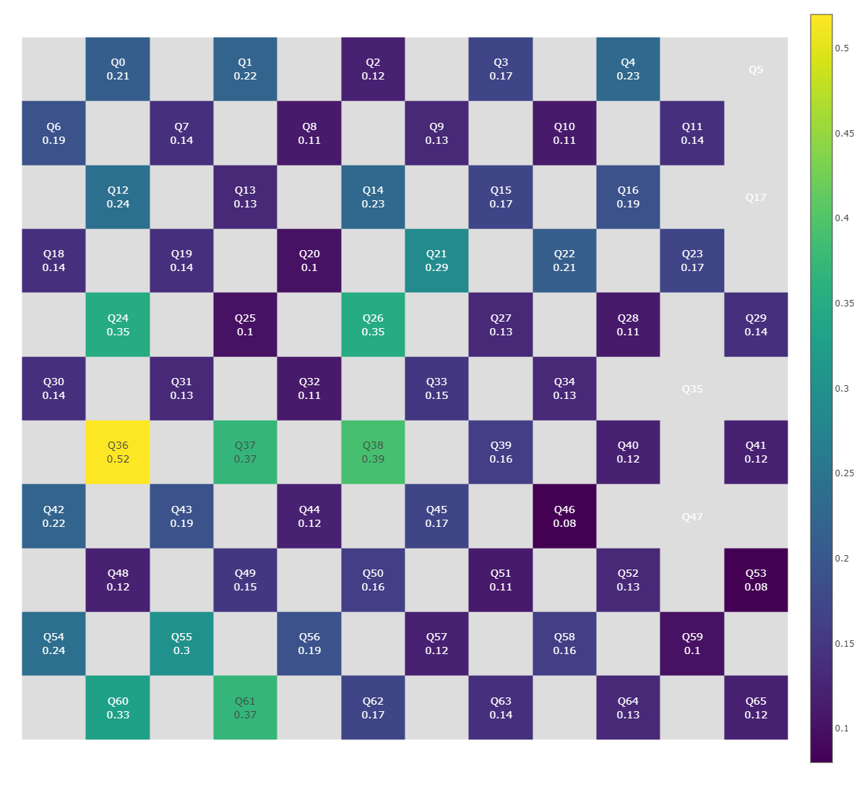
Fig. S9. The single-qubit gate error rate of "Xiaohong" quantum computer.
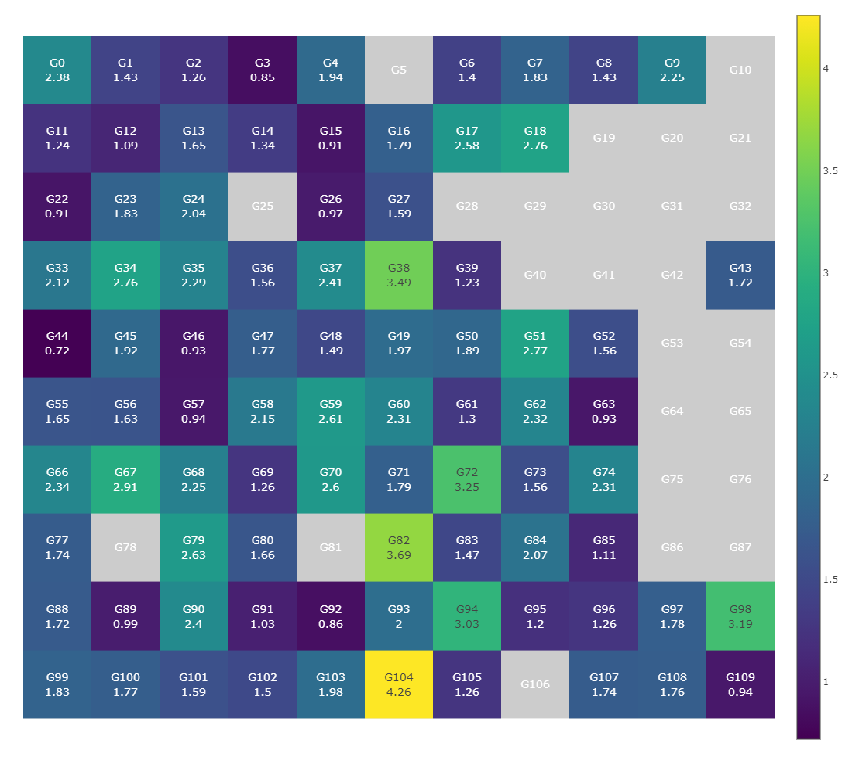
Fig. S10. Two-qubit CZ gate error rate of "Xiaohong" quantum computer.
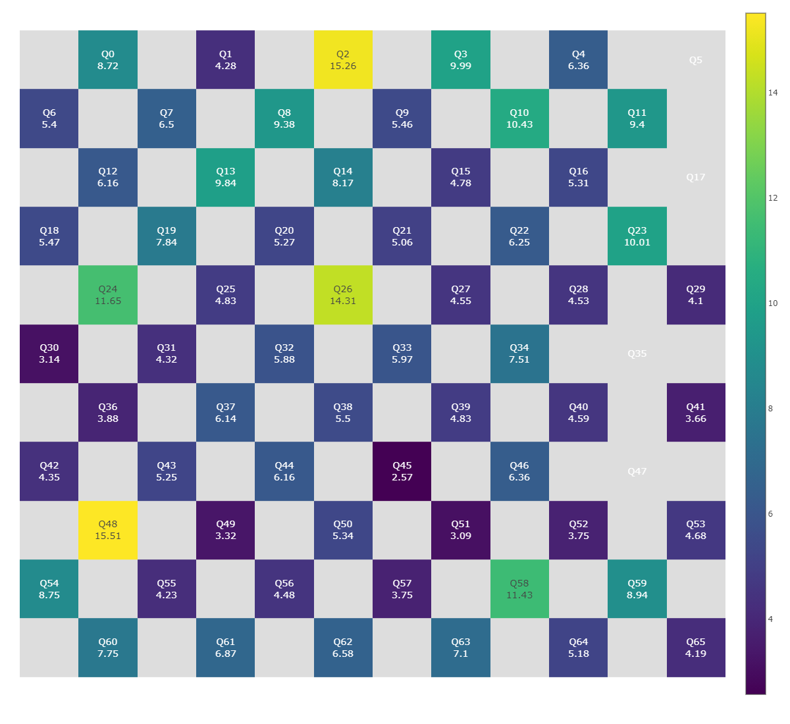
Fig. S11. The readout error for each qubit on "Xiaohong" quantum computer.
S10. Supplementary Codes

S10.1 The codes for two-step feature-selection
The codes for two-step feature-selection are available at:
https://github.com/347251369/Antimicrobial-resistance-prediction-in-Salmonella/blob/main/code/my_feature_selection.py

S10.2 The codes for SARPLLM
The codes for SARPLLM can be available at:
https://github.com/347251369/Antimicrobial-resistance-prediction-in-Salmonella/blob/main/code/SARPLLM.py

S10.3 The codes for QSMOTEN on quantum virtual machine
The codes for QSMOTEN on quantum virtual machine can be available at: https://github.com/347251369/Antimicrobial-resistance-prediction-in-Salmonella/blob/main/code/QSMOTEN.py

S10.4 The codes for QSMOTEN on "Xiaohong" quantum computer
The codes for QSMOTEN on quantum physical machine can be available at: https://github.com/347251369/Antimicrobial-resistance-prediction-in-Salmonella/blob/main/code/QSMOTEN%20on%20physical%20machine.py
We thank the QuantumCTek for supporting the quantum computer "Xiaohong". The website can be access at: https://quantumcomputer.ac.cn/

S10.5 The website of predictive platform for Salmonella antimicrobial resistance
The website of predictive platform for Salmonella antimicrobial resistance can be access at :http://www.combio-lezhang.online/salmonella/home
References
- "National Antimicrobial Resistance Monitoring System (NARMS) Now: Human Data." https://www.cdc.gov/narmsnow (accessed 7-16, 2023).
- J. Bai et al., "Qwen Technical Report," arXiv preprint arXiv:2309.16609, 2023.
- C. S. Chin et al., "Nonhybrid, finished microbial genome assemblies from long-read SMRT sequencing data," (in eng), Nature methods, vol. 10, no. 6, pp. 563-9, Jun 2013, doi: 10.1038/nmeth.2474.
- T. Tatusova et al., "NCBI prokaryotic genome annotation pipeline," Nucleic Acids Research, vol. 44, no. 14, pp. 6614-6624, 2016, doi: 10.1093/nar/gkw569.
- S. Hegselmann, A. Buendia, H. Lang, M. Agrawal, X. Jiang, and D. A. Sontag, "TabLLM: Few-shot Classification of Tabular Data with Large Language Models," 2023. [Online]. Available: https://proceedings.mlr.press/v206/hegselmann23a.html.
- A. Vaswani et al., "Attention is All you Need," in Neural Information Processing Systems, 2017.
- L. Breiman, "Random Forests," Machine Learning, vol. 45, pp. 5-32, 2001.
- T. Chen and C. Guestrin, "XGBoost: A Scalable Tree Boosting System," in Proceedings of the 22nd ACM SIGKDD International Conference on Knowledge Discovery and Data Mining, 2016.
- C. Cortes and V. N. Vapnik, "Support-Vector Networks," Machine Learning, vol. 20, pp. 273-297, 1995.

