Supplementary data for

Phloretin Targets Polyphosphate Kinase 1 to Attenuate Acinetobacter baumannii Virulence and Persistence In Vitro and In Vivo
Hongfa Lv ^{a,#}, Shufang Li ^{a,#}, Jian Guan ª, Peng Zhang ^{d}, Lingcong Kong ^{c}, Hongxia Ma ^{c}, Dan Li ^{e}, Xuming Deng ª, Xiaodi Niu ^{b,}*, Jianfeng Wang ^{a,}*
a State Key Laboratory for Diagnosis and Treatment of Severe Zoonotic Infectious Diseases & Key Laboratory for Zoonosis Research of the Ministry of Education, Institute of Zoonosis, College of Veterinary Medicine, Jilin University, Changchun 130062, China
b College of Food Science and Engineering, Jilin University, Changchun 130062, China
c College of Animal Science and Technology, Jilin Agricultural University, Changchun 130118, China
d Department of Thoracic Surgery, the First Hospital of Jilin University, Changchun 130021, China
e Department of Respiratory Medicine, Center for Pathogen Biology and Infectious Diseases, Key Laboratory of Organ Regeneration and Transplantation of the Ministry of Education, The First Hospital of Jilin University, Changchun 130021, China

* Corresponding author.
E-mail address: niuxd@jlu.edu.cn (X. Niu), wjf927@jlu.edu.cn (J. Wang)
# These authors contributed equally to this work.

Table S1
Primers used in this study
primers | Sequences (5’-3’)
ppk1-BamHI-F CGCGGATCCATGAATACAGCGATTACAG
ppk1-NotI-R ATTTGCGGCCGCTTTAAAAGTTTCTAATAAT
ppk1-R22-F GACCGTTATATTAATGCGGAATTGTCTATTCTTG
ppk1-R22-R CAAGAATAGACAATTCCGCATTAATATAACGGTC
ppk1-N57-F CTCATTTTTTCGCGTGCGTTAGATGAGTTTTTTG
ppk1-N57-R CAAAAAACTCATCTAACGCACGCGAAAAAATGAG
ppk1-R65-F GAGTTTTTTGAAATTGCGGTGGCAGGTGTTATG
ppk1-R65-R CATAACACCTGCCACCGCAATTTCAAAAAACTC
ppk1-I574-F CATTATTCGTTCGGCGTGCTGTTTACGTC
ppk1-I574-R GACGTAAACAGCACGCCGAACGAATAATG
ppk1-M622-F CTGTTCAAGTGCGGACTGGGCGGATCGTAACTTAT
ppk1-M622-R GATTAAATAAGTTACGATCCGCCCAGTCCGCACTT
ppk1-F ATAAAAGCCTTAACTTTATTGTG
ppk1-R TTTAACGCTTTTGCCAAATCTTCAA
ppx-F ACAAATGGGTTGTGTAGCCTATAC
ppx-R ACTTATCTTTAAGTTTATGGAGACCT
phou-F GTAAAGCCAATACTGACCTAGAGC
phou-R AAGTCATTAAAGTACGCGTTGCCG
rpos-F TAAAGGTTTTCATGCAAGATGTTACT
rpos-R TGATTTCTTCATCATCATTGTCTAG

Table S2
The average distances between ligands and residues in the binding sites over the simulation

PPK-PHL | PPK-ATP
ARG-22: 6.315 Å | PHE-29: 8.237 Å
PHI-26: 4.216 Å | VAL-33: 5.327 Å
HIS-30: 7.226 Å | PHI -53: 6.945 Å
ASN-57: 5.768 Å | ARG-56: 5.387 Å
ARG-65: 5.625 Å | ASN-57: 7.395 Å
PHI -574: 5.593 Å | PHI -64: 4.985 Å
MET-622: 7.235 Å | ARG-65: 5.219 Å
ARG-624: 6.215 Å | ARG-384: 6.492 Å
 | ARG-413: 4.961 Å
 | ARG-572: 7.482 Å

Table S3
Calculated energy components, the binding free energy (kcal/mol) of phloretin binding with wild-type PPK1, R22A, N57A, R65A and M622A based on MM-GBSA
Energy components (kcal/mol) | wild-type PPK1 | R22A | N57A | R65A | M622A
ΔE_{ele} | -40.20±1.49 | -33.88±0.94 | -35.44±0.88 | -31.69±1.42 | -30.50±1.15
ΔE_{vdw} | -21.42±0.61 | -17.01±1.08 | -20.73±1.32 | -22.79±1.03 | -19.76±1.32
ΔE_{MM} | -61.62±1.66 | -50.89±2.09 | -56.17±2.11 | -54.48±1.73 | -50.26±1.23
ΔG_{ele,sol} | -3.29±0.10 | -2.02±0.15 | -1.60±0.14 | -3.05±0.23 | -1.95±0.06
ΔG_{nonpolar,sol} | 48.89±1.28 | 41.54±1.25 | 48.61±1.25 | 46.95±1.91 | 40.99±1.16
ΔG_{sol} | 45.60±1.27 | 39.52±1.18 | 47.01±1.39 | 43.90±1.75 | 39.04±1.17
ΔG_{bind} | -16.02±0.96 | -11.37±1.11 | -9.16±0.82 | -10.58±1.04 | -11.22±1.07

Fig. S1 Conventional molecular dynamics (cMD) simulations. (A): RMSD of the protein backbones of apo PPK, PPK-ATP and PPK-phl from their initial coordinates as a function of time. (B): The stable structure of the binding mode of ATP with PPK shows the interactions of ATP with PHE-29, ILE-53, ARG-56, ASP-59 and SER-384. (C and D): Decomposition of the binding energy on a per-residue basis in the PPK-phl complex on the basis of MM-PBSA and binding energy scanning on the basis of Ala mutation. (E): Structure overlap between PPK-ATP (blue) and PPK-phl (green). (F and G): The distances between phl (F) or ATP (G) and the Mg²⁺ ions of PPK over the simulation.

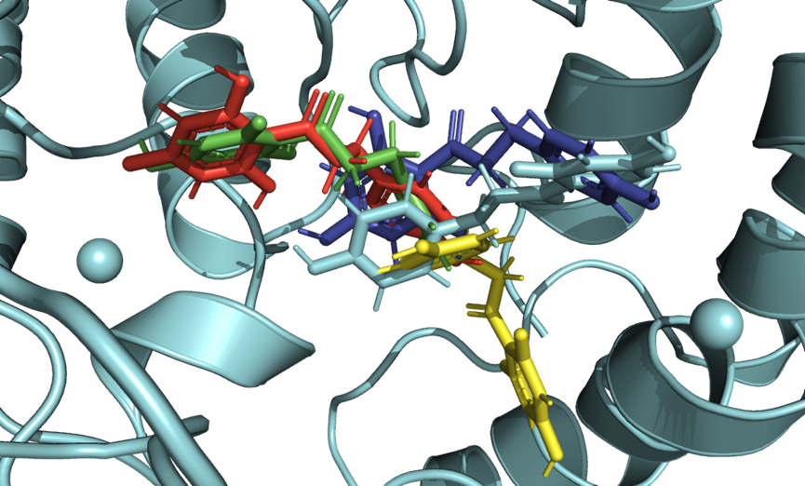
Fig. S2: The structures of wild-type PPK1 and four mutant proteins (R22A, N57A, R65A, and M622A) and the phloretin complex system were simulated and stabilized.

Fig. S3 Phloretin had no toxicity in vitro or in vivo. Cytotoxicity assessment of phloretin in HeLa cells (A) and J774 cells (B). The mice were administered 0 mg/kg, 50 mg/kg, 150 mg/kg or 250 mg/kg phloretin (n=5) via gavage, and the water consumption (C), food consumption (D) and body weight changes (E) were recorded. Gross pathological observation (F) and histopathological analysis (G) of major organs, including the liver, spleen, heart, kidney and lung.

