Supplementary data for
Three-Year Consecutive Field Application of Erythromycin Fermentation Residue Following Hydrothermal Treatment: Cumulative Effect on Soil Antibiotic Resistance Genes
Ziming Han ^{a,b}, Haodi Feng ª, Xiao Luan ª, Yunpeng Shen ^{c}, Liren Ren ^{c}, Liujie Deng ^{c}, D.G. Joakim Larsson ^{d}, Michael Gillings ^{e}, Yu Zhang ^{a,b,}*, Min Yang ^{a,b}

ª State Key Laboratory of Environmental Aquatic Chemistry, Research Center for Eco-Environmental Sciences, Chinese Academy of Sciences, Beijing 100085, China
^{b} University of Chinese Academy of Sciences, Beijing 100049, China
^{c} State Environmental Protection Engineering Center for Harmless Treatment and Resource Utilization of Antibiotic Residues, Khorgos 835007, China
^{d} Institute for Biomedicine & the Centre for Antibiotic Resistance Research, University of Gothenburg, SE-413 46, Göteborg, Sweden
^{e} ARC Centre of Excellence in Synthetic Biology, Department of Biological Sciences, Faculty of Science and Engineering, Macquarie University, Sydney, NSW 2109, Australia

* Corresponding author.
E-mail address: zhangyu@rcees.ac.cn (Y. Zhang)

Section S1: Supplementary Materials and Methods
Experiment design and sampling
The treated EFR after hydrothermal treatment and spray drying was stored within one month in dry environment until use. The treated EFR was so dry so that there is not likely to be any microbial growth there during storage. Chicken manure fertilizer was used as the animal-derived fertilizer, for the comparison with treated EFR, and chlortetracycline and deoxytetracycline was used in the farming.
In each year of 2018-2020, the amendment was finished within one day. During the amendment process, treated EFR was plowed down into the soil to about 30 cm depth. The “after application” stage samples were collected about 2 weeks after soil amendment, and the whole growth period of soybeans was about 3 months. In 2019 and 2020, control plot was divided into four plots and gave them either no fertilizer or high or low dose of manure or chemical fertilizer (Fig. S1).
On each sampling date, soil samples at about 15 cm depth under the ground and 20 cm away from the plant root were collected. For each sample, three subsamples were collected and pooled as one replicate (about 3 kg) to reduce variability. Furthermore, three such composite replicates were collected from different parts of each plot and sampling time (Fig. S1).

Erythromycin A concentration in treated EFR and soils detected by UPLC-MS/MS.
A 1 g aliquot of the freeze-dried sample was accurately weighed into a 50 mL centrifuge tube. 2 mL of Tris-CaCl₂ (Which contained 0.01 mol/L tris(hydroxymethyl)aminomethane, 0.1 mol/ L CaCl₂ and was adjusted the pH value to 5) was added to the tube, vortexed for 60 sec, ultrasonicated for 20 min. After this, 8 mL of ACN was added to the tube, vortexed for 60 sec, ultrasonicated for 20 min. After the extraction process, the centrifuge tube was centrifuged at 3500 r/min for seven min. The whole extraction process is repeated three times and the extracts were combined. The extracts were diluted to 250 mL with Milli-Q water and adjusted the pH of the sample to 6.8-7.0.
The cartridges Oasis HLB were preconditioned sequentially with 5.0 mL of MeOH and 5.0 mL of Milli-Q water. Each sample (250 mL) was passed through the cartridge at a flow rate of 3 mL/min. After sample loading, the cartridges were washed with 5 mL of 50% methanol aqueous solution and 5mL of Milli-Q water, dried under the nitrogen stream for 30 min and eluted with 6 mL of methanol at the flow rate of ≤1 mL/min. The eluate was collected in a 10 mL centrifuge tube, dried under a gentle stream of nitrogen, and then dissolved with 1 mL of MeOH. Extracts were separated and filtered through 0.22 μm PES filters for UPLC–MS/MS analysis. If the extracts were not analyzed on the same day, they were stored at −20℃.
The UPLC apparatus used for the analysis of the target substances was an Acquity Ultra Performance Liquid Chromatography (Waters, Milford, MA, U.S.). Mass spectrometry was performed using a Waters Micromass XEVO TQ MS (triple-quadrupole) detector operated with an electrospray ionization source (Micromass, Manchester, UK) in positive ion mode. The separation of target substances was performed using an ACQUITY UPLC BEH Shield RP18 (2.1× 100 mm, 1.7 μm) column and elution gradient program. Milli-Q water containing 0.1% formic acid (V/V) (A) and MeOH (B) were used as the mobile phases at a flow rate of 0.3 mL/min. The mobile phase gradient started with 95% mobile phase A, keeping constant for 1.0 min. Then, mobile phase gradient reduced to 40% mobile phase A at 6.0 min and kept constant for 1.0 min, then continuously rising to 95% at 8.0 min，and kept constant until 9.0 min. A sample volume of 5.0 μL was injected into the column thermostated at 35 °C. The MS system was operated under the following conditions: Capillary voltage and source temperature were 3.2 kV and 150℃, respectively. Nitrogen was used as desolvation and auxiliary gas, desolvation temperature and desolvation gas flow rate were 300°C and 600 L/hr, respectively.

Data processing of 16S rRNA gene amplicon sequencing.
Raw sequencing data were preprocessed and analyzed using biological-cloud platform of Guangdong Magigene Biotechnology Co. Ltd., China. In details, quality filtering on the paired-end raw reads were performed under specific filtering conditions to obtain the high-quality clean reads according to the Trimmomatic (V0.33, http://www.usadellab.org/cms/?page=trimmomatic) quality-controlled process. At the same time, sequences were assigned to each sample based on their unique barcode and primer, after which the barcodes and primers were removed and got the paired-end clean reads. Paired-end clean reads were merged using FLASH (V1.2.11, https://ccb.jhu.edu/software/FLASH/) according to the relationship of the overlap between the paired-end reads, when at least 10 of the reads overlap the read generated from the opposite end of the same DNA fragment, the maximum allowable error ratio of the overlap region of 0.2, and the spliced sequences were called raw tags. Quality filtering on the spliced sequences were performed under the Trimmomatic software to obtain the effective clean tag. Sequences analysis were performed by usearch software (V8.0.1517, http://www.drive5.com/usearch/). Sequences with ≥97% similarity were assigned to the same OTU. Representative sequence for each OTU was screened for further annotation.
The usearch (http://www.drive5.com/usearch/manual/chimera_formation.html) was used to remove singleton OTU after OTU cluster, and then the chimera sequences were detected and removed using the UCHIME de novo algorithm (http://www.drive5.com/usearch/manual/uchime_algo.html). For each representative sequence, the Silva database was used based on RDP classifier algorithm and the assign_taxonomy.py script (http://qiime.org/scripts/assign_taxonomy.html) in QIIME to annotate taxonomic information (set the confidence threshold as 0.8). OTU abundance information were normalized using a standard of sequence number corresponding to the sample with the least sequences. Subsequent analysis of alpha diversity and beta diversity were all performed basing on this output normalized data.

MGE database.
The custom MGE database was created by fetching CDS for genes that were annotated as IS*, ISCR*, intI1, int2, istA*, istB*, qacEdelta, tniA*, tniB*, tnpA* or Tn916 transposon ORFs or genes in the NCBI nucleotide database and it also includes the PlasmidFinder database. Redundancy in the databases was removed with VSEARCH -usearch_global command with --id 99 option and sequences longer than 4000 bp or shorter than 100 bp were excluded from the database. In total, the MGE database consists of genes with 278 different gene name annotations and more than 2000 unique sequences excluding the sequences from PlasmidFinder database. The custom MGE database is available from https://github.com/KatariinaParnanen/MobileGeneticElementDatabase [1].

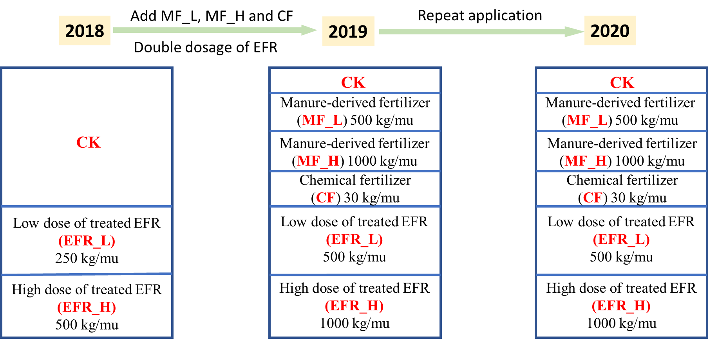

Fig. S1. Scheme diagram of three-year (2018, 2019 and 2020) field application experiment of the treated erythromycin fermentation residue (EFR). The “mu” is a Chinese traditional measurement unit (1 ha = 15 mu), and still widely used in rural areas to this day. Thus, in this study, 250 kg/mu = 3750 kg/ha, 500 kg/mu = 7500 kg/ha, 1000 kg/mu = 15000 kg/ha.
CK, soils without amendment; EFR_L, soils receiving 3750 kg/ha treated EFR in 2018, or soils receiving 7500 kg/ha treated EFR in 2019, 2020; EFR_H, soils receiving 7500 kg/ha treated EFR in 2018, or soils receiving 15000 kg/ha treated EFR in 2019, 2020; MF_L, soils receiving 7500 kg/ha manure-derived fertilizer; MF_H, soils receiving 15000 kg/ha manure-derived fertilizer; CF, soils receiving chemical fertilizer.

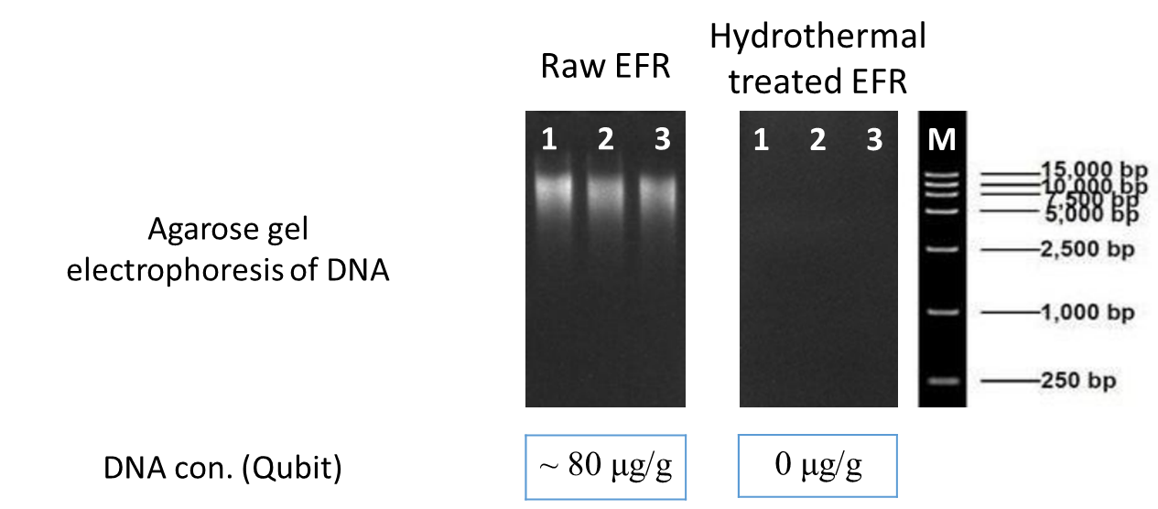
Fig. S2. Agarose gel electrophoresis and concentration measurement of DNA extracted from raw erythromycin fermentation residue (EFR) (i.e., EFR without any treatment) and hydrothermal treated EFR. The entire gel is shown, no small fragments excluded. 1, 2, 3 means three replicates of three independent samples; M means marker.

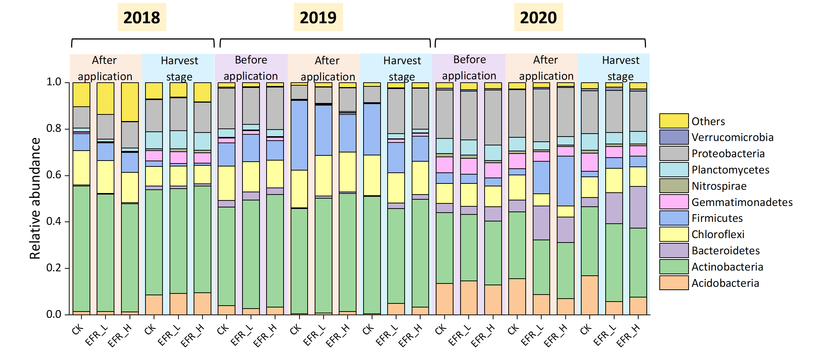
Fig. S3. Soil bacterial community composition (at phylum level) during three-year (2018, 2019 and 2020) field application experiment with treated erythromycin fermentation residue (EFR).

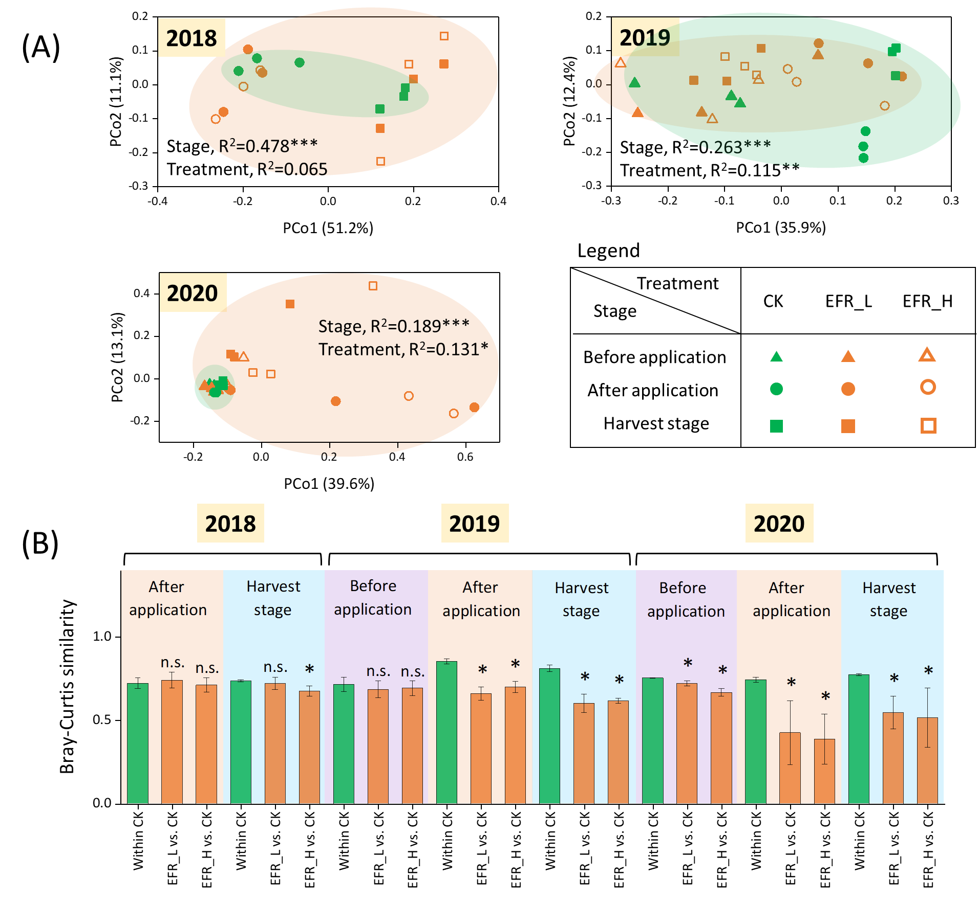
Fig. S4. Bacterial community structure in soils receiving treated erythromycin fermentation residue (EFR) in three sampling stages (before application, after application and harvest stage) for three years (2018, 2019 and 2020).
(A) Principal coordinates analysis (PCoA) and permutational multivariate analysis of variance (PERMANOVA) of ARGs in three sampling stages for three years.
(A) Bray-Curtis similarity of bacterial community within CK soils and between CK soils and soils receiving treated EFR. Samples were compared with “within CK” based on Mann-Whitney U tests.
The n.s. and * indicated P-value ≥ 0.05 and < 0.05 respectively.

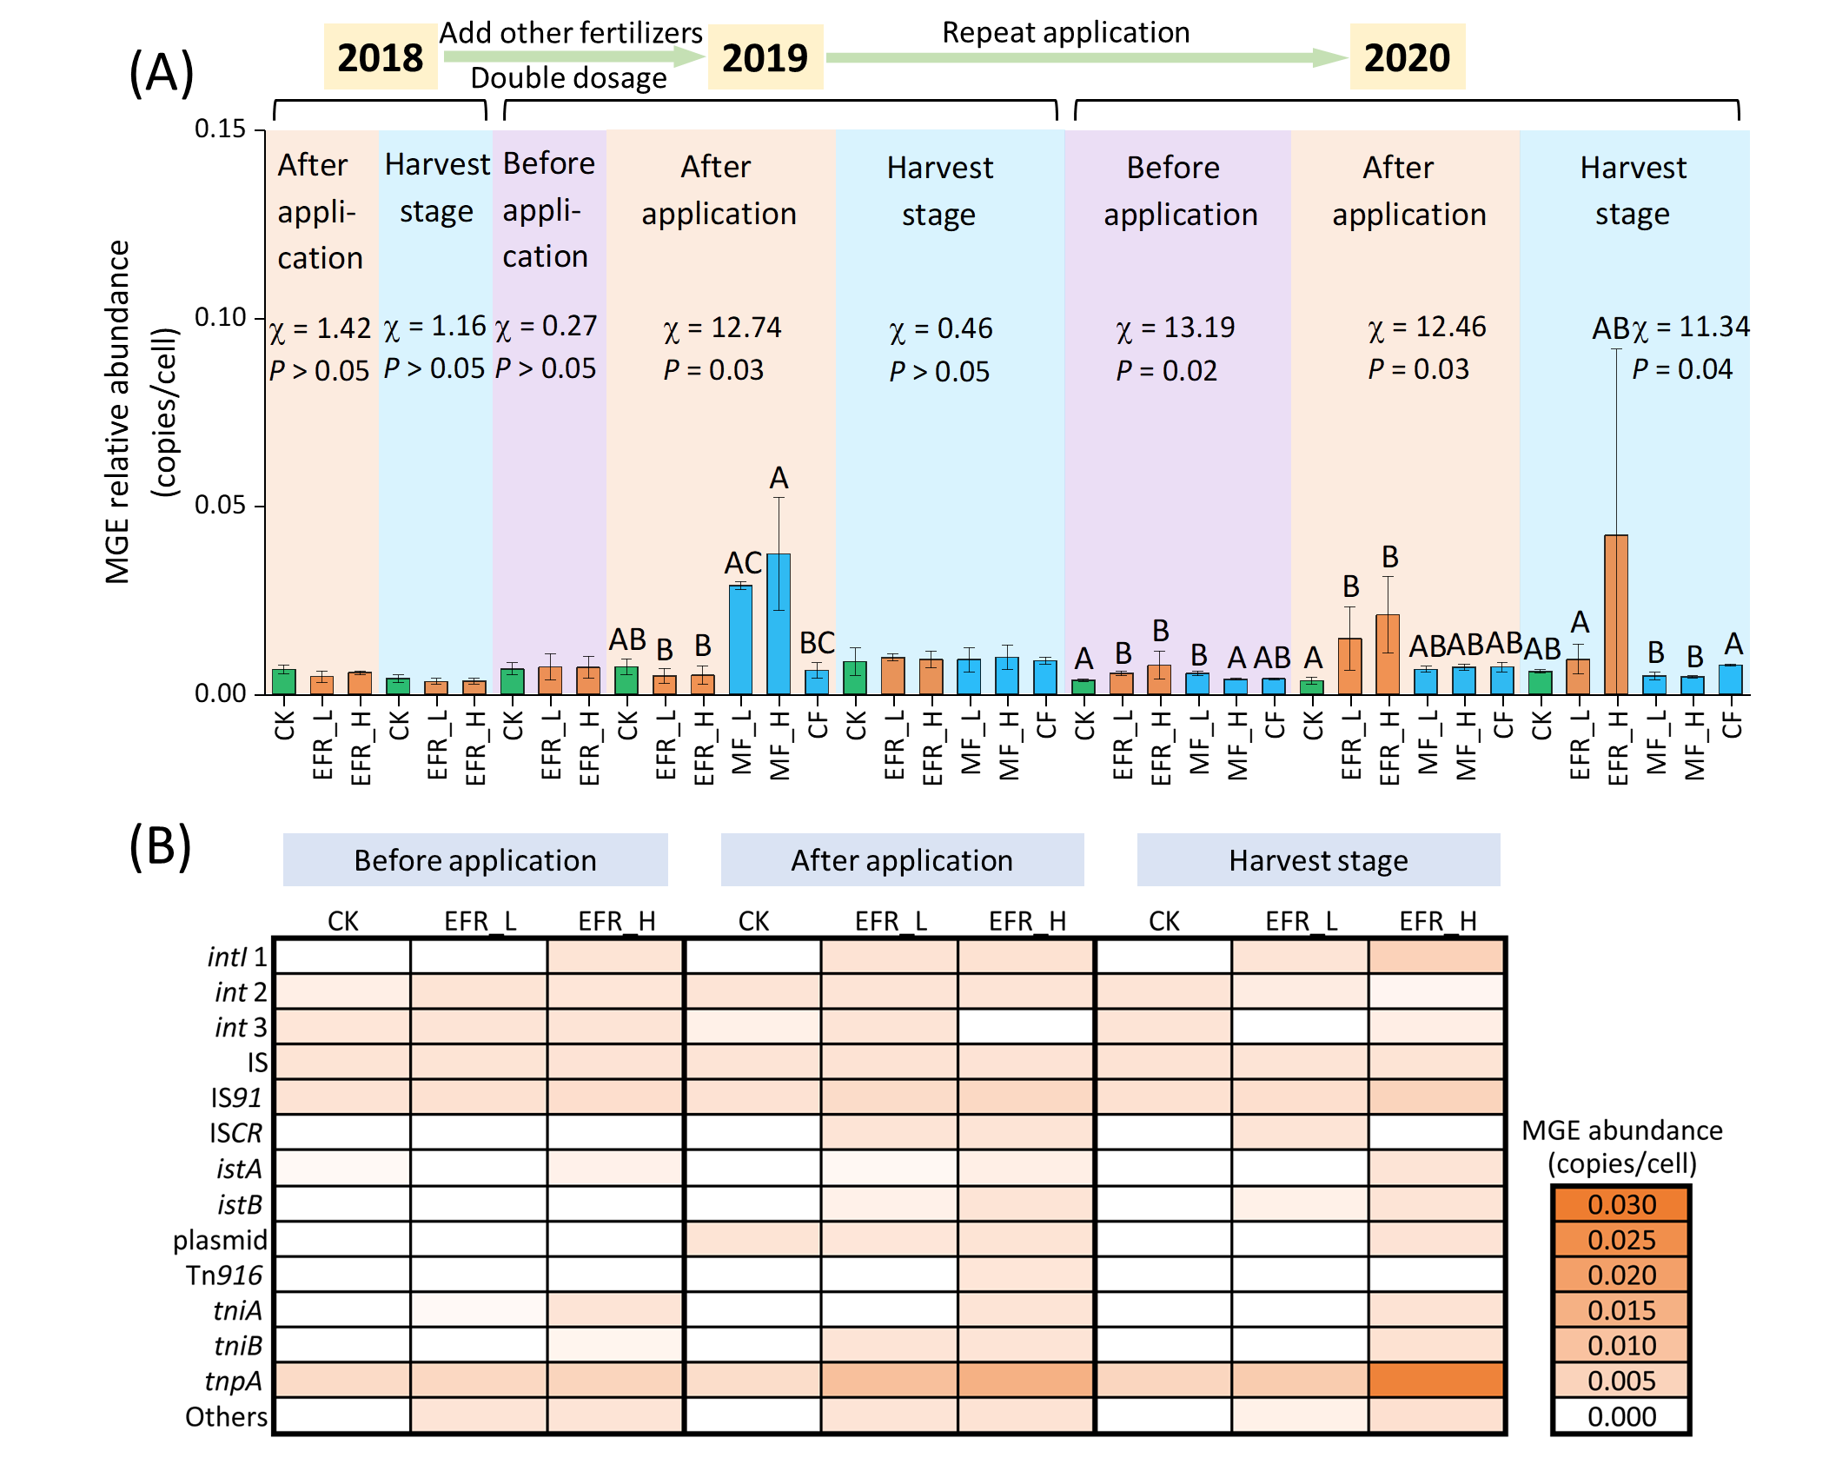
Fig. S5. Mobile genetic element (MGE) abundance in soils receiving treated erythromycin fermentation residue (EFR), manure-derived fertilizer (MF) and chemical fertilizer (CF) in three sampling stages (before application, after application and harvest stage) for three years (2018, 2019 and 2020).
(A) Abundance of all detected MGEs based on a custom MGE database (more details can be found in Material and Method part). Samples within one stage were compared and labeled with the same letter if not significantly different based on K-W one-way ANOVA.
(B) Abundance of all detected MGEs types of soils in 2020.
CK, soils without amendment; EFR_L, soils receiving 3750 kg/ha treated EFR in 2018, or soils receiving 7500 kg/ha treated EFR in 2019, 2020; EFR_H, soils receiving 7500 kg/ha treated EFR in 2018, or soils receiving 15000 kg/ha treated EFR in 2019, 2020; MF_L, soils receiving 7500 kg/ha manure-derived fertilizer; MF_H, soils receiving 15000 kg/ha manure-derived fertilizer; CF, soils receiving chemical fertilizer.

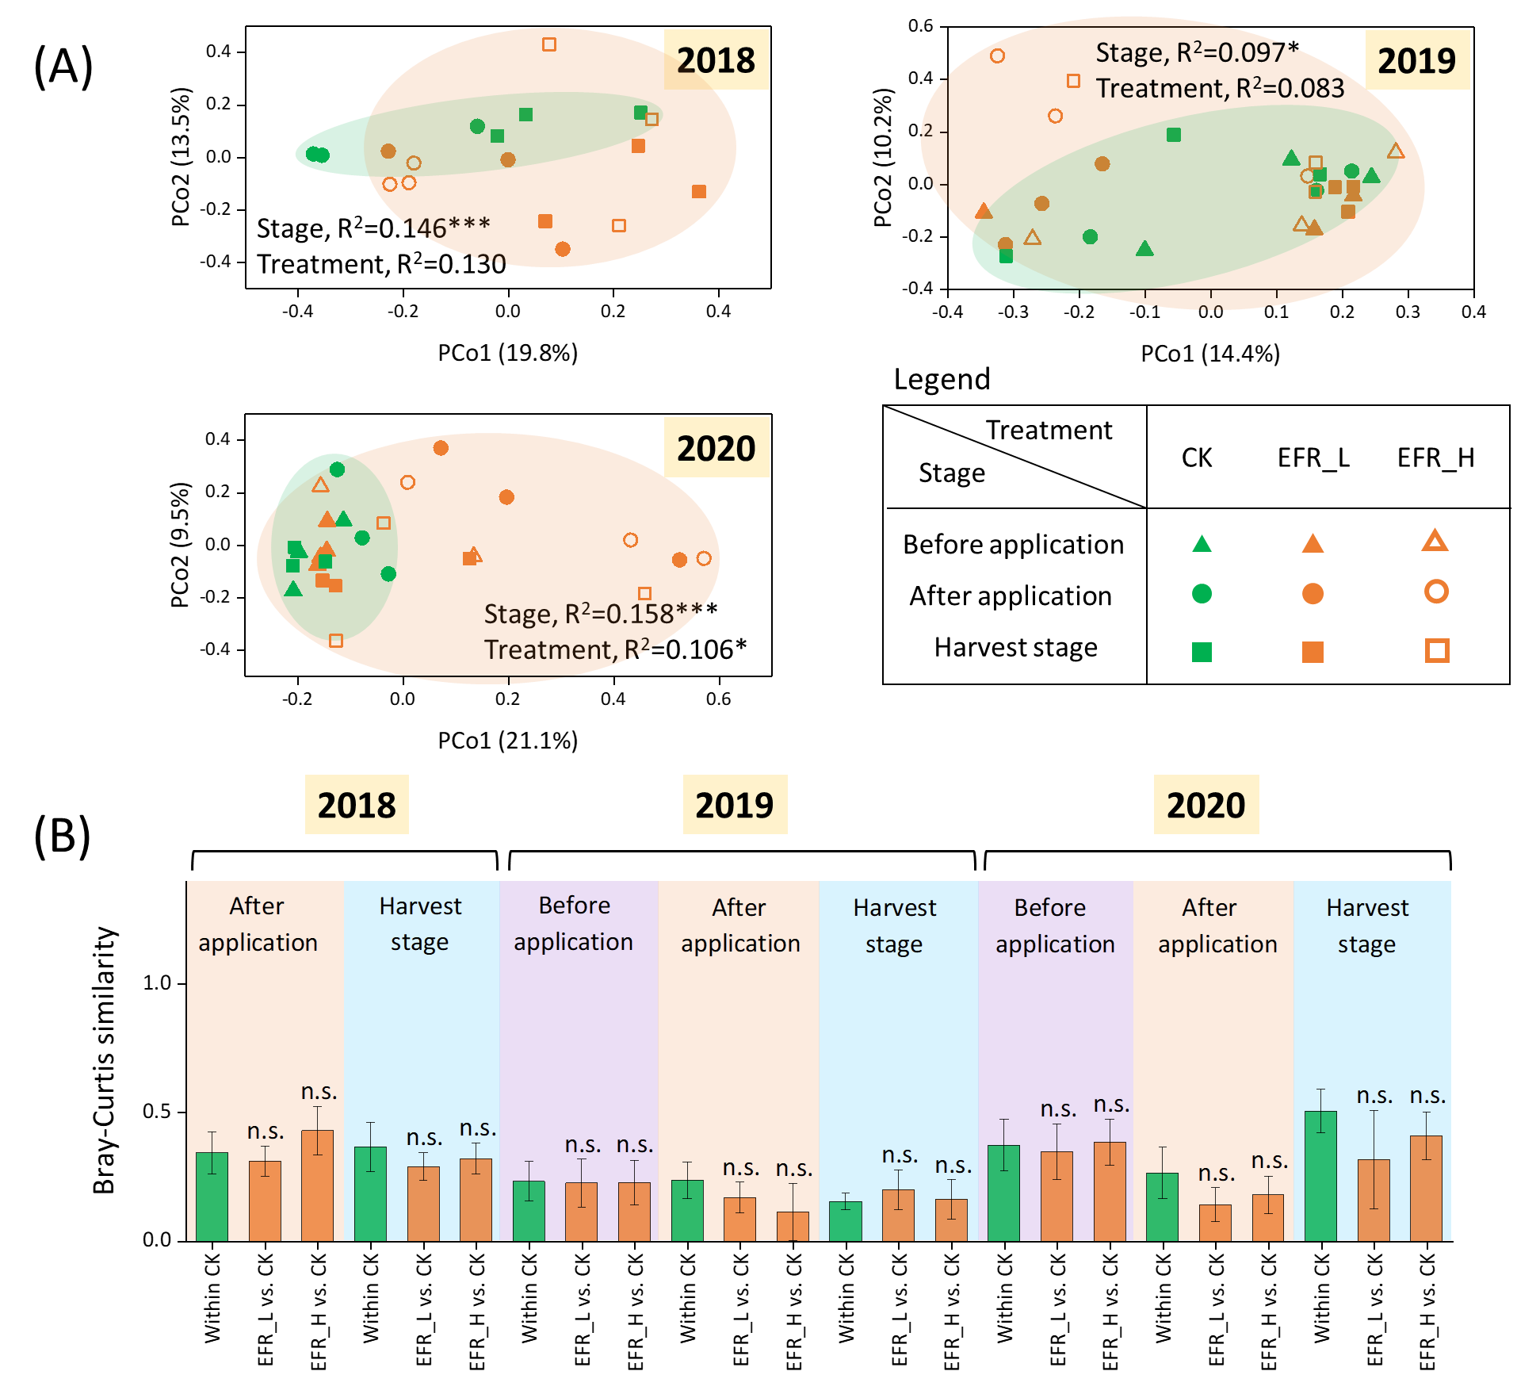
Fig. S6. Mobile genetic element (MGE) structure in soils receiving treated erythromycin fermentation residue (EFR) in three sampling stages (before application, after application and harvest stage) for three years (2018, 2019 and 2020).
(A) Principal coordinates analysis (PCoA) and permutational multivariate analysis of variance (PERMANOVA) of ARGs in three sampling stages for three years.
(A) Bray-Curtis similarity of MGEs within CK soils and between CK soils and soils receiving treated EFR. Samples were compared with “within CK” based on Mann-Whitney U tests.
The n.s. indicated P-value ≥ 0.05.

Table S1
Chemical properties of manure fertilizer and treated EFR used in field application.
 | TN (g/kg) | TC (g/kg)
Manure fertilizer | 11.66±0.42 | 95.04±5.28
Treated EFR | 50.57±11.33 | 429.91±25.14
TN, total nitrogen; TC, total carbon.

Table S2
Soil chemical properties at the harvest stage in 2020.
 | pH | TN (g/kg) | TC (g/kg)
CK | 8.09±0.10 | 0.75±0.01 | 21.22±0.07
EFR_L | 7.62±0.15 * | 1.21±0.22 * | 21.91±0.23 *
EFR_H | 7.85±0.13 | 1.62±0.70 * | 23.86±2.77 *
MF_L | 8.13±0.15 | 0.81±0.06 | 19.65±1.38
MF_H | 7.90±0.10 | 0.80±0.01 * | 20.99±0.06
CF | 8.03±0.06 | 0.89±0.01 * | 21.46±0.05
TN, total nitrogen; TC, total carbon.
* indicates the significantly lower pH or significantly higher TN/TC compared with CK (P < 0.05) based on Mann-Whitney U tests.

Table S3
Erythromycin concentration (μg/kg) of soil samples showed in Fig. 1.
Stage | treatment | Mean | SD
2018 After application | CK | Not detected
 | EFR_L | 12.17 | 1.22
 | EFR_H | 76.00 | 1.47
2018 Harvest stage | CK | Not detected
 | EFR_L | 4.50 | 1.50
 | EFR_H | 15.00 | 0.20
2019 Before application | CK | Not detected
 | EFR_L | 6.00 | 0.00
 | EFR_H | 6.92 | 0.51
2019 After application | CK | Not detected
 | EFR_L | 0.83 | 0.24
 | EFR_H | 59.25 | 11.38
2019 Harvest stage | CK | Not detected
 | EFR_L | 1.83 | 1.12
 | EFR_H | 30.25 | 4.14
2020 Before application | CK | Not detected
 | EFR_L | 1.17 | 0.24
 | EFR_H | 7.58 | 0.96
2020 After application | CK | Not detected
 | EFR_L | 16.17 | 0.85
 | EFR_H | 17.33 | 2.05
2020 Harvest stage | CK | Not detected
 | EFR_L | 3.50 | 1.08
 | EFR_H | 6.42 | 2.18
Detection limit, 0.1 μg/kg·TS.

Table S4
Soil total ARG abundance (copies/cell) showed in Fig 2A.
Stage | treatment | Mean | SD
2018 After application | CK | 0.115 | 0.007
 | EFR_L | 0.114 | 0.003
 | EFR_H | 0.113 | 0.004
2018 Harvest stage | CK | 0.117 | 0.008
 | EFR_L | 0.114 | 0.005
 | EFR_H | 0.123 | 0.004
2019 Before application | CK | 0.104 | 0.005
 | EFR_L | 0.116 | 0.001
 | EFR_H | 0.111 | 0.003
2019 After application | CK | 0.109 | 0.001
 | EFR_L | 0.116 | 0.002
 | EFR_H | 0.103 | 0.008
 | MF_L | 0.140 | 0.016
 | MF_H | 0.151 | 0.021
 | CF | 0.103 | 0.004
2019 Harvest stage | CK | 0.117 | 0.007
 | EFR_L | 0.119 | 0.014
 | EFR_H | 0.118 | 0.003
 | MF_L | 0.092 | 0.001
 | MF_H | 0.100 | 0.008
 | CF | 0.116 | 0.003
2020 Before application | CK | 0.118 | 0.003
 | EFR_L | 0.114 | 0.002
 | EFR_H | 0.137 | 0.008
 | MF_L | 0.118 | 0.002
 | MF_H | 0.113 | 0.003
 | CF | 0.107 | 0.002
2020 After application | CK | 0.101 | 0.003
 | EFR_L | 0.187 | 0.051
 | EFR_H | 0.278 | 0.123
 | MF_L | 0.108 | 0.003
 | MF_H | 0.113 | 0.004
 | CF | 0.117 | 0.002
2020 Harvest stage | CK | 0.114 | 0.006
 | EFR_L | 0.128 | 0.025
 | EFR_H | 0.208 | 0.086
 | MF_L | 0.106 | 0.000
 | MF_H | 0.105 | 0.002
 | CF | 0.134 | 0.003

Table S5
ARG subtype abundance (copies/cell) in before application stage in 2020 showed in Fig 2B.
 |  | CK |  | EFR_L |  | EFR_H
Type | Subtype | AVE | SD | AVE | SD | AVE | SD
MLS | erm(39) | 0.00018 | 0.00010 | 0.00013 | 0.00002 | 0.00031 | 0.00022
 | ermB | 0.00000 | 0.00000 | 0.00000 | 0.00000 | 0.00000 | 0.00000
 | ermF | 0.00000 | 0.00000 | 0.00000 | 0.00000 | 0.00068 | 0.00090
 | ermT | 0.00000 | 0.00000 | 0.00003 | 0.00004 | 0.00000 | 0.00000
 | macB | 0.00475 | 0.00029 | 0.00522 | 0.00036 | 0.00453 | 0.00051
 | mgtA | 0.00041 | 0.00013 | 0.00046 | 0.00013 | 0.00067 | 0.00052
 | oleD | 0.00035 | 0.00013 | 0.00034 | 0.00007 | 0.00050 | 0.00019
aminoglycoside | aadA | 0.00003 | 0.00004 | 0.00013 | 0.00012 | 0.00021 | 0.00024
bacitracin | bacA | 0.00645 | 0.00029 | 0.00535 | 0.00069 | 0.00613 | 0.00054
beta-lactam | THIN-B | 0.00001 | 0.00002 | 0.00014 | 0.00009 | 0.00008 | 0.00007
chloramphenicol | catB | 0.00000 | 0.00000 | 0.00000 | 0.00003 | 0.00004 | 0.00053
 | chloramphenicol exporter | 0.00055 | 0.00030 | 0.00068 | 0.00007 | 0.00132 | 0.00086
 | floR | 0.00007 | 0.00008 | 0.00010 | 0.00006 | 0.00013 | 0.00062
multidrug | adeB | 0.00005 | 0.00004 | 0.00006 | 0.00006 | 0.00007 | 0.00002
 | amrB | 0.00007 | 0.00001 | 0.00010 | 0.00003 | 0.00027 | 0.00006
 | emrB | 0.00004 | 0.00003 | 0.00004 | 0.00004 | 0.00008 | 0.00002
 | emrE | 0.00000 | 0.00000 | 0.00006 | 0.00006 | 0.00000 | 0.00000
 | mexA | 0.00002 | 0.00002 | 0.00000 | 0.00002 | 0.00006 | 0.00006
 | mexC | 0.00000 | 0.00000 | 0.00000 | 0.00003 | 0.00002 | 0.00002
 | mexD | 0.00011 | 0.00007 | 0.00024 | 0.00004 | 0.00027 | 0.00008
 | mexT | 0.00000 | 0.00000 | 0.00000 | 0.00000 | 0.00008 | 0.00007
 | Multidrug transporter | 0.00208 | 0.00010 | 0.00209 | 0.00013 | 0.00334 | 0.00020
 | oprN | 0.00001 | 0.00002 | 0.00010 | 0.00004 | 0.00003 | 0.00003
 | smeD | 0.00002 | 0.00002 | 0.00012 | 0.00003 | 0.00004 | 0.00026
sulfonamide | sul1 | 0.00000 | 0.00000 | 0.00000 | 0.00003 | 0.00003 | 0.00156
tetracycline | tetA | 0.00000 | 0.00000 | 0.00002 | 0.00001 | 0.00000 | 0.00000
 | tetracycline resistance protein | 0.00087 | 0.00024 | 0.00100 | 0.00020 | 0.00082 | 0.00025
AVE, average value; SD, standard deviation.

Table S6
ARG subtype abundance (copies/cell) in after application stage in 2020 showed in Fig 2B. Only subtypes enriched in treated EFR amended soils according to linear discriminant analysis effect size (LEfSe) analysis were shown.
 |  | CK |  | EFR_L |  | EFR_H
Type | Subtype | AVE | SD | AVE | SD | AVE | SD
MLS | erm(39) | 0.00011 | 0.00009 | 0.00033 | 0.00011 | 0.00052 | 0.00037
 | ermB | 0.00000 | 0.00000 | 0.00555 | 0.00752 | 0.00869 | 0.00914
 | ermF | 0.00000 | 0.00000 | 0.00025 | 0.00035 | 0.00183 | 0.00135
 | ermT | 0.00000 | 0.00000 | 0.02036 | 0.02694 | 0.05475 | 0.05069
 | macB | 0.00418 | 0.00014 | 0.00465 | 0.00087 | 0.00532 | 0.00044
 | mgtA | 0.00050 | 0.00032 | 0.00029 | 0.00005 | 0.00032 | 0.00022
 | oleD | 0.00040 | 0.00022 | 0.00026 | 0.00015 | 0.00025 | 0.00014
aminoglycoside | aadA | 0.00000 | 0.00000 | 0.00092 | 0.00058 | 0.00122 | 0.00080
bacitracin | bacA | 0.00377 | 0.00049 | 0.01649 | 0.00830 | 0.02602 | 0.01518
beta-lactam | THIN-B | 0.00000 | 0.00000 | 0.00019 | 0.00009 | 0.00018 | 0.00015
chloramphenicol | catB | 0.00000 | 0.00000 | 0.00036 | 0.00031 | 0.00072 | 0.00056
 | chloramphenicol exporter | 0.00054 | 0.00016 | 0.00298 | 0.00176 | 0.00427 | 0.00293
 | floR | 0.00000 | 0.00000 | 0.00093 | 0.00055 | 0.00067 | 0.00038
multidrug | adeB | 0.00002 | 0.00001 | 0.00036 | 0.00023 | 0.00033 | 0.00020
 | amrB | 0.00006 | 0.00003 | 0.00039 | 0.00014 | 0.00047 | 0.00024
 | emrB | 0.00002 | 0.00002 | 0.00018 | 0.00008 | 0.00021 | 0.00008
 | emrE | 0.00000 | 0.00000 | 0.00016 | 0.00004 | 0.00021 | 0.00015
 | mexA | 0.00000 | 0.00000 | 0.00039 | 0.00050 | 0.00121 | 0.00089
 | mexC | 0.00000 | 0.00000 | 0.00022 | 0.00013 | 0.00044 | 0.00045
 | mexD | 0.00010 | 0.00005 | 0.00063 | 0.00033 | 0.00101 | 0.00062
 | mexT | 0.00000 | 0.00000 | 0.00170 | 0.00199 | 0.00624 | 0.00461
 | Multidrug transporter | 0.00131 | 0.00019 | 0.00963 | 0.00545 | 0.01492 | 0.00901
 | oprN | 0.00000 | 0.00000 | 0.00061 | 0.00062 | 0.00270 | 0.00221
 | smeD | 0.00000 | 0.00000 | 0.00207 | 0.00255 | 0.00211 | 0.00167
sulfonamide | sul1 | 0.00000 | 0.00000 | 0.00160 | 0.00120 | 0.00378 | 0.00270
tetracycline | tetA | 0.00000 | 0.00000 | 0.00021 | 0.00010 | 0.00023 | 0.00012
 | tetracycline resistance protein | 0.00062 | 0.00016 | 0.00197 | 0.00065 | 0.00267 | 0.00125
AVE, average value; SD, standard deviation.

Table S7
ARG subtype abundance (copies/cell) in harvest stage in 2020 showed in Fig 2B.
 |  | CK |  | EFR_L |  | EFR_H
Type | Subtype | AVE | SD | AVE | SD | AVE | SD
MLS | erm(39) | 0.00007 | 0.00005 | 0.00012 | 0.00017 | 0.00124 | 0.00106
 | ermB | 0.00000 | 0.00000 | 0.00000 | 0.00000 | 0.00030 | 0.00042
 | ermF | 0.00000 | 0.00000 | 0.00000 | 0.00000 | 0.00319 | 0.00451
 | ermT | 0.00000 | 0.00000 | 0.00000 | 0.00000 | 0.00305 | 0.00378
 | macB | 0.00425 | 0.00034 | 0.00341 | 0.00043 | 0.00403 | 0.00110
 | mgtA | 0.00068 | 0.00006 | 0.00038 | 0.00018 | 0.00138 | 0.00027
 | oleD | 0.00059 | 0.00006 | 0.00025 | 0.00002 | 0.00101 | 0.00048
aminoglycoside | aadA | 0.00000 | 0.00000 | 0.00006 | 0.00008 | 0.00465 | 0.00609
bacitracin | bacA | 0.00498 | 0.00041 | 0.00540 | 0.00269 | 0.00828 | 0.00292
beta-lactam | THIN-B | 0.00008 | 0.00011 | 0.00024 | 0.00034 | 0.00010 | 0.00005
chloramphenicol | catB | 0.00007 | 0.00011 | 0.00043 | 0.00053 | 0.00052 | 0.00055
 | chloramphenicol exporter | 0.00108 | 0.00027 | 0.00101 | 0.00060 | 0.00716 | 0.00613
 | floR | 0.00003 | 0.00003 | 0.00042 | 0.00056 | 0.00126 | 0.00111
multidrug | adeB | 0.00008 | 0.00005 | 0.00013 | 0.00014 | 0.00017 | 0.00006
 | amrB | 0.00009 | 0.00004 | 0.00028 | 0.00034 | 0.00027 | 0.00005
 | emrB | 0.00001 | 0.00001 | 0.00005 | 0.00007 | 0.00041 | 0.00048
 | emrE | 0.00000 | 0.00000 | 0.00008 | 0.00011 | 0.00039 | 0.00026
 | mexA | 0.00000 | 0.00000 | 0.00002 | 0.00003 | 0.00030 | 0.00042
 | mexC | 0.00002 | 0.00002 | 0.00007 | 0.00010 | 0.00007 | 0.00004
 | mexD | 0.00015 | 0.00005 | 0.00043 | 0.00032 | 0.00038 | 0.00016
 | mexT | 0.00000 | 0.00000 | 0.00000 | 0.00000 | 0.00063 | 0.00088
 | Multidrug transporter | 0.00217 | 0.00039 | 0.00339 | 0.00237 | 0.00626 | 0.00447
 | oprN | 0.00000 | 0.00000 | 0.00003 | 0.00005 | 0.00051 | 0.00072
 | smeD | 0.00004 | 0.00006 | 0.00024 | 0.00017 | 0.00049 | 0.00051
sulfonamide | sul1 | 0.00000 | 0.00000 | 0.00062 | 0.00088 | 0.02286 | 0.03070
tetracycline | tetA | 0.00000 | 0.00000 | 0.00021 | 0.00026 | 0.00023 | 0.00024
 | tetracycline resistance protein | 0.00059 | 0.00008 | 0.00077 | 0.00022 | 0.00293 | 0.00212
AVE, average value; SD, standard deviation.

Table S8
Relative abundance (%) of different bacterial phyla before the application stage in 2020.
 | 2020 Before application
 | CK |  |  | EFR_L |  |  |  | EFR_H
 | AVE | SD |  | AVE | SD | M-W test |  | AVE | SD | M-W test
Acidobacteria | 0.135 | 0.007 |  | 0.146 | 0.010 |  |  | 0.129 | 0.032
Actinobacteria | 0.305 | 0.015 |  | 0.287 | 0.021 |  |  | 0.274 | 0.033
Bacteroidetes | 0.040 | 0.005 |  | 0.035 | 0.007 |  |  | 0.064 | 0.013
Chloroflexi | 0.086 | 0.002 |  | 0.099 | 0.005 | * |  | 0.088 | 0.009
Firmicutes | 0.045 | 0.005 |  | 0.039 | 0.008 |  |  | 0.035 | 0.008
Gemmatimonadetes | 0.069 | 0.005 |  | 0.070 | 0.006 |  |  | 0.065 | 0.005
Nitrospirae | 0.015 | 0.002 |  | 0.014 | 0.002 |  |  | 0.010 | 0.001 | *
Planctomycetes | 0.064 | 0.010 |  | 0.065 | 0.004 |  |  | 0.067 | 0.009
Proteobacteria | 0.209 | 0.010 |  | 0.210 | 0.008 |  |  | 0.236 | 0.011 | *
Verrucomicrobia | 0.008 | 0.002 |  | 0.006 | 0.001 |  |  | 0.007 | 0.000
* P < 0.05 of M-W test between CK and EFR_L or EFR_H.

Table S9
Relative abundance (%) of bacterial phylum in after application stage in 2020.
 | 2020 After application
 | CK |  |  | EFR_L |  |  |  | EFR_H
 | AVE | SD |  | AVE | SD | M-W test |  | AVE | SD | M-W test
Acidobacteria | 0.156 | 0.021 |  | 0.087 | 0.060 |  |  | 0.071 | 0.047
Actinobacteria | 0.288 | 0.048 |  | 0.235 | 0.016 |  |  | 0.241 | 0.055
Bacteroidetes | 0.050 | 0.012 |  | 0.146 | 0.058 | * |  | 0.109 | 0.062
Chloroflexi | 0.109 | 0.003 |  | 0.052 | 0.029 | * |  | 0.047 | 0.030 | *
Firmicutes | 0.027 | 0.003 |  | 0.140 | 0.150 |  |  | 0.215 | 0.176
Gemmatimonadetes | 0.065 | 0.006 |  | 0.042 | 0.026 |  |  | 0.041 | 0.031
Nitrospirae | 0.010 | 0.001 |  | 0.008 | 0.004 |  |  | 0.006 | 0.005
Planctomycetes | 0.059 | 0.002 |  | 0.035 | 0.019 |  |  | 0.037 | 0.020
Proteobacteria | 0.205 | 0.011 |  | 0.227 | 0.047 |  |  | 0.211 | 0.061
Verrucomicrobia | 0.004 | 0.000 |  | 0.006 | 0.003 |  |  | 0.005 | 0.002
* P < 0.05 of M-W test between CK and EFR_L or EFR_H.

Table S10
Relative abundance (%) of bacterial phylum in harvest stage in 2020.
 | 2020 Harvest stage
 | CK |  |  | EFR_L |  |  |  | EFR_H
 | AVE | SD |  | AVE | SD | M-W test |  | AVE | SD | M-W test
Acidobacteria | 0.168 | 0.013 |  | 0.057 | 0.019 | * |  | 0.077 | 0.045 | *
Actinobacteria | 0.297 | 0.021 |  | 0.336 | 0.050 |  |  | 0.296 | 0.019
Bacteroidetes | 0.040 | 0.007 |  | 0.134 | 0.070 | * |  | 0.180 | 0.098 | *
Chloroflexi | 0.089 | 0.003 |  | 0.105 | 0.009 |  |  | 0.084 | 0.007
Firmicutes | 0.024 | 0.006 |  | 0.046 | 0.007 | * |  | 0.046 | 0.022
Gemmatimonadetes | 0.078 | 0.002 |  | 0.048 | 0.012 | * |  | 0.044 | 0.023 | *
Nitrospirae | 0.012 | 0.001 |  | 0.010 | 0.004 |  |  | 0.008 | 0.005
Planctomycetes | 0.072 | 0.008 |  | 0.050 | 0.007 | * |  | 0.054 | 0.024
Proteobacteria | 0.185 | 0.001 |  | 0.181 | 0.011 |  |  | 0.173 | 0.025
Verrucomicrobia | 0.009 | 0.000 |  | 0.014 | 0.012 |  |  | 0.009 | 0.005
* P < 0.05 of M-W test between CK and EFR_L or EFR_H.

Table S11
Soil MGE abundance (copies/cell) showed in Fig S5A.
Stage | treatment | Mean | SD
2018 After application | CK | 0.0065 | 0.0012
 | EFR_L | 0.0047 | 0.0015
 | EFR_H | 0.0057 | 0.0004
2018 Harvest stage | CK | 0.0041 | 0.0010
 | EFR_L | 0.0033 | 0.0008
 | EFR_H | 0.0034 | 0.0007
2019 Before application | CK | 0.0067 | 0.0016
 | EFR_L | 0.0072 | 0.0034
 | EFR_H | 0.0071 | 0.0029
2019 After application | CK | 0.0073 | 0.0021
 | EFR_L | 0.0048 | 0.0020
 | EFR_H | 0.0050 | 0.0025
 | MF_L | 0.0288 | 0.0011
 | MF_H | 0.0373 | 0.0150
 | CF | 0.0063 | 0.0020
2019 Harvest stage | CK | 0.0086 | 0.0037
 | EFR_L | 0.0097 | 0.0009
 | EFR_H | 0.0092 | 0.0022
 | MF_L | 0.0091 | 0.0032
 | MF_H | 0.0098 | 0.0033
 | CF | 0.0089 | 0.0009
2020 Before application | CK | 0.0037 | 0.0003
 | EFR_L | 0.0055 | 0.0006
 | EFR_H | 0.0077 | 0.0037
 | MF_L | 0.0055 | 0.0007
 | MF_H | 0.0040 | 0.0002
 | CF | 0.0041 | 0.0003
2020 After application | CK | 0.0036 | 0.0009
 | EFR_L | 0.0148 | 0.0084
 | EFR_H | 0.0211 | 0.0103
 | MF_L | 0.0066 | 0.0008
 | MF_H | 0.0071 | 0.0008
 | CF | 0.0072 | 0.0013
2020 Harvest stage | CK | 0.0060 | 0.0004
 | EFR_L | 0.0093 | 0.0039
 | EFR_H | 0.0422 | 0.0495
 | MF_L | 0.0048 | 0.0010
 | MF_H | 0.0046 | 0.0002
 | CF | 0.0077 | 0.0002

Table S12
MGE subtype abundance (copies/cell) in before application stage in 2020 showed in Fig S5B.
Type | Subtype | CK |  | EFR_L |  | EFR_H
 |  | AVE | SD | AVE | SD | AVE | SD
integrase | intI1 | 0.00000 | 0.00000 | 0.00000 | 0.00000 | 0.00026 | 0.00037
integrase | int2 | 0.00003 | 0.00002 | 0.00024 | 0.00014 | 0.00005 | 0.00004
integrase | int3 | 0.00005 | 0.00004 | 0.00011 | 0.00008 | 0.00009 | 0.00007
IS* | IS | 0.00025 | 0.00010 | 0.00029 | 0.00003 | 0.00040 | 0.00005
IS91 | IS91 | 0.00043 | 0.00022 | 0.00110 | 0.00016 | 0.00183 | 0.00071
ISCR | ISCR | 0.00000 | 0.00000 | 0.00000 | 0.00000 | 0.00000 | 0.00000
istA | istA | 0.00001 | 0.00002 | 0.00000 | 0.00000 | 0.00003 | 0.00004
istB | istB | 0.00000 | 0.00000 | 0.00000 | 0.00000 | 0.00000 | 0.00000
plasmid | plasmid | 0.00000 | 0.00000 | 0.00000 | 0.00000 | 0.00000 | 0.00000
Tn916 | Tn916 | 0.00000 | 0.00000 | 0.00000 | 0.00000 | 0.00000 | 0.00000
tniA | tniA | 0.00000 | 0.00000 | 0.00001 | 0.00002 | 0.00011 | 0.00015
tniB | tniB | 0.00000 | 0.00000 | 0.00000 | 0.00000 | 0.00002 | 0.00003
transposase | tnpA | 0.00290 | 0.00035 | 0.00371 | 0.00043 | 0.00469 | 0.00236
others | others | 0.00000 | 0.00000 | 0.00006 | 0.00008 | 0.00021 | 0.00030

Table S13
MGE subtype abundance (copies/cell) in after application stage in 2020 showed in Fig S5B.
Type | Subtype | CK |  | EFR_L |  | EFR_H
 |  | AVE | SD | AVE | SD | AVE | SD
integrase | intI1 | 0.00000 | 0.00000 | 0.00044 | 0.00036 | 0.00082 | 0.00086
integrase | int2 | 0.00011 | 0.00003 | 0.00006 | 0.00008 | 0.00014 | 0.00010
integrase | int3 | 0.00003 | 0.00004 | 0.00020 | 0.00010 | 0.00000 | 0.00000
IS* | IS | 0.00019 | 0.00011 | 0.00049 | 0.00017 | 0.00037 | 0.00017
IS91 | IS91 | 0.00064 | 0.00028 | 0.00249 | 0.00053 | 0.00342 | 0.00081
ISCR | ISCR | 0.00000 | 0.00000 | 0.00015 | 0.00012 | 0.00010 | 0.00007
istA | istA | 0.00000 | 0.00000 | 0.00002 | 0.00003 | 0.00003 | 0.00005
istB | istB | 0.00000 | 0.00000 | 0.00003 | 0.00004 | 0.00006 | 0.00009
plasmid | plasmid | 0.00028 | 0.00040 | 0.00005 | 0.00007 | 0.00026 | 0.00036
Tn916 | Tn916 | 0.00000 | 0.00000 | 0.00000 | 0.00000 | 0.00005 | 0.00007
tniA | tniA | 0.00000 | 0.00000 | 0.00000 | 0.00000 | 0.00014 | 0.00015
tniB | tniB | 0.00000 | 0.00000 | 0.00014 | 0.00010 | 0.00015 | 0.00018
transposase | tnpA | 0.00231 | 0.00071 | 0.01061 | 0.00826 | 0.01503 | 0.00796
others | others | 0.00000 | 0.00000 | 0.00011 | 0.00010 | 0.00050 | 0.00036

Table S14
MGE subtype abundance (copies/cell) in harvest stage in 2020 showed in Fig S5B.
Type | Subtype | CK |  | EFR_L |  | EFR_H
 |  | AVE | SD | AVE | SD | AVE | SD
integrase | intI1 | 0.00000 | 0.00000 | 0.00007 | 0.00000 | 0.00539 | 0.00763
integrase | int2 | 0.00006 | 0.00009 | 0.00004 | 0.00006 | 0.00002 | 0.00003
integrase | int3 | 0.00009 | 0.00007 | 0.00000 | 0.00000 | 0.00004 | 0.00005
IS* | IS | 0.00054 | 0.00018 | 0.00012 | 0.00007 | 0.00031 | 0.00013
IS91 | IS91 | 0.00101 | 0.00045 | 0.00160 | 0.00151 | 0.00493 | 0.00410
ISCR | ISCR | 0.00000 | 0.00000 | 0.00008 | 0.00011 | 0.00000 | 0.00000
istA | istA | 0.00000 | 0.00000 | 0.00000 | 0.00000 | 0.00007 | 0.00010
istB | istB | 0.00000 | 0.00000 | 0.00003 | 0.00004 | 0.00010 | 0.00014
plasmid | plasmid | 0.00000 | 0.00000 | 0.00000 | 0.00000 | 0.00035 | 0.00041
Tn916 | Tn916 | 0.00000 | 0.00000 | 0.00000 | 0.00000 | 0.00000 | 0.00000
tniA | tniA | 0.00000 | 0.00000 | 0.00000 | 0.00000 | 0.00044 | 0.00062
tniB | tniB | 0.00000 | 0.00000 | 0.00000 | 0.00000 | 0.00080 | 0.00099
transposase | tnpA | 0.00432 | 0.00031 | 0.00730 | 0.00212 | 0.02853 | 0.03380
others | others | 0.00000 | 0.00000 | 0.00003 | 0.00005 | 0.00123 | 0.00174

Table S15
Relative abundance and quality of bins.
Bins | Relative abundance in each treatment |  |  |  |  |  |  |  | Quality of bins
 | After application in 2020 |  |  |  | Harvest stage in 2020 |  |  |  | Complete  ness | Contamina  tion | Genome quality | GC | N50 | Size
 | CK | EFR_L | EFR_H |  | CK | EFR_L | EFR_H |  | % | % |  |  | bp | bp
bin.594 | 0.01 | 0.02 | 0.01 |  | 0.05 | 1.94 | 0.07 |  | 98.98 | 8.002 | 58.97 | 0.576 | 13503 | 5723062
bin.533 | 0.05 | 7.53 | 0.14 |  | 0.05 | 0.32 | 1.17 |  | 97.08 | 3.655 | 78.805 | 0.698 | 20659 | 2254146
bin.545 | 0.02 | 1.63 | 1.45 |  | 0.02 | 0.02 | 0.04 |  | 95.55 | 7.433 | 58.385 | 0.668 | 8186 | 3983792
bin.571 | 0.03 | 1.81 | 0.68 |  | 0.02 | 0.02 | 0.28 |  | 93.85 | 8.521 | 51.245 | 0.655 | 7849 | 3582858
bin.614 | 0.00 | 0.01 | 0.00 |  | 0.00 | 0.01 | 3.17 |  | 99.4 | 6.242 | 68.19 | 0.463 | 13001 | 3170059
bin.497 | 0.12 | 0.47 | 0.30 |  | 0.16 | 1.19 | 10.83 |  | 97.52 | 6.361 | 65.715 | 0.736 | 74124 | 5013088
bin.609 | 0.00 | 0.02 | 2.27 |  | 0.00 | 0.00 | 0.00 |  | 71.5 | 1.994 | 61.53 | 0.478 | 34081 | 1020487
bin.536 | 0.05 | 0.06 | 0.07 |  | 0.06 | 0.07 | 3.67 |  | 72.41 | 0.862 | 68.1 | 0.73 | 14322 | 6386194
bin.555 | 0.00 | 3.87 | 5.84 |  | 0.00 | 0.00 | 0.38 |  | 90.81 | 7.347 | 54.075 | 0.507 | 3056 | 2819178
bin.611 | 0.00 | 0.38 | 4.88 |  | 0.00 | 0.00 | 0.12 |  | 95.13 | 7.77 | 56.28 | 0.473 | 4841 | 3650686
bin.479 | 0.17 | 0.43 | 0.56 |  | 1.98 | 0.99 | 1.01 |  | 95.14 | 5.436 | 67.96 | 0.722 | 10555 | 5574384
bin.62 | 1.04 | 0.48 | 0.50 |  | 0.63 | 0.61 | 0.46 |  | 95.21 | 6.435 | 63.035 | 0.564 | 4623 | 4685610

Genome quality = completeness – 5×contamination, and bins with genome quality > 50% were viewed as high-quality bins. Only high-quality bins were shown.

Table S16
GTDB-based Taxonomy information of high-quality bins.
Bins | Taxonomy
bin.594 | p_Verrucomicrobiota; c_Verrucomicrobiae; o_Pedosphaerales; f_SXQI01; g_; s_
bin.533 | p_Proteobacteria; c_Gammaproteobacteria; o_Xanthomonadales; f_Xanthomonadaceae; g_WF-2; s_
bin.545 | p_Proteobacteria; c_Gammaproteobacteria; o_Xanthomonadales; f_Xanthomonadaceae; g_Stenotrophomonas; s_Stenotrophomonas sp002836635
bin.571 | p_Proteobacteria; c_Alphaproteobacteria; o_Rhodobacterales; f_Rhodobacteraceae; g_Paracoccus; s_
bin.614 | p_Bacteroidota; c_Bacteroidia; o_Flavobacteriales; f_Flavobacteriaceae; g_Salinimicrobium; s_
bin.497 | p_Actinobacteriota; c_Thermoleophilia; o_Solirubrobacterales; f_Solirubrobacteraceae; g_VAWY01; s_
bin.609 | p_Patescibacteria; c_Saccharimonadia; o_Saccharimonadales; f_Saccharimonadaceae; g_UBA6022; s_
bin.536 | p_Actinobacteriota; c_Actinomycetia; o_Streptosporangiales; f_Streptosporangiaceae; g_Nocardiopsis; s_Nocardiopsis dassonvillei
bin.555 | p_Firmicutes; c_Bacilli; o_Bacillales; f_Planococcaceae; g_Planococcus; s_
bin.611 | p_Firmicutes; c_Bacilli; o_Bacillales; f_Planococcaceae; g_Planococcus; s_Planococcus glaciei
bin.479 | p_Actinobacteriota; c_Actinomycetia; o_Streptomycetales; f_Streptomycetaceae; g_Streptomyces; s_
bin.62 | p_Chloroflexota; c_Dehalococcoidia; o_UBA3495; f_UBA3495; g_Casp-Chloro-G3; s_

References
[1] K. Pärnänen, A. Karkman, J. Hultman, C. Lyra, J. Bengtsson-Palme, D.G.J. Larsson, S. Rautava, E. Isolauri, S. Salminen, H. Kumar, R. Satokari, M. Virta, Maternal gut and breast milk microbiota affect infant gut antibiotic resistome and mobile genetic elements, Nature Communications 9 (2018) 3891.

