Supplementary data for

A One-Health Sampling Strategy to Explore the Dissemination and Relationship Between Colistin Resistance in Human, Animal, and Environmental Sectors in Laos
Yuqing Zhou ^{a,b,c}*, Refath Farzana ^{a,b,c}, Somsavanh Sihalath ^{d}, Sayaphet Rattanavong ^{d}, Manivanh Vongsouvath ^{d}, Mayfong Mayxay ^{d,e,f}, Kirsty Sands ^{a,b,c}, Paul N. Newton ^{d,e,g}, David A. B. Dance ^{d,e,g}, Brekhna Hassan ^{c}, Timothy R. Walsh ^{a,b}
ª Department of Zoology, University of Oxford, Oxford OX1 3SZ, UK
^{b} Ineos Oxford Institute for Antimicrobial Research (IOI), University of Oxford, OX1 3RE, UK
^{c} Department of Medical Microbiology, Institute of Infection and Immunity, School of Medicine, Cardiff University, Cardiff CF14 4XN, UK
^{d} Lao-Oxford-Mahosot Hospital-Wellcome Trust Research Unit, Microbiology Laboratory, Mahosot Hospital, Vientiane, PO Box 292, Lao PDR
^{e} Centre for Tropical Medicine & Global Health, Nuffield Department of Medicine, University of Oxford, Oxford OX3 7BN, UK
^{f} Institute of Research and Education Development, University of Health Sciences, Vientiane, PO Box 7444, Lao PDR
^{g} Faculty of Infectious and Tropical Diseases, London School of Hygiene and Tropical Medicine, London WC1E 7HT, UK

* Corresponding author.
E-mail address: yuqing.zhou@zoo.ox.ac.uk

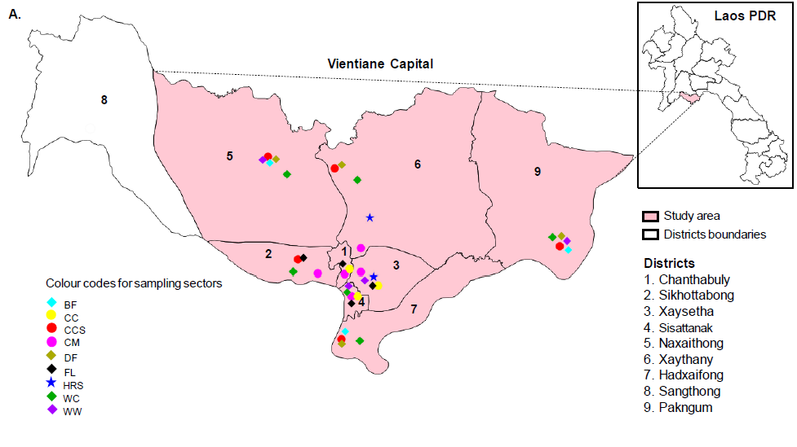
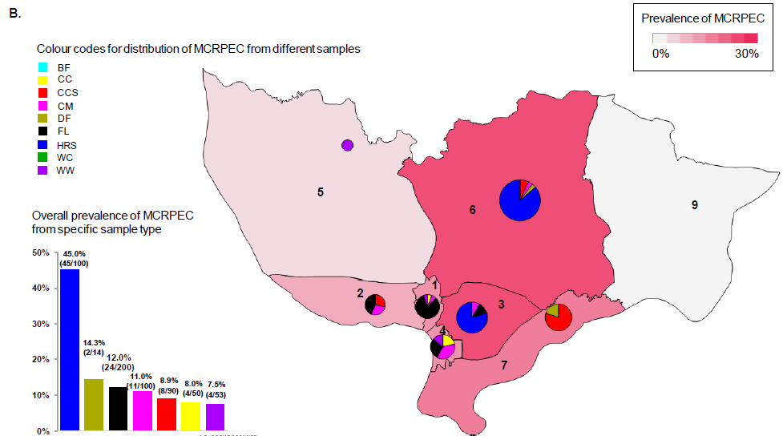
Fig. S1. Map representing sampling locations and MCRPEC prevalence among different sampling sectors in various districts of Laos. (A) Sampling areas in this study, indicated by pink in the map. The numbers 1-9 represent different districts in Vientiane capital. (B) The comparative prevalence of MCRPEC among different sampling sectors in various districts of Laos. The pie charts represent the distribution of MCRPEC from different sampling sectors. Intensity of color in the map and size of pie chart are proportional to increased prevalence of MCRPEC from different districts of Vientiane. The bar chart descries the prevalence of MCRPEC from specific sample type.
Table S1. Metadata definition.
Metadata | Description
Sex | Male or female
District | Based on locality (https://lao.unfpa.org/sites/default/files/pub-pdf/PHC-ENG-FNAL-WEB_0.pdf)
Occupation | Whether the participants were either crop farmer or livestock farmer or unemployed, but statistical analysis was performed only if the participants either raised domestic animals or not as some of the crop farmers had domestic animals
Domestic animals | Whether the participants either raised domestic animals or not
Own farm | Whether the participants were either farm owner or not
Drinking habit | Source of daily-drinking water (either filter water or boiled water or bottled water)
Diet | Whether the participants were either vegetarians or non-vegetarians
Toilet facilities | Type of toilet (either flush or squat or both flush and squat)
Previous antibiotics usage within 3 months | Whether the participants either had history of taking antibiotics within 3 months of sampling or not

Table S2. The origins, sources, STs and plasmid replicon types of recipients for the conjugation assays in this study.
Recipient ID | Countries of origin | Sample sources | STs | Plasmid replicon types
BST-10 | Brazil | Human (blood) | ST131 | IncX3, IncI1-I, IncN, IncFIB, IncFII
FMM.1882 | Laos | Flies | ST10 | Col
CX-17 | China | Animal | ST1193 | Col
BD.DM.147b | Bangladesh | Human (urine) | ST167 | IncFIB, IncFII
J53 | Laboratory strain | - | ST10 | -
Table S3. Primers of gene mcr-1 and mcr-3 for screening and qPCR.
Primer name | Sequence (5'-3') | Length | Tm (°C) | Application | Reference
mcr-1-F | GCTACTGATCACCACGCTGT | 985bp | 60 | PCR screening | [15]
mcr-1-R | TGGCAGCGACAAAGTCATCT
mcr-3.1-F | TTGGCACTGTATTTTGCATTT | 542bp | 59 | PCR screening | [20]
mcr-3.1-R | TTAACGAAATTGGCTGGAACA
rpoB-qF | TCCTTTCTATCCAGCTTGACTCGT | ~200bp | 60 | qPCR | [15]
rpoB-qR | CGCAGTTTAACGCGCAGCGG
rpoB Ec probe | HEX-ACGTCAGCTACCGCCTTGGCGAACCGGTGT-BHQ1
mcr-3-qF | CGTGTTCCTATGCAGGTGTG | ~150bp | 60 | qPCR | [20]
mcr-3-qR | CGAGTATCAGCGGCTTTCTG
mcr-3-probe | FAM-TGCAAACACGCCATATCAACGCCT-BHQ1
mcr-1-qF | TGGCGTTCAGCAGTCATTAT | ~120bp | 60 | qPCR | [15]
mcr-1-qR | AGCTTACCCACCGAGTAGAT
mcr-1-probe | FAM-AGTTTCTTTCGCGTGCATAAGCCG-BHQ1

Table S4. Univariable logistic regression analysis for MCRPEC prevalence from different sampling sectors.
Sampling sectors | MCRPEC (n=98) | OTHERS* (n=575) | p value | OR | 95% CI
Human rectal (n=100) | 45 (45.9） | 55 (9.6） | <0.0001 | 0.125 | 0.077-0.202
Flies (n=200) | 24 (24.5) | 176 (30.6) | 0.222 | 1.360 | 0.830-2.228
Chicken cloacal (n=90) | 8 (8.2) | 82 (14.3) | 0.106 | 1.871 | 0.875-4.001
Chicken caeca (n=50) | 4 (4.1) | 46 (8.0) | 0.180 | 2.043 | 0.719-5.810
Chicken meat (n=100) | 11 (11.2) | 89 (15.5) | 0.276 | 1.448 | 0.744-2.821
Dog feces (n=14) | 2 (2.0) | 12 (2.1) | 0.976 | 1.023 | 0.225-4.643
Wastewater (n=53) | 4 (4.1) | 49 (8.5) | 0.141 | 2.189 | 0.772-6.209
Water from canals, rivers, and reservoirs (n=50) | 0 (0) | 50 (8.7） | - | - | -
Bird feces (n=16) | 0 (0) | 16 (2.8） | - | - | -
Note: *OTHERS refers to samples from which MCRPEC were not isolated. Values in parentheses indicate column percentage. Statistical significance was set at p < 0.05.
Table S5. Univariable logistic regression analysis for MCRPEC prevalence in samples from different locations in Laos.
Sampling locations | MCRPEC (n=98) | OTHERS* (n=575) | p value | OR | 95% CI
Chanthabuly | 17 (11.6) | 129 (88.4) | 0.260 | 0.726 | 0.415-1.268
Hadxaifong | 5 (14.7) | 29 (85.30) | 0.980 | 1.012 | 0.382-2.682
Pakngum | 0 | 45 (100.0) | - | - | -
Naxaithong | 1 (2.5) | 39 (97.5) | 0.055 | 0.142 | 0.019-1.043
Sikhottabong | 7 (8.5) | 75 (91.5) | 0.104 | 0.513 | 0.229-1.148
Sisattanak | 14 (12.1) | 102 (87.9) | 0.404 | 0.773 | 0.422-1.415
Xaysetha | 25 (19.7) | 102 (80.3) | 0.071 | 1.588 | 0.961-2.624
Xaythany | 29 (34.9) | 54 (65.1) | <0.0001 | 4.055 | 2.420-6.796
Note: *OTHERS refers to samples from which MCRPEC were not isolated. Values in parentheses indicate column percentage. Statistical significance was set at p < 0.05.
Table S6. Univariable logistic regression analysis to assess the risks for human faecal carriage of MCRPEC.
Attributes |  | MCRPEC (n=45) | OTHERS*  (n=55) | p value | OR | 95% CI
Sex | Female | 35 (77.8) | 36 (65.5) | 0.179 | 0.541 | 0.221-1.326
Sex | Male | 10 (22.2) | 19 (34.5) | 0.179 | 0.541 | 0.221-1.326
District | Xaysetha | 20 (44.4) | 31 (56.4) | 0.237 | 1.615 | 0.730-3.570
District | Xaythany | 25 (55.6) | 24 (43.6) | 0.237 | 1.615 | 0.730-3.570
Domestic animals | Yes | 31 (68.9) | 27 (49.1) | 0.048 | 2.296 | 1.008-5.231
Domestic animals | No | 14 (31.1) | 28 (50.9) | 0.048 | 2.296 | 1.008-5.231
Own farm | Yes | 1 (2.2) | 6 (10.9) | 0.126 | 0.186 | 0.021-1.603
Own farm | No | 44 (97.8) | 49 (89.1) | 0.126 | 0.186 | 0.021-1.603
Drinking water | Filter water | 2 (4.4) | 4 (7.3) | 0.557 | 0.593 | 0.104-3.396
Drinking water | Boiled water | 1 (2.2) | 1 (1.8) | 0.886 | 1.227 | 0.075-20.187
Drinking water | Bottled water | 42 (93.3) | 50 (90.9) | 0.658 | 1.400 | 0.316-6.206
Toilet facilities | Flush | 7 (15.6) | 12 (21.8) | 0.429 | 0.660 | 0.236-1.848
Toilet facilities | Squat | 35 (77.8) | 37 (67.3) | 0.247 | 1.703 | 0.692-4.191
Toilet facilities | Flush & squat | 3 (6.7) | 6 (10.9) | 0.465 | 0.583 | 0.137-2.477
Previous antibiotics usage within 3 months | Yes | 10 (22.2) | 12 (21.8) | 0.961 | 1.024 | 0.396-2.648
Previous antibiotics usage within 3 months | No | 35 (77.8) | 43 (78.2) | 0.961 | 1.024 | 0.396-2.648
Note: *OTHERS refers to samples from which MCRPEC were not isolated. Values in parentheses indicate column percentage. Dietary habit was not considered for risk assessment seeing most of the participants (98/100) nonvegetarians. Statistical significance was set at p < 0.05.
Table S7. Univariable logistic regression analysis for the distribution of antimicrobial resistance genes in MCRPEC and MCRNEC.
ARGs | MCRPEC (n=98) | MCRNEC (n=140) | p value | OR | 95% CI
aac(3)-IId | 28 (28.6%) | 4 (2.9%) | <0.0001 | 13.6 | 4.588-40.313
aadA2 | 50 (51.0%) | 22 (15.7%) | <0.0001 | 5.587 | 3.056-10.215
aadA5 | 7 (7.1%) | 7 (5.0%) | 0.491 | 1.462 | 0.496-4.308
aph(3'')-Ib | 36 (36.7%) | 28 (20.0%) | 0.005 | 2.323 | 1.296-4.162
aph(3')-Ia | 25 (25.5%) | 5 (3.6%) | <0.0001 | 0.108 | 0.040-0.294
aph(6)-Id | 35 (35.7%) | 29 (20.7%) | 0.011 | 2.126 | 1.189-3.802
ARR-3 | 6 (6.1%) | 4 (2.9%) | 0.227 | 2.217 | 0.609-8.076
bla_{TEM-1B} | 63 (64.3%) | 63 (45.0%) | 0.004 | 2.200 | 1.294-3.740
catA1 | 4 (4.1%) | 7 (5.0%) | 0.740 | 0.809 | 0.230-2.840
cmlA1 | 47 (48.0%) | 25 (17.9%) | <0.0001 | 4.239 | 2.358-7.622
dfrA12 | 40 (40.8%) | 17 (12.1%) | <0.0001 | 4.990 | 2.611-9.536
dfrA14 | 21 (21.4%) | 18 (12.9%) | 0.081 | 1.848 | 0.926-3.690
dfrA17 | 8 (8.2%) | 8 (5.7%) | 0.460 | 1.467 | 0.531-4.051
floR | 53 (54.1%) | 19 (13.6%) | <0.0001 | 7.501 | 4.011-14.026
mef(B) | 16 (16.3%) | 5 (3.6%) | 0.002 | 5.268 | 1.860-14.920
mph(A) | 26 (26.5%) | 8 (5.7%) | <0.0001 | 5.958 | 2.565-13.841
oqxA | 23 (23.5%) | 0 | - | - | -
oqxB | 23 (23.5%) | 0 | - | - | -
qnrS1 | 53 (54.1%) | 35 (25.0%) | <0.0001 | 3.533 | 2.035-6.134
sul2 | 44 (44.9%) | 33 (23.6%) | 0.001 | 2.642 | 1.513-4.613
sul3 | 54 (55.1%) | 27 (19.3%) | <0.0001 | 5.136 | 2.880-9.160
tet(A) | 73 (74.5%) | 62 (44.3%) | <0.0001 | 3.674 | 2.091-6.453
tet(B) | 7 (7.1%) | 17 (12.1%) | 0.212 | 0.557 | 0.222-1.398
tet(M) | 29 (29.6%) | 7 (5.0%) | <0.0001 | 7.986 | 3.329-19.158
Note: Values in parentheses indicate column percentage. Statistical significance was set at p < 0.05.
Table S8. Univariable logistic regression analysis for the distribution of MCRPEC and MCRNEC among the prevalent STs.
STs | MCRPEC (n=98) | MCRNEC (n=140) | p value | OR | 95% CI
ST48 | 6 (6.1%) | 11 (7.9%) | 0.610 | 0.765 | 0.273-2.142
ST206 | 4 (4.1%) | 6 (4.3%) | 0.938 | 0.950 | 0.261-3.461
ST10 | 5 (5.1%) | 4 (2.9%) | 0.378 | 1.828 | 0.478-6.988
ST58 | 3 (3.1%) | 6 (4.3%) | 0.628 | 0.705 | 0.172-2.891
ST46 | 2 (2.0%) | 5 (3.6%) | 0.497 | 0.563 | 0.107-2.960
ST165 | 4 (4.1%) | 2 (1.4%) | 0.219 | 2.936 | 0.527-16.356
ST117 | 0 (0.0%) | 5 (3.6%) | - | - | -
ST5229 | 5 (5.1%) | 0 (0.0%) | - | - | -
Note: Values in parentheses indicate column percentage. Statistical significance was set at p < 0.05.
Table S9. Prevalence of samples from different sectors in predominant STs.
Sampling sectors | ST48 (n=17) | ST206 (n=10) | ST10 (n=9) | ST58 (n=9)
CCS (n=50) | 6 (35.3) | 4 (40.0) | 1 (11.1) | 0
CCS (n=50) | p=0.133 | p=0.132 | p=0.457 | 0
CC (n=11) | 4 (23.5) | 0 | 0 | 0
CC (n=11) | p=0.0001 | 0 | 0 | 0
CM (n=12) | 0 | 3 (30.0) | 0 | 0
CM (n=12) | 0 | p=0.0002 | 0 | 0
HRS (n=65) | 2 (11.8) | 1 (10.0) | 4 (44.4) | 0
HRS (n=65) | p=0.135 | p=0.209 | p=0.240 | 0
FL (n=93) | 5 (29.4) | 1 (10.0) | 4 (44.4) | 9 (100.0)
FL (n=93) | p=0.507 | p=0.113 | p=0.686 | -
Note: Values in parentheses indicate column percentage. The chi-square (χ²) test was performed to compare of distribution of isolates from different sectors in predominant STs. CCS, chicken cloacal swabs; CC, chicken caeca; CM, chicken meat; HRS, human rectal swabs; FL: flies. Statistical significance was set at p < 0.05. Isolate of ST206 recovered from dog faeces (n=1) was not shown in the table.
Table S10. Univariable logistic regression analysis for the distribution of MCRPEC and MCRNEC among phylogroups.
Phylogroups | MCRPEC (n=98) | MCRNEC (n=140) | p value | OR | 95% CI
A | 59 (44.4%) | 74 (55.6%) | 0.262 | 1.349 | 0.800-2.277
B1 | 30 (42.9%) | 40 (57.1%) | 0.734 | 1.103 | 0.627-1.940
B2 | 2 (66.7%) | 1 (33.3%) | 0.388 | 2.896 | 0.259-32.388
C | 2 (66.7%) | 1 (33.3%) | 0.388 | 2.896 | 0.259-32.388
D | 3 (33.3%) | 6 (66.7%) | 0.628 | 0.705 | 0.172-2.891
E | 2 (22.2%) | 7 (77.8%) | 0.254 | 0.396 | 0.080-1.947
F | 0 | 4 (100.0%) | - | - | -
G | 0 | 6 (100.0%) | - | - | -
Clade I | 0 | 1 (100.0%) | - | - | -
Note: Values in parentheses indicate column percentage. Statistical significance was set at p < 0.05.
Table S11. Univariable logistic regression analysis for the distribution of virulence genes in MCRPEC and MCRNEC.
VRGs | MCRPEC (n=98) | MCRNEC (n=140) | p value | OR | 95% CI
aslA | 11 (11.2%) | 21 (15.0%） | 0.402 | 0.716 | 0.328-1.563
astA | 19 (19.4%) | 24 (17.1%) | 0.658 | 1.162 | 0.597-2.263
chuU | 7 (7.1%) | 25 (17.9%) | 0.021 | 0.354 | 0.146-0.855
chuV | 7 (7.1%) | 25 (17.9%) | 0.021 | 0.354 | 0.146-0.855
chuW | 7 (7.1%) | 25 (17.9%) | 0.021 | 0.354 | 0.146-0.855
chuY | 6 (6.1%) | 18 (12.9%) | 0.097 | 0.442 | 0.169-1.158
entD | 40 (40.8%) | 49 (35.0%) | 0.362 | 1.281 | 0.752-2.180
espL1 | 60 (61.2%) | 103 (73.6%) | 0.045 | 0.567 | 0.326-0.986
espL4 | 16 (16.3%) | 28 (20.0%) | 0.473 | 0.780 | 0.397-1.536
espX5 | 76 (77.6%) | 110 (78.6%) | 0.851 | 0.942 | 0.505-1.757
fimB | 68 (69.4%) | 87 (62.1%) | 0.249 | 1.381 | 0.798-2.390
fimC | 78 (79.6%) | 96 (68.6%) | 0.061 | 1.787 | 0.974-3.280
fimD | 76 (77.6%) | 102 (72.9%) | 0.412 | 1.287 | 0.704-2.353
fimE | 76 (77.6%) | 92 (65.7%) | 0.050 | 1.802 | 1.000-3.248
fimF | 89 (90.8%) | 114 (81.4%) | 0.048 | 2.255 | 1.006-5.055
fimG | 89 (90.8%) | 114 (81.4%) | 0.048 | 2.255 | 1.006-5.055
fimH | 91 (92.9%) | 122 (87.1%) | 0.163 | 1.918 | 0.769-4.785
fimI | 78 (79.6%) | 99 (70.7%) | 0.124 | 1.615 | 0.876-2.977
fyuA | 12 (12.2%) | 13 (9.3%) | 0.465 | 1.363 | 0.594-3.129
gspC | 46 (46.9%) | 63 (45.0%) | 0.768 | 1.081 | 0.644-1.815
gspD | 54 (55.1%) | 81 (57.9%) | 0.673 | 0.894 | 0.531-1.504
gspE | 51 (52.0%) | 76 (54.3%) | 0.733 | 0.914 | 0.545-1.533
gspF | 48 (49.0%) | 79 (56.4%) | 0.257 | 0.741 | 0.442-1.245
gspG | 35 (35.7%) | 65 (46.4%) | 0.100 | 0.641 | 0.377-1.089
gspH | 55 (56.1%) | 88 (62.9%) | 0.297 | 0.756 | 0.447-1.279
gspI | 38 (38.8%) | 62 (44.3%) | 0.397 | 0.797 | 0.471-1.348
gspJ | 53 (54.1%) | 87 (62.1%) | 0.214 | 0.717 | 0.425-1.212
gspK | 60 (61.2%) | 97 (69.3%) | 0.197 | 0.700 | 0.407-1.204
gspL | 58 (59.2%) | 84 (60.0%) | 0.899 | 0.967 | 0.571-1.636
gspM | 36 (36.7%) | 46 (32.9%) | 0.536 | 1.187 | 0.691-2.039
iroC | 11 (11.2%) | 10 (7.1%) | 0.278 | 1.644 | 0.669-4.036
irp1 | 12 (12.2%) | 13 (9.3%) | 0.465 | 1.363 | 0.594-3.129
irp2 | 12 (12.2%) | 13 (9.3%) | 0.465 | 1.363 | 0.594-3.129
iucB | 15 (15.3%) | 17 (12.1%) | 0.482 | 1.308 | 0.619-2.763
iucC | 13 (13.3%) | 16 (11.4%) | 0.670 | 1.185 | 0.542-2.591
iutA | 13 (13.3%) | 16 (11.4%) | 0.670 | 1.185 | 0.542-2.591
kpsD | 11 (11.2%) | 12 (8.6%) | 0.497 | 1.349 | 0.569-3.194
ompA | 68 (69.4%) | 106 (75.7%) | 0.280 | 0.727 | 0.408-1.296
shuA | 5 (5.1%) | 22 (15.7%) | 0.016 | 0.288 | 0.105-0.790
shuS | 5 (5.1%) | 18 (12.9%) | 0.054 | 0.364 | 0.130-1.018
shuX | 5 (5.1%) | 21 (15.0%) | 0.021 | 0.305 | 0.111-0.838
ugd | 9 (9.2%) | 12 (8.6%) | 0.870 | 1.079 | 0.436-2.668
yagW/ecpD | 78 (79.6%) | 106 (75.7%) | 0.483 | 1.251 | 0.670-2.337
yagX/ecpC | 73 (74.5%) | 99 (70.7%) | 0.522 | 1.209 | 0.676-2.164
yagY/ecpB | 78 (79.6%) | 105 (75.0%) | 0.409 | 1.300 | 0.697-2.423
yagZ/ecpA | 80 (81.6%) | 104 (74.3%) | 0.185 | 1.538 | 0.814-2.907
ybtA | 12 (12.2%) | 14 (10.0%) | 0.585 | 1.256 | 0.554-2.847
ybtE | 12 (12.2%) | 13 (9.3%) | 0.465 | 1.363 | 0.594-3.129
ybtP | 12 (12.2%) | 14 (10.0%) | 0.585 | 1.256 | 0.554-2.847
ybtQ | 12 (12.2%) | 14 (10.0%) | 0.585 | 1.256 | 0.554-2.847
ybtS | 12 (12.2%) | 14 (10.0%) | 0.585 | 1.256 | 0.554-2.847
ybtT | 12 (12.2%) | 13 (9.3%) | 0.465 | 1.363 | 0.594-3.129
ybtU | 12 (12.2%) | 13 (9.3%) | 0.465 | 1.363 | 0.594-3.129
ybtX | 12 (12.2%) | 14 (10.0%) | 0.585 | 1.256 | 0.554-2.847
ykgK/ecpR | 76 (77.6%) | 106 (75.7%) | 0.742 | 1.108 | 0.601-2.043
Note: Values in parentheses indicate column percentage. Statistical significance was set at p < 0.05. The virulence genes, chuU, chuV, chuW, espL1, shuA and shuX were significantly present among MCRNEC.

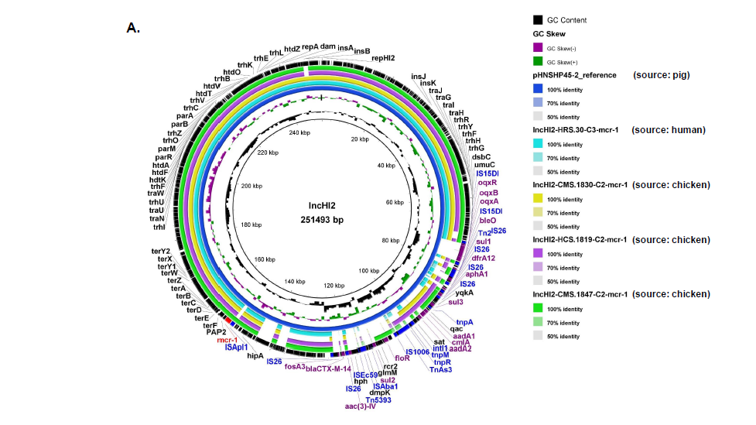
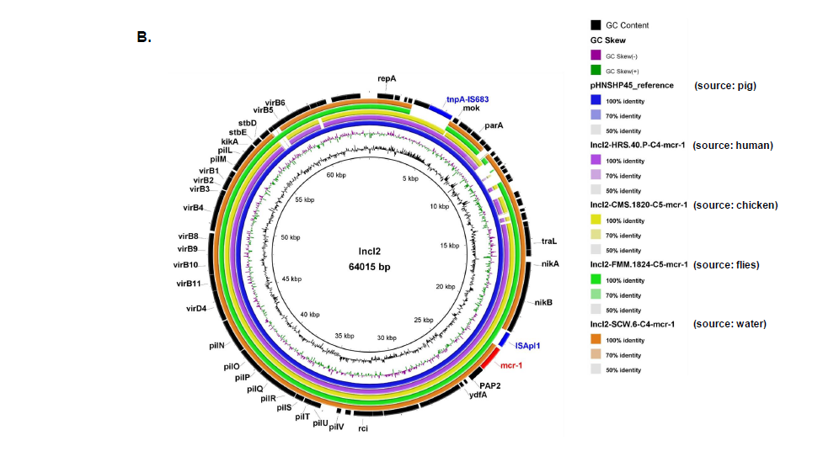
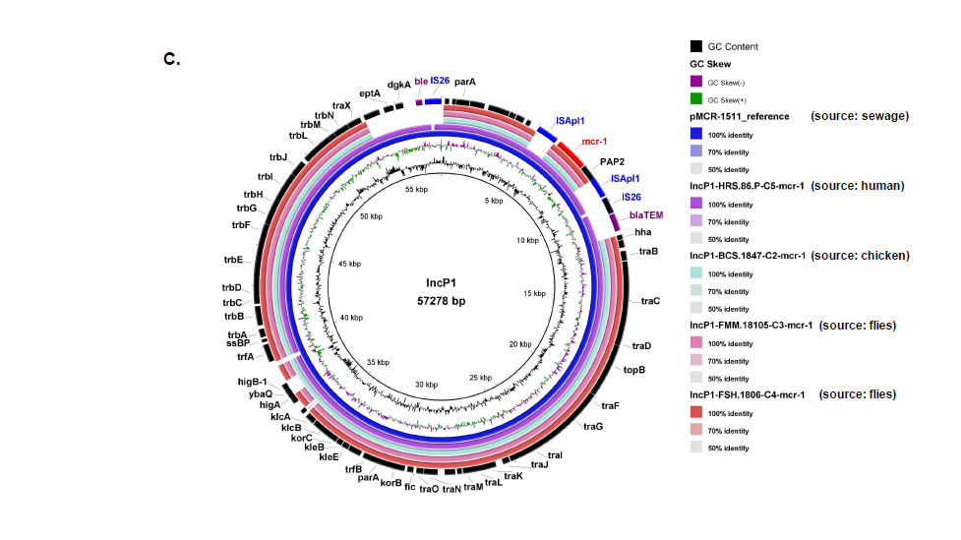
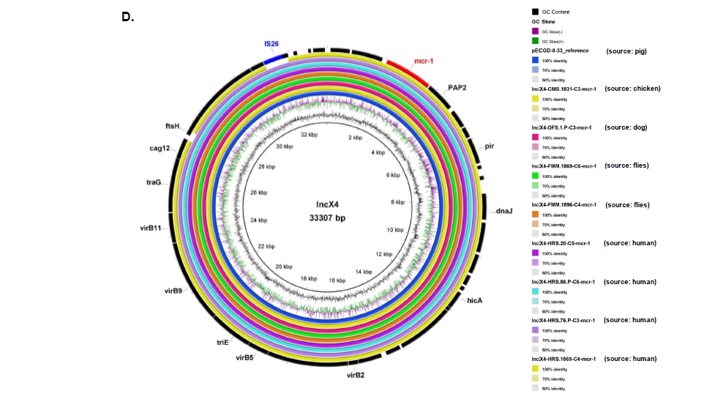
Fig. S2. Circular sequence alignments of reference plasmids with homologous contigs of four groups of plasmids harboring the mcr-1 gene using BLASTn and BLAST Ring Image Generator (BRIG). The concentric rings display similarity between the reference sequence in the inner ring and the other sequences in the outer rings. The various color levels indicate a BLAST result with a matched degree of shared regions, as shown to the right of the ring. (A) Comparative analysis of plasmids belonged to IncHI2. Plasmid, pHNSHP45-2 (accession number: KU341381) was used as reference. (B) Comparative analysis of plasmids belonged to IncI2. Plasmid, Phnshp45 (accession number: KP347127) was used as reference. (C) Comparative analysis of plasmids belonged to IncP1. Plasmid, pMCR_1511 (accession number: KX377410) was used as reference. (D) Comparative analysis of plasmids belonged to IncX4. Plasmid, pECGD-8-33 (accession number: KX254343) was used as reference.
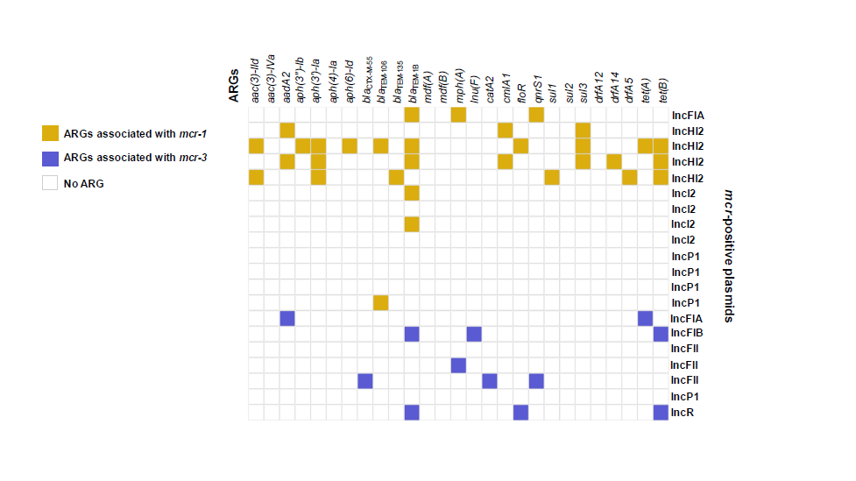
Fig. S3. Heatmap representing the associations between mcr variants with other ARGs located in the respective plasmid background. The presence of ARGs is denoted by colors. IncX4 plasmids are not included in this figure as none of the plasmids contained ARGs other than mcr-1.1.

Table S12. Transfer rates of plasmids carrying mcr among ten donors and recipients of four STs and E. coli J53.
Donor strain | Source | STs | Plasmids harboring mcr | Size of plasmids (bp) | Transfer rates  (No. of transconjugants/donor)
 |  |  |  |  | ST10 | ST131 | ST1193 | ST167 | J53
FMM.1860 | Flies | ST58 | IncFII | 71,212 | 7.6e-04 | 1.3e-04 | 8.5e-07 | 7.6e-05 | 3.2e-01
HRS.1827 | Human | ST226 | IncFII | 87,148 | 2.2e-04 | 2.5e-05 | 3.3e-07 | 1.9e-04 | 4.4e-02
HCS.1819 | Chicken | ST212 | IncHI2 | 278,445 | ND | ND | 8.8e-06 | ND | 3.3e-07
CMS.1847 | Chicken | ST373 | IncHI2 | 253,557 | ND | ND | 4.9e-03 | ND | 1.9e-03
CMS.1820 | Chicken | ST641 | IncI2 | 87,571 | 1.6e-05 | ND | 7.0e-05 | 4.2e-06 | 8.8e-02
SCW.1806 | Water | ST636 | IncI2 | 63,542 | 1.2e-04 | 1.2e-04 | 4.5e-03 | 2.5e-05 | 5.7e-01
FSH.1806 | Flies | ST4429 | IncP1 | 47,695 | 1.5e-04 | 5.0e-06 | 3.8e-03 | 8.9e-06 | 4.6e-02
BCS.1847 | Chicken | ST2690 | IncP1 | 48,815 | 3.6e-04 | 6.0e-06 | 7.5e-05 | ND | 1.4e-03
FMM.1869 | Flies | ST58 | IncX4 | 33,309 | 2.8e-06 | ND | 4.4e-07 | 5.0e-08 | 7.5e-08
HRS.1869 | Human | ST209 | IncX4 | 33,858 | 7.2e05 | 1.8e-07 | 7.3e-06 | 1.7e-05 | 2.7e-03
Note: ND refers to transconjugants not detected.
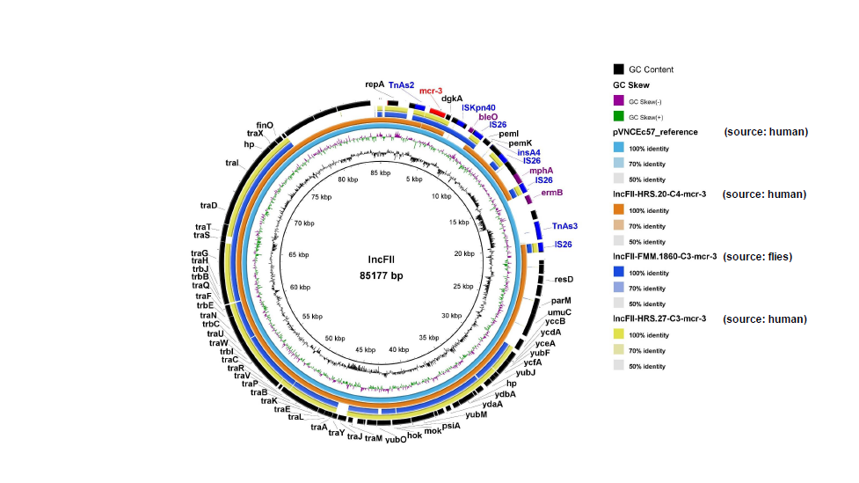
Fig. S4. Circular sequence alignments of reference plasmid, pVNCEc57 (accession number: LC549806) with homologous contigs of IncFII plasmids harboring the mcr-3 gene using BRIG. The concentric rings display similarity between the reference sequence in the inner ring and the other sequences in the outer rings. The various color levels indicate a BLAST result with a matched degree of shared regions, as shown to the right of the ring.
Table S13. The effects of particulars of donors, recipients, and Inc types of plasmids on the conjugation frequency.
Rate of conjugation based on STs of donors
Donor STs | Mean frequency of conjugation | Number of observations | p value
ST58 | 0.0001386 | 7 | 0.6924
ST226 | 6.219e-005 | 4 | 0.6924
ST212 | 1.257e-006 | 1 | 0.6924
ST373 | 0.0007 | 1 | 0.6924
ST641 | 1.289e-005 | 3 | 0.6924
ST636 | 0.0006807 | 4 | 0.6924
ST4429 | 0.0005663 | 4 | 0.6924
ST2690 | 6.300e-005 | 3 | 0.6924
ST209 | 1.378e-005 | 4 | 0.6924
Rate of conjugation based on source of donors
Source | Mean frequency of conjugation | Number of observations | p value
Human | 6.648e-005 | 8 | 0.5967
Chicken | 0.00068 | 8 | 0.5967
Water | 0.001191 | 4 | 0.5967
Flies | 0.0004485 | 11 | 0.5967
Rate of conjugation based on plasmids carrying mcr of different Inc types
Inc types | Mean frequency of conjugation | Number of observations | p value
IncFII | 0.0001753 | 8 | 0.7875
IncHI2 | 0.0006136 | 2 | 0.7875
IncI2 | 0.0006069 | 7 | 0.7875
IncP1 | 0.0005506 | 7 | 0.7875
IncX4 | 1.247e-005 | 7 | 0.7875
Rate of conjugation based on recipient STs
Recipient STs | Mean frequency of conjugation | Number of observations | p value
ST10 | 0.0001701 | 8 | 0.0256
ST131 | 2.862e-005 | 6 | 0.0256
ST167 | 3.212e-005 | 8 | 0.0256
ST1193 | 0.001336 | 7 | 0.0256
Note: The conjugation frequency data was assessed using one-way analysis (ANOVA) (GraphPad v7.04). Statistical significance was set at p < 0.05.

