Supplementary data for

Recognition of Fluvial Bank Erosion Along the Main Stream of the Yangtze River
Ge Yan ª, Heqin Cheng ^{a,c,}*, Zeyu Jiang ª, Lizhi Teng ª, Ming Tang ª, Tian Shi ª, Yuehua Jiang ^{b}, Guoqiang Yang ^{b}, Quanping Zhou ^{b}
ª State Key Laboratory of Estuarine and Coastal Research, East China Normal University, Shanghai 200000, China
^{b} Nanjing Center, China Geological Survey, Nanjing 210000, China
^{b} Institute of Eco-Chongming, Shanghai 200000, China

* Corresponding author.
E-mail address: hqch@sklec.ecnu.edu.cn (H. Cheng)

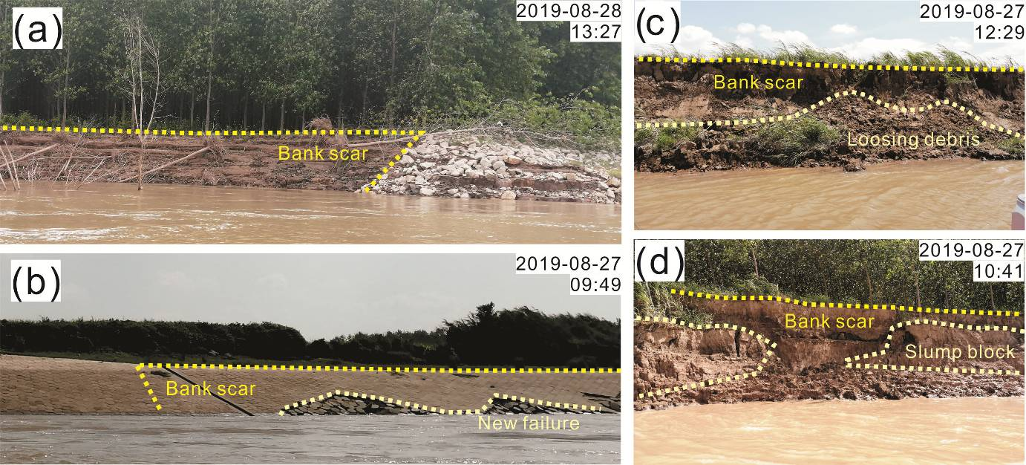
Fig. S1 Photos of bank erosion, including arc collapse at NBZ 1 (a) and NBZ 3 (b), and strip collapse at NBZ 2 (c) and NBZ 6 (d).

Table S1
Different flatness in existing literature for various landscape.
Researchers | Time | Elevation range | Grid size (m) | Lookup distance | Flatness (°) | Landscape
Jasiewicz and Stepinski [26] | 2013 | about 0 to 2500 m | 30 | 50 cells / 1500 m | 1 | Coastal plains, Lowlands, Uplands and Mountains
Pinto et al. [31] | 2016 | 1137 to 1733 m | 10 | 60 cell/ 600 m | 1 | Fluvial plains
Kramm et al. [32] | 2017 | 45 m and 300 m above mean sea level | 5,10,30 | 5,10,20 cell / 25-600 m | 3 | Loess plateau
Luo and Liu. [33] | 2018 | 10/100m to 2000m above sea level | about 50 | 50 cell / 2500 m | 1 | Coastal area and Mountain
Flynn et al. [35] | 2019 | 94 m to 218 m above sea level | 30 | 200 cell / 6000 m | 1 | Tributary catchment
Cui et al. [27] | 2020 | 1180 to 4246 m depth | 250 | 37 cell / 9250 m | 3 | Seafloor

