Supplementary Data for

Machine-Learning-Assisted Compositional Design of Refractory High-Entropy Alloys with Optimal Strength and Ductility
Cheng Wen ^{a,b}, Yan Zhang ^{b,c}, Changxin Wang ^{b,c}, Haiyou Huang ^{c}, Yuan Wu ^{d}, Turab Lookman ^{e,}*, Yanjing Su ^{b,c,}*
ª School of Mechanical and Power Engineering, Guangdong Ocean University, Zhanjiang 529500, China
^{b} Beijing Advanced Innovation Center for Materials Genome Engineering, University of Science and Technology Beijing, Beijing 100083, China
^{c} Corrosion and Protection Center, University of Science and Technology Beijing, Beijing 100083, China
^{d} State Key Laboratory for Advanced Metals and Materials, University of Science and Technology Beijing, Beijing 100083, China
^{e} AiMaterials Research LLC, Santa Fe, NM 87501, USA

* Corresponding authors.
E-mail addresses: turablookman@gmail.com (T. Lookman), yjsu@ustb.edu.cn (Y. Su).

S1. Machine learning for property prediction
In order to select ML models to predict the two target properties of RHEAs, we evaluated nine models commonly used in regression, including enet (elastic net model), svr.l (support vector regression model with linear kernel), krr (kernel ridge regression model), svr.r (support vector regression model with radial based kernel), gp (Gaussian process model), rf (random forest model), xgb (extreme gradient boosting model), nn (neural network model) and knn (k-Nearest neighbor). To construct the ML models, 80% of the initial data samples were used as training data with five-fold cross validation to optimize model parameters. Model performance was evaluated by testing the model on the remaining 20% of the data. We used the “caret” package with five-fold cross validation. We set the range of hyperparameters, such as the k value for knn, the C and sigma values for svr.r, to be optimized for different ML models. The parameter ranges for different ML models and the final choice of the parameters are given in Table S1. This process was repeated 100 times by splitting randomly different training set and testing set, to eliminate the effect of data partition on model evaluation. The mean prediction was then used as a measure for model selection. Three indicators of RMSE (root mean square error), MAE (mean absolute error) and r² (Pearson correlation coefficient) were adopted to evaluate the performance of ML models. These are defined as follows:
,
where n is the number of samples; y_{exp} and y_{pre} represent the experimental and predicted values, respectively. The RMSE and MAE monitor the deviation of predicted result from experimental value. The r² describes the correlation between variable x and variable y, that is, the predicted properties and the experimental properties in our case. The smaller are RMSE and the MAE, the higher is the r² value, the better perfomance is the ML model. All the machine learning algorithms were implemented within the RStudio environment [1]. A more detailed description can be seen from the reference source involving the introduction of the used ML models (https://github.com/NLP-LOVE/ML-NLP), and the models evaluation/execution via R studio software and the associated R packages (http://topepo.github.io/caret/index.html).

Table S1
The parameters used for different ML models with the final choice made by five-fold cross validation
ML models | Parameters range | Parameter choice
enet | lambda (0.01, 0.05, 0.1, 0.5, 1)  fraction (0, 0.1, 0.3, 0.5, 0.7, 0.9, 1) | lambda (0.1), fraction (0.3)
svr.l | C (10⁻³, 10⁻², 10⁻¹, 1, 10¹, 10², 10³) | C (10)
krr | group (null) | group (null)
svr.r | C (10⁻³, 10⁻², 10⁻¹, 1, 10¹, 10², 10³)  sigma (2⁻⁴, 2⁻³, 2⁻², 2⁻¹, 1, 2¹, 2², 2³, 2⁴) | C (10²), sigma (2²)
rf | ntree (range: 100–1000, step: 100)  mtry (1, 2, 3, 4, 5, 6, 7, 8, 9, 10) | ntree (500), mtry (4)
gp | sigma (2⁻⁴, 2⁻³, 2⁻², 2⁻¹, 1, 2¹, 2², 2³, 2⁴) | sigma (2⁻¹)
xgb | nrounds (range: 10–100, step: 10)  eta (range: 0.1–1, step: 0.1) | nrounds (60), eta (0.3)
nn | size (1, 2, 3, 4)  decay (0, 0.005, 0.01, 0.02, 0.03, 0.04, 0.05,) | size (1), decay (0.02)
knn | k (range: 1–10, step: 1) | k (4)

S2. EI indicator for Pareto plot
Given that the search space is quite large for the RHEAs system. It is inadequate to navigate this landscape by searching for materials with optimal properties solely based on the predictions of the ML model trained on small data. A utility function can be defined so that some alloys are selected for experiments to maximize the expected utility. In the present study, we employed the expected improvement (EI) as a utility indicator balancing exploration (aimed at improving the predictive model) and exploitation (aimed at finding the best prediction) [2]. We calculate EI values of the two target properties from ML predictions for each alloy. Specifically, we utilized the well-known statistical method of “bootstrap” sampling with replacement to build more datasets. These are used to train different ML models to predict the properties of the searched alloys via the NSGA-Ⅱ algorithm. For our preselected ML algorithm, svr.r, we trained 1000 svr.r models based on 1000 bootstrap datasets to obtain 1000 predictions for the searched alloys at each generation in NSGA-Ⅱ. The mean predicted value and standard deviation (uncertainty) are estimated from the 1000 predictions. We assume that the predictive values follow a normal distribution, thus the EI value for a given alloy can be calculated based on the standard normal density and the cumulant distribution function. Thus, in the process of genetic search via NSGA-Ⅱ, EI values of the two properties were used to obtain the final Pareto front. For each target property, we considered “bootstrap” samples to obtain the mean of the property and its associated uncertainty to evaluate EI for a given alloy composition. The detailed process is given previously [3].

S3. NSGA-Ⅱ for alloy search
We used NSGA-II (non-dominated sorting algorithm-II) [4] to search for alloys. NSGA-II is a generic non-explicit evolutionary algorithm applied to multi-objective problems based on the original design of NSGA [5]. NSGA-II builds a population of competing individuals and ranks and sorts each individual according to the level of non-domination. It applies evolutionary operations to create a new pool of offsprings, and then combines the parents and offspring before partitioning the new combined pool into fronts. It utilizes crowding distance in its selection to keep a diverse front by making sure each member stays a crowding distance apart, which helps the algorithm to explore the search space. In the present research, the original NSGA-II works with a population of individuals—here symbolizing RHEAs—over several generations. These individuals are defined as a combination of genes each corresponding to the composition of an alloying element. At each generation, the genes may be crossed and mutated in order to modify the properties of the alloys in the population, according to the EI values of the two target properties based on ML model prediction. At the end of a generation, the Darwinian “survival of the fittest” principle is applied so far the “best” or “fittest” alloys are retained in the population for the next generation to eventually obtain a Pareto optimal set. Furthermore, in order to eliminate the influence of the random initial population on the search result, we perform 100 genetic optimization processes at each iteration to obtain 100 different PFs of EI values. We sort all the alloys in the 100 PFs to determine the final PF. For the NSGA-II algorithm, our parameters included an initial population of 500, 20 generations, a crossover rate of 0.8 and mutation rate of 0.02.

S4. Cluster analysis for experimental selection
We use the K-means algorithm to cluster the candidate alloys in the optimized PF of EI values to obtain alloys for experimental synthesis and characterization. To select the final experimental alloys, we need to determine the optimal number of clusters. As a distance-based algorithm, K-means is sensitive to the range of variable values (i.e. EI values), thus logarithmic transformation and normalization are performed on the EI values of the two target properties before clustering analysis. We use the “elbow method” to determine the number of clusters by calculating the sum of squares (within-groups sum of squares (WGSS)—the sum of squares of the distances from each point to the center of the cluster to which it belongs) within groups as the number of clusters varies. The WGSS usually shows a downward trend as the number of clusters increases (if the number of clusters is equal to the number of samples, the WGSS value will be 0), and the decline rate will decrease after reaching a certain number (K) clusters. If WGSS decreases very slowly, the effect of further increase is minimal and this suggests that clustering into K categories is a good fit for the data. The “elbow” K is the final number of clusters. Once K is specified, we can cluster the alloys based on their EI values and determine the experimental alloys from the center of mass of the clusters.
The predicted properties of candidate alloys on the Pareto front (PF) changes with experimental iterations, as shown in Fig. S1. It can be seen that the distribution of the alloys in the early search has a large span, covering alloys from high fracture strain and low strength to high strength and low fracture strain. In the region of high strength, the ML predictions show large uncertainties (error bars). A similar situation can be seen in the high ductility region. The number of alloy samples with extreme values of properties in the initial data set is small. This may result in large fluctuations of the predicted properties during the genetic search because the predicted properties are obtained by the ML model trained on the data set by bootstrap sampling of the initial training data. Compared to the PF of the initial training set (T-data), all the searched candidate alloys from iteration 1 are almost dominated. From iteration 2, there appear candidate samples with properties that are not different from alloys in the PF of T-data, in the medium strength and ductility range. In iteration 3, the candidate alloys dominating all the samples from the T-data begin to appear, while in the experimental feedback to iteration 4, the predicted properties of the searched alloys are generally low. When the MOO strategy is implemented on iteration 5, the alloys searched by the NSGA-Ⅱ algorithm begin to develop towards higher yield strength, and there appears more candidate alloys that can dominate the samples of T-data. By analyzing the experimental results of the selected alloys in the first five iterations, we find that the frequency to optimize to obtain alloys with good comprehensive properties is high for the ZrNbMoHfTa alloy system with seven alloys dominating the T-data samples (Table S2). Therefore, for iteration 6, instead of searching alloys via NSGA-Ⅱ, we use only the composition space of the ZrNbMoHfTa alloy system (i.e. the content range of each element is 5–35 at%) for the next iteration to predict the properties of all the 553 401 alloys. From iteration 6, there are more candidate alloys with good HT yield strength and improved RT ductility on the PF, and we experimentally prepared the alloys with excellent properties. This suggests that ZrNbMoHfTa is a potential RHEA system identified using our MOO strategy and we obtain a batch of potential RHEAs for high temperature applications.

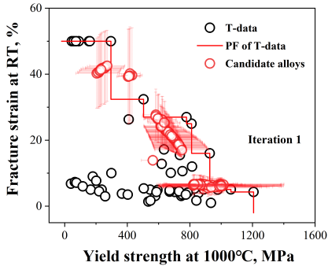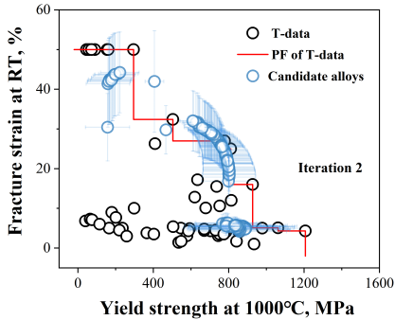
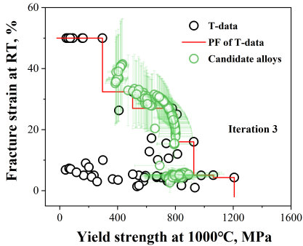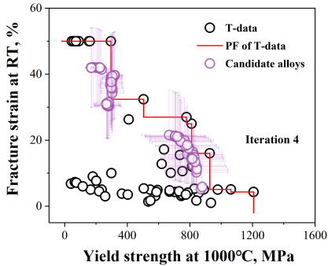
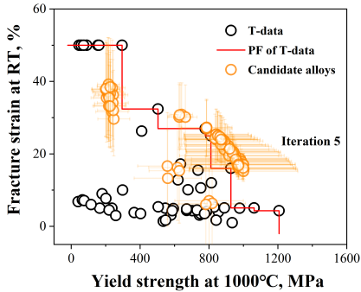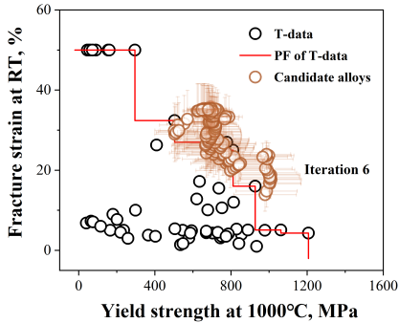
Fig. S1. The predicted properties of the searched alloys change with the number of experimental iterations.

Table S2
The designed RHEAs and their properties after six MOO iterations.
No. of iteration | No. of alloys | Alloys formula | σ_{y}^{1000℃} (MPa) | ε_{f}^{RT} (%)
Iteration 1 | E1 | Ti_{0.26}V_{0.23}Zr_{0.25}Nb_{0.26} | 76.5 | ＞50
Iteration 1 | E2 | Al_{0.23}Ti_{0.18}Zr_{0.12}Cr_{0.13}Nb_{0.19}Mo_{0.15} | 617 | 2.2
Iteration 1 | E3 | Zr_{0.22}Nb_{0.22}Mo_{0.14}Hf_{0.22}Ta_{0.2} | 717 | 32.8
Iteration 1 | E4 | Ti_{0.18}Zr_{0.1}Nb_{0.21}Mo_{0.1}Hf_{0.21}Ta_{0.2} | 550 | ＞50
Iteration 2 | E5 | Zr_{0.23}Nb_{0.23}Mo_{0.11}Hf_{0.23}Ta_{0.2} | 663 | ＞50
Iteration 2 | E6 | V_{0.2}Cr_{0.21}Nb_{0.17}Mo_{0.21}Hf_{0.21} | 548 | 4.3
Iteration 2 | E7 | Ti_{0.26}V_{0.22}Zr_{0.26}Nb_{0.26} | 59 | ＞50
Iteration 2 | E8 | Al_{0.15}Ti_{0.14}Zr_{0.22}Cr_{0.12}Nb_{0.22}Ta_{0.15} | 366 | 6.52
Iteration 3 | E9 | Al_{0.18}Ti_{0.18}Zr_{0.12}Cr_{0.14}Nb_{0.2}Mo_{0.18} | 552 | 30.3
Iteration 3 | E10 | Zr_{0.21}Nb_{0.2}Mo_{0.16}Hf_{0.23}Ta_{0.2} | 710 | 17
Iteration 3 | E11 | Ti_{0.18}Zr_{0.21}Nb_{0.2}Hf_{0.23}Ta_{0.18} | 188 | ＞50
Iteration 3 | E12 | Ti_{0.17}Zr_{0.18}Nb_{0.18}Mo_{0.1}Hf_{0.2}Ta_{0.17} | 433 | 22.6
Iteration 4 | E13 | Zr_{0.19}Nb_{0.23}Mo_{0.2}Hf_{0.18}Ta_{0.2} | 958 | 17.4
Iteration 4 | E14 | Al_{0.17}Ti_{0.19}Zr_{0.11}Cr_{0.13}Nb_{0.2}Mo_{0.2} | 890 | 4.03
Iteration 4 | E15 | Al_{0.14}Ti_{0.2}Zr_{0.07}Cr_{0.19}Nb_{0.2}Mo_{0.2} | 745 | 4.95
Iteration 4 | E16 | Al_{0.06}Ti_{0.16}Zr_{0.21}Nb_{0.18}Hf_{0.26}Ta_{0.13} | 104 | ＞50
Iteration 5 | E17 | Zr_{0.19}Nb_{0.26}Mo_{0.2}Hf_{0.16}Ta_{0.19} | 974 | 30.5
Iteration 5 | E18 | Zr_{0.21}Nb_{0.26}Mo_{0.14}Hf_{0.19}Ta_{0.2} | 870 | 34.5
Iteration 5 | E19 | Zr_{0.23}Nb_{0.28}Mo_{0.14}Hf_{0.15}Ta_{0.2} | 894 | 35.7
Iteration 5 | E20 | Zr_{0.17}Nb_{0.25}Mo_{0.22}Hf_{0.16}Ta_{0.2} | 892 | 25.4
Iteration 6 | E21 | Zr_{0.13}Nb_{0.27}Mo_{0.26}Hf_{0.13}Ta_{0.21} | 1061 | 17.2
Iteration 6 | E22 | Zr_{0.15}Nb_{0.31}Mo_{0.23}Hf_{0.14}Ta_{0.17} | 979 | 20.1
Iteration 6 | E23 | Zr_{0.21}Nb_{0.22}Mo_{0.21}Hf_{0.15}Ta_{0.21} | 998 | 15.7
Iteration 6 | E24 | Zr_{0.24}Nb_{0.29}Mo_{0.9}Hf_{0.2}Ta_{0.18} | 714 | ＞50

In addition to using the “elbow method” to obtain the number of clusters by calculating the WGSS, we also try another two widely-used Toolbox including the “NbClust” [6] and the “mclust” [7] to determine the number of cluster centers. The result is shown in Fig. S2. In “NbClust” Toolbox, 26 indicators are used to evaluate the clustering effect under the preset clusters number (from 1 to 10 here), and then the optimal number of clusters can be determined according to that the number of clusters with the most supporting indicators. From Fig. S2(a) to Fig. S2(f), we can see that the clusters number is obtained as 4 in iteration 2 to iteration 6 according to the maximum number supporting indicators, which is consistent with the result of “elbow method” shown in Fig. 3 in the manuscript. For iteration 1, although the clusters number 5 can be determined, the second most supporting indicators still show that the clusters number 4 is an acceptable number. In “mclust” Toolbox, the number range of clustering centers should be first defined (1–10 here), then there will be 14 models used to calculate the BIC (Bayesian information criterion) values under a given clusters number in the clustering process. In principle, the larger the BIC value, the better the fitting effect corresponding to the speceial clusters number. Based on the result of all the 14 models, we can determine a proper number of clusters. From Fig. S2(g) to Fig. S2(l), we can see for iteration 2 to iteration 5 the BIC values of all the evaluation models continuously increase with the increase of clusters number. Even though the number of clusters recommended by the BIC reaches 10, the BIC value of all the evaluation models tends to be basically stable when the number of clusters reaches 4. Thus we can also choose 4 as the final clusters number, by an additional consideration of the cost of iterative experiments. As for iteration 1 to iteration 6, it seems that the BIC values begin to be stable when the number of clusters approaches to 6, showing a small deviation from the result of “elbow method.” Overall, the three metrics or method give almost the same number of clusters centers in each iteration.

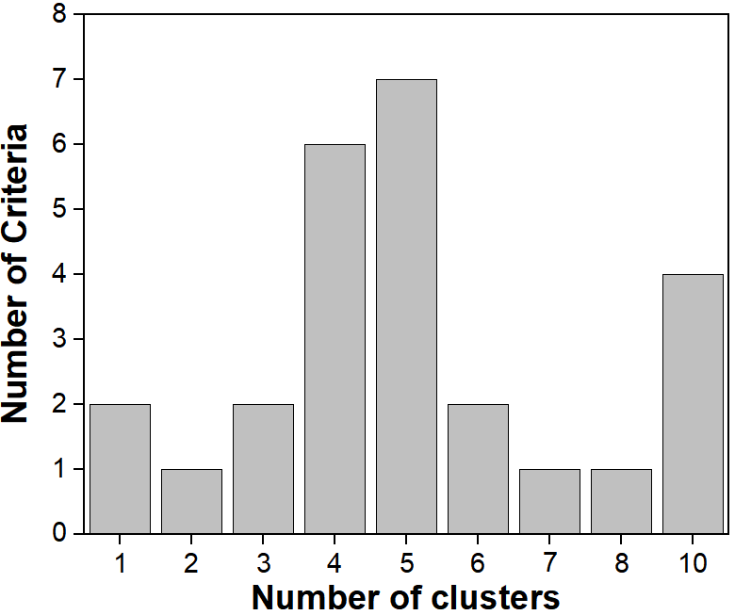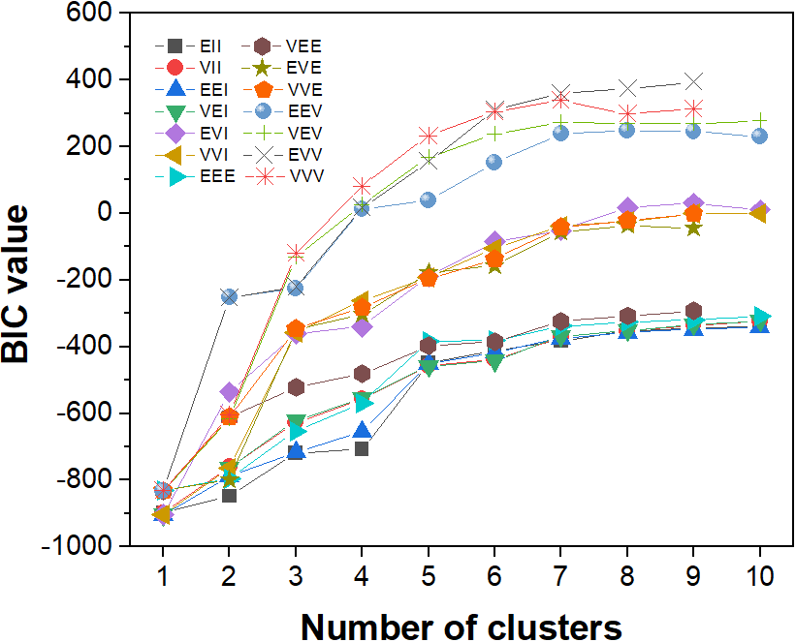
(a) (g)
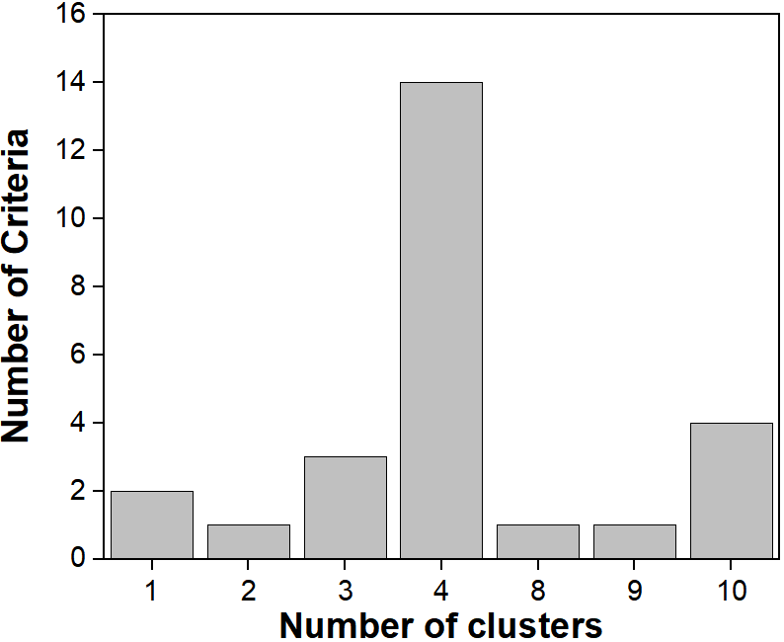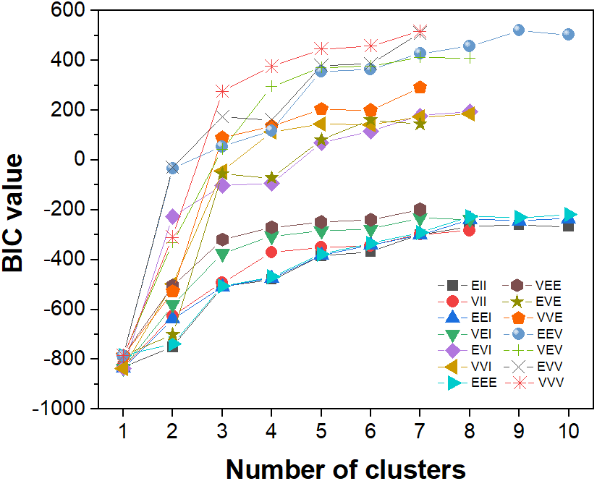
(b) (h)
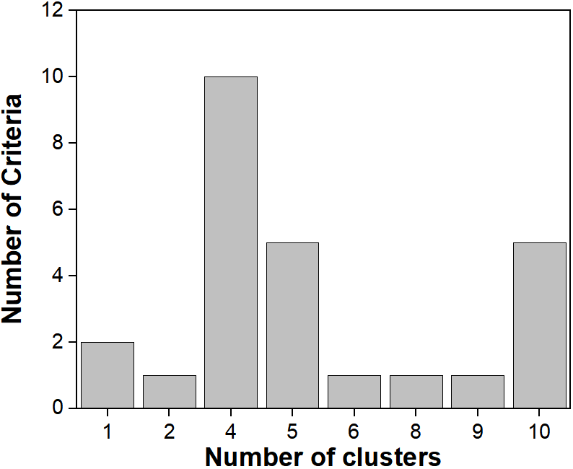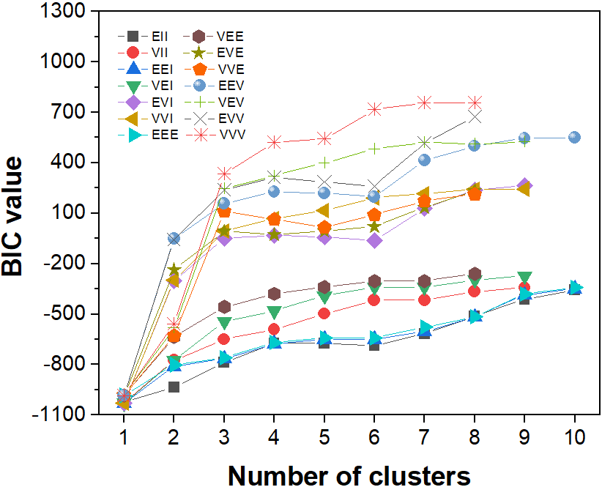
(c) (i)
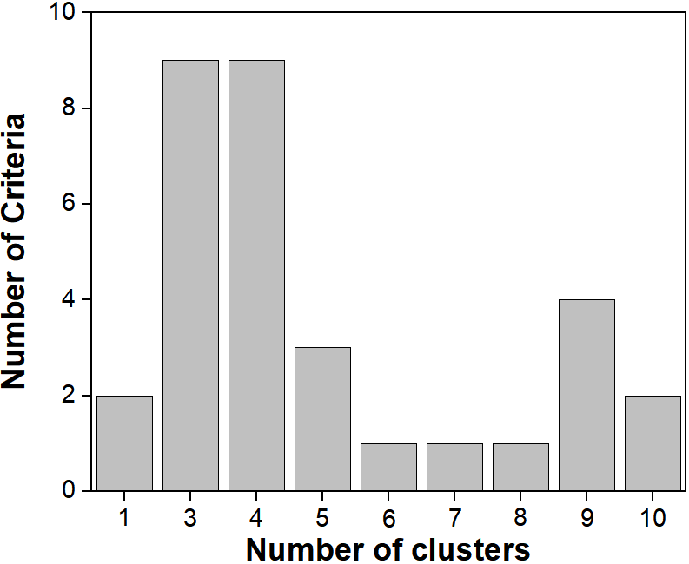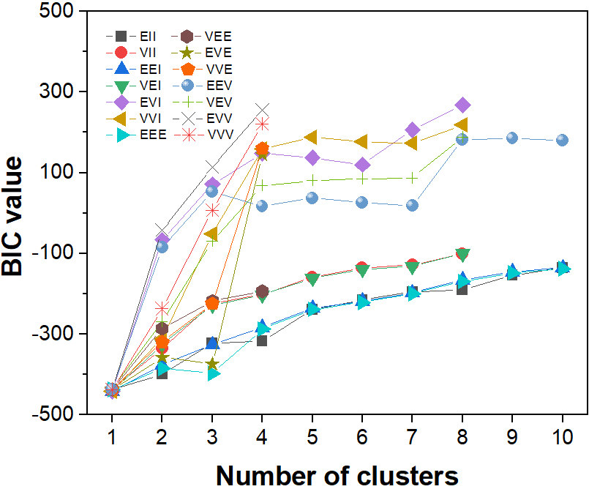
(d) (j)
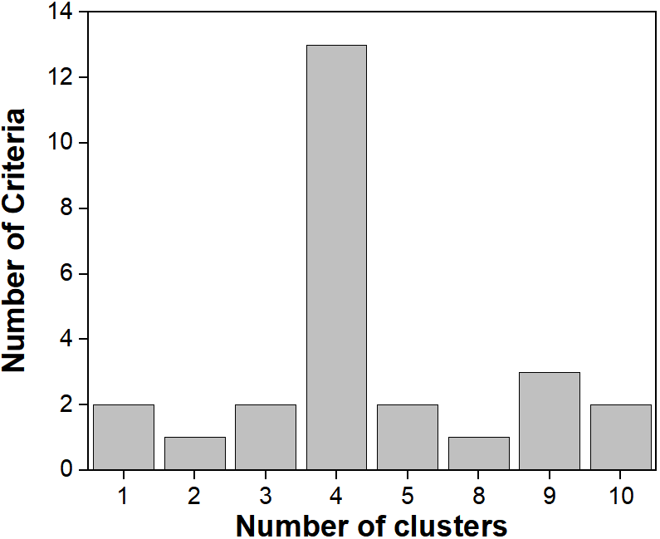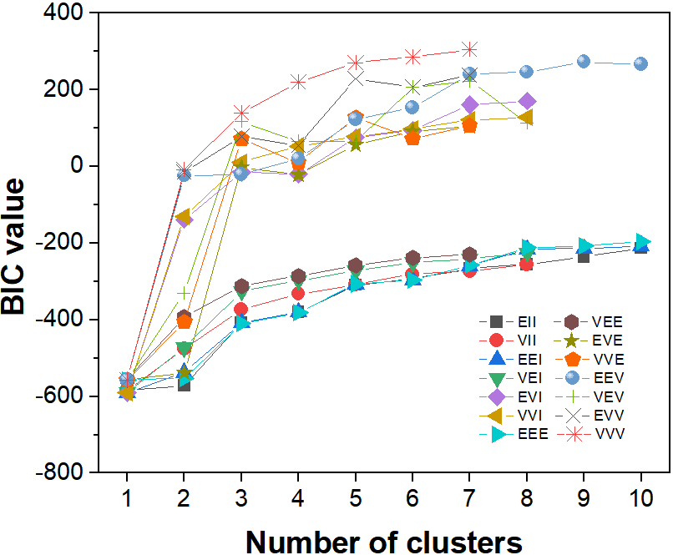
(e) (k)
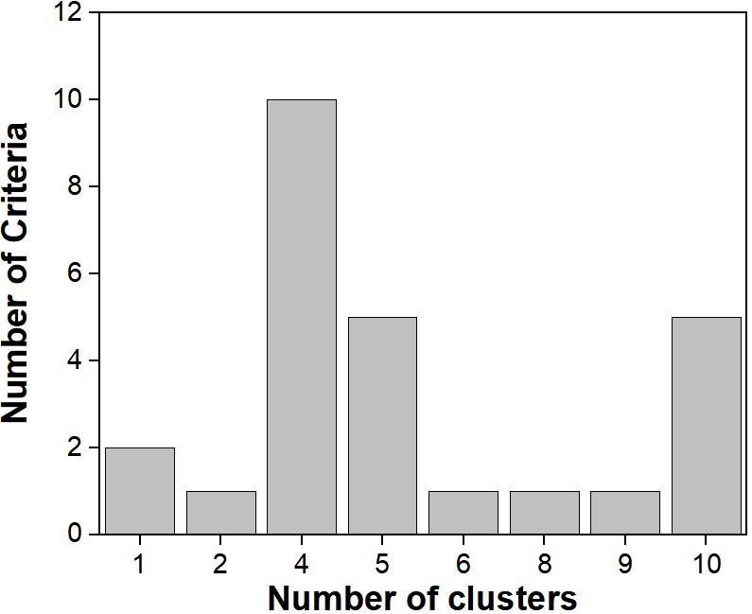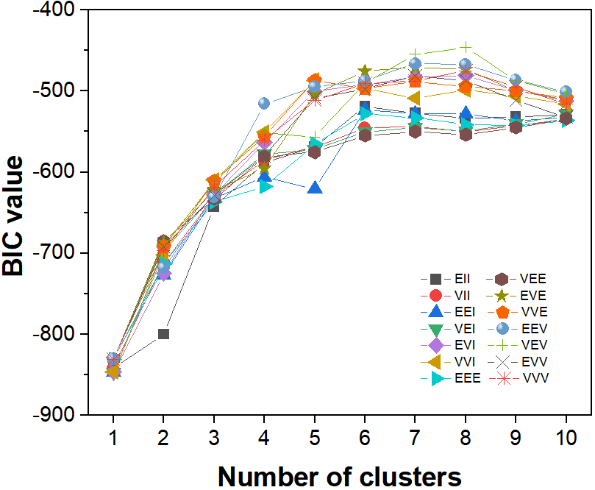
(f) (l)
Fig. S2. The number of cluster centers determined (a–f) by “NbClust” toolbox and (g–l) by “mclust” toolbox from iteration 1 to iteration 6.

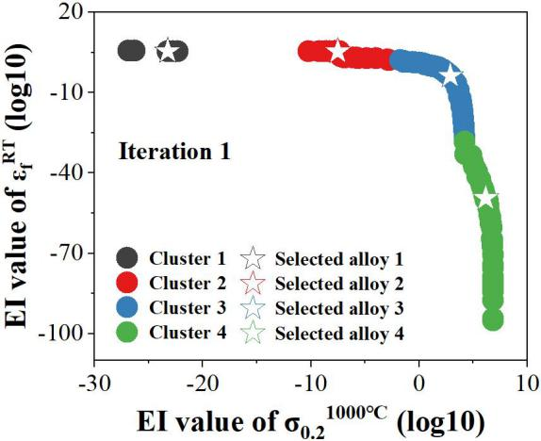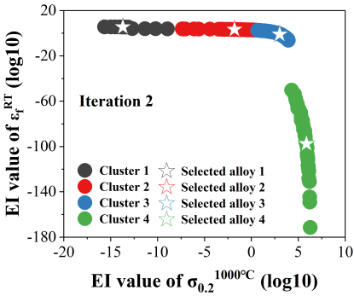
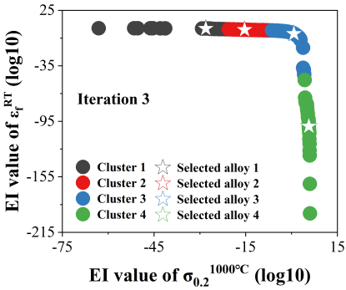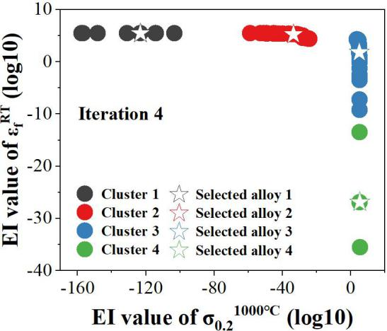
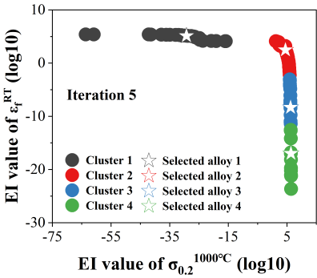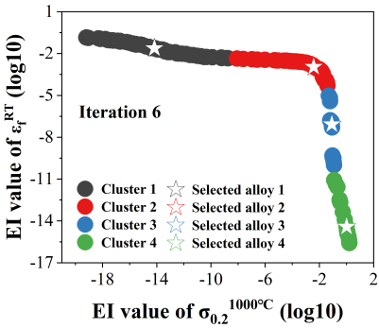
Fig. S3. The cluster analysis at each iteration to select alloys for experiments. For the two-dimensional clustering in our case, the PF is curved, and four alloys are suggested for experimental synthesis at each iteration.

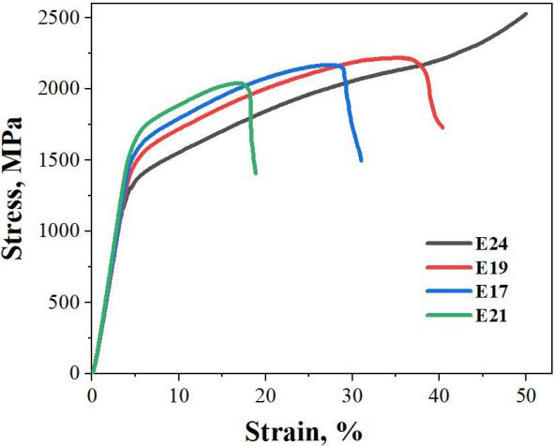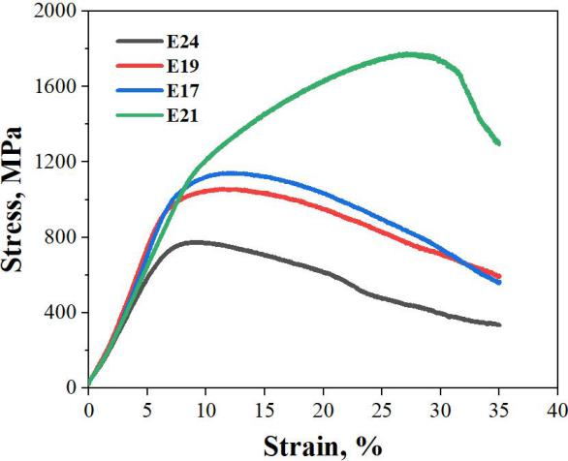
(a) (b)
Fig. S4. The stress–strain curves obtained during compression at (a) RT and (b) 1000 ℃ for the four optimized alloys of E24, E19, E17, and E21.

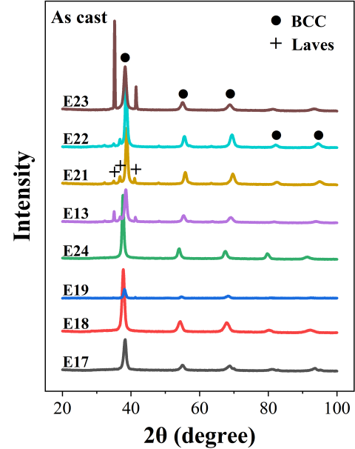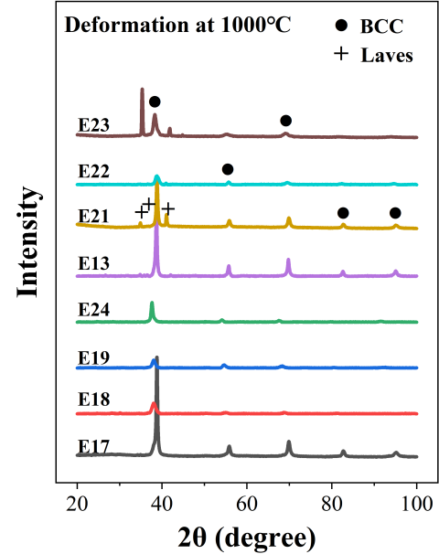
(a) (b)
Fig. S5. Phase structure of the designed alloys (a) before and (b) after compression deformation at 1000 ℃.

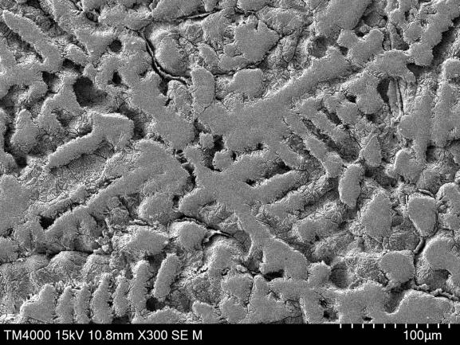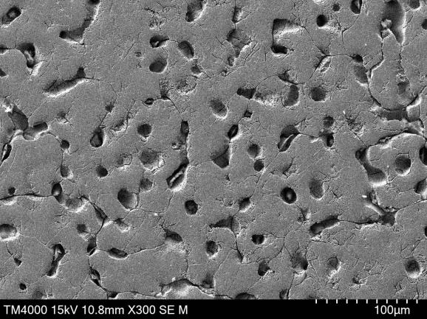
(a) (b)
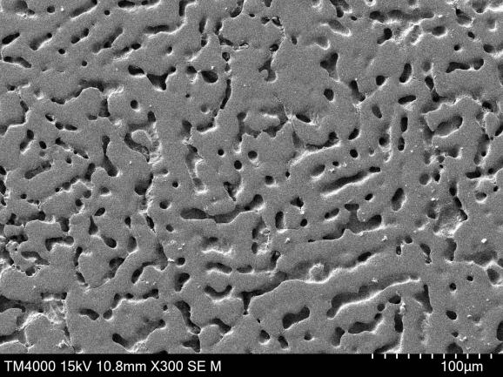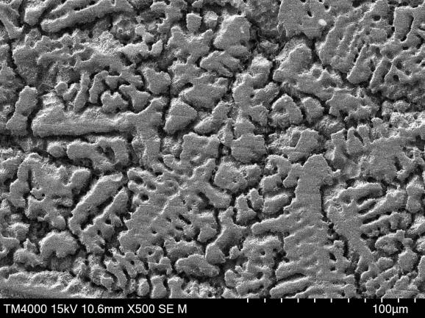
(c) (d)
Fig. S6. The SEM microstructure of the optimized alloys (a) E24, (b) E19, (c) E17, and (d) E21.

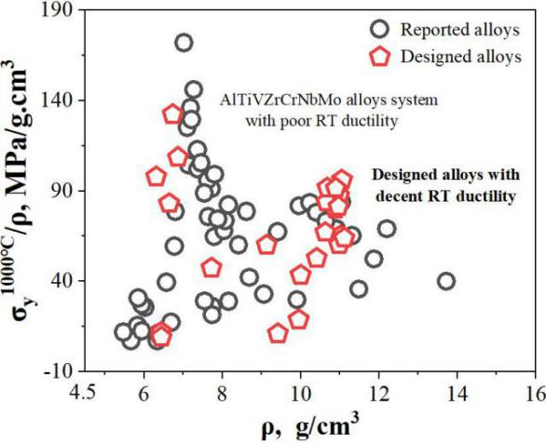
Fig. S7. Specific yield strength at 1000 ℃, comparing the designed alloys to those reported in the initial data.

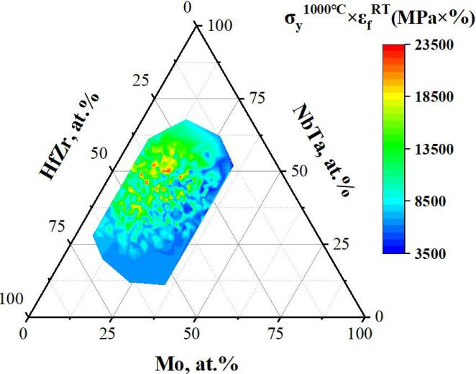
Fig. S8. The pseudo-ternary composition diagram of the distribution of σ_{y}^{1000℃} × ε_{f}^{RT} for the ZrNbMoHfTa alloy system. It provides an intuitive index for MOO design of RHEAs

References
[1] The R Foundation. The R project for statistical computing (version 4.0.2). 2020 Jun 22 [2020 Aug 10]. Available from: http://www.R-project.org/.
[2] Jones DR, Schonlau M, Welch WJ. Efficient global optimization of expensive black-box functions. J Glob Optim 1998;13(4):455–92.
[3] Wen C, Zhang Y, Wang C, Xue D, Bai Y, Antonov S, et al. Machine learning assisted design of high entropy alloys with desired property. Acta Mater 2019;170:109–17.
[4] Deb K, Pratap A, Agarwal S, Meyarivan T. A fast and elitist multiobjective genetic algorithm: NSGA-II. IEEE Trans Evol Comput 2002;6(2):182–97.
[5] Srinivas N, Deb K. Multiobjective optimization using nondominated sorting in genetic algorithms. Evol Comput 1994;2(3):221–48.
[6] Charrad M. NbClust (version 3.0.1). 2022 May 2 [2023 May 2]. Available from: https://www.rdocumentation.org/packages/NbClust/versions/3.0.1/topics/NbClust.
[7] Scrucca L. mclust (version 6.0.0). 2022 Oct 31 [2023 May 2]. Available from: https://www.rdocumentation.org/packages/mclust/versions/6.0.0/topics/Mclust.

