Intratumoral Bacteria Dysbiosis Is Associated with Human Papillary Thyroid Cancer and Correlated with Oncogenic Signaling Pathways
Shuang Yu ^{a,#}, Yanqiang Ding ^{b,#}, Xuejie Wang ^{a,#}, Siu Kin Ng ^{b}, Siting Cao ª, Weixin Liu ^{b}, Zhuming Guo ^{c}, Yubin Xie ^{d}, Shubin Hong ª, Lixia Xu ^{e,f}, Xiaoxing Li ^{e}, Jie Li ^{g}, Weiming Lv ^{g}, Sui Peng ^{d,e}, Yanbing Li ª, Joseph JY Sung ^{e,h}, Jun Yu ^{b,e,}*, Haipeng Xiao ^{a,}*
ª Department of Endocrinology, The First Affiliated Hospital of Sun Yat-Sen University, Guangzhou 510080, China
^{b} Institute of Digestive Disease and Department of Medicine and Therapeutics, State Key Laboratory of Digestive Disease, The Chinese University of Hong Kong, Hong Kong 999077, China
^{c} Department of Head and Neck Surgery, Sun Yat-Sen University Cancer Center, Guangzhou 510060, China
^{d} Clinical Trials Unit, The First Affiliated Hospital of Sun Yat-Sen University, Guangzhou 510080, China
^{e} Institute of Precision Medicine, The First Affiliated Hospital of Sun Yat-Sen University, Guangzhou 510080, China
^{f} Department of Oncology, The First Affiliated Hospital of Sun Yat-Sen University, Guangzhou 510080, China
^{g} Department of Breast and Thyroid Surgery, The First Affiliated Hospital of Sun Yat-Sen University, Guangzhou 510080, China
^{h} Lee Kong Chian School of Medicine, Nanyang Technology University, Singapore 308232, Singapore
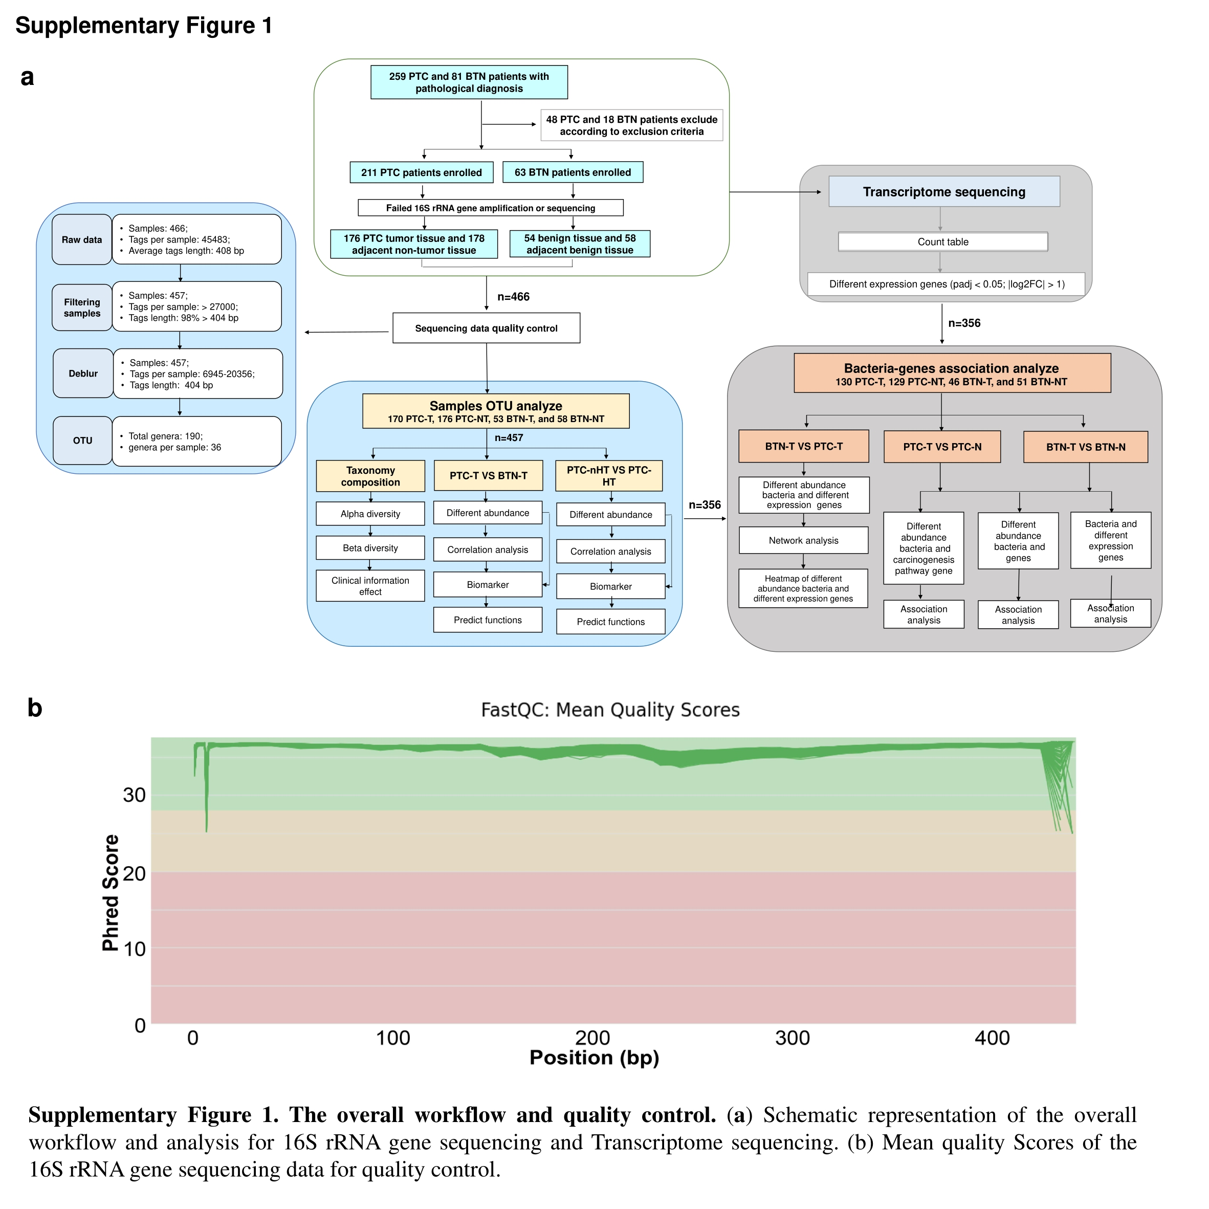

Table S1
Clinical and Demographic Characteristics of Patients
Characteristics | PTC | BTN
Subjects | 202 | 62
Age (years) | 37.08 ± 9.65* | 44.74 ± 12.01*
Gender
Male | 49 | 19
Female | 153 | 43
Tumor diameter (cm)
≤ 1 | 53 | ··
> 1 | 149 | ··
Lymph node metastasis
Yes | 67 | ··
No | 135 | ··
Extrathyroidal invasion
Yes | 128 | ··
No | 74 | ··
TNM
I, II | 197 | ··
III, IV | 5 | ··
With HT | 65 | ··
TPO-Ab (IU·mL^{–1}, mean ± SD) | 207.61 ± 241.42 | ··
TPO-Ab > 35 IU·mL^{–1} (P/N, P %) | 52/65 (80%) | ··
TG-Ab (IU·mL^{–1}, mean ± SD) | 368.31 ± 821.43 | ··
TG-Ab > 20 IU·mL^{–1} (P/N, P %） | 41/65 (63.1%) | ··
Age, TPO-Ab, and TG-Ab were presented as mean ± SD. Wilcoxon rank-sum test was used in comparison of age and gender between each group. PTC group was compared with BTN group, * P < 0.05 in average age by Wilcoxon rank-sum test was found. No difference in gender were found in PTC vs BTN.
P/N: positive/negative ratio; ··: not applicable.



