Supplementary data for
Experimental Realization of Physical Unclonable Function Chip Utilizing Spintronic Memories
Xiuye Zhangª, Chuanpeng Jiangª, Jialiang Yinª, Daoqian Zhuª, Shiqi Wangª, Sai Liª, Zhongxiang Zhangª, Ao Duª, Wenlong Caiª, Hongxi Liu^{b}, Kewen Shiª, Kaihua Caoª, Zhaohao Wangª, Weisheng Zhao^{a,}*
ªFert Beijing Institute, MIIT Key Laboratory of Spintronics, School of Integrated Circuit Science and Engineering, Beihang University, Beijing 100191, China
^{b}Truth Memory Corporation, Beijing 100088, China
* Corresponding author.
E-mail address: weisheng.zhao@buaa.edu.cn (W. Zhao).

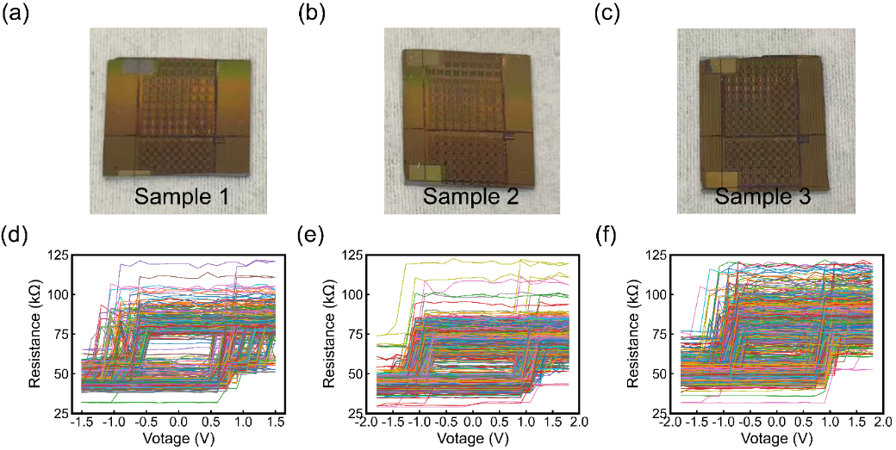
Fig. S1. Repeatability of variations in switching threshold voltage due to the manufacturing process. Optical images of (a) Chip Sample 1, (b) Chip Sample 2, and (c) Chip Sample 3. The resistance of all units in the array as a function of applied writing voltage for (d) Chip Sample 1, (e) Chip Sample 2, and (f) Chip Sample 3.
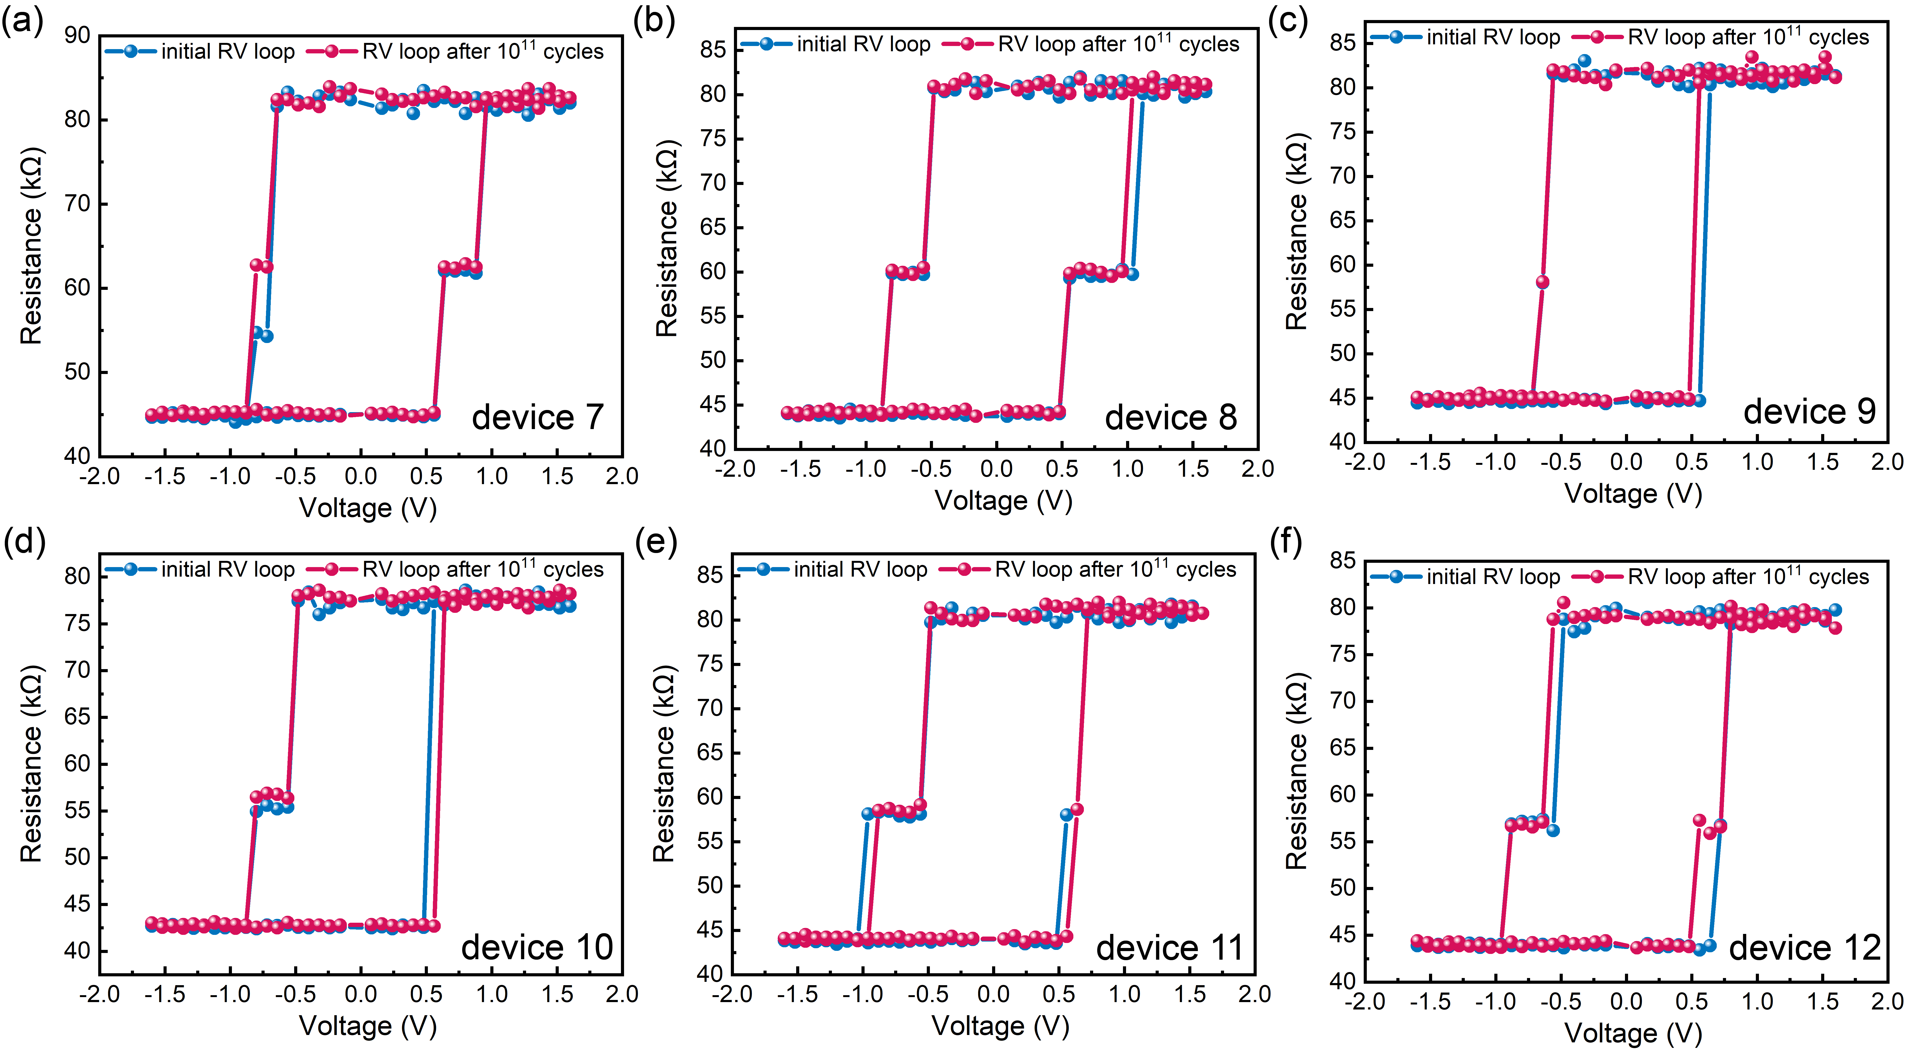
Fig. S2. The function of resistance versus applied writing voltage for another 6 devices before and after the endurance test. The threshold switching voltage of these devices remained unchanged, demonstrating that write cycles do not degrade SOT-MRAM chip performance.
Table S1.
Comparison of this work with state-of-the-art PUFs
 | Ref [1] | Ref [2] | Ref [3] | Ref [4] | Ref [5] | This work
Technology | Passive memristor | 130 nm SRAM | 2T2R RRAM/  130 nm CMOS | Discrete SOT device | 2T2R STT-MRAM/  22 nm CMOS | 3T1R SOT-MRAM/  180 nm CMOS
Entropy Source | * | ** | Resistance variation | Switching polarity | Time delay | Switching  threshold voltage
Demo Complexity | 10×10×2  3D | Not mentioned | 2×8 Kb  (M/D mode) | 4×8 | 6.6 Mb | 1 kb
Cell Aera (μm²) | 0.1225 | 6.3 | 2.86/1.815 | Not mentioned | Not  mentioned | 0.315
CRP Capacity  (PUF type) | ~7×10⁶  (strong PUF) | 2000  (weak PUF) | 64 per chip  (weak PUF) | 12  (weak PUF) | Not mentioned (weak PUF) | ~10⁹  (strong PUF)
Temperature (℃) | 25 - 90 | -40 ­ 120 | 25 - 150 | Not tested | RT | -40 - 100
UF (%) | ~50 | ~50 | 49.53/50.01 | 48.9 | Not mentioned | 50.07
UQ (%) | 50.07 | 49.23 | 49.92/49.99 | 51.7 | 49.99 | 49.89
BER (%) | 1.22/5.93  @RT/90℃ | ~6@120℃ | 0/0 | Not tested | 0 | 0@100℃
DF (%) | 50.01 | Not mentioned | Not  mentioned | Not mentioned | Not  mentioned | 50
ACF  @95% confidence | Not tested | 0.0228 | 0.0075 | Not tested | Not tested | 0.0012
Assistant Technique | Not needed | TMV, EVB | Not needed | Not needed | TMER | Not needed
Reconfigurable? | No | No | Yes | Yes | Yes | Yes
Resist  ML Attack? | Yes | Not tested | Not tested | Not tested | Not tested | Yes
* I-V Nonlinearity Variation ** State trend of volatile memory after power on

References
[1] Nili H, Adam GC, Hoskins B, Prezioso M, Kim J, Mahmoodi MR, et al. Hardware-intrinsic security primitives enabled by analogue state and nonlinear conductance variations in integrated memristors. Nat Electron 2018;1(3):197–202.
[2] Liu K, Min Y, Yang X, Sun H, Shinohara H. A 373-F² 0.21%-native-BER EE SRAM physically unclonable function with 2-D power-gated bit cells and VSS bias-based dark-bit detection. IEEE J Solid-State Circuits 2020;55(6):1719–32.
[3] Lin B, Pang Y, Gao B, Tang J, Wu D, Chang T-W, et al. A Highly Reliable RRAM Physically Unclonable Function Utilizing Post-Process Randomness Source. IEEE J Solid-State Circuits 2021;56(5):1641–50.
[4] Lee S, Kang J, Kim J, Kim N, Han D, Lee T, et al. Spintronic Physical Unclonable Functions Based on Field‐Free Spin–Orbit‐Torque Switching. Adv Mater 2022;34(45):2203558.
[5] Chiu Y-C, Khwa W-S, Yang C-S, Teng S-H, Huang H-Y, Chang F-C, et al. A CMOS-integrated spintronic compute-in-memory macro for secure AI edge devices. Nat Electron 2023;6(7):534–43.

