Supplementary data for

Responses of Soil Bacterial Diversity to Fertilization Are Driven by Local Environmental Context across China
Youzhi Feng ª, Manuel Delgado-Baquerizo ^{b}, Yongguan Zhu ^{c,d}, Xiaozeng Han ^{e}, Xiaori Han ^{f}, Xiuli Xin ª, Wei Li ^{g}, Zhibing Guo ^{h}, Tinghui Dang ^{i}, Chenhua Li ^{j}, Bo Zhu ^{k}, Zejiang Cai ^{l,m}, Daming Li ^{n}, Jiabao Zhang ^{a,}*
ª State Key Laboratory of Soil and Sustainable Agriculture, Institute of Soil Science, Chinese Academy of Sciences, Nanjing, China
^{b} Department of Physical, Chemical, and Natural Systems, Pablo de Olavide University, Sevilla 41013, Spain
^{c} State Key Laboratory of Urban and Regional Ecology, Research Center for Eco-Environmental Sciences, Chinese Academy of Sciences, Beijing, China
^{d} Key Laboratory of Urban Environment and Health, Institute of Urban Environment, Chinese Academy of Sciences, Xiamen, China
^{e} National Observation Station of the Hailun Agroecology System, Key Laboratory of Mollisols Agroecology, Northeast Institute of Geography and Agroecology, Chinese Academy of Sciences, Harbin, China
^{f} College of Land and Environment, National Engineering Laboratory for Efficient Utilization of Soil and Fertilizer Resources, Shenyang Agricultural University, Shenyang, China
^{g} Crop Research Institute, Anhui Academy of Agricultural Sciences, Hefei, China
^{h} Soil and Fertilizer Research Institute, Anhui Academy of Agricultural Sciences, Hefei, China
^{i} Institute of Soil and Water Conservation, Northwest A&F University, Chinese Academy of Science & Ministry of Water Resources, Yangling, China
^{j} Fukang Station of Desert Ecology, Key Laboratory of Oasis Ecology and Desert Environment, Xinjiang Institute of Ecology and Geography, Chinese Academy of Sciences, Urumqi, China
^{k} Key Laboratory of Mountain Environment Evolvement and Regulation, Institute of Mountain Hazards and Environment, Chinese Academy of Sciences, Chengdu, China
^{l} Qiyang Agroecosystem of the National Field Experimental Station, Yongzhou, China
^{m} National Engineering Laboratory for Improving the Quality of Arable Land, Institute of Agricultural Resources and Regional Planning, Chinese Academy of Agricultural Sciences, Beijing, China
^{n} Jiangxi Institute of Red Soil, Nanchang, China

*Corresponding author.
E-mail: jbzhang@issas.ac.cn (J. Zhang)

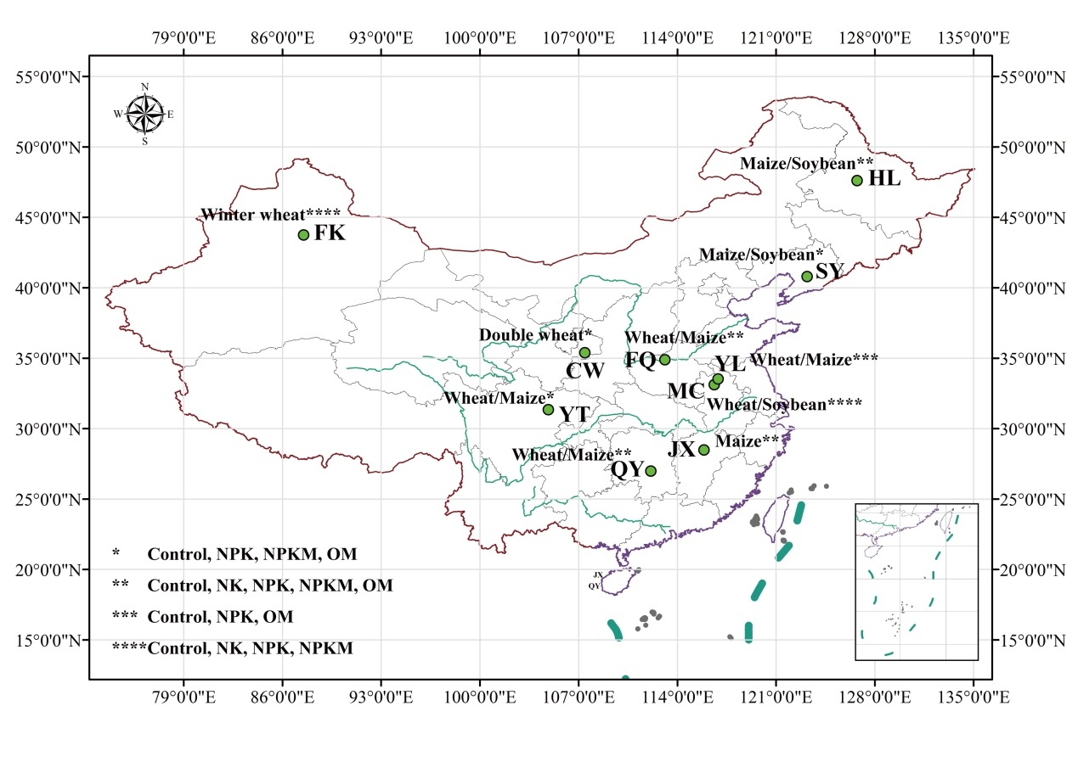
Fig. S1. Information on the locations and fertilization regimes of 10 experimental stations across China: Fukang (FK), Fengqiu (FQ), Changwu (CW), Yingting (YT), Yangliu (YL), Mengcheng (MC), Hailun (HL), Shenyang (SY), Jinxian (JX) and Qiyang (QY).

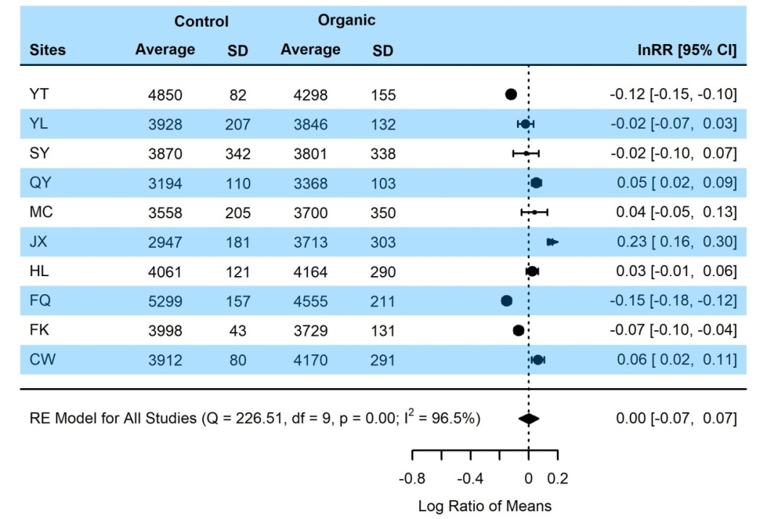
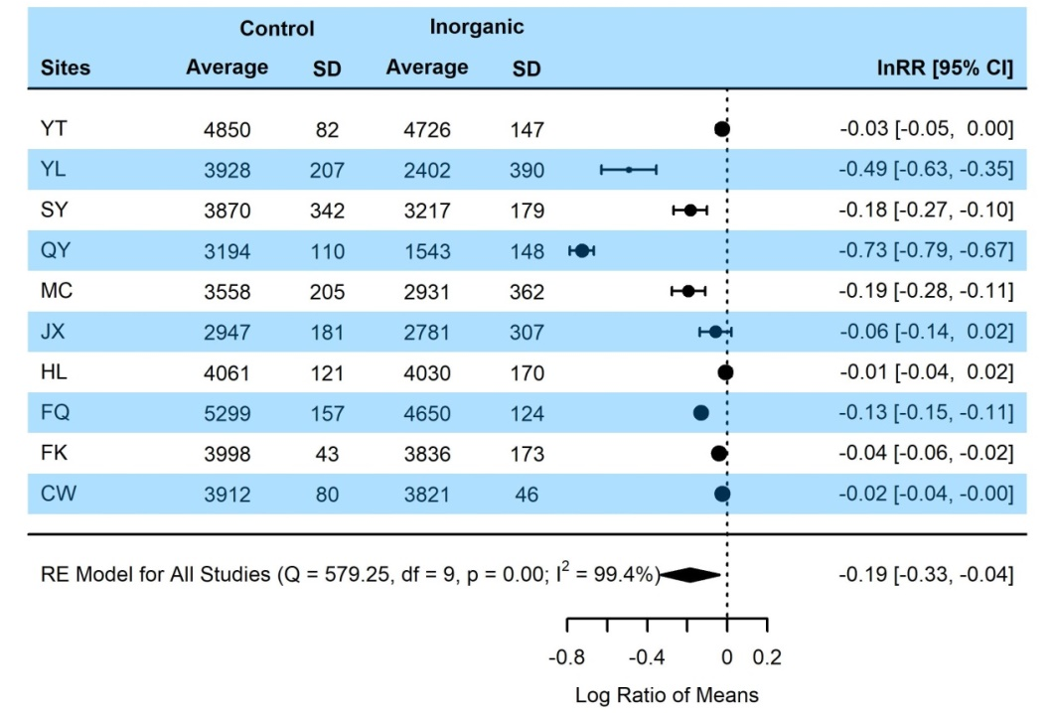
Fig. S2. Detailed information for the lnRR of bacterial richness under organic plus inorganic (NPKM and/or OM) or inorganic (NPK and/or NK) fertilization compared with the control. Horizontal black bars are 95% confidence intervals for the effect sizes of each site included in the model; the size of the black squares represents the relative weight that each site had on the overall analysis. Numbers in the right column are average lnRRs with their respective lower and upper confidence intervals. Black diamonds are the mean effect sizes for all sites, and their length represents confidence intervals.
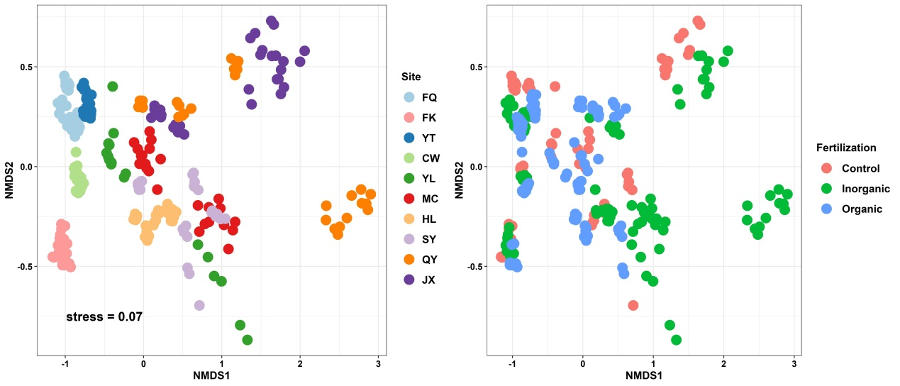
Fig. S3. Shifts in bacterial community taxonomic composition based on Bray-Curtis dissimilarity across 10 fertilization experimental sites and among fertilization regimes across China.

Fig. S4. Direct and indirect effects of latitude, longitude, climate, soil properties, and inorganic vs. organic fertilization on shifts in community composition across 10 experimental sites. The inset bar graph is the standardized total effects (direct plus indirect effects) of fertilization regimes and local environmental conditions derived from the SEM on shifts in community composition. The degrees of shifts in bacterial taxonomic communities under fertilization are characterized by F model values derived from PERMANOVA within each experimental site and across all sites.

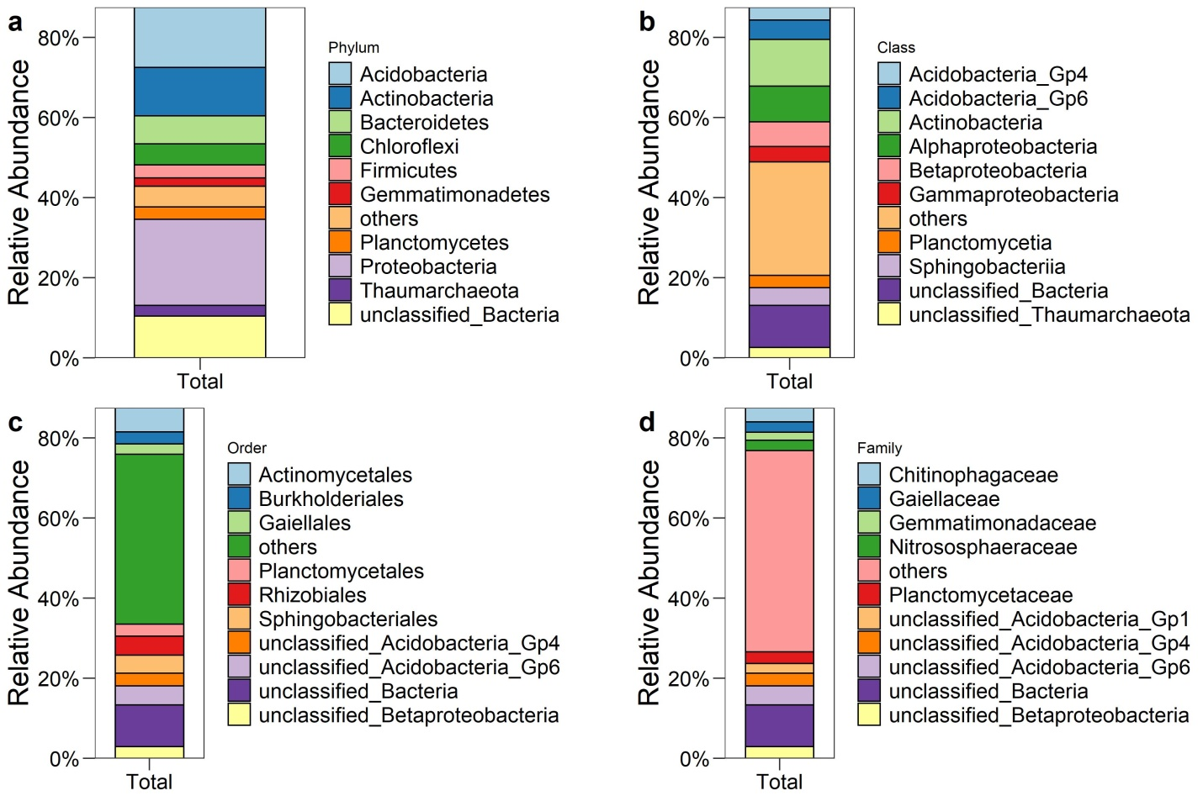
Fig. S5. Taxonomy information for the top 10% of taxa in terms of relative abundance and accounting for 87.5% of all bacterial 16S rRNA gene reads.

Fig. S6. (A) Percentages of opportunistic (positive responders), sensitive (negative responders), tolerant (unchanged), and context-dependent (no consistent pattern) taxa and (B) their taxonomic distributions at the phylum level under organic or inorganic fertilization across China.

Table S1
Background information for 10 fertilization experimental stations.

Table S2
Changes in soil chemical variables among fertilizations at 10 experimental sites.

Table S3
Pearson correlations between soil chemical properties and bacterial richness in total soils, acidic soils (HL, SY, JX, and QY), and alkaline soils (CW, FK, FQ, and YT).
Pearson | Total | Acidic soils# | Alkaline soils
Pearson | N=284 | N=124 | N=118
TN | -0.012 | 0.556** | -0.201*
TP | -0.023 | 0.126 | -0.711**
TK | 0.598** | 0.594** | -0.407**
SOM | 0.025 | 0.599** | -0.289**
pH | 0.725** | 0.818** | -0.438**
AP | 0.043 | 0.258** | -0.330**
AK | 0.078 | 0.031 | -0.308**
NO₃⁻ | 0.264** | 0.416** | 0.350**
NH₄⁺ | -0.003 | 0.247** | 0.158
DOC | 0.188** | 0.572** | -0.424**
AN | 0.176** | 0.514** | 0.299**
#Acidic soils include JX, QY, SY, and HL, with pH ranging from 4.04 to 6.88; alkaline soils include FQ, FK, YT, and CW, with pH ranging from 7.92 to 9.13.

Table S4
Pearson correlations between soil chemical properties and bacterial richness in acidic (HL, SY, JX, and QY) and alkaline (CW, FK, FQ, and YT) soils under inorganic and organic fertilization, respectively.
Pearson | Acidic soils |  | Alkaline soils
Pearson | Organic | Inorganic | Organic | Inorganic
TN | 0.596** | 0.564** | -0.303** | -0.412**
TP | 0.062 | -0.352** | -0.754** | -0.737**
TK | 0.686** | 0.739** | -0.444** | -0.485**
SOM | 0.644** | 0.637** | -0.346** | -0.607**
pH | 0.454** | 0.931** | -0.251* | -0.459**
AP | 0.397** | -0.302** | -0.468** | -0.286*
AK | 0.302** | -0.563** | -0.411** | -0.455**
NO₃⁻ | 0.520** | 0.263* | 0.133 | 0.325**
NH₄⁺ | 0.396** | -0.572** | 0.192 | 0.186
DOC | 0.630** | 0.609** | -0.414** | -0.586**
AN | 0.497** | 0.580** | 0.024 | 0.283*

Table S5
PERMAONVA tests of significant differences in bacterial community taxonomic composition based on Bray-Curtis dissimilarity among 10 fertilization experimental sites.
Pairs | F model | R² | P value
CW vs. FK | 21.360 | 0.291 | 0.001
CW vs. FQ | 8.828 | 0.125 | 0.001
CW vs. HL | 13.451 | 0.178 | 0.001
CW vs. JX | 7.916 | 0.132 | 0.002
CW vs. MC | 20.069 | 0.304 | 0.001
CW vs. SY | 18.347 | 0.285 | 0.001
CW vs. QY | 16.019 | 0.236 | 0.001
CW vs. YL | 14.973 | 0.277 | 0.001
CW vs. YT | 34.890 | 0.431 | 0.001
FK vs. FQ | 14.372 | 0.174 | 0.001
FK vs. HL | 15.747 | 0.188 | 0.001
FK vs. JX | 18.039 | 0.237 | 0.001
FK vs. MC | 43.909 | 0.458 | 0.001
FK vs. SY | 41.655 | 0.445 | 0.001
FK vs. QY | 33.671 | 0.367 | 0.001
FK vs. YL | 30.520 | 0.404 | 0.001
FK vs. YT | 40.646 | 0.439 | 0.001
FQ vs. HL | 11.470 | 0.128 | 0.001
FQ vs. JX | 8.791 | 0.114 | 0.001
FQ vs. MC | 15.353 | 0.198 | 0.001
FQ vs. SY | 11.986 | 0.162 | 0.001
FQ vs. QY | 11.555 | 0.145 | 0.001
FQ vs. YL | 9.822 | 0.152 | 0.001
FQ vs. YT | 24.511 | 0.283 | 0.001
HL vs. JX | 4.968 | 0.068 | 0.003
HL vs. MC | 25.548 | 0.292 | 0.001
HL vs. SY | 20.798 | 0.251 | 0.001
HL vs. QY | 20.156 | 0.229 | 0.001
HL vs. YL | 14.194 | 0.205 | 0.001
HL vs. YT | 12.334 | 0.166 | 0.001
JX vs. MC | 17.126 | 0.248 | 0.001
JX vs. SY | 14.528 | 0.218 | 0.001
JX vs. QY | 14.979 | 0.205 | 0.001
JX vs. YL | 12.010 | 0.211 | 0.001
JX vs. YT | 16.729 | 0.243 | 0.001
MC vs. SY | 5.880 | 0.113 | 0.002
MC vs. QY | 6.360 | 0.109 | 0.001
MC vs. YL | 9.467 | 0.195 | 0.001
MC vs. YT | 46.381 | 0.502 | 0.001
SY vs. QY | 5.730 | 0.099 | 0.001
SY vs. YL | 5.646 | 0.126 | 0.001
SY vs. YT | 40.192 | 0.466 | 0.001
QY vs. YL | 4.735 | 0.095 | 0.003
QY vs. YT | 33.653 | 0.393 | 0.001
YL vs. YT | 27.051 | 0.410 | 0.001

Table S6
Standardized total effects (direct plus indirect effects) derived from the SEM.
 | lnRR of richness | Shift in composition | Opportunistic  under organic | Opportunistic  under inorganic
Fertilization | -0.468 | -0.114 | 0.910 | 0.714
NH₄⁺ | -0.300 | 0.272 | NA | 0.600
TP | 0.475 | 0.293 | 0.015 | -0.105
SOM | -0.454 | -0.199 | 0.091 | 0.004
pH | 1.622 | -0.695 | 0.131 | -1.060
TK | 0.075 | -0.357 | -0.002 | 0.050
MAT | -0.315 | -0.023 | -0.290 | -0.217
MAP | 0.645 | 0.551 | -0.162 | -0.032
NO₃⁻ | NA | NA | 0.252 | NA
Space | NA | NA | -0.290 | -0.165
Latitude | 0.634 | -0.320 | NA | NA
Longitude | 0.668 | 0.333 | NA | NA

Table S7
Shifts in bacterial community composition under organic or inorganic fertilization compared with the control without fertilization.
 | Organic vs. control |  |  | Inorganic vs. control
Sites | F model | R² | P value | F model | R² | P value
YT | 8.74 | 0.35 | 0.001 | 4.42 | 0.31 | 0.004
YL | 8.92 | 0.50 | 0.002 | 42.07 | 0.82 | 0.002
SY | 10.06 | 0.39 | 0.001 | 15.99 | 0.62 | 0.003
QY | 32.29 | 0.67 | 0.001 | 43.79 | 0.73 | 0.001
MC | 8.86 | 0.47 | 0.003 | 20.07 | 0.56 | 0.001
JX | 57.86 | 0.78 | 0.001 | 14.14 | 0.47 | 0.001
HL | 19.97 | 0.48 | 0.001 | 2.45 | 0.10 | 0.011
FQ | 27.13 | 0.55 | 0.001 | 7.21 | 0.25 | 0.001
FK | 7.71 | 0.39 | 0.002 | 5.79 | 0.21 | 0.001
CW | 12.04 | 0.43 | 0.001 | 4.14 | 0.29 | 0.003
For all sites | 10.89 | 0.06 | 0.003 | 6.07 | 0.03 | 0.003

Table S8
Pearson correlations between soil chemical properties and shifts in bacterial community composition under organic or inorganic fertilization.
 | Organic vs. control |  | Inorganic vs. control
 | R | P | R | P
pH | -0.325 | 0.36 | -0.773** | 0.009
TP | 0.588 | 0.074 | -0.31 | 0.383
AP | -0.116 | 0.75 | -0.073 | 0.84
TN | 0.284 | 0.426 | 0.066 | 0.856
TK | -0.45 | 0.192 | -0.765** | 0.01
SOM | 0.251 | 0.484 | -0.011 | 0.977
AK | 0.205 | 0.57 | -0.237 | 0.509
NO₃⁻ | -0.335 | 0.344 | 0.139 | 0.701
NH₄⁺ | 0.34 | 0.336 | 0.830** | 0.003
DOC | 0.173 | 0.632 | -0.244 | 0.498
AN | -0.25 | 0.486 | -0.042 | 0.908

Table S9
Mantel tests between soil chemical properties and bacterial community composition under organic and/or inorganic fertilization.
Pearson | Total | Organic | Inorganic
pH | 0.81** | 0.78** | 0.82**
TP | 0.09** | 0.34** | 0.19**
AP | 0.01 | 0.25** | 0.12**
TN | 0.02 | 0.2** | 0.2**
TK | 0.36** | 0.31** | 0.48**
SOM | 0.02 | 0.19** | 0.13**
AK | 0.02 | 0.14** | 0.19**
NO₃⁻ | 0 | 0.06* | 0.09**
NH₄⁺ | -0.02 | 0.03 | 0.22**
DOC | 0.06* | 0.14** | 0.23**
AN | 0.03 | 0.17** | 0.1**

Table S10
Variation partitioning analysis of soil chemical variables between fertilization regimes and spatial variables.
 | Fertilization | Sites | Fertilization and sites | Residual | Total
pH | 0.083 | 0.782 | 0.116 | 0.019 | 1
TP | 0.257 | 0.461 | 0.197 | 0.084 | 1
AP | 0.695 | 0.079 | 0.165 | 0.060 | 1
TN | 0.227 | 0.652 | 0.106 | 0.014 | 1
TK | 0.014 | 0.950 | 0.015 | 0.022 | 1
SOM | 0.173 | 0.717 | 0.095 | 0.015 | 1
AK | 0.309 | 0.309 | 0.348 | 0.033 | 1
NO₃⁻ | 0.216 | 0.333 | 0.309 | 0.142 | 1
NH₄⁺ | 0.049 | 0.461 | 0.347 | 0.143 | 1
DOC | 0.296 | 0.355 | 0.237 | 0.112 | 1
AN | 0.285 | 0.358 | 0.289 | 0.068 | 1

Table S11
Information on four life strategists under organic and inorganic fertilization across multiple experimental sties.
 |  | Opportunistic | Sensitive | Tolerant | Others
Consistent across 10 sites | Organic vs. control | 41 | 6 | 257 | 3012
Consistent across 10 sites | Inorganic vs. control | 4 | 8 | 423 | 2923
Consistent across at least 9 sites | Organic vs. control | 77 | 11 | 257 | 2971
Consistent across at least 9 sites | Inorganic vs. control | 7 | 24 | 423 | 2904
Consistent across at least 8 sites | Organic vs. control | 178 | 43 | 257 | 2838
Consistent across at least 8 sites | Inorganic vs. control | 17 | 72 | 423 | 2846

