Supplementary Information for

Structural and Functional NIR-II Fluorescence Bioimaging in Urinary System via Clinically Approved Dye Methylene Blue
Dingwei Xue ª, Di Wu ^{b}, Zeyi Lu ª, Jochen Neuhaus ^{c}, Abudureheman Zebibula ª, Zhe Feng ^{d}, Sheng Cheng ª, Jing Zhou ^{d}, Jun Qian ^{a,d,}*, Gonghui Li ^{a,}*
ª Department of Urology, Sir Run Run Shaw Hospital, School of Medicine, Zhejiang University, Hangzhou 310016, China
^{b} Department of General Surgery, Sir Run Run Shaw Hospital, School of Medicine, Zhejiang University, Hangzhou 310016, China
^{c} Department of Urology, University of Leipzig, Leipzig 04103, Germany
^{d} State Key Laboratory of Modern Optical Instrumentation, Centre for Optical and Electromagnetic Research, College of Optical Science and Engineering, Zhejiang University, Hangzhou 310058, China

* Corresponding authors.
E-mail addresses: qianjun@zju.edu.cn (J. Qian), 3193119@zju.edu.cn (G. Li).

Fig. S1. Schematic illustration for (a) NIR-I and (b) NIR-II fluorescence imaging system.
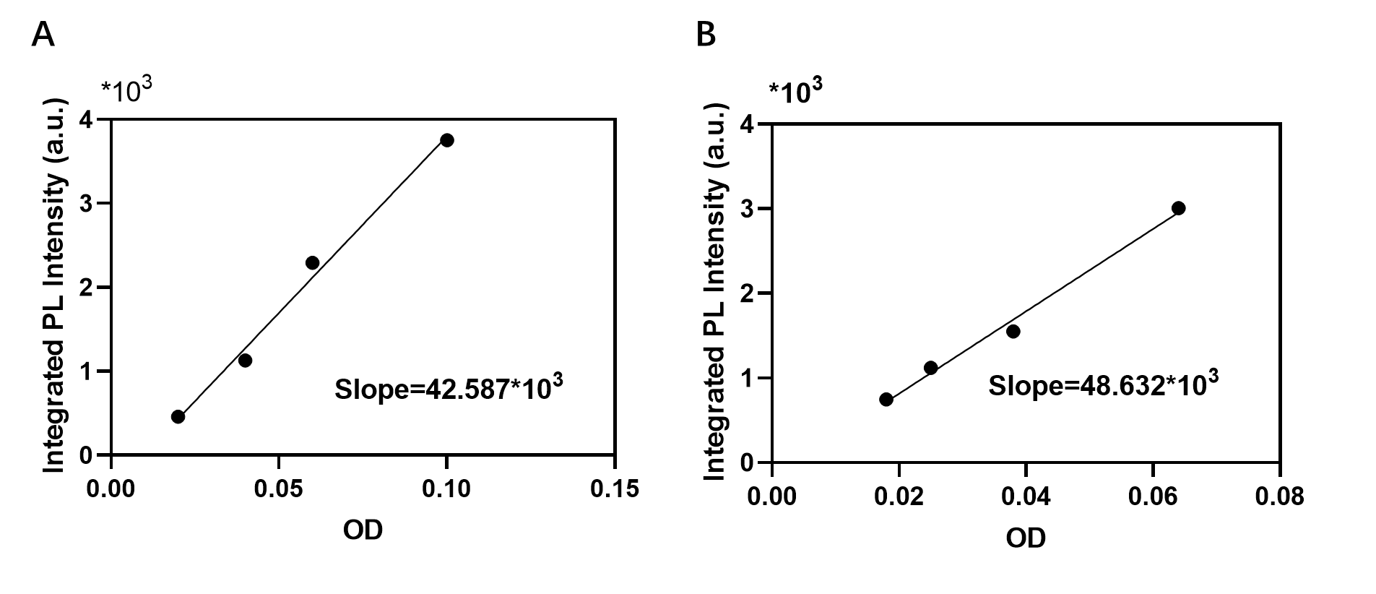
Fig.S2. Integrated NIR-II fluorescence intensities (1000-1500 nm) plotted a function of OD at 623 nm for (A) MB aqueous solution and (B) IR-26 in DCE (reference solution). The data were fitted into linear functions with slopes of 48632 for IR-26 in DCE and 42587 for MB in water. The measured NIR-II quantum yields of MB aqueous solution is 0.2%.
Fig. S3. NIR-II fluorescence images of (a) CH-1055-PEG in water and MB in water at the same concentration (0.1 mg‧mL⁻¹) under the 793 nm laser (30 mW‧cm⁻²) and 623 nm LED irradiation (30 mW‧cm⁻²), respectively. Exposure time: 20 ms. (b) Quantitative analysis of (a).

Fig. S4. (a) NIR-II fluorescence (with a 1000 nm long-pass filter) and bright-field images of vials filled with MB aqueous solution at six different concentrations. (b) The photostability and NIR-II fluorescence intensity measurement of MB aqueous solution under the excitation of a 623 LED at different time points during LED illumination (density: 80 mW‧cm⁻²).
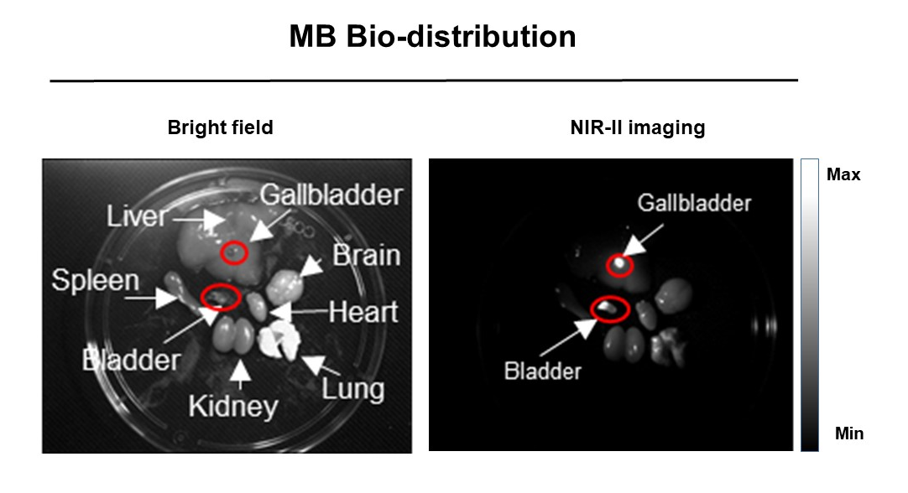
Fig. S5. Ex vivo NIR-II fluorescence images of major organs dissection from the mouse at 1 h post the intravenous injection of MB (0.5 mg‧mL⁻¹, 200 μL). All images were taken under 623 nm LED excitation (50 mW‧cm⁻²). Exposure time: 30 ms.

