Supplementary data for
Differences in Immunoglobulin G Glycosylation Between Influenza and COVID-19 Patients
Marina Kljaković-Gašpić Batinjan ^{a,#}, Tea Petrović ^{b,#}, Frano Vučković ^{b}, Irzal Hadžibegović ^{c,d}, Barbara Radovani ^{e}, Ivana Jurin ^{c}, Lovorka Đerek ^{f}, Eva Huljev ^{g}, Alemka Markotić ^{h,i,j}, Ivica Lukšić ^{k}, Irena Trbojević-Akmačić ^{b}, Gordan Lauc ^{b,l}, Ivan Gudelj ^{b,e,}*, Rok Čivljak ^{g,m}
ª University Hospital Centre Zagreb, Zagreb 10000, Croatia
^{b} Genos Glycoscience Research Laboratory, Zagreb 10000, Croatia
^{c} Department of Cardiology, University Hospital Dubrava, Zagreb 10000, Croatia
^{d} Faculty of Dental Medicine and Health, Josip Juraj Strossmayer University, Osijek 31000, Croatia
^{e} Department of Biotechnology, University of Rijeka, Rijeka 51000, Croatia
^{f} Department for Laboratory Diagnostics, University Hospital Dubrava, Zagreb 10000, Croatia
^{g} Department for Acute Respiratory Infections, University Hospital for Infectious Diseases “Dr. Fran Mihaljević”, Zagreb 10000, Croatia
^{h} Department for Urogenital Infections, University Hospital for Infectious Diseases “Dr. Fran Mihaljević”, Zagreb 10000, Croatia
^{i} Department for Infectious Diseases, School of Medicine, Catholic University of Croatia, 10000 Zagreb, Croatia.
^{j} Postdoctoral Study, Faculty of Medicine, University of Rijeka, Rijeka 51000, Croatia
^{k} Department of Maxillofacial Surgery, University of Zagreb School of Medicine, Dubrava University Hospital, Zagreb 10000, Croatia
^{l} Faculty of Pharmacy and Biochemistry, University of Zagreb, Zagreb 10000, Croatia
^{m} Department of Infectious Diseases, University of Zagreb School of Medicine, Zagreb 10000, Croatia

Table S1
Survival data about COVID-19 patients.
Characteristics | COVID-19 (n = 77)
Death | No (n = 33) | Yes (n = 44)
Age (years/median (IQR)) | 70 (54–80) | 73 (53–80)

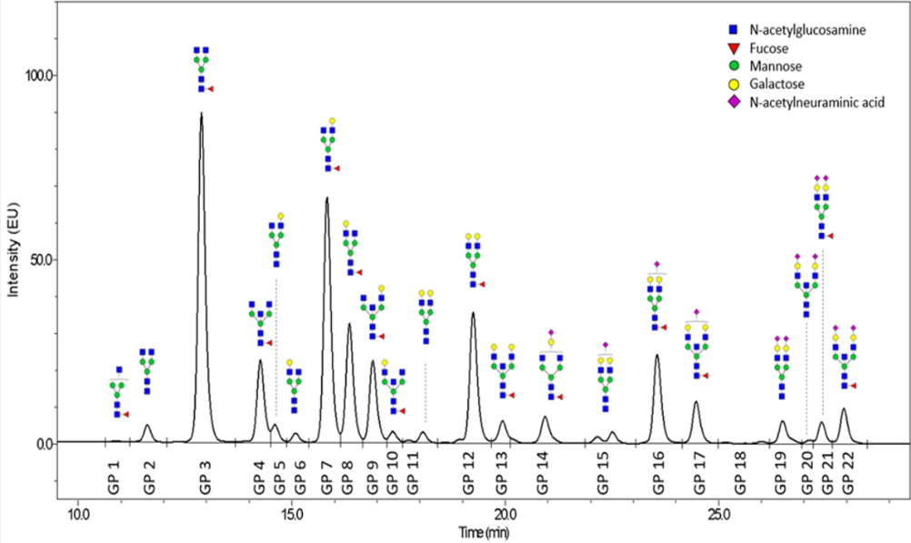
(a)
(b)
Fig. S1. Representative chromatogram of (a) RapiFluor-MS- and (b) 2-AB-labelled N-glycans released from IgGs isolated from human serum and separated by HILIC–UHPLC. The integration areas, together with a major structure presented in each glycan peak are given. Glycan peaks are numbered as used in the paper (peaks labelled “a” and “b” are merged to one).

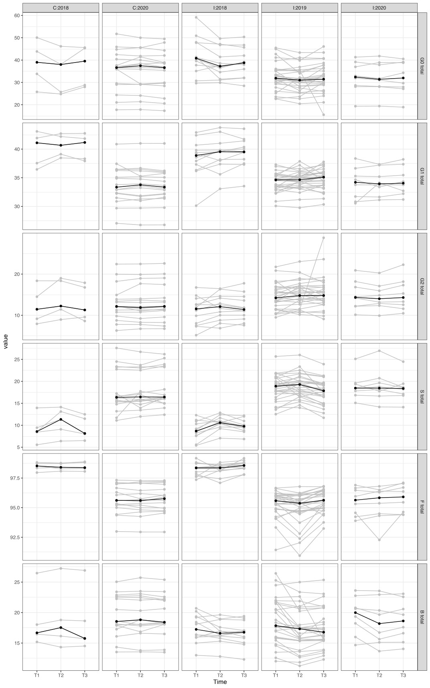
Fig. S2. IgG glycan composition changes in relative abundance (y axis) of given glycosylation trait during influenza infection. Value: glycan measurement.
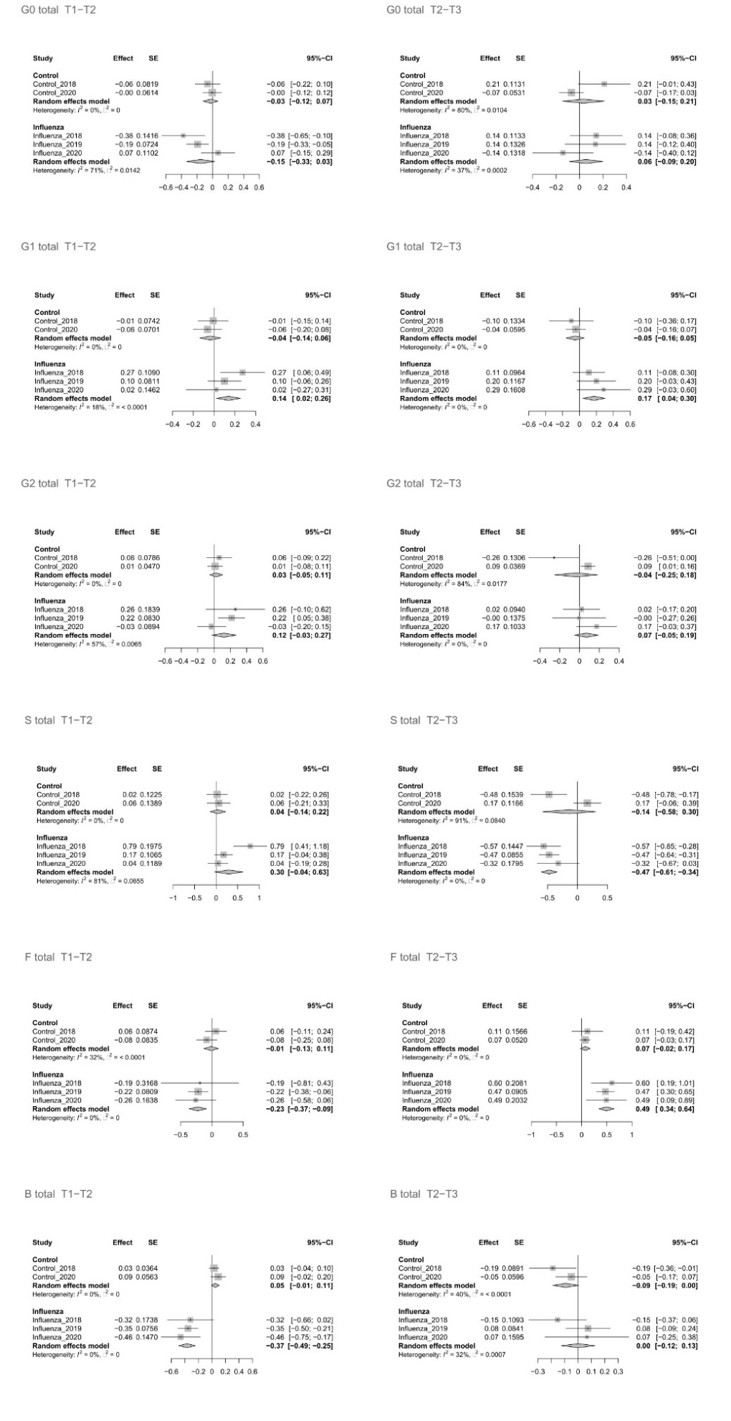
Fig. S3. Results of the meta-analysis. SE: standard error; CI: confidence interval.

Table S2
Association of healthy controls with changes of IgG N-glycome between three time points after meta-analysis.
Glycan trait | Time | Effectª | SE | P value | Adjusted P value^{b}
GP1 | T1–T2 | –0.0146 | 0.0628 | 0.8162 | 1
GP1 | T2–T3 | 0.0450 | 0.1667 | 0.7872 | 1
GP2 | T1–T2 | –0.0465 | 0.0508 | 0.3603 | 1
GP2 | T2–T3 | 0.1226 | 0.1954 | 0.5306 | 1
GP3 | T1–T2 | –0.0573 | 0.0685 | 0.4032 | 1
GP3 | T2–T3 | –0.0328 | 0.0922 | 0.7223 | 1
GP4 | T1–T2 | –0.0606 | 0.0499 | 0.2252 | 1
GP4 | T2–T3 | –0.0871 | 0.0457 | 0.0568 | 1
GP5 | T1–T2 | –0.1004 | 0.0953 | 0.2921 | 1
GP5 | T2–T3 | –0.0055 | 0.2444 | 0.9819 | 1
GP6 | T1–T2 | –0.0322 | 0.0334 | 0.3350 | 1
GP6 | T2–T3 | –0.1031 | 0.0413 | 0.0126 | 1
GP7 | T1–T2 | –0.0404 | 0.0406 | 0.3200 | 1
GP7 | T2–T3 | 0.0219 | 0.0861 | 0.7993 | 1
GP8 | T1–T2 | 0.0374 | 0.0424 | 0.3770 | 1
GP8 | T2–T3 | 0.0163 | 0.0647 | 0.8008 | 1
GP9 | T1–T2 | –0.0300 | 0.0460 | 0.5152 | 1
GP9 | T2–T3 | –0.0018 | 0.0575 | 0.9751 | 1
GP10 | T1–T2 | 0.0469 | 0.0374 | 0.2095 | 1
GP10 | T2–T3 | –0.1444 | 0.0712 | 0.0426 | 1
GP11 | T1–T2 | 0.0352 | 0.0508 | 0.4875 | 1
GP11 | T2–T3 | –0.0986 | 0.0549 | 0.0725 | 1
GP12 | T1–T2 | –0.0023 | 0.0430 | 0.9570 | 1
GP12 | T2–T3 | 0.0100 | 0.0351 | 0.7756 | 1
GP13 | T1–T2 | 0.0977 | 0.0892 | 0.2733 | 1
GP13 | T2–T3 | –0.1827 | 0.1467 | 0.2130 | 1
GP14 | T1–T2 | 0.0276 | 0.0406 | 0.4963 | 1
GP14 | T2–T3 | 0.0150 | 0.0782 | 0.8484 | 1
GP15 | T1–T2 | 0.0676 | 0.0714 | 0.3432 | 1
GP15 | T2–T3 | 0.0218 | 0.0748 | 0.7704 | 1
GP16 | T1–T2 | –0.0531 | 0.0506 | 0.2938 | 1
GP16 | T2–T3 | –0.1781 | 0.2237 | 0.4260 | 1
GP17 | T1–T2 | 0.0882 | 0.0878 | 0.3152 | 1
GP17 | T2–T3 | –0.0167 | 0.0811 | 0.8369 | 1
GP18 | T1–T2 | 0.0488 | 0.0641 | 0.4459 | 1
GP18 | T2–T3 | –0.0829 | 0.1658 | 0.6170 | 1
GP19 | T1–T2 | 0.1407 | 0.1087 | 0.1957 | 1
GP19 | T2–T3 | 0.1298 | 0.0974 | 0.1828 | 1
GP20 | T1–T2 | 0.0955 | 0.1072 | 0.3733 | 1
GP20 | T2–T3 | –0.1637 | 0.1434 | 0.2536 | 1
GP21 | T1–T2 | 0.1915 | 0.1495 | 0.2003 | 1
GP21 | T2–T3 | –0.4027 | 0.2788 | 0.1487 | 1
GP22 | T1–T2 | 0.1787 | 0.1235 | 0.1479 | 1
GP22 | T2–T3 | 0.1165 | 0.1296 | 0.3688 | 1
GP23 | T1–T2 | 0.0746 | 0.0832 | 0.3697 | 1
GP23 | T2–T3 | –0.0912 | 0.1867 | 0.6253 | 1
GP24 | T1–T2 | 0.1216 | 0.1174 | 0.3005 | 1
GP24 | T2–T3 | 0.2158 | 0.1196 | 0.0711 | 1
ª Effect: model coefficient (slope) representing the change of a glycan (expressed in standard deviation (SD) units) per unit of time.
^{b} Adjustment for multiple testing using Benjamini–Hochberg procedure.

Table S3
Association of COVID-19 disease with changes of IgG N-glycome.
Glycan trait | Effectª | SE | P value | Adjusted P value^{b}
GP1 | 0.0853 | 0.0106 | 5.1E-10 | 2.2E-09
GP2 | –0.0187 | 0.0093 | 0.0602 | 0.0662
GP3 | 0.0618 | 0.0123 | 1.5E-05 | 3.6E-05
GP4 | –0.0724 | 0.0095 | 1.1E-10 | 8.2E-10
GP5 | –0.0328 | 0.0117 | 0.0113 | 0.0146
GP6 | –0.0462 | 0.0103 | 0.0001 | 0.0002
GP7 | 0.0164 | 0.0135 | 0.2407 | 0.2407
GP8 | –0.0210 | 0.0103 | 0.0481 | 0.0557
GP9 | –0.0835 | 0.0096 | 2.2E-12 | 4.8E-11
GP10 | –0.0819 | 0.0109 | 1.6E-10 | 8.7E-10
GP11 | –0.0672 | 0.0108 | 2.2E-06 | 6.8E-06
GP12 | –0.0493 | 0.0126 | 0.0005 | 0.0007
GP13 | –0.0927 | 0.0108 | 1.2E-11 | 1.4E-10
GP14 | 0.0175 | 0.0079 | 0.0277 | 0.0339
GP15 | –0.0478 | 0.0098 | 4.2E-05 | 8.5E-05
GP16 | –0.0371 | 0.0128 | 0.0093 | 0.0128
GP17 | –0.0591 | 0.0106 | 1.2E-06 | 4.3E-06
GP18 | –0.0567 | 0.0105 | 4.1E-05 | 8.5E-05
GP19 | –0.0455 | 0.0146 | 0.0051 | 0.0074
GP20 | –0.0505 | 0.0116 | 9.2E-05 | 0.0002
GP21 | 0.0135 | 0.0080 | 0.0930 | 0.0974
GP22 | –0.0508 | 0.0102 | 9.4E-06 | 2.6E-05
ª Effect: model coefficient (slope) representing the change of a glycan (expressed in SD units) per unit of time.
^{b} Adjustment for multiple testing using Benjamini–Hochberg procedure.

Table S4
Association of COVID-19 mortality with changes of IgG N-glycome.
Glycan trait | Effectª | SE | P value | Adjusted P value^{b}
GP1 | 0.0271 | 0.0238 | 0.2697 | 0.3488
GP2 | –0.0282 | 0.0205 | 0.1726 | 0.2556
GP3 | 0.0725 | 0.0246 | 0.0059 | 0.0261
GP4 | –0.0352 | 0.0208 | 0.0932 | 0.1709
GP5 | –0.0743 | 0.0254 | 0.0051 | 0.0261
GP6 | –0.0780 | 0.0212 | 0.0005 | 0.0052
GP7 | –0.0559 | 0.0307 | 0.0766 | 0.1533
GP8 | –0.0312 | 0.0228 | 0.1743 | 0.2556
GP9 | –0.0484 | 0.0199 | 0.0185 | 0.0556
GP10 | –0.0483 | 0.0238 | 0.0451 | 0.0993
GP11 | –0.1112 | 0.0214 | 1.9E-06 | 4.2E-05
GP12 | –0.0803 | 0.0244 | 0.0023 | 0.0166
GP13 | –0.0498 | 0.0226 | 0.0352 | 0.0860
GP14 | 0.0294 | 0.0194 | 0.1313 | 0.2222
GP15 | –0.0247 | 0.0261 | 0.3442 | 0.3986
GP16 | –0.0695 | 0.0260 | 0.0127 | 0.0464
GP17 | –0.0291 | 0.0239 | 0.2368 | 0.3256
GP18 | –0.0717 | 0.0298 | 0.0202 | 0.0556
GP19 | –0.0387 | 0.0358 | 0.2854 | 0.3488
GP20 | –0.0169 | 0.0263 | 0.5252 | 0.5502
GP21 | 0.0141 | 0.0187 | 0.4582 | 0.5040
GP22 | –0.0041 | 0.0229 | 0.8606 | 0.8606
ª Effect : difference between two model coefficients (slopes) where each coefficient represent group specific change of glycan trait (expressed in SD units) per unit of time.
^{b} Adjustment for multiple testing using Benjamini–Hochberg procedure.

Table S5
Association of influenza disease with changes of IgG N-glycome between three time points after meta-analysis.
Glycan trait | Time | Effectª | SE | P value | Adjusted P value^{b}
GP1 | T1–T2 | 0.1225 | 0.1629 | 0.4521 | 1
GP1 | T2–T3 | –0.1700 | 0.0722 | 0.0185 | 1
GP2 | T1–T2 | 0.2112 | 0.0532 | 7.18E-05 | 0.0103
GP2 | T2–T3 | –0.1926 | 0.0609 | 0.0016 | 0.2252
GP3 | T1–T2 | –0.0017 | 0.1154 | 0.9880 | 1.0000
GP3 | T2–T3 | 0.1122 | 0.1047 | 0.2840 | 1.0000
GP4 | T1–T2 | –0.1898 | 0.1142 | 0.0964 | 1.0000
GP4 | T2–T3 | 0.0339 | 0.0710 | 0.6334 | 1.0000
GP5 | T1–T2 | –0.3467 | 0.1059 | 0.0011 | 0.1529
GP5 | T2–T3 | –0.2523 | 0.1048 | 0.0161 | 1.0000
GP6 | T1–T2 | –0.1679 | 0.0457 | 0.0002 | 0.0343
GP6 | T2–T3 | 0.0100 | 0.0537 | 0.8527 | 1.0000
GP7 | T1–T2 | 0.2379 | 0.0662 | 0.0003 | 0.0467
GP7 | T2–T3 | –0.2362 | 0.0539 | 1.15E-05 | 0.0017
GP8 | T1–T2 | 0.3940 | 0.0781 | 4.54E-07 | 6.54E-05
GP8 | T2–T3 | 0.0650 | 0.0852 | 0.445307 | 1
GP9 | T1–T2 | –0.2036 | 0.0518 | 8.37E-05 | 0.0121
GP9 | T2–T3 | 0.1160 | 0.0535 | 0.0300 | 1
GP10 | T1–T2 | –0.3167 | 0.1171 | 0.0069 | 0.9875
GP10 | T2–T3 | 0.1652 | 0.1085 | 0.127712 | 1
GP11 | T1–T2 | –0.4171 | 0.0765 | 5.01E-08 | 7.21E-06
GP11 | T2–T3 | –0.0808 | 0.0813 | 0.3201 | 1
GP12 | T1–T2 | 0.2791 | 0.0808 | 0.0006 | 0.0795
GP12 | T2–T3 | –0.3037 | 0.0586 | 2.15E-07 | 3.10E-05
GP13 | T1–T2 | –0.2770 | 0.1066 | 0.0093 | 1
GP13 | T2–T3 | 0.0834 | 0.0780 | 0.2851 | 1
GP14 | T1–T2 | 0.1242 | 0.0878 | 0.1570 | 1
GP14 | T2–T3 | 0.0526 | 0.0688 | 0.4442 | 1
GP15 | T1–T2 | –0.1784 | 0.2244 | 0.4264 | 1
GP15 | T2–T3 | –0.0502 | 0.0822 | 0.5413 | 1
GP16 | T1–T2 | 0.1484 | 0.1195 | 0.2142 | 1
GP16 | T2–T3 | –0.3480 | 0.0706 | 8.29E-07 | 0.0001
GP17 | T1–T2 | 0.3185 | 0.0925 | 0.0006 | 0.0828
GP17 | T2–T3 | –0.5902 | 0.0731 | 7.06E-16 | 1.02E-13
GP18 | T1–T2 | 0.3794 | 0.1302 | 0.0036 | 0.5134
GP18 | T2–T3 | –0.2572 | 0.0718 | 0.0003 | 0.0491
GP19 | T1–T2 | –0.1196 | 0.3207 | 0.7092 | 1
GP19 | T2–T3 | –0.1217 | 0.0753 | 0.1060 | 1
GP20 | T1–T2 | –0.2921 | 0.1987 | 0.1416 | 1
GP20 | T2–T3 | –0.6279 | 0.1409 | 8.28E-06 | 0.001192
GP21 | T1–T2 | –0.1218 | 0.2028 | 0.5479 | 1
GP21 | T2–T3 | –0.9292 | 0.1180 | 3.47E-15 | 5.00E-13
GP22 | T1–T2 | –0.1982 | 0.0701 | 0.0047 | 0.6710
GP22 | T2–T3 | –0.2894 | 0.0819 | 0.0004 | 0.0589
GP23 | T1–T2 | 0.4506 | 0.2685 | 0.0933 | 1
GP23 | T2–T3 | –0.4379 | 0.0706 | 5.66E-10 | 8.16E-08
GP24 | T1–T2 | –0.0279 | 0.2706 | 0.9180 | 1
GP24 | T2–T3 | –0.3077 | 0.0832 | 0.0002 | 0.0313
ª Effect: model coefficient (slope) representing the change of a glycan (expressed in SD units) per unit of time.
^{b} Adjustment for multiple testing using Benjamini–Hochberg procedure.

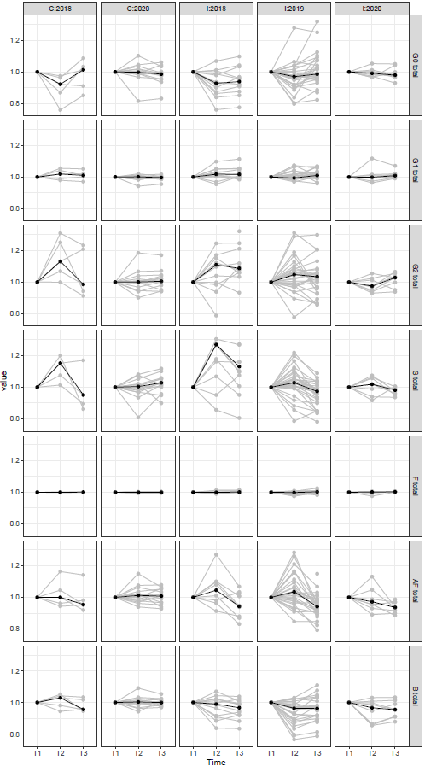
Fig. S4. IgG glycan composition changes during three seasons of influenza infection normalized to the first point. Value: standardized glycan measurement.

