Supplementary Data for

Microbial-Enhanced Steel Slag Fixation of CO₂ from Cement Kiln Flue Gas for the Production of Supplementary Cementitious Material
Chunxiang Qian ^{a,b,c,d,e,}*, Yijin Fan ^{a,b,c,d,e}, Yafeng Rui ^{a,b,c,d,e}, Xiao Zhang ^{a,b,c,d,e}, Yangfan Xu ^{a,b,c,d,e}
ª School of Materials Science and Engineering, Southeast University, Nanjing 211189, China
^{b} Key Laboratory of Microbial Bio-Mineralization Technology, China Construction Materials Industry, Nanjing 211189, China
^{c} Research Center of Green Construction Materials and Carbon Utilization, Southeast University, Nanjing 211189, China
^{d} Jiangsu Key Laboratory of Construction Materials, Southeast University, Nanjing 211189, China
^{e} State Key Laboratory of Engineering Materials for Major Infrastructure, Southeast University, Nanjing 211189, China

* Corresponding author.
E-mail address: cxqianseu1@163.com (C. Qian).

Table S1

Chemical composition (wt%) and specific surface area of steel slag powder.
Type | CaO | Fe₂O₃ | SiO₂ | MgO | P₂O₅ | MnO | Al₂O₃ | Othersª | LOI^{b} | D₅₀^{c} (μm) | SA^{d} (m²∙kg⁻¹)
SS1 | 40.88 | 17.16 | 17.48 | 5.69 | 1.56 | 3.35 | 6.56 | 7.32 | 2.16 | 24.98 | 338.5
SS2 | 42.28 | 17.79 | 16.47 | 5.37 | 1.44 | 3.10 | 6.22 | 7.33 | 6.18 | 25.47 | 339.6
SS3 | 41.69 | 16.65 | 18.68 | 7.11 | 1.16 | 1.75 | 6.64 | 6.32 | 3.20 | 19.56 | 391.1
SS4 | 41.88 | 18.74 | 16.70 | 7.10 | 1.18 | 1.75 | 6.67 | 5.98 | 2.37 | 22.75 | 353.6
ª “Others” includes a small amount of TiO₂, V₂O₅, K₂O, Cr₂O₃, BaO, SrO, ZrO₂, Nb₂O₅, CuO, etc.
^{b} LOI represents the loss on ignition (caused by the decomposition of a small amount of hydration products, calcium hydroxide, and carbonate minerals).
^{c} D₅₀ refers to the corresponding particle size when the cumulative distribution percentage reaches 50%.
^{d} SA stands for specific surface area.

Table S2

Monitoring results of flue gas from cement kiln tail chimney emissions.
Date | Temperature (°C) | Flow rate (×10⁵ m³∙h⁻¹) | O₂ (%) | PM (mg∙m⁻³) | SO₂ (mg∙m⁻³) | NO_{x} (mg∙m⁻³) | NH₃ (mg∙m⁻³) | Fluoride (mg∙m⁻³) | CO₂ (vol%)
July 2022 | 57.0–59.3 | 3.84–4.40 | 5.8–6.5 | 10.9–11.7 | 18–24 | 223–248 | 1.80–1.93 | 0.81–1.25 | 23–30
December 2022 | 49.4–59.4 | 5.28–8.53 | 9.8–10.5 | 17.1–18.8 | 10–17 | 174–192 | 0.40–0.51 | 0.76–1.37 | 23–29
May 2023 | 55.1–66.9 | 4.98–6.78 | 9.3–10.2 | 6.3–6.7 | 23–43 | 62–75 | — | 0.51–0.72 | 22–30
June 2023 | 48.0–59.6 | 5.43–8.26 | 9.7–10.3 | 3.6–4.0 | 3–6 | 35–42 | 0.70–0.80 | 0.99–1.20 | 23–31

Table S3

Chemical composition of Portland cement (wt%).
 | CaO | MgO | SiO₂ | Al₂O₃ | Fe₂O₃ | Na₂O | K₂O | SO₃ | LOI | Total
Average | 65.72 | 1.85 | 21.60 | 5.49 | 3.00 | 0.14 | 0.93 | 0.63 | 0.21 | 99.57

Table S4

Mechanical properties of Portland cement.
 | 7 d (MPa) |  |  | 28 d (MPa)
 | Compressive strength | Flexural strength |  | Compressive strength | Flexural strength
Value | 44.12 | 7.65 |  | 58.90 | 8.75

Table S5

Preparation period of each batch of carbonated steel slag powder and temperature and humidity during reaction.
Steel slag powder type | Date | Temperature and relative humidity (RH) in the carbon fixation reaction device
SS3 | July 2022 | T = 41–48 °C, RH = 80%–90%
SS4 | December 2022 | T = 37–45 °C, RH = 97%–98%
SS1 | May 2023 | T = 47–61 °C, RH = 90%–95%
SS2 | June 2023 | T = 47–56 °C, RH = 90%–95%

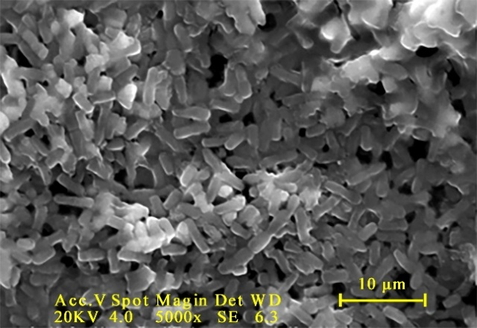

Fig. S1. Microscopic morphology of Bacillus mucilaginosus.

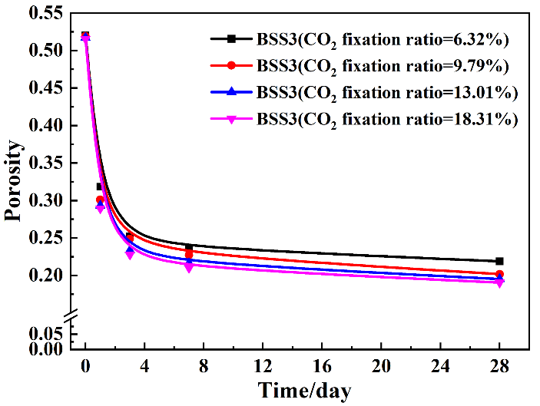

Fig. S2. Variation in porosity of cement-based materials containing BSS3 with different CO₂-fixation ratios.

Fig. S3. Fitting curves of the degree of the hydration reaction of cement with the addition of microorganisms and carbonate minerals. (a) Cement (cells); (b) 95% cement + 5% Bio-CaCO₃; (c) 95% cement + 5% Che-CaCO₃; (d) 95% cement + 5% LS. α: the degree of hydration; t: hydration time; F1: the differential equation of NG process; F2: the differential equation of I process; F3: the differential equation of D process.
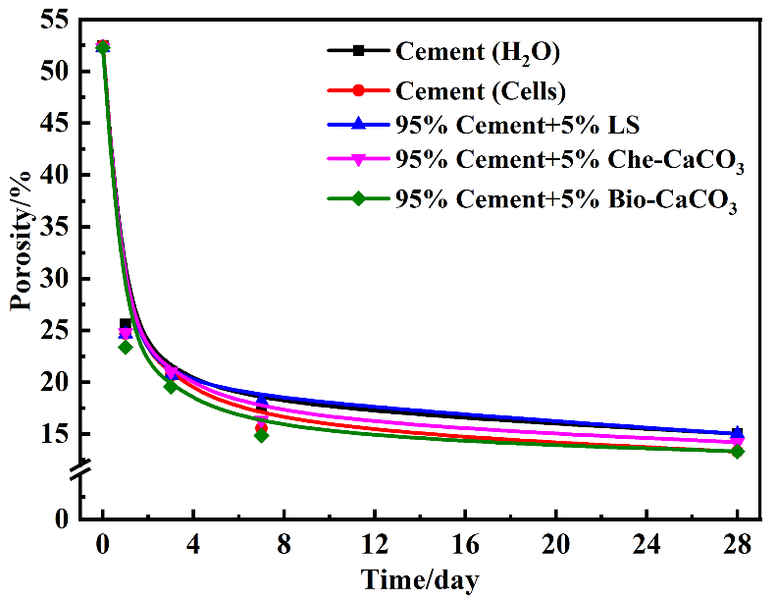

Fig. S4. Effect of microorganisms and carbonate minerals on the porosity of Portland cement.

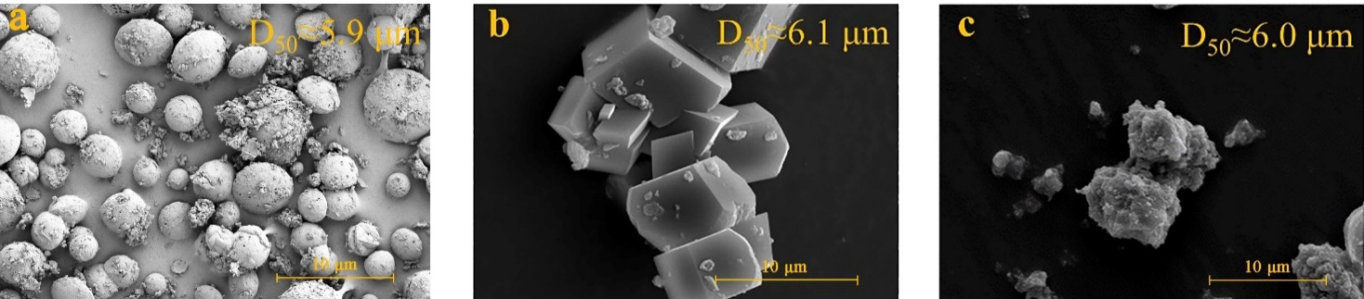

Fig. S5. SEM images of calcium carbonate minerals. (a) Bio-CaCO₃; (b) Che-CaCO₃; (c) LS.

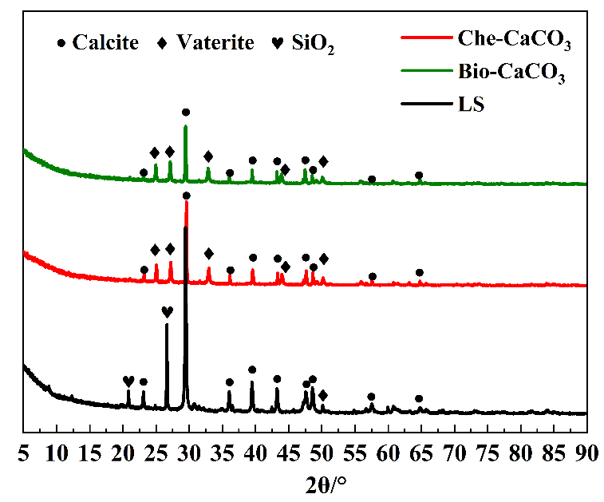

Fig. S6. XRD pattern of calcium carbonate minerals.

