Supplementary Data for

Chemical Looping Steam Reforming of Methane under Mild Conditions via Non-Thermal Plasma
Zunrong Sheng ^{a,b,c,d}, Donglong Fu ^{a,b,c}, Tingting Yang ^{a,b,c,e}, Xianhua Zhang ^{a,b,c,e}, Zheyuan Ding ^{a,b,c}, Chunlei Pei ^{a,b,c,f,g},
Sai Chen ^{a,b,c}, Zhi-Jian Zhao ^{a,b,c,f,g}, Jinlong Gong ^{a,b,c,h,i,}*
ª Key Laboratory for Green Chemical Technology of Ministry of Education, School of Chemical Engineering and Technology, Tianjin University, Tianjin 300072, China
^{b} Collaborative Innovation Center for Chemical Science and Engineering, Tianjin 300072, China
^{c} International Joint Laboratory of Low-Carbon Chemical Engineering of Ministry of Education, Tianjin 300350, China
^{d} School of Electrical Engineering, Dalian University of Technology, Dalian 116024, China
^{e} Joint School of National University of Singapore and Tianjin University, International Campus of Tianjin University, Fuzhou 350207, China
^{f} Haihe Laboratory of Sustainable Chemical Transformations, Tianjin 300192, China
^{g} National Industry–Education Platform for Energy Storage, Tianjin University, Tianjin 300350, China
^{h} State Key Laboratory of Synthetic Biology, Tianjin University, Tianjin 300072, China
^{i} Tianjin Normal University, Tianjin 300387, China

* Corresponding author.
E-mail address: jlgong@tju.edu.cn (J. Gong).

Supplementary methods

S1. Calculation of based on electron–molecule collision theory and electrical diagnostics
The collision between electrons and methane molecule, leading to the formation of vibrationally excited methane (CH₄^{v}), occurs with a rate coefficient k_{e}, as described in reaction (S1). The coefficient k_{e} was obtained by solving the electron Boltzmann equation using the BOLSIG+ solver with an appropriate cross-section set for CH₄ [1]. Its value varies with the reduced electric field (E/N), as shown in Fig. 3(a). Detailed instructions for operating BOLSIG+ are available at https://www.bolsig.laplace.univ-tlse.fr/wp-content/uploads/2016/03/bolsigdoc0316.pdf. The mean E/N was calculated using Eq. (S2), where U_{dis}, L_{dis}, P, N_{A}, R, and T denote the discharge voltage, discharge gap length, gas pressure, Avogadro’s constant, gas constant, and gas temperature, respectively. The U_{dis} was estimated from the sustained discharge voltage (U_{sus}) obtained from the charge–voltage (Q–U) plot (Fig. S14), as described elsewhere [2]. The L_{dis} corresponds to the distance between the high-voltage electrode and the inner wall of the quartz tube, which is 2.5 mm in this study. The generation rate of vibrationally excited molecules () was determined using Eq. (S3), where the denotes the number density of vibrationally excited CH₄^{v}, impact factor A represents the number of CH₄^{v} molecules generated per electron impaction during streamer propagation, and r_{e} is the average electron transfer rate (electron∙s⁻¹). The impact factor A was calculated using Eq. (S4), incorporating the rate coefficient k_{e} (as a function of E/N, Fig. 3(a)), the methane molecular concentration ( in molecules∙m⁻³), the estimated electron density in a DBD streamer (N_{e} ≈ 1 × 10¹⁸ electrons∙m⁻³) [3], and the streamer propagation time (Δt ≈ 10 ns) [3]. The electron transfer rate r_{e} was obtained from Eq. (S5), where ΔQ is the net charge transferred per half cycle (from the Q–U plot, Fig. S14) and f is the discharge frequency, set at 8.7 kHz. All key parameters used in calculating are summarized in Table S1 to ensure transparency and reproducibility.
${\text{e}}^{-}+{CH}_{4} \underset{→}{k_{\text{e}}} {{CH}_{4}}^{\text{v}}+{\text{e}}^{-}$ (S1)
$\frac{E}{N}=\frac{{U_{\text{dis}}}/{L_{\text{dis}}}}{{P∙N_{\text{A}}}/{R∙T}} (\text{V∙}{\text{m}}^{\text{2}})$ (S2)
$r_{{{\text{CH}}_{\text{4}}}^{\text{v}}}=\frac{\text{d}N_{{{CH}_{4}}^{ν}}}{\text{d}t}={A×r}_{\text{e}} (number∙{\text{s}}^{-1}{\text{∙m}}^{-3})$ (S3)
$A=\frac{k_{\text{e}}{{×N}_{{CH}_{4}}×N}_{\text{e}}×∆t}{N_{\text{e}}}= k_{\text{e}}{×N}_{{CH}_{4}}×∆t$ (S4)
$r_{\text{e}}=2×\frac{∆Q}{2e}×f (\text{electron}∙{\text{s}}^{-1})$ (S5)

S2. Density functional theory calculations
All spin-polarized density functional theory (DFT) calculations were performed using the Vienna ab initio simulation package (VASP) [4,5]. The projector-augmented wave method [6,7] was applied with a plane-wave cutoff energy of 600 eV [8]. The Perdew–Burke–Ernzerhof (PBE) exchange–correlation functional was employed to describe electron–electron interactions [9]. To correct for the strong self-interaction of Fe 3d electrons, the DFT + U approach was adopted with an effective Hubbard parameter of U_{eff} = 4.3 eV [10]. Geometric optimizations were conducted with convergence criteria of 10⁻⁵ eV for energy and 0.05 eV∙Å⁻¹ for force minimization. The transition states for the first C–H bond activation were identified using the climbing-image nudged elastic band (CI-NEB) method [11]. The LaFeO₃(121) surface was modeled as a three-layer slab with a 1 × 2 supercell and a 3 × 2 × 1 Monkhorst–Pack k-point grid. A 15 Å vacuum was introduced along the z-axis to prevent interactions between periodic images. The adsorption energy of CH₄ () was calculated according to Eq. (S6), where , , and represent the total energies of CH₄ absorbed on the surface, the clean surface, and the gas-phase CH₄ molecule, respectively. The Gibbs free energy (G) was calculated using Eq. (S7), where H, T, S, and E_{ZPE} denote enthalpy, temperature, entropy, and the zero-point energy (ZPE). The change in ∆G is defined as the difference between the G values of steps 2–9 and that of step 1 (initial state) shown in Fig. S16.
${∆E}_{\text{C}{\text{H}}_{\text{4}}}=E_{\text{*}\text{C}{\text{H}}_{\text{4}}}-\left(E_{\text{*}}+E_{{\text{CH}}_{\text{4}}}\right)$ (S6)
${G=H-TS=∆E}_{\text{C}{\text{H}}_{\text{4}}}+E_{\text{ZPE}}-TS$ (S7)

S3. The reaction order calculation method
The reaction order was determined by analyzing the logarithmic relationship between the methane concentration () and the methane conversion rate (). The was calculated using Eq. (S8), where $N_{{\text{CH}}_{\text{4}}}^{\text{in}}$ and $N_{{\text{CH}}_{\text{4}}}^{\text{out}}$represent the inlet and outlet concentrations of CH₄ (mol∙m⁻³), respectively, as defined by Eqs. (S9) and (S10). The inlet molar flow rate of methane (M_{CH4-in}, mol∙s⁻¹) and molar conversion rate of methane (C_{CH4}, mol∙s⁻¹) were obtained from Eqs. (S11) and (S12), based on the supplied methane flow rate () and converted methane flow rate (), both expressed in cm³∙min⁻¹. Standard conditions were defined as P₀ = 101 300 Pa and T₀ = 298.15 K, with the gas constant R = 8.314 J∙(mol·K) ⁻¹. The inlet (Q_{in}) and outlet (Q_{out}) volumetric flow rates under standard conditions (cm³∙min⁻¹) were determined using Eqs. (S13) and (S14), taking into account the reaction temperature (T₁ = 720 °C) and pressure (P₁ = 101 300 Pa). The total inlet and outlet flow rates, $Q_{\text{in}}^{\text{total}}$ and $Q_{\text{out}}^{\text{total}}$, correspond to the combined flow of all gaseous components: N₂ and CH₄ at the inlet, and N₂, CH₄, CO, and H₂ at the outlet. The methane conversion rate () was calculated using Eq. (S15), where t represents the residence time of molecules in the reaction zone, as defined by Eq. (S16). The volume of the reaction zone (V) was estimated to be 1005 mm³.
$N_{{CH}_{4}}=\frac{N_{{CH}_{4}}^{in}+N_{{CH}_{4}}^{out}}{2}$ (S8)
$N_{{CH}_{4}}^{in}=\frac{M_{{CH}_{4}\text{-}in}}{{Q_{in}×{10}^{-6}}/{60}}$ (S9)
$N_{{CH}_{4}}^{out}=\frac{M_{{CH}_{4}\text{-}in}-C_{{CH}_{4}}}{{Q_{out}×{10}^{-6}}/{60}}$ (S10)
$M_{{CH}_{4}\text{-}in} =\frac{F_{{CH}_{4}\text{-sup}}×P_{0}×{10}^{6}}{R×T_{0}×60}$ (S11)
$C_{{CH}_{4}} =\frac{F_{{CH}_{4}\text{-con}}×P_{0}×{10}^{6}}{R×T_{0}×60}$ (S12)
$Q_{in}=\frac{P_{0}×(T_{1}+273.15)}{P_{1}×T_{0}}×Q_{in}^{total}$ (S13)
$Q_{out}=\frac{P_{0}×(T_{1}+273.15)}{P_{1}×T_{0}}×Q_{out}^{total}$ (S14)
$r_{{CH}_{4}}=\frac{N_{{CH}_{4}}^{in}-N_{{CH}_{4}}^{out}}{t}×60$ (S15)
$t=\frac{V}{(Q_{in}+Q_{out})/2}$ (S16)

S4. ZPE analysis
The ZPE of methane in its vibrational ground state ($E_{ZPE}^{vib\text{-}g}$) was calculated according to Eq. (S17). The vibrational quantum number (υ = 0, 1, 2, …) denotes the discrete energy levels, where υ = 0 corresponds to the vibrational ground state. The normal mode frequencies (ν_{i}, i = 1, 2, 3, …, 3N − 6, where N is the total number of atoms in the molecule) calculated using VASP are listed in Table S3. Methane possesses nine normal vibrational modes (i = 1–9), which were grouped into four approximate vibration types (v_{n}, n = 1, 2, 3, 4) by averaging the corresponding mode frequencies. These four fundamental vibrational modes can be excited to higher energy levels via electron–molecule collisions in DBD plasma. The vibrational ground state methane (υ = 0) lies at the lowest energy level, while the vibrationally excited transition originates from this level, as expressed by Eq. (S17). Each vibrational mode was treated as independent [12], and the vibrational motion was approximated by uncoupled harmonic oscillators [13,14], as the anharmonic correction term ($χ{\left(υ_{1}+0.5\right)}^{2}hν_{n}$) in Eq. (S18) is significantly smaller than the harmonic term at low excitation levels (i.e., anharmonicity constant), where the h is Planck constant. When the CH₄^{g} is excited through low-energy electron collisions, it transitions from ground state (υ = 0, defined as υ₀ in Eq. (S18)) to the first vibrationally excited state (υ = 1, defined as υ₁ in Eq. (S18)), denoted as CH₄^{v}. Overtone excitations (υ = 2, 3, …) were neglected in this study due to their short lifetimes and because electron impact processes rarely generate overtone CH₄ directly [2,15]. The increase in ZPE of vibrationally excited methane ($∆E_{ZPE}^{vib\text{-}e}$) was estimated using Eq. (S19), which is approximately equal to hv_{n}.
$E_{ZPE}^{\text{vib-g}}=\sum_{i}{(υ+0.5})hν_{i}=\sum_{i}{0.5}hν_{i}$ (S17)
$E_{ZPE}^{\text{vib-e}}=E_{ZPE}^{\text{vib-g}}+\left(υ_{1}+0.5\right)hν_{n}-\left(υ_{0}+0.5\right)hν_{n}-χ{\left(υ_{1}+0.5\right)}^{2}hν_{n}≈E_{ZPE}^{\text{vib-g}}+hν_{n}$ (S18)
$∆E_{ZPE}^{\text{vib-e}}=E_{ZPE}^{\text{vib-e}}-E_{ZPE}^{\text{vib-g}}≈hν_{n}$ (S19)

S5. In-situ plasma DRIFTS study
In-situ plasma diffuse reflectance infrared Fourier transform spectroscopy (DRIFTS) measurements were conducted using a Thermo Scientific Nicolet iS50 FT-IR spectrometer equipped with a liquid nitrogen-cooled mercury cadmium telluride detector. A custom-built plasma DRIFTS cell (Fig. S17(a)) was employed for the experiments (Hefei In-situ Technology Co., Ltd., China). As schematically illustrated in Fig. S17(b), the cell featured a coaxial high-voltage needle electrode housed in a quartz holder to generate a DBD between the electrode and a copper ground plate, with the catalyst powder and holder serving as the dielectric barrier. The plasma was generated under a sinusoidal high voltage of 5.5 kV at 9 kHz. Approximately 100 mg of LaFeO₃ powder was loaded into the holder. The catalyst temperature was maintained at 300 °C during both plasma and thermal experiments. Temperature regulation was achieved using a thermocouple embedded beneath the catalyst holder, while heating elements, cooling water, and plasma-induced heating (under plasma-on conditions) were jointly used to control the temperature. It is noted that the temperature did not exceed 300 °C due to the heat tolerance limits of the sealing materials surrounding the electrodes. Figs. S17(c) and (d) show the side and top views (without the sample and dome) of DBD formation within the holder. The outlet of the in-situ plasma DRIFTS cell was connected to a tee junction, where one branch led to an online quadrupole mass spectrometer (QMS, Pfeiffer Vacuum GSD350) for real-time gas-phase analysis, while the other was vented to the atmosphere to compensate for the QMS flow rate limitation (approximately 1 cm³∙min⁻¹). The temporal resolution of the QMS measurement was approximately 9 s.

S6. Sample treatment before XPS analysis
LaFeO₃ particles (20–40 mesh) were treated under a continuous CH₄/N₂ flow (5/45 cm³∙min⁻¹) at 700 °C for 10 min, both with and without plasma activation. The treated samples were subsequently grounded into fine powders for XPS analysis.

S7. XPS depth profiling analysis
For depth profiling, a LaFeO₃ tablet (thickness ≈ 2 mm; Fig. S19) was exposed to a continuous CH₄/N₂ flow at 700 °C for 10 min under a 15 W plasma discharge. The samples were etched using Ar⁺ sputtering at an ion energy of 2000 eV, corresponding to an etching rate of approximately 0.1 nm∙s⁻¹. Each etching level was achieved with a sputtering duration of 60 s.

S8. Sensible heat requirement in energy analysis
During plasma-assisted reactions at 700 °C, the catalyst bed temperature was maintained using a furnace set to 600 °C (Fig. 6), with the 25 W DBD plasma contributing an additional temperature rise of approximately 100 °C. The sensible heat requirement (Q_{m}) from thermal heating (excluding the Joule heating contribution from plasma) was calculated using Eq. (S20). In this equation, C_{rea} and C_{OC} denotes the specific heat capacities of the stainless-steel reactor and the oxygen carrier (OC), respectively; m_{rea} and m_{OC} represent their corresponding masses, respectively; and ∆T is the temperature increase from 20 °C to either 600 or 800 °C. The parameters used in the calculation are summarized in Table S5.
Q_{m} = C_{rea}m_{rea}∆T + C_{OC}m_{OC}∆T (S20)

S9. Calculation method for energy efficiency of plasma-enhanced hydrogen production
The energy efficiency of plasma-enhanced hydrogen production (Eff_{P}) was evaluated using Eq. (S21), where the Q_{P}, , P, and t_{dis} represent the plasma input energy, the lower heating value of H₂, the discharge power (25 W), and the discharge duration (6 min), respectively. The net H₂ yield () was obtained by subtracting the molar amount of H₂ yield in thermal condition () from molar amount of H₂ yield in plasma condition () at identical catalyst bed temperatures, thereby isolating the plasma activation effect. The molar amounts of net H₂ yield (M_{H2}) during the POM step (yellow bars) and the WS step (blue bars) are presented in Fig. S20, along with the corresponding energy efficiency (red solid line). In this analysis, Joule heating was included as part of the plasma energy input. A discharge power of 25 W applied for 6 min corresponds to a total energy input of 9000 J during the POM step, encompassing both the reaction enthalpy (intrinsic plasma-induced chemistry) and Joule heating. The latter primarily accounts for the observed ~100 °C temperature increase, arising from heat transfer to the OC and reactor walls. As reported by Nozaki et al. [16,17], approximately 80% of the DBD energy is dissipated as Joule heating in dielectric components (e.g., catalysts and quartz) and metallic electrodes, while only ~20% contributes to chemical reactions and sensible heat. To evaluate the intrinsic non-thermal plasma contribution, Joule heating was excluded from the total energy input to obtain a theoretical energy efficiency, represented by the red dashed line in Fig. S20.
${Eff}_{P}=\frac{Y_{{\text{H}}_{\text{2}}\text{,net}}×{\text{LHV}}_{{\text{H}}_{\text{2}}}}{Q_{P}}=\frac{\left(M_{H_{2}}^{Plasma}-M_{H_{2}}^{Thermal}\right)×{\text{LHV}}_{{\text{H}}_{\text{2}}}}{P×t_{dis}}$ (S21)

Supplementary figures
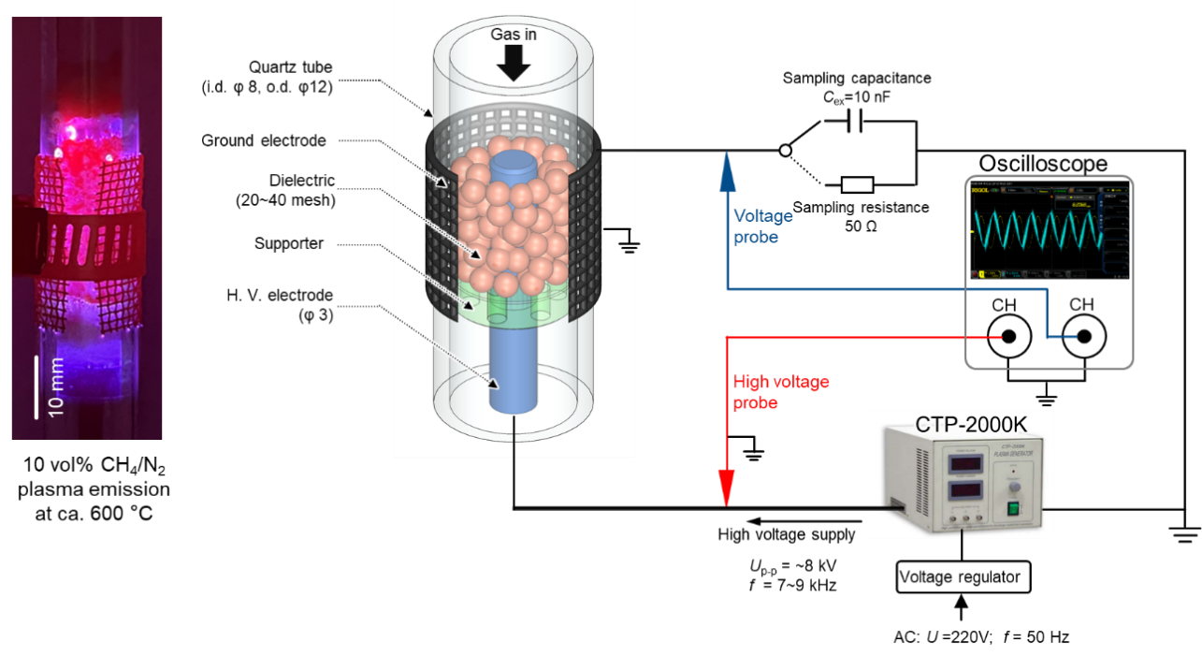

Fig. S1. Schematic of the dielectric barrier discharge (DBD) system used for the chemical looping methane reforming experiment.

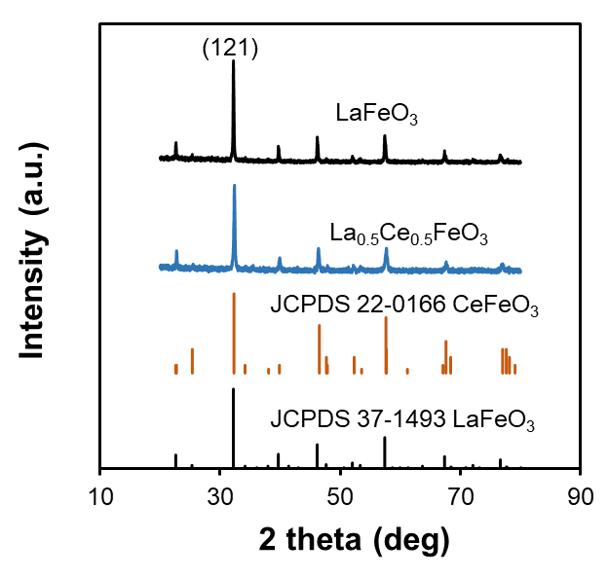

Fig. S2. XRD patterns of fresh LaFeO₃ and La_{0.5}Ce_{0.5}FeO₃ samples.

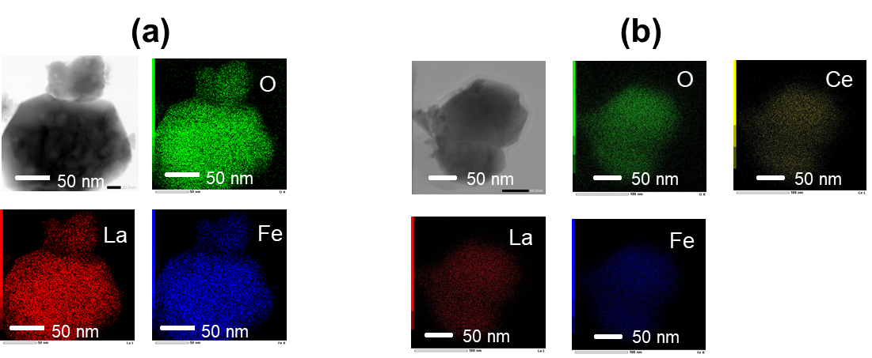

Fig. S3. TEM images and elemental mapping of LaFeO₃ and La_{0.5}Ce_{0.5}FeO₃ samples.

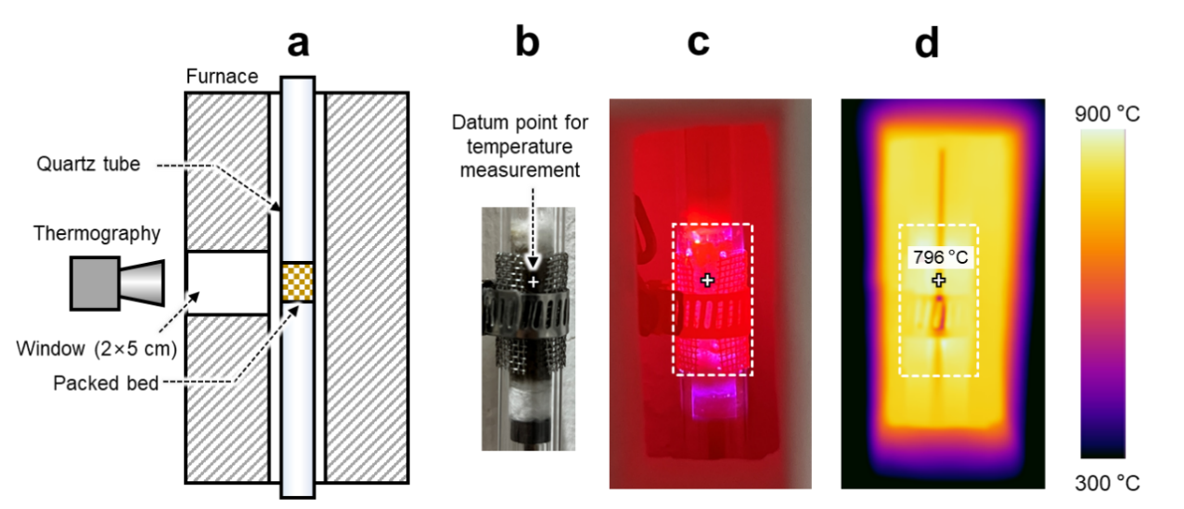

Fig. S4. Infrared thermal camera measurement of reaction temperature. (a) Schematic of the noncontact temperature measurement setup through the observation window. (b, c) Images of the DBD reactor (b) at room temperature and at (c) approximately 800 °C, respectively. (d) Thermal image of the DBD reactor at a furnace temperature of approximately 700 °C.

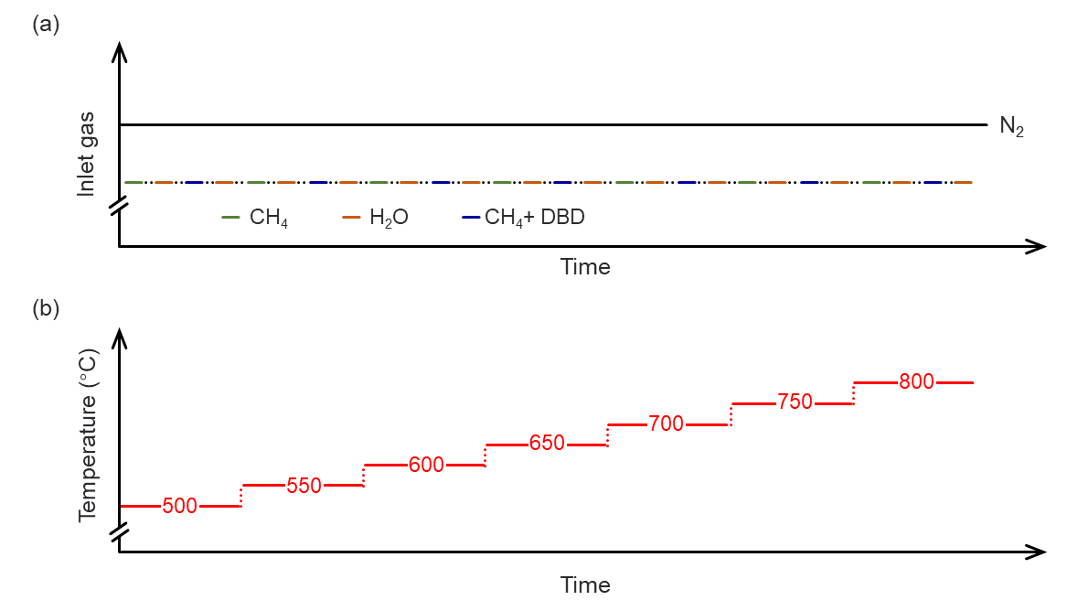

Fig. S5. Schematic diagram illustrating the time-dependent (a) inlet gas flow and (b) proposed temperature profile during continuous POM–WS chemical looping.

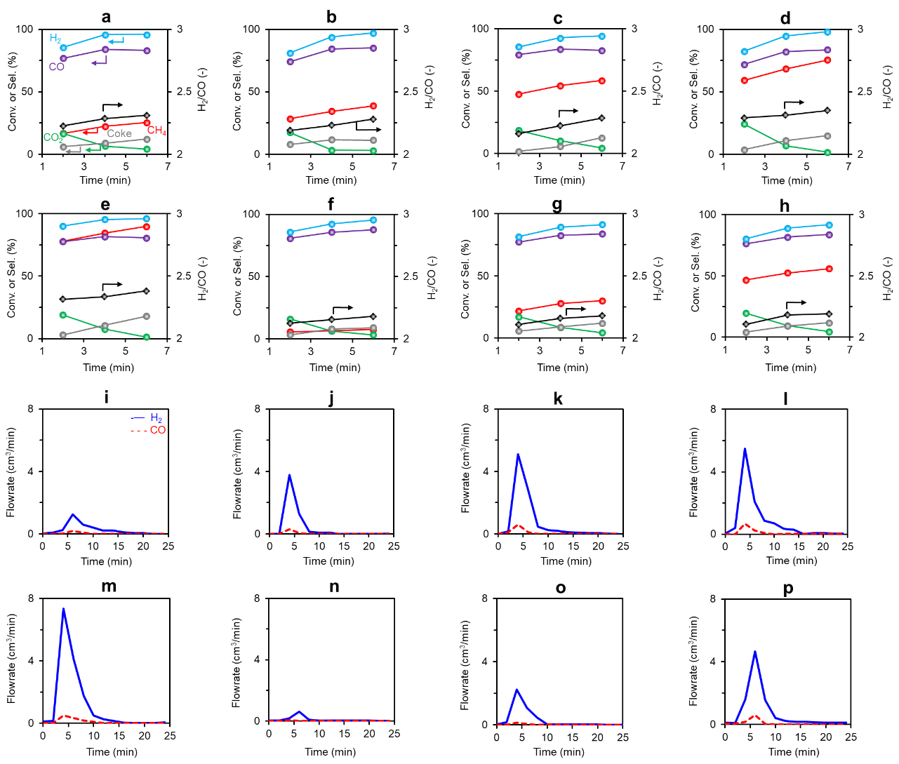

Fig. S6. Reaction performance of partial oxidation of methane (POM) and water splitting (WS) with LaCeFe. Panels (a–h) show on-stream profiles of CH₄ conversion (red) and selectivity for H₂ (blue), CO (purple), CO₂ (green), coke (gray), and the H₂/CO ratio (black diamonds) during the plasma-POM step (a–e) at temperatures of approximately 600–800 °C and the thermal-POM step (f–h) at 700, 750, and 800 °C. Panels (i–p) present the outlet flow rates of H₂ (blue solid line) and CO (red dashed line) as a function of time during the WS step, corresponding to panels (a–e) for the plasma-POM–WS cycle and (f–h) for the thermal-POM–WS cycle.

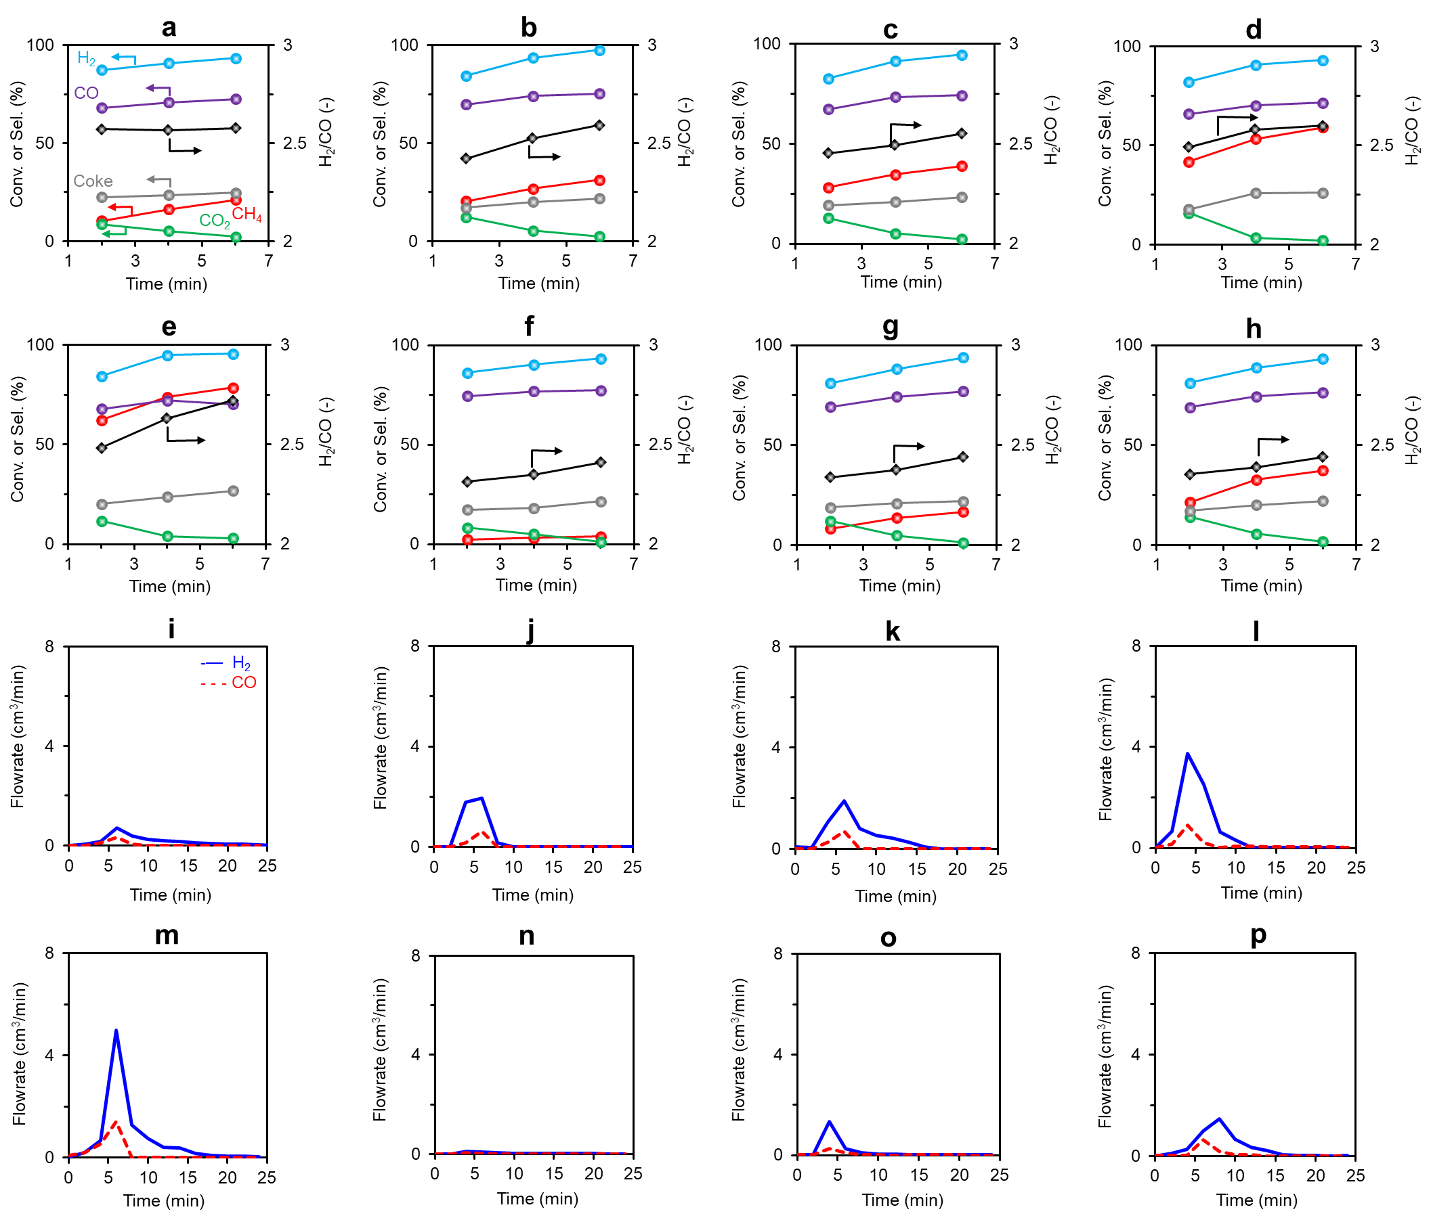

Fig. S7. Reaction performance of POM and WS with LaFeO₃. Panels (a–h) show on-stream profiles of CH₄ conversion (red) and selectivity for H₂ (blue), CO (purple), CO₂ (green), coke (gray), and the H₂/CO ratio (black diamonds) during the plasma-POM step (a–e) at temperatures of approximately 600–800 °C and the thermal-POM step (f–h) at 700, 750, and 800 °C. Panels (i–p) present the outlet flow rates of H₂ (blue solid line) and CO (red dashed line) as a function of time during the WS step, corresponding to panels (a–e) for the plasma-POM–WS cycle and (f–h) for the thermal-POM–WS cycle.

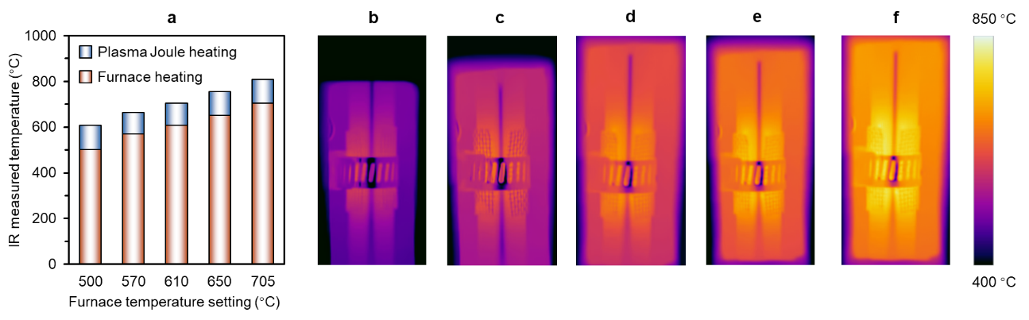

Fig. S8. IR camera-based temperature measurement. (a) Comparison of temperature rise induced by plasma-derived Joule heating and conventional furnace heating. (b–f) IR thermal images of the packed-bed region at furnace temperature settings of 500, 570, 610, 650, and 705 °C, respectively.
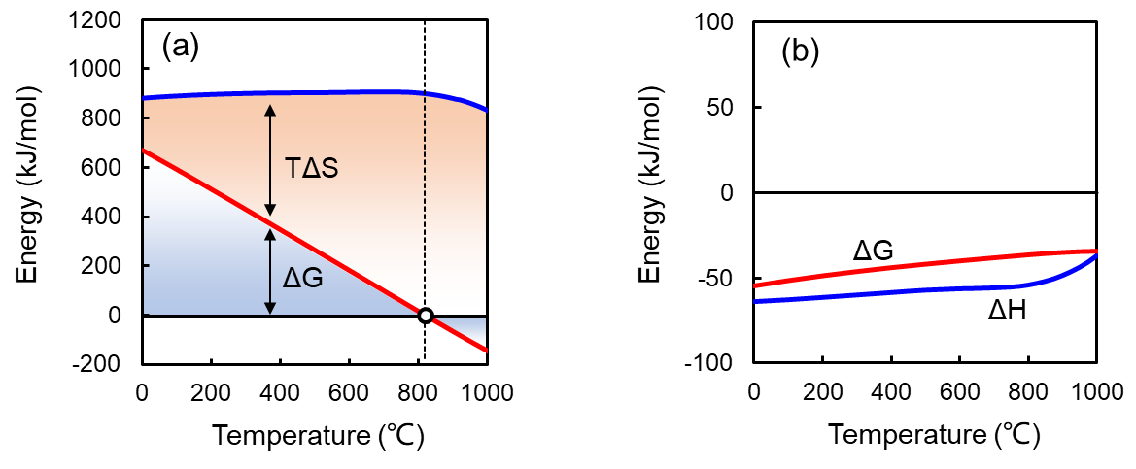

Fig. S9. Energy diagrams of (a) oxygen carrier (OC) reduction by CH₄ (2LaFeO₃ + 3CH₄ = La₂O₃ + 2Fe + 6H₂ + 3CO) and (b) OC oxidation by H₂O (2Fe + La₂O₃ + 3H₂O = 2LaFeO₃ + 3H₂).

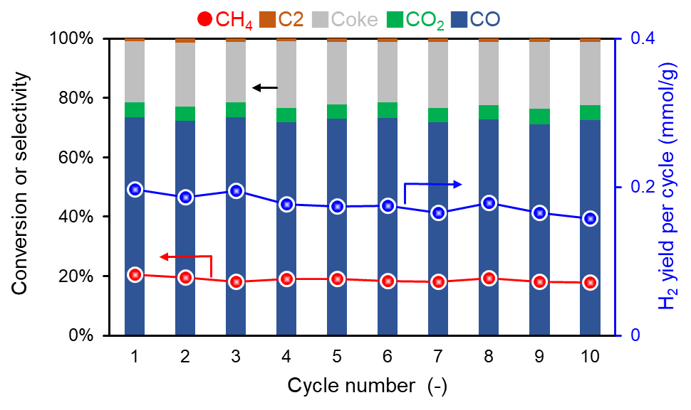

Fig. S10. Durability test of plasma-chemical looping steam reforming of methane at 600 °C with a power input of 15 W. The C₂ products comprise C₂H₆ and C₂H₄, with average selectivities of 0.73% and 0.4%, respectively.

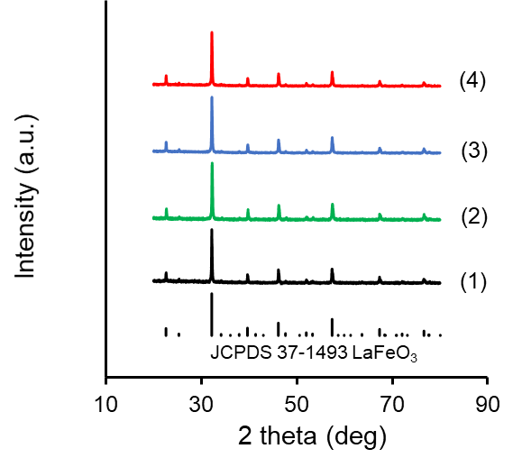

Fig. S11. XRD patterns of LaFeO₃ under different conditions: (1) fresh, (2) after thermal CH₄ treatment, (3) after 10-cycle plasma CH₄ treatment, and (4) after 10-cycle H₂O treatment.

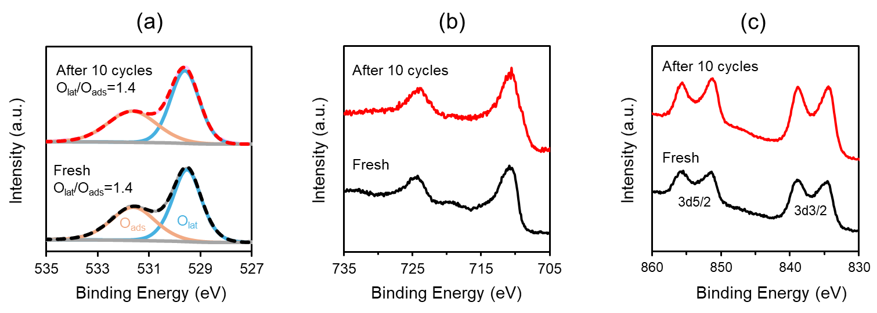

Fig. S12. XPS spectra of (a) O 1s, (b) Fe 2p, and (b) La 3d for fresh and post-10-cycle LaFeO₃ oxygen carriers (final treatment: water splitting step).

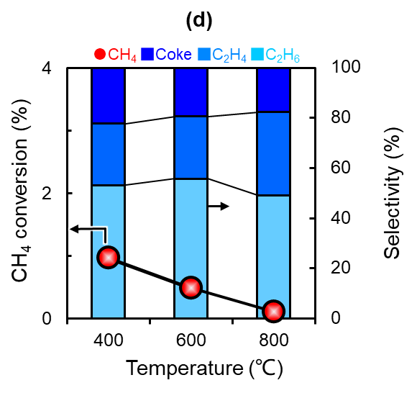

Fig. S13. CH₄ conversion and product selectivity in a SiO₂-packed DBD reactor under a plasma power input of 15 W.

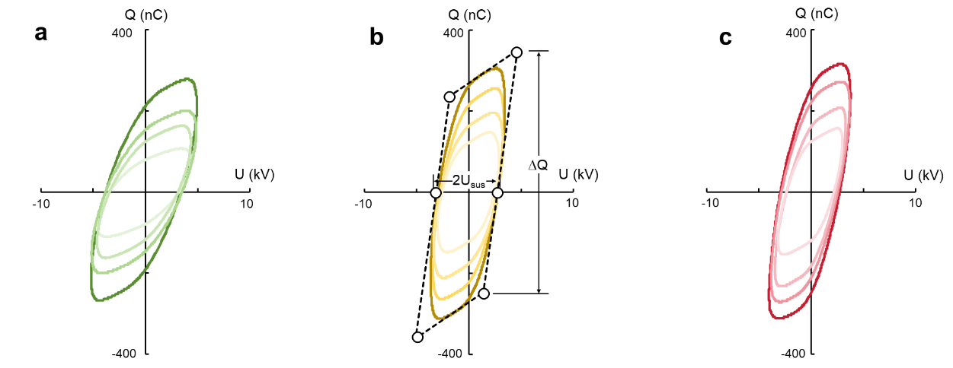

Fig. S14. Q–U plots for electrical diagnostics under plasma powers of approximately 10, 15, 20, and 25 W (lighter to darker colors represent increasing power) at a frequency of 8.7 kHz, CH₄/N₂ = 5/45 cm³∙min⁻¹, and temperature of (a) 600 °C, (b) 700 °C, and (c) 800 °C. U_{sus} and ∆Q represent the discharge-sustained voltage and charge transferred per half cycle, respectively.

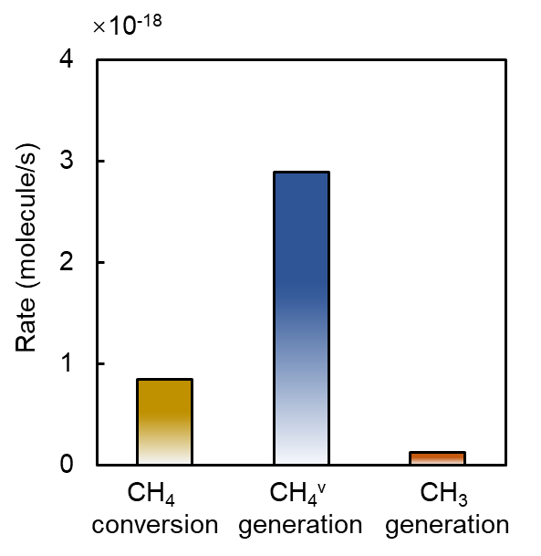

Fig. S15. Comparison of CH₄ conversion rate and the generation rates of CH₄^{v} and •CH₃ radicals at 800 °C with a plasma power of 25 W.

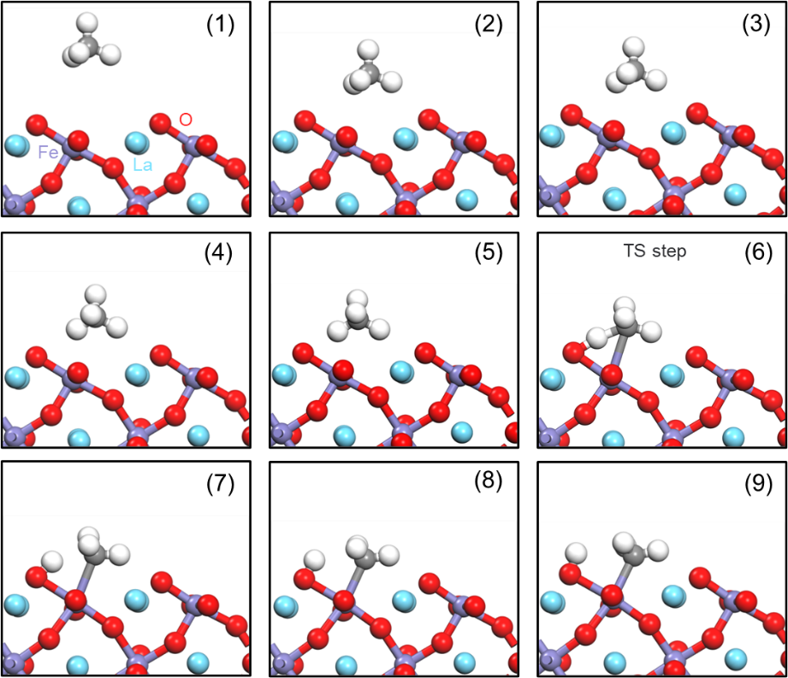

Fig. S16. Snapshots of the dissociative chemisorption pathway.
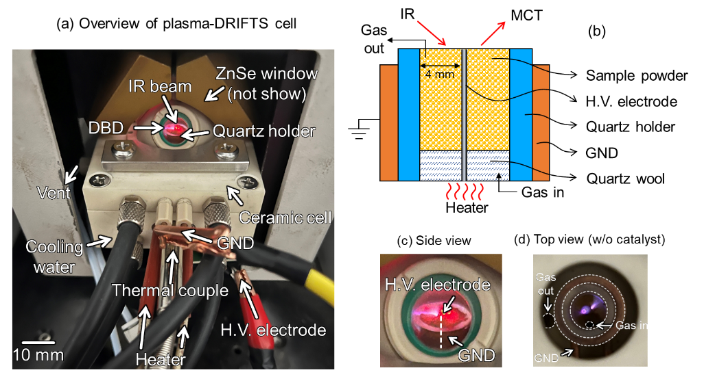

Fig. S17. In-situ plasma DRIFTS cell: (a) overview, (b) schematic diagram, (c) side view, and (d) top view without sample powder. The cell is provided by Hefei In-situ Technology Co., Ltd.

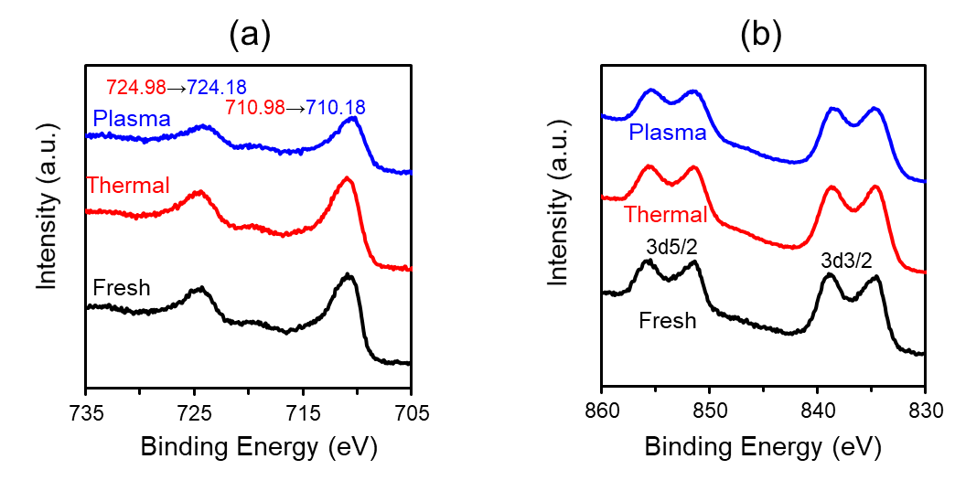

Fig. S18. XPS spectra of (a) Fe 2p and (b) La 3d for thermally and plasma CH₄-treated samples.

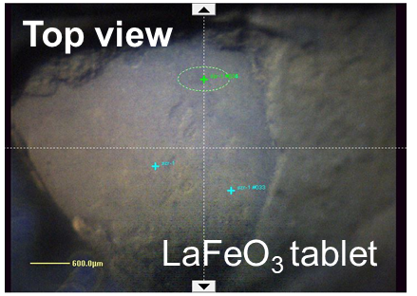

Fig. S19. Top view of the LaFeO₃ tablet used in the depth profiling analysis.

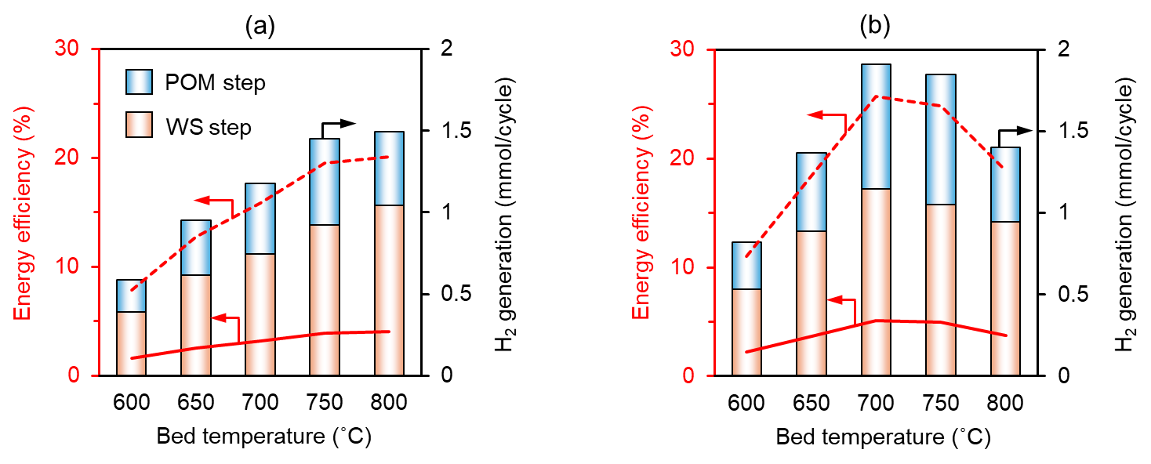

Fig. S20. Energy efficiency of plasma-enhanced hydrogen production using OCs: (a) LaFeO₃ and (b) LaCeFe. Experimental conditions are consistent with those described in Figs. 1 and 2. The red solid line represents the energy efficiency including Joule heating, while the red dashed line indicates the theoretical efficiency excluding Joule heating.

Supplementary tables

Table S1
Electrical parameters, plasma parameters, and reaction performance data.
Temperature (°C) | Discharge power, P (W) | Discharge voltage, U_{sus} (kV) | Charge transferred per half cycle, ΔQ (nC) | Concertation of CH₄, (×10⁻²³ m⁻³) | Reduced electric field, E/N (Td) | Rate coefficient, k_{e} (×10¹⁴ m³∙s⁻¹) | CH₄^{v} generation rate (×10⁻¹⁸ s⁻¹) | CH₄ conversion rate (×10⁻¹⁸ s⁻¹)
600 | $${10.23}_{-0.46}^{+0.36}$$ | $${3.34}_{-0.11}^{+0.10}$$ | $${187.33}_{-13.33}^{+9.67}$$ | 8.40 | 159 | 1.32 | $${1.13}_{-0.08}^{+0.06}$$ | $${0.10}_{-0.03}^{+0.04}$$
600 | $${15.06}_{-0.47}^{+0.86}$$ | $${3.29}_{-0.14}^{+0.12}$$ | $${285.00}_{-15.00}^{+15.00}$$ | 8.40 | 157 | 1.32 | $${1.72}_{-0.09}^{+0.09}$$ | $${0.15}_{-0.04}^{+0.04}$$
600 | $${20.54}_{-0.38}^{+0.54}$$ | $${3.50}_{-0.11}^{+0.13}$$ | $${348.67}_{-10.67}^{+7.33}$$ | 8.40 | 166 | 1.38 | $${2.19}_{-0.06}^{+0.04}$$ | $${0.21}_{-0.05}^{+0.05}$$
600 | $${25.70}_{-0.64}^{+0.73}$$ | $${3.64}_{-0.05}^{+0.09}$$ | $${462.00}_{-16.00}^{+10.00}$$ | 8.40 | 173 | 1.43 | $${3.02}_{-0.10}^{+0.06}$$ | $${0.33}_{-0.06}^{+0.07}$$
700 | $${9.88}_{-0.45}^{+0.41}$$ | $${2.37}_{-0.15}^{+0.13}$$ | $${250.67}_{-12.673}^{+13.33}$$ | 7.54 | 125 | 1.06 | $${1.09}_{-0.05}^{+0.06}$$ | $${0.22}_{-0.02}^{+0.03}$$
700 | $${14.96}_{-0.83}^{+0.70}$$ | $${2.62}_{-0.18}^{+0.15}$$ | $${344.67}_{-18.67}^{+11.33}$$ | 7.54 | 139 | 1.20 | $${1.69}_{-0.09}^{+0.06}$$ | $${0.34}_{-0.06}^{+0.05}$$
700 | $${19.90}_{-0.99}^{+0.88}$$ | $${2.72}_{-0.06}^{+0.06}$$ | $${459.33}_{-7.33}^{+10.67}$$ | 7.54 | 144 | 1.20 | $${2.26}_{-0.05}^{+0.05}$$ | $${0.49}_{-0.07}^{+0.07}$$
700 | $${24.86}_{-0.35}^{+0.38}$$ | $${2.78}_{-0.07}^{+0.09}$$ | $${542.67}_{-12.67}^{+15.33}$$ | 7.54 | 147 | 1.26 | $${2.81}_{-0.06}^{+0.08}$$ | $${0.63}_{-0.08}^{+0.09}$$
800 | $${9.91}_{-0.19}^{+0.18}$$ | $${2.25}_{-0.06}^{+0.05}$$ | $${256.33}_{-16.33}^{+10.67}$$ | 6.84 | 132 | 1.13 | $${1.08}_{-0.07}^{+0.04}$$ | $${0.29}_{-0.02}^{+0.03}$$
800 | $${14.68}_{-0.61}^{+0.39}$$ | $${2.30}_{-0.08}^{+0.06}$$ | $${391.67}_{-15.67}^{+18.33}$$ | 6.84 | 134 | 1.13 | $${1.64}_{-0.07}^{+0.08}$$ | $${0.46}_{-0.05}^{+0.05}$$
800 | $${20.69}_{-0.29}^{+0.29}$$ | $${2.67}_{-0.03}^{+0.03}$$ | $${494.00}_{-14.00}^{+14.00}$$ | 6.84 | 156 | 1.32 | $${2.43}_{-0.07}^{+0.07}$$ | $${0.67}_{-0.08}^{+0.08}$$
800 | $${25.25}_{-0.25}^{+0.25}$$ | $${2.82}_{-0.02}^{+0.02}$$ | $${576.00}_{-12.00}^{+12.00}$$ | 6.84 | 165 | 1.38 | $${2.89}_{-0.06}^{+0.06}$$ | $${0.84}_{-0.09}^{+0.09}$$

Table S2
Calculated energies corresponding to steps 1–9 in Figure S16.
Step | E_{DFT} (meV) | E_{ZPE} (eV) | TS at 600 °C (eV) | G at 600 °C (meV)
1 | −916.04ª | 1.30 | — | −940.58
2 | −940.38 | 1.30 | 1.04 | −940.12
3 | −940.34 | 1.30 | 0.81 | −939.84
4 | −940.28 | 1.31 | 0.76 | −939.73
5 | −940.07 | 1.31 | 0.70 | −939.46
6 | −939.29 | 1.17 | 0.71 | −938.83
7 | −939.62 | 1.27 | 0.81 | −939.16
8 | −939.91 | 1.29 | 0.77 | −939.39
9 | −940.10 | 1.29 | 0.76 | −939.57
ª E_{DFT} in step 1 represents the energy of the LaFeO₃ surface.

Table S3
Vibrational modes and frequencies of methane.
Approximate type of mode | n | v_{n} | i | v_{i} in step x
 |  |  |  | x = 1ª | x = 2 | x = 3 | x = 4 | x = 5 | x = 6 (TS)
Symmetric stretch | 1 | 2975.22 | 1 | 2975.22 | 2972.83 | 2974.75 | 2970.54 | 2769.89 | 1609.26
Torsional bend | 2 | 1512.68 | 2 | 1513.65 | 1535.20 | 1537.99 | 1544.09 | 1559.23 | 1466.49
Torsional bend | 2 | 1512.68 | 3 | 1511.72 | 1512.15 | 1505.30 | 1494.07 | 1484.54 | 1410.67
Antisymmetric stretch | 3 | 3094.57 | 4 | 3096.56 | 3098.62 | 3105.25 | 3117.29 | 3133.23 | 3059.33
Antisymmetric stretch | 3 | 3094.57 | 5 | 3093.81 | 3075.61 | 3078.19 | 3078.27 | 3071.31 | 2965.36
Antisymmetric stretch | 3 | 3094.57 | 6 | 3093.32 | 3066.35 | 3060.38 | 3048.18 | 2982.36 | 2895.21
Umbrella bend | 4 | 1286.34 | 7 | 1287.53 | 1311.37 | 1317.86 | 1337.54 | 1387.25 | 1173.20
Umbrella bend | 4 | 1286.34 | 8 | 1286.51 | 1296.71 | 1288.79 | 1275.25 | 1255.20 | 1163.22
Umbrella bend | 4 | 1286.34 | 9 | 1284.99 | 1283.30 | 1279.86 | 1268.74 | 1240.90 | 645.99
ª Step x = 1 corresponds to gaseous methane without any physical or chemical adsorption.

Table S4
Parameters used in the reaction order analysis.
Reaction type | CH₄ inlet flowrate (cm³∙min⁻¹) | N₂ inlet flowrate (cm³∙min⁻¹) | Discharge power (W) | CH₄ conversion rate (cm³∙min⁻¹) | H₂ generation rate (cm³∙min⁻¹) | CO generation rate (cm³∙min⁻¹)
Thermal reaction | 4 | 96 | 0 | 0.49 | 0.88 | 0.40
Thermal reaction | 6 | 94 | 0 | 0.68 | 1.23 | 0.56
Thermal reaction | 8 | 92 | 0 | 0.82 | 1.47 | 0.65
Thermal reaction | 10 | 90 | 0 | 0.99 | 1.78 | 0.79
Thermal reaction | 13 | 87 | 0 | 1.13 | 2.04 | 0.88
Plasma reaction | 4 | 96 | 12 | 0.85 | 1.53 | 0.67
Plasma reaction | 6 | 94 | 12 | 1.19 | 2.15 | 0.94
Plasma reaction | 8 | 92 | 12 | 1.46 | 2.62 | 1.12
Plasma reaction | 10 | 90 | 12 | 1.74 | 3.13 | 1.31
Plasma reaction | 13 | 87 | 12 | 1.96 | 3.53 | 1.43

Table S5
Parameters used in the sensible heat calculation.
Type of energy source | Plasma reactor | Fired reactor
Furnace temperature (°C) | 600 | 800
Reactor temperature (°C) | ~700 | ~800
Weight of oxygen carrier (g) | 1.5
Estimated weight of stainless-steel reactor (g)ª | 89.6
Specific heat capacity of oxygen carrier/reactor (J∙(kg∙°C)⁻¹) | 0.4 (oxygen carrier)/0.5 (reactor)
Temperature difference from 20 °C (°C) | 580 | 680
Sensible heat requirement (kJ) | 0.35 (oxygen carrier) and 26.00 (reactor) | 0.47 (oxygen carrier) and 34.96 (reactor)
ª Wall thickness = 0.2 cm, assuming 5 vol% packed bed.

Table S6
Parameters used in the exergy analysis.
Type of heat source | Plasma reactor in this work | Fired reactor [18] | Electric resistance-heated reactor [19]
Model | “On-site” energy supply mode | Endothermic reactor + exothermic reactor model | Endothermic reactor + exothermic wall model
Time-averaged heat absorption of endothermic reaction, E_{r} (J∙s⁻¹) | 1.3 | 2,452 | 260
Heating area of endothermic reactor (cm²) | 6.3 | ca.510 | 47
Inward heat flux (W∙cm⁻²) | 4.0 | 390 | 180

References
[1] Morgan WL. A critical evaluation of low-energy electron impact cross sections for plasma processing modeling. II: Cl₄, SiH₄, and CH₄. Plasma Chem Plasma Process 1992;12(4):477–93.
[2] Sheng Z, Watanabe Y, Kim HH, Yao S, Nozaki T. Plasma-enabled mode-selective activation of CH₄ for dry reforming: first touch on the kinetic analysis. Chem Eng J 2020;399:125751.
[3] Sheng Z, Sakata K, Watanabe Y, Kameshima S, Kim HH, Yao S, et al. Factors determining synergism in plasma catalysis of biogas at reduced pressure. J Phys D 2019;52(41):414002.
[4] Kresse G, Furthmüller J. Efficient iterative schemes for ab initio total-energy calculations using a plane-wave basis set. Phys Rev B 1996;54(16):11169–86.
[5] Kresse G, Furthmüller J. Efficiency of ab-initio total energy calculations for metals and semiconductors using a plane-wave basis set. Comput Mater Sci 1996;6(1):15–50.
[6] Blöchl PE. Projector augmented-wave method. Phys Rev B 1994;50(24):17953–79.
[7] Kresse G, Joubert D. From ultrasoft pseudopotentials to the projector augmented-wave method. Phys Rev B 1999;59:1758–75.
[8] Zheng YS, Zhang M, Li Q, Zhu YA, Sui ZJ, Chen D, et al. Electronic origin of oxygen transport behavior in La-based perovskites: a density functional theory study. J Phys Chem C 2019;123(1):275–90.
[9] Perdew JP, Burke K, Ernzerhof M. Generalized gradient approximation made simple. Phys Rev Lett 1996;77(18):3865–8.
[10] Mosey NJ, Liao P, Carter EA. Rotationally invariant ab initio evaluation of Coulomb and exchange parameters for DFT + U calculations. J Chem Phys 2008;129(1):014103.
[11] Henkelman G, Uberuaga BP, Jónsson H. A climbing image nudged elastic band method for finding saddle points and minimum energy paths. J Chem Phys 2000;113(22):9901–4.
[12] Sholl DS, Steckel JA. Density functional theory: a practical introduction. Hoboken: John Wiley & Sons, Inc.; 2010.
[13] Qu C, Bowman JM. Revisiting adiabatic switching for initial conditions in quasi-classical trajectory calculations: application to CH₄. J Phys Chem A 2016;120(27):4988–93.
[14] Czakó G. Gaussian binning of the vibrational distributions for the Cl + CH₄(v_{4/2} = 0, 1) → H + CH₃Cl(n₁n₂n₃n₄n₅n₆) reactions. J Phys Chem A 2012;116(28):7467–73.
[15] Allan M. Excitation of the four fundamental vibrations of CH₄ by electron impact near threshold. J Phys B 2005;38(11):1679–85.
[16] Nozaki T, Miyazaki Y, Unno Y, Okazaki K. Energy distribution and heat transfer mechanisms in atmospheric pressure non-equilibrium plasmas. J Phys D 2001;34(23):3383–90.
[17] Nozaki T, Okazaki K. Non-thermal plasma catalysis of methane: principles, energy efficiency, and applications. Catal Today 2013;211:29–38.
[18] Ngo SI, Lim YI, Kim W, Seo DJ, Yoon WL. Computational fluid dynamics and experimental validation of a compact steam methane reformer for hydrogen production from natural gas. Appl Energy 2019;236:340–53.
[19] Wismann ST, Engbæk JS, Vendelbo SB, Bendixen FB, Eriksen WL, Aasberg-Petersen K, et al. Electrified methane reforming: a compact approach to greener industrial hydrogen production Science 2019;364(6442):756–9.

