Supplementary data for
Development and Validation of a Prognostic Risk Score System for COVID-19 Inpatients: A Multi-Center Retrospective Study in China
Ye Yuan ª, Chuan Sun ª, Xiuchuan Tang ^{b}, Cheng Cheng ª, Laurent Mombaerts ^{c}, Maolin Wang ª, Tao Hu ^{e}, Chenyu Sun ^{f}, Yuqi Guo ª, Xiuting Li ª, Hui Xu ^{g}, Tongxin Ren ^{h}, Yang Xiao ª, Yaru Xiao ^{e}, Hongling Zhu ^{i}, Honghan Wu ^{j}, Kezhi Li ^{j}, Chuming Chen ^{k}, Yingxia Liu ^{k}, Zhichao Liang ^{l}, Zhiguo Cao ª, Hai-Tao Zhang ª, Ioannis Ch. Paschaldis ^{m}, Quanying Liu ^{i}, Jorge Goncalves ^{c,d}, Qiang Zhong ^{e,}*, Li Yan ^{e,}*
ª School of Artificial Intelligence and Automation, Huazhong University of Science and Technology, Wuhan 430074, China
^{b} School of Mechanical Science and Engineering, Huazhong University of Science and Technology, Wuhan 430074, China
^{c} Luxembourg Centre for Systems Biomedicine, University of Luxembourg, L-4367 Belvaux, Luxembourg
^{d} Department of Plant Sciences, University of Cambridge, Cambridge, CB2 1TN, UK
^{e} Department of Emergency, Tongji Hospital, Tongji Medical College, Huazhong University of Science and Technology, Wuhan 430030, China
^{f} AMITA Health Saint Joseph Hospital Chicago, Chicago, IL 60657, USA
^{g} Department of Anesthesiology, Tongji Hospital, Tongji Medical College, Huazhong University of Science and Technology, Wuhan 430030, China
^{h} Huazhong University of Science and Technology-Wuxi Research Institute, Wuxi 214000, China
^{i} Division of Cardiology, Department of Internal Medicine, Tongji Hospital, Tongji Medical College, Huazhong University of Science and Technology, Wuhan 430030, China
^{j} Institute of Health Informatics, University College London, London, WC1E 6BT, UK
^{k} Department of Biomedical Engineering, Southern University of Science and Technology, Shenzhen 518055, China
^{l} Department of Infectious Diseases, Shenzhen Key Laboratory of Pathogenic Microbiology and Immunology, National Clinical Research Center for Infectious Disease, The Third People’s Hospital of Shenzhen (Second Hospital Affiliated with the Southern University of Science and Technology), Shenzhen 518055, China
^{m} Department of Electrical and Computer Engineering &Division of Systems Engineering & Department of Biomedical Engineering, Boston University, MA 02215, USA

Table S1
Lactate dehydrogenase (LDH) (U·L^{–1}).
Range | < 125 | < 149 | < 172 | < 196 | < 219 | < 243 | < 266 | < 290 | < 313 | < 337 | < 360 | < 384
Score | –10 | –9 | –8 | –7 | –6 | –5 | –4 | –3 | -–2 | –1 | 0 | 1
Range | < 407 | < 431 | < 454 | < 478 | < 501 | < 525 | < 548 | < 572 | < 595 | < 619 | < 642 | > 642
Score | 2 | 3 | 4 | 5 | 6 | 7 | 8 | 9 | 10 | 11 | 12 | 13

Table S2
High-sensitivity C-reactive protein (hs-CRP) (mg·L^{–1}).
Range | < 9.82 | < 19.62 | < 29.42 | < 39.23 | < 49.03 | < 58.83 | < 68.63 | < 78.43 | < 88.23
Score | –5 | –4 | –3 | –2 | –1 | 0 | 1 | 2 | 3
Range | < 98.03 | < 107.83 | < 117.63 | < 127.44 | < 137.24 | < 147.04 | < 156.84 | < 166.64 | > 166.64
Score | 4 | 5 | 6 | 7 | 8 | 9 | 10 | 11 | 12

Table S3
Lymphocytes (%).
Range | < 4.52 | < 5.86 | < 7.19 | < 8.53 | < 9.87 | < 11.20 | < 12.54 | < 13.88
Score | 12 | 11 | 10 | 9 | 8 | 7 | 6 | 5
Range | < 15.21 | < 16.55 | < 17.89 | < 19.22 | < 20.56 | < 21.9 | < 23.23 | < 24.57
Score | 4 | 3 | 2 | 1 | 0 | –1 | –2 | –3
Range | < 25.91 | < 27.24 | < 28.58 | < 29.92 | < 31.25 | < 32.59 | < 33.93 | < 33.93
Score | –4 | –5 | –6 | –7 | –8 | –9 | –10 | –11

Table S4
Score conversion.
Total score | Risk probability | Total score | Risk probability | Total score | Risk probability
–15 | 0.02 | –1 | 0.25 | 13 | 0.84
–14 | 0.02 | 0 | 0.29 | 14 | 0.87
–13 | 0.03 | 1 | 0.33 | 15 | 0.89
–12 | 0.04 | 2 | 0.37 | 16 | 0.91
–11 | 0.04 | 3 | 0.42 | 17 | 0.92
–10 | 0.05 | 4 | 0.47 | 18 | 0.94
–9 | 0.06 | 5 | 0.52 | 19 | 0.95
–8 | 0.07 | 6 | 0.57 | 20 | 0.96
–7 | 0.09 | 7 | 0.62 | 21 | 0.96
–6 | 0.11 | 8 | 0.67 | 22 | 0.97
–5 | 0.13 | 9 | 0.71 | 23 | 0.98
–4 | 0.15 | 10 | 0.75 | 24 | 0.98
–3 | 0.18 | 11 | 0.78 | 25 | 0.98
–2 | 0.21 | 12 | 0.82

Table S5
Example of calculating the risk score from the above lookup tables for a COVID-19 patient.
Blood sample feature | Patient blood test | Score | Source
LDH (U·L^{–1}) | 550 | 9 | Table S1
hs-CRP (mg·L^{–1}) | 50 | 0 | Table S2
Lymphocytes (%) | 5.1 | 7 | Table S3
Total score (sum) |  | 16 (= 9 + 0 + 7)
Probability |  | 91% | Table S4

In general, first add the scores corresponding to the three indicators found in Tables S1–S3 to obtain the total score. Second, use Table S5 to obtain the risk probability corresponding to the total score.

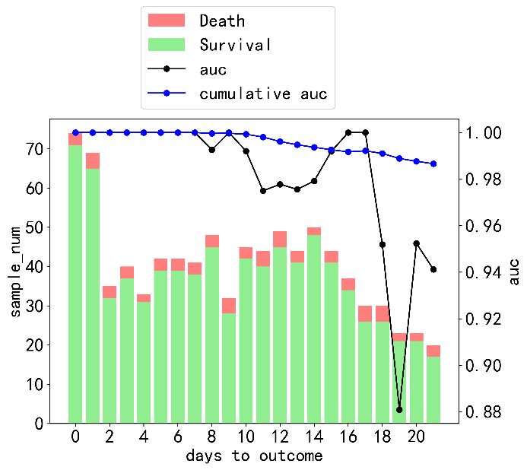
Fig. S1. The predictive performance was evaluated on validation cohort 2 (The Third People’s Hospital of Shenzhen). 194 patients are excluded due to the lack of a discharge date.

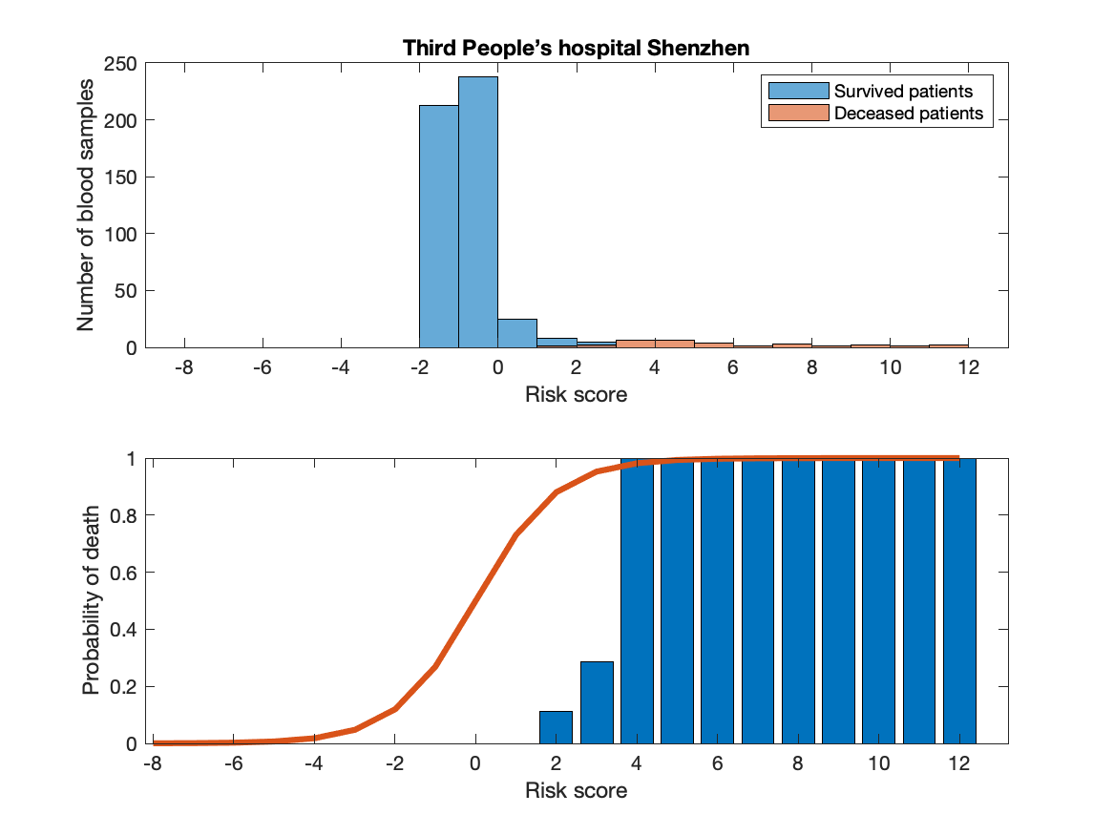
Fig. S2. Visualization of the risk score over patients with two definite outcomes using measurements taken within 10 d of the outcome from external validation cohort 2 (The Third People’s Hospital of Shenzhen).

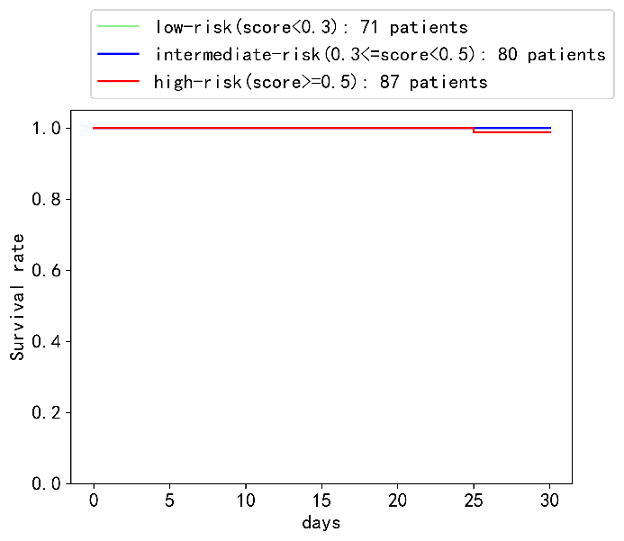
Fig. S3. Kaplan–Meier survival curve for the validation cohort 2. 29.8% of the patients were in the low-risk group, 33.6% were in the intermediate-risk group, and 36.6% were in the high-risk group.194 patients are excluded due to the lack of a discharge date.

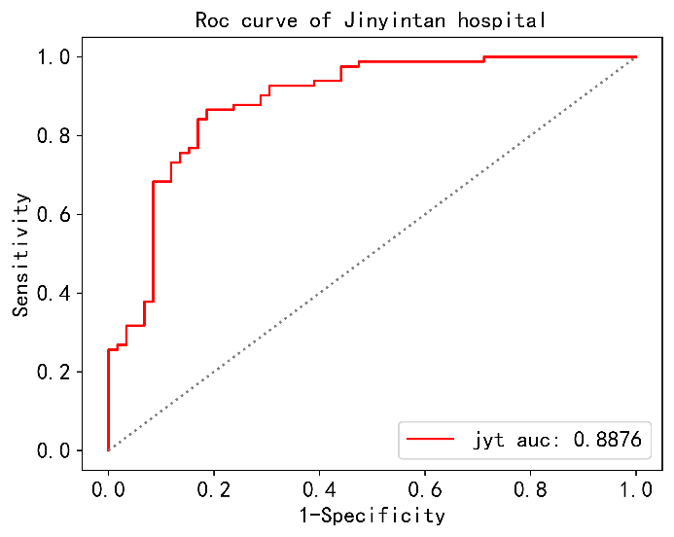
Fig. S4. ROC curve of the proposed model on validation cohort 1 with an AUC value of 0.8876. jyt: Jinyintan Hospital.

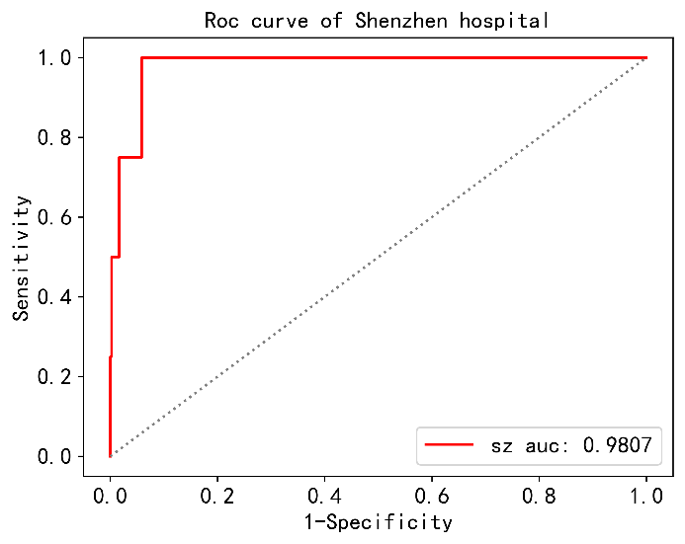
Fig. S5. ROC curve of the proposed model in validation cohort 2 with an AUC value of 0.9807. sz: The Third People’s Hospital of Shenzhen.

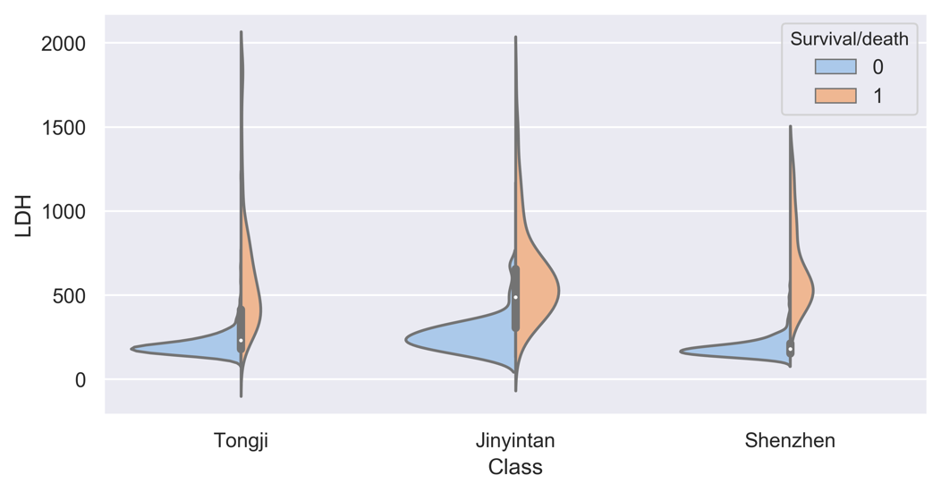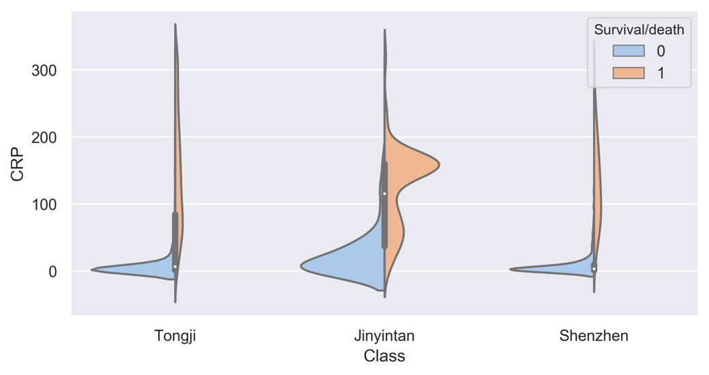
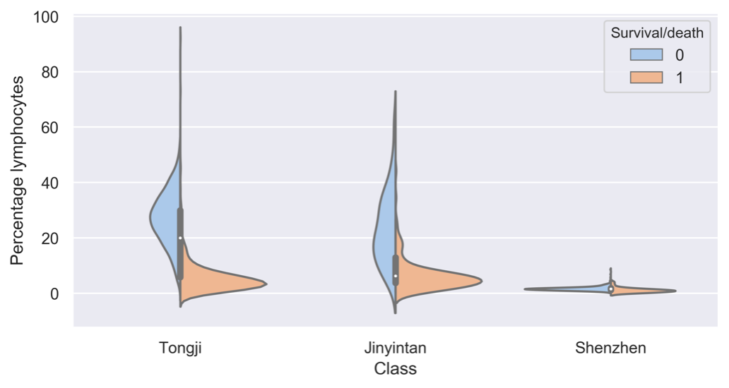
Fig. S6. Visualization of three biomarkers using measurements taken within 10 d of the definite outcome for three different hospitals.

