Supplementary Information for

Joule Heating of Ionic Conductors Using Zero-Phase Frequency Alternating Current to Suppress Electrochemical Reactions
Lei Shi ^{a,b}, Zongyi Han ª, Yixuan Feng ª, Changgeng Zhang ª, Qi Zhang ª, He Zhu ª, Shiping Zhu ^{a,}*
ª School of Science and Engineering, The Chinese University of Hong Kong, Shenzhen 518172, China
^{b} School of Materials, Sun Yat-sen University, Shenzhen 518107, China

* Corresponding authors.
E-mail address: shipingzhu@cuhk.edu.cn

Materials and methods
Unless otherwise specified, the electrodes used in this work were made of 304 stainless steel with thickness of 0.1 mm and the water used in this work was distilled water (Watsons). Sodium chloride (NaCl; Shanghai Hushi 10019318) was used to prepare ionic conductive aqueous solutions of different concentrations and also used as additive in hydrogels and agar gels to improve their conductivities. 1-Hexyl-3-methylimidazolium bis(trifluoromethanesulfonyl)imide ([EMIM]TF₂N 99%; Linzhou Keneng Material Technology Co., Ltd.) was used in the demonstration of ionic liquid heating. Mengniu Pure Milk was used in the heating of milk. Lithium chloride hydrate (LiCl·H₂O; Energy Chemical E060169) and cobalt(II) chloride hexahydrate (CoCl₂·6H₂O; Aladdin C118625) were used to prepare the red aqueous fluid to be heated in pipe. Agar powder (Aladdin A109142) was used to fabricate the agar gels. For poly(PEGMA) thermo-responsive hydrogels, poly(ethylene glycol) methyl ether methacrylate (PEGMA; Sigma-Aldrich 447935) was used as monomer, poly(ethylene glycol) dimethacrylate (PEGDMA; Sigma-Aldrich 409510) was used as crosslinker and 2-hydroxy-1-[4-(2-hydroxyethoxy)phenyl]-2-methyl-1-propanone (Irgacure 2959; TCI H1361) was used as photoinitiator. For heating of ionic conductive ceramic, 2 cm × 2 cm × 300 μm LAGP (Li_{1.5}Al_{0.5}Ge_{1.5}P₃O₁₂; MTI) sheet was used in the demonstration.

Supplementary text
Electrochemical impedance spectroscopy (EIS) tests. All EIS tests were performed using an electrochemical workstation (Mulit Autolab M204). Testing V_{rms} was set at 0.1 V and testing current range was set at 10 nA–100 mA. EIS tests were performed before any ionic Joule heating in this work. The zero-phase frequency was directly read from the measured EIS.
Heating 1 mol·L⁻¹ NaCl solution in U-shaped tube at different frequencies. 75 mL 1 mol·L⁻¹ NaCl solution was poured into a 2 cm × 20 cm U-shaped tube and a 10 cm × 1 cm iron electrode was inserted 1 cm below the liquid level on each side of the tube. According to the electrochemical impedance spectroscopy (EIS), 100 kHz was chosen as the applied frequency to ensure a nearly zero phase angle. For comparison purposes, 50 Hz was chosen to simulate the domestic electricity condition in the control experiments. 3.1 V_{pp} sinusoidal electrical signals with corresponding frequencies were generated by a function/arbitrary waveform generator (UNI-T UTG2062B) and amplified by a power amplifier (Aigtek ATA-4052) to 110 V_{rms}. The temperature variation was recorded by thermometer (UNI-T UT325). At the frequency of 100 kHz, the phase angle was very small (−ϕ = 1.04°) and thus there were no distinct electrochemical reactions and no related phenomena observed. During the whole heating process, there was no change in color of the solution, and no bubble was generated until the temperature reached approximately 90 °C. As the temperature increased from room temperature (23.4 °C), the electrical resistivity of the solution gradually decreased, leading to an increase in current (from 0.843 to 2.025 A) and heating power (from 92.7 to 220.5 W). After the experiment, there was no visible corrosion on the iron electrodes. In contrast, at the frequency of 50 Hz, the phase angle was large (−ϕ ≈ 48°) and the electrolysis reactions were violent. Due to the alternative current, there were hydrogen gas bubbles generated on both sides of the U-shaped tube simultaneously and the iron electrodes corroded at a very fast rate. The reduction reaction and oxidation reaction took place:
Anode: $Fe → {Fe}^{2+} + 2e^{-}$
Cathode: $2H_{2}O +2e^{-} → H_{2} + 2{OH}^{-}$
The color of the solution gradually turned to yellow because of the oxidation of ferro (${Fe}^{2+}$) to ferric (${Fe}^{3+}$). Due to the alkaline environment and escape of hydrogen, brown ferric hydroxide deposit formed and floated on the liquid level.
$${Fe}^{2+}→ {Fe}^{3+} +{ e}^{-}$$
$${Fe}^{3+}+3{OH}^{-} → Fe(OH)_{3}$$
As the ion concentration increased, the resistivity of the solution decreased and the heating power might exceed the setting limits. Thus, the applied voltage was reduced several times to control the heating power and boiling of the solution.
Heating of 10⁻² mol·L⁻¹ NaCl aqueous solution at 10 kHz (−ϕ = 0.19°) and different voltages. 800 mL 10⁻² mol·L⁻¹ NaCl (aq) solution was prepared in advance. For the heating cell, 200 mL 10⁻² mol·L⁻¹ NaCl (aq) solution was poured into a 10 cm × 5 cm × 5 cm quartz container. Two 10 cm × 5 cm stainless steel electrodes were parallelly fixed at two 10 cm × 5 cm internal side surfaces of the container. The output signal from the function/arbitrary waveform generator (UNI-T UTG2062B) was then set as sinusoidal, 1 V_{rms} and 10 kHz. Thereafter, this signal was amplified by the power amplifier (Aigtek ATA-L8). The output voltage range of the power amplifier was selected at 0–170 V_{rms}. To apply different voltages on the heating cell, the output voltage was adjusted to 118, 134, 152, and 168 V, separately. For heating at each voltage, the temperature change was recorded by the thermal imaging camera (FLIR E95) and the current change was read from the digital storage oscilloscope (KEYSIGHT DSOX1204A). The records were stopped until the temperature of the NaCl (aq) solution rose to 70 °C. After each heating, the heating cell was cleaned by distilled water and cooled down to room temperature and was then loaded with another 200 mL 10⁻² mol·L⁻¹ NaCl (aq) solution at room temperature for heating at next voltage.
Heating of flowing NaCl aqueous solution at different voltages and flow rates. 5 L 1 mol·L⁻¹ NaCl (aq) solution was prepared in advance for fluid Joule heating. A peristaltic pump (Baoding Longer Precision Pump Co., Ltd., BT100-2J/YZII15) was used to drive and control the flow rate of the NaCl fluid. Silicone pipe having 6.4 mm inner diameter and 10 mm outer diameter was used as the flow channel. Two identical ring stainless-steel electrodes were fixed in parallel within the pipe, at a distance of 8 cm apart. The diameters of the ring electrodes were the same as the inner diameter of the silicone pipe. The output signal from the function/arbitrary waveform generator (UNI-T UTG2062B) was set as sinusoidal, 1 V_{rms} and 50 kHz (−ϕ = 1.28°).
For heating at different voltages, the signal from the function/arbitrary waveform generator was amplified by the power amplifier (Aigtek ATA-L8). The output voltage range of the power amplifier was selected at 0–340 V_{rms}. The output voltage applied on the fluid was then adjusted to 204, 238, 272, 306, and 340 V, separately. The flow rate of the NaCl fluid was set as 307 mL·min⁻¹ at all the five voltages. For heating at each voltage, the temperature of the NaCl fluid at the outlet of the pipe was recorded by the thermal imaging camera (FLIR E95) for 35 s.
For heating at different flow rates, the flow rate of the NaCl fluid was adjusted to 85, 185, and 307 mL·min⁻¹, separately, by the peristaltic pump. The output voltage of the power amplifier was set as 152 V at all the three flow rates. For heating at each flow rate, the temperature of the NaCl fluid at the pipe outlet was recorded by the thermal imaging camera for 60 s.
Heating of pure milk at 10 kHz (−ϕ = 0.4°). The heating cell was the same as that described in the section “Heating of 10⁻² mol·L⁻¹ NaCl aqueous solution at 10 kHz (−ϕ = 0.19°) and different voltages”. Pure milk of 200 mL was heated. Firstly, the signal (3.1 V_{pp}, 10 kHz) from the function/arbitrary waveform generator (UNI-T UTG2062B) was amplified by the power amplifier (Aigtek ATA-4052) to 110 V_{rms}. The output voltage was then applied on the heating cell. Temperature change of milk was recorded by a thermometer (UNI-T UT325). Change in the current was read from the power amplifier.
Heating of tap water in a chemical reactor. A 1 L glass chemical reactor (Zhengzhou Greatwall Scientific Industrial and Trade Co., Ltd., GR-2CE) filled with 1 L tap water ($σ=150 μS·cm$⁻¹) at room temperature was used as the heating cell. Two identical ring stainless-steel electrodes of 1 cm in width were used as electrodes and fixed in parallel at a distance of 10 cm apart within the chemical reactor. The diameters of the ring electrodes were the same as the inner diameter of the chemical reactor. The speed of the stirrer was set to 70 r·min⁻¹. Temperature was measured by a built-in temperature sensor in the chemical reactor.
For ionic Joule heating method, firstly a 1 V_{rms}, 10 kHz ((−ϕ = 0.34°) sinusoidal electrical signal was generated by the function/arbitrary waveform generator (UNI-T UTG2062B), and amplified by the power amplifier (Aigtek ATA-L8) to 500 V_{rms}. The tap water within the chemical reactor was then heated by 500 V_{rms,} 10 kHz electricity until the tap water rose to 80 °C.
For comparison, traditional heating by heat conduction through the outer jacket of the reactor was also carried out as follows. Circulating water of 85 °C was pumped through the outer jacket of the reactor to heat up the tap water within the chemical reactor until the tap water reached 80 °C.
Heating of flowing tap water at different flow rates. Two 7 cm × 7 cm stainless steel electrodes were parallelly fixed at a distance of 5 mm apart between two 10 cm × 10 cm × 1 cm outer organic glass jackets. Tap water ($σ=150$) $μS·cm$⁻¹ was pumped by a peristaltic pump (Baoding Longer Precision Pump Co., Ltd., BT100-2J/YZII15) through the space between the two electrodes. The output signal from the function/arbitrary waveform generator (UNI-T UTG2062B) was set as sinusoidal, 3.1 V_{pp} and 1 kHz ((−ϕ = 0.13°). This signal was amplified by the power amplifier (Aigtek ATA-4052) to 110 V_{rms}. The flowing tap water was then heated by such 110 V_{rms}, 1 kHz electricity. The flow rate of the tap water was adjusted to 85, 185, and 307 mL·min⁻¹, separately, by the peristaltic pump. For heating at each flow rate, the outlet temperature of the tap water was recorded by the thermal imaging camera (FLIR E95).
Fabrication and heating of agar gels. Firstly, agar powder and NaCl were dissolved in 1 L boiled water to form an aqueous precursor solution. The weight percentage of the agar powder was 1% and the molar concentration of NaCl (aq) was 0.1 mol·L⁻¹. The hot solution was then poured into two identical cylindrical plastic molds (6 cm in diameter and 10 cm in height). Two cylindrical agar gels were formed after the hot solution cooled down. An agar gel was placed between two round stainless-steel electrodes with the same diameter of 6 cm for ionic Joule heating. The other agar gel was placed on a 4 cm × 4 cm × 2 cm ceramic heating plate (XH-RJ404020-12V96W) for conventional conductive heating.
For ionic Joule heating, the signal (3.1 V_{pp}, 100 kHz) from the function/arbitrary waveform generator (UNI-T UTG2062B) was firstly amplified by the power amplifier (Aigtek ATA-4052) to 110 V_{rms}. The output voltage was then applied on the agar gel. Temperature change and IR video of the agar gel were recorded by the thermal imaging camera (FLIR E95).
For conventional conductive heating, the output voltage from the power amplifier was firstly adjusted to 12 V_{rms}. The output voltage was then applied on the ceramic heating plate. Again, temperature change and IR video of the agar gel were recorded by the thermal imaging camera.
Synthesis and heating of thermo-responsive hydrogels. An aqueous precursor solution was firstly prepared by mixing PEGMA (24 wt%), PEGDMA, Irgacure 2959 and NaCl. The molar percentages of PEGDMA and Irgacure 2959 with respect to PEGMA were 0.5% and 1%, respectively. The molar concentration of NaCl (aq) was 1 mol·L⁻¹ in the precursor solution. After careful mixing and degassing, the solution was poured into a $9 cm×9 cm×1 mm$ glass mold coated with release film. Poly(PEGMA) hydrogel was cured in 15 min by ultraviolet light irradiation (365 nm, 50 mJ·cm⁻²). After curing, the hydrogel was taken out and tailored to a $5 cm × 7 cm$ sheet. Two $9 cm × 1 cm$ stainless steel electrodes were then attached on two short opposite sides of the hydrogel.
To apply voltage on the hydrogel, the signal (3.1 V_{pp}, 100 kHz (−ϕ = 0.04°)) from the function/arbitrary waveform generator (UNI-T UTG2062B) was firstly amplified by the power amplifier (Aigtek ATA-4052) to 67.2 V_{rms}. The hydrogel was then heated by such 67.2 V_{rms}, 100 kHz electricity. Temperature change and IR video of the hydrogel were recorded by the thermal imaging camera (FLIR E95).
Heating of ionic conductive ceramic. Two $6 cm×5 mm$ stainless steel electrodes were adhered on two opposite sides of the LAGP ionic conductive ceramic by a conductive tape. To apply voltage on the ceramic, the signal (3.1 V_{pp}, 10 kHz (−ϕ = 1.18°)) from the function/arbitrary waveform generator (UNI-T UTG2062B) was firstly amplified by the power amplifier (Aigtek ATA-4052) to 88 V_{rms}. The ceramic was then heated by such 88 V_{rms}, 10 kHz electricity. Temperature change and IR video of the ceramic were recorded by the thermal imaging camera (FLIR E95).

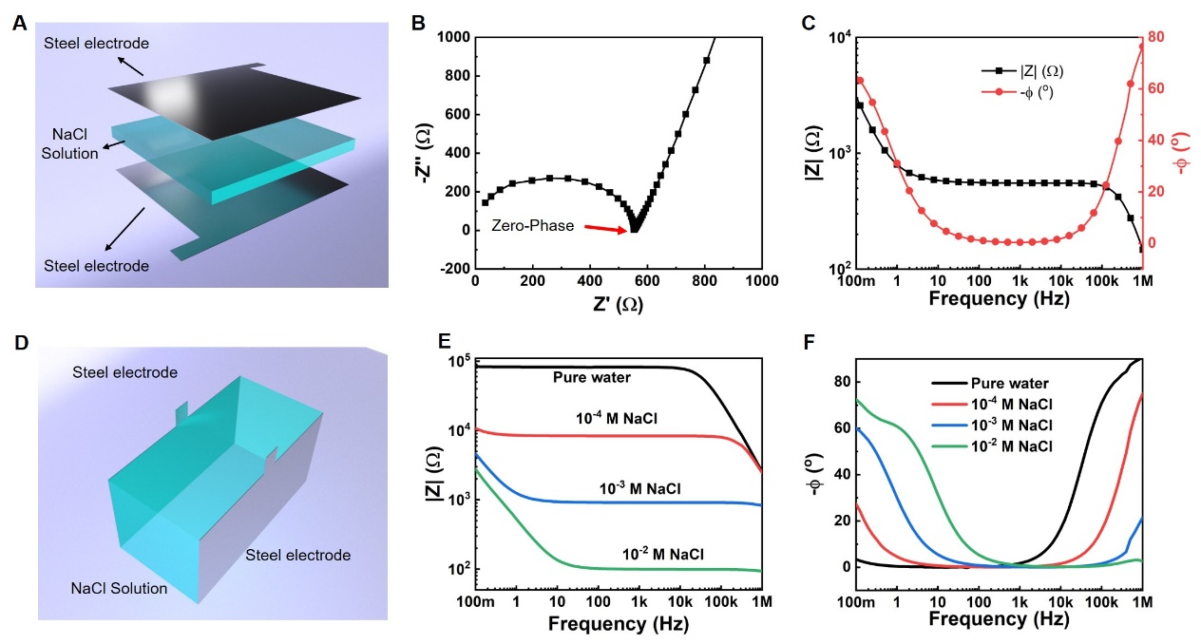

Fig. S1. (a) A designed device for ionic Joule heating. The concentration of the NaCl solution is 10⁻⁴ mol·L⁻¹. (b) Nyquist plot of the device. (c) Impedance property of the device in Bode plot. (d) A designed device for ionic Joule heating. (e, f) EIS spectra of the device with the NaCl aqueous solution having different concentrations.
Heating of 10⁻⁴ mol·L⁻¹ NaCl aqueous solution in the container shown in Fig S1(a). For the heating cell, 36 mL 10⁻⁴ mol·L⁻¹ NaCl (aq) solution was poured into a 10 cm × 4 cm ×10 cm glass container. Two 10 cm × 10 cm stainless steel electrodes were fixed in parallel at two 10 cm × 10 cm internal surfaces of the container. For the applied voltage, a sinusoidal electrical signal of 3.1 V_{pp}, 1 Hz (−ϕ = 27.3°), 1 kHz (−ϕ = 0.27°) and 500 kHz (−ϕ = 61.6°) was firstly generated by a function/arbitrary waveform generator (UNI-T UTG2062B) This signal was amplified by a power amplifier (Aigtek ATA-4052) to 50 V_{rms}. The NaCl (aq) solution was then heated by 50 V_{rms}, 1 Hz electricity for 60 s. Thereafter, the electrodes were taken out for examination. For heating at 1 kHz, a sinusoidal electrical signal with 3.1 V_{pp} and 1 kHz was generated by the function/arbitrary waveform generator (UNI-T UTG2062B). For heating at 500 kHz, a sinusoidal electrical signal with 3.1 V_{pp} and 500 kHz was generated by the same function/arbitrary waveform generator. For each heating case, the power amplifier (Aigtek ATA-4052) was used to amplify the small electrical signal and the output apparent power of this power amplifier was controlled at S = 21 VA. The NaCl (aq) solution was then heated from room temperature to 50 °C by the electricity from the power amplifier. Temperature changes were recorded by a thermal imaging camera (FLIR E95) for both heating cases.
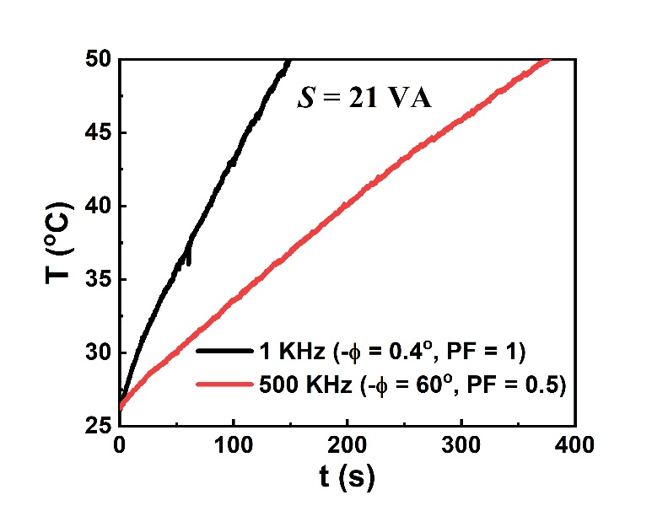

Fig. S2. Heating curve of the 10⁻⁴ mol·L⁻¹ NaCl aqueous solution at a zero-phase frequency (1 kHz) and ultra-high frequency (500 kHz).
Heating of ionic liquid at 10 kHz (−ϕ = 0.61°). For the heating cell, 30 mL ionic liquid [EMIM]TFSI was poured into a 10 cm × 10 cm × 1 cm quartz container. Two 10 cm × 1 cm stainless steel electrodes were fixed in parallel at two 10 cm × 1 cm internal side surfaces of the container. For the applied voltage, a 3.1 V_{pp}, 10 kHz sinusoidal electrical signal was firstly generated by the function/arbitrary waveform generator (UNI-T UTG2062B). This signal was amplified by the power amplifier (Aigtek ATA-4052) to 110 V_{rms}. The ionic liquid was then heated by 110 V_{rms}, 10 kHz electricity for 93 s. Temperature change, infrared (IR) images and video were recorded by the thermal imaging camera (FLIR E95). Change in the current was read from the power amplifier.
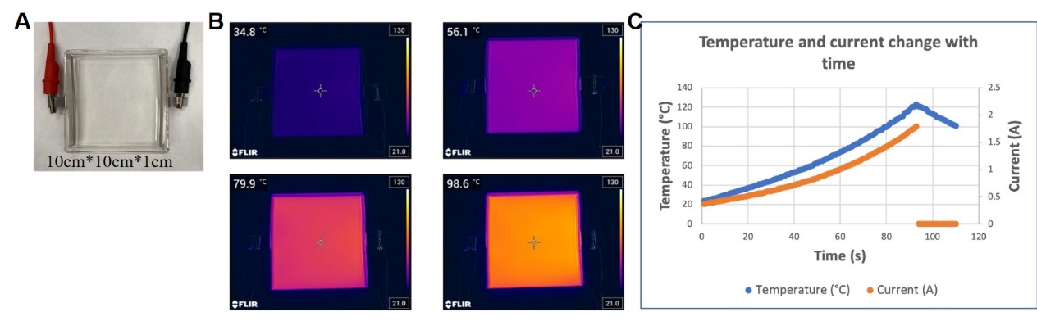

Fig. S3. Heating of ionic liquid [EMIM]TFSI. (a) A designed ionic Joule heating device for heating of an ionic liquid. (b) Infrared images. (c) Heating curve and responding current curve at a constant V_{rms} = 110 V.
Heating of flowing mixed LiCl and CoCl₂ aqueous solution with color change. 500 mL LiCl and CoCl₂ mixed aqueous solution (6 mol·L⁻¹ LiCl + 0.2 mol·L⁻¹ CoCl₂) was prepared in advance for fluid Joule heating. This solution was driven and controlled by the peristaltic pump (Baoding Longer Precision Pump Co., Ltd., BT100-2J/YZII15). Silicone pipe having 6.4 mm inner diameter and 10 mm outer diameter was used as the flow channel. Two identical ring stainless-steel electrodes were fixed in parallel within the pipe, at a distance of 8 cm apart. The diameters of the ring electrodes were the same as the inner diameter of the silicone pipe. The output signal from the function/arbitrary waveform generator (UNI-T UTG2062B) was set as sinusoidal, 3.1 V_{pp} and 100 kHz (−ϕ = 1.58°). This signal was amplified by the power amplifier (Aigtek ATA-4052) to 110 V_{rms}. The flowing mixed solution was then heated by such 110 V_{rms}, 100 kHz electricity. The flow rate of the mixed fluid was adjusted to 85 mL·min⁻¹. The temperature change was recorded by the thermometer (UNI-T UT325).
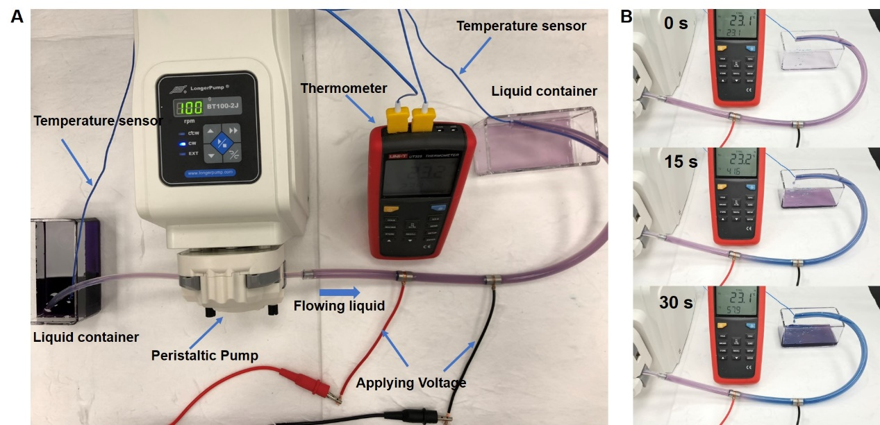

Fig. S4. Heating of a temperature sensitive flowing system. (a) Design of the heating flowing system. (b) Photographs of the system at different heating times.
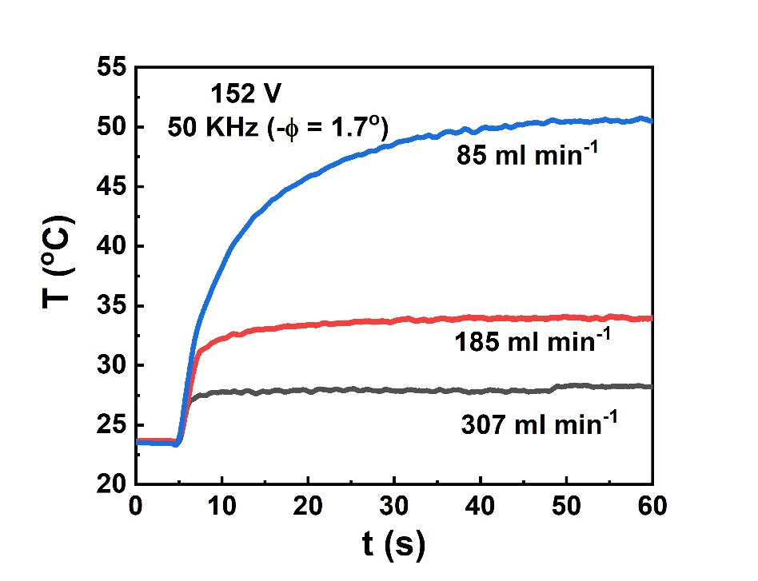

Fig. S5. Heating curves of flowing 1 mol·L⁻¹ NaCl solution with different velocity at zero-phase frequency.

