Supplementary data for
Multi-Omics-Guided Discovery of Omicsynins Produced by Streptomyces sp. 1647: Pseudo-Tetrapeptides Active Against Influenza A Viruses and Coronavirus HCoV-229E
Hongmin Sun ^{a,b,#}, Xingxing Li ^{a,b,#}, Minghua Chen ^{a,#}, Ming Zhong ^{a,c}, Yihua Li ^{a,b}, Kun Wang ^{a,c}, Yu Du ^{a,b}, Xin Zhen ª, Rongmei Gao ^{a,c}, Yexiang Wu ª, Yuanyuan Shi ^{a,b}, Liyan Yu ª, Yongsheng Che ª, Yuhuan Li ^{a,c,}*, Jian-Dong Jiang ^{a,c,}*, Bin Hong ^{a,b,}*, Shuyi Si ^{a,}*
ª NHC Key Laboratory of Biotechnology of Antibiotics, Institute of Medicinal Biotechnology, Chinese Academy of Medical Sciences & Peking Union Medical College, Beijing 100050, China
^{b} CAMS Key Laboratory of Synthetic Biology for Drug Innovation, Institute of Medicinal Biotechnology, Chinese Academy of Medical Sciences & Peking Union Medical College, Beijing 100050, China
^{c} CAMS Key Laboratory of Antiviral Drug Research, Institute of Medicinal Biotechnology, Chinese Academy of Medical Sciences & Peking Union Medical College, Beijing 100050, China

Table S1
Strains and plasmids used in this study.
Strain/plasmid | Relevant characteristic | References
Strain
Streptomyces sp. 1647 | A strain of Streptomyces with high anti-influenza activity | This study
Streptomyces sp. 1647/pL-7081 | Overexpression plasmid pL-7081 was introduced in Streptomyces sp. 1647, Am^{r} | This study
Streptomyces sp. 1647/pL-7082 | Overexpression plasmid pL-7082 was introduced in Streptomyces sp. 1647, Am^{r} | This study
Streptomyces sp. 1647/pL-7083 | Overexpression plasmid pL-7083 was introduced in Streptomyces sp. 1647, Am^{r} | This study
Streptomyces sp. 1647/pL-7089 | Overexpression plasmid pL-7089 was introduced in Streptomyces sp. 1647, Am^{r} | This study
Streptomyces sp. 1647/pL-7102 | Overexpression plasmid pL-7102 was introduced in Streptomyces sp. 1647, Am^{r} | This study
7098-KO | 7098 gene deletion mutant in Streptomyces sp. 1647 | This study
7098-KOC | 7098 genetically complementary strain of 7098-KO, Am^{r} | This study
E. coli DH5α | General cloning host | [1]
E. coli ET12567/pUZ8002 | Strain used for E. coli/Streptomyces sp. 1647 conjugation, Cm^{r}, Km^{r} | [2]
Plasmid
pSET152 | A Streptomyces integrative vector that can be used for conjugative transfer, containing ΦC31 integration site, Am^{r} | [3]
pL646 | pSET152 derivative plasmid containing the constitutive promoter ermE*p, Am^{r} | [4]
pL-7081 | pL646 derivative plasmid containing 780 bp coding region of gene 7081, Am^{r} | This study
pL-7082 | pL646 derivative plasmid containing 864 bp coding region of gene 7082, Am^{r} | This study
pL-7083 | pL646 derivative plasmid containing 315 bp coding region of gene 7083, Am^{r} | This study
pL-7089 | pL646 derivative plasmid containing 1172 bp coding region of gene 7089, Am^{r} | This study
pL-7098 | pL646 derivative plasmid containing 1815 bp coding region of gene 7098, Am^{r} | This study
pL-7102 | pL646 derivative plasmid containing 576 bp coding region of gene 7102, Am^{r} | This study
pOJ260 | E. coli vector, nonreplicating in Streptomyces, Am^{r} | [3]
pOJ-7098LR | The pOJ260 derivative for disruption of 7098 gene, Am^{r} | This study

Am^{r}: apramycin resistance; Cm^{r}: chloramphenicol resistance; Km^{r}: kanamycin resistance; E. coli: Escherichia coli

Methods

1. Components of the main fermentation media
A1 medium: glucose 0.5%, malt extract 1.0%, cottonseed powder 1.0%, soluble starch 2.0%, yeast extract 0.5%, K₂HPO₄ 0.05%, (NH₄)₂SO₄ 0.5%, CaCO₃ 0.3%, NaCl 0.1%. A2 medium: glucose 0.5%, yeast extract 0.5%, peptone 0.5%, beef extract 0.5%, corn syrup 0.4%, soybean powder 1.0%, CaCO₃ 0.4%, CoCl₂ 0.002%, soluble starch 2.0%. A3 medium: glycerol 2.0%, dextrin 2.0%, peptone 1.0%, yeast extract 0.5%, (NH₄)₂SO₄ 0.2%, CaCO₃ 0.2%. B7 medium: K₂HPO₄ 0.1%, CaCO₃ 0.03%, NaCl 0.02%, KNO₃ 0.1%, FeSO₄·7H₂O 0.001%, CaCO₃ 0.05%, glucose 2.0%. The fermentation media were adjusted to pH 7.2–7.4 using 6 M NaOH or 6 M HCl.

2. Genome sequencing and bioinformatic analysis
Extraction of the total genomic DNA from Streptomyces sp. 1647 was carried out as described by Shi et al. [5]. High-throughput sequencing was performed by the Beijing Genomics Institute (BGI), Shenzhen, China, with the third-generation sequencing Pacbio RSII platform and the second-generation sequencing Illumina Hiseq 4000 platform. Sequence assembly and correction were completed by SMRT Analysis v2.3.0 [6], coupled with SOAPsnp [7], SOAPindel [8], and GATK [9]. Glimmer 3.0 software was employed to predict protein-coding sequences (CDSs) [10]. Gene functional annotation was performed by blastp searches of the COG, KEGG, TrEMBL, Swiss-Port, NR, and GO databases. The online resource antibiotics and Secondary Metabolite Analysis Shell (antiSMASH) Version 5.0.0† was used to predict secondary metabolic biosynthesis gene clusters [11].

3. Total RNA extraction and RNA-sequencing
Total RNA extraction was performed as described by Li et al. [12]. RNA-sequencing (RNA-seq) was performed by the BGI (China), using the second-generation sequencing platform BGISEQ-500. To ensure reliability of the results, the sequencing raw data were filtered to remove low-quality and adapter contamination. Then, clean reads were aligned to the gene sequences of the Streptomyces sp. 1647 genome or genes by means of the HISAT [13] and Bowtie 2 [14] tools, respectively. The expression levels of genes were quantified by RSEM software [15]. The Integrative Genomics Viewer (IGV) was used to visualize the results in BAM format in order to compare and analyze the genome-wide transcription levels between different biological samples [16].

4. Reverse transcription and real-time quantitative PCR
The cDNA was synthesized from 2.0 μg total RNA using the TransScript one-step gDNA Removal and cDNA Synthesis SuperMix Kit (TransGen, China). Every RNA sample was also incubated in a reaction mix without reverse transcriptase, as a control to detect genomic DNA contamination. Then, gene fragments were amplified and detected using a CFX96 Touch Real-Time PCR Detection System (Bio-Rad, Singapore), as described previously by Wang et al. [17]. Each reaction (25 μL) contained 2.5 μL cDNA, 12.5 μL SYBR Green PCR Master Mix, 5 μL of forward and reverse primers mix (Table S2), and 5 μL water. Expression levels of target genes were normalized utilizing the level of hrdB based on the method described by Pfaffl [18].

Table S2
PCR primers used in this study.
Primer | Oligonucleotide (5' to 3') | Restriction site | Purpose
7081-F | TACATATGGTTGCGGTGGTGCGGCAGGA | NdeI | Used for amplifying gene 7081
7081-R | GATCTAGACTGTTTGTTTCTGGGCGGAG | XbaI
7082-F | TACATATGGTCGTCGTGGAAATCCGGGT | NdeI | Used for amplifying gene 7082
7082-R | TAGGATCCCAACAATCTCCGACGCATCC | BamHI
7083-F | TACATATGCCCACCGACGTGTTCGGCGC | NdeI | Used for amplifying gene 7083
7083-R | TAGGATCCGAACTTCTCGCAGGTGATCG | BamHI
7089-F | TACATATGGAACTGCGGCAGCTCCAGTA | NdeI | Used for amplifying gene 7089
7089-R | GATCTAGAAGTTGACGGAGGCCAAGC | XbaI
7102-F | TATCTAGAACCGACGGCAGCTCAGAGCG | NdeI | Used for amplifying gene 7102
7102-R | TAGGATCCGCGGTGTCACCTCGTGTCCC | BamHI
7098-F | TACATATGACCACCGCGACCCTGCCCGC | NdeI | Used for amplifying gene 7098
7098-R | TAGGATCCTCATCGGGCCGCTCCCCGGG | BamHI
7098 Left arm-F | CGAAGCTTGAGTTCCTGTACCGCTACGT | HindIII | Used for amplifying the left arm of gene 7098
7098 Left arm-F | TAGAATTCGGTGGTCCCTTCCGGGCGCC | EcoRI
7098 Right arm-F | TAGAATTCGCGCCGTGGACCAGGCCGAA | EcoRI | Used for amplifying the right arm of gene 7098
7098 Right arm-R | CGAAGCTTGTGCAGGCGGAGTGGATC | HindIII
attB-Streptomyces | CGGTGGGGGTGCCAGGG | — | Used for verifying the integration of ΦC31 attB site
pSET152 | TTCGGCGGCTTCAAGTTCGG | — | Used for verifying the integration of ΦC31 attB site
7098_KOcheckP1 | CGAGTACCAGCACGTCCA | — | Used for verifying the gene 7098 knockout strain
7098_KOcheckP2 | GCTCGGTCTTGGTGTCGA | — | Used for verifying the gene 7098 knockout strain
7098_KOcheckP3 | CCCACCGACAACTTCCTGG | — | Used for verifying the gene 7098 knockout strain
7098_KOcheckP4 | GATCCGCTCGCAGTCCAG | — | Used for verifying the gene 7098 knockout strain
7098_KOcheckP5 | CTCCACCGTCCTCACCTAC | — | Used for verifying the gene 7098 knockout strain
7098_KOcheckP6 | CGATCCAGAGTTCGCCGA | — | Used for verifying the gene 7098 knockout strain
hrdB-RT1 | CTCATCGAGCGGGGCAAG | — | Used for the detection of hrdB transcription
hrdB-RT2 | CCCTCCTCAATCAGCACCTG | — | Used for the detection of hrdB transcription
5814RT1 | GAAACTGATCCCGCGCAC | — | Used for the detection of gene 5814 transcription
5814RT2 | CAGCACGCACAGGTACAC | — | Used for the detection of gene 5814 transcription
5819RT1 | CTCGCCGAGGACCACATC | — | Used for the detection of gene 5819 transcription
5819RT2 | GACCATCCAGAGCACCGG | — | Used for the detection of gene 5819 transcription
5821RT1 | CTGCTGTTCCGGGCCTTC | — | Used for the detection of gene 5821 transcription
5821RT2 | CAGGAGAGGTGTTCGGTGAG | — | Used for the detection of gene 5821 transcription
7090RT1 | GGCCTCGACATCACCGTG | — | Used for the detection of gene 7090 transcription
7090RT2 | CGAAGAAACGCAGGGAGAAG | — | Used for the detection of gene 7090 transcription
7091RT1 | GGAAGCCAGGTCACCGAT | — | Used for the detection of gene 7091 transcription
7091RT2 | CATCGGATCGCCCCAGTAG | — | Used for the detection of gene 7091 transcription
7092RT1 | GGCTGATCTGGCTGTCGA | — | Used for the detection of gene 7092 transcription
7092RT2 | CATGGTGGCGTTCATCCG | — | Used for the detection of gene 7092 transcription
7093RT1 | CGCTACGCCTGCTGATCG | — | Used for the detection of gene 7093 transcription
7093RT2 | GAGTACCCCGAGCGACTG | — | Used for the detection of gene 7093 transcription
7094RT1 | ACCTGTTCACCGTCTACCG | — | Used for the detection of gene 7094 transcription
7094RT2 | AGCTCCTTGGTCCAGAAGTC | — | Used for the detection of gene 7094 transcription
7096RT1 | CTGGGTGATCAACGGGCG | — | Used for the detection of gene 7096 transcription
7096RT2 | CTGGTCCATCGGCAGCAC | — | Used for the detection of gene 7096 transcription
7097RT1 | GCACGTGATGGAGCTGTG | — | Used for the detection of gene 7097 transcription
7097RT2 | AGGATGGTCGCGGTGATG | — | Used for the detection of gene 7097 transcription
7098RT1 | GCCAGTCCCGGATCTTCG | — | Used for the detection of gene 7098 transcription
7098RT2 | GTTGACCAGTTCGAGCCAG | — | Used for the detection of gene 7098 transcription
7099RT1 | TCGACACCAAGACCGAGC | — | Used for the detection of gene 7099 transcription
7099RT2 | ATGTGGTGGATCGTCAGGG | — | Used for the detection of gene 7099 transcription
7101RT1 | GACGACTGGGACGCCATG | — | Used for the detection of gene 7101 transcription
7101RT2 | GGGGACTTCACGACGTAGG | — | Used for the detection of gene 7101 transcription
7102RT1 | GCGGCTCTTCCTCGACTAC | — | Used for the detection of gene 7102 transcription
7102RT2 | CGTCCATCAGTTCGGTGAGG | — | Used for the detection of gene 7102 transcription
N sense | CGATGAGGCTATTCCGACTAGGT | — | Used for the detection of gene of N protein of HCoV-OC43
N antisense | CCTTCCTGAGCCTTCAATATAGTAACC | — | Used for the detection of gene of N protein of HCoV-OC43
Probe-1 | TAMRA-TCCGCCTGGCACGGTACTCCCT-BHQ2 | — | Used for the detection of gene of N protein of HCoV-OC43
Sense | CGGAGTCAACGGATTTGGTCGTAT | — | Used for the detection of gene GAPDH
Antisense | AGCCTTCTCCATGGTGGTGAAGAC | — | Used for the detection of gene GAPDH
Probe-2 | TAMRA- CCGTCAAGGCTGAGAACGG -BHQ2 | — | Used for the detection of gene GAPDH
M2 sense | GACCRATCCTGTCACCTCTGAC | — | Used for the detection of gene of M2 protein of IAV
M2 antisense | GGGCATTYTGGACAAAKCGTCTACG | — | Used for the detection of gene of M2 protein of IAV
β-actin sense | AGTCAAGGCTGAGAACGGGAAACT | — | Used for the detection of gene β-actin
β-actin antisense | TCCACAACATACTCAGCACCAGCA | — | Used for the detection of gene β-actin
Restriction endonuclease recognition sequences introduced by the oligonucleotides are in bold and underlined.

Table S3
Anti-IAV activity of the fermentation crude extract from Streptomyces sp. 1647.
Sample information# | Dose | TC₅₀ | A/Wuhan/359/1995 (H3N2) |  |  | A/Tianjin Jinnan/15/2009 (H1N1, OP resistant) |  |  | A/Fort Monmouth/1/1947 (H1N1)
Sample information# | Dose | TC₅₀ | IC₅₀ | SI |  | IC₅₀ | SI |  | IC₅₀ | SI
1647-A3-1 | Dilution ratio | >1/10 | 4/10000 | >250.0 |  | 13/10000 | 76.9 |  | 12/10000 | >83.3
1647-A3-2 | Dilution ratio | >1/10 | 5/10000 | >200.0 |  | 7/10000 | 142.8 |  | 8/10000 | >125.0
1647-A3 + Fe³⁺ | Dilution ratio | 1/10 | 7/10000 | 142.9 |  | NT | NT |  | NT | NT
OP | µg∙mL^{–1} | 1260.00 | 1.63 | 773.0 |  | 50.66 | 24.9 |  | 2.01 | 626.9
RBV | µg∙mL^{–1} | 1164.10 | 1.92 | 606.3 |  | 3.18 | 366.1 |  | 2.06 | 565.1
1647-A3-1 and 1647-A3-2 are two biological duplicate samples of Streptomyces sp. 1647 WT strain cultured by A3 medium. 1647-A3 + Fe³⁺ is the sample of WT strain cultured by A3 + Fe³⁺ medium. The fermentation supernatants of the 1647 strains at 5 days were collected and tested for anti-IAV activity. Oseltamivir phosphate (OP) and ribavirin (RBV) were used as positive control compounds. NT: not tested.
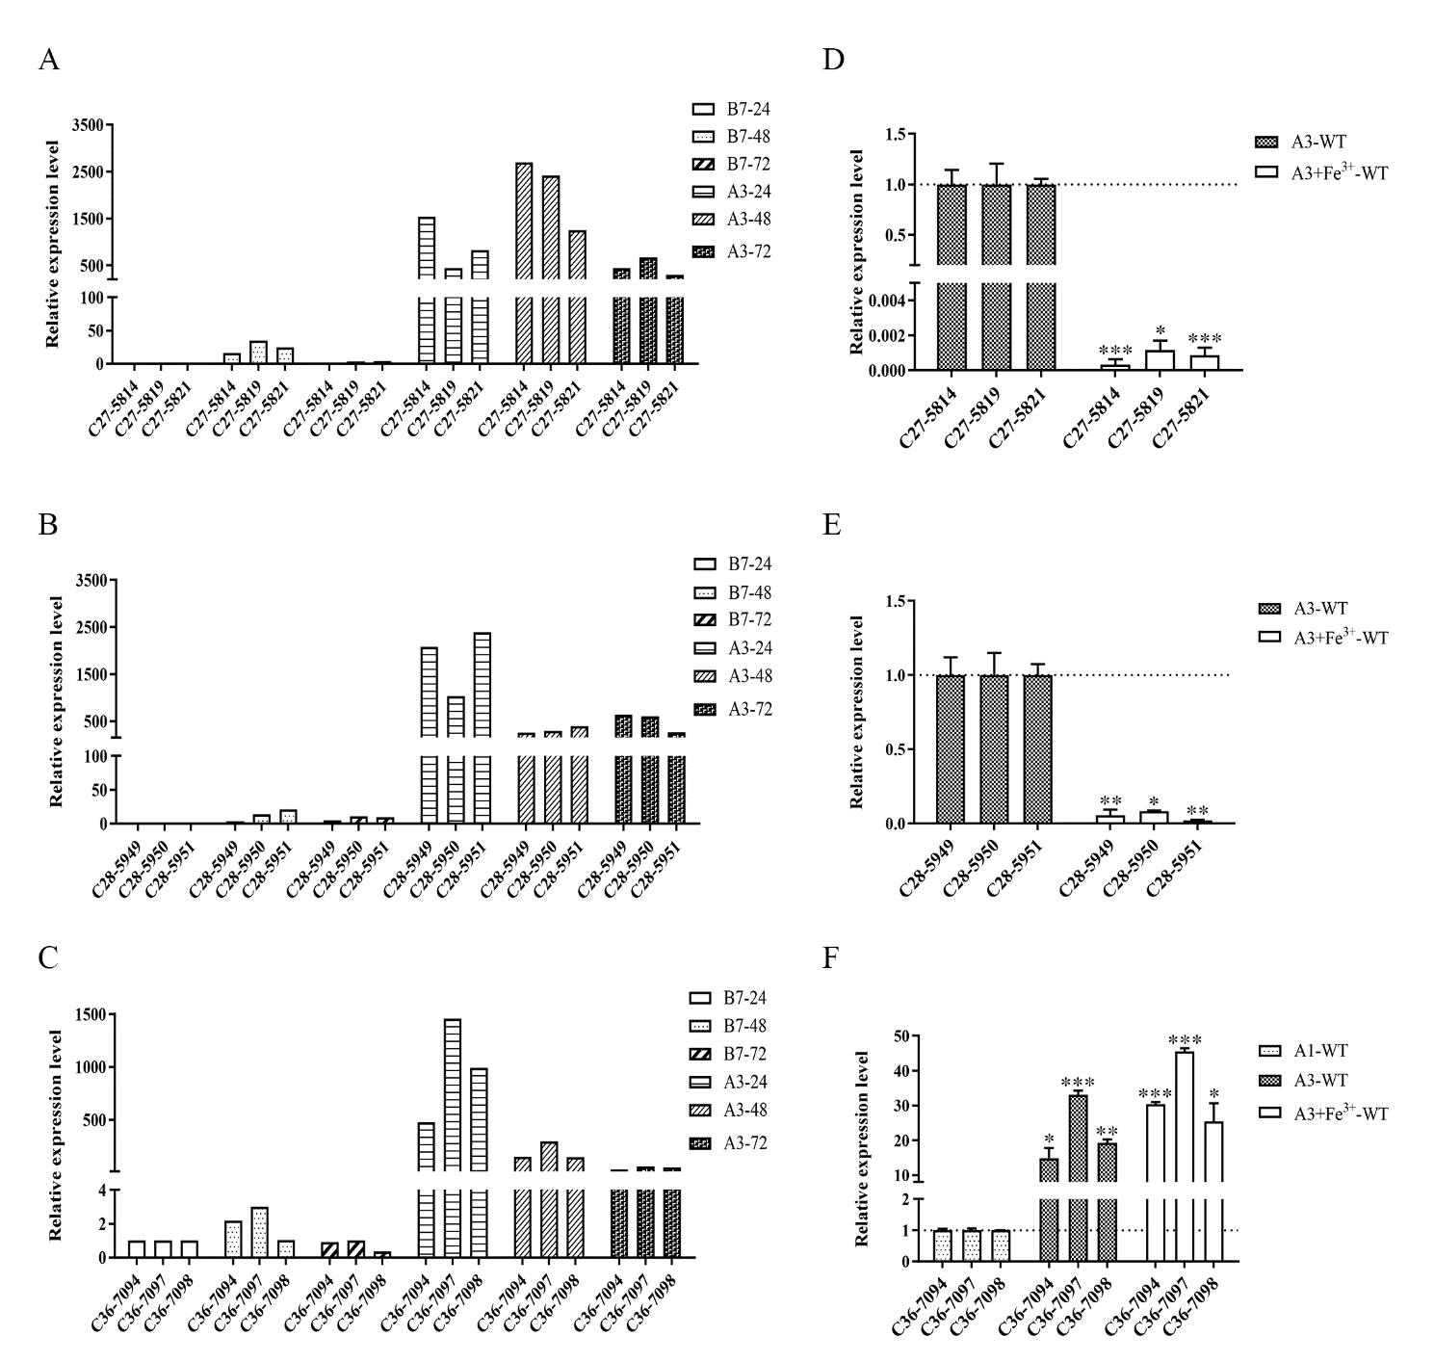

Fig. S1. Gene expression levels of clusters 27, 28, and 36 in Streptomyces sp. 1647 as detected by qRT-PCR. The mycelia of Streptomyces sp. 1647 from A3 and B7 media at the early stage of fermentation (24, 48, and 72 h) and A3 + Fe³⁺ medium at 48 h were collected for the extraction of total RNA. The genes—namely, C27-5814 (dhb), C27-5819 (NRPS), and C27-5821 (transporter) in cluster 27; C28-5949 (IucA_IucC), C28-5950 (transporter), and C28-5951 (ATP-grasp) in cluster 28; and C36-7094 (NRPS), C36-7097 (NRPS), and C36-7098 (NRPS) in cluster 36—were selected to detect their expression levels under different fermentation conditions (A3, B7, and A3 + Fe³⁺ media). The expression levels of the target genes were normalized to the principal sigma factor gene hrdB. (a)–(c) The relative expression level of each sample was represented as the value related to the sample B7-24. The gene expression level in clusters (d) 27 and (e) 28 from A3 medium and in cluster (f) 36 of strain from A1 medium were set as the control, respectively. The error bars represent the SD of triplicate independent experiments. Student’s t-test, * p < 0.05, ** p < 0.01, *** p < 0.001.
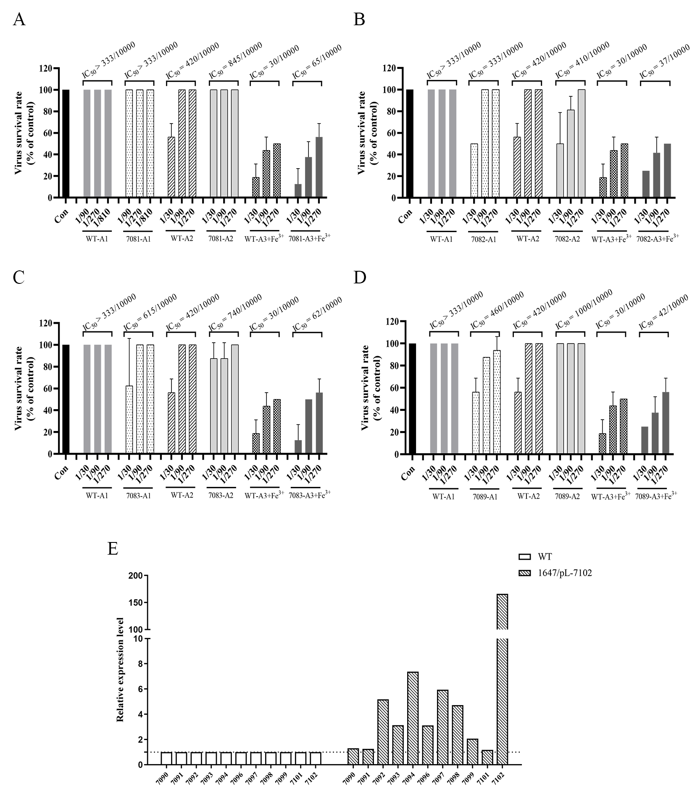
Fig. S2. Inhibitory activities and qRT-PCR analysis of gene expression in the core NRPS region of cluster 36 in the WT strain and overexpression strains. Inhibitory activities of the fermentation supernatant samples, collected from the WT strain and gene (a) 7081, (b) 7082, (c) 7083, and (d) 7089 overexpression strains cultured in A1, A2, and A3 + Fe³⁺ media, are given. The fermentation broth was diluted three-fold and the reduction of virus-induced CPE was recorded. (e) The qRT-PCR analysis of the gene expression level in the core NRPS region of the cluster 36 WT strain and gene 7102-overexpressing strain (1647/pL-7102) cultured by A1 medium. The mycelia of these two strains were collected at 48 h for the extraction of total RNA. The mRNA levels of the target genes were normalized to the principal sigma factor gene hrdB. The relative fold changes of the genes in the core NRPS region of cluster 36 from the 7102-overexpressing strain compared with those from the WT strain were calculated. Con: treated with equal amounts of ddH₂O.

Table S4
Proposed functions of the core genes in cluster 36.
Gene | Proposed function | Protein homolog  (GenBank accession number and origin) | Identity (%) / Similarity (%)
7092 | MFS transporter | WP_097234569.1, Streptomyces | 95/97
7093 | Condensation domain-containing protein | WP_051830313.1, Streptomyces novaecaesareae | 84/89
7094 | Non-ribosomal peptide synthetase | WP_030244576.1, Streptomyces sp. NRRL S-350 | 90/92
7096 | Acyl-CoA dehydrogenase | WP_030244573.1, Streptomyces sp. NRRL S-350 | 96/98
7097 | Amino acid adenylation domain-containing protein | WP_033332634.1, Streptomyces novaecaesareae | 88/89
7098 | AFD class I and PP-binding domain-containing protein | WP_063832417.1, Streptomyces novaecaesareae | 89/92
7099 | NAD-dependent Epimerase/dehydratase family protein | WP_030062138.1, Streptomyces novaecaesareae | 84/87
7100 | Hypothetical protein | WP_063347501.1, Streptomyces sp. MJM8645 | 51/66
7101 | SDR family oxidoreductase | WP_100573496.1, Streptomyces sp. CB01201 | 86/91
7102 | TetR family transcriptional regulator | WP_037961261.1, Streptomyces sp. PRh5 | 81/88

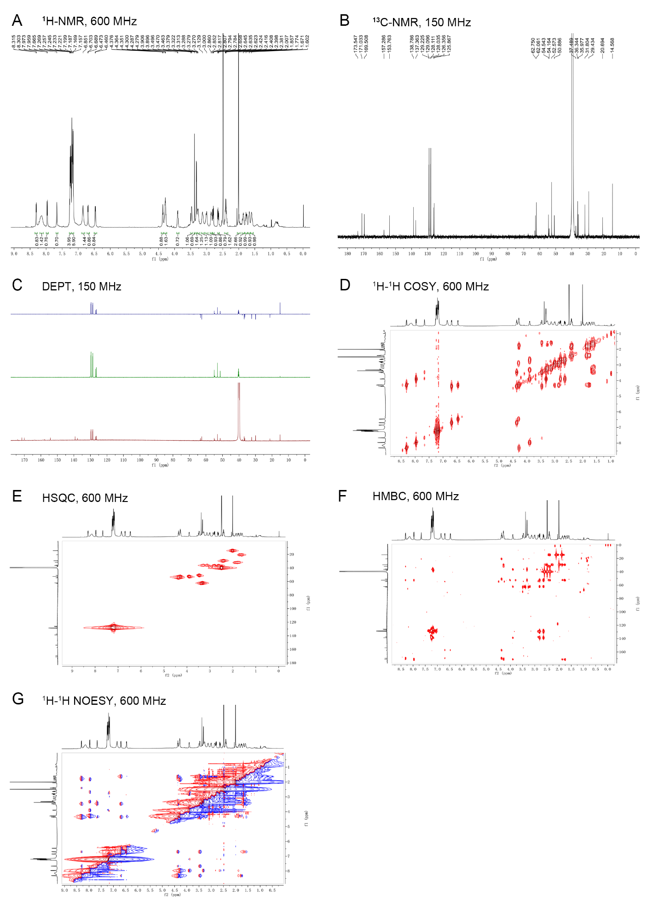
Fig. S3. NMR spectra for omicsynin A1. (a) ¹H-NMR in DMSO-d₆; (b) ¹³C-NMR in DMSO-d₆; (c) DEPT in DMSO-d₆; (d) ¹H–¹H COSY in DMSO-d₆; (e) HSQC in DMSO-d₆; (f) HMBC in DMSO-d₆; (G) ¹H–¹H NOESY in DMSO-d₆.

Table S5
NMR data of omicsynin A1 and omicsynin A2ª.
AA | No. | Omicsynin A1 |  |  | Omicsynin A2
AA | No. | δ_{H} | δ_{C}, type |  | δ_{H} | δ_{C}, type
Phe | 1 | — | 173.5, C |  | — | 173.8, C
Phe | 2 | 4.28, m^{c} | 54.2, CH |  | 4.30, m | 54.1, CH
Phe | 3 | 3.01, dd (13.8, 6.0) | 37.5, CH₂ |  | 2.98, dd (12.2, 3.6) | 37.5, CH₂
Phe | 3 | 2.86, dd (13.8, 5.4) | 37.5, CH₂ |  | 2.86, dd (12.2, 6.6) | 37.5, CH₂
Phe | 4 | — | 137.4, C |  | — | 137.4, C
Phe | 5 | 7.16, ov^{b} | 129.2, CH |  | 7.16, ov ^{b} | 129.2, CH
Phe | 6 | 7.23, ov | 128.1, CH |  | 7.22, ov | 128.1, CH
Phe | 7 | 7.16, ov | 126.4, CH |  | 7.16, ov | 126.3, CH
Phe | 8 | 7.23, ov | 128.1, CH |  | 7.22, ov | 128.1, CH
Phe | 9 | 7.16, ov | 129.2, CH |  | 7.16, ov | 129.2, CH
Phe | NH | 6.46, d (7.8) | – |  | 6.32, d (5.4) | —
Phe | 10 | — | 157.3, C |  | — | 157.2, C
Cap | 11 | 4.36, br t (7.8) | 54.5, CH |  | 4.11, m | 52.4, CH
Cap | 12 | 3.46, m | 50.9, CH |  | 1.57, m; 1.43, m | 29.4, CH₂
Cap | 13 | 1.60, m; 1.67, m | 20.7, CH₂ |  | 1.43, m | 24.7, CH₂
Cap | 14 | 3.28, m; 3.15, m | 36.0, CH₂ |  | 3.07, m | 40.4, CH₂
Cap | 15 | — | 153.8, C |  | — | 156.7, C
Cap | 16 | — | 169.5, C |  | — | 172.0, C
Cap | NH-11 | 6.70, d (7.8) | — |  | 6.48, d (5.4) | —
Cap | NH-12 | 7.53, br s | — |  | — | —
Cap | NH-14 | — | — |  | 7.57, br s | —
Met | 17 | 4.28, m | 52.6, CH |  | 4.25, m | 52.0, CH
Met | 18 | 1.86, m; 1.77, m | 31.8, CH₂ |  | 1.82, m; 1.74, m | 32.0, CH₂
Met | 19 | 2.40, m | 29.4, CH₂ |  | 2.36, m | 30.1, CH₂
Met | 20 | 2.01, s | 14.6, CH₃ |  | 1.99, s | 14.6, CH₃
Met | 21 | — | 171.0, C |  | — | 170.5, C
Met | NH-17 | 8.31, d (7.2) | — |  | 7.98, d (7.2) | —
Pheol | 22 | 3.90, m | 52.6, CH |  | 3.87, m | 52.3, CH
Pheol | 23 | 2.80, dd (13.8, 6.0) | 36.3, CH₂ |  | 2.80, dd (13.2, 5.4) | 36.4, CH₂
Pheol | 23 | 2.64, dd (13.8, 7.2) | 36.3, CH₂ |  | 2.63, dd (13.2, 8.4) | 36.4, CH₂
Pheol | 24 | — | 138.8, C |  | — | 138., C
Pheol | 25 | 7.19, ov | 129.1, CH |  | 7.19, ov | 129.1, CH
Pheol | 26 | 7.25, ov | 128.0, CH |  | 7.25, ov | 128.0, CH
Pheol | 27 | 7.19, ov | 125.9, CH |  | 7.19, ov | 125.9, CH
Pheol | 28 | 7.25, ov | 128.0, CH |  | 7.25, ov | 128.0, CH
Pheol | 29 | 7.19, ov | 129.1, CH |  | 7.19, ov | 129.1, CH
Pheol | 30 | 3.31, d (5.4) | 62.1, CH₂ |  | 3.29, ov | 62.2, CH₂
Pheol | NH-22 | 7.96, d (8.4) | — |  | 7.74, d (8.4) | —
ª NMR data (δ) were measured at 600 MHz for ¹H and at 150 MHz for ¹³C in DMSO-d₆. The “δ_{H}” and “δ_{C}” represent “chemical shift” values of the protons and carbons, respectively. Proton coupling constants (J) in Hz are given in parentheses. The assignments were based on ¹H–¹H COSY, HSQC, and HMBC experiments.
^{b} J value was not determined due to overlapped signals.
^{c} The letter “m” represents “multiplet” in the ¹H NMR spectrum.
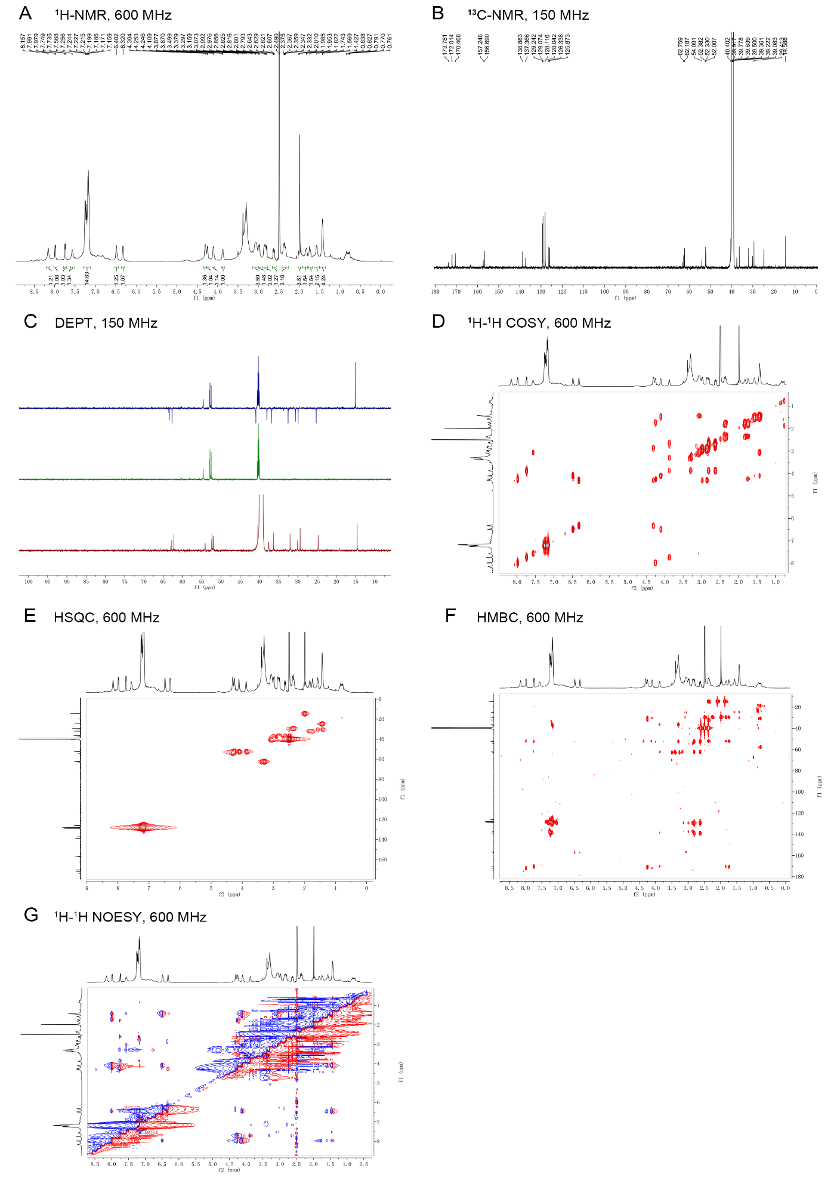
Fig. S4. NMR spectra for omicsynin A2. (a) ¹H-NMR in DMSO-d₆; (b) ¹³C-NMR in DMSO-d₆; (c) DEPT in DMSO-d₆; (d) ¹H–¹H COSY in DMSO-d₆; (e) HSQC in DMSO-d₆; (f) HMBC in DMSO-d₆; (g) ¹H–¹H NOESY in DMSO-d₆.

Table S6
LC–MS retention times (t_{R}, min) of the derivatized amino acids from the hydrolysate of omicsynin A1, omicsynin A2, and chymostatin.
Compounds | Amino acids | m/z [M–H]⁻ | t_{R} (min)
Compounds | Amino acids | m/z [M–H]⁻ | L-FDLA derivate | L/D-FDLA derivate
Omicsynin A1ª | L-Phe | 457.7 | 68.74 | 68.81, 78.61
Omicsynin A1ª | (2S, 3S)-Cap | 464.8 | 34.27 | 34.47, 35.49
Omicsynin A1ª | L-Met | 441.7 | 60.51 | 60.60, 70.97
Omicsynin A1ª | L-Pheol | 443.8 | 69.86 | 69.97, 78.12
Chymostatinª | L-Phe | 457.7 | 68.68 | 68.85, 78.63
Chymostatinª | (2S, 3S)-Cap | 464.8 | 34.36 | 34.45, 35.48
L-Pheª | — | 457.7 | 68.61 | 68.60, 78.44
Omicsynin A2^{b} | L-Phe | 457.7 | 45.47 | 45.45, 56.01
 | L-Arg | 466.8 | 16.42 | 14.52, 16.51
 | L-Met | 441.7 | 37.67 | 37.70, 48.57
 | L-Pheol | 443.8 | 47.54 | 47.51, 56.15
ª The gradient elution from 17% of B in A for 20 min followed by 17%–50% of B in A over 60 min; ^{b} the linear gradient of 20%–50% of B in A for 60 min. L-FDLA: (1-fluoro-2,4,-dinitrophenyl-5)-L-leucinamide.
The analyses of L- and L/D-FDLA derivatives were carried out with LC–MS using the following conditions: column, Cosmosil MG II C18 column (5 μm, 4.6 mm × 150 mm); flow rate, 1.0 mL∙min^{–1}; solvent A, 0.1% formic acid; solvent B, acetonitrile; UV detection at 340 nm; column temperature, 40 °C.
Fig. S5. HRMS analysis of the (a) omicsynins As, (b) Bs, and (c) Cs in the positive-ion mode. The exp. mass represents the m/z values of the omicsynins obtained from the experiment and the calc. mass is the calculated data. R1 and R2 represent different amino acid residue substituents. “d,” “e,” and “f” represent the “d,” “e,” and “f” fragments, respectively. Ppm: part per million.

References
[1] Sambrook J, Fritsch EF, Maniatis T. Molecular cloning: a laboratory manual. 2nd ed. New York: Cold Spring Harbor Laboratory Press; 1989.
[2] Paget MS, Chamberlin L, Atrih A, Foster SJ, Buttner MJJ. Evidence that the extracytoplasmic function sigma factor ς^{E} is required for normal cell wall structure in Streptomyces coelicolor A3(2). J Bacteriol 1999;181(1):204–11.
[3] Bierman M, Logan R, O’Brien K, Seno ET, Rao RN, Schoner BE. Plasmid cloning vectors for the conjugal transfer of DNA from Escherichia coli to Streptomyces spp. Gene 1992;116(1):43–9.
[4] Hong B, Phornphisutthimas S, Tilley E, Baumberg S, McDowall KJ. Streptomycin production by Streptomyces griseus can be modulated by a mechanism not associated with change in the adpA component of the A-factor cascade. Biotechnol Lett 2007;29(1):57–64.
[5] Shi Y, Jiang Z, Li X, Zuo L, Lei X, Yu L, et al. Biosynthesis of antibiotic chuangxinmycin from Actinoplanes tsinanensis. Acta Pharm Sin B 2018;8(2):283–94.
[6] Chin CS, Alexander DH, Marks P, Klammer AA, Drake J, Heiner C, et al. Nonhybrid, finished microbial genome assemblies from long-read SMRT sequencing data. Nat Methods 2013;10(6):563–9.
[7] Li R, Li Y, Fang X, Yang H, Wang J, Kristiansen K, et al. SNP detection for massively parallel whole-genome resequencing. Genome Res 2009;19(6):1124–32.
[8] Li S, Li R, Li H, Lu J, Li Y, Bolund L, et al. SOAPindel: efficient identification of indels from short paired reads. Genome Res 2013;23(1):195–200.
[9] McKenna A, Hanna M, Banks E, Sivachenko A, Cibulskis K, Kernytsky A, et al. The Genome Analysis Toolkit: a MapReduce framework for analyzing next-generation DNA sequencing data. Genome Res 2010;20(9):1297–303.
[10] Delcher AL, Bratke KA, Powers EC, Salzberg SL. Identifying bacterial genes and endosymbiont DNA with Glimmer. Bioinformatics 2007;23(6):673–9.
[11] Blin K, Shaw S, Steinke K, Villebro R, Ziemert N, Lee SY, et al. antiSMASH 5.0: updates to the secondary metabolite genome mining pipeline. Nucleic Acids Res 2019;47(W1):W81–7.
[12] Li X, Zhang C, Zhao Y, Lei X, Jiang Z, Zhang X, et al. Comparative genomics and transcriptomics analyses provide insights into the high yield and regulatory mechanism of Norvancomycin biosynthesis in Amycolatopsis orientalis NCPC 2-48. Microb Cell Fact 2021;20(1):28.
[13] Kim D, Langmead B, Salzberg SL. HISAT: a fast spliced aligner with low memory requirements. Nat Methods 2015;12(4):357–60.
[14] Langmead B, Salzberg SL. Fast gapped-read alignment with Bowtie 2. Nat Methods 2012;9(4):357–9.
[15] Li B, Dewey CN. RSEM: accurate transcript quantification from RNA-Seq data with or without a reference genome. BMC Bioinformatics 2011;12(1):323.
[16] Thorvaldsdóttir H, Robinson JT, Mesirov JPJ. Integrative Genomics Viewer (IGV): high-performance genomics data visualization and exploration. Brief Bioinform 2013;14(2):178–92.
[17] Wang L, Hu Y, Zhang Y, Wang S, Cui Z, Bao Y, et al. Role of sgcR3 in positive regulation of enediyne antibiotic C-1027 production of Streptomyces globisporus C-1027. BMC Microbiol 2009;9(1):14.
[18] Pfaffl MW. A new mathematical model for relative quantification in real-time RT-PCR. Nucleic Acids Res 2001;29(9):e45.

† http://antismash.secondary metabolites.org

