Research
Methodology for Calibrating Fatigue Load Models for Composite Road Bridges
Lulu Liu ª, Johan Maljaars ^{b,c}, Thomas Keller ^{a,}*
ª Composite Construction Laboratory (CCLab), École Polytechnique Fédérale de Lausanne (EPFL), Lausanne, CH-1015, Switzerland
^{b} The Netherlands Organization for Applied Scientific Research (TNO), Delft, 2629 JD, The Netherlands
^{c} Department of the Built Environment, Eindhoven University of Technology, Eindhoven, 5612 AE, The Netherlands

* Corresponding author.
E-mail address: thomas.keller@epfl.ch (T. Keller).

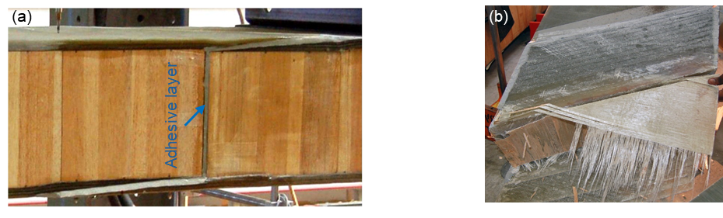
Fig. S1. (a) Adhesively bonded joint for Avançon bridge prior to experiments (side view) and (b) fiber-tear failure in face sheets and failure in balsa core of bonded joint (top view) [14].

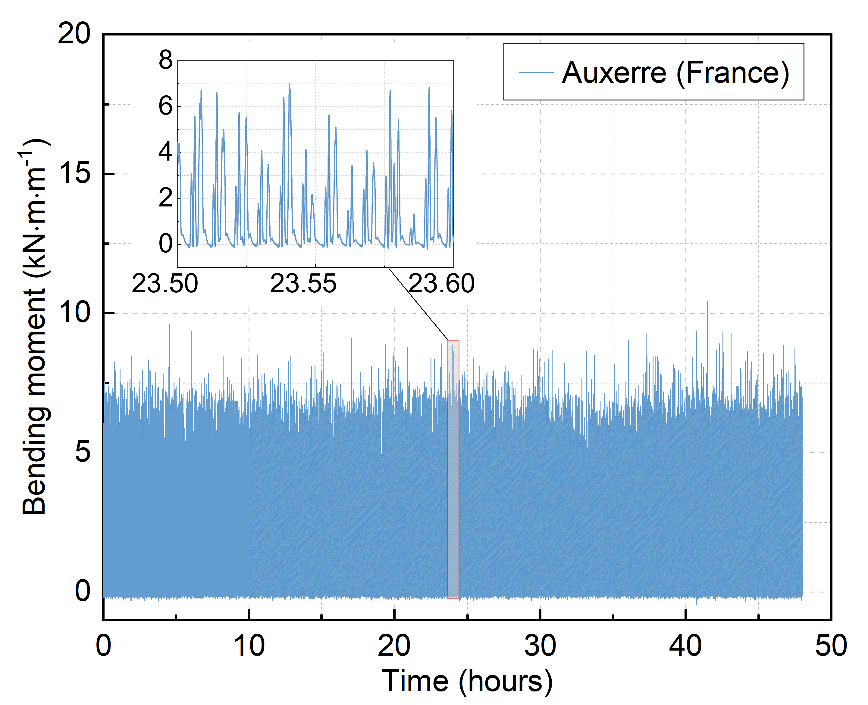
Fig. S2. A representative moment response history at point “A” generated by a series of traffic records (two days) from Auxerre motorway.

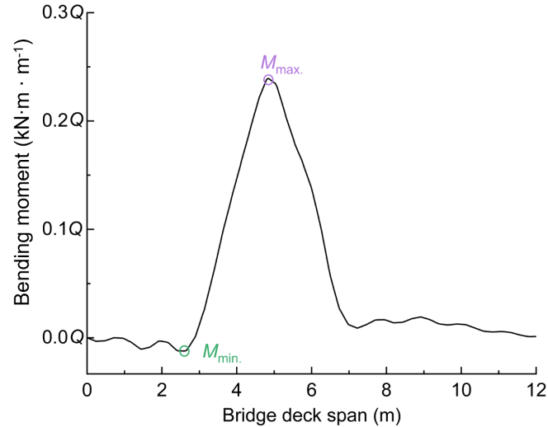
Fig. S3. Moment response history at point “A” when running FLM across influence surface along bridge deck span.
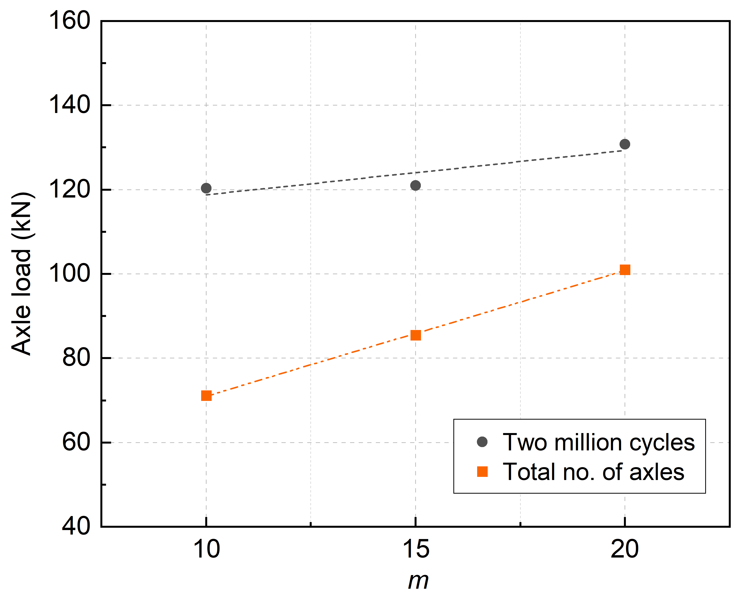
Fig. S4. Characteristic values of axle loads of FLM for different slope coefficients and total number of cycles over a 100 years design service life.

