Supplementary data for

MOF-5@Ni Derived ZnO@Ni₃ZnC_{0.7}/PMS System for Organic Matter Removal: A Thorough Understanding of the Adsorption−Degradation Process
Youwen Shuaiª, Xue Huangª, Benyin Zhangª, Lu Xiangª, Hao Xuª, Qian Yeª, Jinfeng Lu^{b,*}, Jing Zhang^{a,*}
ª College of Architecture and Environment, Sichuan University, Chengdu 610065, China
^{b} College of Environmental Science and Engineering, Nankai University, Tianjin 300071, China

*Corresponding author.
Email addresses: zjing428@163.com (J. Zhang), lujinfeng@nankai.edu.cn (J. Lu)

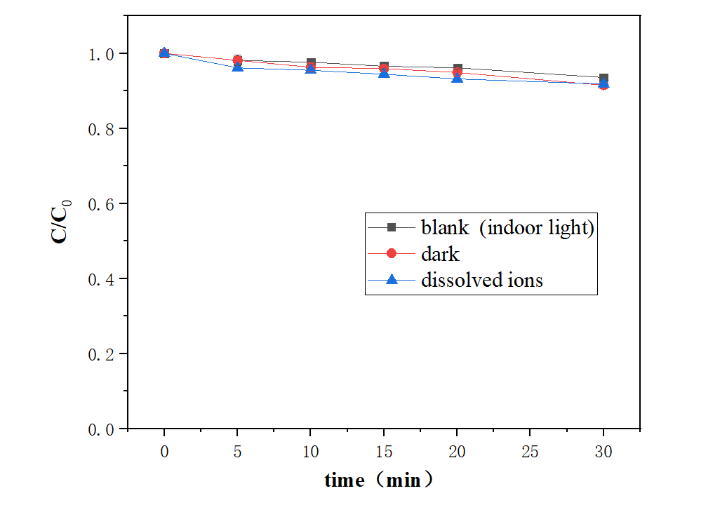
Fig. S1. Removal efficiency of RhB under different conditions. Reaction condition: [ZN-CS] = 100 m g/L, [Zn(Ⅱ)] = 15.85 m g/L, [Ni(Ⅱ)] = 6.28 m g/L, [PMS] = 200 mg/L, [RhB] = 7.6 mg/L.

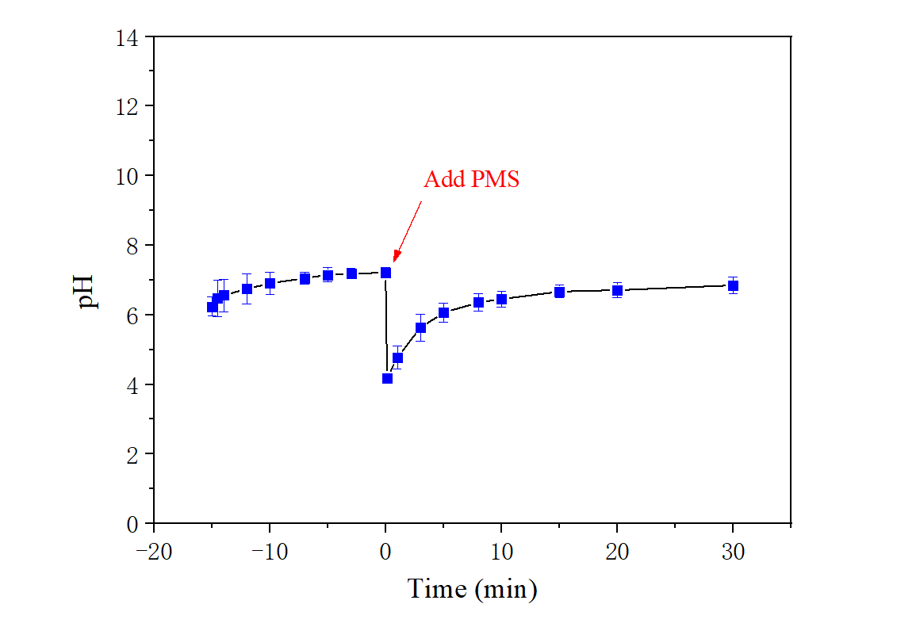
Fig. S2. The pH change of the solution during the removal process. Reaction conditions: catalyst dose = 100 mg/L, PMS dose = 200 mg/L, initial RhB concentration = 7.6 mg/L.

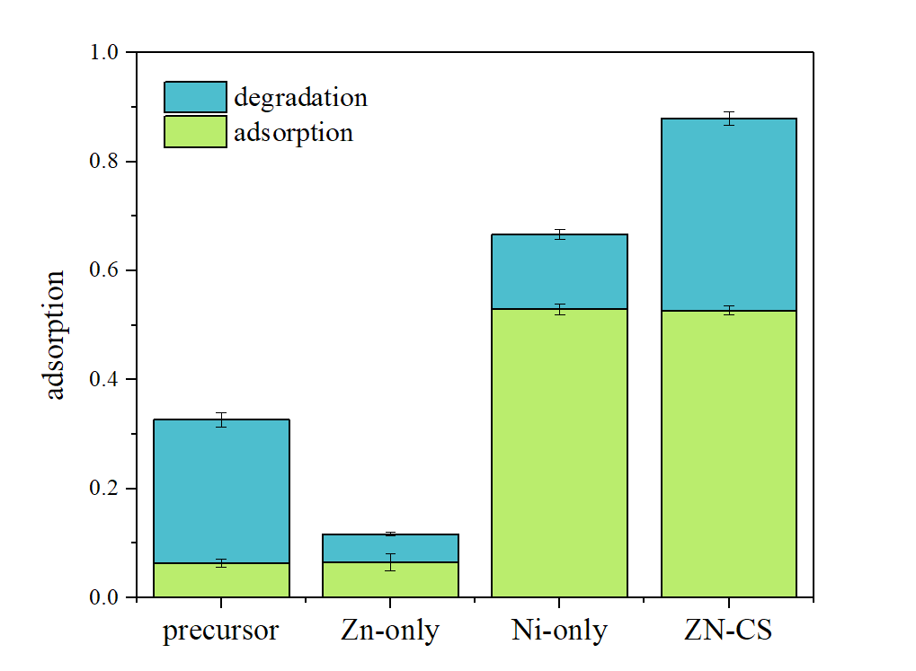
Fig. S3. Adsorption and degradation efficiency on different catalyst. Reaction conditions: catalyst dose = 100 mg/L, PMS dose = 200 mg/L, initial RhB concentration = 7.6 mg/L, room temperature, pH = pH₀.

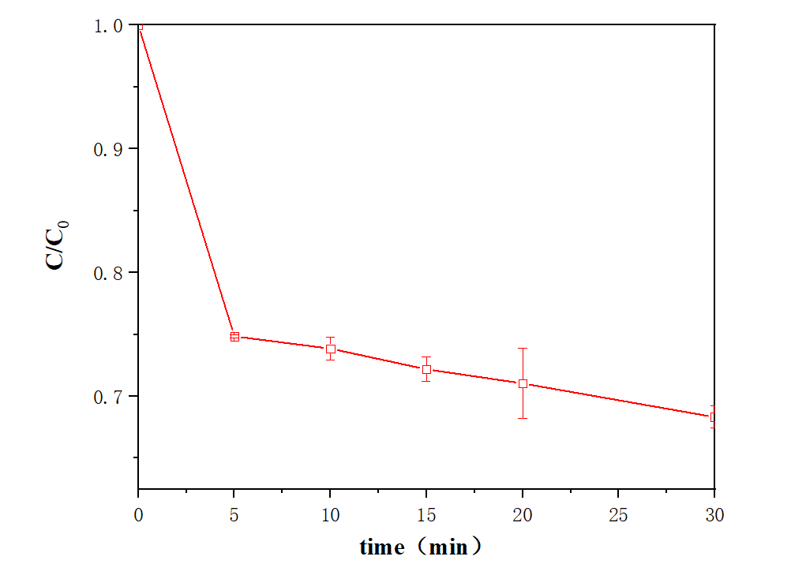
Fig. S4. Utilization of PMS in degradation system. Reaction condition: [ZN-CS] = 100mg/L, [RhB] = 7.6 mg/L, [PMS] = 200mg/L.
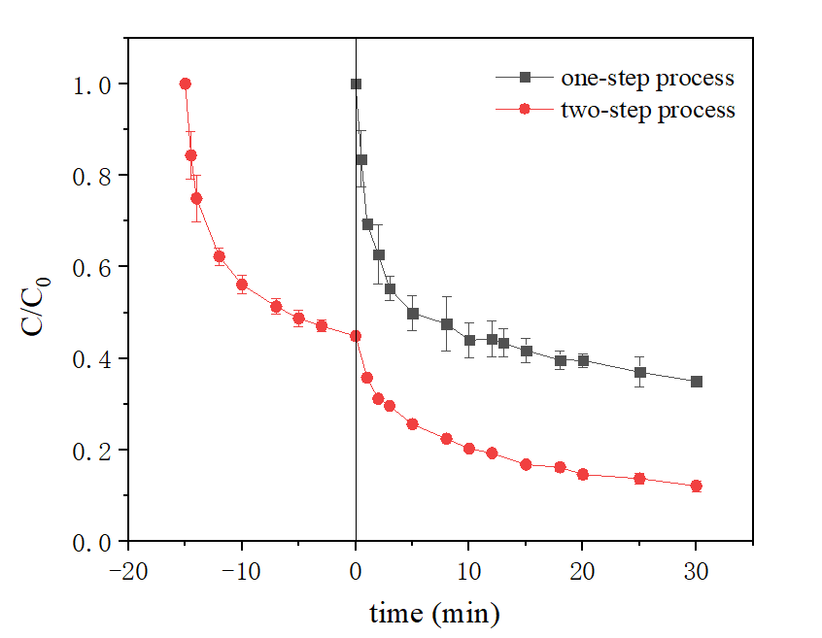
Fig. S5. Comparison between one-step process and two-step process to eliminate RhB. Reaction condition: [RhB] = 7.6 mg/L, [ZN-CS] = 100 mg/L, [PMS] = 200 mg/L.

Fig. S6. The scanning area of EDS and elemental content peak of different area (a), (b) and (c).

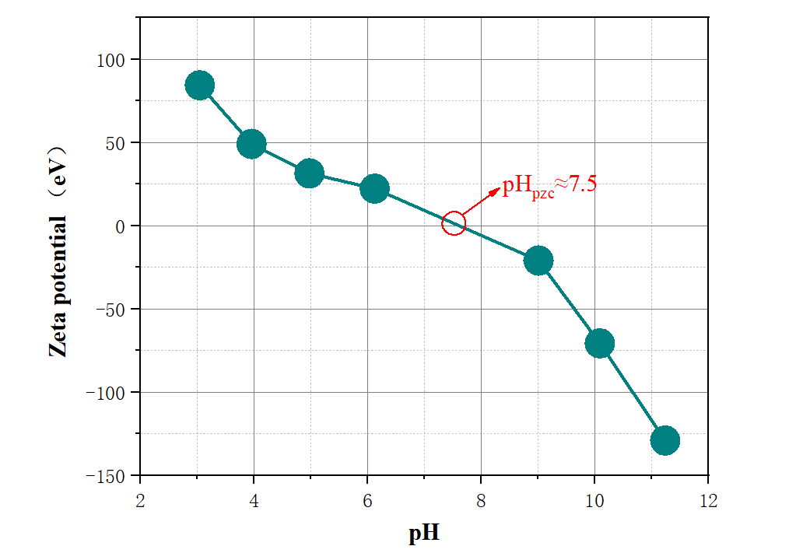
Fig. S7. Zeta potential value of ZN-CS under different pH conditions.

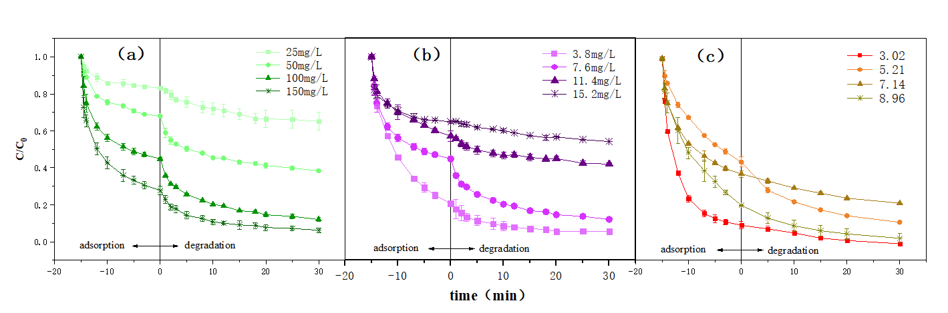
Fig. S8. Influence of the operational parameters on RhB degradation by ZN-CS/PMS system: (a) catalyst dosage; (b) RhB concentration; (c) initial PH. Except the studied parameters, other parameters fixed at pH₀, [ZN-CS] = 100mg/L, [PMS] = 200mg/L, [RhB] = 7.6 mg/L and room temperature.

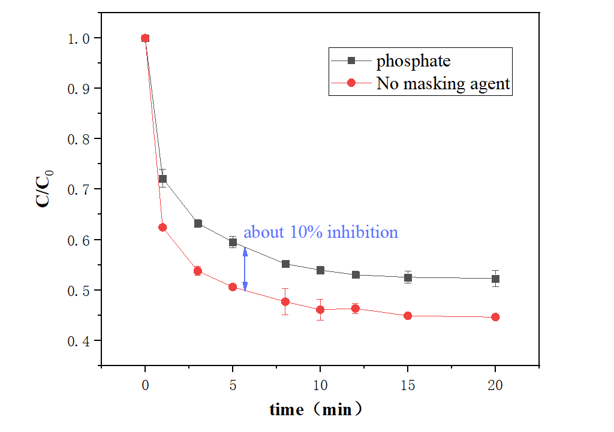
Fig. S9. Influence of masking agent (phosphate) in adsorption process. Reaction conditions: pH= 8.6, [ZN-CS]= 100mg/L, [RhB]₀= 5.0 mg/L , [phosphate]= 3.25mmol/L and room temperature.

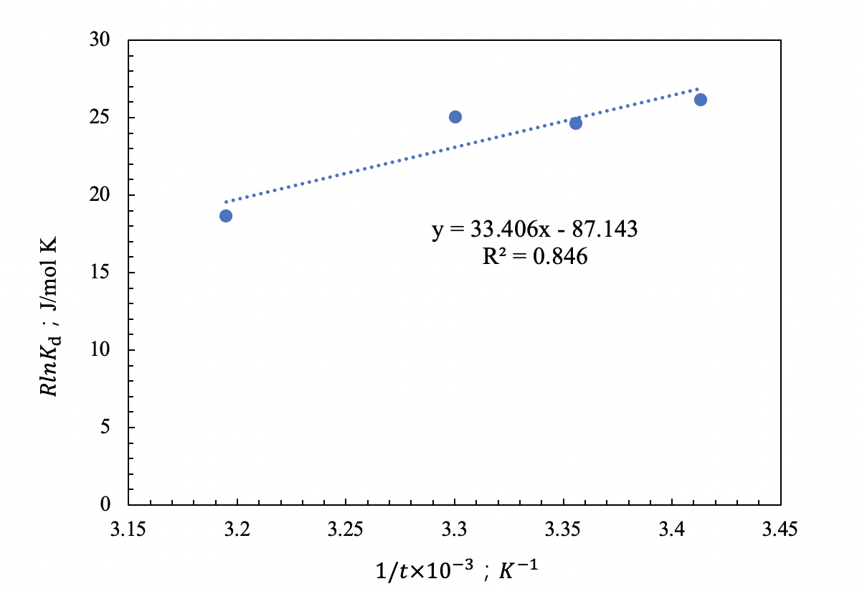
Fig. S10. Plot of RlnKd vs. 1/T for the estimation of thermodynamic parameters for sorption of RhB onto ZN-CS.

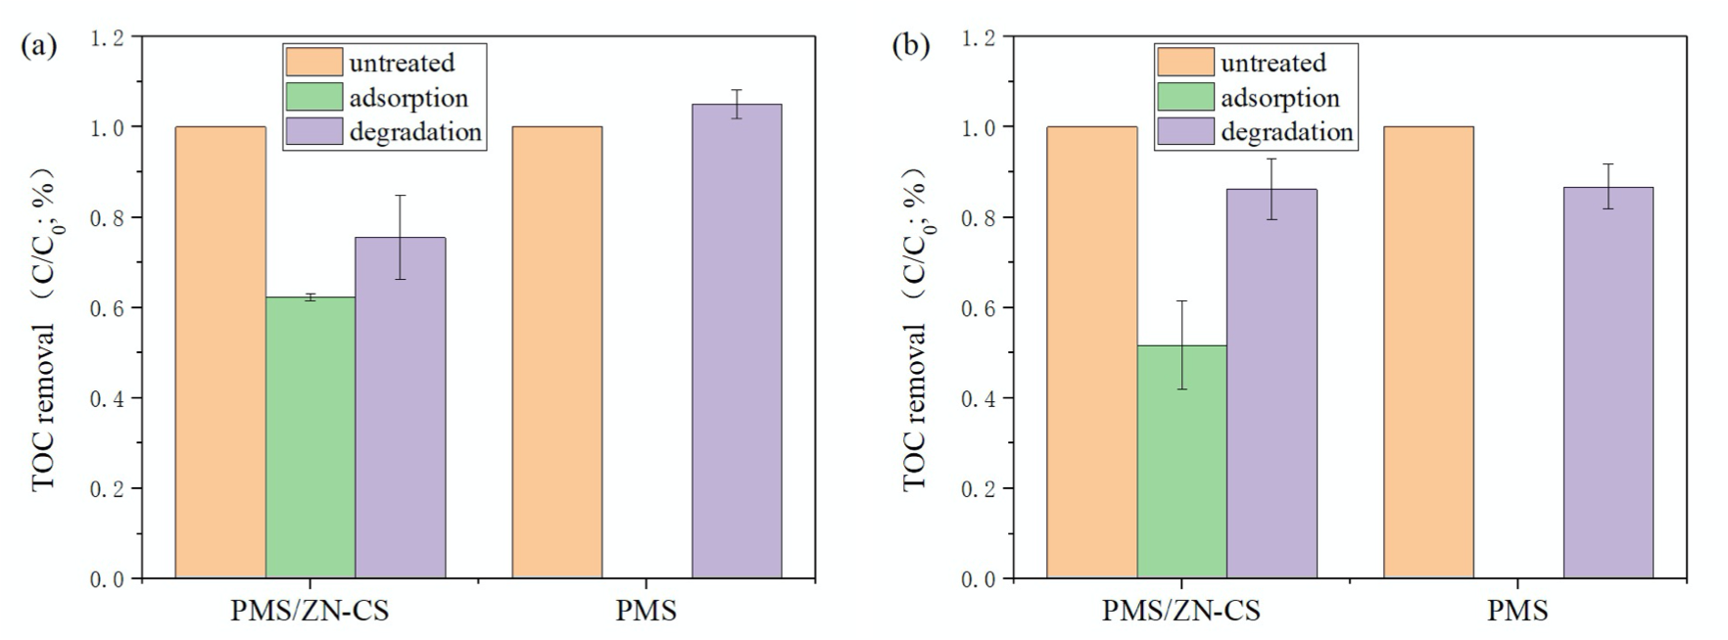
Fig. S11. Different target contaminants absorbed and degraded by ZN-CS/PMS and PMS system. ([ZN-CS] = 100 mg/L, [PMS] = 200 mg/L, pHin = pH0): (a). Norfloxacin (Nor). Reaction condition: [Nor] = 5.0 mg/L; (b). Tetracycline hydrochloride. Reaction condition: [TC] = 10 mg/L.

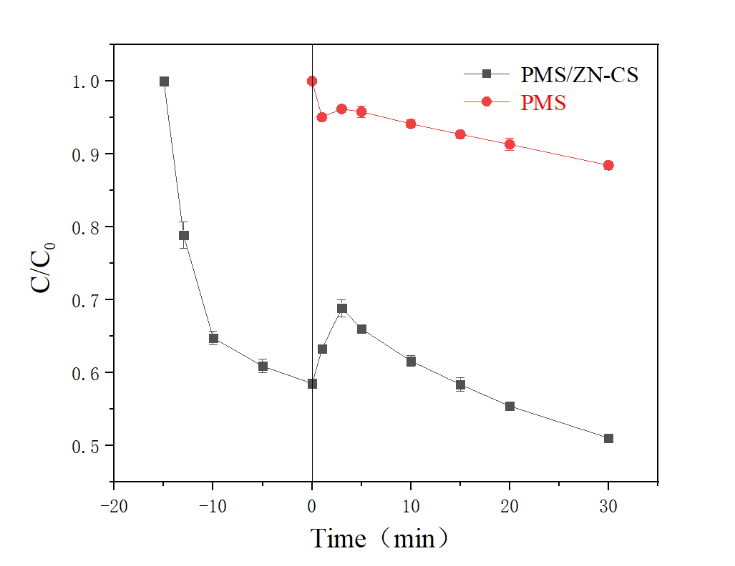
Fig. S12. Elimination of RhB in real water sample under PMS and PMS/ZN-CS systems. Reaction condition: [RhB] = 7.6 mg/L, [ZN-CS] = 100 mg/L, [PMS] = 200 mg/L.

Text S1. The kinetics of RhB degradation.
The kinetics of RhB degradation ($k_{obs})$ could be well simulated with pseudo-second-order rate law by Eq. (S26).
$$\frac{d\left[RhB\right]}{dt}=-k_{obs}{\left[RhB\right]}^{2} Eq. (S26)$$
Where $k_{obs}$ is the pseudo-second-order rate constant (mg·L⁻¹·min⁻¹) of RhB degradation by ZN-CS/PMS system. And the calculation results are represented in Table S4(a, b, c, d).

Text S2. Adsorption kinetics simulation method.
$$q_{t}=\frac{（C_{0}-C_{t}）V}{W} Eq. (S1)$$
$$q_{e}=\frac{（C_{0}-C_{e}）V}{W} Eq. (S2)$$
$$\log{（q_{e}-q_{t}）}=logq_{e}-\frac{k_{1}}{2.303}t Eq. (S3)$$
$$\frac{t}{q_{t}}=\frac{1}{k_{2}q_{e}^{2}}+\frac{t}{q_{e}} Eq. (S4)$$
The quantity of RhB absorbed onto the catalysts at time t [q_{t} (mg/g)] was calculated by Eq. (S1). The RhB adsorption amount at equilibrium, q_{e} (mg/g), was calculated by Eq. (S2), where C₀ and C_{t} and C_{e} (all in the unit of mg/L) are RhB concentrations initially, at time t, and equilibrium. And V (L) and W (g) are the RhB solution volume and the adsorbent mass, respectively. Where k₁ (min⁻¹) and k₂ (g⋅mg⁻¹⋅min⁻¹) are the adsorption rate constants of the pseudo-first-order and the pseudo-second-order models, respectively.

Text S3. Adsorption isotherm models.
(a) Dubinin–Redushckevich (D–R) model:
Dubinin–Redushckevich (D–R) model is applied to further reveal the mechanism of the adsorption process whether it is physical or chemical. It is reported that [1] the D–R isotherm is more general than the Langmuir isotherm, because it does not assume a homogeneous surface or constant adsorption potential. The equilibrium data were also examined by the Dubinin–Radushkevich (D–R) model to determine the nature of adsorption processes whether it is physical or chemical. The linear form of the D–R isotherm equation [2] is shown in Eq. S(5) :
$$lnq_{e}=lnq_{m}-βε^{2} Eq. (S5)$$
where $q_{e}$ is the amount of RhB adsorbed on per unit weight of catalyst (mol g⁻¹), $q_{m}$ is the maximum sorption capacity (mol g⁻¹), β is the activity coefficient related to mean sorption energy (mol² J⁻²), and ε is the Polanyi potential (J mol⁻¹) that can be written by Eq. (S6). Ce is the equilibrium concentration of the RhB (mg L⁻¹)
$$ε=RTln(1+\frac{1}{C_{e}}) Eq. (S6)$$
The nature of the sorption mechanism can be determined with the mean free energy of sorption (E), which is calculated by the following equation:
$$E=\frac{1}{\sqrt{-2β}} Eq. (S7)$$
The D-R isotherm constants were shown in Table. S2 and the values of $q_{m}$ and $β$ were found to be 4.02 × 10⁻⁵ mol g⁻¹ and 5.17 × 10⁻⁹ mol² J⁻², respectively.
As mentioned before, the mean free energy of sorption gives information about the nature of the sorption mechanism. If E value lies between 9 and 16 kJ mol⁻¹, the sorption process is accepted to take place chemically. The sorption process is physical, however, if E value is smaller than 8 kJ mol⁻¹ [2–4]. The equilibrium data were fitted well to the D–R isotherm model (R ² = 0.999). The mean sorption energy was calculated as 9.83 kJ mol⁻¹, which indicated that the sorption of RhB onto ZN-CS was essentially chemical.
(b) The linear equations of Langmuir, Ferundlich and Temkin models [5,6]:
$$q_{e}=k_{F}{(C_{e})}^{1/n} Eq. (S8)$$
Where $C_{e}$ is equilibrium RhB concentrations after adsorption (mg/L), q_{e} is adsorption capacity (mg/g). K_{F} $[mg/g{(L∙mg)}^{1/n}]$ and n are Freundlich constants indicating sorption capacity (mg g⁻¹) and intensity, respectively.
$$q_{e}=(q_{m}k_{L}C_{e})/(1+k_{L}C_{e}) Eq. (S9)$$
And where q_{m} is the maximum adsorption at monolayer (mg g⁻¹), C_{e} is the equilibrium concentration of metal ion, q_{e} is the amount of ion adsorbed per unit weight of adsorbent at equilibrium concentration (mg g⁻¹) and K_{L} is the Langmuir constant related to the affinity of binding sites (L/mg). A linearized plot of C_{e}/q_{e} against C_{e} gives q_{m} and K_{L}.
$$q_{e}=q_{m}lnk_{T}+{q_{m}lnC}_{e} Eq. (S10)$$
Where q_{m} (mg g⁻¹) and $k_{T}$ are the relevant parameters of Temkin mode. K_{F} and n can be determined from linear plot of log q_{e} against log C_{e}. All the calculated results of Langmuir, Freundlich, and Temkin models regarding the RhB adsorption on ZN-CS are given in Table S2.
And the results in Table S2 showed that the adsorption of RhB onto ZN-CS well fitted with the Langmuir model compared to the Freundlich and Tempkin models based on obtained regression coefficients. This indicates that the adsorption process happens on a homogeneous surface and takes place in a monolayer manner [7]. And similar observations have reported for different adsorbents in the literature [8].

Text S4. Thermodynamic calculation of adsorption process.
$$lnK_{d}=\frac{∆S°}{R}-\frac{∆H°}{R}\frac{1}{T} Eq. (S11)$$
$$∆G°=∆H°-T∆S° Eq. (S12)$$
$$K_{d}=\frac{q_{e}}{C_{e}} Eq. (S13)$$
Where $q_{e}$ is the amount of RhB adsorbed at equilibrium (mg/g) and Ce is the equilibrium concentration of RhB in solution (mg/L). R (8.314 J/mol K) is the universal gas constant and T (°K) is the solution temperature. The parameters of ∆Ho and ∆So can be obtained from the intercept and slope of the van’t Hoff plot (lnkd versus 1/T), respectively.
It is noted in Table S3 that the amount of ∆H_{o} was found to be -33.41 KJ/mol. The negative ΔH° is indicator of exothermic nature of the sorption and also its magnitude gives information on the type of biosorption, which can be either physical or chemical. The enthalpy or heat of sorption, ranging from 2.1 to 20.9 kJ mol⁻¹ corresponds a physical sorption, and a range from 20.9 to 418.4 kJ mol−1 indicates a chemical sorption [9]. The ΔH value in the present study showed that chemisorption processes predominated for the sorption process. The amount of ∆S was also found to be negative (−0.087 KJ/mol), indicating that with increasing the temperature the adsorption efficiency decreases in solid/liquid phases. The negative value of ∆Go indicates that the adsorption process is spontaneous [10].The decrease in ΔG values with increase in temperature shows a decrease in feasibility of sorption at higher temperatures.

Text S5. The self-decomposition of $SO_{5}^{∙-}$ radicals.
$$HSO_{5}^{-}→SO_{5}^{∙-}+H^{+}+e^{-} Eq. (S14)$$
$$SO_{5}^{∙-}+SO_{5}^{∙-}→S_{2}O_{8}^{2-}+{}_{}^{1}{O_{2}} Eq. (S15)$$

Text S6. Possible reactions with Ni and Zn of radical pathway in the ZN-CS /PMS system[11,12].
$$HSO_{5}^{-}+ZnO→Zn^{2+}+OH∙+SO_{5}^{∙-} Eq. (S16)$$
$$Ni^{2+}+HSO_{5}^{-}→Ni^{3+}+SO_{4}^{2-}+OH^{∙} Eq. (S17)$$
$$Ni^{2+}+HSO_{5}^{-}→Ni^{3+}+SO_{4}^{∙-}+OH^{-} Eq. (S18)$$
$$Ni^{3+}+HSO_{5}^{-}→Ni^{2+}+SO_{4}^{∙-}+HO^{+} Eq. (S19)$$

Text S7. Contribution of radicals and nonradical pathway.
The contribution of radical and non-radical pathway can be evaluated quantitively by Eqs. (S20) and (S21) [13].
$$R_{nonradical}=\frac{k_{MeOH/EtOH}}{k_{overall}}×100\% Eq. (S20)$$
$$R_{radical}=100\%-R_{nonradical} Eq. (S21)$$
where $k_{overall}$is the overall degradation rate of a target organic pollutant in a persulfate activation system, while $k_{MeOH/EtOH}$is the degradation rate of the target organic pollutant in the presence of excess MeOH or EtOH. $R_{nonradical}$ and $R_{radical}$ are the estimated contribution rates of radical and nonradical reactive species, respectively.
And the kinetics of RhB elimination with and without MeOH ($k_{overall}$ and $k_{MeOH}$) could be well simulated with pseudo-second-order rate law by Eq. (S22).
$$\frac{d\left[RhB\right]}{dt}=-k{\left[RhB\right]}^{2} Eq. (S22)$$
Where $k$ is the pseudo-second-order rate constant (mg·L⁻¹·min⁻¹) of RhB removal by ZN-CS/PMS system with and without MeOH.
In general, the calculation results are as follows:
$$k_{MeOH}=0.0166 （R^{2}=0.966）；k_{overall}=0.0252 (R^{2}=0.982)$$
$R_{nonradical}=65.9 \%；R_{radical}=34.1 \%$ ’’

Text S8. Preparation of the working electrode.
At first, a homogenous slurry was fabricated in NMP with 70 wt.% ZN-CS, 20 wt.% acetylene black (conductive agent) and 10 wt.% polyvinylidene fluoride (PVDF, binder). Then the slurry was coated on foamed nickel (current collector) to form the electrode. The working electrode was dried at 100℃ under vacuum overnight, then punched at 10 MPa pressure. The active material loading of the electrode is about 150 mg/cm².

Text S9. Influence of the operational parameters on RhB degradation by ZN-CS/PMS system.
Several experiments were conducted to study the effect of reaction parameters on the RhB degradation with catalysts. Fig.1 showed that an increase of the PMS concentration slightly enhanced the RhB degradation efficiency. When the Oxone dosage changed from 100mg/L to 400mg/L, the RhB degradation efficiency at 10 min increased from 84.2% to 88.3%. As the source of active radicals, the higher concentration of PMS, the more active radicals will produce and attack the RhB molecules, which accounts for the faster removal. However, the modest increase may due to self-decomposition between the over-produced sulfate radicals, shown in Eqs. (S23–S25) [14,15], thus diminishing the degradation efficiency of RhB.
$$HSO_{5}^{-}+H_{2}O →SO_{5}^{-}+H_{3}O^{+} Eq. (S23)$$
$$HSO_{5}^{-}+SO_{5}^{-} →HSO_{6}^{-}+ SO_{4}^{-} Eq. (S24)$$
$$HSO_{6}^{-}+OH^{-}→H_{2}O+SO_{4}^{-}+O_{2} Eq. (S25)$$
Fig. S5(a) depicts the influences of catalyst dosage on the RhB degradation in the ZN-CS /PMS systems. With the catalyst dosage changing from 25 to 150 mg/L, the removal rate increased from 34.9% to 93.8%. The remarkable enhancement might be caused by more adsorption sites and active surface sites for PMS activation, which facilitated the faster formation of active radicals. On the other hand, the reduction rate may be due to the agglomeration of nanoparticles and self-quenching of radicals generated in a short time.
Fig. S5(b) exhibited the effect of initial RhB concentration on its degradation efficiency. At initial RhB concentration of 3.8 mg/L, 94.3% elimination of 4 RhB can be achieved within 30 min, but only 45.8% RhB removed at 15.2 mg/L RhB. To explore the influence of other factors, other experiments were carried out at the RhB concentration of 7.6mg/L.
The impact of the solution pH on the RhB degradation was examined, and non-negligible changes in the removal efficiency were observed in a wide pH range from 3.02 to 8.96. The result shown in Fig. S5©, demonstrate that pH can significantly affect the adsorption and degradation process. First, pH affects the charge on the catalyst surface and the presence of RhB, which makes the adsorption effect of catalyst different as mentioned before. Analogically, the present form of PMS depends mainly on solution pH and the second pKa. The pK_{a} of PMS is 9.4, and its parent acid ($H_{2}SO_{5}$) is a strong acid as sulfuric acid [16,17]. Thus,$HSO_{5}^{-}$ is the only PMS species appearing in the solution in the pH range explored. Since the surface electrical properties of ZN-CS varies with pH, therefore under different pH conditions, the affinity between catalyst and oxidant will also be altered. At the same time, we know that when the solution pH value is close to pH_{pzc} of the catalyst, the catalyst Zeta potential is low, and it is easy to flocculate, which will reduce the adsorption and degradation effect. Moreover, the redox potential varies with pH value, affecting non-radical degradation process, so the influence of pH value on the adsorption and degradation reaction system is various and complex.

Table S1 (a) The kinetic results of different catalyst dosage.
Catalyst dosage (mg/L) | $$k_{obs}$$ | $$R^{2}$$
150 | 0.0512 | 0.979
100 | 0.0252 | 0.982
50 | 0.0043 | 0.892
25 | 0.0015 | 0.913
Table S1 (b) The kinetic results of different PMS concentration.
PMS concentration (mg/L) | $$k_{obs}$$ | $$R^{2}$$
400 | 0.0279 | 0.920
300 | 0.0265 | 0.951
200 | 0.0252 | 0.982
100 | 0.0176 | 0.988
Table S1 (c) The kinetic results of different RhB concentration.
RhB concentration (mg/L) | $$k_{obs}$$ | $$R^{2}$$
3.8 | 0.0123 | 0.923
7.6 | 0.0252 | 0.982
11.4 | 0.0017 | 0.907
15.2 | 0.0007 | 0.971
Table S1 (d) The kinetic results of different pH value.
pH value | $$k_{obs}$$ | $$R^{2}$$
3.02 | 0.0297 | 0.989
5.21 | 0.0141 | 0.983
7.14 | 0.0054 | 0.990
8.96 | 0.0241 | 0.992
10.92 | 0.0106 | 0.999

Table S2. The proportion of zinc and nickel atoms in different area according to EDS result.
Area | Shell (a) | Shell (b) | Shell (average) | Core (c)
Ni (%) / Zn (%) | 0.70 | 0.57 | 0.64 | 0.61

Table S3. The isotherm parameters of Langmuir, Freundlich, Temkin models and Dubinin–Redushckevich (D–R) model regarding the RhB adsorption on ZN-CS.
Langmuir |  |  |  | Freundlich |  |  |  |  | Tempkin |  |  |  |  | D–R
$$k_{L}$$  $(L/mg$) | $$q_{m}$$  $$(mg/g)$$ | R² |  |  | $$k_{F}$$  $$[mg/g{(L∙mg)}^{1/n}]$$ | $$n$$ | R² |  |  | $$k_{T}$$ | $$q_{m}$$  $$(mg/g)$$ | R² |  | $$q_{m}$$  $$(mmol/g)$$ | $$β$$  $${mol}^{2}/{kJ}^{-2}$$ | R²
1.00 | 57.80 | 0.995 |  |  | 31.83 | 4.41 | 0.999 |  |  | 76.38 | 8.38 | 0.995 |  | 0.0402 | 0.0517 | 0.999

Table S4 The values of thermodynamic parameter of RhB adsorption on ZN-CS.
Temperature (K) | $$lnK_{d}$$  $$(KJ/mol)$$ | $$∆G°$$  $$(KJ/mol)$$ | $$∆H°$$  $$(KJ/mol)$$ | $$∆S°$$  $$(KJ/mol∙K)$$
293 | 3.15 | -7.67 | -33.41 | -0.087
298 | 2.96 | -7.34
303 | 3.01 | -7.59
313 | 2.25 | -5.84

Table S5 Basic information about different target pollutants.
Target pollutant | Molecular structure | 3D  molecular structure | Molecular weight | Molecular formula | pH₀ | Hydrogen bond |  | $$λ$$  $$(detect)$$
 |  |  |  |  |  | receptor | donor | $$λ$$  $$(detect)$$
RhB (Rhodamine B) |  | 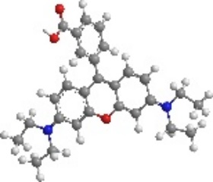 | 479.01 | $$C_{28}H_{31}ClN_{2}O_{3}$$ | 5.2 | 5 | 1 | 554
AO7 (Acid Orange 7) |  | 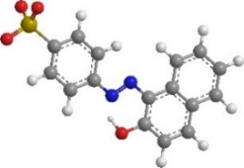 | 350.32 | $$C_{16}H_{11}N_{2}NaO_{4}S$$ | 5.6 | 6 | 1 | 484
MB (Methylene blue trihydrate) |  | 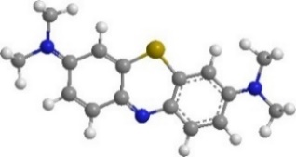 | 319.86 | $$C_{16}H_{18}ClN_{3}S$$ | 5.5 | 7 | 3 | 664
TC (Tetracycline hydrochloride) |  | 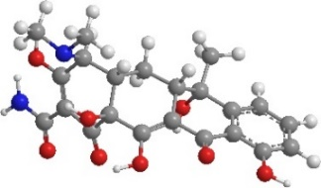 | 480.90 | $$C_{22}H_{25}{ClN}_{2}O_{8}$$ | 4.7 | 9 | 6 | 356
Nor (norfloxacin) |  | 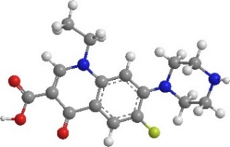 | 319.34 | $$C_{16}H_{18}FN_{3}O_{3}$$ | 10.1 | 7 | 2 | 336
pH₀ represents the initial pH of the solution in the degradation experiment.

References
[1] Dikici H, Saltali K, Bingölbalı S. Equilibrium and Kinetics Characteristics of Copper (II) Sorption onto Gyttja. Bull Environ Contam Toxicol 2010;84 (1):147–51.
[2] Dubinin MM, Zaverina ED RL. Equilibrium and Kinetics Characteristics of Copper (I) Sorption onto Gyttja. Zhurnal Fiz Khimii 1947;21:1351–1362.
[3] Saltalı K, Sarı A, Aydın M. Removal of ammonium ion from aqueous solution by natural Turkish (Yıldızeli) zeolite for environmental quality. J Hazard Mater 2007;141 (1):258–63.
[4] Donat R, Akdogan A, Erdem E CH. Thermodynamics of Pb and Ni adsorption onto natural bentonite from aqueous solution. J Col Inter Sci 2005;286:43–52.
[5] Massoudinejad M, Asadi A, Vosoughi M, Gholami M, Kakavandi B, Karami MA. A comprehensive study (kinetic, thermodynamic and equilibrium) of arsenic (V) adsorption using KMnO4 modified clinoptilolite. Korean J Chem Eng 2015;32 (10):2078–86.
[6] Azari A, Kakavandi B, Kalantary RR, Ahmadi E, Gholami M, Torkshavand Z, et al. Rapid and efficient magnetically removal of heavy metals by magnetite-activated carbon composite: a statistical design approach. J Porous Mater 2015;22 (4):1083–96.
[7] Kakavandi B, Kalantary RR, Farzadkia M, Mahvi AH, Esrafili A, Azari A, et al. Enhanced chromium (VI) removal using activated carbon modified by zero valent iron and silver bimetallic nanoparticles. J Environ Heal Sci Eng 2014;12 (1):115.
[8] Yu H, Che M, Zhao B, Lu Y, Zhu S, Wang X, et al. Enhanced electrosorption of rhodamine B over porous copper-nickel foam electrodes modified with graphene oxide/polypyrrole. Synth Met 2020;262:116332.
[9] Sarı A, Tuzen M. Biosorption of Pb(II) and Cd(II) from aqueous solution using green alga (Ulva lactuca) biomass. J Hazard Mater 2008;152 (1):302–8.
[10] Hu X, Li Y, Wang Y, Li X, Li H, Liu X, et al. Adsorption kinetics, thermodynamics and isotherm of thiacalix[4]arene-loaded resin to heavy metal ions 2010;259 (1–3).
[11] Sun H, Feng X, Wang S, Ang HM, Tadé MO. Combination of adsorption, photochemical and photocatalytic degradation of phenol solution over supported zinc oxide: Effects of support and sulphate oxidant. Chem Eng J 2011;170 (1):270–7.
[12] Ramachandran R, Thangavel Sakthivel, Minzhang Li, Haiquan Shan, Zong-Xiang Xu, Wang F. Efficient degradation of organic dye using Ni-MOF derived NiCo-LDH as peroxymonosulfate activator. Chemosphere 2021;271:128509.
[13] Ding Y, Wang X, Fu L, Peng X, Pan C, Mao Q, et al. Nonradicals induced degradation of organic pollutants by peroxydisulfate (PDS) and peroxymonosulfate (PMS): Recent advances and perspective. Sci Total Environ 2021;765:142794.
[14] Rastogi A, Al-Abed SR, Dionysiou DD. Sulfate radical-based ferrous–peroxymonosulfate oxidative system for PCBs degradation in aqueous and sediment systems. Appl Catal B Environ 2009;85 (3–4):171–9.
[15] Ball DL, Edwards JO. The Kinetics and Mechanism of the Decomposition of Caro’s Acid. I. J Am Chem Soc 1956;78 (6):1125–9.
[16] Lawrance GA, Ward CB. Kinetics of oxidation of manganese(II) by peroxomonosulfuric acid in aqueous acidic solution. Transit Met Chem 1985;10 (7):258–61.
[17] Rani SK, Easwaramoorthy D, Bilal IM, Palanichamy M. Studies on Mn(II)-catalyzed oxidation of α-amino acids by peroxomonosulphate in alkaline medium-deamination and decarboxylation: A kinetic approach. Appl Catal A Gen 2009;369 (1–2):1–7.

