Sumplementary data for

Toward sustainable revegetation in the Loess Plateau using coupled water and carbon management
Fubo Zhaoª, Yiping Wu^{a,}*, Xiaowei Yinª, Georgii Alexandrov^{b}, Linjing Qiuª
ª Department of Earth and Environmental Science, School of Human Settlements and Civil Engineering, Xi’an Jiaotong University, Xi’an 710049, China
^{b} A.M. Obukhov Institute of Atmospheric Physics, Russian Academy of Sciences, Moscow 119017, Russia

Table S1.
The calibrated parameters of SWAT and their sensitivity ranks.
Parameter name | Description | Range | Optimized value | Sensitivity rank
CN2 | Curve number II value | -0.2-0.2 | 0.1* | 1
SOL_K | Effective hydraulic conductivity (mm/h) | -0.9-0.9 | -0.81* | 2
SOL_AWC | Soil available water capacity (mm) | -0.5-0.5 | 0.29* | 3
HRU_SLP | Average slope steepness (m m⁻¹) | -0.6-0.6 | 1.1* | 4
SPCON | Linear parameter for calculating the maximum amount of sediment that can be re-entrained during channel sediment routing | 0.0001-0.03 | 0.009 | 5
RAINHHMX | Maximum 0.5 hour rainfall in entire period of record for month (mm) | 0-125 | 38 | 6
ALPHA_BF | Baseflow recession constant | 0.001-0.1 | 0.06 | 7
CH_K2 | Effective hydraulic conductivity (mm/h) | 0-8 | 7.6 | 8
ESCO | Soil evaporation compensation factor | 0.1-0.9 | 0.3 | 9
CH_COV2 | Channel cover factor (m/m) | 0-1 | 0.8 | 10
USLE_P | USLE equation support pra | 0-1 | 0.5 | 11
CH_COV1 | Channel erodibility factor | 0-1 | 0.6 | 12
*Relative change: the existing parameter value is multiplied by (1+given value).

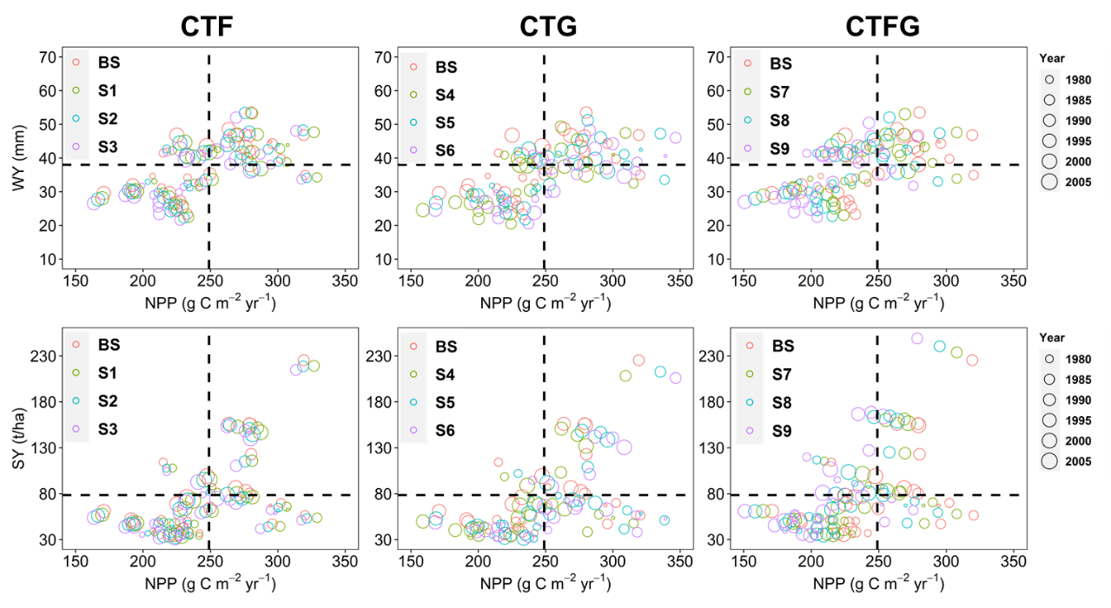
Fig. S1. Temporal changes in water yield (WY), carbon sequestration (NPP), and sediment yield (SY) under baseline and nine scenarios from 1976 to 2005. Scenarios were color-coded, and the temporal changes in the environmental indicators were calculated at the watershed scale. Bubble size indicates the time point during 1976–2005. Dashed lines are the baseline estimates (averaged 1976–2005) for comparison.

