Supplementary Data for

An Integrated Anti-Fouling and Anti-Corrosion Coating Enabled by rGO/AgNPs and Amphiphilic Networks
Shu Tian ^{a,c,#}, Jinli Zhang ^{a,b,#}, Shuan Liu ª, Jingyu Li ª, Jibin Pu ª, Yugang Hao ª, Guobing Ying ^{b}, Qunji Xue ª, Guangming Lu ^{a,}*
ª Key Laboratory of Advanced Marine Materials, Ningbo Institute of Materials Technology and Engineering, Chinese Academy of Sciences, Ningbo 315201, China
^{b} Department of Material Science and Engineering, College of Mechanics and Engineering Science, Hohai University, Nanjing 211100, China
^{c} Department of Biochemical Engineering, School of Chemical Engineering and Technology, Tianjin University, Tianjin 300350, China

* Corresponding author.
E-mails address: luguangming@nimte.ac.cn (G. Lu).
# These authors contributed equally to this work.

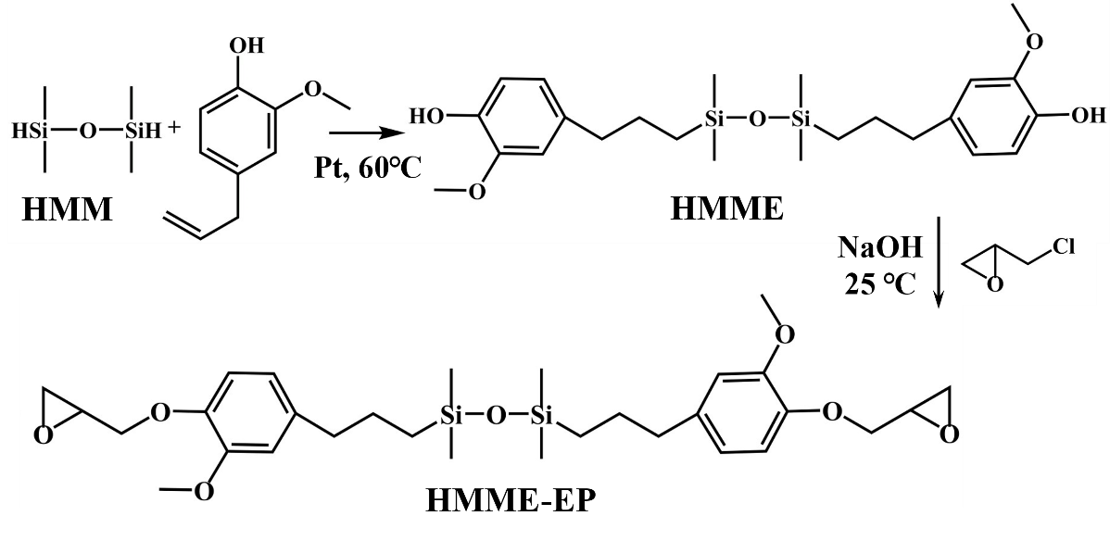
Fig. S1. Synthetic route of bio-based silicone–epoxy resin.

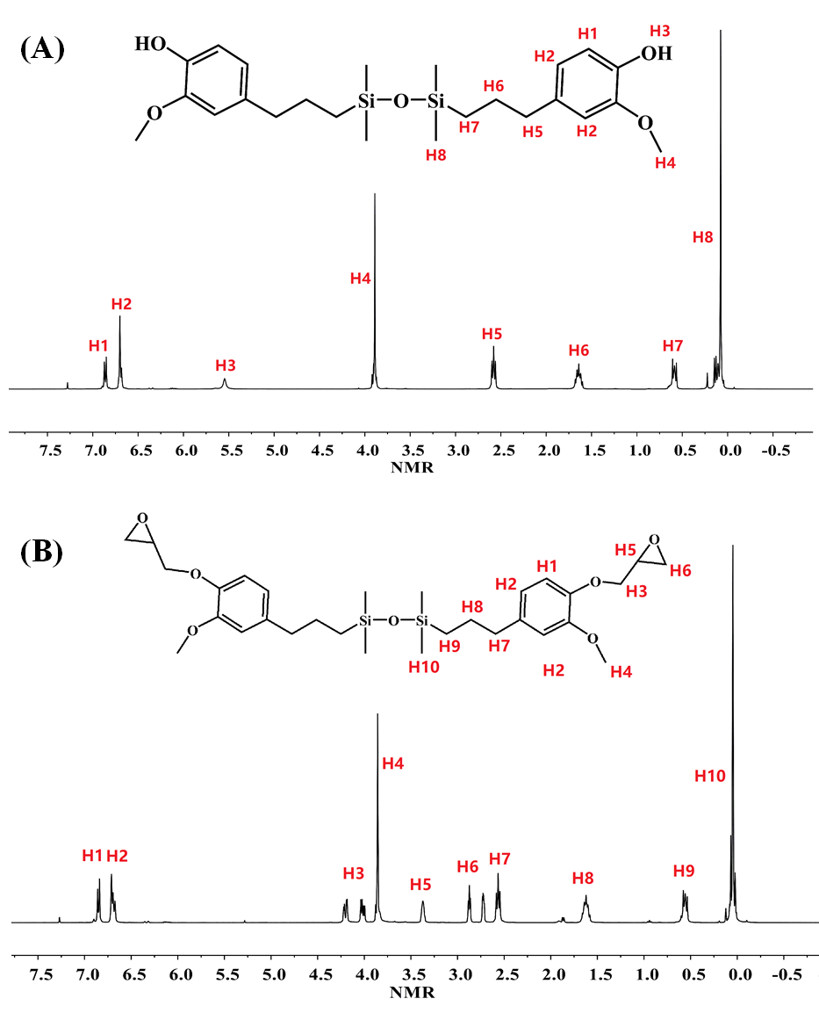
Fig. S2. ¹H NMR spectra of (A) HMME and (B) HMME-EP.

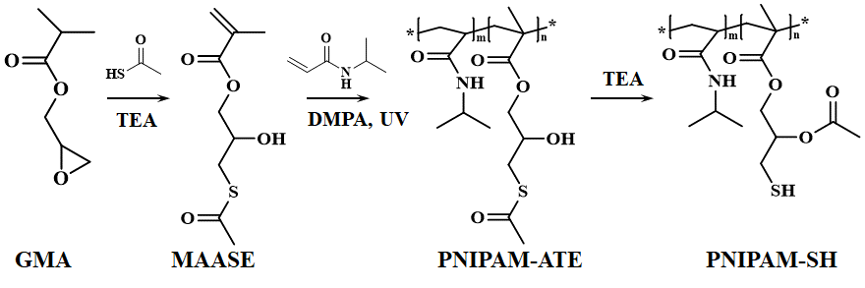
Fig. S3. Synthetic route of PNIPAM-SH.

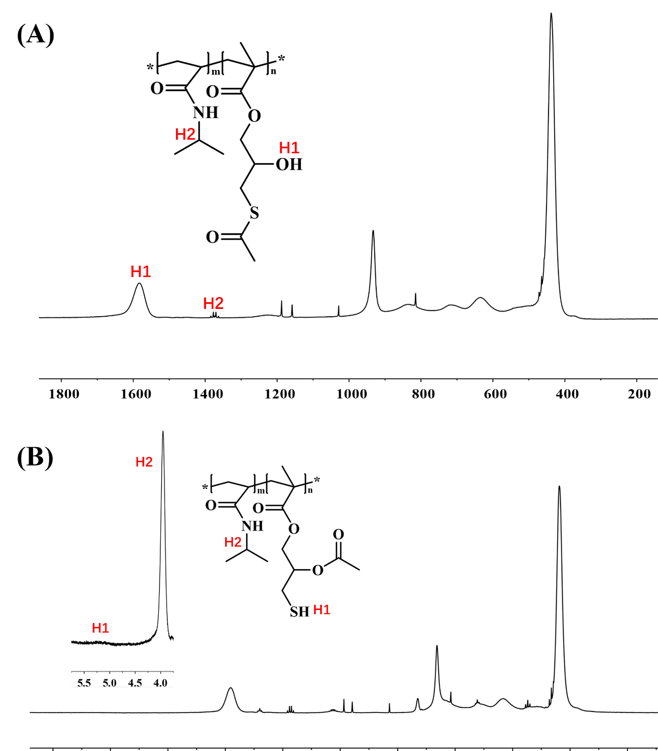
Fig. S4. ¹H NMR spectra of (A) PNIPAM-ATE and (B) PNIPAM-SH.

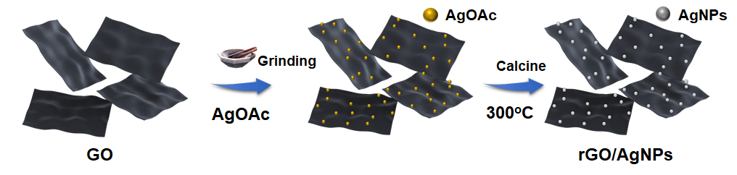
Fig. S5. Schematic illustration of the formation of rGO/AgNPs nanocomposite.

Fig. S6. The killing efficiency of the coatings toward S. aureus.

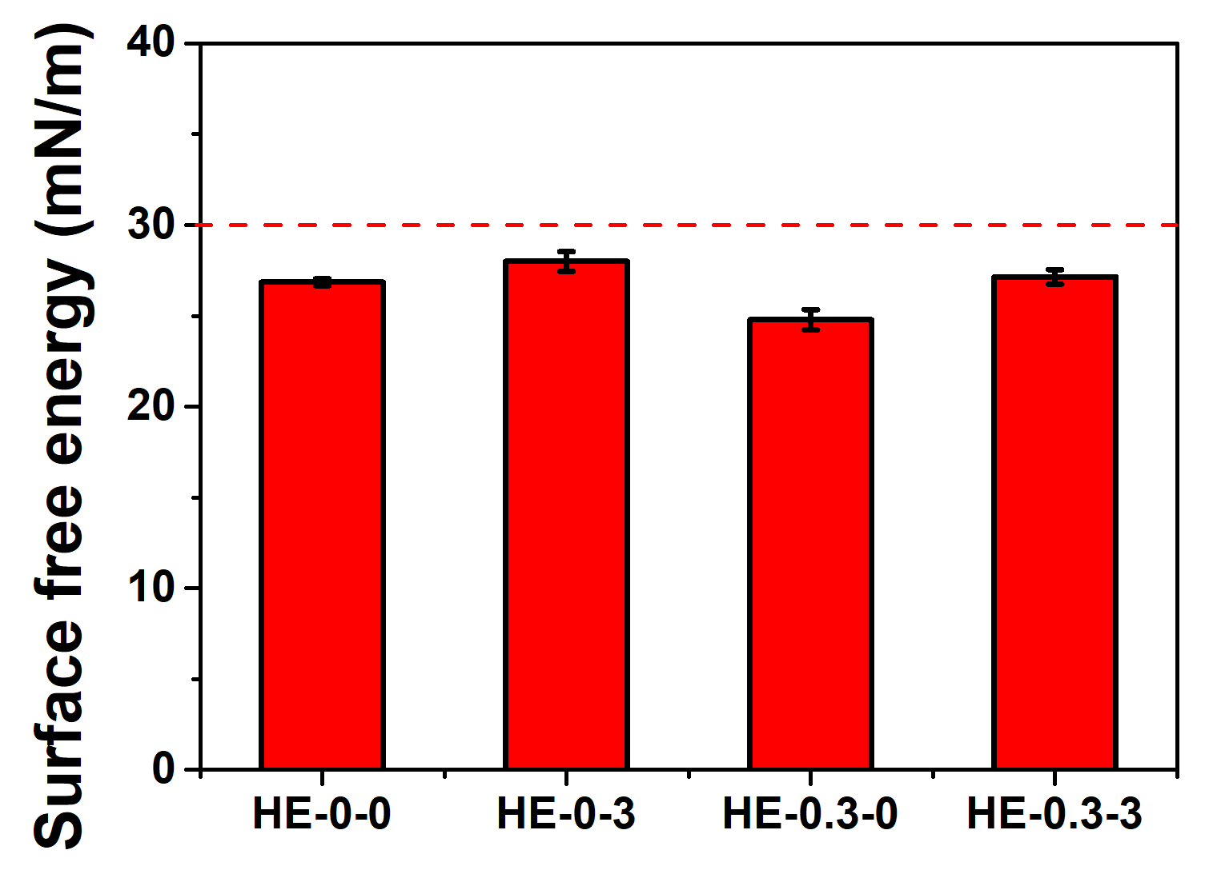
Fig. S7. Surface free energy of the coatings.

