Supplementary Information for

Continuous-Flow Synthesis of the Nucleobase Unit of Remdesivir
Yongxing Guo ª, Minjie Liu ^{b,c}, Meifen Jiang ^{b,c}, Yuan Tao ^{b,c}, Dang Cheng ^{b,c,}*, Fen-Er Chen ^{a,b,c,}*
ª Key Laboratory of Green Chemical Engineering Process of the Ministry of Education, School of Chemical Engineering and Pharmacy, Wuhan Institute of Technology, Wuhan 430205, China
^{b} Engineering Center of Catalysis and Synthesis for Chiral Molecules, Department of Chemistry, Fudan University, Shanghai 200433, China
^{c} Shanghai Engineering and Technology Research Center for Industrial Asymmetric Catalysis of Chiral Drugs, Shanghai 200433, China
* Corresponding authors.
E-mail addresses: dcheng@fudan.edu.cn (D. Cheng), rfchen@fudan.edu.cn (F. E. Chen).

Table of Contents
S1. Abbreviations used 3
S2. Batch synthesis procedures 4
S2.1. Batch synthesis of pyrrole-2-carboxaldehyde 4
S2.2. Batch synthesis of pyrrole-2-carbonitrile 5
S2.3. Batch synthesis of 1-amino-1H-pyrrole-2-carbonitrile 6
S2.4. Batch synthesis of pyrrolo[2,1-f][1,2,4]triazin-4-amine 7
S2.5. Batch synthesis of 7-bromopyrrolo[2,1-f][1,2,4]triazin-4-amine 8
S3. Continuous Flow Equipment and Devices 10
S3.1. Continuous flow reactors 10
S3.2. Micro-mixers 11
S3.3. Gas liquid separator 13
S3.4. Continuous-flow solid filter 14
S3.5. Miniature continuous stirred-tank reactor 15
S3.6. Liquid-liquid membrane separator 16
S3.7. Annular centrifugal extractor 17
S3.8. Fixed bed reactor 17
S4. Continuous Flow Synthesis Procedures 17
S4.1. Continuous flow synthesis of pyrrole-2-carbaldehyde 17
S4.2. Continuous flow synthesis of pyrrole-2-carbonitrile 18
S4.3. Continuous flow synthesis of 1-amino-1H-pyrrole-2-carbonitrile 19
S4.4. Continuous flow synthesis of pyrrolo[2,1-f][1,2,4]triazin-4-amine 21
S4.5. Continuous flow synthesis of 7-bromopyrrolo[2,1-f][1,2,4]triazin-4-amine 22
S5. ¹H and ¹³C NMR spectra of the synthesized compounds 23

S1. Abbreviations used
ACE = annular centrifugal extractor, ACR = Coflore agitating cell reactor, aq = aqueous, BTC = bis(trichloromethyl) carbonate, CFSF = continuous flow solid filter, Conv = Conversion, DBDMH = 1,3-dibromo-5,5-dimethylhydantoin, DBU = 1,8-diazabicyclo[5.4.0]undec-7-ene, DCE = dichloroethane, DCM = dichloromethane, DMF = N, N-dimethylformamide, DPPH = O-(diphenylphosphinyl) hydroxylamine, equiv. = equivalents, EtOH = ethanol, EtOAc = ethyl acetate, FAA = formamidine acetate, FBR = fixed bed reactor, GLS = gas liquid separator, h = hours, HOSA = hydroxylamine-O-sulfonic acid, I.D. = internal diameter, LLMS =liquid-liquid membrane separator, m-CSTR = miniature continuous stirred-tank reactor, min = minutes, NBS = N-bromosuccinimide, O.D. = outer diameter, org = organic, P = pump, PET = petroleum ether, PTFE = polytetrafluoroethylene, PYL = pyrrole, rt = room temperature, RE = rotary evaporator, T₁ = temperature of reactor I, T₂ = temperature of reactor II, T₃ = temperature of reactor III, T₄ = temperature of reactor IV, T₅ = temperature of reactor V, t_{R} = residence time, t-BuOK = potassium t-butoxide, THF = tetrahydrofuran, V₁ = internal volume of reactor I, V₂ = internal volume of reactor II, V₃ = internal volume of reactor III, V₄ = internal volume of reactor IV, V₅ = internal volume of reactor V.

S2. Batch synthesis procedures

S2.1. Batch synthesis of pyrrole-2-carboxaldehyde
Experimental Procedure: To a stirred solution of pyrrole (30 g, 0.447mol, 1.0 equiv.) and DMF (34.279 g, 0.469 mol, 1.05 equiv.) at 0 ℃ was added dropwise a solution of BTC (53.059 g, 0.179 mol, 0.4 equiv.) in anhydrous DCE (400 mL) under N₂ protection over a period of 15 min. The reaction mixture was stirred for 15–30 min after addition and then warmed to 45 ℃ for 5 h. After cooled down to room temperature, the mixture was poured onto ice (400 g). The resulting mixture was treated with saturated Na₂CO₃ aqueous solution to adjust its pH to 7–8. The layers were separated and the aqueous layer was extracted three times with 10:1 dichloromethane/methanol (3 × 400 mL). The combined organic layers were washed with brine, dried over anhydrous Na₂SO₄, and filtered. The filtrate was concentrated using rotary evaporation under reduced pressure to give 39.09 g of product 7 as a dark brown solid (95% purity by GC/Mass, 92% yield). The crude product was employed in the next step without further purification. Purification via flash column chromatography on silica gel afforded the pale yellow crystalline product 7 in 83% isolated yield with purity > 99% (GC/MS).
Characterization data: pale yellow crystalline, m.p. 43.8–44.5 ℃. ¹H NMR (400 MHz, CDCl₃) δ 9.01 (s, 1H), 7.01 (td, J = 2.8, 1.4 Hz, 1H), 6.92 (ddd, J = 3.8, 2.5, 1.4 Hz, 1H), 6.33 (dt, J = 3.8, 2.6 Hz, 1H); ¹³C NMR (100 MHz, CDCl₃) δ 179.6, 132.8, 127.3, 122.2, 111.4.

S2.2. Batch synthesis of pyrrole-2-carbonitrile
Experimental Procedure: A mixture of pyrrole-2-carbaldehyde (28.78 g, 302.6 mmol, 1.0 equiv.), hydroxylamine-O-sulfonic acid (41.08 g, 363.2 mmol, 1.2 equiv.) and water (200 mL) was stirred at ambient temperature for 1 h. Then the reaction mixture was treated with saturated Na₂CO₃ aqueous solution to adjust its pH to 7–8. The layers were separated and the aqueous layer was extracted three times with ethyl acetate (3 × 200 mL). The combined organic layers were washed with brine, dried over anhydrous Na₂SO₄, and filtered. The filtrate was concentrated using rotary evaporation under reduced pressure to give 27.87 g of product 8 as a dark brown oil (95% purity by GC/Mass, 98% yield). The crude product was employed in the next step without further purification. Distillation of the crude dark brown oil in vacuo afforded 23 g of product 8 as a yellow oil in 83% isolated yield with > 99% purity (GC/Mass).
Characterization data: yellow oil, ¹H NMR (400 MHz, CDCl3) δ 9.01 (s, 1H), 7.01 (td, J = 2.8, 1.4 Hz, 1H), 6.92 (ddd, J = 3.8, 2.5, 1.4 Hz, 1H), 6.33 (dt, J = 3.8, 2.6 Hz, 1H). ¹³C NMR (100 MHz, CDCl3) δ 123.9, 120.2, 114.9, 109.9, 100.3.

S2.3. Batch synthesis of 1-amino-1H-pyrrole-2-carbonitrile
Experimental Procedure: To a stirred suspension of NaH (1.6579 g, 69.08 mmol, 1.3 equiv., 60% dispersion in mineral oil) in dry THF (200 mL) at 0 ℃ was added dropwise a solution of pyrrole-2-carbonitrile (4.8941 g, 53.14 mmol, 1.0 equiv.) in dry THF under N₂ protection followed by portionwise addition of Ph₂PO(O)NH₂ in THF (15 g, 63.77 mmol, 1.2 equiv.). The reaction mixture was then stirred for 5 h at 0 ℃. The resulting mixture was washed with saturated NH₄Cl aqueous solution (50 mL). The layers were separated, and the aqueous phase was extracted three times with ethyl acetate (3 × 200 mL). All of the organic layers were combined and washed with brine (2 × 10 mL), and dried over anhydrous Na₂SO₄, and then filtered. The filtrate was concentrated using rotary evaporation under reduced pressure to give 5.428 g of product 9 as a dark brown oil (95% purity by GC/Mass, 94% yield). The crude product was employed in the next step without further purification. Purification via flash column chromatography on silica gel afforded yellow oil as final product 9 in 80% isolated yield (99% purity by GC/Mass).
Characterization data: yellow oil, ¹H NMR (400 MHz, CDCl₃) δ 6.95–6.86 (m, 1H), 6.72–6.62 (m, 1H), 6.11–5.97 (m, 1H), 5.08 (s, 2H); ¹³C NMR (100 MHz, CDCl₃) δ 128.1, 118.0, 113.2, 107.1, 105.4.

S2.4. Batch synthesis of pyrrolo[2,1-f][1,2,4]triazin-4-amine
Method A
Experimental Procedure: A mixture of 1-amino-1H-pyrrole-2-carbonitrile (3.064 g, 28.081 mmol, 1.0 equiv.), formamidine acetate (35.083 g, 0.337 mol, 12.0 equiv.), anhydrous K₂CO₃ (50.454 g, 0.365 mol, 13.0 equiv.) and ethanol absolute (150 mL) was heated to 85 ℃ under N₂ protection. The reaction mixture was stirred for 10 h and then washed with water (100 mL). The resultant slurry was filtered and the cake was washed with cold water (150 mL) and dried to afford 2.349 g brown dark solid of product 5 in 63% isolated yield (99% purity by GC/Mass).
Characterization data: brown dark solid, m.p. 221.1–223.8 ℃, ¹H NMR (400 MHz, d₆-DMSO) δ 7.78 (s, 1H), 7.74 (s, 1H), 7.59 (s, 1H), 6.85 (m, 1H), 6.62–6.55 (m, 1H); ¹³C NMR (100 MHz, d₆-DMSO) δ 156.0, 148.5, 118.6, 114.8, 110.6, 101.7.

Method B
Experimental Procedure: A mixture of 1-amino-1H-pyrrole-2-carbonitrile (0.055 g, 0.505 mmol, 1.0 equiv.), formamidine acetate (0.631 g, 6.060 mmol, 12.0 equiv.), DBU (0.999 g, 6.654mol, 13.0 equiv.) and ethanol absolute (5 mL) was heated to 85 ℃ under N₂ protection. The reaction mixture was stirred for 4 h and then washed with saturated NH₄Cl aqueous solution (5 mL). The resultant mixture was extracted three times with ethyl acetate (3 × 20 mL). All of the organic extracts were combined, dried over anhydrous Na₂SO₄, and then filtered. The filtrate was concentrated using rotary evaporation under reduced pressure to a brown dark solid. Recrystallization from water afforded 5 as a brown dark solid (0.033 g, 50% isolated yield, > 99% purity by GC/MS).
Characterization data: brown dark solid, m.p. 221.1–223.8 ℃, ¹H NMR (400 MHz, d₆-DMSO) δ 7.78 (s, 1H), 7.74 (s, 1H), 7.59 (s, 1H), 6.85 (m, 1H), 6.62–6.55 (m, 1H); ¹³C NMR (100 MHz, d₆-DMSO) δ 156.0, 148.5, 118.6, 114.8, 110.6, 101.7.

S2.5. Batch synthesis of 7-bromopyrrolo[2,1-f][1,2,4]triazin-4-amine
Method A
Experimental Procedure: To a stirred solution of (5) (250 mg, 1.864 mmol, 1.0 equiv.) in anhydrous DMF (6 mL) at ~20 ℃ was added dropwise of a solution of DBDMH in anhydrous DMF (331.7 mg, 1.957 mmol, 1.05 equiv.) over 45 min. The reaction mixture was stirred for 2 h and monitored by TLC. Upon completion, the reaction mixture was successively washed with saturated Na₂SO₃ aqueous solution and water. The resultant slurry was filtered and the retentate was washed with cold water and ethyl acetate.
Table S1. Optimization of batch bromination of 5 with DBDMH.
Entry | T (℃) | Equiv. | Conv.ª | Selectivity^{b}
1 | −40 | 0.6 equiv. DBDMH | 100%
2 | −20 | 0.2 equiv. DBDMH | 68%
3 | −40 | 0.2 equiv. DBDMH | 64%
^{a,b} Conversion and selectivity were determined by GC/MS peak area percentage.

Method B
Experimental Procedure: To a stirred solution of 5 (250 mg, 1.864 mmol, 1.0 equiv.) in anhydrous DMF (6 mL) at ~40 ℃ was added dropwise of a solution of N-bromosuccinimide (331.7 mg, 1.957 mmol, 1.05 equiv.) in DMF over 45 min. The reaction mixture was stirred for 2 h and monitored by GC/Mass until complete conversion. The reaction mixture was then washed with saturated Na₂SO₃ aqueous solution and water. The resultant slurry was filtered and the retentate was washed with cold water and ethyl acetate. The resulting solid was dried under vacuum to afford 212 mg white powder with > 95% purity by GC/Mass. Recrystallization from ethyl acetate delivered 4 as a white powder (185.58 mg) in 47% isolated yield with > 99% purity (GC/Mass).
Characterization data: white powder, m. p. 252.1–253.2 ℃, ¹H NMR (400 MHz, d₆-DMSO) δ 7.92 (s, 3H), 6.89 (d, J = 91.7 Hz, 2H); ¹³C NMR (100 MHz, d₆- DMSO) δ 155.4, 149.0, 115.9, 112.5, 102.7, 99.7.
Table S2. Optimization of batch bromination of 5 with NBS.
Entry | T (℃) | Equiv. | Conv.ª | Selectivity^{b}
1 | −40 | 1.05 equiv. NBS | 98%
2 | −78 | 1.0 equiv. NBS | 81%
^{a,b} Conversion and selectivity were determined by GC/MS peak area percentage.

S3. Continuous Flow Equipment and Devices

S3.1. Continuous flow reactors
The Reactor I, Reactor II, Reactor IV and Reactor V were constructed from perfluoroalkoxy (PFA) tubing with 0.6 mm I.D. and 1.6 mm O.D. The Reactor III was Coflore agitating cell reactor (ACR, AM Technology, UK), which features a hastelloy reaction block mounted on a laterally shaking motor [1]. There is a central flow plate in the reaction block containing reaction chambers, interconnecting channels and the agitators. The reaction chambers are made up of a series of individual cells of approximately 9.8 mL each with a freely-moving agitator inside. The individual cells are joined by the interconnecting channels of 30 mm in length and 4 mm in width. The agitators move in rapidly reversing transverse movements in the cells when the reaction block is shaken by the shaking motor [2]. In principle, the reaction chambers emulate a cascade of milliliter-scale CSTRs for plug flow performance. More details about the ACR can be referred to its user’s manual [1].
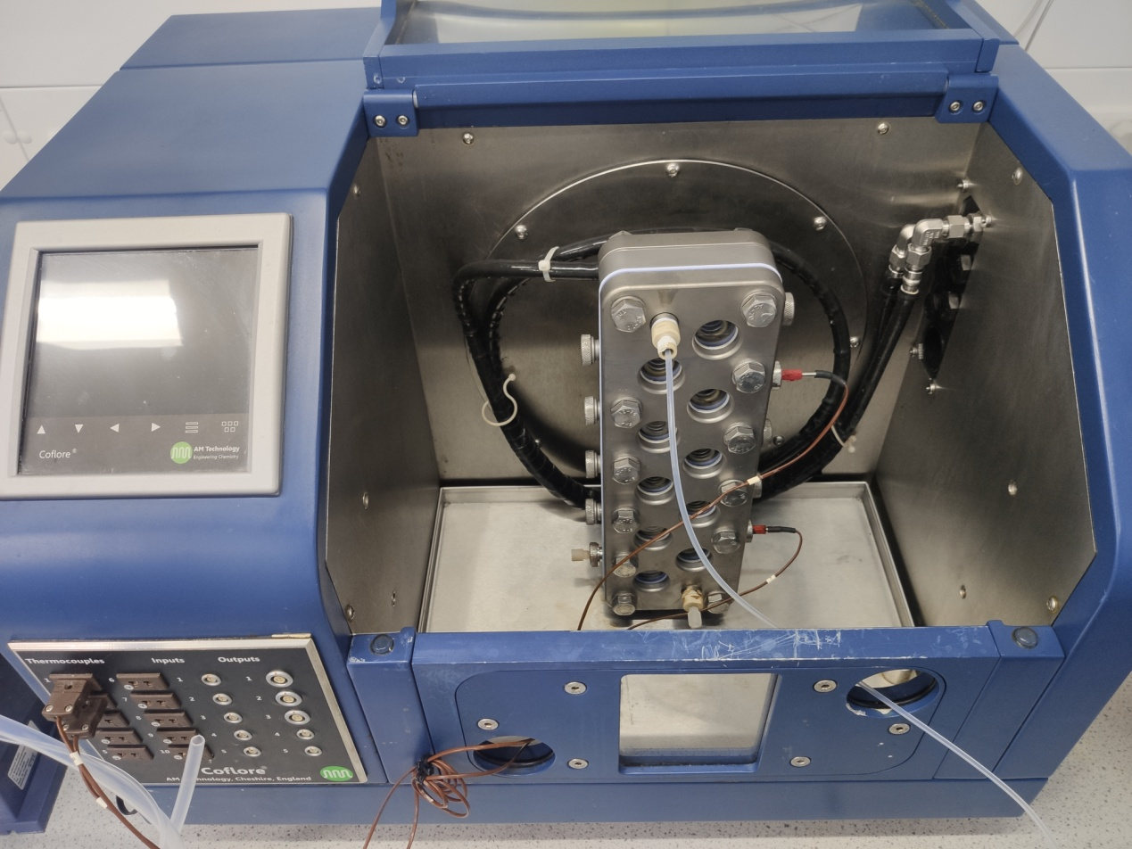 | 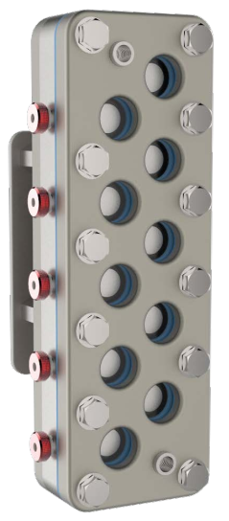
(a) | (b)
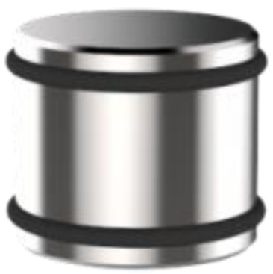 | 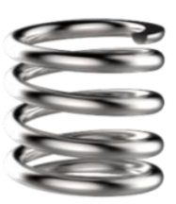
(c) | (d)
Fig. S1. (a) The ACR; (b) Reaction block; (c) Representative hastelloy agitator; (d) Representative high shear agitator.

S3.2. Micro-mixers
The T-type micro-mixers were employed for mixing fluids in this work unless otherwise indicated. It was found that good mixing was provided by using the simple T-type micro-mixers for miscible fluids (steps 1, 4, and 5). However, when two streams were immiscible, the use of T-type micro-mixer led to unideal mixing of the reacting streams. Therefore, the so-called two-phase cross-flow micro-mixer (CFMM) was employed to mix immiscible liquids in step 2.
The in-house manufactured CFMM comprises a first fluid process microchannel (0.8 mm × 0.5 mm × 25 mm) and a second fluid process microchannel (0.8 mm × 0.5 mm × 15 mm) parallel to each other; one end of the first fluid process microchannel is provided with a first fluid inlet, and the other end of the first fluid process microchannel is provided with a fluid outlet; one end of the second fluid process microchannel is provided with a second fluid inlet, and the other end of the second fluid process microchannel is closed; the first fluid inlet and the second fluid inlet are arranged at the same end; there is an apertured section in the wall shared by the first fluid process microchannel and the second fluid process microchannel, where a plurality of micro pores (with diameter of 100 μm) are provided. The design allows for flowing a second fluid stream through the apertured section into the first fluid process microchannel in contact with the first fluid stream to form a two-phase mixture. The first fluid forms the continuous phase, and the second fluid forms the dispersed phase.
In step 2 of this work, the aqueous solution of hydroxylamine-O-sulfonic acid was pumped into the first fluid process microchannel, and the organic phase from step 1 was pumped into the second fluid process microchannel; so the organic phase flowed through the apertured section into the first fluid process microchannel to form a biphasic mixture, where the organic phase was the dispersed phase and the aqueous solution of hydroxylamine-O-sulfonic acid was the continuous phase.
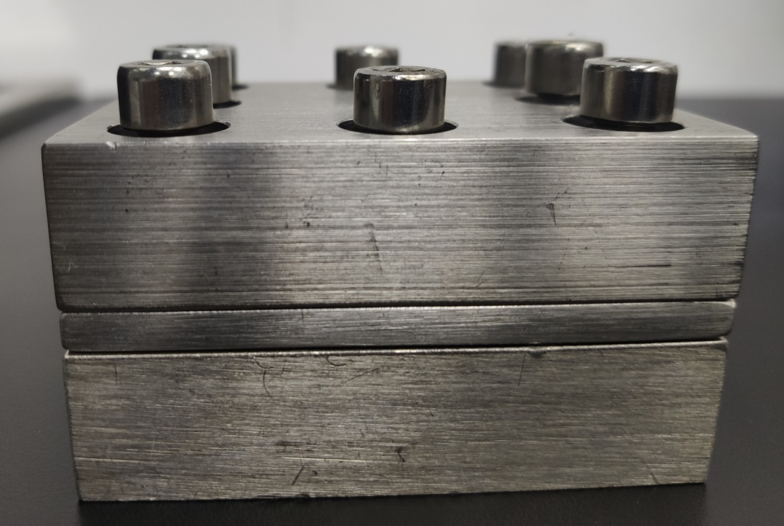
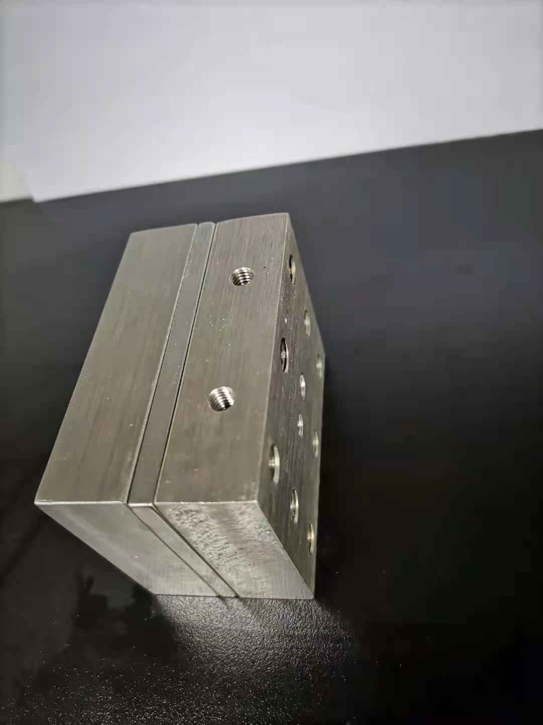
(a) | (b)
Fig. S2. (a) Schematic illustration of the two-phase cross-flow micro-mixer (CFMM), 1: inlet of the first fluid process microchannel; 2: the first fluid process microchannel; 3: inlet of the second fluid process microchannel; 4: the second fluid process microchannel; 5: outlet of the first fluid process microchannel; 6: aperture; (b) pictures of the two-phase cross-flow micro-mixer.

S3.3. Gas liquid separator
An unsteady flow rate was observed when a gas-liquid biphasic mixture directly flowed through the back pressure regulator (BPR). Therefore, a gas liquid separator (GLS) was needed for the continuous-flow gas-liquid two-phase system that required a back pressure. Basically, the gas liquid separator consists of a collection vessel, a process inlet, a process outlet, a process outlet valve, pressurized gas inlet, a pressurized gas outlet and a back pressure regulator as show in Fig. S2. The process inlet allows a stainless steel tube to deliver the process stream directly into the collection vessel. The pressurized gas feed (e.g., N₂) via the pressurized gas inlet maintains the vessel and connected upstream flow reactors at a set pressure, whose value can be controlled by adjusting the back pressure regulator on the pressurized gas outlet. As a matter of fact, the pressure inside the collection vessel is equal to the set value of the back pressure regulator. In this approach, the upstream flow reactors can be pressurized by gas (e.g., N₂).
 | 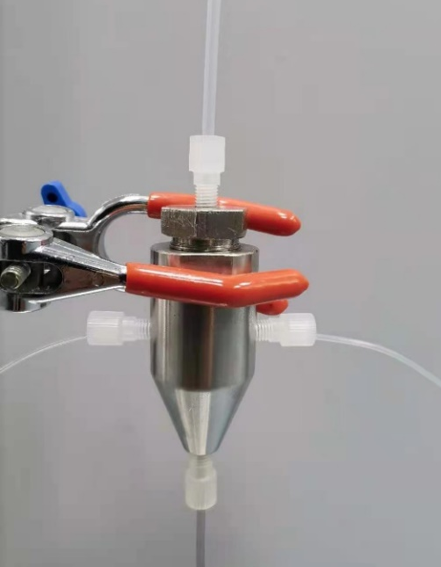
(a) | (b)
Fig. S3. (a) Schematic illustration of the gas liquid separator; (b) picture of the gas liquid separator.

S3.4. Continuous-flow solid filter
The continuous flow solid filter (CFSF) with an outer diameter of 70 mm and a height of 35 mm was made of stainless steel (316 L). It consists of a cylindrical retentate chamber, millipore filter membrane, disc-shaped steel frit and a cylindrical permeate chamber. The retentate chamber has an inner diameter of 40 mm and a depth of 16 mm. The permeate chamber has an inner diameter of 40 mm and a depth of 10 mm. A vacuum pump was connected to the permeate chamber in order to expedite the filtration process.
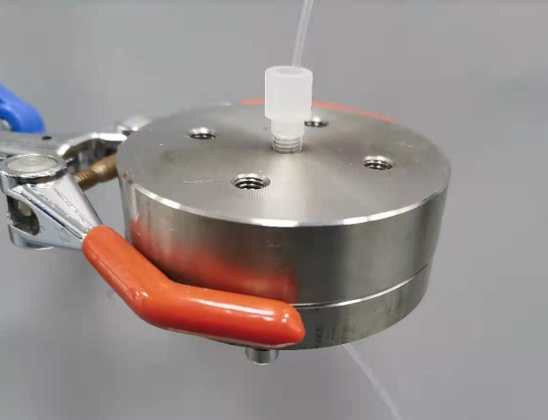
Fig. S4. Picture of the continuous-flow solid filter.

S3.5. Miniature continuous stirred-tank reactor
The miniature continuous stirred-tank reactor (m-CSTR) made of stainless steel (304) is a cylindrical reactor with a cylindrical reaction chamber inside and a lid. The cylindrical reactor has a height of 15 mm and an outer diameter of 30 mm. The inner reaction chamber has a diameter of 22 mm and a depth of 6 mm. There are three connection ports (1/4’’−28 threads) in the wall, which are positioned at an angle of 90° to each other.
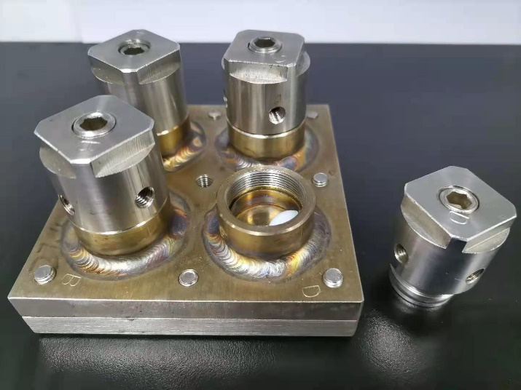
Fig. S5. Picture of the miniature continuous stirred-tank reactor.

S3.6. Liquid-liquid membrane separator
The liquid-liquid membrane separator (LLMS) is composed of two steel plates (160 mm × 24 mm × 10 mm), each plate has a separating channel 0.8 mm (width) × 0.6 mm (depth) × 100 mm (length). A piece of 0.45 μm pore hydrophobic PTFE membrane (Pall Zeflour, USA) was placed between the two plates to divide the two separating channels. Inlets and outlets were 0.4 mm holes drilled directly into the separating channels, respectively.
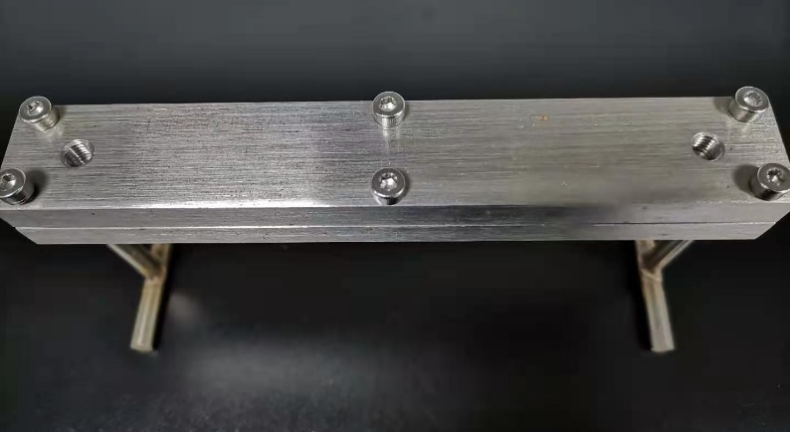
Fig. S6. Picture of the liquid-liquid membrane separator.

S3.7. Annular centrifugal extractor
The annular centrifugal extractors (ACE, CINC Deutschland GmbH & Co. KG, Germany) were used to perform continuously extraction of the relevant products from the aqueous phase to the organic phase.

S3.8. Fixed bed reactor
The fixed bed reactor (FBR) is stainless steel (316 L) column with 10 mm I.D. and 200 mm in length.

S4. Continuous flow synthesis procedures

S4.1. Continuous flow synthesis of pyrrole-2-carbaldehyde
Fig. S7. Continuous flow synthesis of pyrrole-2-carbaldehyde (7).
Syringe pump P1 was used to pump the solution of PYL (1.0 equiv.) and DMF (1.05 equiv.) dissolved in DCE, and syringe pump P2 was used to pump the solution of BTC (0.35 equiv.) dissolved in DCE. The two solutions were mixed via a T mixer and immediately streamed through Reactor I (step 1). The gas liquid separator (GLS) was connected after Reactor I and the adjustable back pressure regulator was installed on the gas outlet of the gas liquid separator. Pressurized nitrogen (6 bar) was fed into the gas liquid separator from the pressurized gas inlet. The process outlet valve was left partially open to continuously release the reaction mixture. In this way, a stable pressure was maintained in the upstream Reactor I and the chamber of gas liquid separator by controlling the adjustable back pressure regulator. The reaction mixture discharged from the gas liquid separator was directed into m-CSTR-1 along with an incoming Na₂CO₃ aqueous solution that was pumped by a HPLC pump (P3). The collective flow stream was allowed to pump into CFSF-1, and then the filtrate was delivered to LLMS-1 via m-CSTR-2. The organic phase output from LLMS-1 was collected and purified off-line. The reaction optimization processes are shown in Table 2. The flow protocol offered productivity up to 3.18 g·h⁻¹ of product 7.

S4.2. Continuous flow synthesis of pyrrole-2-carbonitrile
Fig. S8. Continuous flow synthesis of pyrrole-2-carbonitrile (8).
The organic phase output from LLMS-1 was streamed into a two phase cross-flow micro-mixer (CFMM) via a small container together with HOSA aqueous solution (1.2 equiv. in H₂O) using a HPLC pump (P5) and a syringe pump (P6), respectively. The two streams were mixed via the CFMM and then streamed through Reactor II. The output from Reactor II was directed into m-CSTR-3 along with an incoming saturated Na₂CO₃ aqueous solution that was pumped by a HPLC pump (P7). The collective flow stream was then pumped into CFSF-2, and the filtrate was allowed to pump into LLMS-2 via m-CSTR-4. The organic phase output from LLMS-2 was collected and purified off-line. The reaction optimization processes are shown in Table 3. Under the optimal two-step flow process, we obtained 47.6% isolated yield of 8 with a productivity of 3.02 g·h⁻¹.

S4.3. Continuous flow synthesis of 1-amino-1H-pyrrole-2-carbonitrile
Fig. S9. 1-Amino-1H-pyrrole-2-carbonitrile (9) formation in flow.
The synthesis of 1-amino-1H-pyrrole-2-carbonitrile (9) was first independently examined in flow processing using ACR as Reactor III (step 3, Fig. S9). The peristaltic pump P9 was used to pump the slurry of 8 (1.0 equiv.) and DPPH (i.e., Ph₂PO(O)NH₂, 1.2 equiv.) in THF, and the peristaltic pump P10 was used to pump the suspension of NaH (1.3 equiv.) in THF. The reactants were mixed and reacted while flowed through Reactor III at 30 ℃. The reaction optimization processes are shown in Table 4. Once the optimal conditions were established, the output from ACR was collected and purified off-line. The single flow process led to 97% isolated yield of 9.
In connecting step 3 to the previous two-step flow protocol, the organic phase output from LLMS-2 was streamed into Reactor III via a small container together with DPPH (i.e., Ph₂PO(O)NH₂) aqueous solution (1.2 equiv. in THF) and NaH (1.3 equiv.) in THF using a HPLC pump (P9-1) and two peristaltic pumps (P9-2, P10), respectively (Fig. S10). The reaction mixture flowed through Reactor III (ACR). The output from Reactor III first passed through CFSF-3 and the filtrate was directed into m-CSTR-5 along with an incoming saturated NH₄Cl aqueous solution that was pumped by a HPLC pump (P11). The collective flow stream was then pumped into ACE-1 using a peristaltic pump (P12) together with EtOAc delivered by a HPLC pump (P13). The organic phase output from ACE-1 was allowed to pump into RE-1 using a HPLC pump (P14) via a small container. The output from RE-1 was collected. The flow protocol offered productivity up to 2.6 g·h⁻¹ of product 9.
Fig. S10. Continuous flow synthesis of 1-amino-1H-pyrrole-2-carbonitrile (9).

S4.4. Continuous flow synthesis of pyrrolo[2,1-f][1,2,4]triazin-4-amine
Fig. S11. Pyrrolo[2,1-f][1,2,4]triazin-4-amine (5) formation in flow.
The synthesis of pyrrolo[2,1-f][1,2,4]triazin-4-amine (5) was initially independently examined in flow processing using Reactor IV (step 4, Fig. S11). The solution of 9 (1.0 equiv.), FAA (12 equiv.) and DBU (13 equiv.) in THF was streamed into Reactor IV using a HPLC pump (P15). The Reactor IV was back pressurized by an adjustable back pressure regulator. The reaction optimization processes are shown in Table 5. The optimal conditions were determined at 140 ℃ and 10 bar back pressure, and the output from Reactor IV was collected and purified off-line. The single flow process led to 60% isolated yield of 5.
In connecting step 4 to the previous three-step flow protocol, as shown in Fig. S12, the output from RE-1 was streamed to a T mixer with incoming solution of FAA (12 equiv.) and DBU (13 equiv.) dissolved in EtOH that was pumped by a HPLC pump (P15-2). The reaction mixture then flowed through Reactor IV (step 4). The output from Reactor IV was directed into a m-CSTR-6 along with an incoming saturated NH₄Cl aqueous solution that was pumped by a HPLC pump (P16). The collective flow stream was then pumped into ACE-2 together with EtOAc and the product 5 was continuously extracted into EtOAc. The organic phase output from ACE-2 was allowed to pump into RE-2 via a small container. The output from RE-2 was collected.

S4.5. Continuous flow synthesis of 7-bromopyrrolo[2,1-f][1,2,4]triazin-4-amine
Fig. S12. Continuous flow synthesis of 7-bromopyrrolo[2,1-f][1,2,4]triazin-4-amine (4).
As shown in Fig. S12, the output from RE-2 was connected to a T mixer with incoming solution of NBS (1.05 equiv.) dissolved in DMF that was pumped by a HPLC pump (P21). The reaction mixture then flowed through Reactor V (step 5). The outcome from Reactor V was collected and purified off-line. The reaction optimization processes are shown in Table 6. Under optimal flow protocol, 7-bromopyrrolo[2,1-f][1,2,4]triazin-4-amine (4) was obtained in 51% isolated yield.

S5. ¹H and ¹³C NMR spectra of the synthesized compounds
¹H NMR

¹³C NMR
¹H NMR

¹³C NMR

¹H NMR

¹³C NMR
¹H NMR

¹³C NMR
¹H NMR

¹³C NMR
References
(1). Coflore ACR laboratory scale flow reactor [Internet]. Cheshire: AM Technology; [cited 2021 Feb 18]. Available from: https://www.amt.uk/coflore-acr.
(2). Browne DL, Deadman BJ, Ashe R, Baxendale IR, Ley SV. Continuous flow processing of slurries: evaluation of an agitated cell reactor. Org Process Res Dev 2011;15(3):693–7.

