Supplementary file for

Pocket Modification of ω-Amine Transaminase AtATA for Overcoming the Trade-Off between Activity and Stability toward 1-Acetonaphthone
Jiaren Cao ª, Fangfang Fan ª, Changjiang Lyu ª, Sheng Hu ^{b}, Weirui Zhao ^{b}, Jiaqi Mei ^{c}, Shuai Qiu ^{a,}*, Lehe Mei ^{b,d,e,}*, Jun Huang ^{a,}*
ª Key Laboratory of Chemical and Biological Processing Technology for Farm Products of Zhejiang Province, Zhejiang Provincial Collaborative Innovation Center of Agricultural Biological Resources Biochemical Manufacturing, School of Biological and Chemical Engineering, Zhejiang University of Science and Technology, Hangzhou 310023, China
^{b} School of Biological and Chemical Engineering, Ningbo Tech University, Ningbo 315100, China
^{c} Hangzhou Huadong Medicine Group Co. Ltd., Hangzhou 310011, China
^{d} College of Chemical and Biological Engineering, Zhejiang University, Hangzhou 310027, China
^{e} Jinhua Advanced Research Institute, Jinhua 321019, China

* Corresponding authors.
E-mail addresses: huangjun@zust.edu.cn (J. Huang), qiushuai@zust.edu.cn (S. Qiu), meilh@zju.edu.cn (L. Mei)

Table S1
Primers used for site-saturation mutagenesis of AtATA.
Mutation position | Primerª
Y60X-F | TGCACTCCGATCTGACCNNKGACGTACCGTCTGTTTG
Y60X-R | CCAAACAGACGGTACGTCMNNGGTCAGATCGGAGTGCATG
V62X-F | CGATCTGACCTACGACNNKCCGTCTGTTT
V62X-R | ATCCCAAACAGACGGMNNGTCGTAGGTCAGAT
R79X-F | TTTAGATGATCATATTACANNKCTGGAAGCAAG
R79X-R | AGCTTGCTTCCAGMNNTGTAATATGATCATCT
R128X-F | TTAAAGGGGTNNKAGGAACTCGTCCGGAAGAT
R128X-R | ATATCTTCCGGACGAGTTCCTMNNACCCCTTT
V147XV149X-F | TAGTGAACAACCTGTACATGTTTGTGCAGCCGTACNNKTGGNNKATGGAGCCGGATAT
V147XV149X-R | TCCGGCTCCATMNNCCAMNNGTACGGCTGCACAAACATGTACAGGTTGTTCACTATAT
L182X-F | TATTGATCCGACCGTCAAGAATNNKCAGTGGGGTGATCTTGTT
L182X-R | AACAAGATCACCCCACTMNNGATTCTTGACGGTCGGATCAATA
L187X-F | GAATCTTCAGTGGGGTGATNNKGTTCGTGGAATGTTTGAAG
L187X-R | GCTTCAAACATTCCACGAACMNNATCACCCCACTGAAGATTC
L235XV238X-F | TATACGCCAGATCGCGGGGTGNNKCAGGGCNNKACTCGCAAGTCCGTTATCAAC
L235XV238X-R | GATAACGGACTTGCGAGTMNNGCCCTGMNNCACCCCGCGATCTGGCGTATAC
A276X-F | ATTTTCATGTGCACGACGNNKGGTGGCATTATG
A276X-R | TAATGCCACCMNNCGTCGTGCACATGAAAATCT
BCAT-G161F-F | CAACCGCAGCAAAAGCTTTTGGTAACTACCTGTCC
BCAT-G161F-R | GGACAGGTAGTTACCAAAAGCTTTTGCTGCGGTTG
BCAT-Y129A-F | CCGTGGGGTGCTGCGCTGGGTGCGGAAG
BCAT-Y129A-R | CTTCCGCACCCAGCGCAGCACCCCACGG
BCAT-S167F-F | GTAACTACCTGTCCTTCCTGCTGGTTGGTAG
BCAT-S167F-R | CTACCAACCAGCAGGAAGGACAGGTAGTTAC
117-I157A-F | CCCCGTATCAGTGGGCGGTGCCGTTTGATCG
117-I157A-R | CGATCAAACGGCACCGCCCACTGATACGGGG
117-L195F-F | CAGTGGGGTGACTTTATTCGTGCCATTC
117-L195F-R | GAATGGCACGAATAAAGTCACCCCACTG
pdATA-L56F-F | CTGGACGCAAATTCAGGTTTTTGGAATATGGTCGCAGG
pdATA-L56F-R | CCTGCGACCATATTCCAAAAACCTGAATTTGCGTCCAG
pdATA-E316A-F | GTTGAAGCCATTGAAGCGTTTCCGCATGGTTTTAC
pdATA-E316A-R | GTAAAACCATGCGGAAACGCTTCAATGGCTTCAAC
pdATA-E223F-F | CGGGCTTTTTTGCGTTTCCGGTGATGGGTGCC
pdATA-E223F-R | GGCACCCATCACCGGAAACGCAAAAAAGCCCG
ª Underscores indicate mutation sites.

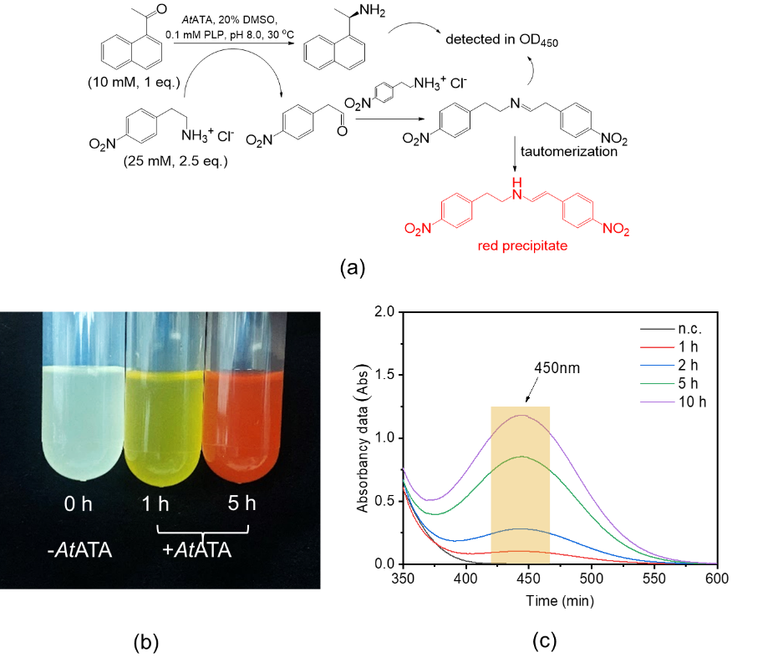
Fig. S1. High-throughput screening method. (a) Asymmetric ammoniation of 1-acetonaphthone (10 mmol·L^{–1}) into (R)-NEA using 2-(4-nitrophenyl)ethan-1-amine hydrochloride as amine donor (2.5 equiv) via AtATA. (b) The color change of reaction mixture (left, no adding AtATA; middle, adding enzyme for 1 h; right, adding enzyme for 5 h). (c) The change of absorbance at 450 nm wavelength with the extension of reaction time. n.c.: negative control.
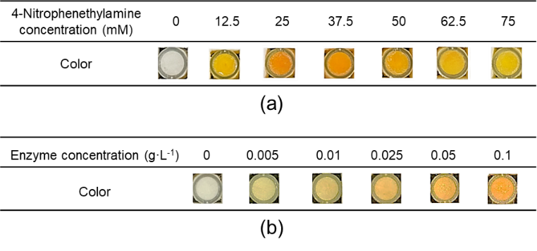
Fig. S2. The color rendering diagram in the 96-well plate under different enzyme or substrate concentrations. The reaction condition of (a): 0–30 mmol·L^{–1} 1-acetonaphthone, 0–75 mmol·L^{–1} (2-(4-nitrophenyl)ethan-1-amine hydrochloride (2.5 equiv), 20% (v/v) DMSO, 0.1 mmol·L^{–1} PLP, and 0.1 g·L^{–1} purified enzyme in 50.0 mmol·L^{–1} PBS buffer (pH 8.0) at 30 °C for 1 h. The reaction condition of (b): 10 mmol·L^{–1} 1-acetonaphthone, 25 mmol·L^{–1} (2-(4-nitrophenyl)ethan-1-amine hydrochloride, 20% (v/v) DMSO, 0.1 mmol·L^{–1} PLP, and 0–0.1 g·L^{–1} purified enzyme in 50.0 mmol·L^{–1} PBS buffer (pH 8.0) at 30 °C for 1 h.

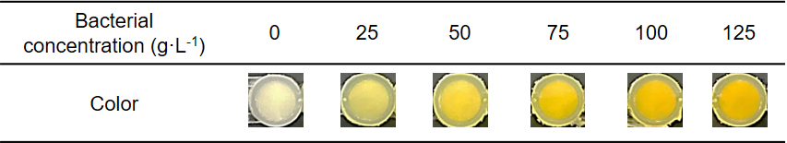
Fig. S3. The production of (R)-NEA and the color changes under different bacterial concentrations. Reaction condition: 10 mmol·L^{–1} 1-acetonaphthone, 25 mmol·L^{–1} (2-(4-nitrophenyl)ethan-1-amine hydrochloride, 20% (v/v) DMSO, 0.1 mmol·L^{–1} PLP, and 0–125 g_{DCW}·L^{–1} E. coli expressing AtATA in 50.0 mmol·L^{–1} PBS buffer (pH 8.0) at 30 °C for 0.5 h.

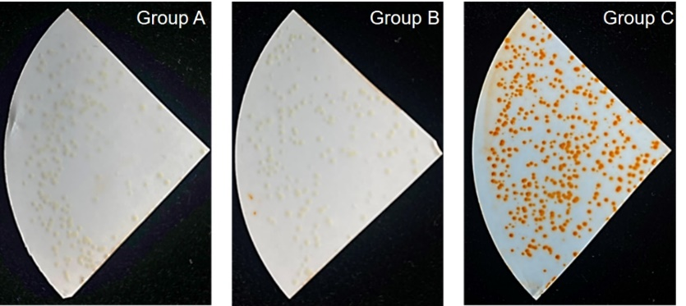
Fig. S4. The plate colony color reaction. Group A: single colony without isopropylthio-β-galactoside (IPTG) inducing for solid-phase color reaction; group B: single colony with IPTG inducing and without 1-acetonaphthone for solid-phase color reaction; group C: single colony with IPTG inducing and adding 1-acetonaphthone for solid-phase color reaction.
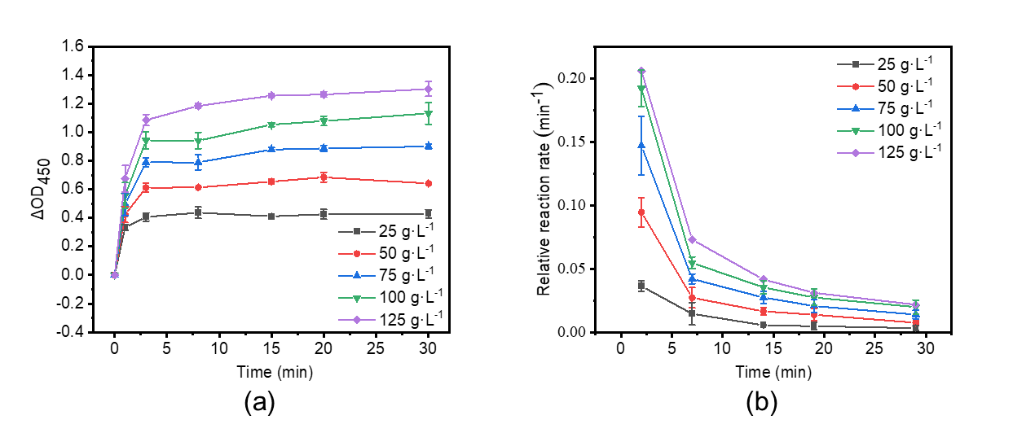
Fig. S5. (a) The change of ΔOD₄₅₀ under different bacterial concentrations, and (b) the average rate change of ΔOD₄₅₀ under different bacterial concentrations.

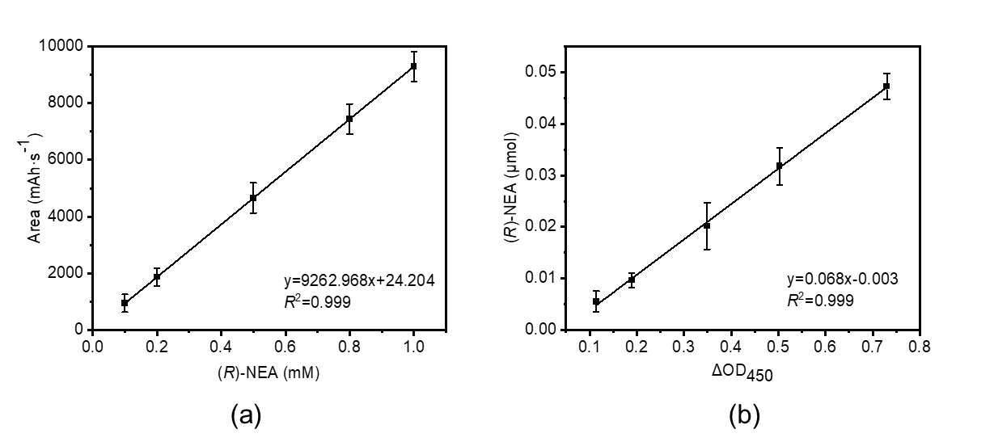
Fig. S6. (a) The linear fitting between the concentration of (R)-NEA and peak area via HPLC assay, and (b) the linear fitting between the concentration of (R)-NEA and ΔOD₄₅₀.

Table S2
Effects of different amino donors on asymmetric ammoniation via AtATA-Pa^{a,b}.
Entry | Amino donor (mmol·L^{–1}) | 1-acetonaphthone (mmol·L^{–1}) | Yield (%) | e.e. (%)
1 | 1n 5.0 | 20.0 | 3.3 ± 1.5 | R > 99.5%
2 | 1o 5.0 | 20.0 | 9.3 ± 1.5 | R > 99.5%
3 | 1p 5.0 | 20.0 | n. d. | —
4 | 2c 5.0 | 20.0 | 3.3 ± 0.2 | R > 99.5%
5 | 1b 5.0 | 20.0 | 52.8 ± 3.4 | R > 99.5%
6 | 1n 20.0 | 5.0 | 5.9 ± 0.2 | R > 99.5%
7 | 1o 20.0 | 5.0 | 21.1 ± 3.5 | R > 99.5%
8 | 1p 20.0 | 5.0 | n. d. | —
9 | 2c 20.0 | 5.0 | 8.5 ± 1.9 | R > 99.5%
10 | 1b 20.0 | 5.0 | 30.2 ± 2.7 | R > 99.5%
ª Reaction condition: 5.0 (or 20.0) mmol·L^{–1} 1-acetonaphthone, 20.0 (or 5.0) mmol·L^{–1} amino donor, 20% (v/v) DMSO, 0.1 mmol·L^{–1} PLP and 0.5 g·L^{–1} purified enzyme in 50.0 mmol·L^{–1} PBS buffer (pH 8.0) at 30 °C for 20 h.
^{b} Experiments were conducted in triplicate.
n. d.: not detected.

Table S3
The comparison of enzyme activity and stability toward 1-acetonaphthone between M4 and other mutants in previous literatures.
Enzyme | Substitutions | Strategy | Location | Effect on enzyme properties | Specific activity (U·g^{–1}) | t_{1/2} (h) | k_{cat}/K_{m}^{1-acetonaphthone} (L·min^{–1}·mmol^{–1}) | Ref
ArTA | F225M/C281I | Molecular docking and sequence conservation analysis | Substrate-binding pocket | Enhanced catalytic efficiency (3.4-fold) | 9.37 | 9.9 | 0.5 | [1]
ArTA | V199W/S223P | Molecular docking and sequence conservation analysis | Substrate-binding pocket | Enhanced activity (3.6-fold) | 18.7 | 9.6 | 1.9 | [2]
MvTA | G68Y/F129A | Error-prone PCR | Substrate-binding pocket | Enhanced activity (more than 15.0-fold) | 500.0 | — | 34.4 | [3]
AtATA | V149A/D224K/L182F/L187F | Pocket modification | Substrate-binding pocket | Enhanced thermostability (1.6-fold) and catalytic efficiency (58.0-fold) | 242.4 | 0.8 | 5.9 | This study

Table S4
Comparison of catalytic performance toward 1-acetonaphthone of AtATA with other ATAs.
Biocatalyst | Substrate loading (mmol·L^{–1}) | Scale (mL) | Reaction time (h) | Conversion (%) | Ref
ArTA-F225M/C281I | 10 | 1 | 12 | 78.9 | [1]
ArTA-V199W/S223P | 20 | 1 | 24 | 81.8 | [2]
MvTA-G68Y/F129A | 10 | 1 | — | — | [3]
AtATA-V149A/D224K/L182F/L187F | 20 | 50 | 10 | 78.0 | This study

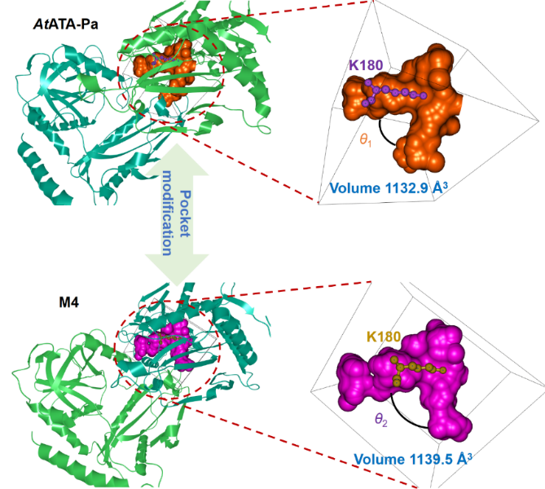
Fig. S7. External shapes of binding pockets of AtATA-Pa and M4. The volume calculation of substrate- and PLP-binding pocket was computed by CAVER Analyst 2.0 BETA and the probe was set as 1.63 Å. The protein structures were the stable state structure after energy minimization. The angles of θ₁ and θ₂ were 83.2° and 104.7°, respectively.

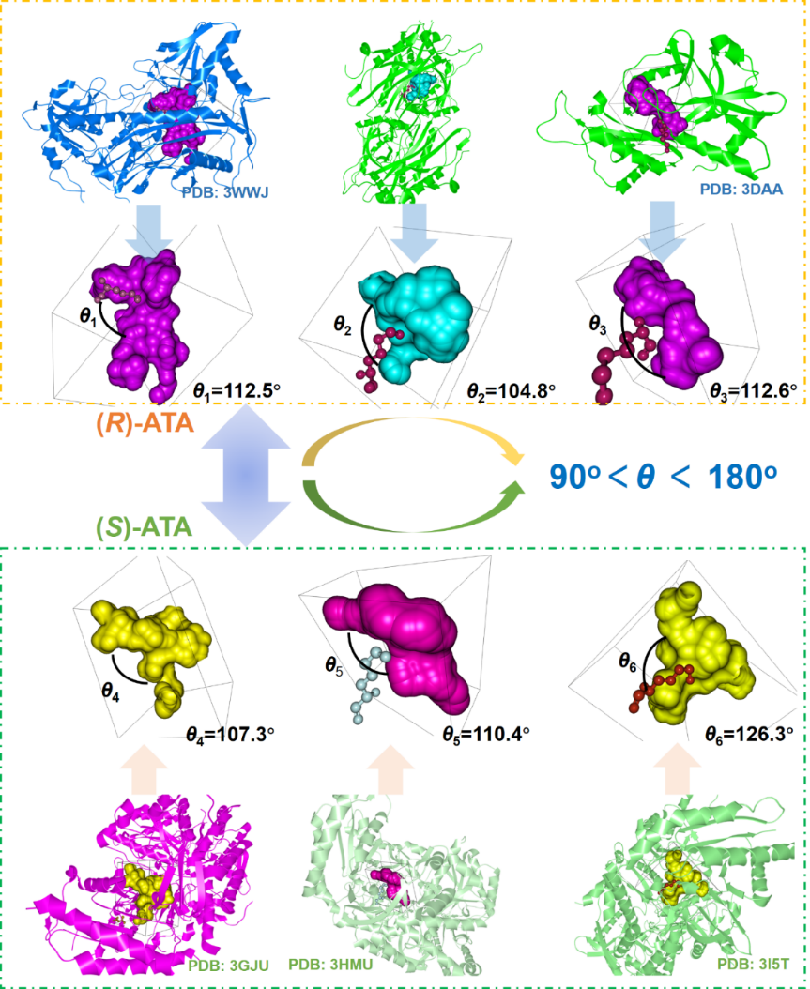
Fig. S8. Substrate-binding pocket of reported ATAs. θ₁–θ₆ are the angles, formed between the substrate- and PLP-binding pockets. The three structures in the orange dashed box are (R)-selectivity ATAs and the three structures in the green dashed box are (S)-selectivity ATAs.

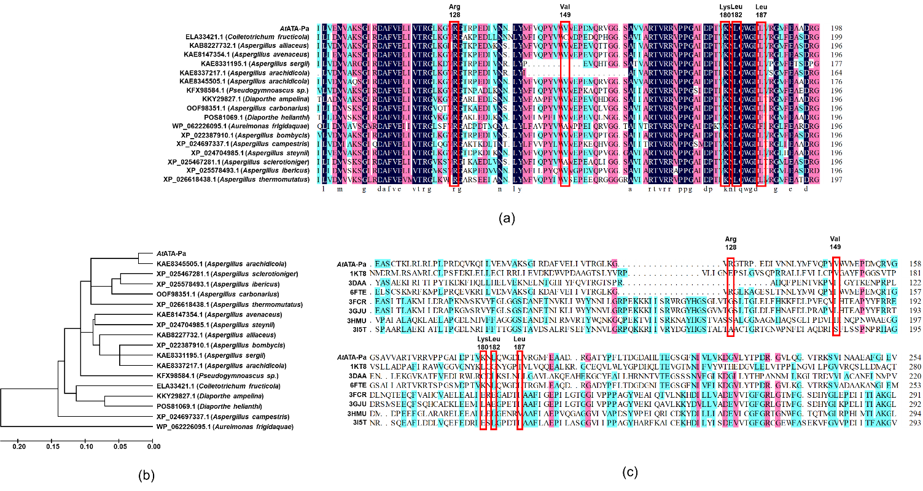
Fig. S9. Multiple sequence alignment and phylogenetic tree of ATAs. (a) Multiple sequence alignment of 18 reported ATAs (including AtATA and other 17 ATAs). The key residues and motifs are shown in red boxes. (b) The phylogenetic tree was constructed from the multiple sequence alignment of the complete amino acid sequences of 18 ATAs. The tree was constructed using MEGA 5.0. (c) Multiple sequence alignment of eight structure-available ATAs with AtATA and the key residues and motifs are shown in red boxes.

Table S5
Key residues for controlling activity in the substrate-binding pocket or the entrance of the substrate-binding pocket on structure available ATAs.
PDB | (R)/(S)-ATA | Position A | Position B | Position C | Position D
4CE5 | (R)-ATA | R128 | V149 | L182 | L187
1KT8 | (R)-ATA | E150 | A172 | G205 | T210
3DAA | (R)-ATA | / | T115 | L147 | A152
3WWJ | (R)-ATA | R138 | Q155 | F190 | L195
6FTE | (R)-ATA | R126 | V148 | L181 | L186
3FCR | (S)-ATA | G160 | T182 | E215 | I220
3GJU | (S)-ATA | G161 | T183 | E216 | I221
3HMU | (S)-ATA | S164 | I185 | L217 | V222
3I5T | (S)-ATA | A161 | L183 | L214 | I219

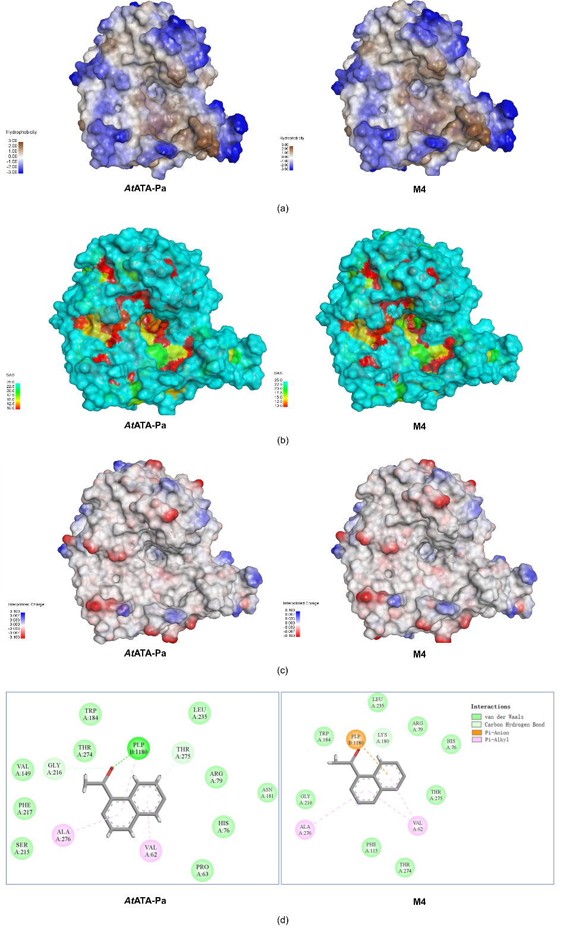
Fig. S10. Structural property analysis of AtATA-Pa and M4. (a) Hydrophobic analysis of AtATA-Pa and M4. (b) Solvent accessibility surface (SAS) analysis of AtATA-Pa and M4. (c) Interpolated charge of AtATA-Pa and M4. (d) Interaction analysis between AtATA-Pa or M4 and 1-acetonaphthone.

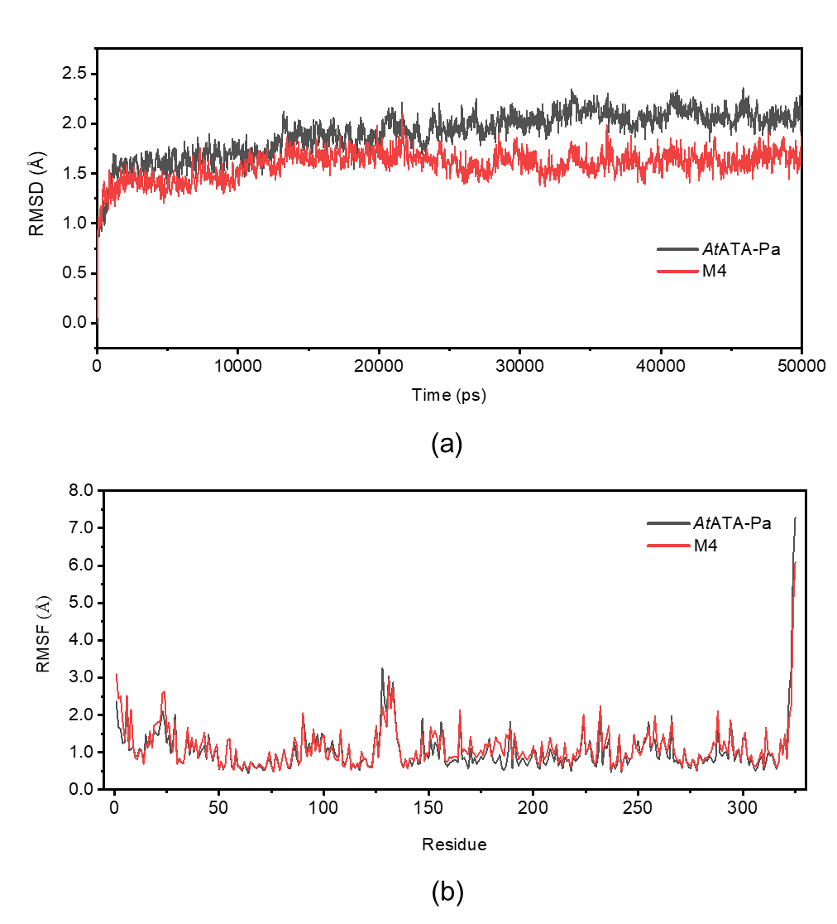
Fig. S11. MD simulations of AtATA-Pa and M4 at 313 K. (a) RMSD of the alpha-carbon atoms for AtATA-Pa and M4 bound with the PLP. The fluctuation of M4 was significantly lower than that of AtATA-Pa. (b) RMSF of the alpha-carbon atoms for AtATA-Pa and M4 bound with the PLP. No significant difference was found in the respective MD replicas.

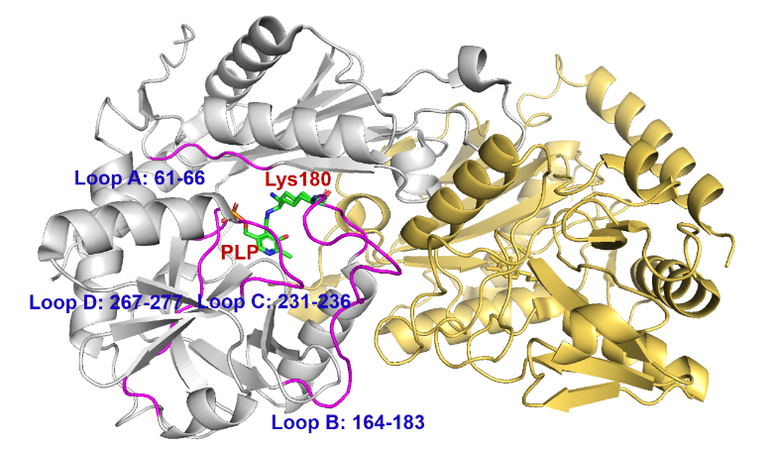
Fig. S12. The structure of AtATA’s binding-pocket-decorating loops.

Table S6
The RMSFs of the binding-pocket-decorating loops and key residues of AtATA.
Enzyme | Loop A | Loop B | Loop C | Loop D
AtATA-Pa | 1.002 | 1.127 | 1.524 | 0.798
M4 | 1.075 | 1.122 | 1.242 | 0.740
Enzyme | Position 128 | Position 149 | Position 182 | Position 187
AtATA-Pa | 2.226 | 0.979 | 1.420 | 1.472
M4 | 3.259 | 0.972 | 0.699 | 0.641

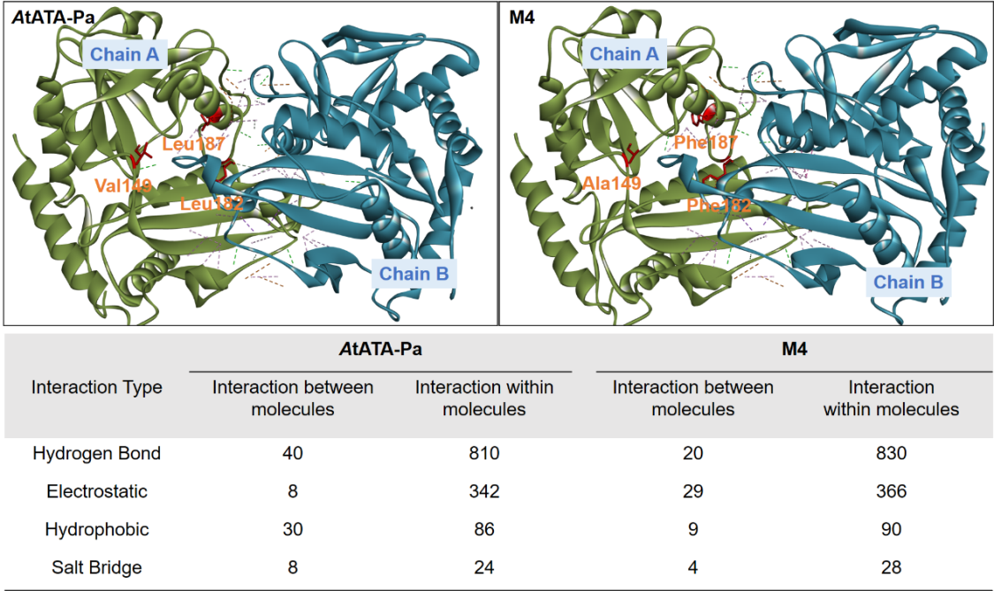
Fig. S13. The number of interactions between or within molecules of AtATA-Pa or M4. The above two pictures presented the interactions between molecules. The green dotted line represents the hydrogen bond, and the purple dotted line represents hydrophobic interaction. The number of interactions between or within molecules is calculated by the software of Discovery Studio 2019 Client.

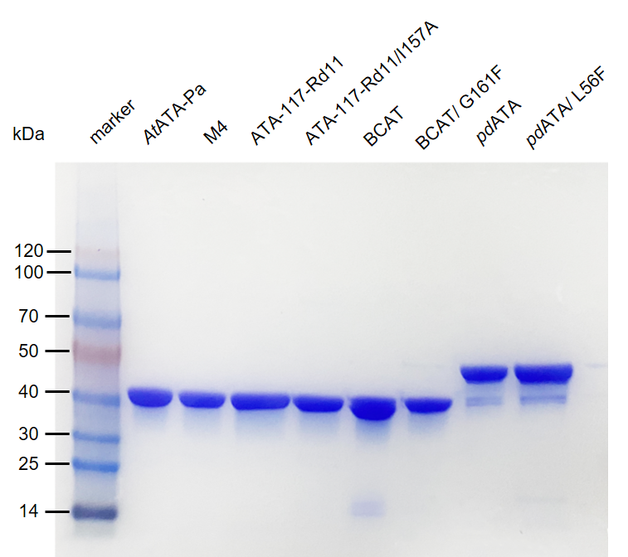
Fig. S14. The SDS-PAGE analysis of different ATAs and the corresponding variants. The enzymes were purified using Ni²⁺-NTA affinity chromatography as described in the material and methods.

HPLC analytical data
Analytical data for the determination of yield
HPLC Method for 2a and 2c-2l (Method A): HPLC analyses were carried out in an Agilent chromatographic system, using a reversed-phase column (Agilent InfinityLab Poroshell 120 HPH-C18 column, 4.6 mm × 150 mm, 4.0 μm) and acetonitrile (MeCN)/deionized water containing 0.015% (v/v) ethanolamine as solvents. Samples were eluted with isocratic in 8–10 min, at a flow rate of 1.0 mL·min^{–1} at 25 °C. Detection and spectral characterization of peaks was performed at 210 nm with a diode array detector (Agilent 1220 Infinity II, USA).
HPLC Method for 1b, 2a, and 2d-2l (Method B): An chirality of reaction product was mixed with 20 μL NaHCO₃ (100 mM, pH 9.8) and 50 μL marfey solution in acetone (1%, m/v) at 40 °C for 2 h, and quenched the reaction via 20 μL HCl (2 M). Then, the reaction mixture was dissolved in a 50% (v/v) acetonitrile aqueous solution and detected via HPLC. HPLC analyses were carried out in an Agilent chromatographic system, using a reversed-phase column (Agilent InfinityLab Poroshell 120 EC-C18 column, 4.6 mm × 150 mm, 4.0 μm) and MeCN/deionized water containing 0.1% (v/v) formic acid as solvents. Samples were eluted with isocratic in 12–20 min, at a flow rate of 1.0 mL·min^{–1} at 25 °C. Detection and spectral characterization of peaks was performed at 340 nm with a diode array detector (Agilent 1220 Infinity II).
Analytical data for assaying the enantiomeric excess of products
The detailed HPLC conditions are shown in Tables S7 and S8.

Table S7
Analytical method for determination of yield (%) via HPLC.
Method | Eluent (MeCN/H₂O, v/v) | Retention time (t_{R}, min)
Method | Eluent (MeCN/H₂O, v/v) | Ketone | t_{R} | Amine | t_{R}
A | 40:60 | 1a | 9.178 | 2a | 4.501
A | 40:60 | 1c | 3.539 | 2c | 2.065
A | 40:60 | 1d | 4.229 | 2d | 2.652
A | 30:70 | 1e | 14.116 | 2e | 7.097
A | 40:60 | 1f | 7.827 | 2f | 4.063
A | 20:80 | 1g | 14.651 | 2g | 7.689
A | 40:60 | 1h | 5.442 | 2h | 3.282
A | 40:60 | 1i | 10.101 | 2i | 4.895
A | 20:80 | 1j | 17.083 | 2j | 9.054
A | 40:60 | 1k | 9.686 | 2k | 4.816
A | 40:60 | 1l | 5.223 | 2l | 3.407

Table S8
Analytical method for determination of e.e. value via HPLC.
Method | Chiral amine | Eluent (MeCN/H₂O, v/v) | Retention time (min)
B | 1bª | 60:40 | 3.243 (R), 3.711 (S)
B | 2aª | 60:40 | 4.779 (R), 5.502 (S)
B | 2dª | 40:60 | 16.453 (R), 23.342 (S)
B | 2eª | 60:40 | 4.074 (R), 4.997 (S)
B | 2fª | 60:40 | 4.350 (R), 5.426 (S)
B | 2gª | 40:60 | 16.117 (R), 19.466 (S)
B | 2hª | 60:40 | 4.062 (R), 4.720 (S)
B | 2iª | 60:40 | 4.556 (R), 5.416 (S)
B | 2jª | 60:40 | 3.143 (R), 3.371 (S)
B | 2kª | 60:40 | 4.895 (R), 5.760 (S)
B | 2lª | 60:40 | 4.723 (R), 4.407 (S)
ª Derivatized as marfey-derivative.

HPLC chromatograms for chiral amines and corresponding ketones
Method | acetonitrile and deionized water (20:80, v/v) containing 0.015% (v/v) ethanolamine
Entry | Product | Area (mAU·s) | Retention time (min)
1 |  | 9972.435 | 12.063

Method | acetonitrile and deionized water (20:80, v/v) containing 0.015% (v/v) ethanolamine
Entry | Product | Area (mAU·s) |  | Retention time (min)
2 |  | 9798.562 |  | 7.121
Method | acetonitrile and deionized water (30:70, v/v) containing 0.015% (v/v) ethanolamine
Entry | Product | Area (mAU·s) | Retention time (min)
1 |  | 8539.479 | 6.604

Method | acetonitrile and deionized water (30:70, v/v) containing 0.015% (v/v) ethanolamine
Entry | Product | Area (mAU·s) |  | Retention time (min)
2 |  | 9598.014 |  | 3.547
Method | acetonitrile and deionized water (40:60, v/v) containing 0.015% (v/v) ethanolamine
Entry | Product | Area (mAU·s) | Retention time (min)
1 |  | 21344.844 | 3.747

Method | acetonitrile and deionized water (40:60, v/v) containing 0.015% (v/v) ethanolamine
Entry | Product | Area (mAU·s) |  | Retention time (min)
2 |  | 9058.118 |  | 2.428
Method | acetonitrile and deionized water (40:60, v/v) containing 0.015% (v/v) ethanolamine
Entry | Product | Area (mAU·s) | Retention time (min)
3 |  | 53629.804 | 9.718

Method | acetonitrile and deionized water (40:60, v/v) containing 0.015% (v/v) ethanolamine
Entry | Product | Area (mAU·s) |  | Retention time (min)
4 |  | 25754.319 |  | 4.501
Method | acetonitrile and deionized water (40:60, v/v) containing 0.015% (v/v) ethanolamine
Entry | Product | Area (mAU·s) | Retention time (min)
5 |  | 5790.243 | 3.539

Method | acetonitrile and deionized water (40:60, v/v) containing 0.015% (v/v) ethanolamine
Entry | Product | Area (mAU·s) |  | Retention time (min)
6 |  | 9865.810 |  | 2.065
Method | acetonitrile and deionized water (40:60, v/v) containing 0.015% (v/v) ethanolamine
Entry | Product | Area (mAU·s) | Retention time (min)
7 |  | 9575.130 | 4.229

Method | acetonitrile and deionized water (40:60, v/v) containing 0.015% (v/v) ethanolamine
Entry | Product | Area (mAU·s) |  | Retention time (min)
8 |  | 8785.548 |  | 2.652
Method | acetonitrile and deionized water (30:70, v/v) containing 0.015% (v/v) ethanolamine
Entry | Product | Area (mAU·s) | Retention time (min)
9 |  | 16990.092 | 14.116

Method | acetonitrile and deionized water (30:70, v/v) containing 0.015% (v/v) ethanolamine
Entry | Product | Area (mAU·s) |  | Retention time (min)
10 |  | 10624.649 |  | 7.097
Method | acetonitrile and deionized water (40:60, v/v) containing 0.015% (v/v) ethanolamine
Entry | Product | Area (mAU·s) | Retention time (min)
11 |  | 13881.852 | 7.827

Method |  | acetonitrile and deionized water (40:60, v/v) containing 0.015% (v/v) ethanolamine
Entry |  | Product | Area (mAU·s) |  | Retention time (min)
12 |  |  | 12078.950 |  | 4.063
Method | acetonitrile and deionized water (20:80, v/v) containing 0.015% (v/v) ethanolamine
Entry | Product |  | Area (mAU·s) | Retention time (min)
13 |  |  | 9719.934 | 14.651

Method | acetonitrile and deionized water (20:80, v/v) containing 0.015% (v/v) ethanolamine
Entry | Product | Area (mAU·s) |  | Retention time (min)
14 |  | 7866.307 |  | 7.689
Method | acetonitrile and deionized water (40:60, v/v) containing 0.015% (v/v) ethanolamine
Entry | Product | Area (mAU·s) | Retention time (min)
15 |  | 15418.030 | 5.442

Method | acetonitrile and deionized water (40:60, v/v) containing 0.015% (v/v) ethanolamine
Entry | Product | Area (mAU·s) |  | Retention time (min)
16 |  | 10962.934 |  | 3.282
Method | acetonitrile and deionized water (40:60, v/v) containing 0.015% (v/v) ethanolamine
Entry | Product | Area (mAU·s) | Retention time (min)
17 |  | 17060.281 | 10.101

Method | acetonitrile and deionized water (40:60, v/v) containing 0.015% (v/v) ethanolamine
Entry | Product | Area (mAU·s) |  | Retention time (min)
18 |  | 8461.396 |  | 4.895
Method | acetonitrile and deionized water (20:80, v/v) containing 0.015% (v/v) ethanolamine
Entry | Product | Area (mAU·s) | Retention time (min)
19 |  | 8072.847 | 17.083

Method | acetonitrile and deionized water (20:80, v/v) containing 0.015% (v/v) ethanolamine
Entry | Product | Area (mAU·s) |  | Retention time (min)
20 |  | 4914.948 |  | 9.054
Method | acetonitrile and deionized water (40:60, v/v) containing 0.015% (v/v) ethanolamine
Entry | Product | Area (mAU·s) | Retention time (min)
21 |  | 24872.644 | 9.686

Method | acetonitrile and deionized water (40:60, v/v) containing 0.015% (v/v) ethanolamine
Entry | Product | Area (mAU·s) |  | Retention time (min)
22 |  | 25955.116 |  | 4.816
Method | acetonitrile and deionized water (40:60, v/v) containing 0.015% (v/v) ethanolamine
Entry | Product | Area (mAU·s) | Retention time (min)
23 |  | 21043.380 | 5.223

Method | acetonitrile and deionized water (40:60, v/v) containing 0.015% (v/v) ethanolamine
Entry | Product | Area (mAU·s) | Retention time (min)
24 |  | 12992.169 | 3.407

Entry | Product | Area (mAU·s) |  | Retention time (min)
25 |  | R | 20023.378 | R | 3.243
25 |  | S | 702.624 | S | 3.711

Entry | Product | Area (mAU·s) |  | Retention time (min)
26 |  | R | 16147.389 | R | 4.779
26 |  | S | 15113.403 | S | 5.502

Entry | Product | Area (mAU·s) |  | Retention time (min)
27 |  | R | 25593.314 | R | 16.453
27 |  | S | 22868.608 | S | 23.342

Entry | Product | Area (mAU·s) |  | Retention time (min)
28 |  | R | 16465.237 | R | 4.074
28 |  | S | 18870.462 | S | 4.997

Entry | Product | Area (mAU·s) |  | Retention time (min)
29 |  | R | 3964.293 | R | 4.350
29 |  | S | 17886.263 | S | 5.426

Entry | Product | Area (mAU·s) |  | Retention time (min)
30 |  | R | 17026.821 | R | 16.117
30 |  | S | 18312.976 | S | 19.466

Entry | Product | Area (mAU·s) |  | Retention time (min)
31 |  | R | 18294.435 | R | 4.062
31 |  | S | 19353.475 | S | 4.720

Entry | Product | Area (mAU·s) |  | Retention time (min)
32 |  | R | 12294.362 | R | 4.556
32 |  | S | 10047.033 | S | 5.416

Entry | Product | Area (mAU·s) |  | Retention time (min)
33 |  | R | 13251.498 | R | 3.143
33 |  | S | 9710.125 | S | 3.371

Entry | Product | Area (mAU·s) |  | Retention time (min)
34 |  | R | 11290.202 | R | 4.895
34 |  | S | 12298.624 | S | 5.760

Entry | Product | Area (mAU·s) |  | Retention time (min)
35 |  | R | 13141.694 | R | 4.723
35 |  | S | 8635.821 | S | 4.407

HPLC chromatograms for chiral amines after transamination with M4
Entry | Product | Area (mAU·s) |  | Retention time (min)
36 |  | 33256.568 |  | 4.577
Entry | Product | Area (mAU·s) |  | Retention time (min) |  | e.e. (%)
36 |  | R | 14289.592 | R | 4.783 | > 99.5 (R)
36 |  | S | n.d. | S | n.d. | > 99.5 (R)

Entry | Product | Area (mAU·s) | Retention time (min)
37 |  | 11961.641 | 2.018

Entry | Product | Area (mAU·s) |  | Retention time (min)
38 |  | 6929.153 |  | 2.623
Entry | Product | Area (mAU·s) |  | Retention time (min) |  | e.e. (%)
38 |  | R | 8269.868 | R | 16.441 | > 99.5 (R)
38 |  | S | n.d. | S | n.d. | > 99.5 (R)

Entry | Product | Area (mAU·s) |  | Retention time (min)
39 |  | 9869.671 |  | 7.024
Entry | Product | Area (mAU·s) |  | Retention time (min) |  | e.e. (%)
39 |  | R | 8564.134 | R | 4.075 | > 99.5 (R)
39 |  | S | n.d. | S | n.d. | > 99.5 (R)

Entry | Product | Area (mAU·s) |  | Retention time (min)
40 |  | 12133.669 |  | 4.063
Entry | Product | Area (mAU·s) |  | Retention time (min) |  | e.e. (%)
40 |  | R | 9846.036 | R | 4.356 | > 99.5 (R)
40 |  | S | n.d. | S | n.d. | > 99.5 (R)

Entry | Product | Area (mAU·s) |  | Retention time (min)
41 |  | 3239.463 |  | 7.692
Entry | Product | Area (mAU·s) |  | Retention time (min) |  | e.e. (%)
41 |  | R | 2262.840 | R | 16.123 | > 99.5 (R)
41 |  | S | n.d. | S | n.d. | > 99.5 (R)

Entry | Product | Area (mAU·s) |  | Retention time (min)
42 |  | 8134.247 |  | 3.229
Entry | Product | Area (mAU·s) |  | Retention time (min) |  | e.e. (%)
42 |  | R | 6570.271 | R | 4.062 | > 99.5 (R)
42 |  | S | n.d. | S | n.d. | > 99.5 (R)

Entry | Product | Area (mAU·s) |  | Retention time (min)
43 |  | 12318.062 |  | 4.897
Entry | Product | Area (mAU·s) |  | Retention time (min) |  | e.e. (%)
43 |  | R | 8671.391 | R | 4.555 | > 99.5 (R)
43 |  | S | n.d. | S | n.d. | > 99.5 (R)

Entry | Product | Area (mAU·s) |  | Retention time (min)
44 |  | 13528.183 |  | 9.083
Entry | Product | Area (mAU·s) |  | Retention time (min) |  | e.e. (%)
44 |  | R | 14380.015 | R | 3.043 | > 99.5 (R)
44 |  | S | n.d. | S | n.d. | > 99.5 (R)

Entry | Product | Area (mAU·s) |  | Retention time (min)
45 |  | 30084.135 |  | 4.799
Entry | Product | Area (mAU·s) |  | Retention time (min) |  | e.e. (%)
45 |  | R | 8229.277 | R | 4.892 | > 99.5 (R)
45 |  | S | n.d. | S | n.d. | > 99.5 (R)

Entry | Product | Area (mAU·s) |  | Retention time (min)
46 |  | 335.988 |  | 3.381
Entry | Product | Area (mAU·s) |  | Retention time (min) |  | e.e. (%)
46 |  | R | 89.441 | R | 4.717 | > 99.5 (R)
46 |  | S | n.d. | S | n.d. | > 99.5 (R)

Reference
[1] Cao XD, Han RZ, Fang HH, Ni Y. Engineering ω-transaminase by random mutagenesis and semi-rational design for the synthesis of (R)-(+)-1-(1-naphthyl)ethylamine. Chin J Biotechnol 2020;36(9):1828-–37.
[2] Han RZ, Cao XD, Fang HH, Zhou J, Ni Y. Structure-based engineering of ω-transaminase for enhanced catalytic efficiency toward (R)-(+)-1-(1-naphthyl)ethylamine synthesis. Mol Catal 2021;502:111368.
[3] Cheng F, Chen XL, Xiang C, Liu ZQ, Wang YJ, Zheng YG. Fluorescence-based high-throughput screening system for R-ω-transaminase engineering and its substrate scope extension. Appl Microbiol Biot 2020;104:2999–3009

