Appendix A:

Highly Efficient Broadband Achromatic Microlens Design Based on Low-Dispersion Materials
Xueqian Wang ª, Chuanbao Liu ^{b}, Feilou Wang ^{c}, Weijia Luo ^{c}, Chengdong Tao ª, Yuxuan Hou ª, Lijie Qiao ª, Ji Zhou ^{c}, Jingbo Sun ^{c,}*, and Yang Bai ^{a,}*
ª Beijing Advanced Innovation Center for Materials Genome Engineering, Institute for Advanced Materials and Technology, University of Science and Technology Beijing, Beijing 100083, China
^{b} School of Materials and Engineering, University of Science and Technology Beijing, Beijing 100083, China
^{c} State Key Laboratory of New Ceramics and Fine Processing, School of Materials Science and Engineering, Tsinghua University, Beijing 100084, China
* Corresponding authors.
E-mail addresses: jingbosun@mail.tsinghua.edu.cn (J. Sun), baiy@mater.ustb.edu.cn (Y. Bai).

Fig. S1. (a) The thickness profile around the location of the traces on D20 microlens, the black line represents the measured result, the green line represents the theoretical value, and the protruding line is highlighted with a red circle. The inset is the AFM diagram and the white dashed line is the measured range. The data indicates a protruding line with a depth of about 15 nm and a width of about 400 nm. (b-f) Simulation results of the microlens section profile along the white dashed line direction. (b) Electric field distribution along the direction of light propagation, the solid and dashed lines represent with or without protruding lines, respectively. (c) focal length, (d) FWHM of microlenses. Simulated light profile of broadband achromatic lenses (e) without protruding lines and (f) with protruding lines as wavelength increases from 410 nm to 680 nm. The white dashed lines correspond to the focal length of 93 μm.
Fig. S2. Simulated light profile of broadband achromatic microlenses with NA of (a) 0.149, (b) 0.109, and (c) 0.097 as wavelength increases from 410 to 680 nm. The white dashed lines correspond to the values of dashed lines in the measured light profile for each microlens. Incident light is set as Gaussian light, and it is worth noting that the same phenomenon is observed with plane waves.

Fig. S3. AFM images of the fabricated achromatic microlens (a) D30 with diameter = 29.4 μm, NA = 0.097, (b) D10 with diameter = 10.5 μm, NA = 0.149. SEM images of the fabricated achromatic microlens (c) D30, and (d) D10.
Fig. S4. (a) Normalized intensity profiles around the focal point of the fabricated achromatic microlens D30 for different wavelengths from 410 to 680 nm. The white dashed line represents the target focal length f = 151 μm. (b) Focal plane intensity distributions of achromatic microlens D30 at select wavelengths. Scale bar: 2 μm.

Fig. S5. (a) Normalized intensity profiles around the focal point of the fabricated achromatic microlens D10 (D = 10 μm and NA = 0.141) for different wavelengths from 410 to 680 nm. The white dashed line represents the target focal length f = 35 μm. (b) Focal plane intensity distributions of achromatic microlens D10 at select wavelengths. Scale bar: 2 μm.

Fig. S6. Simulated (a) electric field distribution along the direction of light propagation, (b) focal length, (c) FWHM, and (d) focusing efficiency of large aperture size and NA fused silica microlens (Diameter = 100 μm, NA = 0.264). The gray area in (a) represents the range of focal lengths in the visible region. The dashed lines in (b) and (c) are the average focal length and diffraction limit, respectively.
Figs. S6 (a) and (b) shows an average focal length of 183 μm and a focal length shift of less than 5%, indicating a good achromatic performance which is consistent with the design. The FWHMs show the near diffraction-limited focuses and are linearly proportional to the wavelength. Besides, the large microlens manifests a high average focusing efficiency of 64% at visible wavelengths of 410–680 nm as expected. In summary, our efficient achromatic design approach works well for large aperture lenses, but at the cost of larger thicknesses. According to Eq. 3, the thickness of the lens is 14 μm, an order of magnitude higher than the thickness of D20, and in Fig. 1 we limit the thickness of the lens to no more than 1.5 μm to achieve a wavelength equivalent size. If larger apertures and ultra-thin thicknesses are simultaneously expected, the development and preparation of materials with higher refractive indices while satisfying the relatively weak dispersion conditions of Fig. 1 need to be developed.

Fig. S7. (a) The MTF curves and (b) the Strehl ratio of the microlens D20. The modulation transfer function (MTF) of the microlens is calculated by the absolute value of the Fourier transform of each measured point spread function.

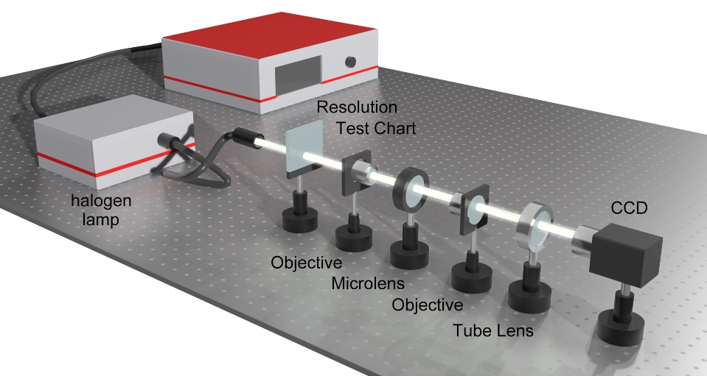
Fig. S8. Schematic of the optical measurement setup used for imaging by the achromatic microlenses. The resolution test chart (Thorlabs, R1L1S1N) serves as an example object to demonstrate the achromatic imaging capability of the microlens.

