Supplementary file for
Knockdown of a specific circular non-coding RNA significantly suppresses osteosarcoma progression
Shidong Wang ^{a,b,#}, Hongliang Zhang ^{c,#}, Bo Li ^{d}, Chenglong Chen ^{a,b}, Tingting Ren ^{a,b}, Yi Huang ^{a,b}, Kai Liu ^{d,e,}*, Jingjing Li ^{d,}*, Wei Guo ^{a,b,}*
ª Musculoskeletal Tumor Center, Peking University People’s Hospital, Beijing 100044, China
^{b} Beijing Key Laboratory of Musculoskeletal Tumor, Peking University People’s Hospital, Beijing 100044, China
^{c} Department of Spine Surgery and Musculoskeletal Tumor, Zhongnan Hospital of Wuhan University, Wuhan 430071, China
^{d} State Key Laboratory of Rare Earth Resource Utilization, Changchun Institute of Applied Chemistry, Chinese Academy of Sciences, Changchun 130022, China
^{e} Department of Chemistry, Tsinghua University, Beijing 100084, China

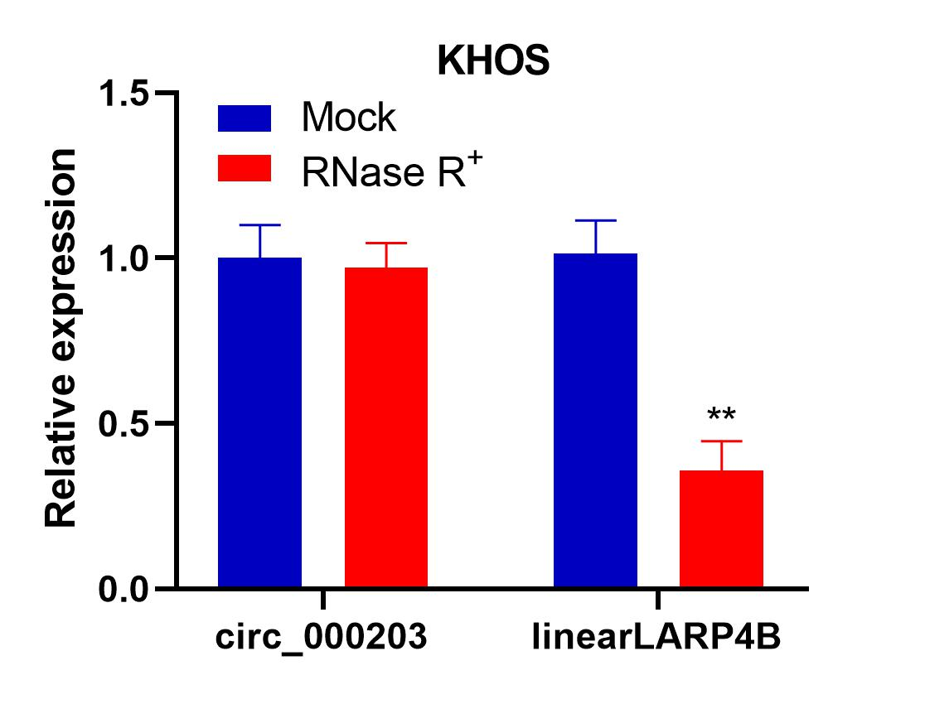
Fig. S1. RNase R was used to verify the closed-loop structures of circ_000203, and the results showed that circ_000203 was not digested by RNase R, whereas linear LARP4B was digested in KHOS cells. **: p < 0.01.
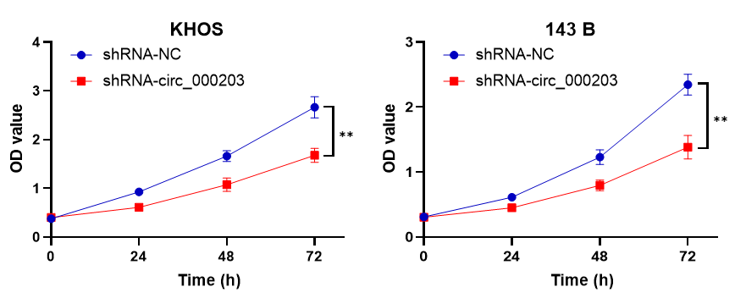
Fig. S2. The CCK-8 assay showed that circ_000203 knockdown restrained the proliferation of OS cells. **: p < 0.01.
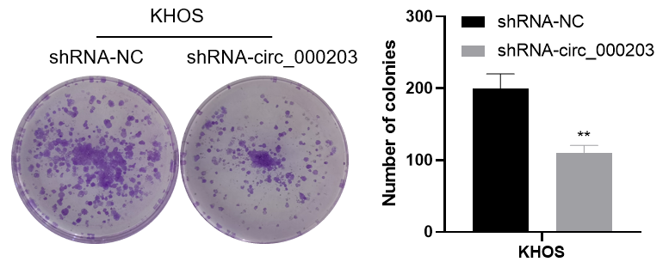
Fig. S3. The colony formation assay showed that circ_000203 knockdown restrained the proliferation of KHOS cells. **: p < 0.01.
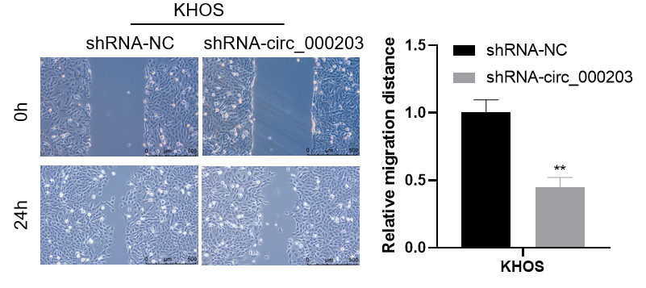
Fig. S4. Wound healing assay indicated that circ_000203 knockdown significantly inhibited the migration of KHOS cells. **: p < 0.01.
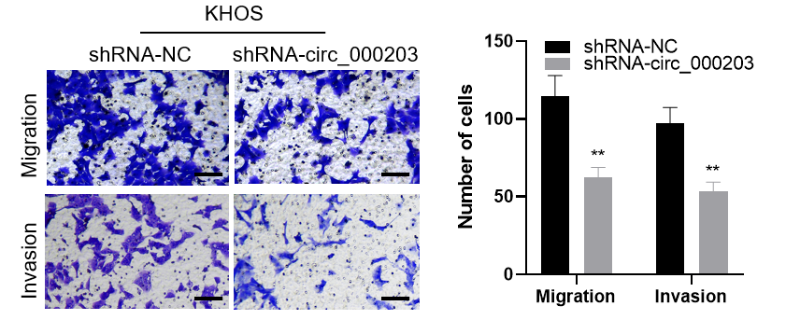
Fig. S5. Transwell assay showed that circ_000203 knockdown suppressed both migration and invasion of KHOS cells. The scale bar represents 100 μm. **: p < 0.01.
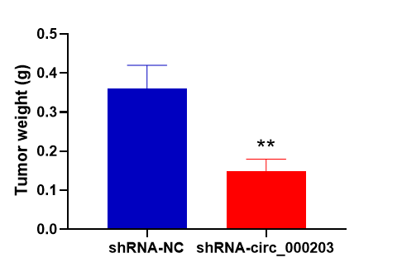
Fig. S6. The weight of tumor xenografts. **: p < 0.01.
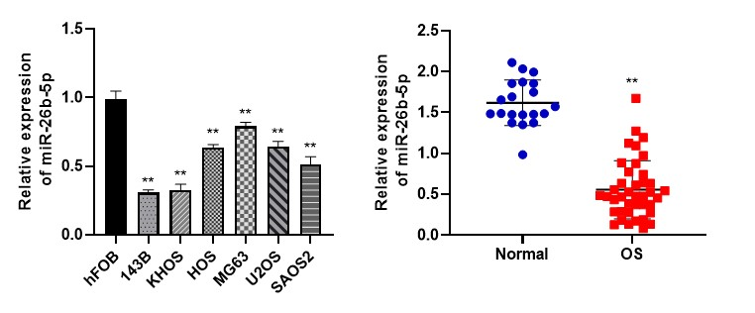Fig. S7. qRT-PCR results showed that miR-26b-5p was downregulated in OS cells (left) and tissues (right) compared with healthy cells and tissues.
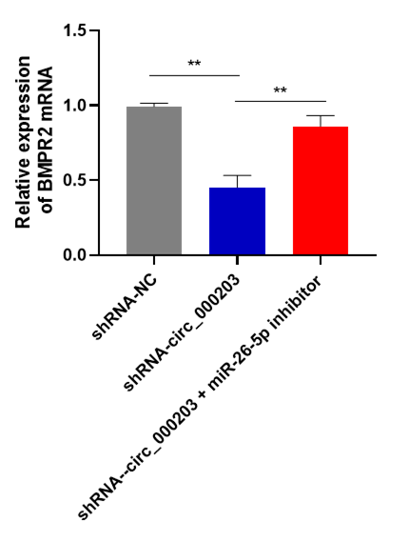
Fig. S8. Knockdown of miR-26b-5p can reverse circ_000203 knockdown downregulated BMPR2 in 143 B cells.
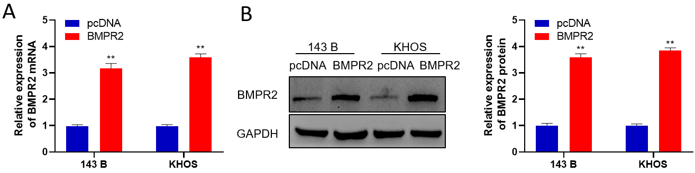
Fig. S9. We transfected an overexpression vector targeting BMPR2 or pcDNA into OS cells, and BMPR2 expression was assessed by (A) qRT-PCR and (B) western blotting.
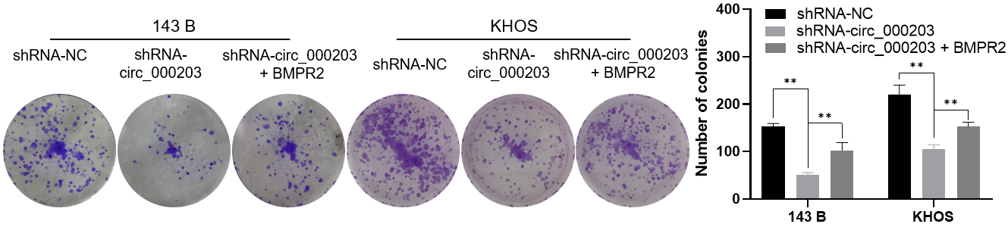
Fig. S10. Colony formation assay indicated that circ_000203 knockdown-induced proliferation inhibition could be reversed by increasing BMPR2 expression. **: p < 0.01.
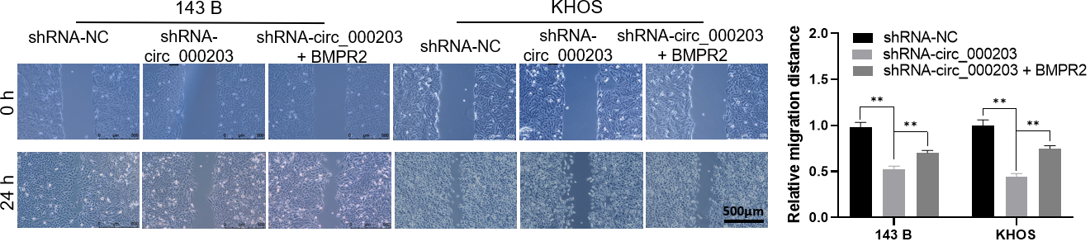
Fig. S11. The results of the wound healing showed that circ_000203 knockdown induced migration inhibition could also be partially relieved by BMPR2 overexpression. **: p < 0.01.
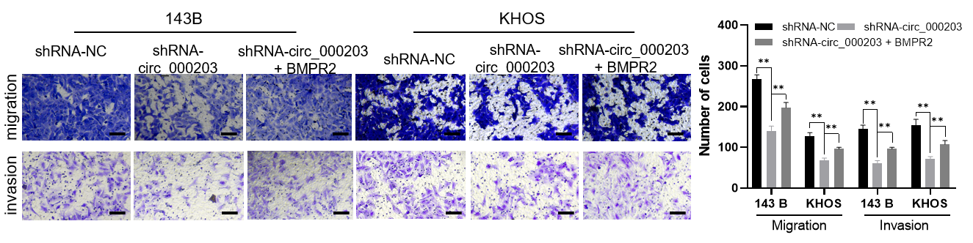
Fig. S12. The results of the transwell assays showed that circ_000203 knockdown induced invasion inhibition could also be partially relieved by BMPR2 overexpression. Scale bar = 100 μm. **: p < 0.01.
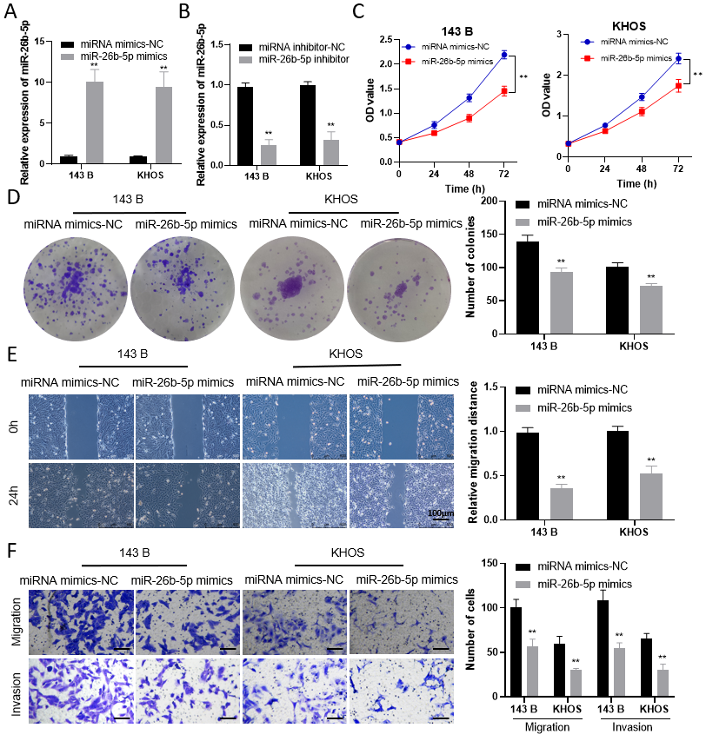
Fig. S13. (A) MiR-26b-5p mimics and (B) inhibitor significantly regulated miR-26b-5p expression in OS cells. After transfection with miR-26b-5p mimic, (C) cck-8 assay and (D) colony formation assay were performed, and the results showed that miR-26b-5p significantly inhibited the proliferation of OS cells. Furthermore, the results of the (E) wound healing assay and (F) transwell assay demonstrated that miR-26b-5p can significantly inhibit the migration and invasion abilities of OS cells. Scale bar = 100 μm. **: p < 0.01.
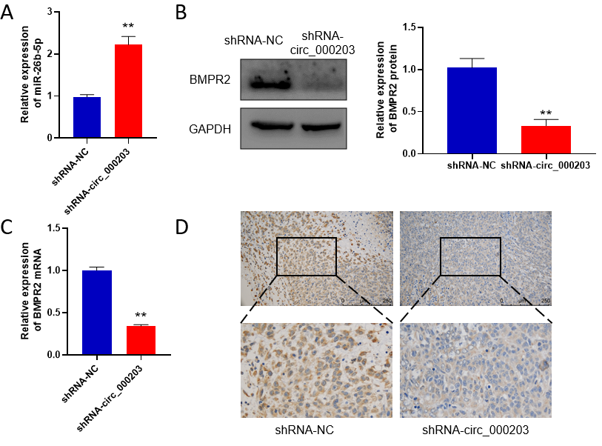
Fig. S14. We further detected the expression of miR-26b-5p and BMPR2 in collected xenografts. Compared with NC groups, miR-26b-5p was significantly upregulated, but BMPR2 was downregulated in circ_000203 knockdown tumors. (A) The expression of miR-26b-5p in tumors. (B) The expression of BMPR2 protein in tumors was detected by western blotting. (C) The expression of BMPR2 mRNA in tumors. (D) BMPR2 downregulation was detected by immunohistochemistry in circ_000203 knockdown xenograft samples. **: p < 0.01.

