Molecular Simulation of Cement-based Materials and Their Properties: A Review
Ashraf A. Bahraq¹, Mohammed A. Al-Osta^{1, 2}, Omar S. Baghabra Al-Amoudi^{1, 2}, I. B. Obot², Mohammed Maslehuddin², Habib-ur-Rehman Ahmed¹, and Tawfik A. Saleh ^{4,3} *
¹ Department of Civil and Environmental Engineering, King Fahd University of Petroleum & Minerals, Dhahran 31261, Saudi Arabia
² Interdisciplinary Research Center for Construction and Building Materials
³ Interdisciplinary Research Center for Advanced Materials, King Fahd University of Petroleum and Minerals, Dhahran 31261, Saudi Arabia
⁴ Department of Chemistry, King Fahd University of Petroleum and Minerals, Dhahran 31261, Saudi Arabia
*Correspondence to: E-mail address: tawfik@kfupm.edu.sa

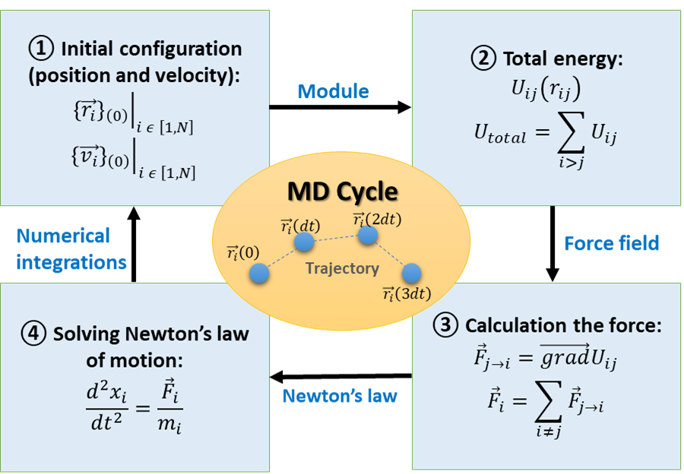
Figure S1 Key steps in a molecular dynamics cycle.
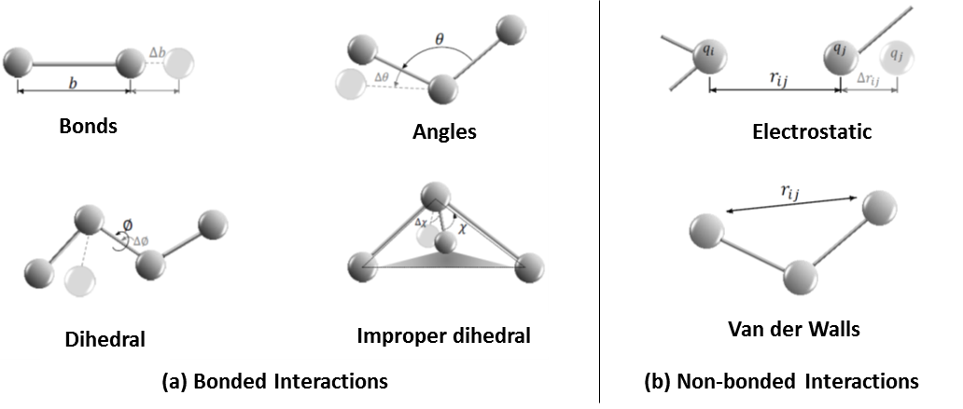
Figure S2 Schematic illustration of the bonded and non-bonded interactions in the potential force field systems [29].
Table S1 Force fields commonly used in modeling cementitious systems.
Force field* | Background | Applications in cementitious materials
COMPASS | It was originally developed for covalent molecules (e.g., polymer, organic, and small inorganic molecules). It has complicated cross-terms, including valence and non-bonded interaction terms (for the van der Waals term and a Coulombic function) [30]. Generally, it is a high-quality ab initio force field. | - Hydrated cement phases [31]–[33].  - Silicate phases (C₃S and C₂S) [31].  - Alumino-silicates [34].  - Chemical admixtures [20], [35], [36].
ClayFF | It was developed for mineral/water interfaces (mostly for clay-related phases). It treats most inter-atomic interactions as being non-bonded [37]. | - Hydrated cement phases [38].  - Cement-polymer interaction [39].  - Cement-water interaction [40].  - Geopolymer-ions interaction [41], [42].  - Hydrated crystalline compounds interaction with liquid phases [43].
IFF | It was developed for inorganic-organic and inorganic-biomolecular interfaces. It covers all elements of the periodic table [44]. | - The initial hydration and cohesive properties of C₃S and C₃A [45], [46].  - Tricalcium aluminate crystals [47].  - Ettringite [48].  - Chemical admixtures [49].
CSH-FF | This is a modified version of ClayFF. It is specially designed to describe the interaction between atoms in the cement systems [50]–[52]. | - Property prediction of C-S-H [50].  - Fracture of C-S-H under loading [51].  - C-S-H-polymer nanocomposites [53].
CVFF | It is a generalized valence force field that has been parameterized for water, amino acids, free ions and a variety of other functional groups, as well as some inorganic materials, including silica [54], [55]. | - Cement-coating interface [56].  - Silica-polymer interface [57], [58].  - Cement-PVA interaction [59].  - Graphene oxide sheet [60], [61].
Universal | It is mainly a diagonal, harmonic force field where electrostatic and van der Waals interactions are described by atomic monopoles and Lennard-Jones potential, respectively. It is applicable to all elements of the periodic table.  [31], [62]. | - Cement clinker phases [30].  - Hydrated cement phases [31].
Dreiding | It is a good robust all-purpose force field. It permits for fair prediction of many numbers of structures [31]. | - Hydrated cement phases [31].
PCFF | It is primarily developed for application to polymers and organic materials. It is similar to the COMPASS force field; however, it is parametrized for a range of functional groups [63]. | - Chemical admixtures in cement [49].
ReaxFF | It was developed by Duin et al. [64] for applications to catalysis, gas-phase reaction, and material failure. It is the force field that links the quantum mechanics and classical MD simulations. Currently, it is used for chemical simulations of a variety of materials, including metals, ceramics, silicon, and polymers [23], [65]. | - Chemical reaction of C-S-H [66], [67].  - Polymerization and hydrolytic reactions of C-A-S-H [68].  - Rebar passivation in concrete [23].  - Polymers [69].
*COMPASS = Condensed-phase Optimized Molecular Potentials for Atomistic Simulation Studies
CVFF = Consistent valence force field
IFF = INTERFACE force field
PCFF = Polymer Consistent Force Field
ReaxFF = Reactive force field

