Supplementary Information for

Taming Electrons in Pt/C Catalysts to Boost the Mesokinetics of Hydrogen Product

ion
Wenyao Chen ^{a,#}, Wenzhao Fu ^{a,#}, Xuezhi Duan ^{a,}*, Bingxu Chen ª, Gang Qian ª, Rui Si ^{b,}*, Xinggui Zhou ª, Weikang Yuan ª, De Chen ^{c,}*
ª State Key Laboratory of Chemical Engineering, East China University of Science and Technology, Shanghai 200237, China
^{b} Shanghai Synchrotron Radiation Facility, Shanghai Institute of Applied Physics, Chinese Academy of Sciences, Shanghai 201204, China
^{c} Department of Chemical Engineering, Norwegian University of Science and Technology, Trondheim N-7491, Norway

* Corresponding authors.
E-mail addresses: xzduan@ecust.edu.cn (X. Duan), sirui@sinap.ac.cn (R. Si), de.chen@ntnu.no (D. Chen)
# These authors contributed equally to this work.

Table S1. The textural properties of CNT-0, CNT-200, CNT-400, CNT-600, CNT-800, and CNT-1000.
Support | Specific surface area (m²·g⁻¹) | Pore volume (cm³·g⁻¹)
CNT-0 | 225 | 1.64
CNT-200 | 226 | 1.56
CNT-400 | 228 | 1.60
CNT-600 | 222 | 1.41
CNT-800 | 221 | 1.40
CNT-1000 | 220 | 1.40

Table S2. A comparison of the activity over monometallic Pt-based catalysts for ammonia borane hydrolysis.
Catalyst | d_{Pt} (nm) | Pt BE (eV) | r (mol_{H2}∙mol_{M}⁻¹∙min⁻¹) | Ref.
Commercial Pt/C | 2.5 | — | 83.3^{a,b} | [1]
Pt/C | 1.9 | — | 111^{a,b} | [1]
Pt(8%)/CCF-500 | 3.4 | 71.80 | 35^{c} | [2]
(Zn′₆)Pt/RGO | 1.2 | 71.53ª | 284^{b} | [3]
SiO₂@Pt@NGO | 1.9 | 71.12 | 324.6^{c} | [4]
Pt20/CNT | 1.9 | 71.5 | 416.5^{b} | [5]
Pt/CNT-G | 2.8 | — | 135^{b} | [6]
Pt/CNT-D | 1.3 | 72.0 | 416.0^{c} | [7]
Pt/CNT-5W | ~1.4 | 71.85 | 710^{c} | [8]
Pt-CeO₂/rGO | 2.8 | 71.26 | 93.8^{b} | [9]
Pt@MIL-101 | 1.8 | — | 414^{b} | [10]
Fe₃O₄@SiO₂@Pt@mSiO₂ | — | — | 5.5^{d} | [11]
Pt-CeO₂ | 5.0 | — | 133^{b} | [12]
SEA-Pt/HNTs | 1.5 | — | 321^{b} | [13]
Pt25@TiO₂ | 2.4 | 71.02 | 311^{b} | [14]
Pt/CNT-400 | 1.2 | 28.9 | 811.3^{b} | This work
ª Estimated from the slope of the fitting line.
^{b} Measured under 25 °C.
^{c} Measured under 30 °C.
^{d} Measured under 35 °C.

Table S3. The percentages of Pt species based on Pt 4f spectra for Pt/CNT-0, Pt/CNT-200, Pt/CNT-400, Pt/CNT-600, Pt/CNT-800, and Pt/CNT-1000.
Catalyst | Pt⁰ | Pt²⁺ | Pt⁴⁺
Pt/CNT-0 | 70.61% | 18.21% | 11.18%
Pt/CNT-200 | 67.77% | 17.30% | 14.93%
Pt/CNT-400 | 74.95% | 14.29% | 10.77%
Pt/CNT-600 | 67.57% | 17.79% | 14.64%
Pt/CNT -800 | 74.05% | 17.53% | 8.42%
Pt/CNT -1000 | 69.95% | 16.43% | 13.62%

Table S4. Charge state of platinum (δ) and Pt L₃-edge EXAFS fitting results () for Pt/CNT-0, Pt/CNT-200, Pt/CNT-400, Pt/CNT-600, Pt/CNT-800 and Pt/CNT-1000.
Sample | Shell | CN | R (Å) | σ² (Å²) | ΔE₀ (eV) | Charge
Pt_foil | Pt–Pt | 12 | 2.764 ± 0.002 | 0.0049 ± 0.0002 (Pt) | 8.3 ± 0.5
Pt/CNT-0 | Pt–Pt | 4.6 ± 0.4 | 2.73 ± 0.01 | 0.0045 ± 0.0003 (O)  0.0075 ± 0.0005 (Cl)  0.0075 ± 0.0005 (Pt) | 6.6 ± 0.7 | +0.71
Pt/CNT-0 | Pt–O | 0.6 ± 0.1 | 1.94 ± 0.02 |  | 6.6 ± 0.7 | +0.71
 | Pt–Cl | 0.8 ± 0.1 | 2.25 ± 0.01 |  | 6.6 ± 0.7
Pt/CNT-200 | Pt–Pt | 3.9 ± 0.3 | 2.73 ± 0.01 |  | 6.6 ± 0.7 | +0.87
Pt/CNT-200 | Pt–O | 0.6 ± 0.1 | 1.94 ± 0.02 |  | 6.6 ± 0.7 | +0.87
 | Pt–Cl | 0.9 ± 0.1 | 2.24 ± 0.01 |  | 6.6 ± 0.7
Pt/CNT-400 | Pt–Pt | 3.1 ± 0.3 | 2.72 ± 0.01 |  | 6.6 ± 0.7 | +1.07
Pt/CNT-400 | Pt–O | 1.0 ± 0.1 | 1.95 ± 0.01 |  | 6.6 ± 0.7 | +1.07
 | Pt–Cl | 0.7 ± 0.1 | 2.25 ± 0.01 |  | 6.6 ± 0.7
Pt/CNT-600 | Pt–Pt | 4.4 ± 0.4 | 2.72 ± 0.01 |  | 6.6 ± 0.7 | +0.90
Pt/CNT-600 | Pt–O | 0.9 ± 0.2 | 1.96 ± 0.01 |  | 6.6 ± 0.7 | +0.90
 | Pt–Cl | 0.6 ± 0.2 | 2.25 ± 0.01 |  | 6.6 ± 0.7
Pt/CNT-800 | Pt–Pt | 4.0 ± 0.4 | 2.72 ± 0.01 |  | 6.6 ± 0.7 | +0.91
Pt/CNT-800 | Pt–O | 0.9 ± 0.2 | 1.95 ± 0.01 |  | 6.6 ± 0.7 | +0.91
 | Pt–Cl | 0.7 ± 0.1 | 2.26 ± 0.01 |  | 6.6 ± 0.7
Pt/CNT-1000 | Pt–Pt | 3.7 ± 0.4 | 2.71 ± 0.01 |  | 6.6 ± 0.7 | +0.88
Pt/CNT-1000 | Pt–O | 0.9 ± 0.1 | 1.94 ± 0.01 |  | 6.6 ± 0.7 | +0.88
 | Pt–Cl | 0.8 ± 0.1 | 2.27 ± 0.01 |  | 6.6 ± 0.7
R: distance; CN: coordination number; σ²: Debye–Waller factor; ΔE₀: inner potential correction.–

Table S5. The molar ratio of oxygen to carbon (n_{O}/n_{C}) for EWGs and EDGs based on O 1s spectra for Pt/CNT-0, Pt/CNT-200, Pt/CNT-400, Pt/CNT-600, Pt/CNT-800, and Pt/CNT-1000.
Catalyst | (n_{O}/n_{C}) × 1000
Catalyst | EWGs |  |  |  |  |  | EDGs
Catalyst | Carbonyl | Ester | Carboxyl | Total |  |  |  | Hydroxyl | Total
Pt/CNT-0 | 4.98 | 4.23 | 2.75 | 11.95 |  |  |  | 14.70 | 14.70
Pt/CNT-200 | 5.38 | 2.87 | 3.02 | 11.27 |  |  |  | 12.73 | 12.73
Pt/CNT-400 | 5.51 | 2.82 | 2.21 | 10.54 |  |  |  | 6.50 | 6.50
Pt/CNT-600 | 5.66 | 2.47 | 0.96 | 9.09 |  |  |  | 5.82 | 5.82
Pt/CNT-800 | 2.49 | 0.85 | 0.65 | 3.99 |  |  |  | 3.50 | 3.50
Pt/CNT-1000 | 1.43 | 0.86 | 0.61 | 2.91 |  |  |  | 3.08 | 3.08

Table S6. The molar ratio of oxygen to carbon (n_{O}/n_{C}) for EWGs and EDGs based on TPD-MS profiles for CNT-0, CNT-200, CNT-400, CNT-600, CNT-800, and CNT-1000.
Catalyst | Content (μmol·g⁻¹)
Catalyst | EWGs |  |  |  |  | EDGs
Catalyst | Carbonyl | Ester | Carboxyl | (n_{O}/n_{C})_{EWG} |  | Hydroxyl | (n_{O}/n_{C})_{EDG}
Pt/CNT-0 | 45.18 | 159.04 | 105.96 | 89.35 |  | 110.61 | 110.61
Pt/CNT-200 | 50.50 | 156.03 | 39.28 | 83.05 |  | 95.37 | 95.37
Pt/CNT-400 | 49.29 | 39.44 | 14.66 | 58.30 |  | 17.10 | 17.10
Pt/CNT-600 | 22.20 | 38.31 | 8.33 | 29.97 |  | 0.00 | 0.00
Pt/CNT-800 | 14.69 | 17.85 | 2.66 | 18.11 |  | 0.00 | 0.00
Pt/CNT-1000 | 0.00 | 20.38 | 3.70 | 4.01 |  | 0.00 | 0.00

Table S7. E_{a} and lnA_{i} of Pt/CNT-0, Pt/CNT-200, Pt/CNT-400, Pt/CNT-600, Pt/CNT-800, Pt/CNT-1000, 0.3-Pt/CNT, 0.8-Pt/CNT, and 1.2-Pt/CNT.
Catalyst | E_{a} (kJ·mol⁻¹) | lnA_{i}
Pt/CNT-0 | 46.49 | 18.65
Pt/CNT -200 | 36.39 | 16.20
Pt/CNT -400 | 28.89 | 14.25
Pt/CNT -600 | 30.30 | 14.63
Pt/CNT -800 | 33.47 | 15.46
Pt/CNT -1000 | 34.10 | 15.59
0.3-Pt/CNT | 52.12 | 19.92
0.8-Pt/CNT | 62.74 | 25.29
1.2-Pt/CNT | 72.34 | 27.16

Table S8. ∆H^{0*}, τ, and ∆S^{0*} of Pt/CNT-0, Pt/CNT-200, Pt/CNT-400, Pt/CNT-600, Pt/CNT-800, Pt/CNT-1000, 0.3-Pt/CNT, 0.8-Pt/CNT, and 1.2-Pt/CNT.
Catalyst | ∆H^{0*} (kJ∙mol⁻¹) | τª | ∆S^{0*} (J∙mol⁻¹∙K⁻¹)
Pt/CNT-0 | 46.49 | 0.26 | −78.68
Pt/CNT-200 | 36.39 | 0.26 | −99.06
Pt/CNT-400 | 28.89 | 0.24 | −114.83
Pt/CNT-600 | 30.30 | 0.23 | −111.02
Pt/CNT-800 | 33.47 | 0.20 | −103.35
Pt/CNT-1000 | 34.10 | 0.23 | −103.11
0.3-Pt/CNT | 52.12 | 0.18 | −65.27
0.8-Pt/CNT | 62.74 | 0.18 | −20.62
1.2-Pt/CNT | 72.34 | 0.16 | −4.24
ª Based on Pt(111) atoms.

Table S9. The relationship between Pt particle size and the dispersion of Pt(111) site.
d | N_{T} | m | N_{S} | N₁₁₁ | Dispersion (N₁₁₁/N_{T})
1.00 | 35.25218 | 1.966451 | 31.22859 | 7.221833 | 0.204862026
1.02 | 37.40989 | 1.992938 | 31.83202 | 7.831716 | 0.209348813
1.04 | 39.6539 | 2.019406 | 32.47705 | 8.474789 | 0.213718922
1.06 | 41.9859 | 2.045857 | 33.16364 | 9.151026 | 0.217954728
1.08 | 44.40759 | 2.07229 | 33.89174 | 9.860388 | 0.222042873
1.10 | 46.92065 | 2.098708 | 34.6613 | 10.60284 | 0.225973866
1.12 | 49.52677 | 2.125112 | 35.47226 | 11.37835 | 0.229741354
1.14 | 52.22765 | 2.151501 | 36.32459 | 12.18688 | 0.233341529
1.16 | 55.02498 | 2.177877 | 37.21825 | 13.02841 | 0.236772634
1.18 | 57.92045 | 2.20424 | 38.1532 | 13.90291 | 0.240034559
1.20 | 60.91576 | 2.230592 | 39.12939 | 14.81036 | 0.24312851
1.22 | 64.01259 | 2.256933 | 40.14682 | 15.75073 | 0.246056732
1.24 | 67.21264 | 2.283263 | 41.20543 | 16.724 | 0.248822285
1.26 | 70.51761 | 2.309582 | 42.30521 | 17.73016 | 0.251428858
1.28 | 73.92917 | 2.335892 | 43.44612 | 18.76918 | 0.253880615
1.30 | 77.44903 | 2.362193 | 44.62816 | 19.84105 | 0.256182071
1.32 | 81.07887 | 2.388485 | 45.85128 | 20.94575 | 0.258337987
1.34 | 84.8204 | 2.414769 | 47.11547 | 22.08327 | 0.26035329
1.36 | 88.6753 | 2.441045 | 48.42072 | 23.25359 | 0.262233067
1.38 | 92.64525 | 2.467314 | 49.76699 | 24.45669 | 0.263982162
1.40 | 96.73197 | 2.493575 | 51.15427 | 25.69258 | 0.265605867
1.42 | 100.9371 | 2.519829 | 52.58256 | 26.96123 | 0.267109092
1.44 | 105.2624 | 2.546076 | 54.05182 | 28.26262 | 0.268496788
1.46 | 109.7096 | 2.572318 | 55.56205 | 29.59677 | 0.269773806
1.48 | 114.2802 | 2.598553 | 57.11323 | 30.96364 | 0.270944882
1.50 | 118.9761 | 2.624778 | 58.70509 | 32.36301 | 0.272012691
1.52 | 123.7989 | 2.651003 | 60.33822 | 33.79539 | 0.272986246
1.54 | 128.7503 | 2.677222 | 62.01224 | 35.26046 | 0.273867106
1.56 | 133.8319 | 2.703436 | 63.72715 | 36.75821 | 0.274659518
1.58 | 139.0456 | 2.729645 | 65.48293 | 38.28864 | 0.27536757
1.60 | 144.3929 | 2.755849 | 67.27959 | 39.85175 | 0.275995194
1.62 | 149.8756 | 2.782048 | 69.11712 | 41.44753 | 0.27654617
1.64 | 155.4954 | 2.808243 | 70.9955 | 43.07597 | 0.277024121
1.66 | 161.2539 | 2.834433 | 72.91474 | 44.73707 | 0.277432526
1.68 | 167.1528 | 2.860619 | 74.87483 | 46.43083 | 0.277774713
1.70 | 173.1939 | 2.886802 | 76.87575 | 48.15725 | 0.278053874
1.72 | 179.3789 | 2.91298 | 78.9175 | 49.9163 | 0.27827306
1.74 | 185.7093 | 2.939155 | 81.00008 | 51.70801 | 0.278435193
1.76 | 192.187 | 2.965324 | 83.12332 | 53.53221 | 0.278542357
1.78 | 198.8135 | 2.991493 | 85.28762 | 55.38927 | 0.278599089
1.80 | 205.5907 | 3.017659 | 87.49268 | 57.27891 | 0.278606522
1.82 | 212.5201 | 3.04382 | 89.73851 | 59.20115 | 0.278567232
1.84 | 219.6036 | 3.069979 | 92.02512 | 61.156 | 0.278483625
1.86 | 226.8427 | 3.096135 | 94.35257 | 63.1435 | 0.278358129
1.88 | 234.2391 | 3.122286 | 96.72068 | 65.16352 | 0.278192261
1.90 | 241.7947 | 3.148437 | 99.12967 | 67.21623 | 0.2779889
1.92 | 249.5109 | 3.174584 | 101.5794 | 69.30153 | 0.277749475
1.94 | 257.3897 | 3.200728 | 104.0699 | 71.41945 | 0.277475981
1.96 | 265.4325 | 3.226871 | 106.6013 | 73.57 | 0.277170251
1.98 | 273.6412 | 3.253012 | 109.1734 | 75.75321 | 0.276834088
2.00 | 282.0174 | 3.279147 | 111.786 | 77.96873 | 0.276467809
2.02 | 290.5628 | 3.305282 | 114.4396 | 80.21702 | 0.276074635
2.04 | 299.2791 | 3.331415 | 117.1339 | 82.4979 | 0.27565538
2.06 | 308.168 | 3.357545 | 119.8689 | 84.81137 | 0.275211435
2.08 | 317.2312 | 3.383673 | 122.6447 | 87.15741 | 0.274744123
2.10 | 326.4704 | 3.4098 | 125.4613 | 89.53604 | 0.274254703
2.12 | 335.8872 | 3.435924 | 128.3185 | 91.94724 | 0.273744376
2.14 | 345.4834 | 3.462046 | 131.2165 | 94.39101 | 0.27321428
2.16 | 355.2607 | 3.488166 | 134.1552 | 96.86734 | 0.272665494
2.18 | 365.2207 | 3.514284 | 137.1346 | 99.37621 | 0.272099042
2.20 | 375.3652 | 3.540403 | 140.155 | 101.9179 | 0.271516708
2.22 | 385.6957 | 3.566519 | 143.2159 | 104.492 | 0.270918226
2.24 | 396.2141 | 3.592633 | 146.3175 | 107.0987 | 0.270305018
2.26 | 406.9221 | 3.618745 | 149.4599 | 109.7379 | 0.269677929
2.28 | 417.8212 | 3.644855 | 152.643 | 112.4097 | 0.269037804
2.30 | 428.9132 | 3.670964 | 155.8668 | 115.1141 | 0.268385427
2.32 | 440.1998 | 3.697072 | 159.1313 | 117.851 | 0.267721548
2.34 | 451.6827 | 3.723178 | 162.4365 | 120.6205 | 0.267046882
2.36 | 463.3636 | 3.749282 | 165.7824 | 123.4225 | 0.266362112
2.38 | 475.2442 | 3.775386 | 169.1691 | 126.2571 | 0.265667888
2.40 | 487.3261 | 3.801487 | 172.5964 | 129.1243 | 0.26496483
2.42 | 499.611 | 3.827588 | 176.0644 | 132.024 | 0.264253529
2.44 | 512.1007 | 3.853687 | 179.5732 | 134.9562 | 0.263534546
2.46 | 524.7969 | 3.879785 | 183.1226 | 137.921 | 0.262808415
2.48 | 537.7011 | 3.905881 | 186.7127 | 140.9184 | 0.262075643
2.50 | 550.8152 | 3.931977 | 190.3434 | 143.9482 | 0.261336713
2.52 | 564.1408 | 3.958073 | 194.0152 | 147.0109 | 0.260592626
2.54 | 577.6797 | 3.984166 | 197.7275 | 150.106 | 0.259842948
2.56 | 591.4334 | 4.010259 | 201.4804 | 153.2336 | 0.259088486
2.58 | 605.4037 | 4.03635 | 205.274 | 156.3937 | 0.258329645
2.60 | 619.5922 | 4.06244 | 209.1084 | 159.5864 | 0.257566813
2.62 | 634.0008 | 4.088529 | 212.9834 | 162.8116 | 0.256800359
2.64 | 648.631 | 4.114618 | 216.8991 | 166.0694 | 0.256030634
2.66 | 663.4846 | 4.140705 | 220.8554 | 169.3597 | 0.255257976
2.68 | 678.5632 | 4.166791 | 224.8525 | 172.6826 | 0.254482702
2.70 | 693.8686 | 4.192876 | 228.8902 | 176.038 | 0.253705117
2.72 | 709.4024 | 4.218961 | 232.9687 | 179.426 | 0.252925513
2.74 | 725.1663 | 4.245044 | 237.0878 | 182.8465 | 0.252144167
2.76 | 741.162 | 4.271127 | 241.2476 | 186.2995 | 0.251361343
2.78 | 757.3913 | 4.297209 | 245.4481 | 189.7851 | 0.250577293
2.80 | 773.8557 | 4.32329 | 249.6892 | 193.3032 | 0.249792257
2.82 | 790.5571 | 4.34937 | 253.9711 | 196.8538 | 0.249006463
2.84 | 807.497 | 4.375449 | 258.2936 | 200.437 | 0.248220128
2.86 | 824.6773 | 4.401528 | 262.6568 | 204.0527 | 0.247433461
2.88 | 842.0994 | 4.427606 | 267.0606 | 207.701 | 0.246646658
2.90 | 859.7653 | 4.453683 | 271.5052 | 211.3818 | 0.245859908
2.92 | 877.6765 | 4.479759 | 275.9904 | 215.0952 | 0.24507339
2.94 | 895.8348 | 4.505835 | 280.5163 | 218.841 | 0.244287273
2.96 | 914.2418 | 4.53191 | 285.0828 | 222.6194 | 0.24350172
2.98 | 932.8992 | 4.557984 | 289.6901 | 226.4304 | 0.242716886
3.00 | 951.8087 | 4.584058 | 294.338 | 230.2739 | 0.241932916
3.02 | 970.9721 | 4.61013 | 299.0266 | 234.1499 | 0.24114995
3.04 | 990.391 | 4.636203 | 303.7558 | 238.0584 | 0.240368121
3.06 | 1010.067 | 4.662274 | 308.5257 | 241.9995 | 0.239587555
3.08 | 1030.002 | 4.688345 | 313.3363 | 245.9731 | 0.23880837
3.10 | 1050.198 | 4.714416 | 318.1876 | 249.9792 | 0.238030682
3.12 | 1070.655 | 4.740485 | 323.0795 | 254.0179 | 0.237254597
3.14 | 1091.377 | 4.766555 | 328.0121 | 258.0891 | 0.236480219
3.16 | 1112.365 | 4.792623 | 332.9853 | 262.1928 | 0.235707643
3.18 | 1133.619 | 4.818691 | 337.9992 | 266.3291 | 0.234936962
3.20 | 1155.143 | 4.844759 | 343.0538 | 270.4979 | 0.234168264
3.22 | 1176.938 | 4.870826 | 348.1491 | 274.6992 | 0.23340163
3.24 | 1199.005 | 4.896892 | 353.285 | 278.9331 | 0.232637138
3.26 | 1221.346 | 4.922958 | 358.4616 | 283.1994 | 0.231874864
3.28 | 1243.963 | 4.949024 | 363.6788 | 287.4983 | 0.231114876
3.30 | 1266.857 | 4.975089 | 368.9367 | 291.8298 | 0.23035724
3.32 | 1290.031 | 5.001153 | 374.2353 | 296.1937 | 0.229602019
3.34 | 1313.486 | 5.027217 | 379.5745 | 300.5902 | 0.228849272
3.36 | 1337.223 | 5.05328 | 384.9544 | 305.0192 | 0.228099053
3.38 | 1361.244 | 5.079343 | 390.3749 | 309.4808 | 0.227351415
3.40 | 1385.551 | 5.105406 | 395.8361 | 313.9748 | 0.226606407
3.42 | 1410.147 | 5.131468 | 401.338 | 318.5014 | 0.225864075
3.44 | 1435.031 | 5.15753 | 406.8805 | 323.0606 | 0.225124462
3.46 | 1460.206 | 5.183591 | 412.4637 | 327.6522 | 0.224387609
3.48 | 1485.674 | 5.209652 | 418.0875 | 332.2764 | 0.223653552
3.50 | 1511.437 | 5.235712 | 423.7521 | 336.9331 | 0.222922329
3.52 | 1537.496 | 5.261772 | 429.4572 | 341.6223 | 0.222193971
3.54 | 1563.852 | 5.287831 | 435.203 | 346.344 | 0.221468509
3.56 | 1590.508 | 5.313891 | 440.9895 | 351.0983 | 0.220745973
3.58 | 1617.465 | 5.339949 | 446.8164 | 355.8849 | 0.220026291
3.60 | 1644.725 | 5.366007 | 452.6843 | 360.7043 | 0.219309698
3.62 | 1672.29 | 5.392065 | 458.5927 | 365.5561 | 0.218596102
3.64 | 1700.161 | 5.418123 | 464.5419 | 370.4405 | 0.217885522
3.66 | 1728.34 | 5.44418 | 470.5316 | 375.3574 | 0.217177978
3.68 | 1756.829 | 5.470237 | 476.5621 | 380.3068 | 0.216473487
3.70 | 1785.628 | 5.496294 | 482.6332 | 385.2887 | 0.215772066
3.72 | 1814.741 | 5.52235 | 488.7449 | 390.3032 | 0.215073729
3.74 | 1844.169 | 5.548406 | 494.8973 | 395.3502 | 0.214378488
3.76 | 1873.913 | 5.574461 | 501.0903 | 400.4297 | 0.213686356
3.78 | 1903.975 | 5.600517 | 507.324 | 405.5417 | 0.212997342
3.80 | 1934.357 | 5.626572 | 513.5984 | 410.6862 | 0.212311455
3.82 | 1965.061 | 5.652626 | 519.9133 | 415.8633 | 0.211628703
3.84 | 1996.088 | 5.67868 | 526.269 | 421.0729 | 0.210949092
3.86 | 2027.439 | 5.704734 | 532.6653 | 426.315 | 0.210272627
3.88 | 2059.117 | 5.730788 | 539.1022 | 431.5896 | 0.209599313
3.90 | 2091.124 | 5.756841 | 545.5799 | 436.8967 | 0.208929152
3.92 | 2123.46 | 5.782894 | 552.0981 | 442.2364 | 0.208262148
3.94 | 2156.128 | 5.808947 | 558.657 | 447.6086 | 0.207598301
3.96 | 2189.13 | 5.834999 | 565.2566 | 453.0133 | 0.206937612
3.98 | 2222.466 | 5.861051 | 571.8968 | 458.4505 | 0.206280079
4.00 | 2256.139 | 5.887103 | 578.5776 | 463.9202 | 0.205625703
4.02 | 2290.151 | 5.913155 | 585.2992 | 469.4225 | 0.20497448
4.04 | 2324.502 | 5.939206 | 592.0613 | 474.9572 | 0.204326408
4.06 | 2359.196 | 5.965257 | 598.8641 | 480.5245 | 0.203681484
4.08 | 2394.233 | 5.991308 | 605.7076 | 486.1244 | 0.203039703
4.10 | 2429.615 | 6.017359 | 612.5917 | 491.7567 | 0.202401061
4.12 | 2465.344 | 6.043409 | 619.5165 | 497.4215 | 0.201765551
4.14 | 2501.422 | 6.069458 | 626.4818 | 503.1188 | 0.20113313
4.16 | 2537.85 | 6.095508 | 633.4879 | 508.8487 | 0.200503885
4.18 | 2574.63 | 6.121558 | 640.5346 | 514.6112 | 0.199877748
4.20 | 2611.763 | 6.147607 | 647.622 | 520.4061 | 0.199254712
4.22 | 2649.252 | 6.173657 | 654.75 | 526.2336 | 0.198634772
4.24 | 2687.098 | 6.199705 | 661.9187 | 532.0935 | 0.198017919
4.26 | 2725.303 | 6.225754 | 669.128 | 537.986 | 0.197404146
4.28 | 2763.868 | 6.251802 | 676.378 | 543.911 | 0.196793443
4.30 | 2802.795 | 6.27785 | 683.6686 | 549.8685 | 0.196185803
4.32 | 2842.086 | 6.303898 | 690.9998 | 555.8586 | 0.195581214
4.34 | 2881.742 | 6.329946 | 698.3717 | 561.8811 | 0.194979651
4.36 | 2921.766 | 6.355994 | 705.7843 | 567.9362 | 0.194381149
4.38 | 2962.158 | 6.382041 | 713.2375 | 574.0238 | 0.193785651
4.40 | 3002.921 | 6.408088 | 720.7313 | 580.1439 | 0.193193163
4.42 | 3044.057 | 6.434135 | 728.2658 | 586.2965 | 0.192603671
4.44 | 3085.566 | 6.460182 | 735.8409 | 592.4816 | 0.192017166
4.46 | 3127.451 | 6.486228 | 743.4567 | 598.6993 | 0.191433636
4.48 | 3169.713 | 6.512274 | 751.1132 | 604.9495 | 0.19085307
4.50 | 3212.354 | 6.538321 | 758.8103 | 611.2322 | 0.190275459
4.52 | 3255.377 | 6.564366 | 766.548 | 617.5473 | 0.189700736
4.54 | 3298.781 | 6.590412 | 774.3263 | 623.895 | 0.189128968
4.56 | 3342.57 | 6.616457 | 782.1453 | 630.2753 | 0.188560109
4.58 | 3386.744 | 6.642503 | 790.005 | 636.688 | 0.187994146
4.60 | 3431.306 | 6.668548 | 797.9053 | 643.1333 | 0.187431065
4.62 | 3476.257 | 6.694593 | 805.8463 | 649.6111 | 0.186870854
4.64 | 3521.599 | 6.720638 | 813.8279 | 656.1214 | 0.186313498
4.66 | 3567.333 | 6.746682 | 821.8501 | 662.6642 | 0.185758984
4.68 | 3613.462 | 6.772727 | 829.913 | 669.2395 | 0.185207297
4.70 | 3659.987 | 6.798771 | 838.0166 | 675.8474 | 0.184658424
4.72 | 3706.909 | 6.824815 | 846.1608 | 682.4877 | 0.184112351
4.74 | 3754.231 | 6.850859 | 854.3456 | 689.1606 | 0.183569062
4.76 | 3801.953 | 6.876903 | 862.5711 | 695.866 | 0.183028545
4.78 | 3850.079 | 6.902946 | 870.8372 | 702.6039 | 0.182490784
4.80 | 3898.609 | 6.92899 | 879.1439 | 709.3743 | 0.181955764
4.82 | 3947.545 | 6.955033 | 887.4913 | 716.1772 | 0.181423473
4.84 | 3996.888 | 6.981076 | 895.8794 | 723.0127 | 0.180893893
4.86 | 4046.641 | 7.007119 | 904.3081 | 729.8806 | 0.180367012
4.88 | 4096.806 | 7.033162 | 912.7774 | 736.7811 | 0.179842814
4.90 | 4147.383 | 7.059204 | 921.2874 | 743.7141 | 0.179321284
4.92 | 4198.375 | 7.085247 | 929.838 | 750.6796 | 0.178802407
4.94 | 4249.783 | 7.11129 | 938.4294 | 757.6777 | 0.178286205
4.96 | 4301.609 | 7.137332 | 947.0613 | 764.7082 | 0.1777726
4.98 | 4353.855 | 7.163374 | 955.7339 | 771.7713 | 0.177261605
5.00 | 4406.522 | 7.189416 | 964.4471 | 778.8669 | 0.176753207
d is the particle size of Pt; N_{T} is the total atom number of each particle; m is the number of atoms lying on an equivalent edge (corner atoms included); N_{S} is the surface atom number of each particle; N₁₁₁ is the number of (111) facet atom of each particle.

Table S10. The nano-kinetics modeling of catalytic activity based on Pt charge and Pt particle size.
 |  |  |  | d (nm) | 1.00 |  | 1.10 |  | 1.20 |  | 1.30 |  | 1.40 |  | 1.50 |  | 1.60 |  | 1.70 |  | 1.80 |  | 1.90
 |  |  |  | Dispersion | 0.20486 |  | 0.22597 |  | 0.24313 |  | 0.25618 |  | 0.26561 |  | 0.27201 |  | 0.27600 |  | 0.27805 |  | 0.27861 |  | 0.2780
Pt charge | TOF (min⁻¹) |  |  | Activity
+0.40 | 29.56836 |  |  |  | 6.06 |  | 6.68 |  | 7.19 |  | 7.57 |  | 7.85 |  | 8.04 |  | 8.16 |  | 8.22 |  | 8.24 |  | 8.22
+0.45 | 43.73151 |  |  |  | 8.96 |  | 9.88 |  | 10.63 |  | 11.20 |  | 11.62 |  | 11.90 |  | 12.07 |  | 12.16 |  | 12.18 |  | 12.16
+0.50 | 64.67877 |  |  |  | 13.25 |  | 14.62 |  | 15.73 |  | 16.57 |  | 17.18 |  | 17.59 |  | 17.85 |  | 17.98 |  | 18.02 |  | 17.98
+0.55 | 95.6597 |  |  |  | 19.60 |  | 21.62 |  | 23.26 |  | 24.51 |  | 25.41 |  | 26.02 |  | 26.40 |  | 26.60 |  | 26.65 |  | 26.59
+0.60 | 141.4804 |  |  |  | 28.98 |  | 31.97 |  | 34.40 |  | 36.24 |  | 37.58 |  | 38.48 |  | 39.05 |  | 39.34 |  | 39.42 |  | 39.33
+0.65 | 209.2491 |  |  |  | 42.87 |  | 47.28 |  | 50.87 |  | 53.61 |  | 55.58 |  | 56.92 |  | 57.75 |  | 58.18 |  | 58.30 |  | 58.17
+0.70 | 309.4787 |  |  |  | 63.40 |  | 69.93 |  | 75.24 |  | 79.28 |  | 82.20 |  | 84.18 |  | 85.41 |  | 86.05 |  | 86.22 |  | 86.03
+0.75 | 457.718 |  |  |  | 93.77 |  | 103.43 |  | 111.28 |  | 117.26 |  | 121.57 |  | 124.51 |  | 126.33 |  | 127.27 |  | 127.52 |  | 127.24
+0.80 | 676.9636 |  |  |  | 138.68 |  | 152.98 |  | 164.59 |  | 173.43 |  | 179.81 |  | 184.14 |  | 186.84 |  | 188.23 |  | 188.61 |  | 188.19
+0.85 | 1001.227 |  |  |  | 205.11 |  | 226.25 |  | 243.43 |  | 256.50 |  | 265.93 |  | 272.35 |  | 276.33 |  | 278.40 |  | 278.95 |  | 278.33
+0.90 | 1480.812 |  |  |  | 303.36 |  | 334.62 |  | 360.03 |  | 379.36 |  | 393.31 |  | 402.80 |  | 408.70 |  | 411.75 |  | 412.56 |  | 411.65
+0.95 | 2190.116 |  |  |  | 448.67 |  | 494.91 |  | 532.48 |  | 561.07 |  | 581.71 |  | 595.74 |  | 604.46 |  | 608.97 |  | 610.18 |  | 608.83
+1.00 | 3239.174 |  |  |  | 663.58 |  | 731.97 |  | 787.54 |  | 829.82 |  | 860.34 |  | 881.10 |  | 894.00 |  | 900.67 |  | 902.46 |  | 900.45
+1.05 | 4790.729 |  |  |  | 981.44 |  | 1082.58 |  | 1164.76 |  | 1227.30 |  | 1272.45 |  | 1303.14 |  | 1322.22 |  | 1332.08 |  | 1334.73 |  | 1331.77
+1.10 | 7085.473 |  |  |  | 1451.54 |  | 1601.13 |  | 1722.68 |  | 1815.17 |  | 1881.94 |  | 1927.34 |  | 1955.56 |  | 1970.14 |  | 1974.06 |  | 1969.68
 |  |  |  | d (nm) |  | 2.00 |  | 2.10 |  | 2.20 |  | 2.30 |  | 2.40 |  | 2.50 |  | 2.60 |  | 2.70 |  | 2.80 |  | 2.90
 |  |  |  | Dispersion |  | 0.27647 |  | 0.27425 |  | 0.27152 |  | 0.26839 |  | 0.26496 |  | 0.26134 |  | 0.25757 |  | 0.25371 |  | 0.24979 |  | 0.24586
Pt charge |  |  | TOF (min⁻¹) | Activity
+0.40 |  |  | 29.56836 |  |  | 8.17 |  | 8.11 |  | 8.03 |  | 7.94 |  | 7.83 |  | 7.73 |  | 7.62 |  | 7.50 |  | 7.39 |  | 7.27
+0.45 |  |  | 43.73151 |  |  | 12.09 |  | 11.99 |  | 11.87 |  | 11.74 |  | 11.59 |  | 11.43 |  | 11.26 |  | 11.09 |  | 10.92 |  | 10.75
+0.50 |  |  | 64.67877 |  |  | 17.88 |  | 17.74 |  | 17.56 |  | 17.36 |  | 17.14 |  | 16.90 |  | 16.66 |  | 16.41 |  | 16.16 |  | 15.90
+0.55 |  |  | 95.6597 |  |  | 26.45 |  | 26.24 |  | 25.97 |  | 25.67 |  | 25.35 |  | 25.00 |  | 24.64 |  | 24.27 |  | 23.90 |  | 23.52
+0.60 |  |  | 141.4804 |  |  | 39.11 |  | 38.80 |  | 38.41 |  | 37.97 |  | 37.49 |  | 36.97 |  | 36.44 |  | 35.89 |  | 35.34 |  | 34.78
+0.65 |  |  | 209.2491 |  |  | 57.85 |  | 57.39 |  | 56.81 |  | 56.16 |  | 55.44 |  | 54.68 |  | 53.90 |  | 53.09 |  | 52.27 |  | 51.45
+0.70 |  |  | 309.4787 |  |  | 85.56 |  | 84.88 |  | 84.03 |  | 83.06 |  | 82.00 |  | 80.88 |  | 79.71 |  | 78.52 |  | 77.31 |  | 76.09
+0.75 |  |  | 457.718 |  |  | 126.54 |  | 125.53 |  | 124.28 |  | 122.84 |  | 121.28 |  | 119.62 |  | 117.89 |  | 116.13 |  | 114.33 |  | 112.53
+0.80 |  |  | 676.9636 |  |  | 187.16 |  | 185.66 |  | 183.81 |  | 181.69 |  | 179.37 |  | 176.92 |  | 174.36 |  | 171.75 |  | 169.10 |  | 166.44
+0.85 |  |  | 1001.227 |  |  | 276.81 |  | 274.59 |  | 271.85 |  | 268.71 |  | 265.29 |  | 261.66 |  | 257.88 |  | 254.02 |  | 250.10 |  | 246.16
+0.90 |  |  | 1480.812 |  |  | 409.40 |  | 406.12 |  | 402.07 |  | 397.43 |  | 392.36 |  | 386.99 |  | 381.41 |  | 375.69 |  | 369.90 |  | 364.07
+0.95 |  |  | 2190.116 |  |  | 605.50 |  | 600.65 |  | 594.65 |  | 587.80 |  | 580.30 |  | 572.36 |  | 564.10 |  | 555.64 |  | 547.07 |  | 538.46
+1.00 |  |  | 3239.174 |  |  | 895.53 |  | 888.36 |  | 879.49 |  | 869.35 |  | 858.27 |  | 846.52 |  | 834.30 |  | 821.80 |  | 809.12 |  | 796.38
+1.05 |  |  | 4790.729 |  |  | 1324.48 |  | 1313.88 |  | 1300.76 |  | 1285.76 |  | 1269.37 |  | 1251.99 |  | 1233.93 |  | 1215.43 |  | 1196.69 |  | 1177.85
+1.10 |  |  | 7085.473 |  |  | 1958.91 |  | 1943.22 |  | 1923.82 |  | 1901.64 |  | 1877.40 |  | 1851.69 |  | 1824.98 |  | 1797.62 |  | 1769.90 |  | 1742.03
 |  |  |  | d (nm) |  | 3.00 |  | 3.10 |  | 3.20 |  | 3.30 |  | 3.40 |  | 3.50 |  | 3.60 |  | 3.70 |  | 3.80 |  | 3.90
 |  |  |  | Dispersion |  | 0.24193 |  | 0.23803 |  | 0.23417 |  | 0.23036 |  | 0.22661 |  | 0.22292 |  | 0.21931 |  | 0.21577 |  | 0.21231 |  | 0.20893
Pt charge |  | TOF (min⁻¹) |  | Activity
+0.40 |  | 29.56836 |  |  |  | 7.15 |  | 7.04 |  | 6.92 |  | 6.81 |  | 6.70 |  | 6.59 |  | 6.48 |  | 6.38 |  | 6.28 |  | 6.18
+0.45 |  | 43.73151 |  |  |  | 10.58 |  | 10.41 |  | 10.24 |  | 10.07 |  | 9.91 |  | 9.75 |  | 9.59 |  | 9.44 |  | 9.28 |  | 9.14
+0.50 |  | 64.67877 |  |  |  | 15.65 |  | 15.40 |  | 15.15 |  | 14.90 |  | 14.66 |  | 14.42 |  | 14.18 |  | 13.96 |  | 13.73 |  | 13.51
+0.55 |  | 95.6597 |  |  |  | 23.14 |  | 22.77 |  | 22.40 |  | 22.04 |  | 21.68 |  | 21.32 |  | 20.98 |  | 20.64 |  | 20.31 |  | 19.99
+0.60 |  | 141.4804 |  |  |  | 34.23 |  | 33.68 |  | 33.13 |  | 32.59 |  | 32.06 |  | 31.54 |  | 31.03 |  | 30.53 |  | 30.04 |  | 29.56
+0.65 |  | 209.2491 |  |  |  | 50.62 |  | 49.81 |  | 49.00 |  | 48.20 |  | 47.42 |  | 46.65 |  | 45.89 |  | 45.15 |  | 44.43 |  | 43.72
+0.70 |  | 309.4787 |  |  |  | 74.87 |  | 73.67 |  | 72.47 |  | 71.29 |  | 70.13 |  | 68.99 |  | 67.87 |  | 66.78 |  | 65.71 |  | 64.66
+0.75 |  | 457.718 |  |  |  | 110.74 |  | 108.95 |  | 107.18 |  | 105.44 |  | 103.72 |  | 102.04 |  | 100.38 |  | 98.76 |  | 97.18 |  | 95.63
+0.80 |  | 676.9636 |  |  |  | 163.78 |  | 161.14 |  | 158.52 |  | 155.94 |  | 153.40 |  | 150.91 |  | 148.46 |  | 146.07 |  | 143.73 |  | 141.44
+0.85 |  | 1001.227 |  |  |  | 242.23 |  | 238.32 |  | 234.46 |  | 230.64 |  | 226.88 |  | 223.20 |  | 219.58 |  | 216.04 |  | 212.57 |  | 209.19
+0.90 |  | 1480.812 |  |  |  | 358.26 |  | 352.48 |  | 346.76 |  | 341.12 |  | 335.56 |  | 330.11 |  | 324.76 |  | 319.52 |  | 314.39 |  | 309.38
+0.95 |  | 2190.116 |  |  |  | 529.86 |  | 521.31 |  | 512.86 |  | 504.51 |  | 496.29 |  | 488.23 |  | 480.31 |  | 472.57 |  | 464.99 |  | 457.58
+1.00 |  | 3239.174 |  |  |  | 783.66 |  | 771.02 |  | 758.51 |  | 746.17 |  | 734.02 |  | 722.08 |  | 710.38 |  | 698.92 |  | 687.71 |  | 676.76
+1.05 |  | 4790.729 |  |  |  | 1159.04 |  | 1140.34 |  | 1121.84 |  | 1103.58 |  | 1085.61 |  | 1067.96 |  | 1050.65 |  | 1033.71 |  | 1017.13 |  | 1000.92
+1.10 |  | 7085.473 |  |  |  | 1714.21 |  | 1686.56 |  | 1659.19 |  | 1632.19 |  | 1605.61 |  | 1579.51 |  | 1553.91 |  | 1528.85 |  | 1504.33 |  | 1480.36
 |  |  |  | d (nm) |  | 4.00 |  | 4.10 |  | 4.20 |  | 4.30 |  | 4.40 |  | 4.50 |  | 4.60 |  | 4.70 |  | 4.80 |  | 4.90
 |  |  |  | Dispersion |  | 0.20563 |  | 0.20240 |  | 0.19925 |  | 0.19619 |  | 0.19319 |  | 0.19028 |  | 0.18743 |  | 0.18466 |  | 0.18196 |  | 0.17932
Pt charge |  | TOF (min⁻¹) |  | Activity
+0.40 |  | 29.56836 |  |  |  | 6.08 |  | 5.98 |  | 5.89 |  | 5.80 |  | 5.71 |  | 5.63 |  | 5.54 |  | 5.46 |  | 5.38 |  | 5.30
+0.45 |  | 43.73151 |  |  |  | 8.99 |  | 8.85 |  | 8.71 |  | 8.58 |  | 8.45 |  | 8.32 |  | 8.20 |  | 8.08 |  | 7.96 |  | 7.84
+0.50 |  | 64.67877 |  |  |  | 13.30 |  | 13.09 |  | 12.89 |  | 12.69 |  | 12.50 |  | 12.31 |  | 12.12 |  | 11.94 |  | 11.77 |  | 11.60
+0.55 |  | 95.6597 |  |  |  | 19.67 |  | 19.36 |  | 19.06 |  | 18.77 |  | 18.48 |  | 18.20 |  | 17.93 |  | 17.66 |  | 17.41 |  | 17.15
+0.60 |  | 141.4804 |  |  |  | 29.09 |  | 28.64 |  | 28.19 |  | 27.76 |  | 27.33 |  | 26.92 |  | 26.52 |  | 26.13 |  | 25.74 |  | 25.37
+0.65 |  | 209.2491 |  |  |  | 43.03 |  | 42.35 |  | 41.69 |  | 41.05 |  | 40.43 |  | 39.81 |  | 39.22 |  | 38.64 |  | 38.07 |  | 37.52
+0.70 |  | 309.4787 |  |  |  | 63.64 |  | 62.64 |  | 61.67 |  | 60.72 |  | 59.79 |  | 58.89 |  | 58.01 |  | 57.15 |  | 56.31 |  | 55.50
+0.75 |  | 457.718 |  |  |  | 94.12 |  | 92.64 |  | 91.20 |  | 89.80 |  | 88.43 |  | 87.09 |  | 85.79 |  | 84.52 |  | 83.28 |  | 82.08
+0.80 |  | 676.9636 |  |  |  | 139.20 |  | 137.02 |  | 134.89 |  | 132.81 |  | 130.78 |  | 128.81 |  | 126.88 |  | 125.01 |  | 123.18 |  | 121.39
+0.85 |  | 1001.227 |  |  |  | 205.88 |  | 202.65 |  | 199.50 |  | 196.43 |  | 193.43 |  | 190.51 |  | 187.66 |  | 184.89 |  | 182.18 |  | 179.54
+0.90 |  | 1480.812 |  |  |  | 304.49 |  | 299.72 |  | 295.06 |  | 290.51 |  | 286.08 |  | 281.76 |  | 277.55 |  | 273.44 |  | 269.44 |  | 265.54
+0.95 |  | 2190.116 |  |  |  | 450.34 |  | 443.28 |  | 436.39 |  | 429.67 |  | 423.12 |  | 416.73 |  | 410.50 |  | 404.42 |  | 398.50 |  | 392.73
+1.00 |  | 3239.174 |  |  |  | 666.06 |  | 655.61 |  | 645.42 |  | 635.48 |  | 625.79 |  | 616.34 |  | 607.12 |  | 598.14 |  | 589.39 |  | 580.85
+1.05 |  | 4790.729 |  |  |  | 985.10 |  | 969.65 |  | 954.58 |  | 939.87 |  | 925.54 |  | 911.56 |  | 897.93 |  | 884.65 |  | 871.70 |  | 859.08
+1.10 |  | 7085.473 |  |  |  | 1456.96 |  | 1434.11 |  | 1411.81 |  | 1390.07 |  | 1368.86 |  | 1348.19 |  | 1328.04 |  | 1308.39 |  | 1289.24 |  | 1270.58

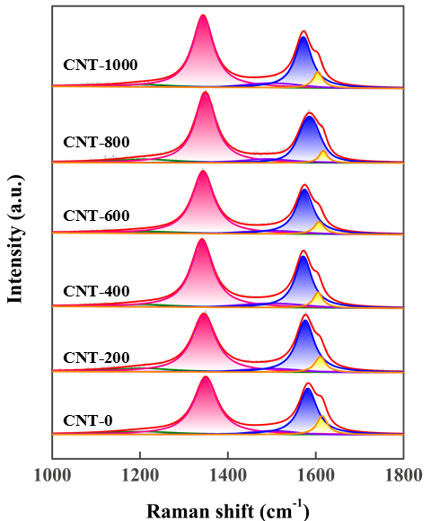
Fig. S1. Raman spectra of CNT-0, CNT-200, CNT-400, CNT-600, CNT-800, and CNT-1000.

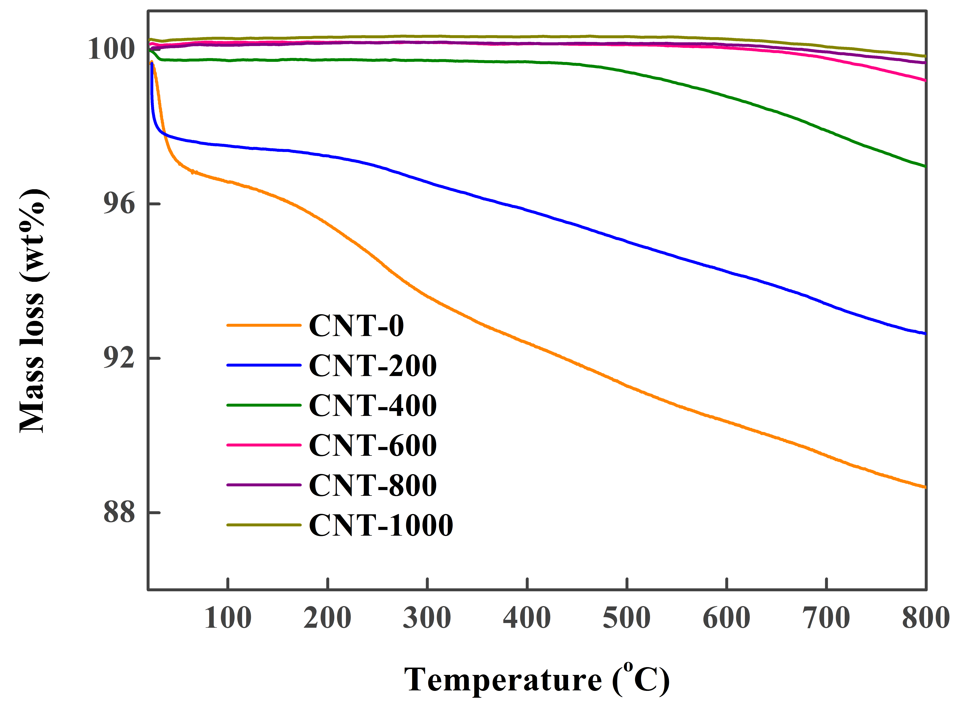
Fig. S2. TGA profiles of CNT-0, CNT-200, CNT-400, CNT-600, CNT-800, and CNT-1000.

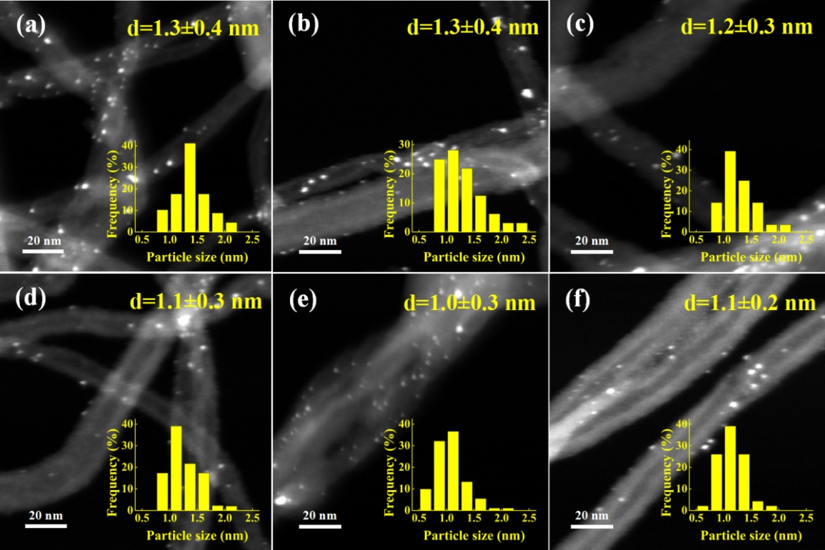
Fig. S3. Typical HAADF-STEM images of (a) Pt/CNT-0, (b) Pt/CNT-200, (c) Pt/CNT-400, (d) Pt/CNT-600, (e) Pt/CNT-800, and (f) Pt/CNT-1000.

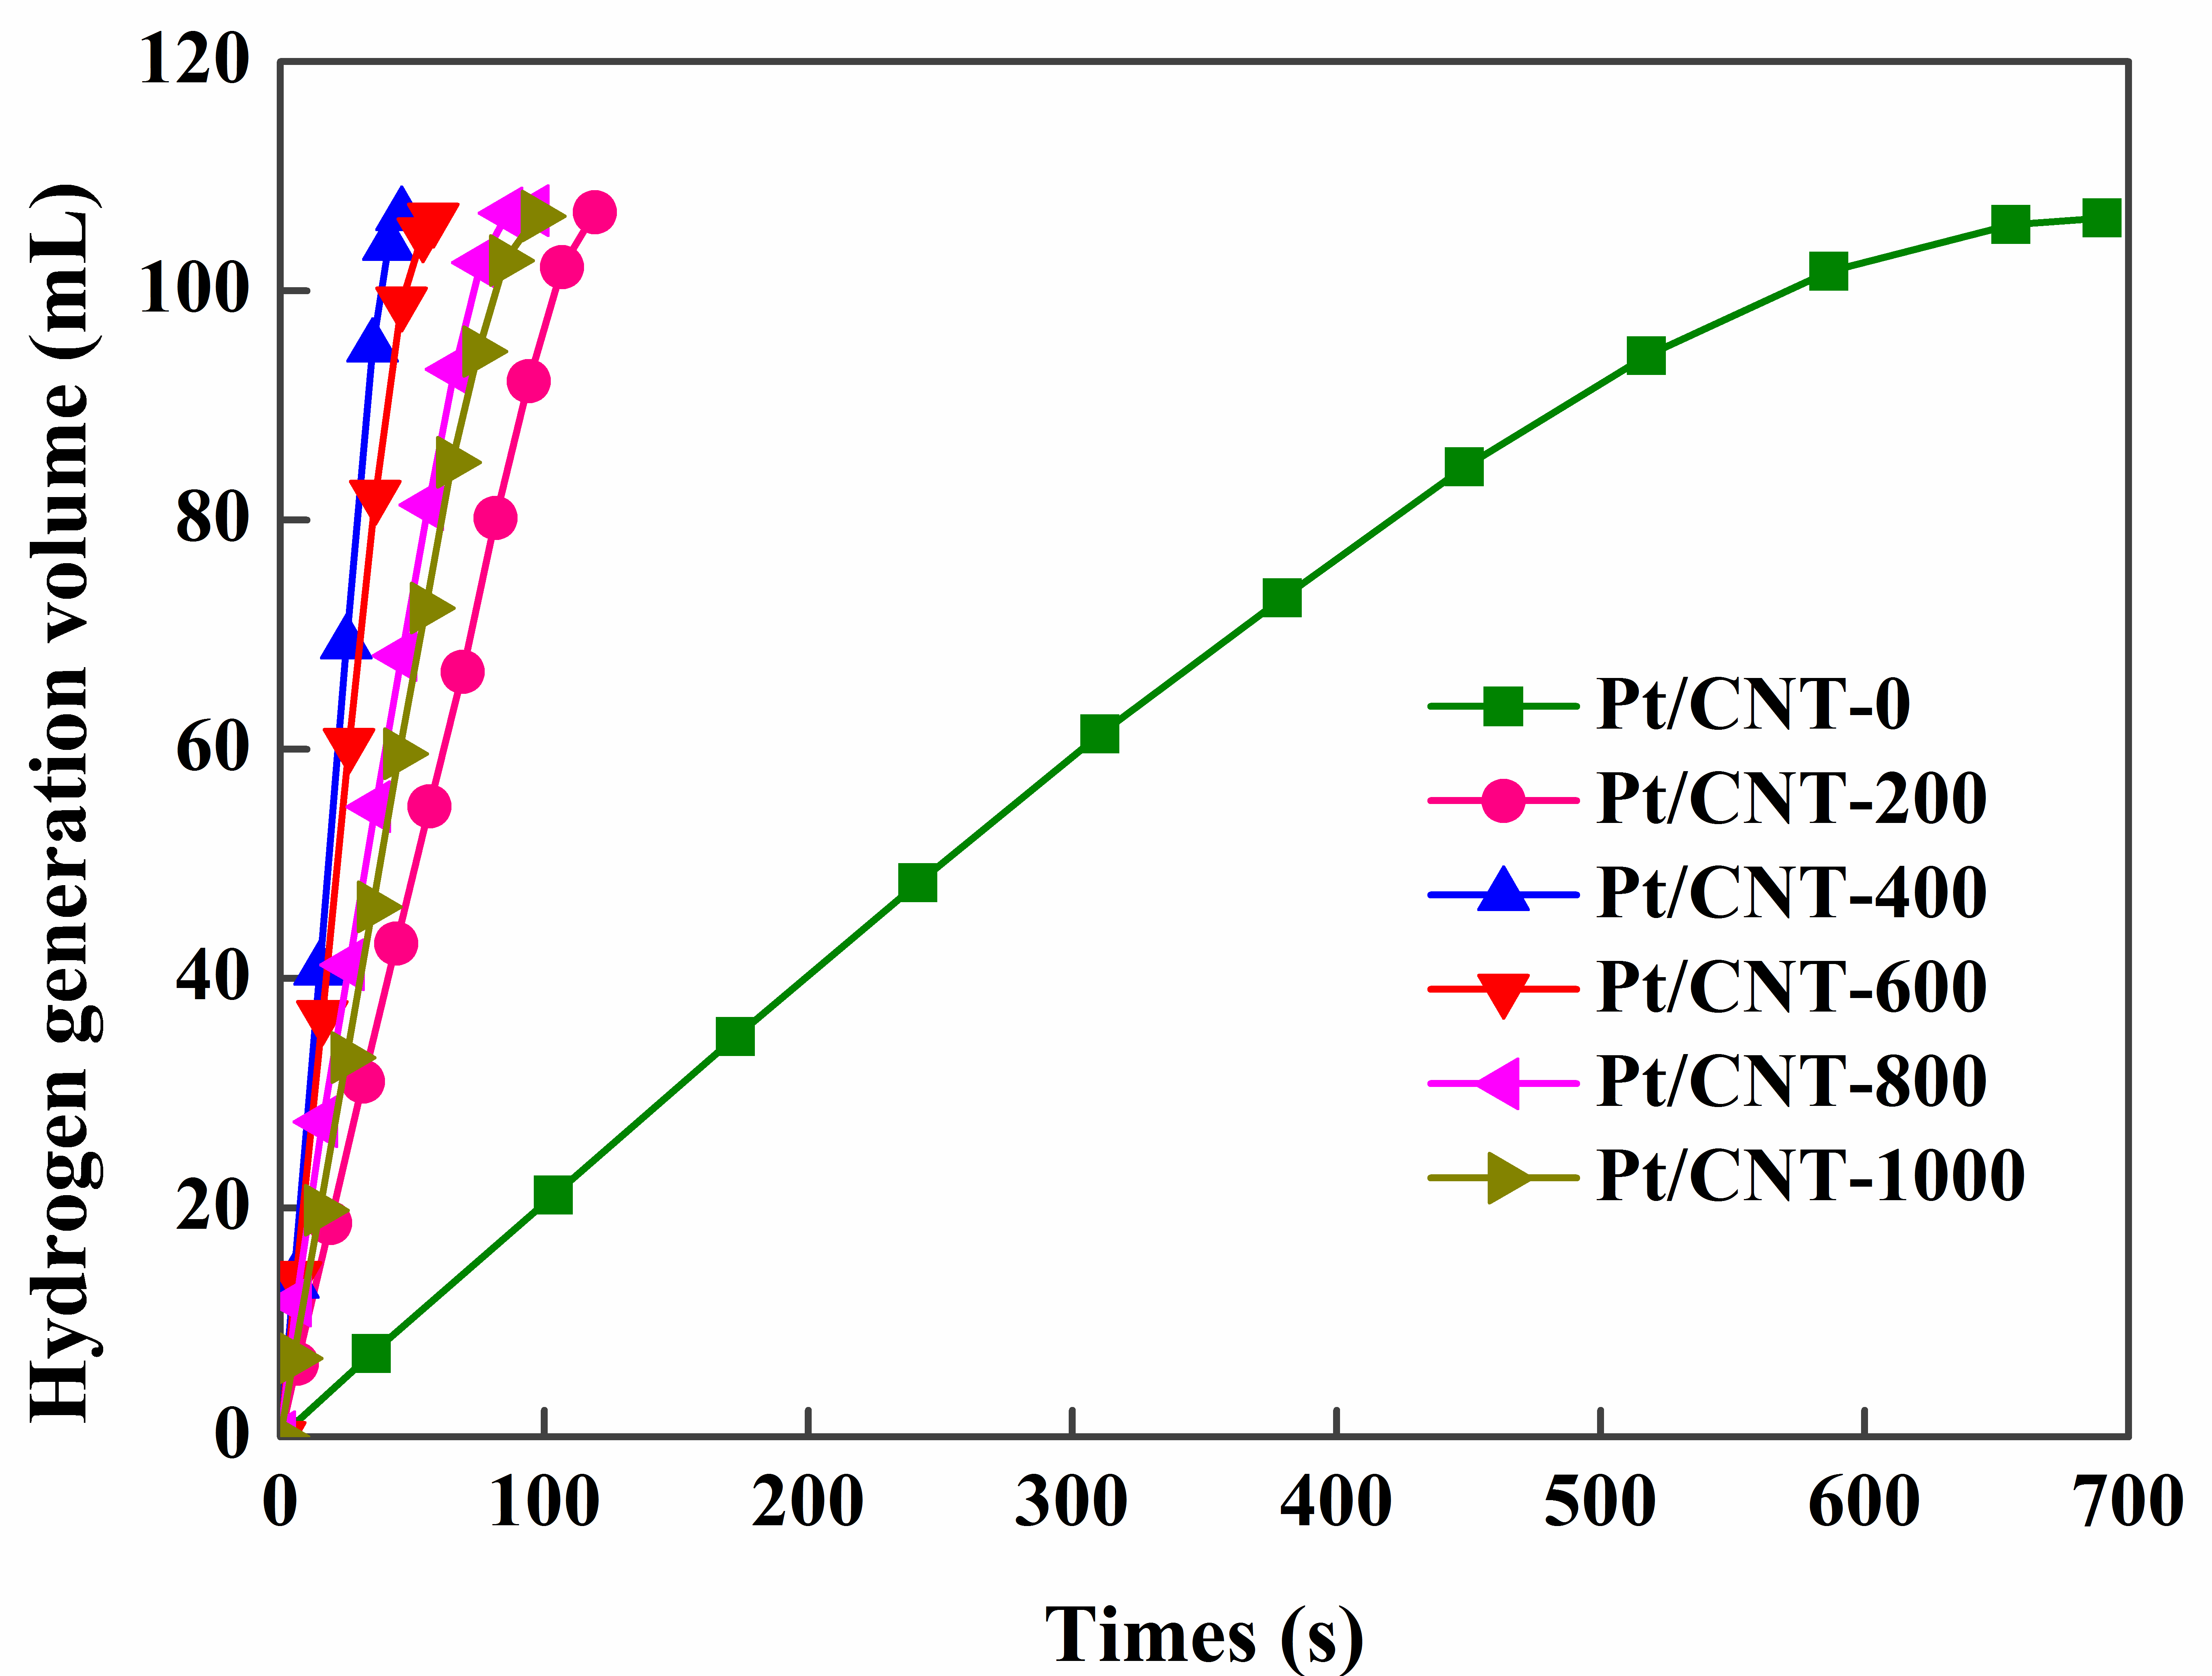
Fig. S4. Hydrogen generation from ammonia borane as a function of time for Pt/CNT-0, Pt/CNT-200, Pt/CNT-400, Pt/CNT-600, Pt/CNT-800, and Pt/CNT-1000 at 25 °C.

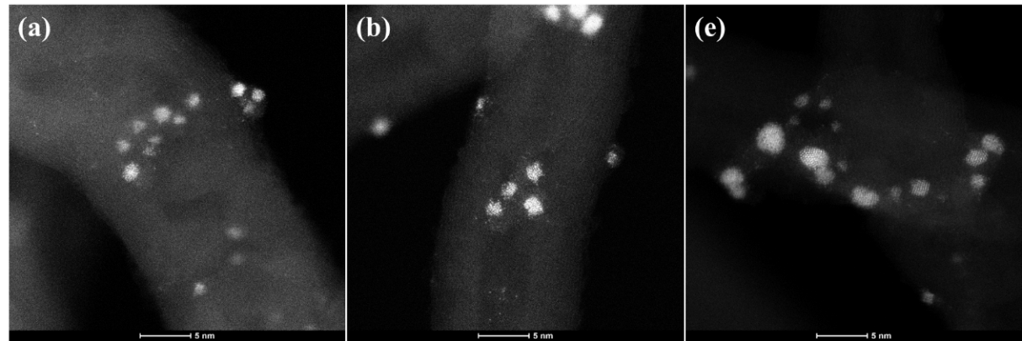
Fig. S5. Typical AC-HAADF-STEM images of (a) Pt/CNT-0, (b) Pt/CNT-200, and (c) Pt/CNT-600.

Fig. S6. Hydrogen generation from ammonia borane as a function of time for Pt/CNT-0, Pt/CNT-200, Pt/CNT-400, Pt/CNT-600, Pt/CNT-800, and Pt/CNT-1000 with low Pt loading (0.05 wt%) at 25 °C.

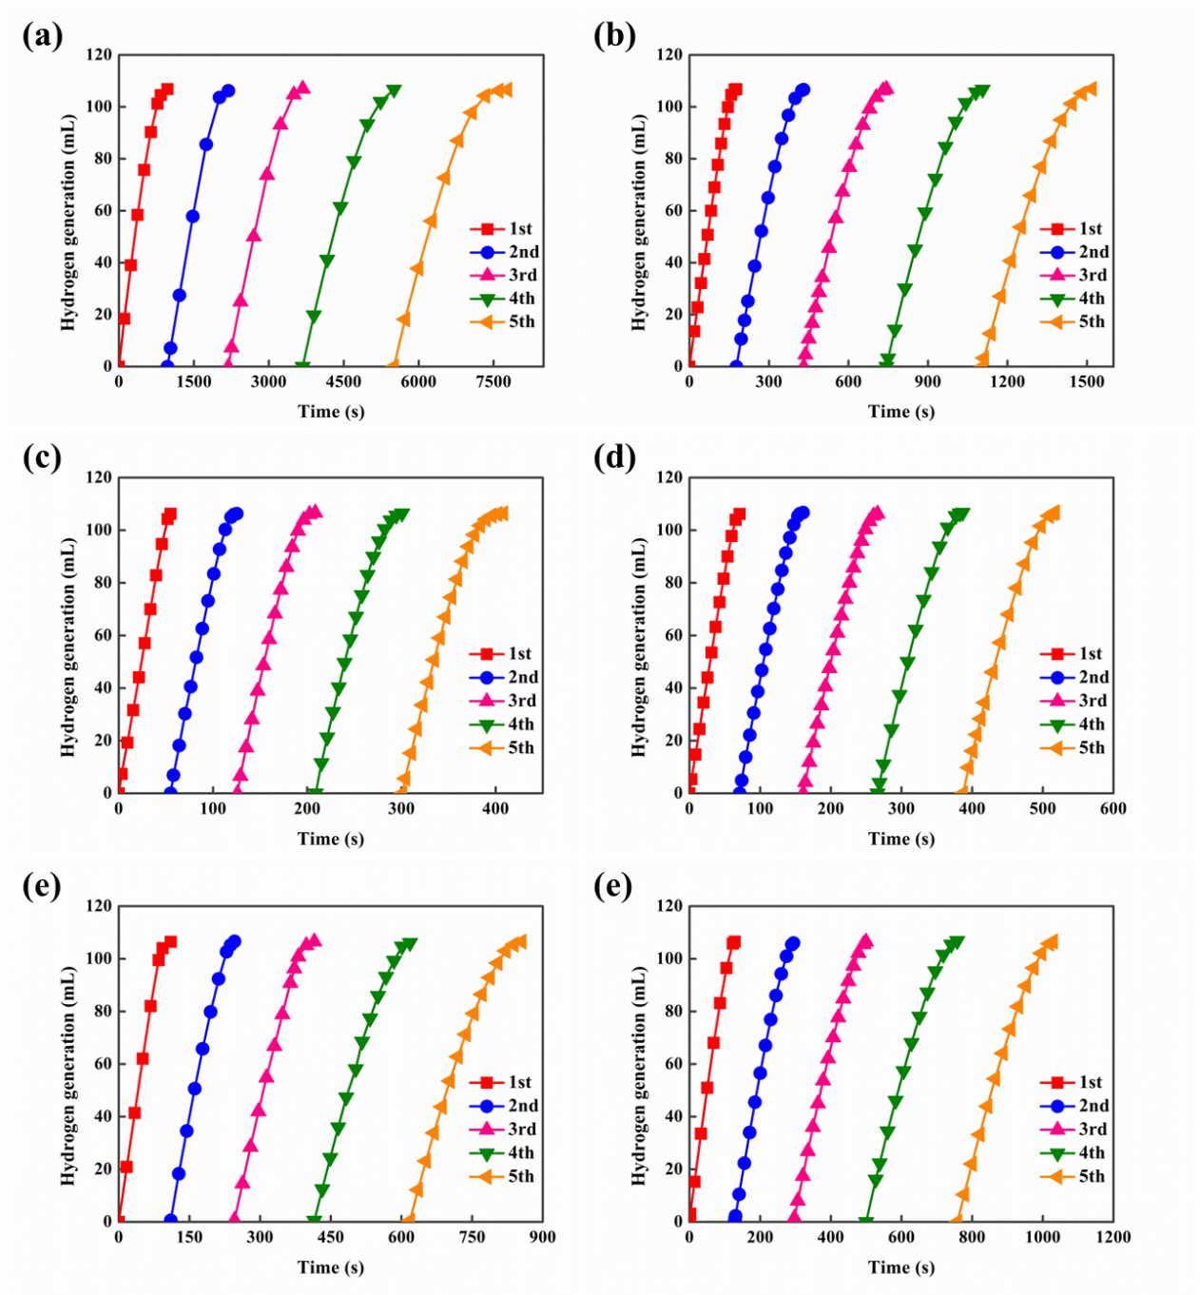
Fig. S7. Durability results of these catalysts 30 °C: (a) Pt/CNT-0, (b) Pt/CNT-200, (c) Pt/CNT-400, (d) Pt/CNT-600, (e) Pt/CNT-800, and (f) Pt/CNT-1000.
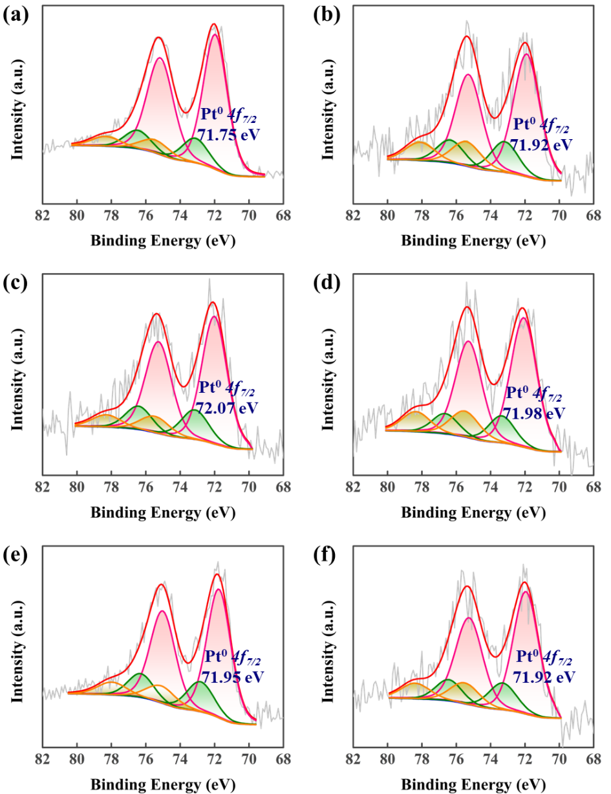
Fig. S8. Typical XPS Pt 4f spectra of (a) Pt/CNT-0, (b) Pt/CNT-200, (c) Pt/CNT-400, (d) Pt/CNT-600, (e) Pt/CNT-800, and (f) Pt/CNT-1000.

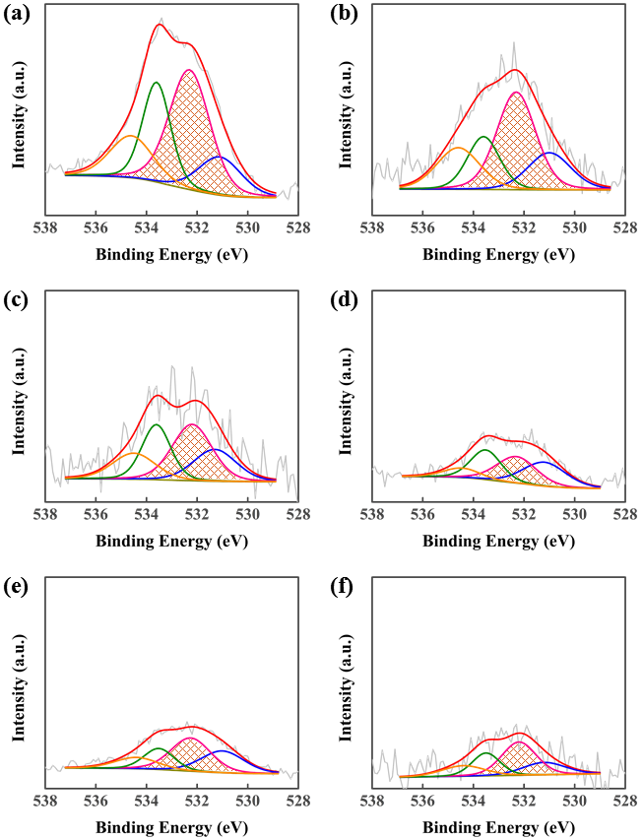
Fig. S9. Typical XPS O 1s spectra of (a) Pt/CNT-0, (b) Pt/CNT-200, (c) Pt/CNT-400, (d) Pt/CNT-600, (e) Pt/CNT-800, and (f) Pt/CNT-1000.

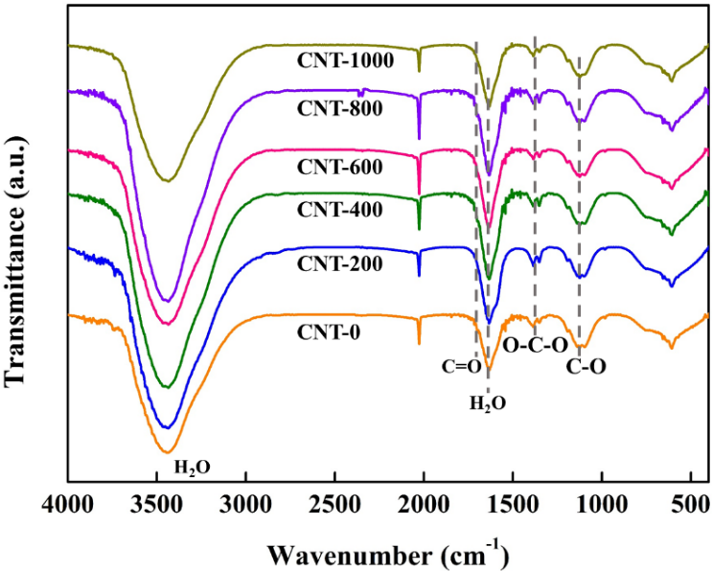
Fig. S10. FTIR spectra of CNT-0, CNT-200, CNT-400, CNT-600, CNT-800, and CNT-1000.

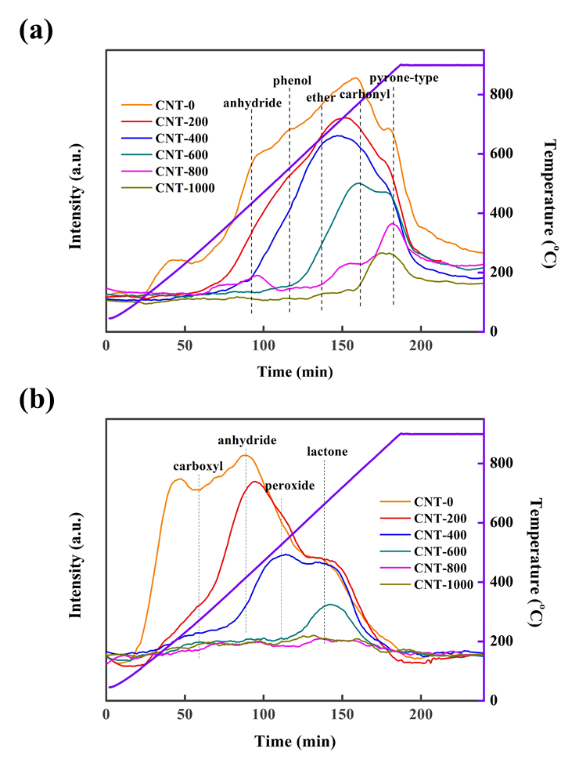
Fig. S11. (a) TPD-MS-CO and (b) TPD-MS-CO₂ profiles of CNT-0, CNT-200, CNT-400, CNT-600, CNT-800, and CNT-1000.

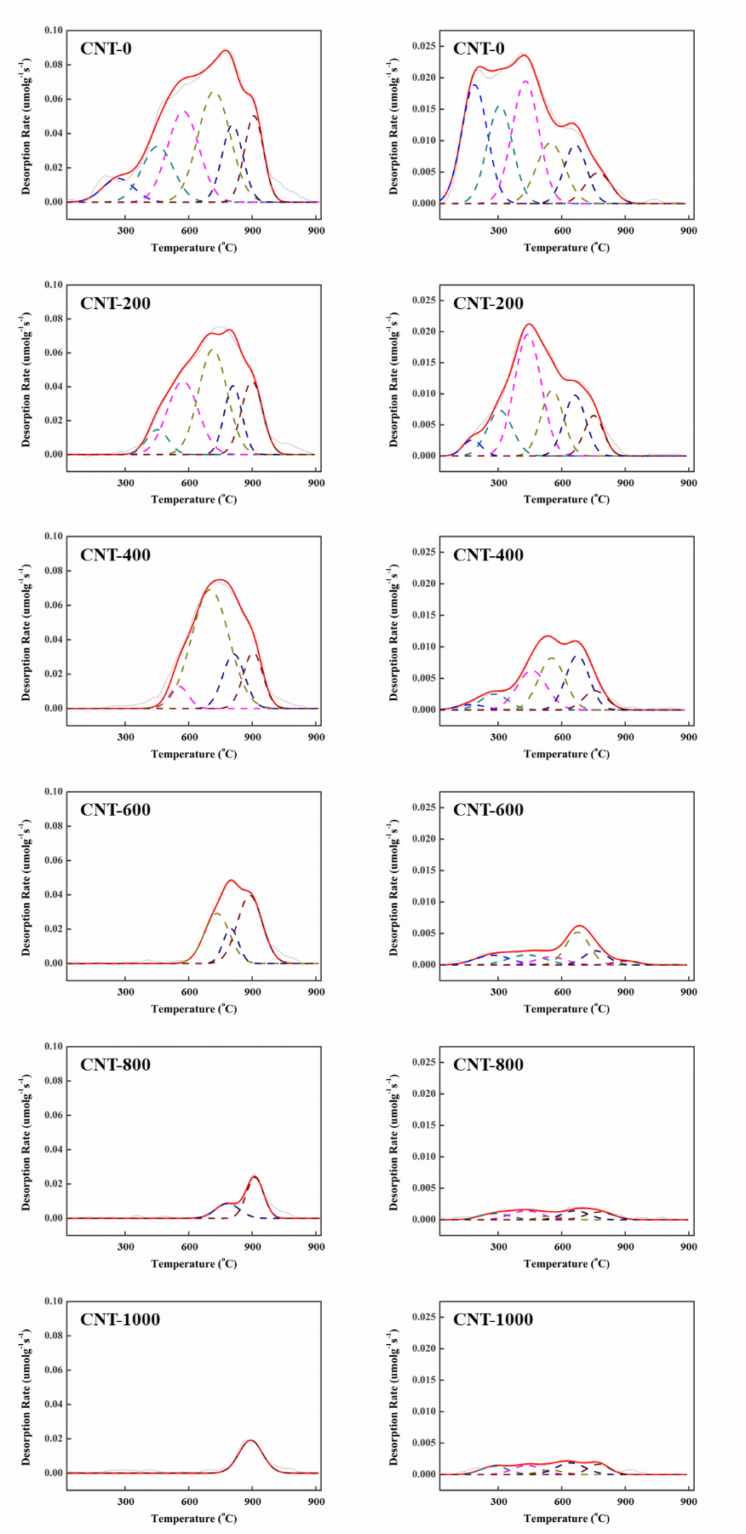
Fig. S12. TPD-MS spectra and deconvolution of carbon supports of CNT-0, CNT-200, CNT-400, CNT-600, CNT-800, and CNT-1000. Left, CO; right, CO₂.
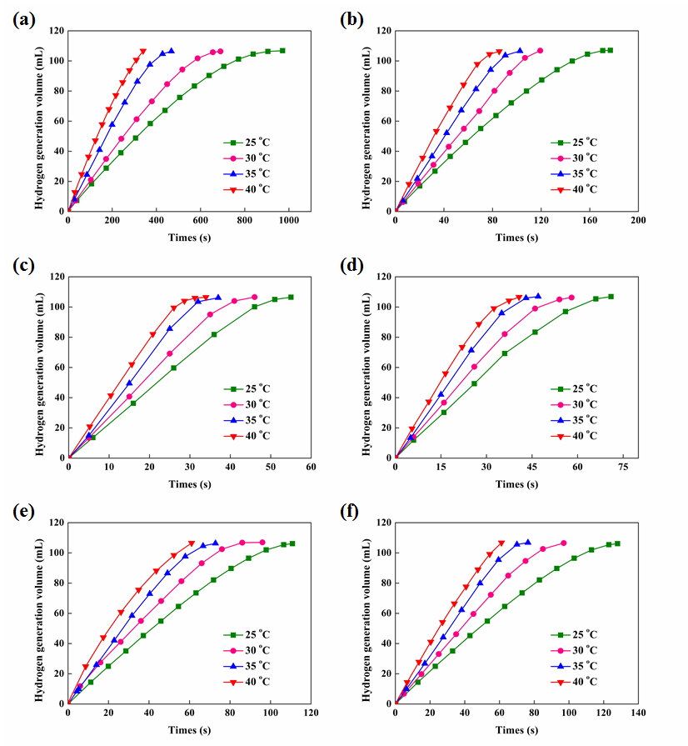
Fig. S13. Hydrogen generation volume as a function of time over different Pt/CNT catalysts at 25, 30, 35 and 40 °C: (a) Pt/CNT-0, (b) Pt/CNT-200, (c) Pt/CNT-400, (d) Pt/CNT-600, (e) Pt/CNT-800, and (f) Pt/CNT-1000.

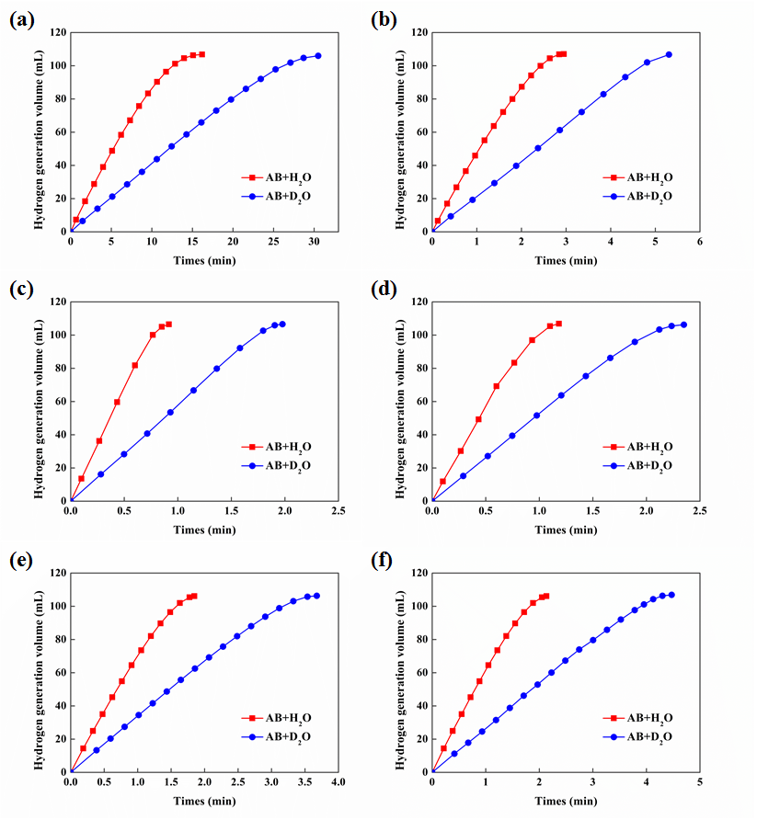
Fig. S14. Hydrogen generation volume as a function of time by using H₂O or D₂O as the reactant: (a) Pt/CNT-0, (b) Pt/CNT-200, (c) Pt/CNT-400, (d) Pt/CNT-600, (e) Pt/CNT-800, and (f) Pt/CNT-1000.

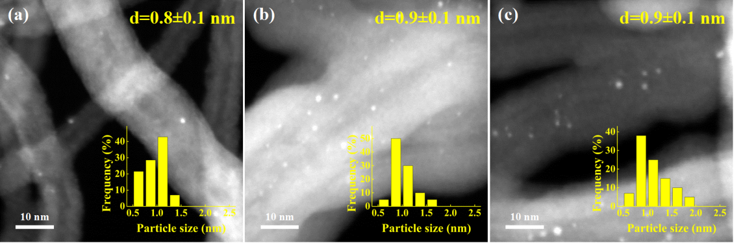
Fig. S15. Typical HAADF-STEM images of (a) 0.3-Pt/CNT, (b) 0.8-Pt/CNT, and (c) 1.2-Pt/CNT.

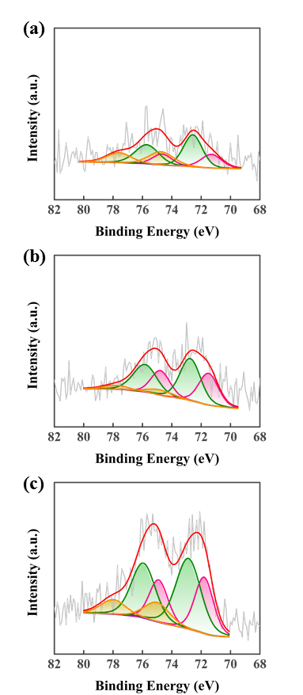
Fig. S16. Typical XPS Pt 4f spectra of (a) 0.3-Pt/CNT, (b) 0.8-Pt/CNT, and (c) 1.2-Pt/CNT.

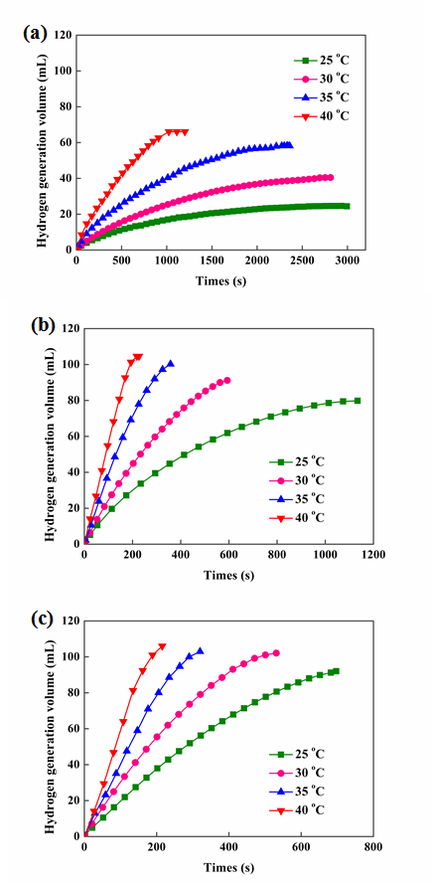
Fig. S17. Hydrogen generation volume as a function of time over different Pt/CNT catalysts at 25, 30, 35 and 40 °C: (a) 0.3-Pt/CNT, (b) 0.8-Pt/CNT, and (c) 1.2-Pt/CNT.

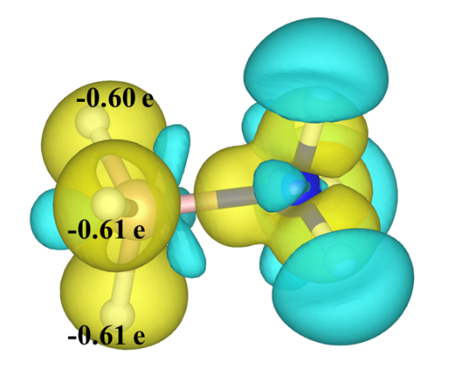
Fig. S18. Bader charge analysis on ammonia borane molecule. The yellow and light blue isosurfaces correspond to the electron increase and depletion zones, respectively.

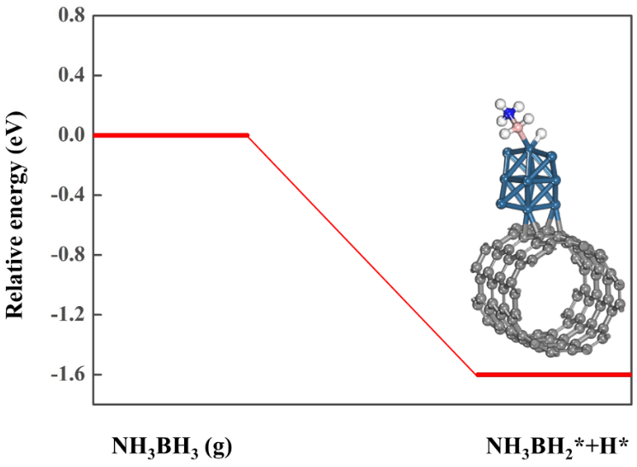
Fig. S19. DFT calculations of ammonia borane activation and the corresponding structure over Pt₁₀ supported on pure CNT.

References
[1] Chandra M, Xu Q. Room temperature hydrogen generation from aqueous ammonia–borane using noble metal nano-clusters as highly active catalysts. J Power Sources 2007;168(1):135–42.
[2] Yuan M, Cui Z, Yang J, Cui X, Tian M, Xu D, et al. Ultrafine platinum nanoparticles modified on cotton derived carbon fibers as a highly efficient catalyst for hydrogen evolution from ammonia borane. Int J Hydrogen Energy 2017;42(49):29244–53.
[3] Chen Y, Yang X, Kitta M, Xu Q. Monodispersed Pt nanoparticles on reduced graphene oxide by a non-noble metal sacrificial approach for hydrolytic dehydrogenation of ammonia borane. Nano Res 2017;10:3811–6.
[4] Ye W, Ge Y, Gao Z, Lu R, Zhang S. Enhanced catalytic activity and stability of Pt nanoparticles by surface coating of nanosized graphene oxide for hydrogen production from hydrolysis of ammonia–borane. Sustain Energy Fuels 2017;1:2128–33.
[5] Zhang J, Chen C, Chen S, Hu Q, Gao Z, Li Y, et al. Highly dispersed Pt nanoparticles supported on carbon nanotubes produced by atomic layer deposition for hydrogen generation from hydrolysis of ammonia borane. Catal Sci Technol 2017;7(2):322–9.
[6] Uzundurukan A, Devrim Y. Carbon nanotube-graphene hybrid supported platinum as an effective catalyst for hydrogen generation from hydrolysis of ammonia borane. Int J Hydrogen Energy 2019;44(49):26773–82.
[7] Chen W, Duan X, Qian G, Chen D, Zhou X. Carbon nanotubes as support in the platinum-catalyzed hydrolytic dehydrogenation of ammonia borane. ChemSusChem 2015;8(17):2927–31.
[8] Chen W, Fu W, Qian G, Zhang B, Chen D, Duan X, et al. Synergistic Pt–WO₃ dual active sites to boost hydrogen production from ammonia borane. iScience 2020;23(3):100922.
[9] Yao Q, Shi Y, Zhang X, Chen X, Lu ZH. Facile synthesis of platinum–cerium(IV) oxide hybrids arched on reduced graphene oxide catalyst in reverse micelles with high activity and durability for hydrolysis of ammonia borane. Chem Asian J 2016;11(22):3251–7.
[10] Aijaz A, Karkamkar A, Choi YJ, Tsumori N, Rönnebro E, Autrey T, et al. Immobilizing highly catalytically active Pt nanoparticles inside the pores of metal–organic framework: a double solvents approach. J Am Chem Soc 2012;134(34):13926–9.
[11] Xu D, Cui Z, Yang J, Yuan M, Cui X, Zhang X, et al. Pt nanoparticles immobilized in mesoporous silica-coated magnetic nanocapsules: a non-leaching catalyst for hydrogen generation from hydrolysis of ammonia borane. Int J Hydrogen Energy 2017;42(44):27034–42.
[12] Wang X, Liu D, Song S, Zhang H. Synthesis of highly active Pt–CeO₂ hybrids with tunable secondary nanostructures for the catalytic hydrolysis of ammonia borane. Chem Commun (Camb) 2012;48(82):10207–9.
[13] Yin L, Feng Y, Zhou X, Dai K, Gao X, Zhao Y, et al. Synthesis of Pt nanocatalyst supported on halloysite nanotubes via strong electronic adsorption for hydrolytic dehydrogenation of ammonia borane. Chem Lett 2019;48(9):1084–7.
[14] Khalily MA, Eren H, Akbayrak S, Susapto HH, Biyikli N, Özkar S, et al. Facile synthesis of three-dimensional Pt–TiO₂ nano-networks: a highly active catalyst for the hydrolytic dehydrogenation of ammonia–borane. Angew Chem Int Ed Engl 2016;55(40):12257–61.

