Supplementary Data for

A Biomimetically Constructed Superhydrophobic Coating with Excellent Mechanical Durability and Chemical Stability for Gas Transmission Pipelines
Xuerui Zang ^{a,#}, Yan Cheng ^{b,c,d,#}, Yimeng Ni ^{c}, Weiwei Zheng ^{c}, Tianxue Zhu ^{b}, Zhong Chen ^{e}, Jiang Bian ^{a,}*,
Xuewen Cao ^{a,}*, Jianying Huang ^{b,}*, Yuekun Lai ^{b,c,}*
ª College of Pipeline and Civil Engineering, China University of Petroleum (East China), Qingdao 266580, China
^{b} Qingyuan Innovation Laboratory, Quanzhou 362801, China
^{c} College of Chemical Engineering, Fuzhou University, Fuzhou 350116, China
^{d} Zhejiang Engineering Research Center for Tissue Repair Materials, Joint Centre of Translational Medicine, Wenzhou Institute, University of Chinese Academy of Sciences, Wenzhou 325001, China
^{e} School of Materials Science and Engineering, Nanyang Technological University, Singapore 639798, Singapore

# These authors contributed equally to this work.
* Corresponding authors.
E-mail addresses: bj@s.upc.edu.cn (J. Bian), caoxw@upc.edu.cn (X. Cao), jyhuang@fzu.edu.cn (J. Huang), yklai@fzu.edu.cn (Y. Lai).

S1. Finite element method (ABAQUS)
With the aim of clarifying the influence of buffer structures on the surface erosion mechanisms of materials, we conducted numerical simulations using ABAQUS 2020. Our method entailed the use of a three-dimensional model based on the Johnson–Cook (JC) damage criterion and hardening criterion. Similar simulations were also undertaken by Takafoli and Papini.
S1.1. Constitutive models
S1.1.1. JC damage criterion
The JC damage model is rooted in the principles of cavitation growth and damage evolution, taking into consideration the influence of stress triaxiality, strain rate, and temperature softening. Consequently, the failure criterion and governing equations of the JC model are articulated as follows:
(S1)
(S2)
(S3)
where, ε_{f}, ε, and ε₀ stands for the fracture strain, equivalent plastic strain rate, and reference strain rate, respectively. σ* signifies the stress triaxiality. The parameters D₁, D₂, D₃, D₄, and D₅ represent the damage constants, T* denotes normalized temperature, while a and R are used to denote the radius and notch radius of the smallest cross-section of the pattern, respectively. Moreover, d₀ indicates the initial diameter of the notched bar, and d₁ is the final diameter after deformation. It is important to note that constants D₁–D₅ can be derived through the utilization of Eq. (S1), and Eqs. (S2) and (S3) provide empirical expressions for the determination of ε_{f} and σ*, respectively.
S1.1.2. JC hardening criterion
Johnson et al. amalgamated viscoplastic and continuum damage mechanics to present an empirical constitutive model tailored to address challenges involving substantial deformation, high-strain rate, and thermal insulation. Within this model, the material’s yield flow stress is expressed as a function of strain, strain rate, and temperature, as detailed in the following equations:
(S4)
(S5)
where, σ represents the static yield stress, and ε_{pl} corresponds to the equivalent plastic strain. The constants A, B, and n are dependent on the material’s characteristics at the transition temperature. Specifically, A designates the yield stress in MPa, B denotes the hardening coefficient in MPa, and n characterizes the hardening index. Additionally, C and m describe the strain rate and thermal softening of the material. T_{m} and T_{r} are associated with the melting temperature and reference temperature, respectively.
S1.2. Boundary conditions
In all simulations, the surface of the top coating and the particle were treated as rigid bodies, resulting in zero particle strain during impact. Initial velocities were applied to the particles via a predefined field, and these input velocities were decomposed along the Y- and Z-directions. Particle motion was constrained along the Y- and Z-directions. To accurately represent the buffer layer’s response to deformation induced by particle impact, the interaction between the top layer of the coating and the particle was specified as “nodes-to-surface contact,” allowing for relative sliding between the particle and the material. Furthermore, movement along the X-direction was restricted on both the left and right sides, and the bottom plane was immobilized. Fig. S4 provides a visual depiction of the applied boundary conditions.
S1.3. Mesh refinement
In the realm of numerical simulations, the implementation of finer grids offers the potential for heightened result accuracy, albeit with a concomitant increase in computational resources. This study adopts a strategy of mesh refinement, focusing on specific areas, namely the contact regions, to attain mesh sizes that ensure a judicious trade-off between result accuracy and computational efficiency. In these regions, the grid count is configured as follows: 1000 along the X-axis, 500 along the Y-axis, and 1200 along the Z-axis.
S2. Erosion loop test
Erosion resulting from solid particles impacting the elbow of a pipeline is effectively simulated through the use of a specialized loop device, as illustrated in Fig. S5(a). The erosion loop comprises several essential components, including a water tank, mixer, systems for flow acquisition and velocity measurement, a visual erosion loop, test elbow, compressor, buffer tank, gas–liquid mixing and separation units, as well as systems for flow and pressure measurement. The test samples have an exposed area measuring 1 cm × 1 cm, with a sample thickness of 0.6 mm. For the experiments, quartz sand with particle sizes ranging from 280 to 320 μm and a density of 2650 kg∙m⁻³ was employed, as depicted in Figs. S5(b) and (c). The sand was transported into the experimental loop by the compressor, with an inlet velocity of 20 m∙s⁻¹ and a sand particle mass flow rate of 0.2 kg∙s⁻¹. The erosion test was conducted over a duration of 12 or 24 h.
To quantify the erosion effects, the weight change of the sample before and after erosion was recorded. The erosion rate (ER) is calculated using the following formula:
(S6)
where, ω₀ and ω₁ represent the mass of the sample before and after the experiment, respectively. S denotes the working area of the sample, t signifies the erosion time, and ρ_{w} is the density of the target material.
The average density of the coating ρ_{w} is determined through the formula:
(S7)
where, m₁ represents the mass of the beaker filled with water, m₂ corresponds to the mass of the coating after submersion in the water-filled beaker, m₃ denotes the total mass of the beaker and the remaining water after the coating is removed, and ρ_{water} represents the density of water.

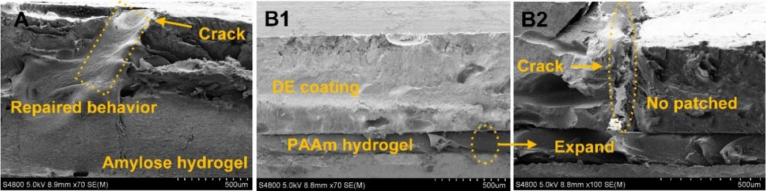
Fig. S1. Repair behavior of amylose hydrogels relative to conventional hydrogels. (a) Amylose hydrogel; (b) polyacrylamide (PAAm) hydrogel.

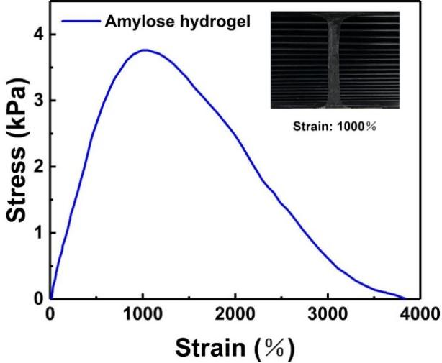
Fig. S2. Stress–strain curves of the amylose hydrogel.

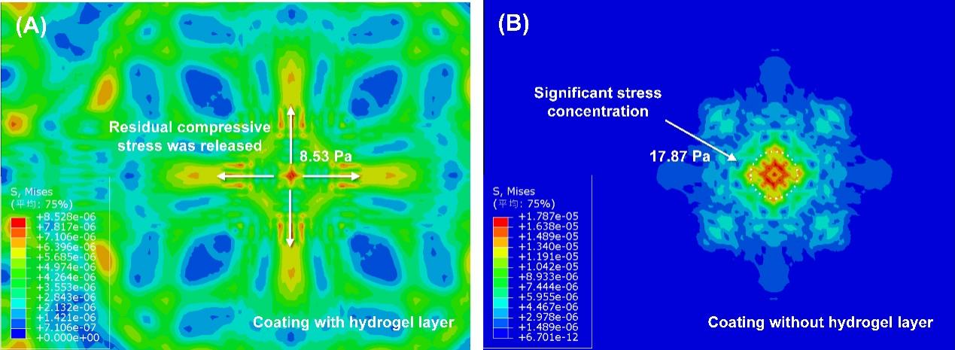
Fig. S3. Simulation results to verify the buffering effect of the hydrogel layer. The buffering effect of the hydrogel layer can effectively alleviate the stress concentration caused by external load, and the maximum stress value was reduced by 52.3%.

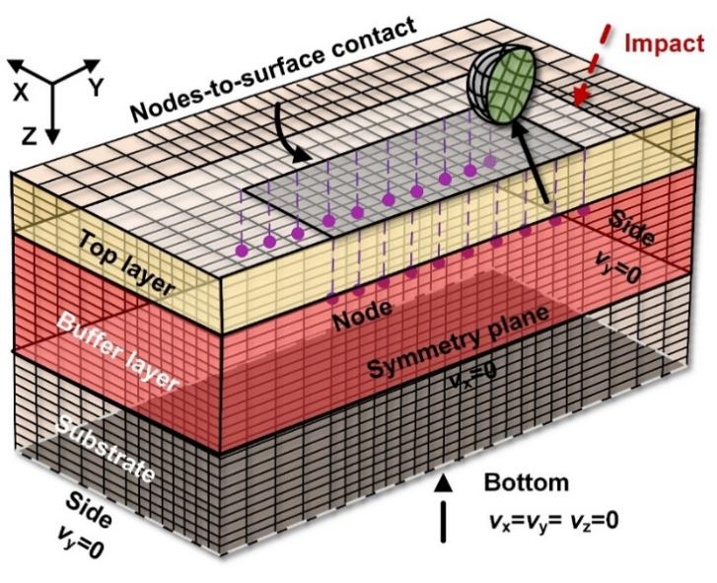
Fig. S4. Boundary conditions. The rigid particles and the surface of the top coating are in “nodes-to-surface contact,” and the contact surfaces of three different materials are in “surface-to surface contact.”

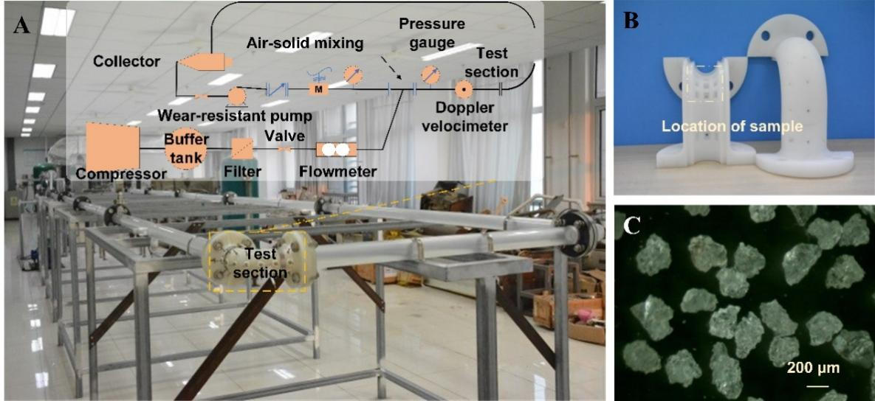
Fig. S5. Erosion loop test. (a) Experimental device and test part; (b) groove in bend; (c) sand size for testing.

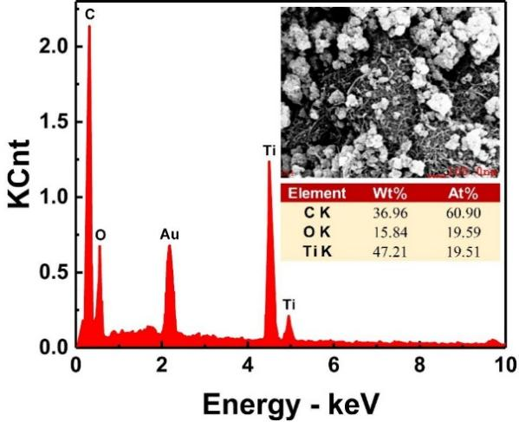
Fig. S6. EDS image of DEA coating. It shows the element distribution curve of the bionic tooth coating surface, in which the gold element is caused by spraying gold to improve the conductivity of the sample.

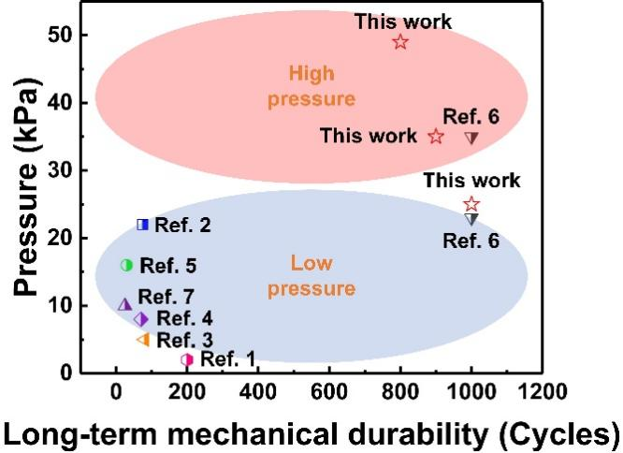
Fig. S7. Comparison of shear strength between DEA coating and reported coatings [1–7].

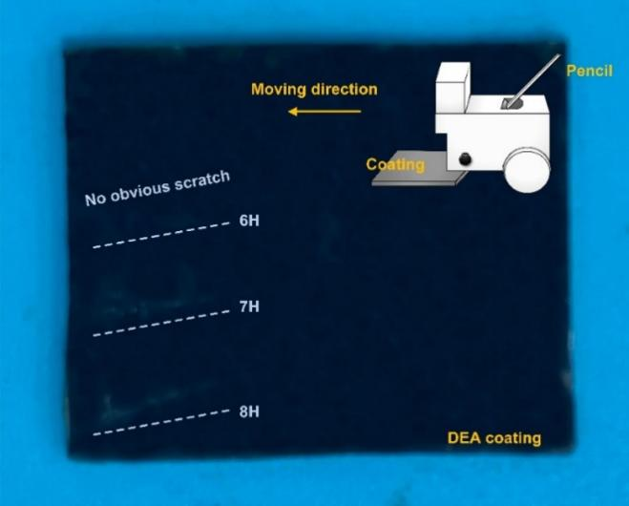
Fig. S8. Pencil scratch test. The coating can withstand the scratch test of 6H pencil.

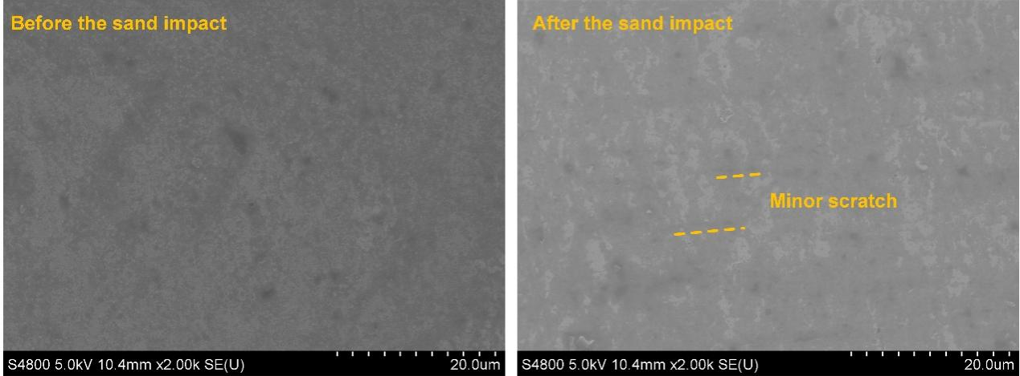
Fig. S9. The surface morphology of the coating before and after the sand impact.

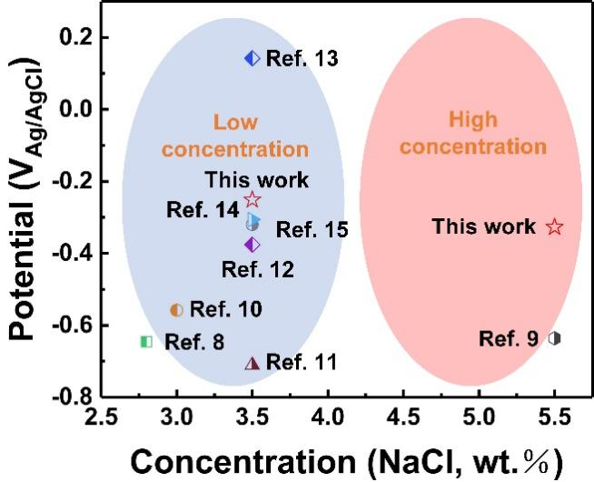
Fig. S10. Comparison of corrosion resistance between DEA coating and reported coatings [8–15].

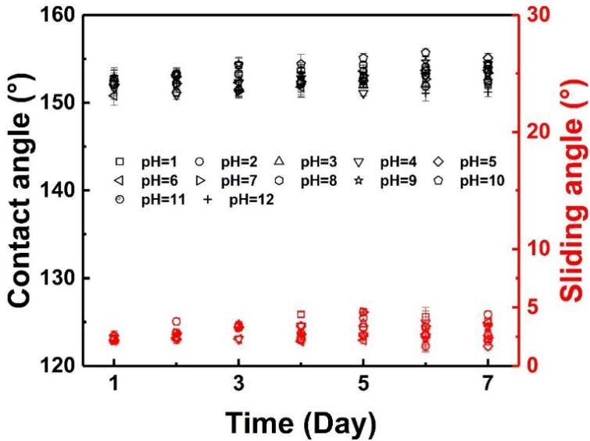
Fig. S11. The contact angle and sliding angle of DEA coating surface in different pH solutions for 7 days.

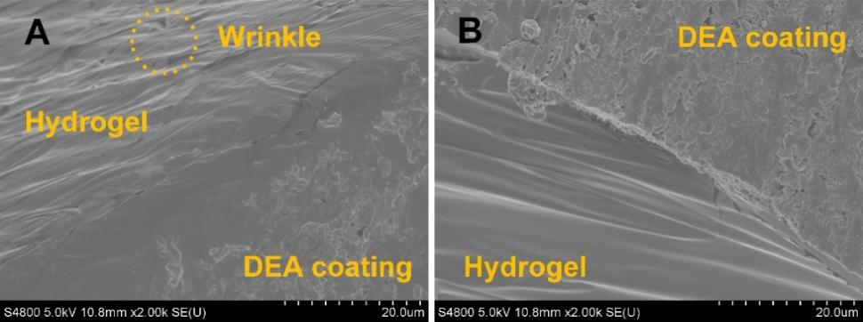
Fig. S12. The surface morphology of the coating before and after immersion.

Table S1
Comparison of wear resistance of two classical particles (TiO₂ NPs, SiO₂ NPs).
Method | NPs contents | Water contact angle | Water sliding angle | Abrasion resistance testª
Hot-pressing | 0.01 g SiO₂ | 142.5° | 16.7° | 50 wear cycles
Hot-pressing | 0.05 g SiO₂ | 152.9° | 8.8° | 100 wear cycles
Hot-pressing | 0.1 g SiO₂ | 156.7° | 4.2° | 100 wear cycles
Spin coating | 0.1 g SiO₂ | 122.4° | 35.4° | 10 wear cycles
Spraying | 0.1 g SiO₂ | 158.8° | 3.8° | 50 wear cycles
Hot-pressing | 0.01 g TiO₂ | 146.6° | 14.2° | 100 wear cycles
Hot-pressing | 0.05 g TiO₂ | 154.1° | 5.5° | 150 wear cycles
Hot-pressing | 0.1 g TiO₂ | 158.5° | 4.1° | 200 wear cycles
Spin coating | 0.1 g TiO₂ | 122.9° | 26.5° | 10 wear cycles
Spraying | 0.1 g TiO₂ | 162.3° | 4.1° | 50 wear cycles
ª 1000 mesh sandpaper, 100 g, 9.8 kPa.

Table S2
The influence of different mass ratios on the hydrophobicity and wear resistance of the coating.
TiO₂: CNTs | Water contact angle | Water sliding angle | Abrasion resistance testª
0 g CNTs | 157.2° | 2.8° | 300 wear cycles
1:20 | 155.6° | 3.0° | 450 wear cycles
4:1 | 153.4° | 4.2° | 500 wear cycles
2:1 | 152.1° | 4.7° | 550 wear cycles
1:1 | 134.7° | 10.8° | 700 wear cycles
ª 600 mesh sandpaper, 500 g, 49 kPa.

Table S3
The relationship between the weight of the hot-pressing method (120 ℃) and the coating thickness on the hydrophobic property of the coating.
Weight during hot-pressing (g) | Thickness of each DE layer (μm) | Mass of particles (g) | CA (° ) | SA (° ) | Abrasion resistance testª
50 (4.9 kPa) | 630.3 | 0.1 | 157.2 | 2.5 | 400 wear cycles
100 (9.8 kPa) | 589.2 | 0.1 | 157.4 | 2.5 | 400 wear cycles
250 (24.5 kPa) | 515.6 | 0.1 | 154.6 | 3.8 | 450 wear cycles
500 (49 kPa) | 128.1 | 0.1 | 152.1 | 4.4 | 500 wear cycles
2000 (196 kPa) | 30.2 | 0.1 | 148.2 | 9.1 | 450 wear cycles
ª 600 mesh sandpaper, 500 g, 49 kPa.

References
[1] Wang N, Xiong D, Deng Y, Shi Y, Wang K. Mechanically robust superhydrophobic steel surface with anti-icing, UV-durability, and corrosion resistance properties. ACS Appl Mater Interfaces 2015;7(11):6260–72.
[2] Celik N, Torun I, Ruzi M, Esidir A, Onses MS. Fabrication of robust superhydrophobic surfaces by one-step spray coating: evaporation driven self-assembly of wax and nanoparticles into hierarchical structures. Chem Eng J 2020;396:125230.
[3] Wang P, Sun B, Yao T, Chen M, Fan X, Han H, et al. A novel dissolution and resolidification method for preparing robust superhydrophobic polystyrene/silica composite. Chem Eng J 2017;326:1066–73.
[4] Wu B, Lyu J, Peng C, Jiang D, Yang J, Yang J, et al. Inverse infusion processed hierarchical structure towards superhydrophobic coatings with ultrahigh mechanical robustness. Chem Eng J 2020;387:124066.
[5] Song J, Li Y, Xu W, Liu H, Lu Y. Inexpensive and non-fluorinated superhydrophobic concrete coating for anti-icing and anti-corrosion. J Colloid Interface Sci 2019;541:86–92.
[6] Wang D, Sun Q, Hokkanen MJ, Zhang C, Lin FY, Liu Q, et al. Design of robust superhydrophobic surfaces. Nature 2020;582(7810):55–9.
[7] Sun R, Zhao J, Li Z, Mo J, Pan Y, Luo D. Preparation of mechanically durable superhydrophobic aluminum surface by sandblasting and chemical modification. Prog Org Coat 2019;133:77–84.
[8] Torbati-Sarraf H, Torbati-Sarraf SA, Chawla N, Poursaee A. A comparative study of corrosion behavior of an additively manufactured Al-6061 RAM2 with extruded Al-6061 T6. Corros Sci 2020;174:108838.
[9] Dzhurinskiy DV, Dautov SS, Shornikov PG, Akhatov IS. Surface modification of aluminum 6061-O alloy by plasma electrolytic oxidation to improve corrosion resistance properties. Coatings 2021;11(1):4.
[10] Valdez B, Kiyota S, Stoytcheva M, Zlatev R, Bastidas JM. Cerium-based conversion coatings to improve the corrosion resistance of aluminium alloy 6061-T6. Corros Sci 2014;87:141–9.
[11] Cao Y, Zheng D, Luo J, Zhang F, Wang C, Dong S, et al. Enhanced corrosion protection by Al surface immobilization of in-situ grown layered double hydroxide films co-intercalated with inhibitors and low surface energy species. Corros Sci 2020;164:108340.
[12] Dou B, Wang Y, Zhang T, Meng G, Shao Y, Lin X, et al. Electrochemically assisted silanization treatment of an aluminum alloy under oxygen pressure for corrosion protection. New J Chem 2018;42(12):9771–82.
[13] Harb SV, dos Santos FC, Caetano BL, Pulcinelli SH, Santilli CV, Hammer P. Structural properties of cerium doped siloxane–PMMA hybrid coatings with high anticorrosive performance. RSC Advances 2015;5(20):15414–24.
[14] Zhang X, Wang R, Long F, Zhou T, Hu W, Liu L. Durable superhydrophobic coating derived from hard-soft technology with enhanced anticorrosion performance. Corros Sci 2021;193:109889.
[15] Li H, Yu S, Han X, Zhao Y. A stable hierarchical superhydrophobic coating on pipeline steel surface with self-cleaning, anticorrosion, and anti-scaling properties. Colloid Surf A 2016;503:43–52.

