Supplementary data for
Vectorial Digitelligent Optics for High-Resolution Non-Line-of-Sight Imaging
Yinghui Guo^{a,b,c,d,#}, Yunsong Lei^{a,b,c,d,#}, Mingbo Pu^{a,b,c,d,}*, Zhibin Zhao^{a,b,c,d}, Fei Zhang^{a,b,c}, Qi Zhang^{a,b,c}, Xiaoyin Li^{a,b,c}, Runzhe Zhang^{a,b,c,d}, Rui Zhou^{e}, Yulong Fan^{a,b}, and Xiangang Luo^{a,b,d,}*
ª National Key Laboratory of Optical Field Manipulation Science and Technology, Chinese Academy of Sciences, Chengdu 610209, China
^{b} State Key Laboratory of Optical Technologies on Nano-Fabrication and Micro-Engineering. Institute of Optics and Electronics, Chinese Academy of Sciences, Chengdu 610209, China
^{c} Research Center on Vector Optical Fields, Institute of Optics and Electronics, Chinese Academy of Sciences, Chengdu 610209, China.
^{d} School of Optoelectronics, University of Chinese Academy of Sciences, Beijing 100049, China
^{e} Tianfu Xinglong Lake Laboratory,Chengdu 610299, China
* Corresponding authors.
E-mail addresses: pmb@ioe.ac.cn (M. Pu), lxg@ioe.ac.cn (X. Luo).
# These authors contributed equally to this work.
S1. Characterization of vector optical field generation
Prior to formally applying our vector optical field (VOF) shaping system to non-line-of-sight (NLOS) imaging, a series of detailed tests were conducted to verify its effectiveness in generating the required VOF. These tests were essential to confirm that the system could effectively produce the desired VOF, thereby playing a key role in NLOS imaging. The optical path layout and related equipment configuration for these tests are detailed in Fig. S1:
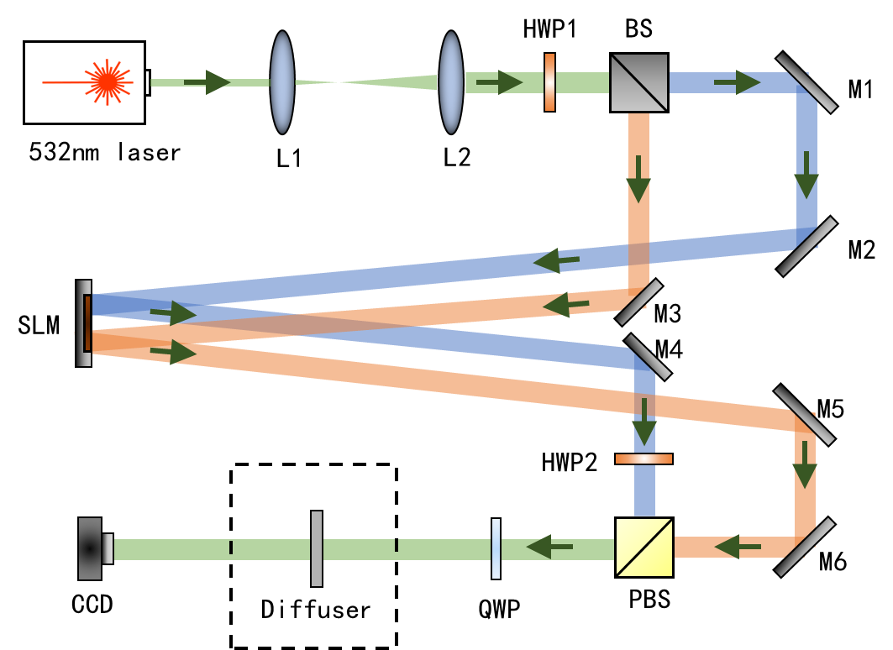
Fig. S1. System setup for testing the generation of VOF. Components include L1-L3(lenses), M1-M6 (mirrors), HWP (half-wave plate), QWP (quarter-wave plate), BS (beam splitter), PBS (polarization beam splitter), SLM (Spatial Light Modulator), Diffuser (test medium, a polarizer or a turbulence plate) and CCD (charge-coupled device).

During this testing stage, we intentionally avoided placing any objects at the Diffuser’s position. This decision aimed to first ensure the system's fundamental ability to generate and control VOF before introducing additional variables or complexities. The preliminary test results have already been shown in Fig. 2 of the manuscript. To further validate this capability, tests for higher-order cylindrical vector light production were conducted, aimed at examining the system's performance in generating more complex VOF. The production results and detailed analysis of these higher-order cylindrical vector lights are presented in Fig. S2:
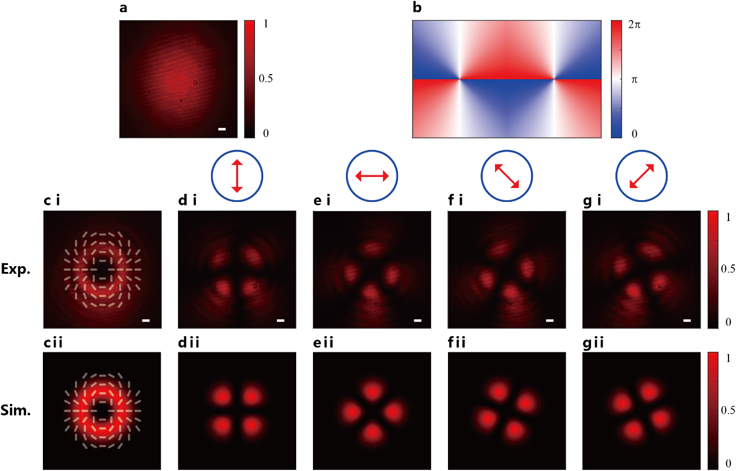
Fig. S2. Generation of higher-order cylindrical VOF. (a) Light spot without modulation on SLM. (b) Specific phase pattern applied to SLM, here a vortex phase with values of ±2. (c) Modulated light spot, with white lines indicating linear polarization direction. (d-i)-(g-i) Results from examining the modulated light spot through polarizing filters at different angles. (d-ii) - (g-ii) Represent the results of the simulation. Scale bar: 220 μm.

The combined results from both test sets clearly demonstrate that our system is capable of efficiently generating VOF. These outcomes lay a solid foundation for the system’s potential in advanced applications, such as NLOS imaging.
S2. Vectorial digitelligent optics for optimal VOF generation at different scanning positions
Wavefront shaping in NLOS imaging is crucial to rectify the wavefront distortion induced by scattering from the intermediate wall and thus enhance the echo signal quality. Stochastic Parallel Gradient Descent (SPGD) algorithm [1,2] was chosen to simultaneously optimize both the wavefront and polarization of the beam [3], effectively generating diffraction-limited focus with maximum intensity (see Section S3 in the supplementary materials). In our practical experiment, we found that overcoming the strong scattering effect of the wall in NLOS imaging couldn’t be solved by solely using SPGD. Given the wall’s strong scattering properties, the feedback-based Hadamard encoding algorithm (HEA) [4] proves more effective than the SPGD algorithm. To implement HEA, a 32×32 Hadamard pattern was used as the basis, and the phase angle for each iteration was calculated using the four-step phase-shifting method, thus achieving rapid beam focusing. Eventually, using HEA in conjunction with SPGD can perfectly meet our NLOS imaging requirement imaging conditions.
Once diffraction-limited focusing is realized by VOF shaping, we initiated the beam scanning on the surface of the target object by applying a tilted phase to the global phase pattern of the digital optical elements, allowing to move the focused spot in space at will, as illustrated in Fig. S3(a). Fig. S3(b) shows a schematic of the focus intensity during the scan, and Fig. S3(c) presents the phase modulation map for each focus, with the enlarged section revealing the superimposed tilted phase. It's critical to note that the scanning range of the focused spot is limited by the optical memory effect associated with the wall surface. The extent of this effect is directly correlated with the wall's roughness [5–7].
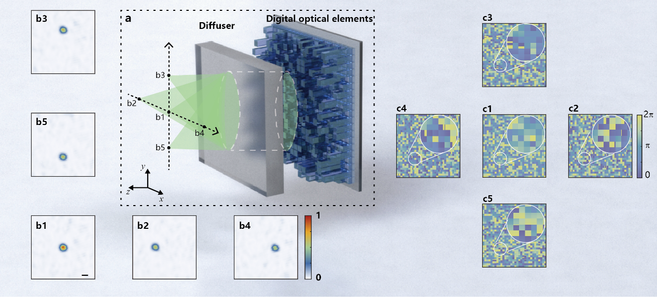
Fig. S3. Scanning process and the associated phase profile. (a) Diagram of focus scanning by adding tilted phases on the digital optical elements, showing 5 typical focusing patterns at different positions, including the center and the 4 extremities at the top, bottom, left, and right. (b1)-(b5) Focusing image of central, left, top, right, and bottom extremities. (c1)-(c5) The corresponding phase profile imparted by the digital optical elements. Scale bar: 300 μm.

In our experiment, we utilized a scanning range of ±0.25° at a 25 cm distance from the wall, covering an area of approximately 2.2×2.2 mm², to image targets close to this system’s diffraction limit. Within the range of the memory effect, although the decrease in focused spot's intensity with the tilting of the light spot is inevitable, the trend of decline is relatively gradual. To prove this point, we measured the intensities at 11 focused spots along the central axis and plotted a chart based on these data, as illustrated in Fig. S4. The results show that the decrease in intensity is relatively gentle, having minimal impact on the experiment.
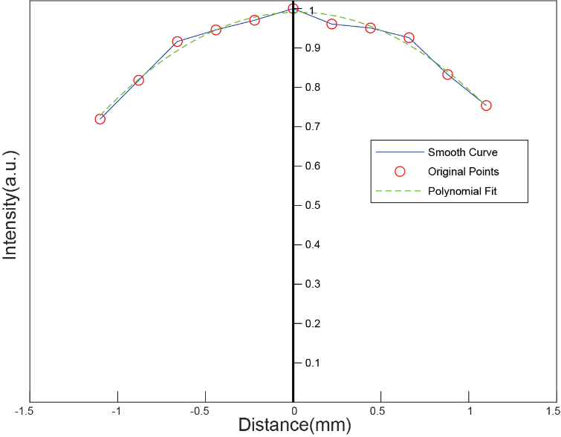
Fig. S4. Characterization of focused spot’s intensity

The maintenance of the consistency of focused spot intensity can ensure the accuracy and reliability of the data, and is vital in improving the quality and efficiency of NLOS imaging. When the target object falls outside the initial scanning range, refocusing the emitted light beam is necessary. Employing field of view stitching technology enables high-precision imaging of larger-sized target objects. Moreover, if the target object is sensitive to the polarization state of light, SNR fluctuations in the echo signal may occur, even if the light spot's intensity remains stable. Therefore, specifically adjusting the polarization state to optimize and maximize the echo signal's SNR is crucial for ensuring signal quality.
S3. Vectorial adaptive optics
Owing to the depolarized effect of the scattering wall, the optimal polarization is not selected by the theoretical model but via feedback iteration. To verify the polarization adaptability, a polarizer was placed at the diffuser position and rotated to an arbitrary angle to attenuate the light spot intensity. Then, the incident polarization is optimized via feedback iteration to maximize the echo intensity. The corresponding results of the polarization adaptability are shown in Fig. S5.
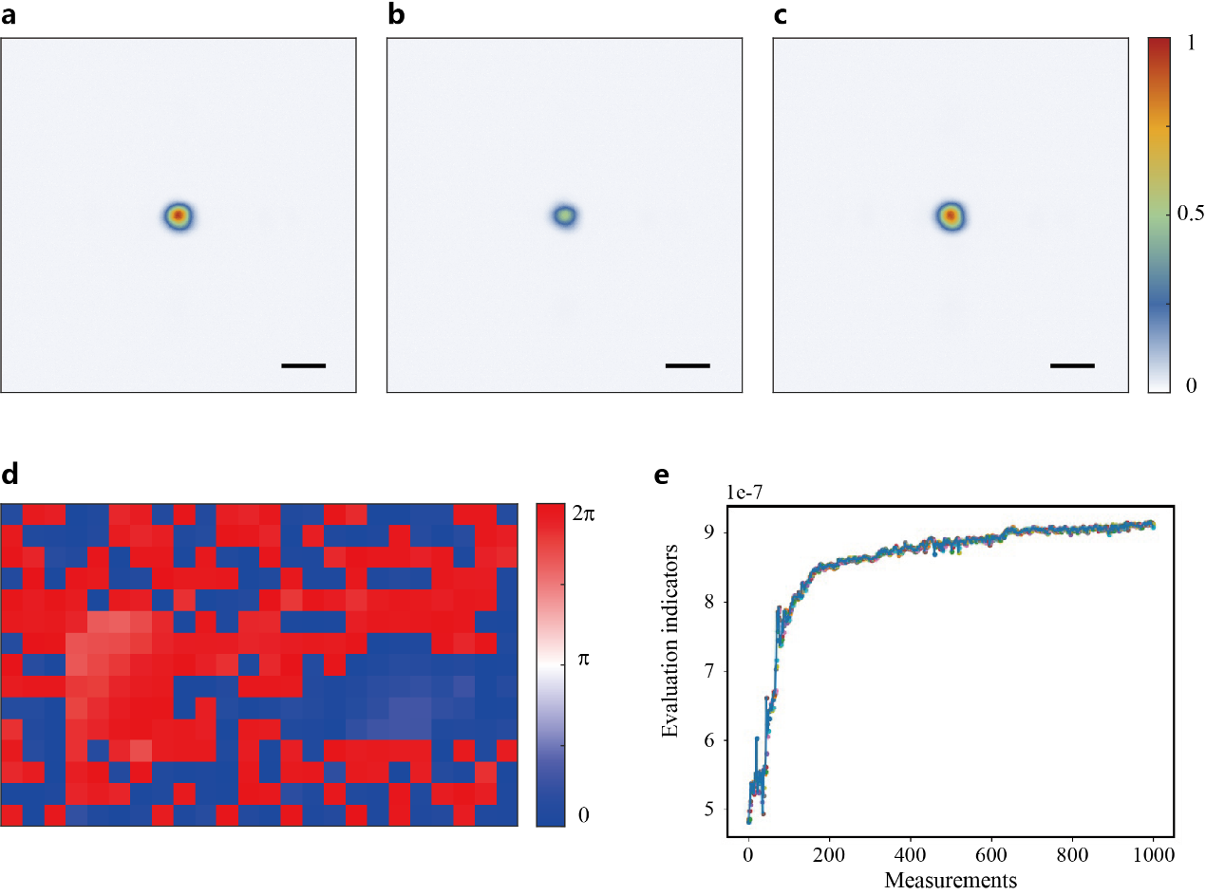
Fig. S5. Polarization adaptability test results. (a) Initial light spot. (b) Light spot after attenuation by the polarizer. (c) Corrected light spot. (d) Phase distribution that used for correction. (e) Measurement count and evaluation metrics during SPGD algorithm operation. Scale bar: 220 μm.

The results show that the system can effectively correct the polarization differences caused by the polarizer. To further assess the system’s capabilities, a turbulence plate was added behind the polarizer, introducing wavefront differences. The combination of the polarizer and turbulence plate introduced vectorial aberrations, presenting a higher challenge to the system's adaptability to these aberrations. Tests were conducted on the system's ability to adaptively respond to the vectorial aberrations produced by the combination of the polarizer and turbulence plate. The results are presented in Fig. S6.
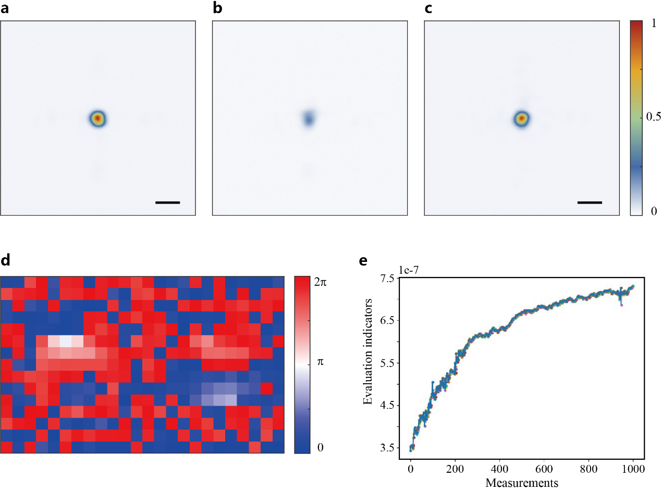
Fig. S6. Vector adaptability test results. (a) Initial light spot. (b) Light spot after interference by the polarizer and turbulence plate. (c) Corrected light spot. (d) Phase distribution used for correction. (e) Measurement count and evaluation metrics during SPGD algorithm operation. Scale bar: 220 μm.

The test results clearly demonstrate the system’s effectiveness in correcting vectorial aberrations, thereby confirming its capability in vector adaptability. To further explore the system’s performance, a more in-depth analysis of the experimental setup was conducted. It was noted that the only difference between the two experiments was the addition of a turbulence plate, and the phase distributions used for correction in each experiment were different. A natural question was could the difference between the two phase distributions be utilized to correct the effects of the turbulence plate. To verify this hypothesis, in subsequent experiments, the previously used polarizer was removed, retaining only the turbulence plate. The difference in the phase distributions from the first and second tests was used to correct for the effects of the turbulence plate. The results of this experiment are presented in Fig. S7.
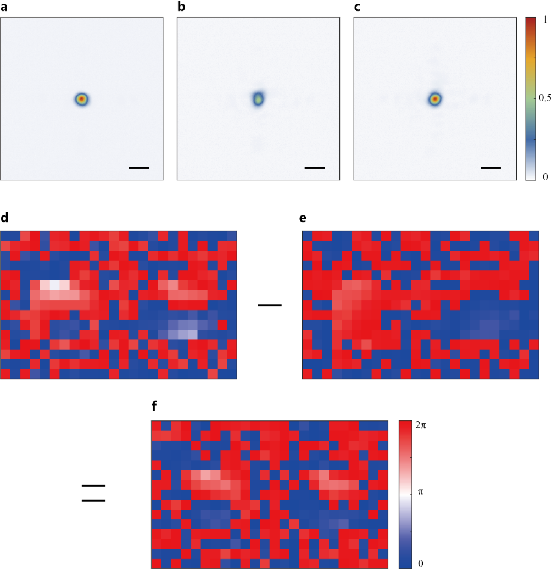
Fig. S7. Addressing turbulence distortions with calculated phase corrections - process and results. (a) Initial light spot. (b) Light spot after turbulence plate interference. (c) Corrected light spot using calculated phase. (d) Phase distribution for vector aberration correction. (e) Phase distribution for polarization optimization. (f) Calculated phase distribution for turbulence mitigation. Scale bar: 220 μm.

The experimental results effectively demonstrate the system’s success in generating VOF using the coherent beam combining method. The key factor is the precise modulation of both the wavefront distribution and the polarization state of the light beam, achieved by applying different phases to the left and right areas of a single SLM. This approach endows the system with vector adaptability, enabling flexible handling of various scattering and polarization conditions for more accurate light field control and imaging results.
S4. Turbulence-resilient NLOS imaging
Long-range NLOS imaging is highly desired but one of the main challenges is how to resist the influence of turbulence. Recent studies have shown that VOF possess turbulence-resist properties [8–10]. Our VDO empowered NLOS imaging technology, potentially compensates for turbulence distortion by VOF shaping, thus offering turbulence-resilient imaging capabilities. To validate this capability, we placed a random phase plate to mimic the turbulence in front of the focused spot and compared imaging results with and without the turbulence phase plate, and after correcting for the turbulence phase plate.
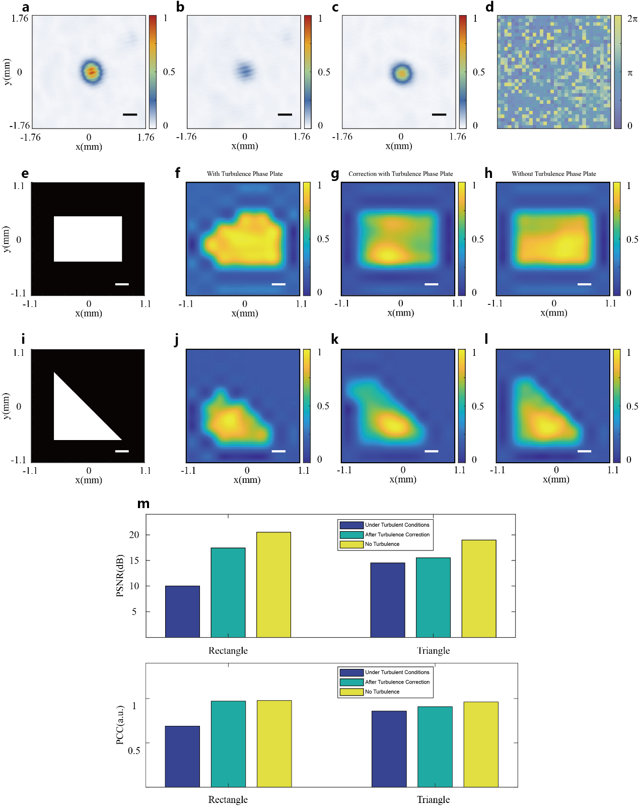
Fig. S8. Turbulence -resilient NLOS imaging experiment results. (a) Optimized focused spot. (b) Turbulence-affected focused spot. (c) Corrected focused spot post-turbulence. (d) Phase pattern for turbulence correction. (e),(i) Schematic of the imaging objects. (f),(j) Imaging results with turbulence phase plate. (g),(k) Corrected imaging results with turbulence phase plate. (h),(l) Ideal imaging results without turbulence phase plate. (m) PSNR and PCC values of the imaging results. Scale bars: 220 μm in (a)-(c); 260 μm in (e)-(l).

The experimental results indicate that random turbulent phase plate causes a decrease in the intensity of the focused spot and partial information lossing, as depicted in Figs. S8(b), (f) and (j). After implementation of vector AO, the intensity of the focused spot is partially restored, as illustrated in Figs. S8(a) and (c). The pre-compenstaed phase distribution is illustrated in Fig. S8(d). The corrected image more closely replicates the imaging effect of the object in turbulence-free conditions, as shown in Figs. S8(g), (h), (k) and (l). This improvement is also evident in the increased PSNR and PCC, as shown in Fig. S8(m). Obvoiusly, the upgraded results via vectorial digitelligent optics show higher PSNR and PCC compared to the original ones.
References
[1] Vorontsov M A, Sivokon V P Stochastic parallel-gradient-descent technique for high-resolution wave-front phase-distortion correction. JOSA A 1998;15(10):2745-58.
[2] Tyson R K, Frazier B W. Principles of adaptive optics. editors. CRC press; 2022.
[3] He C, Antonello J, Booth M J Vectorial adaptive optics. eLight 2023;3(1):23.
[4] Wu Z, Luo J, Feng Y, Guo X, Shen Y, Li Z Controlling 1550-nm light through a multimode fiber using a hadamard encoding algorithm. Optics express 2019;27(4):5570-80.
[5] Freund I, Rosenbluh M, Feng S Memory effects in propagation of optical waves through disordered media. Physical review letters 1988;61(20):2328.
[6] Feng S, Kane C, Lee P A, Stone A D Correlations and fluctuations of coherent wave transmission through disordered media. Physical review letters 1988;61(7):834.
[7] Osnabrugge G, Horstmeyer R, Papadopoulos I N, Judkewitz B, Vellekoop I M Generalized optical memory effect. Optica 2017;4(8):886-92.
[8] Zhou H, Su X, Duan Y, Song H, Zou K, Zhang R, et al. Atmospheric turbulence strength distribution along a propagation path probed by longitudinally structured optical beams. Nature Communications 2023;14(1):4701.
[9] Zhang Z, Li G, Liu Y, Wang H, Hoenders B J, Liang C, et al. Robust measurement of orbital angular momentum of a partially coherent vortex beam under amplitude and phase perturbations. Opto-Electronic Science 2024;3(1):240001-1--12.
[10] Liu Y, Chen Y, Wang F, Cai Y, Liang C, Korotkova O Robust far-field imaging by spatial coherence engineering. Opto-Electron. Adv. 2021;4(12):210027.

