Supplementary data for
Compound Metalens Enabling Distortion-Free Imaging
Hanyu Zheng ª, Fan Yang ^{b}, Hung-I Lin ^{a,b}, Mikhail Y. Shalaginov ^{a,b}, Zhaoyi Li ª, Padraic Burns ^{b}, Tian Gu ^{a,b,c,}*, Juejun Hu ^{a,b,c,}*
ª Department of Materials Science and Engineering, Massachusetts Institute of Technology, Cambridge, MA 02139, USA
^{b} 2Pi Inc., Cambridge, MA 02139, USA
^{c} Materials Research Laboratory, Massachusetts Institute of Technology, Cambridge, MA 02139, USA

*Corresponding authors.
E-mail addresses: gutian@mit.edu (T. Gu); hujuejun@mit.edu (J. Hu).
S1. Meta-atom desgin
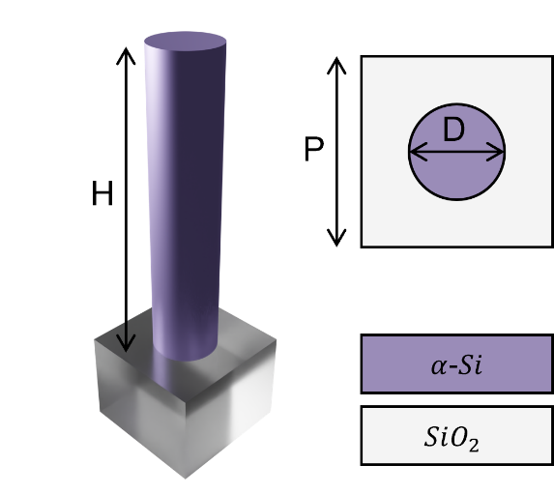
Fig. S1. Schematic of the meta-atom. An amorphous silicon pillar sitting on a fused silica substrate was used as the basic meta-atom structure. The height of silicon is 0.74 μm, the period is fixed at 0.32 μm, and the diameter varies from 0.08 μm to 0.24 μm to offer the entire $2π$ phase control.
S2. Analytical method for compound metalens design
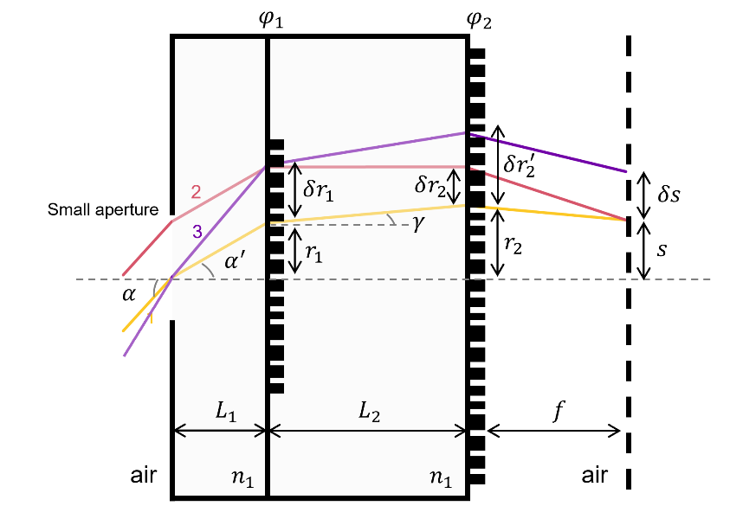
Fig. S2. Ray tracing schematic for the iterative derivation process to retrieve the phase gradient of compound metalens.
The chief ray (labeled as ray 1) is incident on the aperture with an incident angle of $α$ (in air) as shown in Fig. S2. The stigmatic imaging condition specifies that the edge ray (labeled as ray 2) must be focused onto the same image position $s$ with an identical optical path length (OPL) as ray 1. If the phase delays imparted by the two metasurfaces $φ_{1}(r_{1})$ and $φ_{2}(r_{2})$ at $r_{1}$, $r_{2}$ are known, the next step in the iterative solution process is to solve the phases at $r_{1}+δr_{1}$ and $r_{2}+δr_{2}$. Here we presume the small aperture limit, i.e. $δr_{1}$ and $δr_{2}$ are infinitesimal in the following derivation.
According to the Snell’s law, the incident angle $α$ and $r_{1}$ are related through:
$r_{1}=L_{1}∙tan⁡\{\sin^{-1}{[{sin⁡(α)}/{n_{1}}]}\}$ (S1)
Here, $n_{1}$ is the refractive index of the substrate material between the aperture and the first metasurface. $γ$ and $α$ must satisfy the following equation:
$\sin\left(γ\right)={[\sin\left(α\right)+{φ_{1}^{'}(r_{1})}/{k_{0}}]}/{n_{1}}$ (S2)
Here $k_{0}$ is the wave number in vacuum and $φ_{1}^{'}$ is the phase gradient of the first metasurface. $r_{2}$, $r_{1}$ and $γ$ follow:
$r_{2}=r_{1}+L_{2}∙tan⁡(γ)$ (S3)
For a given image height $s$, the phase gradient of the second metasurface $φ_{2}^{'}(r_{2})$ can be calculated using:
$φ_{2}^{'}\left(r_{2}\right)=k_{0}\{\sin\left[\tan^{-1}\left(\frac{s-r_{2}}{f}\right)\right]-n_{1}∙sin⁡(γ)\}$ (S4)
Now consider the ray 2 which is parallel to ray 1 and is incident on the first metasurface at a position $r_{1}+δr_{1}$. Denoting that the phase gradient at $r_{1}+δr_{1}$ is $φ_{1}^{'}(r_{1}+δr_{1})$, we can solve ray 2’s incident position on the second metasurface, $r_{2}+δr_{2}$, and corresponding phase gradient, $φ_{2}^{'}(r_{2}+δr_{2})$ using Eqs. (S2) – (S4).
Next, we consider ray 3, which passes through the center of the aperture and incident upon the first metasurface at $r_{1}+δr_{1}$. Using the target AOI-dependent image height function, $s=c∙α$, $s+δs$ can be trivially calculated. Similarly, using Eqs. (S1)–(S4), we can obtain ray 3’s incident position on the second metasurface $r_{2}+δr_{3}$ and the local phase gradient $φ_{2}^{'}(r_{2}+δr_{3})$.
The following equation holds in the small aperture limit considering $δr_{2}$ and $δr_{3}$ is a small value:
$\frac{φ_{2}^{'}\left(r_{2}+δr_{3}\right)-φ_{2}^{'}(r_{2})}{δr_{3}}=\frac{φ_{2}^{'}\left(r_{2}+δr_{2}\right)-φ_{2}^{'}(r_{2})}{δr_{2}}$ (S5)
By combining Eqs. (S1)–(S5), we can calculate $φ_{1}^{'}(r_{1}+δr_{1})$ and $φ_{2}^{'}\left(r_{2}+δr_{2}\right)$. The phase delays $φ_{1}(r_{1}+δr_{1})$ and $φ_{2}\left(r_{2}+δr_{2}\right)$ can then be computed from $φ_{1}(r_{1})$ and $φ_{2}(r_{2})$ by finite difference. The iterative process is achieved by setting an initial value of $φ_{1}\left(0\right)$, $φ_{2}(0)$, $φ_{1}^{'}(0)$, and $φ_{2}^{'}(0)$, then repeating above process to calculate $φ_{1}(r_{1})$ and $φ_{2}\left(r_{2}\right)$ for each step $δr_{1}$ and $δr_{2}$. Polynomials were then used to fit the calculated phase profile, with the coefficients being set as the initial condition for the numerical optimization process.
S3. Impact of front aperture size
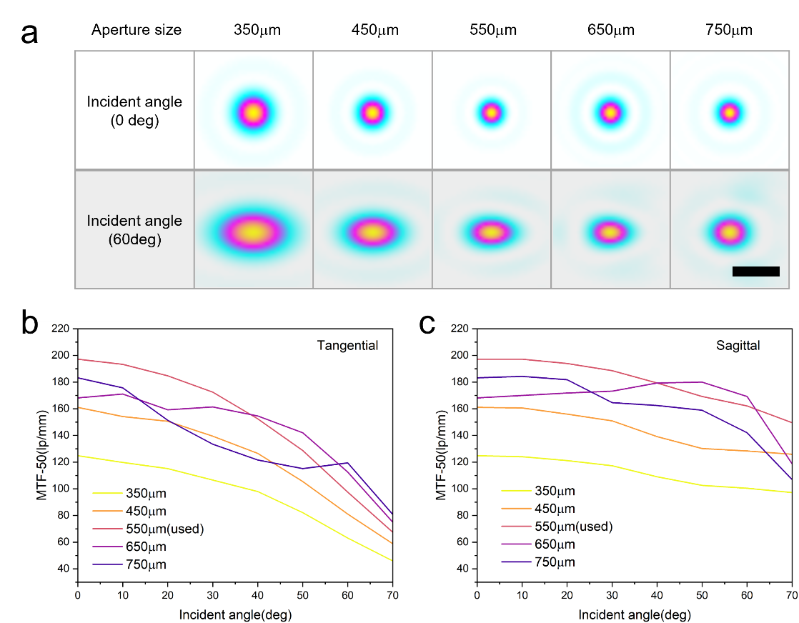
Fig.S3. Impact of the aperture size on PSF of the compound metalens. (a) Comparison of focal spot profile with different aperture sizes. Two different incident angles were chosen for comparison. Scale bar: 5 μm. (b) The MTF-50 curve along tangential and (c) sagittal directions in terms of the incident angle and different aperture sizes.
Optical throughput and aberration suppression present a trade-off as the aperture size changes. Larger aperture introduces more monochromatic aberration whereas smaller aperture limits optical throughput of the system. To demonstrate this, the simulated focal spot profiles and MTF-50 curves as functions of the incident angle are shown in Fig. S3. With an increase of the front aperture size, the MTF-50 drops for most of the incident angles due to the additional PSF aberration. However, there is also a trade-off for the imaging resolution when reducing the aperture size, which will limit the input power and the numerical aperture. This can be verified by the enlarged focal spot and reduced MTF-50 in Fig. S3 when using a larger front aperture.
S4. Evaluating the impact of misalignment in compound metalens assembly
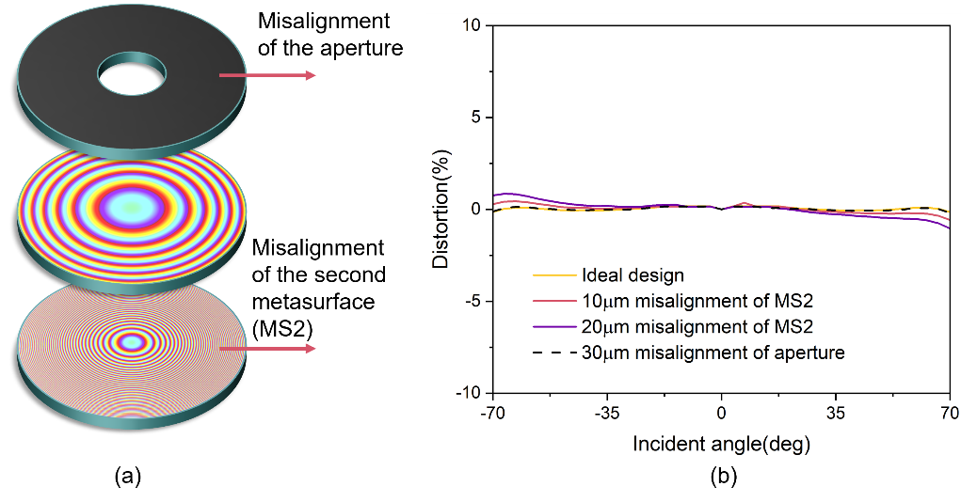
Fig. S4. Illustration of misalignment effects in the compound metalens. (a) Schematic showing the misalignment types. (b) The distortion in terms of incident angle under different misalignment cases.
To assess alignment tolerance of the compound metalens assembly process, we calculated the image distortion in terms of the incident angle under different misalignment cases as shown in Fig. S4. The imaging distortion is minimal (below 2%) with 20 μm misalignment of the second metasurface relative to the first one. The assembly is even more tolerant to misalignment between the front aperture piece and the first metasurface, which show negligible impacts on distortion for up to 30 μm misalignment.
The corresponding MTF-50 curves were also calculated as a function of incident angle under different misalignment situations as shown in Fig. S5. The lateral misalignment of the front aperture and metasurface will result in asymmetrical variation in the MTF-50 curve within the interested FOV. In general, misalignment of the front aperture only has a negligible effect on the MTF, even with 30 μm lateral shift. Since the automatic bonding system used for metalens assembly offers better than 10 μm alignment accuracy, we expect that misalignment introduced during the assembly process does not adversely affect the lens performance.
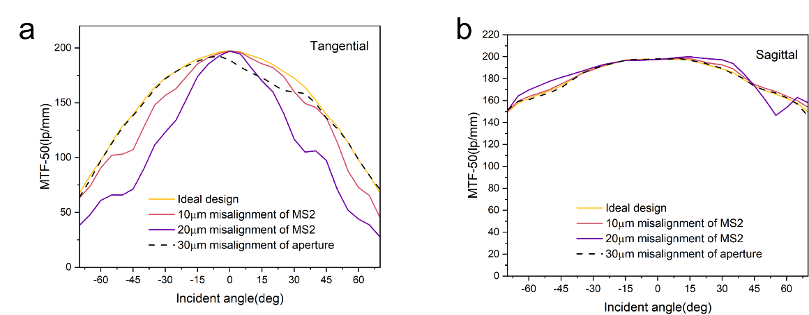
Fig.S5. MTF analysis on misalignment impact. (a) and (b) demonstrate the MTF-50 curves along tangential and sagittal directions, respectively, as a function of the incident angle.
S5. Asymetrical PSF under high incident angle
The asymmetrical PSF under high incident angle can be explained by Fig. S6, where we calculated the variation of the field distribution over the second layer metasurface with an increase of the incident angle. With increasing incident angle, the field distribution along the radial direction will be compressed by the first layer metasurface, while the azimuthal field profile is barely affected. This results in an asymmetric entrance aperture as well as different effective numerical apertures along the tangential and sagittal directions when forming the focal spot.
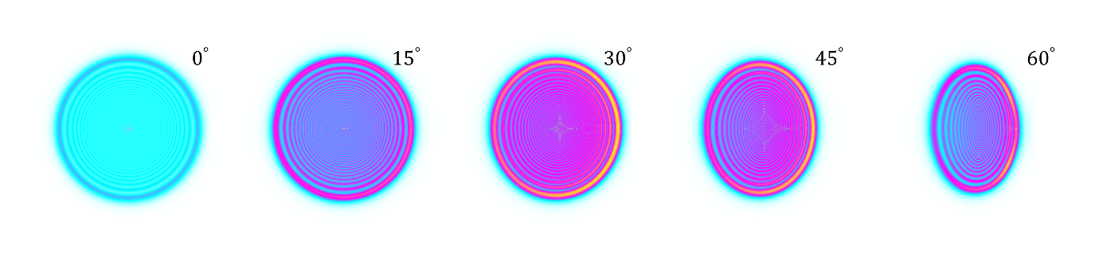
Fig.S6. Schematics of the entrance field upon second metasurface layer with different incident angles.
S6. Schematic of imaging characterization setup
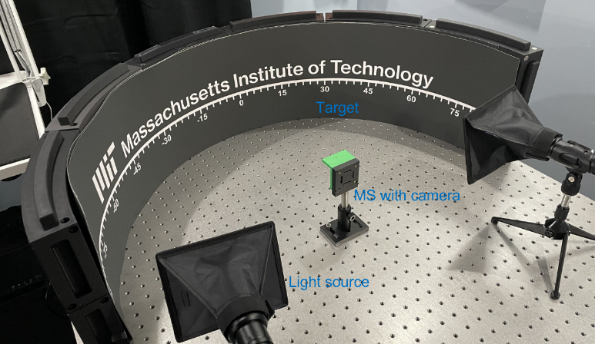
Fig. S7. Schematic of the imaging setup.

