Supplementary Information for

Bio-Printed Hydrogel Textiles Based on Fish Skin Decellularized Extracellular Matrix for Wound Healing
Xiang Lin ^{a,b}, Han Zhang ª, Hui Zhang ª, Zhuohao Zhang ª, Guopu Chen ª, Yuanjin Zhao ^{a,b,c,}*
ª Department of Rheumatology and Immunology, Nanjing Drum Tower Hospital, School of Biological Science and Medical Engineering, Southeast University, Nanjing 210096, China
^{b} Oujiang Laboratory (Zhejiang Lab for Regenerative Medicine, Vision, and Brain Health) & Wenzhou Institute, University of Chinese Academy of Sciences, Wenzhou 325001, China
^{c} Chemistry and Biomedicine Innovation Center, Nanjing University, Nanjing 210023, China

* Corresponding author.
E-mail address: yjzhao@seu.edu.cn (Y. Zhao)

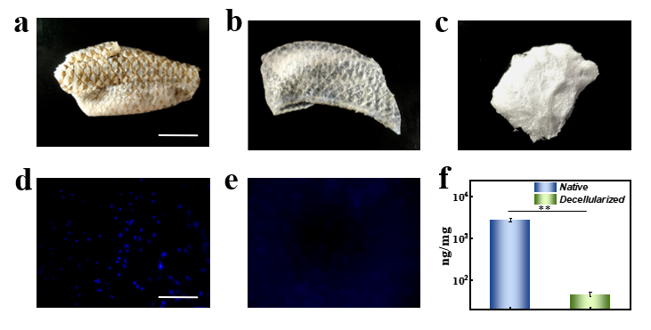
Fig. S1. (a) Tilapia fish skin before decellularization; (b) decellularized tilapia fish skin; (c) freeze-dried FSdMA white foam-like solid; (d, e) the DAPI stain of fish skin (d) before and (e) after decellularization (n = 3); (f) DNA quantification in native and acellular tilapia fish skin, the error bar represents standard deviation, ** p < 0.01. The scale bars are 3 cm in (a) and 100 μm in (d).

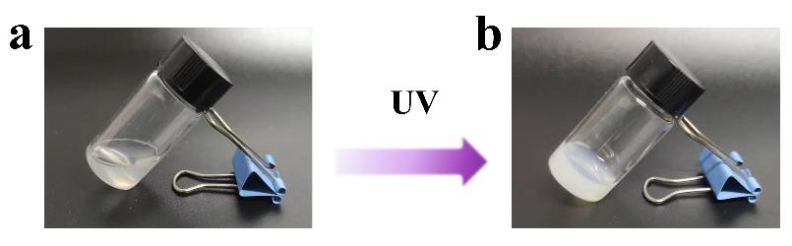
Fig. S2. (a) The FSdMA solution at room temperature; (b) the crosslinked hydrogel after being treated with UV rays.

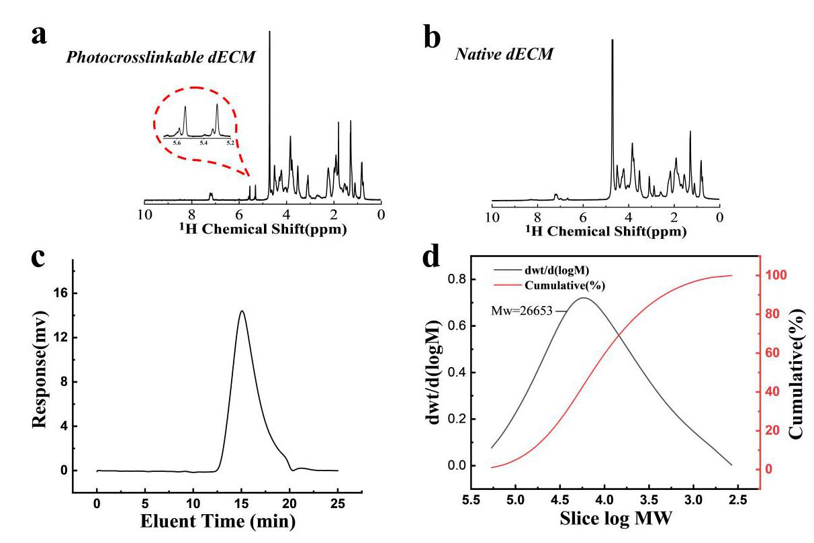
Fig. S3. ¹H NMR of (a) photo-crosslinkable dECM and (b) native dECM in D₂O. (c) The eluent time–response curve; (d) GPC result of molecular weight distribution.

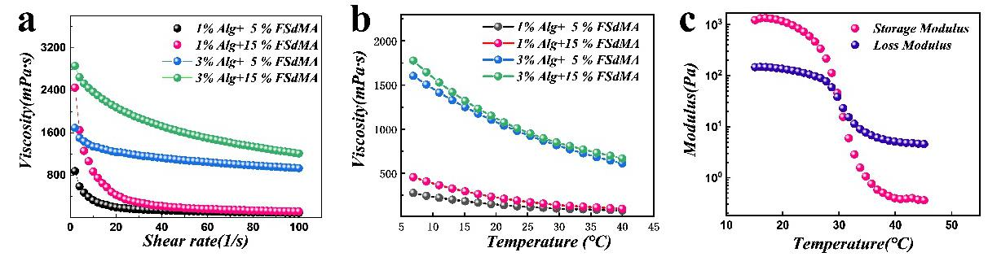
Fig. S4. (a) Viscosity curves with different shear rates; (b) viscosity curves with different temperature changes; (c) the relationship between storage modulus and loss modulus with temperature changes, the ink contains 15%/3% FSdMA/Alg.

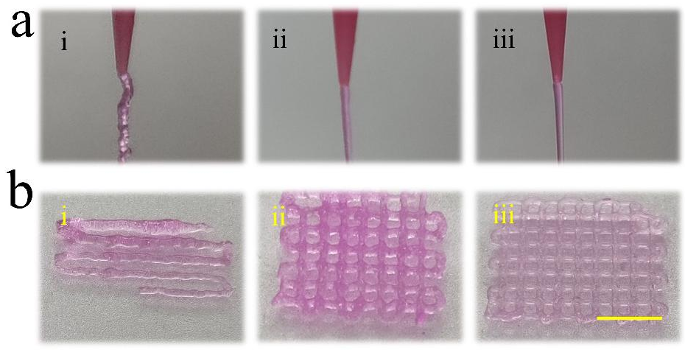
Fig. S5. (a) Extruding process and (b) corresponding morphology images of printed textiles with (i) 15%/1% FSdMA/Alg, (ii) 15%/3% FSdMA/Alg, and (iii) 15%/5% FSdMA/Alg. The scale bar is 5 mm.

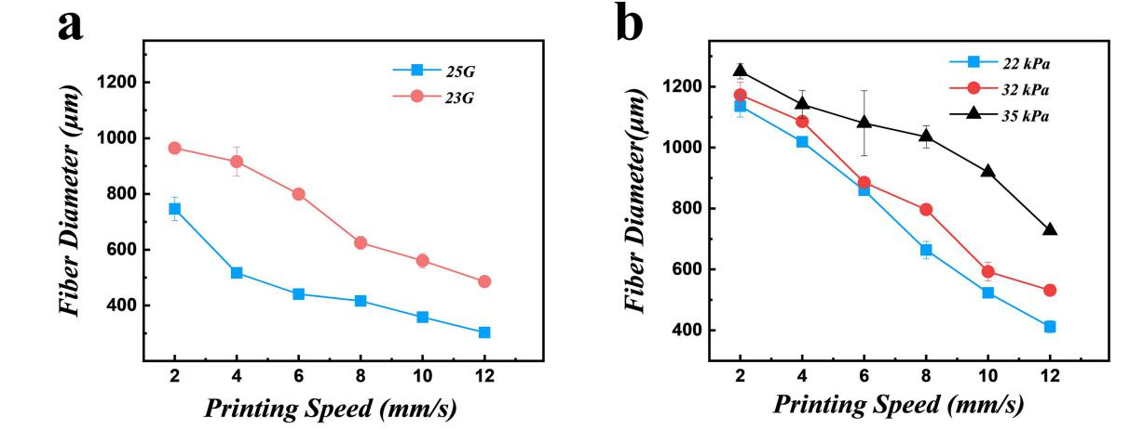
Fig. S6. (a) Effect of nozzle diameter D on printed fiber diameter, needles of 23 (inner diameter: 330 μm) and 25 (inner diameter: 250 μm) gauge were used for extrusion; (b) effect of air pressure P on printed fiber diameter.

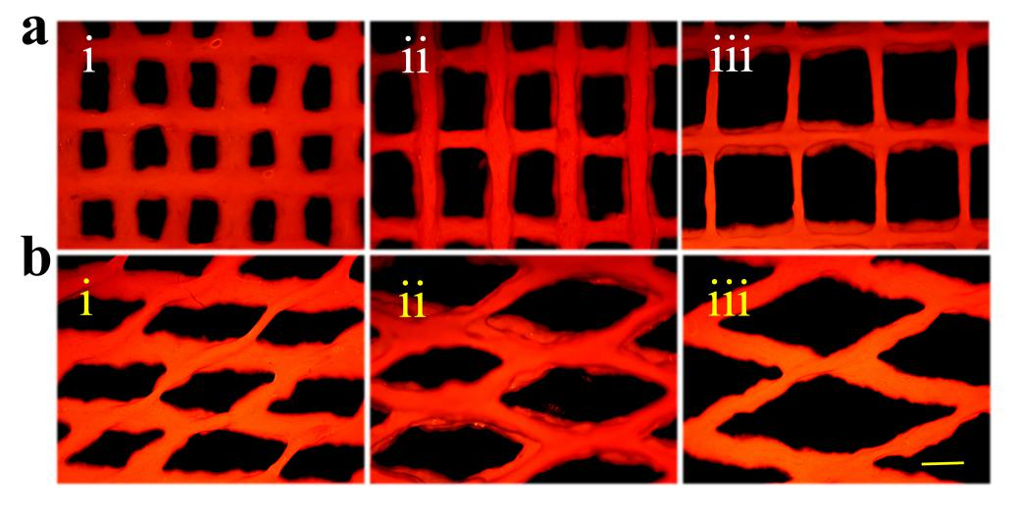
Fig. S7. (a) Fluorescence images of textiles under the cross angle of 90° and the printing spacing is (i) 800 μm, (ii) 1000 μm, and (iii) 1200 μm, respectively; (b) fluorescence images of textiles under the cross angle of 30° and the printing spacing is (i) 800 μm, (ii) 1000 μm, and (iii) 1200 μm, respectively. The scale bar is 500 μm.

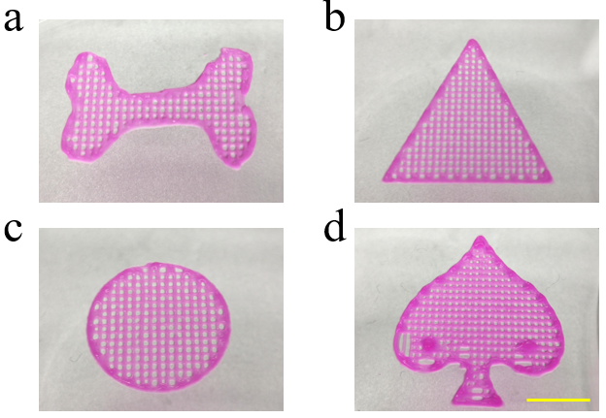
Fig. S8. Optical images of (a) a printed dog bone, (b) a printed triangle, (c) a printed round textile, and (d) a printed Spades scaffold. Scale bar is 1 cm.

Fig. S9. (a) The standard release curve of RhB in the PBS solution, R² > 0.99; (b) the standard release curve of FITC-BSA in the PBS solution, R² > 0.99; (c) the standard release curve of Cur in the PBS solution (containing 0.5% Tween 80), R² > 0.99; (d) the release condition of the Cur-loaded textiles and the lower right curve is that within 6 h (n = 3); the error bar represents standard deviation.

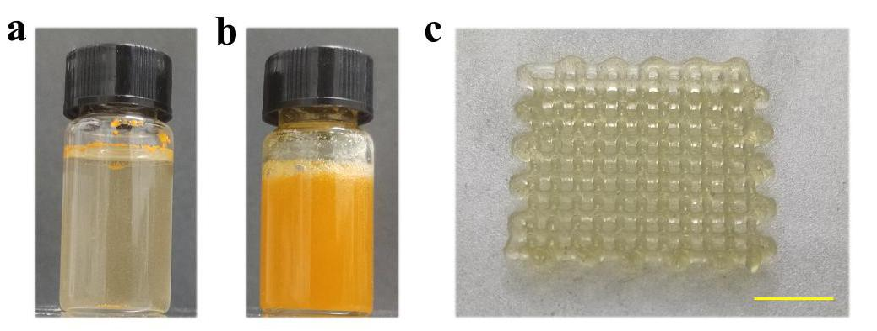
Fig. S10. (a) Photograph of curcumin in water; (b) photograph of curcumin in mixed hydrogel; (c) printed Cur-loaded hydrogel textile. The scale bar is 5 mm.

Fig. S11. (a) Fluorescence microscope images of the 3T3 cells grow on the surface of (Ⅰ) well-plate only, (Ⅱ) commercial porcine collagen group, (Ⅲ) fish skin dECM group, and (Ⅳ) FsdMA/Alg ink group after 3 days of incubation; (b) the statistical graph of cell viability in different groups on Days 1, 2, and 3. NS stands for not significant. The scale bar is 100 μm.

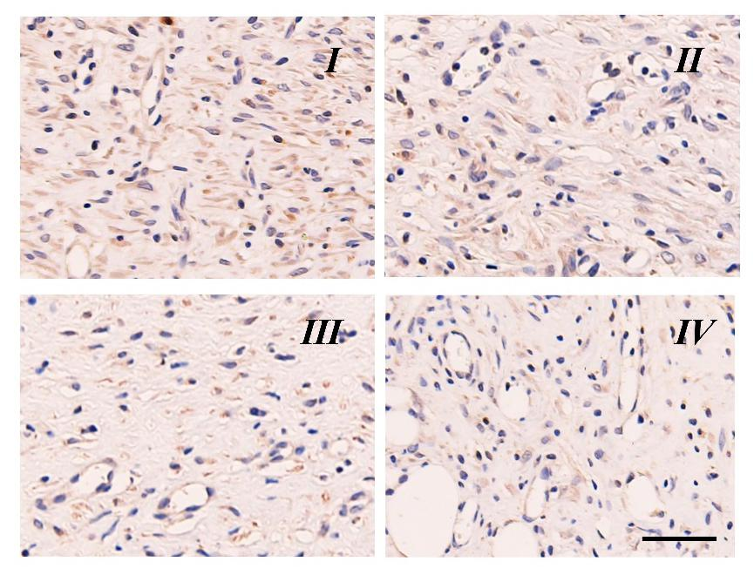
Fig. S12. Corresponding immunohistochemistry staining of IL-6 on Day 9. The scale bar is 100 μm.

