Supplementary file for
Unveiling the mechanism of ammonia affecting n-caproate production: focusing on the influenced pathways, key enzymes, and microbiota functions
Qing-Lian Wu ^{a,b}, Ke-Xin Yuan ª, Wei-Tong Ren ª, Lin Deng ª, Hua-Zhe Wang ª, Xiao-Chi Feng ^{c}, He-Shan Zheng ^{d}, Nan-Qi Ren ª, Wan-Qian Guo ^{a,}*
ª State Key Laboratory of Urban Water Resource and Environment, Harbin Institute of Technology, Harbin 150090, China
^{b} College of Architecture and Environment, Sichuan University, Chengdu 610065, China
^{c} State Key Laboratory of Urban Water Resource and Environment, School of Civil and Environmental Engineering, Harbin Institute of Technology (Shenzhen), Shenzhen 518055, China
^{d} College of Chemistry and Chemical Engineering, Qiqihar University, Qiqihar 161006, China

* Corresponding author.
E-mail address: guowanqian@126.com (W.Q. Guo)

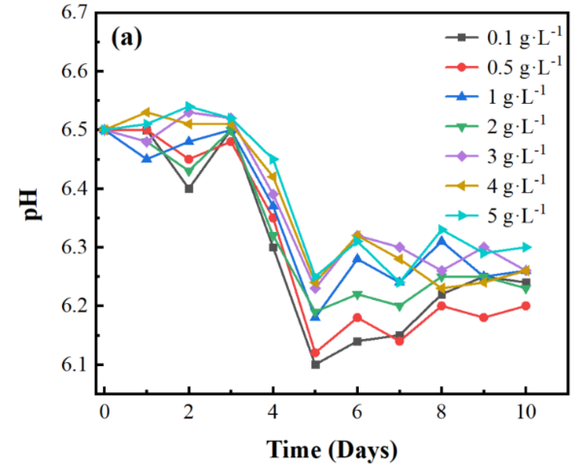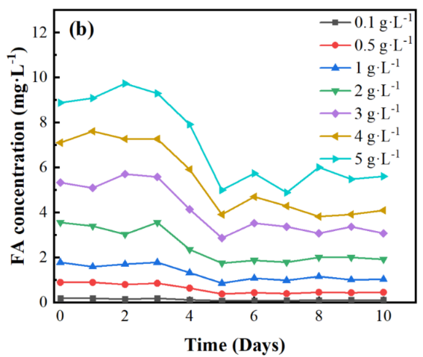
Fig. S1. Variations of the pH and FA concentration under different ammonia dosages.

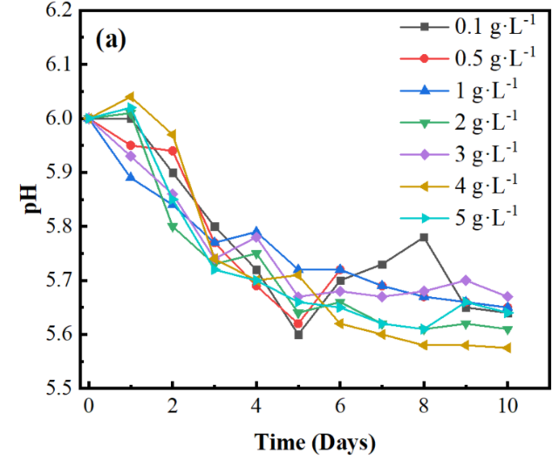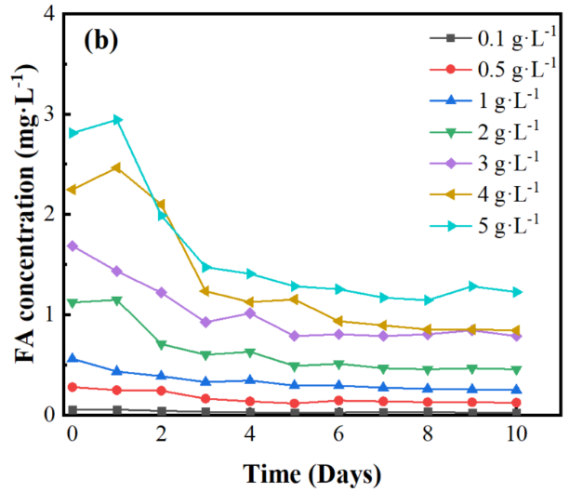
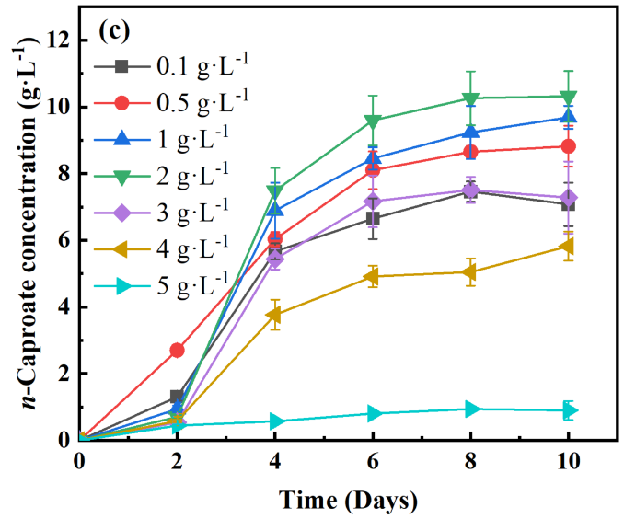
Fig. S2. (a) Variations of pH, (b) FA concentration, and (c) n-caproate productionunder different ammonia dosages at an initial pH 6.

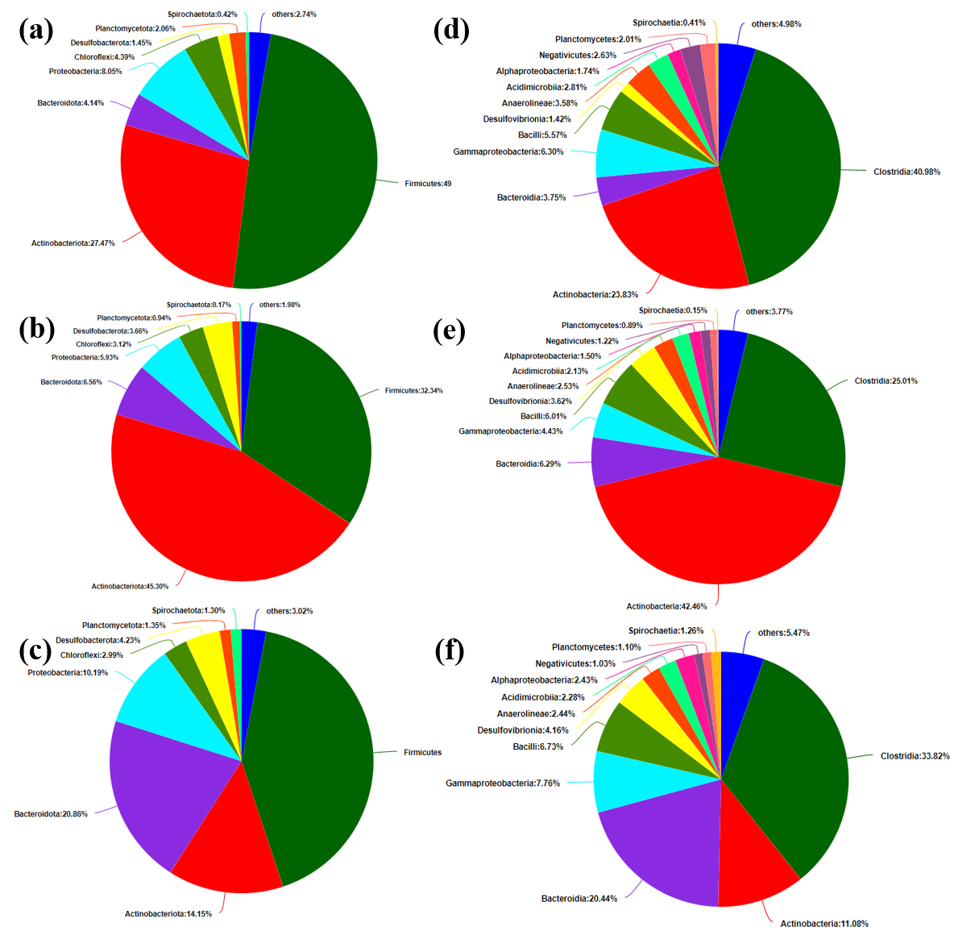
Fig. S3. Microbial community structures: the relative abundance at phylum level at (a) control, (b) 2 g/L ammonia, and (c) 5 g/L ammonia; the relative abundance at class level at (d) control, (e) 2 g/L ammonia, and (f) 5 g/L ammonia.

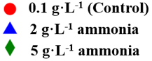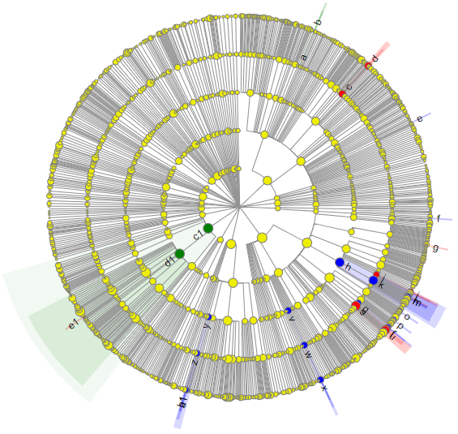
(a)
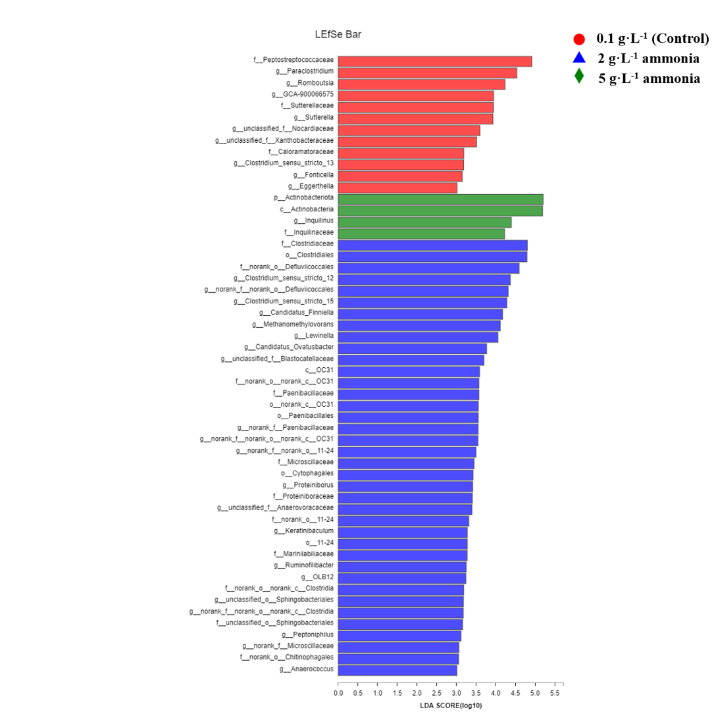
(b)
Fig. S4. (a) Taxonomic cladogram from LEfSe analysis. The phylum, class, order, family and genus levels are listed in order from inside to outside of the cladogram, where a: family Inquilinaceae, b: genus Inquilinus, c: family Sutterellaceae, d: genus Sutterella, e: genus Candidatus Ovatusbacter, f: genus Methanomethylovorans, g: genus GCA , h: order Clostridiales, i: family Caloramatoraceae, j: genus Fonticella, k: family Clostridiaceae, l: genus Clostridium sensu stricto 13, m: genus Clostridium sensu stricto 12, n: genus Clostridium sensu stricto 15, o: genus Peptoniphilus, p: family Anaerovoracaceae, q: family Proteiniboraceae, r: genus Proteiniborus, s: family Peptostreptococcaceae, t: genus Romboutsia, u: genus Paraclostridium, v: order Paenibacillales, w: family Paenibacillaceae, x: genus norank family Paenibacillaceae , y: order Cytophagales, z: family Microscillaceae, a1: genus OLB12 , b1: genus norank family Microscillaceae, c1: phylum Actinobacteriota, d1: class Actinobacteria, e1: family Nocardiaceae. (b) LDA values of the discriminative microbial taxa at control, 2 g·L⁻¹ ammonia, and 5 g·L⁻¹ ammonia reactors.

