Supplementary data for

Freezing-Extraction/Vacuum-Drying Method for Robust and Fatigue-Resistant Polyimide Fibrous Aerogels and Their Composites with Enhanced Fire Retardancy
Kaiqing Yao ª, Chonghu Song ª, Hong Fang ª, Feng Wang ^{b}, Lian Chen ^{b}, Shaohua Jiang ^{b}*, Guojun Zha ^{c}, Haoqing Hou ª*
ª Department of Chemistry and Chemical Engineering, Jiangxi Normal University, Nanchang 330022, China
^{b} Jiangsu Co-Innovation Center of Efficient Processing and Utilization of Forest Resources, International Innovation Center for Forest Chemicals and Materials, College of Materials Science and Engineering, Nanjing Forestry University, Nanjing, 210037, China
^{c} School of New Energy Science and Engineering, Xinyu University, Xinyu 330020, China

*Corresponding authors.
E-mail addresses: shaohua.jiang@njfu.edu.cn (S. Jiang); haoqing@jxnu.edu.cn (H. Hou)
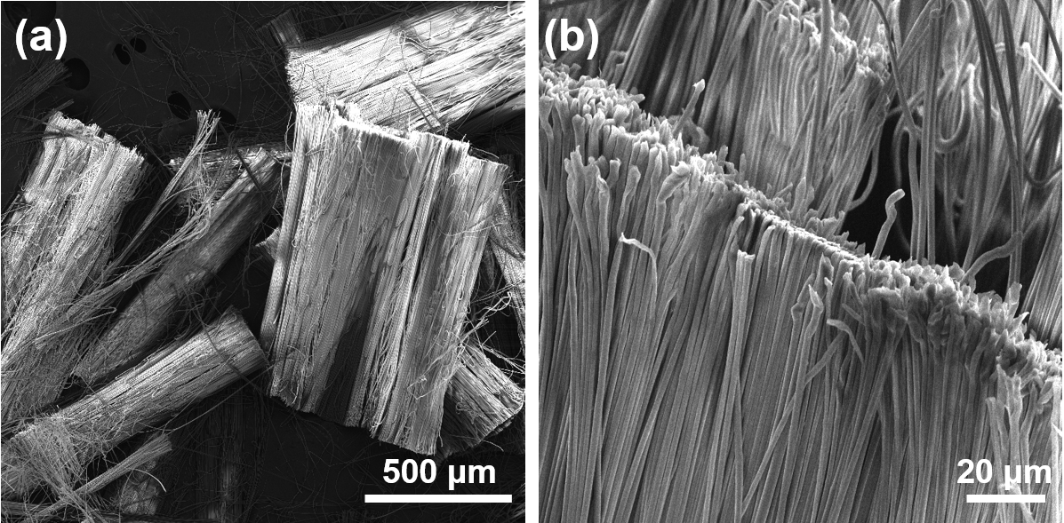
Figure S1. SEM images of short PI fibers with average length of 1 mm and average diameter of 1.2 μm.

Table S1. Characteristics of different methods for the preparation of PI aerogels or sponges.

Sample | Method | Density,  mg cm⁻³ | Reversible compression cycles | Duration of preparation | Thermal conductivity  mW m⁻¹ K⁻¹ | Reference
PI-based aerogels | Vacuum drying | 39.1-52.8 | 20000 | 10h | 36-44 | This work
PI aerogels | Supercritical drying | 100-110 | 1 | 50h | - | [1]
PI aerogels | Supercritical drying | 86-296 | 1 | 72h | - | [2]
PI aerogels | Supercritical drying | 78-226 | 1 | 72h | - | [3]
PI aerogels | Supercritical drying | 77-177 | 1 | 72h | - | [4]
Cellulose/ PI aerogels | Freeze drying | - | 1 | 50h | - | [5]
PI aerogels | Supercritical drying | 71-226 | 1 | 72h | - | [6]
PI/cellulose aerogels | Supercritical drying | 120-300 | 1 | 84h | - | [7]
PI sponges | Freeze drying | 7.6-10.1 | 10000 | 50h | 22-33 | [8]
PI aerogels | Supercritical drying | 70-198 | 1 | 72h | - | [9]
PI composite aerogels | Freeze drying | 100 | 1 | 48h | - | [10]
PI/CNT aerogels | Freeze drying | 84-117 | 1 | 48h | - | [11]
PI composite aerogels | Freeze drying | 70 | 1 | 48h | 21.8-33.2 | [12]
PI/graphene aerogels | Freeze drying | - | 100 | 74h | - | [13]
PI aerogels | Freeze drying | 54.4-62.8 | 1 | 48h | 38.8-40.4 | [14]
PI/cellulose aerogels | Freeze drying | 46 | 1 | 48h | 37-66 | [15]
PI composite aerogels | Freeze drying | - | 1000 | - | 40-46 | [16]
PI composite aerogels | Vacuum drying | 205-329 | 1 | 84h | - | [17]
PI aerogels | Supercritical drying | 200-300 | 1 | 54h | - | [18]
PI composite aerogels | Freeze drying | - | 50 | 54h | - | [19]

References
[1] H. Guo, M.A. Meador, L. McCorkle, D.J. Quade, J. Guo, B. Hamilton, M. Cakmak, G. Sprowl, Polyimide aerogels cross-linked through amine functionalized polyoligomeric silsesquioxane, ACS Applied Materials & Interfaces 3(2) (2011) 546-552.
[2] H. Guo, M.A. Meador, L. McCorkle, D.J. Quade, J. Guo, B. Hamilton, M. Cakmak, Tailoring properties of cross-linked polyimide aerogels for better moisture resistance, flexibility, and strength, ACS Applied Materials & Interfaces 4(10) (2012) 5422-5429.
[3] M.A. Meador, E. McMillon, A. Sandberg, E. Barrios, N.G. Wilmoth, C.H. Mueller, F.A. Miranda, Dielectric and other properties of polyimide aerogels containing fluorinated blocks, ACS Applied Materials & Interfaces 6(9) (2014) 6062-6068.
[4] M.A. Meador, C.R. Aleman, K. Hanson, N. Ramirez, S.L. Vivod, N. Wilmoth, L. McCorkle, Polyimide aerogels with amide cross-links: a low cost alternative for mechanically strong polymer aerogels, ACS Applied Materials & Interfaces 7(2) (2015) 1240-1249.
[5] F. Lai, Y.-E. Miao, L. Zuo, Y. Zhang, T. Liu, Carbon Aerogels Derived from Bacterial Cellulose/Polyimide Composites as Versatile Adsorbents and Supercapacitor Electrodes, ChemNanoMat 2(3) (2016) 212-219.
[6] M.A.B. Meador, M. Agnello, L. McCorkle, S.L. Vivod, N. Wilmoth, Moisture-Resistant Polyimide Aerogels Containing Propylene Oxide Links in the Backbone, ACS Applied Materials & Interfaces 8(42) (2016) 29073-29079.
[7] B.N. Nguyen, E. Cudjoe, A. Douglas, D. Scheiman, L. McCorkle, M.A.B. Meador, S.J. Rowan, Polyimide Cellulose Nanocrystal Composite Aerogels, Macromolecules 49(5) (2016) 1692-1703.
[8] S. Jiang, B. Uch, S. Agarwal, A. Greiner, Ultralight, Thermally Insulating, Compressible Polyimide Fiber Assembled Sponges, ACS Applied Materials & Interfaces 9(37) (2017) 32308-32315.
[9] B.N. Nguyen, M.A.B. Meador, D. Scheiman, L. McCorkle, Polyimide Aerogels Using Triisocyanate as Cross-linker, ACS Applied Materials & Interfaces 9(32) (2017) 27313-27321.
[10] L. Zuo, W. Fan, Y. Zhang, L. Zhang, W. Gao, Y. Huang, T. Liu, Graphene/montmorillonite hybrid synergistically reinforced polyimide composite aerogels with enhanced flame-retardant performance, Composites Science and Technology 139 (2017) 57-63.
[11] W. Fan, L. Zuo, Y. Zhang, Y. Chen, T. Liu, Mechanically strong polyimide / carbon nanotube composite aerogels with controllable porous structure, Composites Science and Technology 156 (2018) 186-191.
[12] W. Fan, X. Zhang, Y. Zhang, Y. Zhang, T. Liu, Lightweight, strong, and super-thermal insulating polyimide composite aerogels under high temperature, Composites Science and Technology 173 (2019) 47-52.
[13] R.-P. Ren, Z. Wang, J. Ren, Y.-K. Lv, Highly compressible polyimide/graphene aerogel for efficient oil/water separation, Journal of Materials Science 54(7) (2018) 5918-5926.
[14] X. Zhao, F. Yang, Z. Wang, P. Ma, W. Dong, H. Hou, W. Fan, T. Liu, Mechanically strong and thermally insulating polyimide aerogels by homogeneity reinforcement of electrospun nanofibers, Composites Part B: Engineering 182 (2020) 107624.
[15] X. Zhang, X. Zhao, T. Xue, F. Yang, W. Fan, T. Liu, Bidirectional anisotropic polyimide/bacterial cellulose aerogels by freeze-drying for super-thermal insulation, Chemical Engineering Journal 385 (2020) 123963.
[16] X. Zhang, W. Li, P. Song, B. You, G. Sun, Double-cross-linking strategy for preparing flexible, robust, and multifunctional polyimide aerogel, Chemical Engineering Journal 381 (2020) 122784.
[17] Y. Lin, C. Chen, S. Hu, D. Zhang, G. Wu, Facile Fabrication of Mechanically Strong and Thermal Resistant Polyimide Aerogels with an Excess of Cross-Linker, Journal of Materials Research and Technology 9(5) (2020) 10719-10731.
[18] B.N. Nguyen, D.A. Scheiman, M.A.B. Meador, J. Guo, B. Hamilton, L.S. McCorkle, Effect of Urea Links in the Backbone of Polyimide Aerogels, ACS Applied Polymer Materials 3(4) (2021) 2027-2037.
[19] Y. Zhou, S.-j. Wang, D.-s. Li, L. Jiang, Lightweight and recoverable ANF/rGO/PI composite aerogels for broad and high-performance microwave absorption, Composites Part B: Engineering 213 (2021) 108701.

