Supplementary Data for

Dual Protein-Based Nanocomposite Hydrogel Scaffolds Synergistically Promote Cartilage Regeneration Through Chondrocyte Differentiation and Immunomodulation
Huan Lei, Daidi Fan *
Shaanxi Key Laboratory of Degradable Biomedical Materials, Shaanxi R&D Center of Biomaterials and Fermentation Engineering, Biotech and Biomed Research Institute, School of Chemical Engineering, Northwest University, Xi’an 710069, China

* Corresponding author.
E-mail address: fandaidi@nwu.edu.cn (D. Fan).

Materials and Methods

Materials
HLC (97 000 Da, China Patent No. ZL01106757.8) was purchased from Xi’an JUZI Biology Gene Technology Co., Ltd. TGase (200 U∙g⁻¹) was obtained from Shanghai Yuanye Biotechnology Company (Shanghai, China). KGN (relative molecular mass: 317.34 Da), 1-ethyl-3-(3-dimethylaminopropyl) carbodiimide (EDC), and N-hydroxysuccinimide (NHS) were obtained from Sigma-Aldrich (USA). Dex was purchased from Macklin Biochemical Technology Co., Ltd. (Shanghai, China).

Silk protein extraction
Cocoons were cleaned after the removal of the pupae and subjected to a degumming treatment by boiling the cocoons in a 5 g∙L⁻¹ sodium carbonate solution for 30 min. Then, the degummed silk protein was washed with deionized water and dried in an oven. For the preparation of soluble silk protein, the dried degummed silk protein was dissolved in a ternary solution of calcium chloride/water/ethanol (molar ratio = 1:8:2) at 80 °C for 1 h. Then, the solution was poured into a dialysis bag (molecular weight cut-off: 8 000–12 000 Da) and dialyzed in deionized water at room temperature for 3 days to remove salt, ethanol, and other small-molecule impurities from the solution. Upon dialysis, the silk protein solution was poured onto a funnel to remove insoluble impurities and produce an aqueous silk protein solution, which was freeze-dried under vacuum conditions to obtain soluble silk protein. The extraction steps of the silk protein are illustrated in Fig. S1.

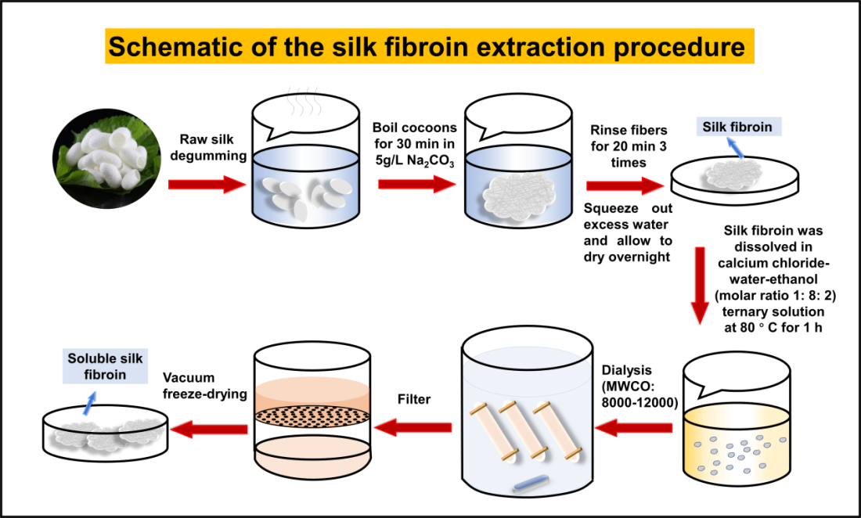
Fig. S1. Schematic of the silk fibroin extraction procedure.

Synthesis of KGN-loaded silk protein nanoparticles
KGN (0.4 mg∙mL⁻¹) was dissolved in dimethyl sulfoxide, and EDC and NHS were added to the solution (the molar ratio of KGN:EDC:NHS = 1:1:1). The solution was stirred for 1 h and added dropwise to a silk protein solution (4 mg∙mL⁻¹). After being reacted for 2–4 h, the solution was centrifuged at 14 000 r∙min⁻¹ for 5 min to remove possibly generated polymers. The excess impurities in the solution were removed by dialysis for one day, and the solution was freeze-dried under vacuum conditions to obtain KGN-loaded silk protein. KGN-loaded silk protein nanoparticles were synthesized by preparing a 2% KGN-loaded silk protein solution and adding the solution dropwise to acetone at the volume ratio of 1:20 under stirring for 2–4 h. The mixture was centrifuged at 100 000 r∙min⁻¹ for 30 min and washed with distilled water. The suspension was washed at least 2 times to produce a homogeneous suspension of KGN-loaded silk protein (SPNs–KGN) nanoparticles, which was stored at 4 °C. The SPNs with no KGN were prepared using pure acetone.

Characterization of KGN-loaded silk protein nanoparticles
The concentration of KGN in KGN-loaded silk protein was determined by high performance liquid chromatography (HPLC) analysis using a C18 reversed-phase column. The mobile phase, which was added with 0.1% formic acid, was the mixture of acetonitrile and water at the ratio of 70:30. The flow rate was 1 mL∙min⁻¹, the detection wavelength was 281 nm, the injection volume was 10 µL, and the retention time was 11 min. The linear regression equation (Fig. S2) for the KGN concentration and peak area of the drug was first determined. The pre-reaction KGN solution and the post-reaction dialysate were collected, and the concentration of unloaded KGN was determined by HPLC and calculated from the regression equation. The encapsulation efficiency and drug loading of KGN were calculated as follows:
$Encapsulation efficiency \left(\%\right)=100\%×{\left({KGN}_{total}-{KGN}_{unloaded}\right)}/{{KGN}_{total}}$ (S1)
$Drug loading \left(\%\right)=100\%×{\left({KGN}_{total}-{KGN}_{unloaded}\right)}/{{silk protein}_{total}}$ (S2)

Fig. S2. (a) High performance liquid chromatography and chromatographic conditions of KGN. (b) Linear relationship between chromatographic peak area and concentration of KGN. (c) High performance liquid chromatography and chromatographic conditions of Dex. (d) Linear relationship between chromatographic peak area and concentration of Dex.

The particle size distribution, zeta potential, and polydispersity of the SPNs–KGN nanoparticles were measured using a dynamic light scattering spectrophotometer (Zetasizer Nano ZS, Malvern). The circular dichroism of the nanoparticles was detected using a circular dichroism spectrometer (BRIGHTTIME Chirascan, Applied Photophysics) at the scan range of 190–250 nm and wavelength step of 2 nm. The SPNs–KGN were dried at 25 ℃ and coated with gold coatings before being observed using scanning electron microscopy (SEM). ¹H NMR spectroscopy was used to characterize the surface chemistry of the nanoparticles.

Synthesis of drug-loaded nanocomposite hydrogels
Dex was dissolved in deionized water at the concentration of 5 mg∙mL⁻¹. The Dex solution was added with HLC (20 mg∙mL⁻¹), and the mixture was heated on a 37 °C water bath to dissolve the HLC completely. After being fully reacted, the solution was dialyzed to remove un-cross-linked small molecules and freeze-dried under vacuum conditions to obtain HLC(Dex). The loading of Dex on HLC was determined by HPLC analysis using a C18 reversed-phase column, The linear regression equation (Fig. S2) for the Dex concentration and peak area of the drug was first determined. The pre-reaction Dex solution and the post-reaction dialysate were collected, and the concentration of unloaded Dex was determined by HPLC and calculated from the regression equation. The encapsulation efficiency and drug loading equations are similar to those for KGN. The mobile phase was the mixture of acetonitrile and water at the ratio of 70:30. The flow rate was 1 mL∙min⁻¹, the detection wavelength was 240 nm, the injection volume was 10 µL, and the retention time was 3.5 min. SPNs–KGN (1 mg∙mL⁻¹) were dissolved completely in deionized water, and the solution was added with 100 mg∙mL⁻¹ of HLC(Dex). After being thoroughly mixed, the solution was added with TGase (60 U∙g⁻¹ of protein), and the mixture was reacted at 4 °C for 6–10 h to obtain HLC(Dex)–SPNs–KGN hydrogel. HLC–SPNs hydrogel was the hydrogel that contained neither Dex nor KGN. HLC hydrogel was the hydrogel that contained none of Dex, KGN, and SPNs. HLC–SPNs–KGN hydrogel was the hydrogel of which HLC and SPNs–KGN were mixed and cross-linked using TGase. HLC(Dex)–SPNs hydrogel was the hydrogel of which HLC(Dex) and SPNs were mixed and crosslinked using TGase.

Characterization of HLC(Dex)–SPNs–KGN hydrogel
HLC(Dex)–SPNs–KGN hydrogels were frozen in liquid nitrogen immediately after cryo-electron microscopy (PP3000T Cryoprep transfer system (Quorum, UK), FEI Quanta 450 environmental scanning electron microscope) to observe the internal pore structure.
To characterize the swelling behavior of the hydrogel, the hydrogel was immersed in PBS and removed at certain intervals. The hydrogel was weighed until the constant weight of the hydrogel was obtained. The swelling rate (SR) of the hydrogel was calculated by the following Eq. (S3), where W_{i} and W_{t} represented the initial weight of the freeze-dried hydrogel before being immersed in PBS and the constant weight of the hydrogel after being immersed in PBS, respectively.
$SR \left(\%\right)=\frac{W_{t}-W_{i}}{W_{i}}×100\%$ (S3)
The rheological properties of the hydrogel were tested using a rheometer (MCR302) set in the oscillatory mode at the 5% strain, 1 rad∙s⁻¹ frequency, and 25 °C temperature. The cyclic compression test was performed on the hydrogel using an INSTRON 5565 testing machine. The modulus data of the cylindrical hydrogel (1 cm diameter and 1 cm thickness) were automatically calculated by the testing machine.
To determine the degree of gel formation, the gel fraction of the hydrogel is calculated by measuring the mass of the hydrogel before and after formation by weight. The steps are as follows: The components of the hydrogel are mixed to determine the mass of the whole component (W), then the mixture is stirred to form a hydrogel, the hydrogel is removed, and the surface water is absorbed with filter paper, and the hydrogel is weighed again (W_{i}), then the gel fraction is calculated as in Eq. (S4).
$Gel fraction \left(\%\right)=\left({W_{i}}/W\right)×\text{100\%}$ (S4)

In-vitro drug release studies
HLC(Dex)–SPNs–KGN hydrogel (100 mg) and SPNs–KGN nanoparticles (10 mg) were immersed in PBS (1 mL, pH 7.4) under shaking (100 r∙min⁻¹) at room temperature. HLC(Dex)–SPNs–KGN hydrogel (100 mg) and SPNs–KGN nanoparticles (10 mg) were also immersed in PBS (1 mL, pH 7.4) with 1 U∙mL⁻¹ collagenase (Shanghai Genye Biotechnology Co., Ltd., S10053) under shaking (100 r∙min⁻¹) at room temperature. At predetermined time intervals, 0.1 mL of release solution was withdrawn, and the peak area was determined by HPLC to calculate the total release rate. Then, 0.1 mL of fresh PBS or PBS with 1 U∙mL⁻¹ collagenase was added to maintain constant total volume, and the dialysis test continued. The amount of KGN and Dex that were released from the hydrogel was determined using HPLC analysis.

Cytocompatibility studies
The cytotoxicity of the HLC(Dex)–SPNs–KGN hydrogel was determined by the MTT assay. To obtain the extract of the hydrogel, the hydrogel was immersed in the culture medium at the concentration of 100 mg∙mL⁻¹ for 24 h at 37 °C. Human articular chondrocytes (HACs) and hMSCs were seeded in a 96-well plate at the density of 1 × 10⁴ cells per well, incubated in a humidified CO₂ incubator under 5% CO₂ conditions for 24 h, and treated with the hydrogel extract. After a 24 h incubation, the extract was replaced with PBS containing the MTT reagent. After 4 h, the MTT solution was removed and replaced with DMSO. The absorbance of each well was measured at 490 nm. Cell viability was determined using the following Eq. (S5), where A_{hydrogel} and A_{control} were the absorbance values of the hydrogel and the control, respectively. For the AO/EB staining of the HACs and hMSCs that were treated with the extracts of hydrogel samples (HLC hydrogel, HLC–SPNs hydrogel, HLC(Dex)–SPNs hydrogel and HLC(Dex)–SPNs–KGN hydrogel), HACs and hMSCs (1 × 10⁴ mL⁻¹) were plated into a 96-well plate. After 24 h incubation, the culture medium was removed and the extracts of the hydrogel samples were added to the plate. The extracts were removed, and the wells were cleaned with PBS after being incubated for 3 days. After the 3-day incubation, the HACs and hMSCs were stained with an L/D cell viability kit. The cells were observed and photographed using a fluorescence microscope. To evaluate the adhesion of HACs and hMSCs on the HLC(Dex)–SPNs–KGN hydrogel, the hydrogel was inserted into a 48-well plate and soaked in the cell culture medium for 24 h. HACs and hMSCs (1 × 10⁵ mL⁻¹) were seeded on each well and incubated at 37 °C. After 2 days, the hydrogel was washed with PBS, added with 2.5% glutaraldehyde, and fixed for 10 h. An alcohol gradient was used to dehydrate the hydrogel, and the hydrogel was observed by SEM.
$Cell viability \left(\%\right)=\left(A_{hydrogel}/A_{control}\right)×100\%$ (S5)

Cell endocytosis of SPNs–KGN
Mesenchymal stem cells were cultured and spread in 6-well plates at a concentration of 1 × 10⁵ cells per well. After cell walling, 100 mg of HLC(Dex)–SPNs–KGN hydrogel was added to each well for co-culture. After 1 and 3 h, cells were collected by digestion and centrifugation, and transmission electron microscopy (TEM) fixative was added. After 12 h of fixation, cells were washed with distilled water, dehydrated with ethanol, and added to the epoxy resin. The cells embedded in epoxy resin were sliced into thin sections using a slicer, then placed on TEM copper grids and stained with uranyl acetate and lead citrate. The morphology of the cells was observed by TEM.

In-vitro anti-inflammatory–activity studies
In-vitro anti-inflammatory–activity experiments were conducted using mouse monocyte/macrophage-like cells (RAW264.7 cells). The experimental samples were grouped into the control group, which was added with the culture medium; the LPS group, which was added with the positive control (10 ng∙mL⁻¹ LPS solution); the HLC(Dex)–SPNs–KGN hydrogel group, which was added with a 50 mg∙mL⁻¹ extract; and the LPS and HLC(Dex)–SPNs–KGN hydrogel group, which was added with a 10 ng∙mL⁻¹ LPS solution and a 50 mg∙mL⁻¹ extract. The RAW264.7 cells were inoculated onto sterile coverslips and incubated for 24 h, and the supernatant was carefully removed. The liquid component of each group was added to the cells, and the cells were incubated for 24 h. The cells were washed with PBS, fixed with 4% paraformaldehyde, subjected to immunofluorescence staining (IL-10 (20850-1-AP) and TNF-α (ab1793), Abcam), and observed using a laser confocal microscope (A1, Nikon, Japan). Experimental groups include normal RAW264.7 cells group, LPS group, HLC–SPNs hydrogel group, HLC(Dex)–SPNs hydrogel group, HLC(Dex)–SPNs–KGN hydrogel group, LPS + HLC–SPNs hydrogel group, LPS + HLC(Dex)–SPNs hydrogel group, and LPS + HLC(Dex)–SPNs–KGN hydrogel group.

In-vitro assays on chondrogenic differentiation of hMSCs
To investigate the effect of the HLC(Dex)–SPNs–KGN hydrogel on the chondrogenic differentiation of hMSCs in vitro, hMSCs were cultured in an induction medium, which was DMEM that was supplemented with Dex (100 nmol∙L⁻¹), valine (50 mmol∙L⁻¹), ascorbic acid (50 mmol∙L⁻¹), and insulin–transferrin–selenium (ITS) (1% v/v). Sterilized hydrogel samples (HLC–SPNs hydrogel, HLC(Dex)–SPNs–KGN hydrogel, HLC–SPNs–KGN hydrogel, and HLC(Dex)–SPNs hydrogel) were immersed in the induction medium and the hMSCs and hydrogel samples were incubated together for 10 days. The experimental groups were the blank control group, which was added with the induction medium; the positive control group, which was added with the induction medium and 600 nmol∙L⁻¹ of KGN; the HLC–SPNs hydrogel group, which was added with the induction medium and 100 mg∙mL⁻¹ of HLC–SPNs hydrogel; the HLC(Dex)–SPNs–KGN hydrogel group, which was added with the induction medium and 100 mg∙mL⁻¹ of HLC(Dex)–SPNs–KGN hydrogel; the HLC–SPNs–KGN hydrogel group, which was added with the induction medium and 100 mg∙mL⁻¹ of HLC–SPNs–KGN hydrogel; and the HLC(Dex)–SPNs hydrogel group, which was added with the induction medium and 100 mg∙mL⁻¹ of HLC(Dex)–SPNs hydrogel. The hMSCs were fixed in 4% paraformaldehyde at 37 °C for 30 min, stained with toluidine blue (Solarbio, China), and observed using a microscope. Immunofluorescence staining was performed after the hMSCs were fixed. The antibodies were Col Ⅱ (bs-10589, Bioss), cartilage oligomeric matrix protein (COMP; bs-10286R, Bioss), aggrecan (ab3778, Abcam), and SOX-9 (bs-4177R, Bioss). The hMSCs were observed using a confocal fluorescence microscope (A1, Nikon, Japan). The Co-60-irradiated sterilized hydrogels (diameter of 10 mm, height of 2 mm) (HLC–SPNs hydrogel, HLC(Dex)–SPNs hydrogel, HLC–SPNs–KGN hydrogel, HLC(Dex)–SPNs–KGN hydrogel) were immersed in chondrogenic differentiation medium for 6 h, then hMSCs were seeded in per hydrogel at 2 × 10⁴ cells. The hydrogels of seeded cells were cultured in chondrogenic differentiation medium for 5 and 10 days. The cells were digested and collected for ELISA kits and qPCR assays for chondrogenic-related proteins and genes, respectively. ELISA kits include Col Ⅱ (ml 038558, Shanghai Enzyme-linked Biotechnology Co., Ltd.), COMP (JN 22626, Shanghai Jining Biotechnology Co.), aggrecan (ab213754, Abcam), and SOX-9 (ab253226, Abcam).

The qPCR assay for detecting gene expression in 3D cultured cells
At 5 and 10 days, the total cellular RNA was extracted using TRIzol reagent (Takara, Japan) according to the manufacturer’s instructions. First-stranded complementary DNA (cDNA) was synthesized with the PrimeScript RT reagent kit (Takara). Subsequently, cDNA was diluted ten-fold in sterile distilled water, and a 4 μL aliquot of the diluted cDNA was subjected to real-time reverse transcription polymerase chain reaction (RT-PCR) using SYBR Premix Ex Taq™ (Takara). Real-time RT-PCR was performed in a 10 μL solution containing 1× PCR buffer, a 4 μL aliquot of the diluted cDNA, 1× SYBR Premix Ex Taq (5 μL), 0.2 μmol∙L⁻¹ (0.4 μL) of each primer (forward and reverse), and 0.2 μL ROX reference dye (50×). The conditions of real-time PCR were as follows: 95 °C for 30 s followed by 40 cycles at 95 °C for 5 s and 60 °C for 34 s. Real-time PCR was performed by a Bio-Rad real-time PCR system (Bio-Rad, USA) on markers of COMP, COL2A1, ACAN, and SOX9 (Table S1). The values obtained were normalized to the negative control as fold change.

Table S1
Real-time RT-PCR primer sequences for chondrogenic marker genes.
Target | Primer sequence forward and reverse (5′–3′)
GAPDH | Forward-CGTCTTCACCACCATGGAGA
GAPDH | Reverse- CGGCCARCACGCCACAGTTT
SOX9 | Forward-TTCATGAAGATGACCGACGA
SOX9 | Reverse-GTCCAGTCGTAGCCCTTGAG
ACAN | Forward-CGAAACATCACCGAGGGT
ACAN | Reverse-GCAAATGTAAAGGGCTCCTC
COL2A1 | Forward-CGCCGCTGTCCTTCGGTGTC
COL2A1 | Reverse-AGGGCTCCGGCTTCCACACAT
COMP | Forward-TGTAAAACGACGGCCAGT
COMP | Reverse-TGTAAAACGACGGCCAGT

In vivo degradation and anti-inflammatory effects of the hydrogels
All animal experiments were reviewed by the Northwest University Laboratory Animal Management and Ethics Committee. The experiments complied with the legal and institutional guidelines related to animal ethics and were approved by the Ethics Committee (NWU-AWC-20210810R). The degradation of hydrogel samples was studied by implanting the samples under the skin (i.e., subcutaneous) of the backs of rabbits. The degradation of the samples was evaluated on weeks 1, 5, and 10. The rabbits were euthanized, and skin tissues were collected from the sites at which the hydrogel samples were implanted. The tissues were fixed in 4% neutral paraformaldehyde for histological evaluation. The degraded hydrogel samples were freeze-dried under vacuum conditions, and the structure of the samples was observed by SEM. The degraded hydrogel samples were freeze-dried under a vacuum and weighed to calculate the degradation rate. H&E staining and the immunohistochemical staining for IL-6 (bs-4539R, Bioss) were performed on the skin tissues.

Establishment of inflammatory cartilage defects and implantation of hydrogel in rabbit knee joints
The 0.3 mL of 4% papain saline solution was injected into the rabbit’s hip joint on days 1, 4 and 7, respectively. After seven days, the rabbits were anesthetized, and their knee joints were disinfected with alcohol. The inflammatory cartilage defects (5.0 mm diameter and 2.5 mm thickness) were established on the rabbits’ hindlimbs using a surgical drill. Twenty-seven rabbits were divided into the control group, HLC–SPNs hydrogel group, and HLC(Dex)–SPNs–KGN hydrogel group. The cartilage defects on the knee joints that belonged to the control group were untreated. On the other hand, the cartilage defects on the knee joints that belonged to the HLC–SPNs hydrogel group and those on the knee joints that belonged to the HLC(Dex)–SPNs–KGN hydrogel groups were filled with the respective hydrogel samples to the surface of native cartilage, which was followed by ligament repositioning and wound closure.

Evaluation of cartilage repair
The rabbits were euthanized on the first, second, or third month, and their knee joints were collected for observation and sample analysis. The International Cartilage Repair Society (ICRS) classification system was used to assess the repair status of the surgical sites on the knee joints (Table S2) by assessing the appearance of the defects on the surgical sites and connection between the defects and their surrounding areas. A micro-CT scanner (SKYSCAN 1172, Bruker) was used to perform qualitative and quantitative analyses of tissue regeneration on the surgical sites. A 0.5 mm aluminum filter was used to perform the micro-CT scans at the 80 kV voltage and 124 µA current. A circular region of interest (ROI) with the diameter of 3 mm and depth of 5 mm was selected from the data set, which corresponded to the areas of the defects. The measurement parameters were bone mineral density (BMD), bone volume/total volume ratio (BV/TV), trabecular thickness (Tb.Th), and trabecular spacing (Tb.Sp). The knee joints of the rabbits were fixed in 4% neutral paraformaldehyde for 7 days and decalcified in ethylenediaminetetraacetic acid until an injection needle penetrated the tissues of the joints easily. To perform histological evaluation, H&E staining was used to assess the distribution of cells and fibrous tissues on the knee joints and safranin green dyeing was used to detect the presence of glycosaminoglycans in the tissues of the knee joints. The images that were obtained by the H&E staining and safranin green dyeing were used to perform ICRS visual histological scoring (Table S3). Immunohistochemical (IHC) staining was performed for TNF-α (ab1793, Abcam), ADAMTS5 (bs-3537R, Bioss), and IL-6 (bs-4539R, Bioss). On the other hand, immunofluorescence staining was performed for BMP2 (bs-6909R, Bioss), TGF-β1 (bs-20411R, Bioss), CD68 (GTX34543, GeneTex), CD86 (ab270719, Abcam), CD206 (60143-1, Proteintech), RUNX1 (bs-6101R, Bioss), SOX-9 (bs-4177R, Bioss), Col Ⅱ (bs-10589, Bioss), aggrecan (ab3778, Abcam), and COMP (bs-10286R, Bioss).

Table S2
International Cartilage Repair Society (ICRS) cartilage repair assessment tool.
Item | Criteria | Points
Degree of defect repair | Level with surrounding cartilage | 4
Degree of defect repair | 75% repair of defect depth | 3
Degree of defect repair | 50% repair of defect depth | 2
Degree of defect repair | 25% repair of defect depth | 1
Degree of defect repair | 0% repair of defect depth | 0
Integration to border zone | Complete integration with surrounding cartilage | 4
Integration to border zone | Demarcating border < 1 mm | 3
Integration to border zone | 3/4 of graft integrated, 1/4 with a notable border > 1 mm width | 2
Integration to border zone | 1/2 of graft integrated with surrounding cartilage, 1/2 with a notable border > 1 mm | 1
Integration to border zone | From no contact to 1/4 of graft integrated with surrounding cartilage | 0
Macroscopic appearance | Intact smooth surface | 4
Macroscopic appearance | Fibrillated surface | 3
Macroscopic appearance | Small, scattered fissures or cracks | 2
Macroscopic appearance | Several, small or few but large fissures | 1
Macroscopic appearance | Total degeneration of grafted area | 0
Overall score | Grade I normal | 12
Overall score | Grade II nearly normal | 11–8
Overall score | Grade III abnormal | 7–4
Overall score | Grade IV severely abnormal | 3–1

Table S3
Histology scoring system for the evaluation of overall tissue, subchondral bone, and cartilage in rabbit osteochondral defects.
Item | Category | Score
Overall defect evaluation (throughout the entire defect)
1. Percentage filling with neo-formed tissue | 0–25% | 0
1. Percentage filling with neo-formed tissue | 25%–50% | 1
1. Percentage filling with neo-formed tissue | 50%–75% | 2
1. Percentage filling with neo-formed tissue | 75%–100% | 3
2. Percentage degradation of scaffold | 0–25% | 0
2. Percentage degradation of scaffold | 25%–50% | 1
2. Percentage degradation of scaffold | 50%–75% | 2
2. Percentage degradation of scaffold | 75%–100% | 3
Subchondral bone evaluation (within the bottom of defect)
3. Percentage filling with neo-formed tissue in sub-chondral bone | 0–25% | 0
 | 25%–50% | 1
 | 50%–75% | 2
 | 75%–100% | 3
4. Subchondral bone morphology | Only fibrous tissue or no tissue | 0
4. Subchondral bone morphology | Compact bone and fibrous tissue | 1
4. Subchondral bone morphology | Compact bone | 2
4. Subchondral bone morphology | Trabecular, with some compact bone | 3
4. Subchondral bone morphology | Normal, trabecular bone | 4
5. Extent of neo-tissue bonding with adjacent tissue | Without continuity on either edge | 0
5. Extent of neo-tissue bonding with adjacent tissue | Partial on both edges | 1
5. Extent of neo-tissue bonding with adjacent tissue | Complete on one edge | 2
5. Extent of neo-tissue bonding with adjacent tissue | Complete on both edges | 3
Cartilage evaluation (within the upper layer of defect)
6. Morphology of neo-formed surface tissue | No tissue | 0
6. Morphology of neo-formed surface tissue | Only fibrous tissue (spherical cell morphology less than 75% of cells) | 2
6. Morphology of neo-formed surface tissue | Fibrocartilage (spherical cell morphology greater than 75% of cells) | 4
6. Morphology of neo-formed surface tissue | Mainly hyaline cartilage | 6
7. Thickness of neo-formed cartilage | No cartilage | 0
7. Thickness of neo-formed cartilage | Less than the surrounding cartilage | 1
7. Thickness of neo-formed cartilage | Greater than surrounding cartilage | 2
7. Thickness of neo-formed cartilage | Similar to the surrounding cartilage | 3
8. Joint surface regularity | Complete disruption of the neo-surface | 0
8. Joint surface regularity | Complete disruption of the neo-surface | 1
8. Joint surface regularity | Surface fissures (< 25% neo-surface thickness) | 2
8. Joint surface regularity | Smooth, intact surface | 3
9. Chondrocyte clustering | No chondrocytes present (no cartilage) | 0
9. Chondrocyte clustering | 25%–100% chondrocytes | 1
9. Chondrocyte clustering | Less than 25% of chondrocytes | 2
9. Chondrocyte clustering | None at all | 3
10. Chondrocyte and GAG content of new cartilage | Few cells with no or little Safranin O staining or no cartilage | 0
10. Chondrocyte and GAG content of new cartilage | Obviously less cells with poor Safranin O staining | 1
10. Chondrocyte and GAG content of new cartilage | Normal cellularity with moderate Safranin O staining | 2
10. Chondrocyte and GAG content of new cartilage | Normal cellularity with normal Safranin O staining | 3
11. Chondrocyte and GAG content of adjacent cartilage | Few cells with no or little Safranin O staining or no cartilage | 0
11. Chondrocyte and GAG content of adjacent cartilage | Obviously less cells with poor Safranin O staining | 1
11. Chondrocyte and GAG content of adjacent cartilage | Normal cellularity with moderate Safranin O staining | 2
11. Chondrocyte and GAG content of adjacent cartilage | Normal cellularity with normal Safranin O staining | 3

Statistical Analysis
Data are presented as means ± standard deviations. Statistical analysis was performed using SPSS software. One-way or two-way ANOVA was used to analyze significant differences at different thresholds: *p < 0.05, **p < 0.01, and ***p < 0.001.

Results
Table S4
The effect of the concentrations of silk protein and KGN on the drug loading and encapsulation efficiency of KGN.
Silk protein concentration (mg∙mL⁻¹) | KGN concentration (mg∙mL⁻¹) | Drug loading (% w/w) | Encapsulation efficiency (% w/w)
4 | 0.2 | 1.24% ± 0.56% | 24.8% ± 3.54%
4 | 0.4 | 2.05% ± 0.32% | 20.3% ± 4.76%
8 | 0.4 | 1.87% ± 0.68% | 37.5% ± 4.92%

Table S5
The size, dispersion, and surface charge of the SPNs–KGN nanoparticles were determined on the basis of the dynamic light scattering and zeta potential of the nanoparticles.
Particle size (nm) | Polydispersity | Zeta-potential (mV)
211.8 ± 8.23 | 0.326 ± 0.018 | 6.25 ± 0.36

Fig. S3. ¹H NMR spectra of the HLC(Dex) compounds.

Fig. S4. The anti-inflammatory effect of the hydrogel on the RAW264.7 cells that were induced by LPS. The confocal microscopy images of the immunofluorescence staining of the cells for TNF-α (red), IL-10 (green), and DAPI (blue). The scale bars indicate 50-µm scales.
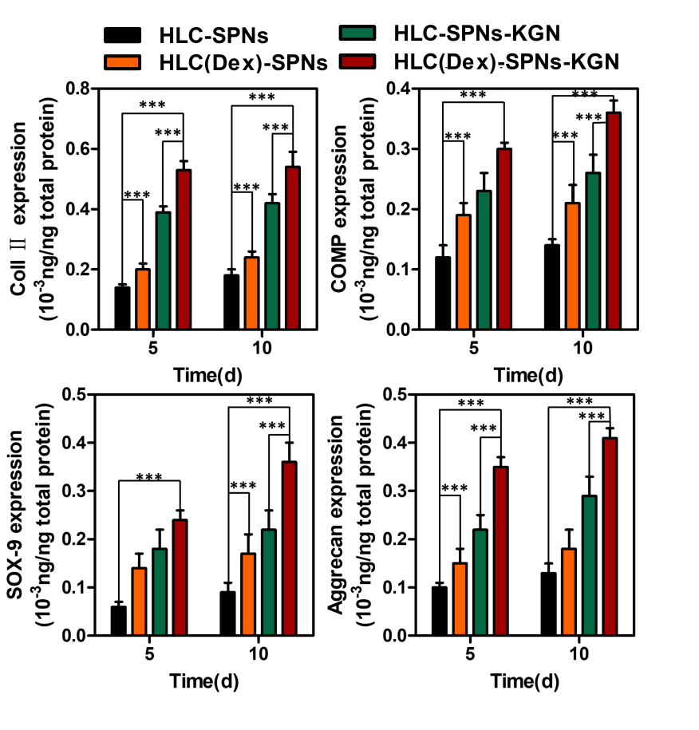
Fig. S5. Enzyme-linked immunosorbent assay (ELISA) was performed to assess the concentration of COMP, Col II, aggrecan, and SOX-9 secreted by the cells.

Fig. S6. In vivo degradation and anti-inflammatory properties. (a) The subcutaneous degradation of hydrogel samples on weeks 1, 5, and 10. (b) The SEM images of the hydrogels after the subcutaneous degradation. (c) The H&E staining of the skin specimens after the subcutaneous implantation of the hydrogel samples. Yellow arrows point to inflammatory cells. The scale bars indicate 100-µm. (d) The immunohistochemical staining for pro-inflammatory factor TNF-α. The scale bars indicate 100 µm.

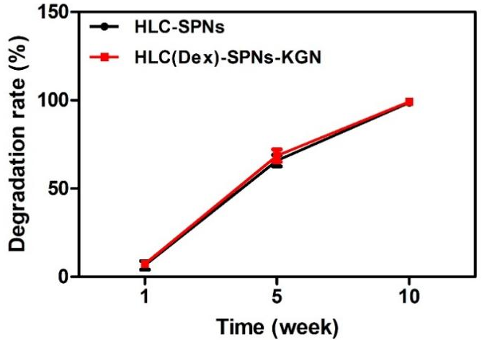
Fig. S7. Weight loss in subcutaneous degradation of hydrogels.

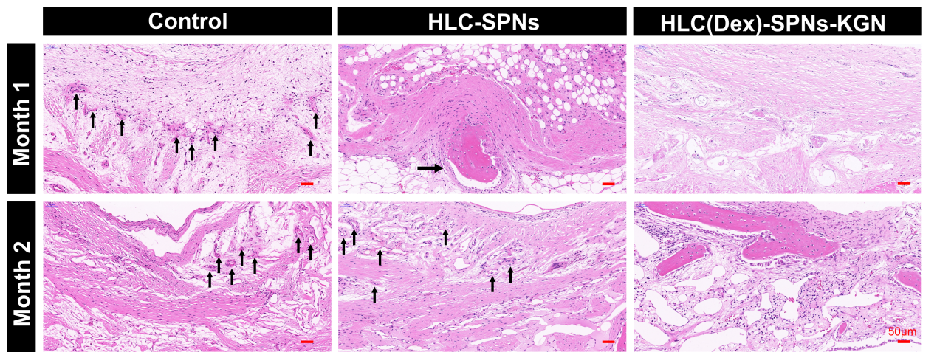
Fig. S8. Fibrous capsule at the site of bone injury (black arrow indicates fibrous capsule).

